Photosynthetic Pigments Responses of Selected Cultivated Plants to Palm Oil Mill Effluent Contamination
ABSTRACT
Contaminations affect plants photosynthetic pigments synthesis. This study determines the effects of palm oil mill effluent (POME) contamination on chlorophyll contents and carotenoids of plants cultivated on non-contaminated and POME-contaminated soils. The study was carried out in Aba Oka, Isinbode, Ekiti State, Nigeria. The study is a field experiment that span through three planting seasons (early rainy, late rainy, and early dry). The study focuses on three selected plants, Nicotiana tabacum, Amaranthus hybridus, and Corchorus olitorius. The photosynthetic pigments was extracted with 5 mL of 80% acetone using mortar and pestle, the homogenate was filtered, and the filtrate was made up to 5 mL with 80% acetone. The pigments in the filtrate were estimated using UV-visible spectrophotometer. Data obtained were subjected to analysis of variance and mean different were separated via Tukey’s multiple range tests. Results show that across all the growing seasons and selected cultivated plants on POME-contaminated soil, the highest (46.99 ± 5.17 mg g⁻¹ FW) photosynthetic pigment was recorded in Nicotiana tabacum during the early dry season and lowest (5.57 ± 0.89 mg g⁻¹ FW) in Corchorus olitorius during the late rainy season compared to the non-contaminated grown plants. The photosynthetic pigments synthesis was significantly (p < 0.05) hampered by POME-contamination in the first two phases of cultivation. However, an improved significant (p < 0.05) production of photosynthetic pigments was recorded in the third phase. The study concluded that, palm oil mill effluent contamination hampered synthesis of photosynthetic pigments across growing seasons.
Keywords: Photosynthetic, contamination, Nicotiana tabacum, Amaranthus hybridus, and Corchorus olitorius.
INTRODUCTION
Photosynthetic pigments are important factors that determine the rate and extent of plant growth and productivity, as these factors are responsible for light capture and conversion into energy through photosynthesis [1]. Chlorophyll a is the major pigment responsible for photochemical reactions, while chlorophyll b and carotenoids are accessory pigments that improve photosynthetic efficiency and also protect it against oxidative stress [2, 3, 4]. The synergistic action of these pigments plays a crucial role in helping plants adapt to different environmental changes; hence they are important for the survival of plants under different environmental stressors [5, 6].
Changes in the concentration of chlorophyll and carotenoids are important factors that determine changes in photosynthetic capacity, nutrient availability, and stress responses such as drought and soil contamination [7]. The environment plays a crucial role in determining the rate and extent of photosynthetic pigment synthesis and degradation, and hence these factors determine the rate and extent of plant growth and development [8]. The analyses of photosynthetic pigments are important factors that determine the performance and responses of plants to different environmental changes.
Soil contamination, especially due to agro-industrial wastes, is considered one of the major environmental problems in various tropical regions worldwide [9]. Palm oil mill effluent (POME), a waste product of palm oil processing, contains high levels of organic matter, suspended solids, and residual oil content [9, 10]. If not disposed of properly, affect soil physicochemical properties, nutrient balance, and stress levels in plants [11]. POME has been reported to have a fertilizing effect on soil at low concentrations due to its nutrient content, thus promoting soil fertility [12]. However, high concentrations of POME can cause phytotoxicity, reduce photosynthesis, and inhibit plant growth. These findings have generated interest in estimating plant responses to soil contamination, especially at the physiological level.
Plant species have different levels of tolerance to contaminated soil, and some species have developed adaptive mechanisms to survive on it and as well clean it up [13, 14]. Some species, such as Nicotiana tabacum, Amaranthus hybridus, and Corchorus olitorius, have been cultivated worldwide and have been reported to show high growth rates and different levels of resistance to environmental stress, thus providing an opportunity to study the plants responses to soil contamination. However, information regarding the comparative impact of palm oil mill effluent on photosynthetic pigments of this different plant species at different planting seasons is still limited.
Seasonal dynamics play a vital role in influencing plant physiological processes in tropical agro-ecosystems [15, 16]. The early rainy, late rainy, and early dry seasons significantly influence plant physiological processes, especially in terms of the synthesis of photosynthetic pigments in plants. Thus, it is important to understand how seasonal changes influence and interact with soil contamination, especially in areas affected by POME contamination. Therefore, this study aim to estimate the concentration of photosynthetic pigments, such as chlorophyll a, chlorophyll b, and carotenoids, in Nicotiana tabacum, Amaranthus hybridus, and Corchorus olitorius grown on non-contaminated and POME-contaminated soils during the early rainy, late rainy, and early dry seasons.
MATERIALS AND METHODS
Study Area
The study was carried out in Aba Oka-Isinbode, Ekiti State, Nigeria, on palm oil processing mill effluent contaminated and non-contaminated soils during rain fed growing seasons (early rainy, late rainy, and early dry). The study area lies within the range of latitudes N7° 41′ 3.813″ to N7° 41′ 4.896″, while the range of longitude lies within E5° 35′ 48.138″ to E5° 35′ 49.075″, located in Ekiti East Local Government Area.
Selected plants for the study
One indegenous plant (Nicotiana tabacum) and the two most cultivated vegetables (Amaranthus hybridus, and Cochorus olitorius) in the study were selected due to their fast growth rate, high biomass yield, and ability to tolerate contaminants.
Experimental design layout and plant management
A complete randomized block design (CRBD) was employed in which the control and POME-contaminated soils experimental units were replicated four times for each of the selected study plant in each season of cultivation. The study soils plot were 15 m x 8.5 m in total which was subdivided into subplots of 2.5 m x 1.5 m with a 1 m passage way between and 0.5 m spacing within the subplots to ensure ease of management of the plants. Seeds of all the selected plants were sown directly to the prepared ridges via drilling and the plants were maintained weed free while growing under natural environment.
Plant tissue harvest
For each planting season, the experiment was terminated 7 week after sowing (WAS). After the plants representative samples being properly collected and washed with water to get rid of any soil debris, they were taken to the laboratory for the estimation of the photosynthetic pigments in the plant leaves using standard method.
Estimation of leaf photosynthetic pigments
The Photosynthetic pigments (chlorophyll a, b, and carotenoid) were estimated using the procedure outlined by [19], with a minor adjustment as suggested by [20]. The 0.05 g of fresh leaf tissue was homogenized using a mortar and pestle with 5 mL of 80% acetone for five minutes to extract the pigment. The homogenate was filtered using Whatman No. 1 filter paper, and 80% acetone was added to the filtrate until its final volume was made up to 5 mL.
Using a UV-visible spectrophotometer, the concentrations of chlorophyll pigments were measured at three different wavelengths: carotenoids (carotene + xanthophyll) at 470 nm, chlorophyll-a at 663.2 nm, and chlorophyll-b at 646.8 nm. The amounts of carotenoids (car) and chlorophyll (chl) in the leaves were calculated using the following formulas from [21]:
$(Carotenoids (Car c+ x)$= (1000 × A470 – 1.82 × $Chl a$ – 85.02 × Chl b) / 198
$(Chlorophyll-a (Chl a)$= 12.25 × A663.2 – 2.79 × A646.8
$(Chlorophyll-b (Chl b)$= 21.50 × A646.8 – 5.10 × A663.2
The absorbance pigment concentration was expressed as milligrams per gram of fresh tissue weight (mg g⁻¹ FW).
Statistical analysis
For computing mean values and standard error of the mean, the data gathered from the estimation of the photosynthetic pigments was entered into Microsoft Excel (version 2010). ANOVA in GraphPad Prism 5.0 was employed for the statistical analysis, and significance was established at p < 0.05. For mean comparison, Tukey's multiple range tests were used.
RESULTS
Photosynthetic Pigments of Plants Cultivated on Non-contaminated and POME-contaminated Soils during Early Rainy Season
The photosynthetic pigments of selected plants cultivated on non-contaminated and POME-contaminated soils during the early rainy planting period are presented in Table 1. The results show that the highest chlorophyll a (14.47 ± 0.96 mg g⁻¹ FW) and b (58.21 ± 11.66 mg g⁻¹ FW) for the selected plants cultivated on non-contaminated soil was recorded in AMA with the least (4.32 ± 1.53 mg g⁻¹ FW) documented in COR while the highest (9.02 ± 0.14 mg g⁻¹ FW) carotenoid was recorded for COR and the lowest (4.32 ± 1.53 mg g⁻¹ FW) in AMA.
However, the highest chlorophyll a (14.85 ± 0.76) and b (6.74 ± 0.14 mg g⁻¹ FW) for the selected plants cultivated on POME-contaminated soil was recorded in NIC and COR respectively while the highest (11.49 ± 0.35 mg g⁻¹ FW) carotenoid was recorded in NIC with the least in AMA. The highest (18.74 ± 1.55 mg g⁻¹ FW) total chlorophyll was documented in NIC cultivated on POME-contaminated soil while the least (4.92 ± 1.14 mg g⁻¹ FW) was recorded in AMA. Generally, the results indicated that during the early rainy season the POME-contamination significantly (p < 0.05) altered the production of photosynthetic pigments adversely.

Table 1: Photosynthetic Pigments of Plants Cultivated on Non-contaminated and POME-contaminated Soils during Early Rainy Planting Period
Plants | Chl a | Chl b | Total Chl (a+b) | Carotenoids
(mg g⁻¹ FW)
Non-contaminated
NIC | 3.92 ± 0.37^{b} | 8.44 ± 0.39^{b} | 12.36 ± 0.75^{b} | 8.05 ± 0.00^{b}
AMA | 14.47 ± 0.96ª | 43.74 ± 10.70ª | 58.21 ± 11.66ª | 4.32 ± 1.53^{c}
COR | 0.84 ± 0.03^{c} | 1.32 ± 0.07^{c} | 2.16 ± 0.10^{c} | 9.02 ± 0.14ª
POME-contaminated
NIC | 14.85 ± 0.76ª | 3.89 ± 0.79^{b} | 18.74 ± 1.55ª | 11.49 ± 0.35ª
AMA | 3.46 ± 1.09^{b} | 1.46 ± 0.05^{c} | 4.92 ± 1.14^{c} | 8.98 ± 0.19^{b}
COR | 4.02 ± 0.31^{b} | 6.74 ± 0.14ª | 10.76 ± 0.45^{b} | 10.69 ± 0.27ª
Note: Mean ± SEM, Number of replicates (n) = 4, Different alphabets along a column indicate significant difference; Tukey's multiple range tests at p < 0.05 show that means with the same alphabet in each column are not significantly different; mg g⁻¹ FW = Milligrams per gram of fresh tissue weight; NIC = Nicotiana tabacum, AMA = Amaranthus hybridus, and COR= Corchorus olitorius; Chl a = Chlorophyll a, Chl b = Chlorophyll b.
Photosynthetic Pigments of Plants Cultivated on Non-contaminated and POME-contaminated Soils during Late Rainy Season
The photosynthetic pigments of selected plants cultivated on non-contaminated and POME-contaminated soils during the late rainy planting period are presented in Table 2. The results show that the highest chlorophyll a (5.25 ± 0.97 mg g⁻¹ FW) and b (5.45 ± 1.44 mg g⁻¹ FW) for the selected plants cultivated on non-contaminated soil was recorded in AMA with the least chlorophyll a (1.19 ± 0.18 mg g⁻¹ FW) and b (1.40 ± 0.11 mg g⁻¹ FW) documented in COR while the highest (1.52 ± 0.64 mg g⁻¹ FW) carotenoid was recorded in NIC and the lowest (1.08 ± 0.50 mg g⁻¹ FW) in AMA.
However, the highest chlorophyll a (3.03 ± 0.11 mg g⁻¹ FW) and b (4.39 ± 0.72 mg g⁻¹ FW) for the selected plants cultivated on POME-contaminated soil was recorded in AMA and NIC respectively while the highest (1.89 ± 0.22 mg g⁻¹ FW) carotenoid was recorded in COR with the least in AMA. The highest (5.99 ± 1.13 mg g⁻¹ FW) total chlorophyll was documented in NIC cultivated on POME-contaminated soil while the least (3.68 ± 0.67 mg g⁻¹ FW) was recorded in COR. Generally, the results showed that during the late rainy season the POME-contamination significantly (p < 0.05) affect the synthesis of photosynthetic pigments negatively.

Table 2: Photosynthetic Pigments of Plants Cultivated on Non-contaminated and POME-contaminated Soils during Late Rainy Season
Plants | Chl a | Chl b | Total Chl (a+b) | Carotenoids
(mg g⁻¹ FW)
Non-contaminated
NIC | 2.68 ± 0.38^{b} | 3.29 ± 1.12^{b} | 5.97 ± 1.50^{b} | 1.52 ± 0.64ª
AMA | 5.25 ± 0.97ª | 5.45 ± 1.44ª | 10.70 ± 2.41ª | 1.08 ± 0.50^{b}
COR | 1.19 ± 0.18^{c} | 1.40 ± 0.11^{c} | 2.59 ± 0.29^{c} | 1.51 ± 0.13ª
 | POME-contaminated
NIC | 1.60 ± 0.41^{c} | 4.39 ± 0.72ª | 5.99 ± 1.13ª | 1.48 ± 0.46^{b}
AMA | 3.03 ± 0.11ª | 2.37 ± 0.34^{b} | 5.40 ± 0.45ª | 0.81 ± 0.35^{c}
COR | 2.02 ± 0.29^{b} | 1.66 ± 0.38^{c} | 3.68 ± 0.67^{b} | 1.89 ± 0.22ª
Note: Mean ± SEM, Number of replicates (n) = 4, Different alphabets along a column indicate significant difference; Tukey's multiple range tests at p < 0.05 show that means with the same alphabet in each column are not significantly different; mg g⁻¹ FW = Milligrams per gram of fresh tissue weight; NIC = Nicotiana tabacum, AMA = Amaranthus hybridus, and COR= Corchorus olitorius; Chl a = Chlorophyll a, Chl b = Chlorophyll b.
Photosynthetic Pigments of Selected Plants Cultivated on Non-contaminated and POME-contaminated Soils during Early dry Season
The photosynthetic pigments of selected plants cultivated on non-contaminated and POME-contaminated soils during the early dry season planting period are presented in Table 3. The results indicated that the highest chlorophyll a (9.43 ± 1.34 mg g⁻¹ FW) and b (12.17 ± 1.45 mg g⁻¹ FW) for the selected plants cultivated on non-contaminated soil was recorded in NIC with the least chlorophyll a (6.25 ± 1.30 mg g⁻¹ FW) and b (9.88 ± 2.91 mg g⁻¹ FW) documented in AMA while the highest (8.30 ± 0.66 mg g⁻¹ FW) carotenoid was recorded in NIC and the lowest (8.04 ± 0.78 mg g⁻¹ FW) in AMA.
However, the highest chlorophyll a (12.62 ± 2.35 mg g⁻¹ FW) and b (29.81 ± 1.12 mg g⁻¹ FW) for the selected plants cultivated on POME-contaminated soil was recorded in AMA and NIC respectively while the highest (10.23 ± 0.33 mg g⁻¹ FW) carotenoid was recorded in COR with the least in COR. The highest (41.93 ± 3.76 mg g⁻¹ FW) total chlorophyll was documented in NIC cultivated on POME-contaminated soil while the least (20.51 ± 2.71 mg g⁻¹ FW) was recorded in AMA. Generally, the results showed that during the early dry season planting period the POME-contamination significantly (p < 0.05) enhanced the synthesis of photosynthetic pigments positively after two previously successful cultivation of the POME-contaminated soil with the selected plants the third time.

Table 3: Photosynthetic Pigments of Plants Cultivated on Non-contaminated and POME-contaminated Soils during Early Dry Season
Plants | Chl a | Chl b | Total Chl (a+b) | Carotenoid
(mg g⁻¹ FW)
Non-contaminated
NIC | 9.43 ± 1.34ª | 12.17 ± 1.45ª | 21.60 ± 2.79ª | 8.30 ± 0.66ª
AMA | 6.25 ± 1.30^{c} | 9.88 ± 2.91^{c} | 16.13 ± 4.21^{c} | 8.26 ± 0.93ª
COR | 8.22 ± 2.22^{b} | 11.56 ± 2.59^{b} | 19.78 ± 4.81^{b} | 8.04 ± 0.78^{b}
 | POME-contaminated
NIC | 12.12 ± 2.64^{b} | 29.81 ± 1.12ª | 41.93 ± 3.76ª | 5.06 ± 1.41^{b}
AMA | 12.62 ± 2.35ª | 7.89 ± 0.36^{c} | 20.51 ± 2.71^{c} | 10.23 ± 0.33ª
COR | 6.38 ± 1.25^{c} | 20.32 ± 3.26^{b} | 26.7 ± 4.51^{b} | 0.97 ± 0.29^{c}
Note: Mean ± SEM, Number of replicates (n) = 4, Different alphabets along a column indicate significant difference; Tukey's multiple range tests at p < 0.05 show that means with the same alphabet in each column are not significantly different; mg g⁻¹ FW = Milligrams per gram of fresh tissue weight; NIC = Nicotiana tabacum, AMA = Amaranthus hybridus, and COR= Corchorus olitorius; Chl a = Chlorophyll a, Chl b = Chlorophyll b.

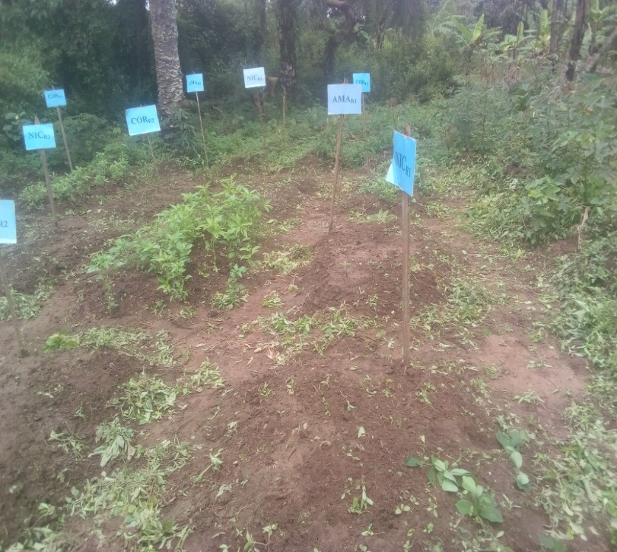
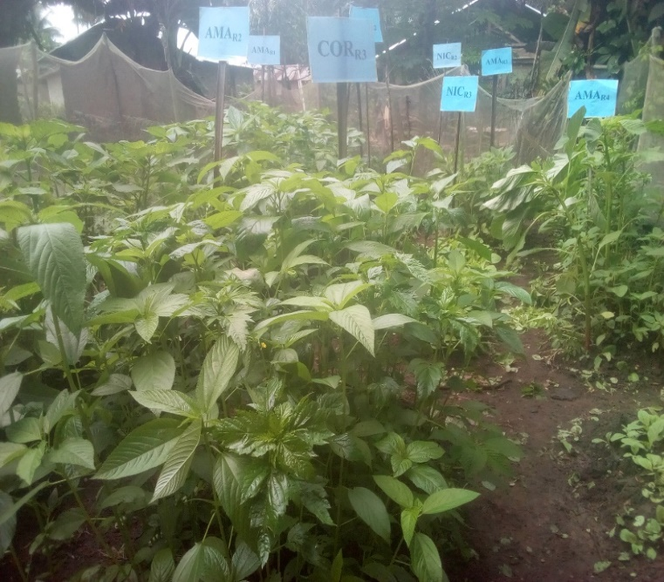
- (b)

Figure 1: The selected cultivated plants during the late rainy season in non-contaminated (a) and POME-contaminated soil (b).

DISCUSSION
The variations in photosynthetic pigments observed across seasons and soil type (non-contaminated and palm oil mill effluent (POME) contaminated soils) show the complex interaction between POME inputs, plant species, and seasonal changes.
The general decline in chlorophyll and carotenoid levels during the early and late rainy seasons under POME contamination indicates that freshly affected soils may put physiological stress on plants. This reduction in photosynthetic pigments in POME-contaminated soil grown plants aligns with the reports that POME contained higher organic load, decreased oxygen, and the presence of harmful compounds that causes oxidative stress and photosystem activity inhibition in plants [22, 23, 11]. In contrast, the increase in pigment synthesis seen during the early dry season points to a temporary improvement in soil conditions after repeated cultivation. This trend may relate to the gradual breakdown of organic materials in POME, which increases the availability of vital nutrients such as nitrogen, magnesium, and iron; these are essential for chlorophyll production [24, 25].
Furthermore, the different responses among species suggest variability in tolerance and ability to adapt to POME-related stress. Species that show improved pigment accumulation in treated conditions may have more effective detoxification mechanisms or better nutrient uptake strategies. The study trends indicated that synthesis of pigments in plants cultivated on contaminated soil depend on both type of plant and seasons of their cultivation, which was in line with the findings of [26, 27] which reported that seasonal changes caused variation in plant pigment formation. Generally, these findings indicate that while POME initially has harmful effects on photosynthesis, its impact may become positive with time and proper management.
CONCLUSIONS
This study concluded that the palm oil mill effluent hampered the synthesis of photosynthetic pigments significantly in Nicotiana tabacum, Amaranthus hybridus, and Corchorus olitorius. It also established that early dry season planting in POME-contamination soil significantly enhanced the synthesis of photosynthetic pigments positively after two successful cultivation of the POME-contaminated soil consecutively.
AUTHOR CONTRIBUTIONS
Conceptualization: Oluwatosin Gabriel Oke; Methodology: Oluwatosin Gabriel Oke, Moses Bamidele Adewole, and Bolajo Ayinke Akinpelu, Formal analysis and investigation: Oluwatosin Gabriel Oke; Writing - original draft preparation: Oluwatosin Gabriel Oke; Writing - review and editing: Moses Bamidele Adewole and Bolajo Ayinke Akinpelu; Funding acquisition: Oluwatosin Gabriel Oke; Resources: Oluwatosin Gabriel Oke; Supervision: Moses Bamidele Adewole and Bolajo Ayinke Akinpelu.
FUNDING
No financial support was received for this work.
DATA AVAILABILITY STATEMENT
Data generated or analyzed in this study are embedded in this published article [and its supplementary information files].
ACKNOWLEDGEMENTS
The authors acknowledge the Institute of Ecology and Environmental Studies for their approval to carry out this research and Department of Biochemistry and Molecular Biology, Obafemi Awolowo University, Ile-Ife, Nigeria, for giving access to their laboratory facilities.

CONFLICTS OF INTEREST
The authors declare that there is no any conflict of interests regarding the publication of this manuscript.
DECLARATIONS
- Ethical approval
Not Applicable
- Consent to participate
Not Applicable
- Consent to publish
Not Applicable
REFERENCES
1. Klavins, L., Zommere, A., Gricenko, T., & Klavins, M. (2026). The multifunctionality of plant pigments: roles, recovery from by-products and stability challenges. Journal of Agriculture and Food Research, 102748. https://doi.org/10.1016/j.jafr.2026.102748.
2. Simkin, A. J., Kapoor, L., Doss, C. G. P., Hofmann, T. A., Lawson, T., & Ramamoorthy, S. (2022). The role of photosynthesis related pigments in light harvesting, photoprotection and enhancement of photosynthetic yield in planta. Photosynthesis research, 152(1), 23-42. https://doi.org/10.1007/s11120-021-00892-6.
3. Sandmann, G. (2019). Antioxidant protection from UV-and light-stress related to carotenoid structures. Antioxidants, 8(7), 219. https://doi.org/10.3390/antiox8070219.
4. Kume, A., Akitsu, T., & Nasahara, K. N. (2018). Why is chlorophyll b only used in light-harvesting systems?. Journal of Plant research, 131(6), 961-972. https://doi.org/10.1007/s10265-018-1052-7.
5. Sun, T., Rao, S., Zhou, X., & Li, L. (2022). Plant carotenoids: recent advances and future perspectives. Molecular Horticulture, 2(1), 3. https://doi.org/10.1186/s43897-022-00023-2.
6. Uarrota, V. G., Stefen, D. L. V., Leolato, L. S., Gindri, D. M., & Nerling, D. (2018). Revisiting carotenoids and their role in plant stress responses: from biosynthesis to plant signaling mechanisms during stress. In Antioxidants and antioxidant enzymes in higher plants (pp. 207-232). Cham: Springer International Publishing. https://doi.org/10.1007/978-3-319-75088-0_10.
7. Talebzadeh, F., & Valeo, C. (2022, April). Evaluating the effects of environmental stress on leaf chlorophyll content as an index for tree health. In IOP conference series: earth and environmental science (Vol. 1006, No. 1, p. 012007). IOP Publishing. DOI 10.1088/1755-1315/1006/1/012007.
8. Bhardwaj, R. A. J. N. E. E. S. H. (2024). Environmental Factors Affecting the Crops‟ Growth and Development: An Analytical Study. International Journal of Psychosocial Rehabilitation, 23(1), 1160-1167. https://doi.org/10.53555/V23I1/400051.
9. Kristanti, R. A., Hadibarata, T., Yuniarto, A., & Muslim, A. (2021). Palm oil industries in Malaysia and possible treatment technologies for palm oil mill effluent: A review. Environmental Research, Engineering and Management, 77(3), 50-65. https://doi.org/10.5755/j01.erem.77.3.29522.
10. Kamyab, H., Chelliapan, S., Din, M. F. M., Rezania, S., Khademi, T., & Kumar, A. (2018). Palm oil mill effluent as an environmental pollutant. Palm oil, 13(10.5772). https://dx.doi.org/10.5772/intechopen.75811.
11. Osubor, C. C., & Oikeh, E. I. (2013). Impact of Palm Oil Mill Effluent (POME) on soil physico-chemical properties and some vegetative parameters of maize (Zea mays L.) plant. Nigerian Society for Experimental Biology, 13(1), 19-22.
12. Loh, S. K., Lai, M. E., & Ngatiman, M. (2019). Vegetative growth enhancement of organic fertilizer from anaerobically-treated palm oil mill effluent (POME) supplemented with chicken manure in food-energy-water nexus challenge. Food and Bioproducts Processing, 117, 95-104. https://doi.org/10.1016/j.fbp.2019.06.016.
13. Zulfiqar, U., Haider, F. U., Ahmad, M., Hussain, S., Maqsood, M. F., Ishfaq, M., ... & Eldin, S. M. (2023). Chromium toxicity, speciation, and remediation strategies in soil-plant interface: A critical review. Frontiers in Plant Science, 13, 1081624. https://doi.org/10.3389/fpls.2022.1081624.
14. Kushwaha, A., Rani, R., Kumar, S., & Gautam, A. (2015). Heavy metal detoxification and tolerance mechanisms in plants: Implications for phytoremediation. Environmental Reviews, 24(1), 39-51.https://doi.org/10.1139/er-2015-0010
15. Araujo, L. C. D., Santos, P. M., Rodriguez, D., & Pezzopane, J. R. M. (2018). Key factors that influence for seasonal production of Guinea grass. Scientia Agricola, 75(3), 191-196. https://doi.org/10.1590/1678-992X-2016-0413.
16. Sinha, S. K. (1993). Response of tropical agroecosystems to climate change. International Crop Science I, 281-289. https://doi.org/10.2135/1993.internationalcropscience.c43.
19. Al-Jobori, K. M., & Kadhim, A. K. (2019). Evaluation of sunflower (Helianthus annuus L.) for phytoremediation of lead contaminated soil. Journal of Pharmaceutical Sciences and Research, 11(3), 847-854.
20. Sarker, U., Oba, S., & Daramy, M. A. (2020). Nutrients, minerals, antioxidant pigments and phytochemicals, and antioxidant capacity of the leaves of stem amaranth. Scientific reports, 10(1), 3892. https://doi.org/10.1038/s41598-020-60252-7.
21. Lichtenthaler, H. K. (1987). Chlorophyll fluorescence signatures of leaves during the autumnal chlorophyll breakdown. Journal of plant physiology, 131(1-2), 101-110. https://doi.org/10.1016/S0176-1617(87)80271-7.
22. Low, S. S., Bong, K. X., Mubashir, M., Cheng, C. K., Lam, M. K., Lim, J. W., ... & Show, P. L. (2021). Microalgae cultivation in palm oil mill effluent (POME) treatment and biofuel production. Sustainability, 13(6), 3247.Nath, A., Das, K. and Dhal, G. C. (2023). Global status of agricultural waste-based industries, challenges, and future prospects. Agricultural Waste to Value-Added Products: Technical, Economic and Sustainable Aspects, 21-45. https://doi.org/10.1007/978-981-99-4472-9_2.
23. Ubani, S. C., Chukwudi, O., Okpashi, V. E., & Osuji, C. A. (2017). Palm oil mill effluent effect on soil fertility: a longitudinal assessment of Zea mays plant. EQA-International Journal of Environmental Quality, 23, 43-53. https://doi.org/10.6092/issn.2281-4485/7135.
24. Handayani, T., Djarot, I. N., Widyastuti, N., Arianti, F. D., Rifai, A., Sitomurni, A. I., ... & Putri, N. A. (2024). Biogas quality and nutrient remediation in palm oil mill effluent through Chlorella vulgaris cultivation using a photobioreactor. Global Journal of Environmental Science & Management (GJESM), 10(4). DOI: 10.22034/gjesm.2024.04.
25. Arora, P. K., Tripathi, S., Omar, R. A., Chauhan, P., Sinhal, V. K., Singh, A., ... & Singh, V. P. (2024). Next-generation fertilizers: the impact of bionanofertilizers on sustainable agriculture. Microbial cell factories, 23(1), 254. https://doi.org/10.1186/s12934-024-02528-5.
26. Ivanov, L. A., Ronzhina, D. A., Yudina, P. K., Zolotareva, N. V., Kalashnikova, I. V., & Ivanova, L. A. (2020). Seasonal dynamics of the chlorophyll and carotenoid content in the leaves of steppe and forest plants on species and community level. Russian Journal of Plant Physiology, 67(3), 453-462. https://doi.org/10.1134/S1021443720030115.
27. Darawsheh, M. K., & Bouranis, D. L. (2006). Season vs. nutrition-dependent fruit loading: effects on pigment dynamics of tomato leaves. Journal of plant nutrition, 29(4), 699-715. https://doi.org/10.1080/01904160600564527.

