TITLE

Semiconductor: Devices for Energy Storage and Energy Conversion

1 .ABSTRACT
Semiconductor devices play a crucial role in modern energy systems by enabling efficient energy conversion and storage. With increasing global energy demand and environmental concerns, semiconductor-based technologies such as solar cells, batteries, fuel cells, and supercapacitors are becoming essential. This research paper presents a detailed overview of semiconductor principles, energy band theory, and electrochemical processes that govern energy storage and conversion. It also discusses recent advancements in nanotechnology and integrated systems, highlighting the future potential of semiconductor devices in sustainable energy solutions It highlights the indispensable role of energy storage in modern society, particularly in facilitating the transition towards renewable energy sources. Additionally, it explores cutting-edge developments in energy storage technologies and ongoing research initiatives aimed at addressing global energy challenges and promoting sustainability within the energy sector

KEYWORDS
Energy Storage,Energy Converation, Solar Cell, Supercapacitors,Fuel Cell, Battery

INTRODUCTION
Energy is a fundamental requirement for human civilization, and its efficient generation, conversion, and storage are key challenges of the 21st century. Traditional energy sources such as fossil fuels are depleting and contribute significantly to environmental pollution. Therefore, renewable energy technologies have gained importance.

Semiconductors are at the heart of modern energy devices due to their unique electrical properties. They can control the flow of electrons and holes, making them suitable for converting solar energy into electricity, storing energy in chemical form, and enabling efficient electrochemical reactions.

Recent research shows that semiconductor-based electrochemical 4.FUNDAMENTALS OF SEMICONDUCTORS

Semiconductors are materials whose electrical conductivity lies between conductors and

insulators. Common semiconductor materials include silicon (Si), germanium (Ge), and compound semiconductors such as gallium arsenide (GaAs).

Types of Semiconductors:
- Intrinsic Semiconductors: Pure materials with equal electron and hole concentration
- Extrinsic Semiconductors: Doped materials
  - n-type (electron-rich)
  - p-type (hole-rich)

Key Properties:
- Conductivity depends on temperature
- Presence of charge carriers (electrons and holes)
- Tunable electrical properties via doping
These characteristics allow semiconductors to be used in devices such as diodes, transistors, and photovoltaic cells.

ENERGY BAND THEORY
Energy band theory explains the behavior of electrons in solids and is crucial for understanding semiconductor devices.
  - Valence Band (VB): Occupied by electrons
  - Conduction Band (CB): Free electrons move here
  - Band Gap (Eg): Energy difference between VB and CB

When energy (light or heat) is applied:

  - Electrons jump from VB to CB
  - This creates electron-hole pairs
Proper alignment of energy bands in semiconductor heterojunctions improves efficiency by reducing recombination losses and enhancing charge separation.

SEMICONDUCTOR–ELECTROLYTE INTERFACE
The semiconductor–electrolyte interface is essential in electrochemical devices such as batteries, fuel cells, and photoelectrochemical cells.

Key Concepts:

  - Band bending at the interface
  - Charge transfer between semiconductor and electrolyte
  - Formation of electric double layer
This interface controls:
  - Reaction kinetics
  - Efficiency of energy conversion
  - Ion transport
Semiconductors can enhance ionic conductivity and improve electrochemical performance compared to traditional electrolytes.

SEMICONDUCTOR DEVICES FOR ENERGY CONVERSION
Conventional Solar
CellsConventional solar cells are generally considered as the first and second generation solar celltechnology which covers the major portion of the photovoltaic market around the globe. The longterms stability along with the scalability of these first and second generation technology made itfurther intriguing yet common in terms of grid power. The marriage of thin films into the Si waferbased first generation solar cell made a quantum leap in terms of stability and efficiency .The solar cell technology can be classifieds into different category depending upon the activematerials that have been used to fabricate it . Almost a significant portion of the currentphotovoltaic market is dominated by the silicon technology.It acts as an essential ingredient for single36crystalline as well as polycrystalline silicon solar cells. Conventional solar cells technology 11tilizesmaterials such as Silicon (Si), Cadmium Sulphide (CdS), Cadmium Telluride (CdTe), CopperIndium Gallium Di-Selenide [CIGS] etc. Even though the third generation photovoltaic technologyshines in terms of its power conversion efficiency, but it lags behind when comes to the long termdurability and robustness
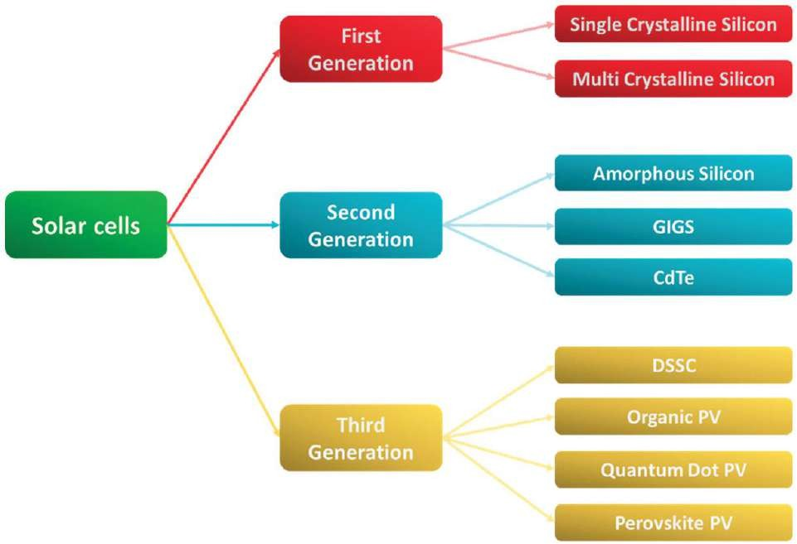
First Generation: Crystalline Silicon CellsIn 1954, Bell laboratories developed the first silicon solar cells with a 6 % efficiency. The Ptype (positive) and N-type (negative) sides of a PN junction solar cell are made of semiconductormaterial. When sunlight strikes the cell, electron-hole pairs are formed. The junction’s built-inelectric field separates these charges, resulting in an electric current. This current is then convertedinto energy and used to power gadgets or charge batteries (Figure 4).Approximately 80 % of the solar technology available today is made up of silicon solar cells.Among the various elements on earth,silicon is considered to be the most abundant element,secondonly to oxygen. A band gap of 1.1 eV is considered to be the most efficient band gap in manyphotovoltaic applications as well.
According to the silicon wafers used in the production of the cells,crystalline silicon solar cells can be divided into three

main groups .• Monocrystalline• Polycrystalline• AmorphousSolar cells made of thin silicon wafers are one of the most commonly used yet most efficienttechnologies as of today. The monocrystalline silicon solar cells were produced and distributedin 1963 by Japan’s Sharp Corporation. In comparison to other solar cell technologies, they havedemonstrated higher efficiency levels, with an efficiency of 26% . To produce single crystal37silicon wafers, the Czochralski process was adopted, which was already widely used in silicon-basedelectronics manufacturing at the time. As of today, it occupies 30 percent of the silicon market.Although single crystal silicon has a higher production cost than its bulk counterpart due to thepurification process. Polycrystalline and amorphous silicon are cheaper than single-crystalline siliconand perform better in terms of cost . As long as the molten salt of silicon is poured directlyinto the cast, polycrystalline silicon solar cells are more economical than single crystal silicon.Polycrystalline silicon solar cells have been recorded to have the highest efficiency of around 21%
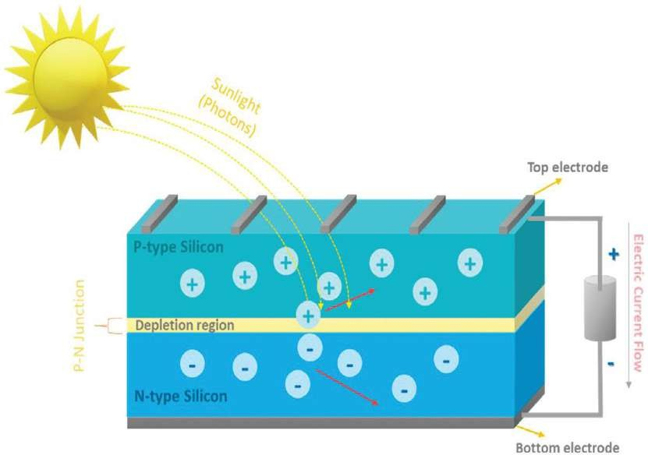
General structure of PN junction silicon solar cell.

Second Generation: Thin Film Solar CellsSecond generation solar cell technology is even more intriguing and challenging since it involvesthe production of a few micrometres of film rather than the deposition of silicon. There has beena significant increase in the use of thin film solar cells over the past two decades . Comparedto crystalline silicon solar cells, thin film solar cells have a lower cost of electricity involved in theirmanufacturing, which allows them to be more demanding than the first generation solar technologydue to the lower cost of electricity involved in their production. A thin film solar cell is composedof thin layers that range in thickness from one to four micrometres. Thin films can be integratedinto flexible and rigid substrates such as glass, PET, or aluminium, and because of this fact, they arecapable of being implemented into the commercial space in a viable fashion. The second generationthin film solar cells account for 15% of all solar panels sold in the world . There are four maintypes of second generation solar cells, and they are classified as follows.• Cadmium Telluride (Cd-Te)• Copper-Indium-Selenide (CIS)• Copper-Indium-Gallium-Diselenide (CIGS).

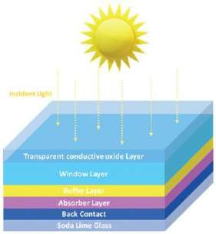
Schematic structure of thin flim solar cells.

Although the mechanism of first and second generation solar cells is similar, there are somefundamental differences. One of the significant differences is the type of semiconductor used as theabsorber layer . The semiconductor material used in second generation solar cells has a directband gap, which is in contrast with the first generation solar cells. As illustrated in the Figure 5, thinfilm solar cells consist mainly of a top layer with a wider band gap semiconductor that captures higherenergy photons . In the bottom layer, a low band gap material effectively captures lower energyphotons that escape through the upper broad band gap. The design of the thin film solar cell allowsthe device to utilise more portions of the spectrum thereby generating more output power. The peakefficiency of a thin film solar cell is around 22% . While thin film solar cells are more efficientand robust, their material availability has lost its appeal. The materials used in thin film solar cells areeither cadmium of Indium which are toxic and rare in nature . These problems must be properlyaddressed before scaling up the technology to the next avenue.
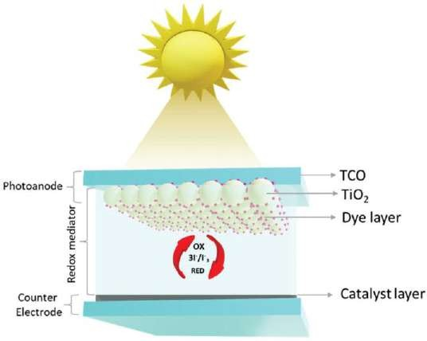
Illustration of dye-sensitized solar cells.
Dye-Sensitized Solar Cells: Dye-Sensitized solar cells belong to the group of low-cost thin-film photovoltaic cells recentlydeveloped and discovered by Prof. Michael. In 1991, Gratzel and Brian O’Regan from EcolePolytechnique Federale de Lausanne (EPFL), Switzerland constructed a DSSC using TiO2nanoparticles along with Ruthenium dye (cis-Bis(thiocyanatobis(2,2′-bipyridine-4,4′-dicarboxylate) ruthenium-(II) (N3)) where Iodine/Iodide (I-/I3-
) was used as the redox electrolyte andPlatinum was employed as the counter electrode. This DSSC showed a power conversion efficiencyof 7.1% (52). DSSCs are third-generation solar cells, also known as thin film solar cells.
TheseDSSCs satisfy the energy needs of the near future by being efficient energy conversion devices. Inaddition, they are cost-effective, weightless, high efficiency and applicable for indoor and outdoorapplications. In contrast to conventional first-generation silicon solar cells, these DSSCs have thephotosensitizer dye as the light absorber and the semiconductor as the charge carrier. Both of theseelectrodes are are separated by a separator. This kind of solar cell is preferred due to its

notableefficiency performance when compared to amorphous silicon which makes DSSCs to be low-costsolar cells and the schematic and photograph of DSSC shown in Figure 6. Typically, the working ofDSSCs is based on the following major components
- Transparent conductive substrate
- Semiconductor layer
( 3) Sensitizer
- Redox electrolyte
- Counter electrode
Transparent Conductive Substrate:One of the major components of DSSCs is the substrate for both the photoanode and thecathode. Metal foils, Transparent Conductive Oxide (TCO), and Coated Transparent GlassSubstrates, such as Fluorine-Doped Tin Oxide (FTO) and Indium-Doped Tin Oxide (ITO), mayalso be employed.
These FTO and ITO plates were used as substrates and have the ability to covera wide range of band-gap energy due to their transparent nature towards solar radiation from visibleto near-infrared . Additionally, these substrates provide higher stability at higher temperaturesand high electrical conductivity due to their electron accessibility. While metal foils and polymerbased plastic films as substrate materials do not have practical applications because of their corrosiveand sensitive nature at elevated temperatures . Although there are various conducting substrates,FTO glasses remain the most used as they are more highly conductive and cost-efficient than ITOand metal foil. Among the conducting glass substrates, FTO is the most preferable for theconstruction of DSSCs, because of its capability of holding stable electric charge carriers and costcompetitiveness over ITO
Photoanode:Nanocrystalline semiconducting oxide is the second most vital component of dye-sensitizedsolar cells. These have a higher surface area and porosity which helps in adsorbing the dye andtransferring the photo-excited electrons from the dye to the transparent conductive oxide (TCO)substrate. Several semiconducting oxides like ZnO, TiO2, Nb2O5and TiO2are most commonly40used as photoanodes in DSSCs. TiO2remains a standard photoanode material today due to itsnature being non-toxic, easily accessible, cost-effective and biologically compatible etc. The mostessential part of semiconducting oxides in DSSCs is to consistently adsorb the photosensitizer dyeto transfer the photo-generated electrons to the TCO substrate. Furthermore, these semiconductingoxide substrates should be transparent enough to permit light to easily pass through the substrate
Electrolyte:The electrolyte is the fourth component in DSSC, this lies between the photoanode and counterelectrode acting as a transport medium for the photogenerated charge carriers this is also a redoxspecies. Iodide/triiodide (I-/I3-) is a frequently used electrolyte which is dissolved in organicsolvents like acetonitrile and pentane nitrile. The electrolytes based on metals like copper and cobaltcomplexes were found to improve the Voc and Redox potential . An increase in alkyl chainsleads to an increase in viscosity in ionic liquid electrolytes which leads to a decrease in ion mobility.Solid electrolytes like copper iodide, copper thiocyanate and nickel oxide and quasi-solid transportmaterials increased the stability of DSSC. Poly(3,4-ethylenedioxythiophene) (PEDOT)and poly(3-hexylthiophene) (P3HT) are polymer electrolytes which have good adaptability and high stabilitybut low penetrating activity to the semiconductor
Counter Electrode: Counter electrodes govern the DSSC photovoltaic performance. Counter electrodes can beprepared through thermal decomposition, chemical reduction, hydrothermal reaction, sputterdeposition, in-situ polymerization etc. Since platinum (Pt) has a high catalytic activity, corrosionresistance, and reduced overpotential during redox reaction, it is the most commonly used counterelectrode material in DSSC. Platinum as an electrode has high cost. Platinum alternates includemetal oxides, transition metal dichalcogenides and other micro and nano-sized materials (64). Thesematerials have excellent stability and catalytic activity. Nanosized counter electrodes have Manyalloys, transition metals, transition metal dichalcogenides,carbon materials, like graphite, diamond,fullerenes, carbon nanotubes and nanofibers, graphene and other conducting polymers have alsobeen used as counter-electrode materials in the DSSC. Figure 7 schematically illustrates theoperational principle of DSSC. In the following steps, we will discuss the overall process ofconverting solar energy into electric power.

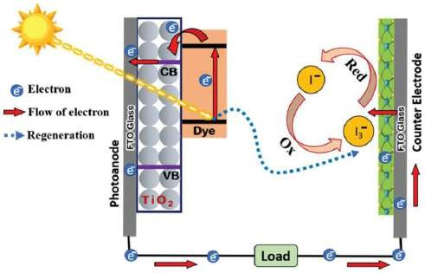
Illustration of operational principle of dye sensitized solar cells.
The Operational Principle of Dye-Sensitized Solar Cell
At first, the photosensitizer (dye) of the DSSC typically will be in its ground state (S0) thedye molecule in the ground state excites from the highest occupied molecular orbital(HOMO) level to the lowest unoccupied molecular orbital (LUMO) level (S*) when lightis illuminated,
the electron jump over the conduction band of the semiconductor to the TCO fromLUMO level, During the excitation of dye molecules the holes (S+)are taken away by the electron whichresults in an oxidized form of redox electrolyte,42
The electrons after reaching the TCO move through the external circuit to the counterelectrode to power up the electrical load. The oxidized electrolyte gets reduced at thecounter electrode at last. This forms the complete circuit.
Solar Cells
A solar cell directly converts light energy into electrical energy through the photovoltaic effect. Solar cells have an antireflection layer and two or more layers of semiconductor material. When light strikes the cell, photons excite electrons, causing them to jump from a lower energy state to a higher one, allowing them to move through the material. The junction-forming layers induce a built- in electric field, which causes the electrons to flow in a specific direction. This creates an electric current that can be used to power an external circuit. cells convert sunlight into electricity using the photovoltaic effect.

Working Principle:
- Light absorption
- Generation of electron-hole pairs
- Charge separation
- Electricity generation

Types:

  - Silicon solar cells
  - Thin-film solar cells
  - Perovskite solar cells
Semiconductor heterojunctions improve efficiency by optimizing band alignment and reducing recombination.

Photocatalysis and Water Splitting
Water splitting to form hydrogen and oxygen using solar energy in the presence of semiconductor photocatalysts has long been studied as a potential means of clean, large-scale fuel production. In general, overall water splitting can be achieved when a photocatalyst is modified with a suitable cocatalyst. It is therefore important to develop both photocatalysts and cocatalysts. In the past five years, there has been significant progress in water splitting photocatalysis, especially in the development of cocatalysts and related physical and materials chemistry. can split water into hydrogen and oxygen using sunlight.

Process:
  - Absorption of photons
  - Generation of electron-hole pairs
  - Redox reactions:

    - Reduction → Hydrogen production
    - Oxidation → Oxygen production
This technology is promising for hydrogen fuel generation.

Fuel Cells

fuel cell is a device that generates electricity by a chemical reaction. Every fuel cell has two electrodes called, respectively, the anode and cathode. The reactions that produce electricity take place at the electrodes. Every fuel cell also has an electrolyte, which carries electrically charged particles from one electrode to the other, and a catalyst, which speeds the reactions at the electrodes.Hydrogen is the basic fuel, but fuel cells also require oxygen. One great appeal of fuel cells is that they generate electricity with very little pollution–much of the hydrogen and oxygen used in generating electricity ultimately combine to form a harmless byproduct, namely water cells convert chemical energy directly into electrical energy.

Components:
  - Anode
  - Cathode
  - Electrolyte
Semiconductor-based fuel cells use:
  - Built-in electric fields
  - Heterostructures
These improve efficiency and reduce operating temperature compared to traditional systems.

SEMICONDUCTOR DEVICES FOR ENERGY STORAGE

Energy storage devices are “charged” when they absorb energy, either directly from renewable
generation devices or indirectly from the electricity grid. They “discharge” when they deliver the stored energy back into the grid. Charge and discharge normally require power conversion devices, to transform electrical energy (AC or DC) into a different form of chemical, electrochemical, electrical, mechanical, and thermal. Energy storage can store surplus energy from intermittent renewable sources, such as solar PV and wind power, until it is required – allowing therefore for the integration of additional renewable energy into the system.

Batteries (Lithium-ion, Sodium-ion)
There is ample precedent for the history of lithium-ion batteries to be framed as story ofinnovation and progress over a period of several decades. The concept of lithium-ion batteries datesback to the 1970s, when John B. Goodenough, as part of his research at Oxford University, firstidentified lithium cobalt oxide as a promising cathode material in the 1960s. However, SonyCorporation commercialized the first practical Li-ion battery in the 1980s, primarily for use incamcorders and later in portable electronics like laptops and mobile phones. In the 21st century, thisdiscovery ushered in a new era of portable energy storage, revolutionizing consumer electronics andpaving the way for electric vehicles and renewable energy storage systems .Batteries store energy in chemical form and release it as electricity.

Working Principles of Lithium-Ion Batteries
The lithium-ion battery operates on the basis of reversible electrochemical reactions that occurbetween the positive and negative electrodes of a cell. To give you a better understanding of theirworking principles, here is a simplified overview:
- Cathode (Positive Electrode):The cathode typically consists of a lithium metal oxide,suchas lithium cobalt oxide (LiCoO2), lithium manganese oxide (LiMn2O4), or lithium ironphosphate (LiFePO4). During discharge, when the battery is providing power to a device,lithium ions within the cathode material move toward the anode.
- Anode (Negative Electrode): The anode is usually made of graphite or other carbon-basedmaterials. When the battery is discharging, the anode absorbs the lithium ions released bythe cathode. This movement of lithium ions constitutes the flow of electricity.
- Electrolyte: The electrolyte is a lithium salt dissolved in a solvent. It separates the cathodeand anode and allows lithium ions to move between them during charging and discharging.The electrolyte also plays a crucial role in the safety of the battery.
- Separator: A separator, typically made of a porous material, physically separates thecathode and anode to prevent direct contact while allowing the passage of lithium ions.This prevents short circuits.
During the charging process, a power source (such as a charger) applies a voltage externally tothe battery, causing lithium ions to migrate from the anode to the cathode as a result of this voltage.Battery storage is accomplished through this process. In the case of a discharged battery, the lithiumions are transported back to the anode, producing an electrical current that powers the connecteddevice.

Working Principle:
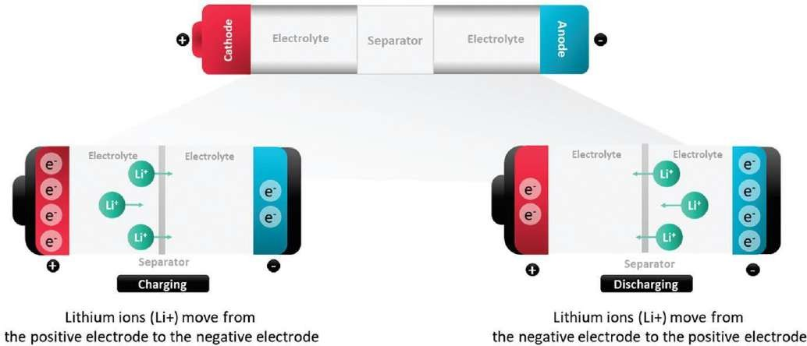
–

- Redox reactions
- Ion movement between electrodes

Example: Lithium-ion Battery

- Anode: Graphite
- Cathode: Lithium metal oxide
- Electrolyte: Lithium salt solution
Semiconductors enhance:
- Charge transfer
- Reaction kinetics
- Energy density

Energy storage involves conversion of electrical energy into chemical energy and back into electricity.

Supercapacitors:
An electrochemical capacitor, also known as a supercapacitor, has a history that dates back tothe earliest capacitor technology. In the 18th century, capacitors were first developed as a meansof storing electrical energy in an electric field between two conductive plates.
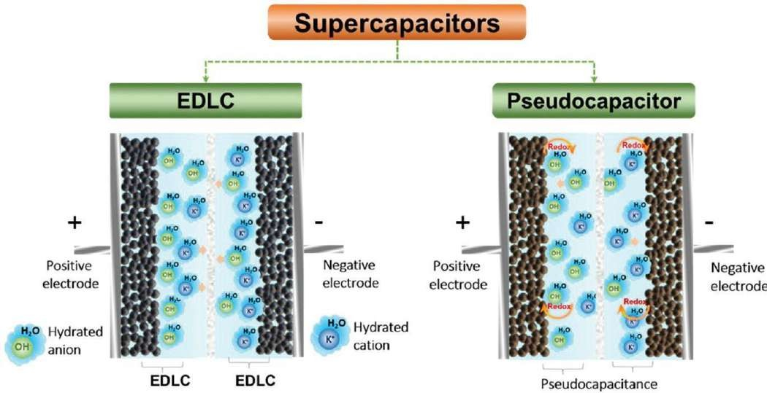
Nevertheless,supercapacitors took shape around the mid-20th century. Researchers explored the use of doublelayer capacitors in the 1950s and 1960s, which rely on the high surface area of activated carbonelectrodes in order to store electrical energy. A breakthrough was made in the 1970s whenresearchers discovered that the high capacitance of these devices was due to the formation of anelectric double layer between electrodes and electrolytes. Ultimately, this discovery led to thedevelopment of supercapacitors which have a much higher capacitance than traditional capacitors.The technology of supercapacitors continues to evolve with improvements in electrode materials,electrolytes, and manufacturing methods. In the modern world, supercapacitors can be found in awide variety of industries, such as automotive and transportation

Working mechanism of supercapacitors

Features:
- Fast charging
- High power density
- Long cycle life
Semiconductor nanomaterials increase surface area and improve performance.

INTEGRATED ENERGY CONVERSION AND STORAGE SYSTEMS
Modern systems combine energy conversion and storage into a single unit.

Examples:

  - Solar cell + battery systems
  - Photocatalytic storage devices
  - Hybrid supercapacitor systems
Integration improves:

  - Efficiency
  - Energy management
  - Sustainability
Recent studies emphasize the importance of combining photovoltaic and storage technologies for future energy systems.

Energy Storage and Conversion Integrated Devices in Future
The electrode, electrolyte, and packing materials must all be flexible to produce a flexiblebatteries or Solar cells. Given that the flexible packing materials are marketed. The development offlexible electrodes and electrolytes with superior electrochemical properties is the focus of currentresearch. Slurry-casting is the primary technique used to create the electrodes for conventional Liion batteries. Active materials are combined with binders and conductive additives like carbon blackand graphite, and the resulting mixture is cast onto a current collector composed of metal foil ormesh. High energy density active materials and a small number of inactive components are neededfor high-efficiency LIBs. This makes settling the active elements directly onto a flexible conductivesubstrate without the use of binders or additives the most widely utilized technique for producingflexible electrodes.The use of solar energy is popular, environmentally benign, and renewable. Solar cells havemostly been created for the purpose of collecting solar energy and transforming it further intoelectrical energy, allowing us to use solar energy in our daily lives. The energy output of a singlesolar cell may vary due to variations in sunshine intensity at various times, locations, and weatherconditions, making it unsuitable for direct use in electronic equipment. The integrated energy devicecombines energy storage and conversion into one unit. The conventional configuration is a planarshape, making it simple to combine these two components into a single entity. In the beginning,DSSCs are coupled with Li-ion batteries or solar cells due to their low cost and simple manufacture.Both DSSC and Li-ion batteries, or solar cells components, need different electrolytes. Theseelectrolytes are typically liquid and are cumbersome or even problematic due to leakage andvolatilization. For practical applications, it is important to further seal such integrated energy devices.The fabrication of solid-state DSSCs and subsequent integrated energy devices has therefore been50suggested using gel electrolytes, albeit mechanical and thermal stability still need to be improved.In order to achieve this, a fully solid-state integrated energy device has been extensively researchedusing solid-state solar cells and solar cells.

ADVANCED MATERIALS AND NANOTECHNOLOGY
Nanotechnology has revol system utionized semiconductor devices.

Key Materials:

  - Nanowires
  - Quantum dots
  - Graphene
  - Perovskites

Advantages:
  - High surface area
  - Enhanced conductivity
  - Improved light absorption
Nanostructured semiconductors enable:
  - Faster charge transfer
  - Better efficiency
  - Miniaturization of devices

ADVANTAGES AND LIMITATIONS

Advantages:

  - High efficiency
  - Renewable energy utilization
  - Low environmental impact
  - Scalability

Limitations:
  - High initial cost
  - Material stability issues
  - Efficiency losses due to recombination
  - Limited lifetime of some devices

FUTURE SCOPE AND EMERGING TRENDS

Future research focuses on:

- Artificial photosynthesis
- Hydrogen energy systems
- Perovskite solar cells
- Solid-state batteries
- Quantum semiconductor devices
Semiconductor electrochemistry is expected to play a major role in next-generation energy systems by combining physics, chemistry, and materials science.

CONCLUSION
Semiconductor devices are essential for efficient energy conversion and storage. Their ability to control electron flow and participate in electrochemical reactions makes them ideal for modern energy technologies. Advances in nanotechnology and materials science have significantly improved their performance.

Integrated systems combining energy conversion and storage represent the future of sustainable energy. Continued research in semiconductor electrochemistry will lead to more efficient, cost- effective, and environmentally friendly energy solutions.

REFERENCES
- Zhu, B. et al. Semiconductor Electrochemistry for Clean Energy Conversion and Storage, Electrochemical Energy Reviews (2021).
- ScienceDirect, Solar energy conversion in semiconductor heterojunctions (2022).
- MDPI, Energy Storage: Principles and Applications (2024).
- ScienceDirect, Integrated energy conversion and storage devices (2022).
- Abdelfattah, I.; El-Shamy, A. M. Review on the Escalating Imperative of Zero Liquid Discharge(ZLD) Technology for Sustainable Water Management and Environmental Resilience. J. Envir.Manag. 2024, 351, 119614. DOI: 10.1016/j.jenvman.2023.119614.512.
- Devi, M.; Moorthy, B.; Thangavel, R. Recent Developments in Zinc Metal Anodes,

Cathodes,and Electrolytes for Zinc-ion Hybrid Capacitors. Sust. Ener. Fuels 2023, 7, 3776–3795. DOI:10.1039/D3SE00565H.
- Tuc Altaf,C.; Rostas, A. M.; Popa, A.;Toloman,D.; Stefan, M.;Demirci Sankir, N.; Sankir, M.Recent Advances in Photochargeable Integrated and All-in-One Supercapacitor Devices. ACSOmega 2023, 8 (50), 47393–47411. DOI: 10.1021/acsomega.3c07464.
- Murphy, R. What is Undermining Climate Change Mitigation? How Fossil-Fuelled PracticesChallenge Low-Carbon Transitions. Ener. Res. Soc. Sci. 2024, 108, 103390. DOI: 10.1016/j.erss.2023.103390.
- . Gohar, O.; Khan, M. Z.; Bibi, I.; Bashir, N.; Tariq, U.; Bakhtiar, M.; Karim, M. R. A.; Ali,F.; Hanif, M. B.; Motola, M. Nanomaterials for Advanced Energy Applications: RecentAdvancements and Future Trends. Mat. Des. 2024, 241, 112930. DOI: 10.1016/j.matdes.2024.112930.

