THE DIGITAL DIVIDE IN WELLNESS: UNPACKING THE EFFECTS OF ARTIFICIAL INTELLIGENCE ON UNIVERSITY STUDENT MENTAL HEALTH

ABSTRACT
The rapid proliferation of Artificial Intelligence (AI) within higher education constitutes a profound socio-technical shift, carrying dual implications for pedagogical sustainability and student welfare. While AI serves as a powerful catalyst for youth empowerment and innovation, its integration demands a rigorous interrogation of its impact on the affective domain of the learner. This study investigates the influence of AI-mediated pedagogical processes on university students’ mental health, using the Unified Theory of Acceptance and Use of Technology 2 (UTAUT2) as a theoretical lens. Adopting a convergent parallel mixed-methods design at a leading public university in Zimbabwe, the research synthesises quantitative survey data (N = 489) with in-depth qualitative insights from faculty members. The findings elucidate a critical tension: while AI is highly valued for its cognitive scaffolding—with 61.29% of students utilising it as a personalised, "always-on" tutor—it is paradoxically associated with escalating adverse mental health outcomes. These manifest as "Turnitin Anxiety" and a pervasive state of "ethical panic" stemming from a persistent institutional "policy vacuum," in which 33.72% of the cohort remain unaware of AI regulations. Furthermore, 65% of students acknowledge that an over-reliance on generative tools risks creating an "intellectual crutch," potentially compromising critical thinking and cognitive resilience. The study concludes that institutional innovation must transcend mere technical implementation, advocating for human-centred ethical frameworks that balance algorithmic efficiency with the preservation of mental well-being and independent enquiry in the "Reasoning Age."
Keywords: Artificial Intelligence, Mental Health, Higher Education, UTAUT2, Zimbabwe, Education 5.0, Ethical Literacy.

INTRODUCTION
Globally, the integration of Artificial Intelligence (AI) has transitioned from an emergent technological trend to an unprecedented pedagogical force within the higher education sector. This shift marks a significant departure from the "Information Age" towards an increasingly complex "Reasoning Age," where AI agents are fundamentally redefining the student experience and the nature of academic enquiry [1]. Whilst the broader field of AI has its foundations in research spanning seven decades, its application for academic development in emerging economies, such as Zimbabwe, remains a nascent phenomenon [2]. Current scholarship is characterised by an "intellectual cleavage," with researchers divided along an optimism-pessimism continuum regarding the technology’s ultimate impact on student reflexivity, academic integrity, and long-term institutional welfare [3, 4].
The landscape of mental health education has undergone a dramatic digital transformation within this intelligent era [5, 6]. AI offers innovative models for psychological support, ranging from the use of Internet of Things (IoT) technologies for evaluating student wellness [7] to adaptive feedback systems designed to bolster learner motivation [8]. Proponents argue that personalised learning driven by AI can significantly enhance self-regulated learning (SRL) and student autonomy [9, 10]. Furthermore, the conceptualisation of AI as an "apprentice" suggests a collaborative future where technology serves to augment, rather than replace, human capability [11].
However, this rapid integration introduces profound "planetary costs" and ethical pitfalls [12]. Critics contend that Generative AI (GenAI) may undermine human reflexivity and scientific responsibility, potentially leading to a "dawn of idiocracy" if students bypass the cognitive struggle essential for intellectual mastery [3, 13]. Negative externalities include heightened anxieties regarding data privacy, virtual network addiction, and the "existential dread" associated with professional displacement [11, 14]. Scholars increasingly acknowledge this duality, noting that whilst AI provides customisable support, it simultaneously heightens the risk of psychological pressure and academic integrity stress [4, 15].
As AI adoption accelerates across the Global South, international frameworks from bodies such as UNESCO are being scrutinised for their role in global educational governance [16]. In Zimbabwe, national policies have been introduced to regularise technological utility; however, institutional measures for safeguarding student mental health remain insufficiently addressed [17]. There is an urgent need to move beyond "epistemic parochialism"—limited, single-institution studies—to understand how AI-automated feedback impacts learner autonomy in diverse socio-technical settings [2, 9, 15].

Objectives and Research Questions
This study seeks to bridge a critical empirical lacuna by investigating the psychological implications of Artificial Intelligence (AI) adoption among tertiary students in Zimbabwe. The central enquiry driving this research is framed as follows:
Main Research Question: How does the integration of Artificial Intelligence into higher education pedagogy influence the nexus between academic efficiency and student psychological well-being within the Zimbabwean socio-technical context?
By interrogating the dialectical tension between AI as a constructive "scaffold" for conceptual comprehension and its potential to devolve into an "intellectual crutch," this research provides vital insights into the preservation of human agency in an increasingly automated academic landscape [13, 18]. To address this overarching problem, the enquiry is operationalised through the following specific sub-questions:
- RQ1: How do specific AI-mediated pedagogical habits—primarily generative research and automated summarisation—correlate with self-reported academic anxiety among students?
- RQ2: To what extent do current institutional AI policies mitigate "ethical panic" and integrity stress, given the prevailing gap in student policy awareness?
- RQ3: How can a human-centred AI literacy and wellness framework be structured to balance technological efficiency with the preservation of critical thinking and psychological resilience?

II. PROBLEM STATEMENT
Despite the rapid proliferation of Artificial Intelligence (AI) within the Zimbabwean higher education landscape, a profound empirical deficit remains regarding the psychological implications of these technologies on the student body. While current institutional frameworks—most notably the National AI Policy—prioritise technological regulation and the optimisation of academic output, they significantly neglect the affective domain of the learner [17, 19].
Consequently, students are traversing a "digital frontier" where the mandate for algorithmic efficiency, exacerbated by a lack of robust ethical guidance and the pervasive fear of sophisticated plagiarism detection, has induced a state of "ethical panic" and chronic anxiety [4, 15]. This phenomenon threatens to create a "digital divide in wellness", potentially undermining the cognitive resilience of the human capital central to Zimbabwe’s Education 5.0 philosophy. Unless addressed, the tension between automated efficiency and student well-being may compromise the integrity of the pedagogical process. This study, therefore, investigates the nexus between AI adoption and student mental health to propose a framework for a more holistic, human-centred technological transformation.

III. LITERATURE REVIEW

Conceptualising the Shift: Conventional Pedagogy vs Algorithmic Logic
Globally, the integration of Artificial Intelligence (AI) within tertiary institutions is fundamentally reshaping the dual pillars of teaching and learning. Conventional pedagogical models emphasise active student participation as a prerequisite for developing high-order analytical and problem-solving skills [8]. Within these traditional frameworks, the student's learning experience is contingent upon their capacity for critical reflexivity, often fostered through discursive questioning strategies and collaborative enquiry [8, 20]. However, the rise of AI-driven information processing challenges these established boundaries, necessitating a rigorous re-evaluation of the distinction between machine-based data synthesis and human cognition. Whilst AI demonstrates unparalleled efficiency in data processing, it frequently lacks the sophisticated comprehension, contextual nuance, and innate inventiveness characteristic of human intelligence [9, 11].

The Duality of AI: Educational Opportunities and Ethical Pitfalls
The successful integration of AI requires a nuanced understanding of both the technology and the socio-emotional context of the educational process. Within the disciplines of the Arts and Humanities, this shift is particularly contentious. Scholars have highlighted the potential for "epistemic parochialism"—where technology-driven results lack the institutional or cultural depth required for genuine scholarship [2]. Ethical concerns further complicate this landscape, particularly regarding the growing application of generative AI. There is compelling evidence that students may utilise AI-generated content in unapproved or unethical ways, leading to a breakdown in academic integrity and the subsequent erosion of student-teacher trust [16, 21]. Furthermore, the deployment of AI in invasive monitoring and evaluation procedures risks diminishing student autonomy, potentially transforming the learning environment into a site of surveillance rather than exploration [15, 21].

Personalised Learning Systems and Adaptive Support
Conversely, AI presents transformative opportunities when applied through human-computer interactions, intelligent tutoring systems, and adaptive learning platforms [10, 11]. Intelligent tutoring systems have been demonstrated to improve learning outcomes by providing real-time, tailored feedback that mimics the support of a human mentor [9]. Similarly, adaptive platforms leverage AI to customise course materials to specific cognitive needs, resulting in a more efficient and individualised learning trajectory [22]. Such systems can effectively support self-regulated learning (SRL), allowing students to navigate complex academic requirements at a pace suited to their personal development [11].

Theoretical Alignment and the Current Research Gap
A critical concern in contemporary scholarship is the alignment of AI with established educational theories. Although extensive research has interrogated technological barriers [23] and future prospects [24], few studies have rigorously examined how AI applications intersect with sociocultural or constructivist frameworks that prioritise critical thinking, context, and teamwork [9]. Furthermore, the long-term impact of AI on educational equity and student mental resilience remains largely under-researched [25]. This study addresses this lacuna by providing empirical evidence from the Zimbabwean context, advocating for a human-centred, balanced strategy that ensures AI serves to empower students rather than marginalise them through unmanaged psychological strain.
To maintain the scholarly excellence of your manuscript, I have refined the Theoretical Framework using precise British English. The discussion synthesises the UTAUT2 constructs with the specific psychological stressors identified in your study, ensuring the framework is not merely descriptive but analytically integrated.

IV. THEORETICAL FRAMEWORK
To unpack the complex psychological and behavioural dimensions of Artificial Intelligence (AI) adoption, this study utilises the Unified Theory of Acceptance and Use of Technology 2 (UTAUT2), as extended by Venkatesh, Thong, and Xu [26]. This framework is particularly suited for this enquiry as it shifts the focus from purely organisational technology utility to consumer-based contexts, allowing for a nuanced exploration of how individual student motivations influence digital behaviour and, consequently, psychological well-being.
The adoption and integration of AI within the Faculty of Arts and Humanities are governed by several core constructs that directly influence a student's intention to use these tools, as conceptualised in Figure 1.

Fig. 1. Conceptual Framework of AI Adoption Drivers
- Performance Expectancy: Identified as the primary predictor of behavioural intention in this study, this construct reflects the degree to which a student believes that utilising AI—specifically for generative research and concept clarification—will enhance their academic output and efficiency [26].
- Effort Expectancy: This pertains to the perceived ease of use associated with AI interfaces. As Generative AI (GenAI) tools become increasingly conversational and intuitive, the "effort barrier" decreases, facilitating rapid, high-frequency adoption among the student body [12, 22].
- Social Influence: This captures the internal and external pressures exerted by peers, lecturers, and the broader institutional culture to adopt emerging technologies. In a competitive academic environment, the fear of "falling behind" technologically acts as a significant catalyst for adoption [15, 26].
- Facilitating Conditions: This construct examines the availability of essential technical infrastructure, such as university computer laboratories and high-speed internet access. Within the Zimbabwean context, these conditions are vital to ensure that technological adoption does not exacerbate the existing digital divide [23].
- Hedonic Motivation: Defined as the perceived enjoyment or intellectual stimulation derived from using AI. When students perceive AI tools as engaging rather than purely functional, their psychological attachment to the technology deepens, impacting their long-term mental resilience [26].
- Price Value: This involves the cognitive trade-off between the perceived benefits of AI and the associated financial costs, such as mobile data subscriptions or premium software fees, which are significant factors in resource-constrained environments [23, 26].

UTAUT2 as a Lens for Digital Wellness
In the context of Zimbabwean higher education, the UTAUT2 model provides a robust lens for understanding the "Digital Divide in Wellness." While high Performance Expectancy compels students to adopt AI for academic survival, it simultaneously introduces unique psychological stressors. The relentless drive for efficiency often manifests as "ethical panic"—a state of heightened anxiety where students utilise AI to meet rigorous academic demands but live in perpetual fear of algorithmic judgement or plagiarism detection [4, 16].
By evaluating these drivers, the study identifies how constructs such as Effort Expectancy and Social Influence can inadvertently foster an "intellectual crutch" phenomenon. In this state, the ease of technological utility overrides the cognitive "struggle" necessary for deep, transformative learning [14]. This theoretical grounding facilitates the design of institutional policies that transcend mere technical regulation, moving towards a human-centred approach that ensures AI serves as a constructive partner in enhancing, rather than undermining, the mental resilience of the student body.

RESEARCH METHODOLOGY

Research Design
This investigation employs a mixed-methods research design, a choice predicated on the requirement to systematically integrate quantitative and qualitative modalities to achieve a nuanced understanding of AI’s influence on student mental health. The potency of mixed-methods research lies in its capacity to combine disparate data forms within a single enquiry, thereby facilitating a more robust interpretation than a singular approach could afford [27]. This dual methodology allows for the capture of a broad statistical landscape alongside the intricate, lived experiences of both faculty and students [28].
Specifically, the study adopts a convergent parallel design, often termed the Triangulation Model. Under this framework, quantitative and qualitative data are gathered concurrently yet subjected to independent analysis. The resultant findings are merged during the interpretative phase to identify critical points of convergence or divergence [29, 30]. This approach is anchored in a realist philosophical worldview, utilising methodological pluralism to map the "what" of the phenomenon through generalisable patterns while addressing the "why" and "how" through "thick description" [31].

5.2 Target Population and Sampling Strategy
The target population comprises students and lecturers within the Faculty of Arts and Humanities at Midlands State University (MSU). The faculty population consists of N = 489 students and 79 lecturers. To determine a representative sample for the quantitative phase, Slovin’s Formula was applied:
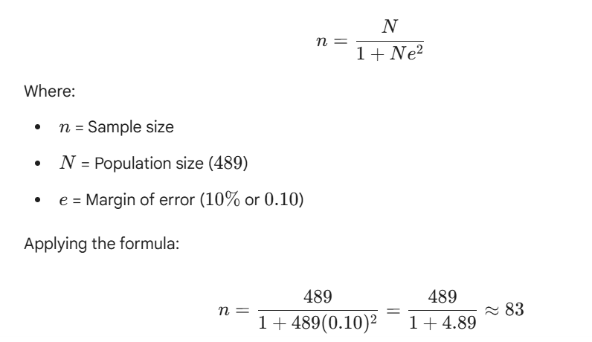
Based on this calculation, the study utilised a sample of students enrolled at Level 4 in the Department of Development Studies to ensure data was derived from participants with significant academic experience. For the qualitative phase, a purposive and convenient sampling strategy was employed to select ten lecturers and a diverse group of students for deeper enquiry.

5.3 Data Collection Instruments
A multi-tooled approach was employed for data solicitation:
- Questionnaires: Administered via Kobo Collect, these instruments focused on mapping the prevalence and motivations of AI usage among the student body.
- Focus Group Discussions (FGDs): Six FGDs were conducted at the MSU Zvishavane Campus. Each group comprised 12 students, gender-balanced and representing levels 1 to 4, including those on Work-Related Learning (WRL).
- Semi-Structured Interviews: In-depth interviews were conducted with ten lecturers. Utilising a flexible interview guide, the researchers explored pre-established themes while allowing for the emergence of novel issues during the exchange [32].

5.4 Adherence to Ethical Principles
The research was conducted in strict adherence to international and institutional ethical protocols. Formal administrative and ethical clearance was granted by the Midlands State University Research Ethics Committee (Ref: 2025-EC2834-01R). Prior to data collection, all participants received a plain-language statement detailing the study's objectives, and written informed consent was obtained.
The researchers maintained a rigorous commitment to voluntary participation, ensuring respondents could withdraw at any juncture without prejudice. To safeguard privacy, strict anonymity was maintained through the use of pseudonyms, and all raw data were stored in encrypted digital files. Furthermore, full transparency was maintained regarding the use of AI tools during the analysis phase to ensure all meta-inferences remained authentically grounded in the empirical evidence [33].

VI. FINDINGS AND DISCUSSION

Integrated Analytical Overview
The findings of this study are presented through an integrated analysis that merges quantitative statistical trends with qualitative thematic insights. This convergent approach elucidates the complex relationship between Artificial Intelligence (AI) adoption and student mental health within the Faculty of Arts and Humanities at Midlands State University (MSU). By synthesising empirical data derived from Kobo Collect and Microsoft Excel with the lived experiences of students and lecturers, the study uncovers a digital landscape defined by a critical tension: the pursuit of algorithmic efficiency versus profound psychological strain.

Demographic Architectures and Digital Identity
The demographic profile of the participants establishes the essential context for their digital engagement. As illustrated in Figure 2, the student population is overwhelmingly dominated by the 23–27 age bracket (69.01%), followed by the 18–22 cohort (25.35%), with a negligible representation of those under 18 (1.41%).

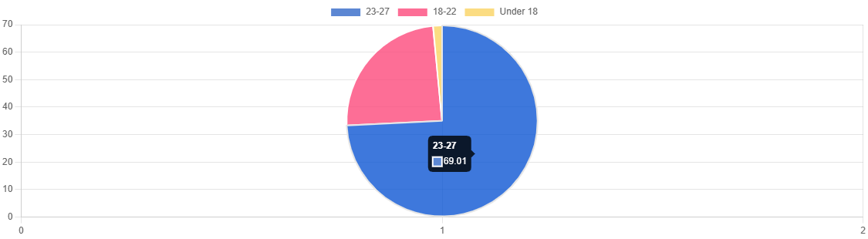

Figure 2. Pie Chart showing Demographic Characteristics (Source: Research Field Data, 2025)
This distribution characterises the sample as a group of "mature digital natives"—individuals who are not merely passive consumers of technology but are actively integrating digital tools into their professional and academic identities. Within the "Reasoning Age", this cohort demonstrates a high Performance Expectancy, viewing AI as a non-negotiable partner in their academic trajectory [1, 26].

Gendered Dimensions of AI Adoption
Gender-wise, the population is significantly skewed toward females (59.15%) compared to males (40.85%), reflecting broader enrolment trends within the Faculty, particularly in the Department of Development Studies. This demographic composition is vital when analysing the psychological dimensions of the study.
Qualitative insights from the focus group discussions (FGDs) indicate that female students in this cohort frequently reported higher levels of "Turnitin Anxiety"—a specific form of academic integrity stress exacerbated by the opacity of AI-detection algorithms [4, 16]. Furthermore, female participants demonstrated a greater tendency to utilise AI for both instructional and emotional scaffolding, suggesting that for this group, AI functions as a "digital companion" that mediates the stress of high-stakes academic requirements.

The Nexus of Efficiency and Anxiety
The data suggests that while Effort Expectancy is high—meaning students find AI tools increasingly easy to navigate—this ease of use paradoxically contributes to a "Digital Divide in Wellness." The convenience of automated summarisation and generative research creates a cognitive trade-off. As students move towards the "intellectual crutch" phenomenon [14], the fear of being "outpaced" by peers (Social Influence) or penalised by institutional detection systems creates a state of perpetual "ethical panic". This anxiety is not merely a technical concern but a fundamental threat to the mental resilience of the student body, necessitating a more human-centred approach to technological integration within Zimbabwe's Education 5.0 framework.

The Hardware Hierarchy and Wellness Equity
The quantitative data indicates that the laptop is overwhelmingly the preferred medium for academic engagement. As illustrated in Figure 3, the laptop remains the undisputed tool of choice, utilised by 85% of participants. Desktop computers serve as the second most common interface (16%), while tablet usage remains marginal at approximately 7%.

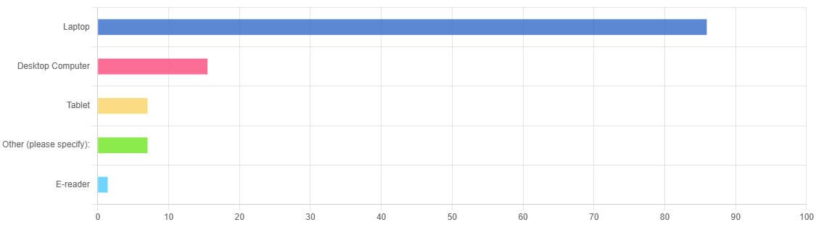

Figure 3. Graph showing types of gadgets used by students
Source: Research Field Data, 2025)
Qualitative narratives suggest that this preference is driven by the perceived rigour and professionalism required for university-level scholarship. A final-year male student during a Focus Group Discussion (FGD) elucidated this distinction:
"Whilst I make use of my smartphone for social media, the laptop remains my 'academic station.' When I engage with ChatGPT for research, I require screen space for cross-referencing what the AI provides with my own drafts. This way, the process feels more professional and less like a mere shortcut."
This hardware preference highlights an evolving "Digital Divide," confirming that technological access is no longer solely defined by internet connectivity, but by possessing the specific hardware capable of performing high-level synthesis. Within the Faculty of Arts and Humanities, the laptop facilitates the cognitive "multi-tasking" necessary to verify AI outputs against primary sources, thereby mitigating the anxiety of "algorithmic inaccuracy."
In this context, Midlands State University’s investment in functional computer laboratories serves as a critical equaliser. For resource-constrained students, these facilities represent a vital defense against "techno-exclusion." By providing the necessary hardware for deep academic enquiry, the institution supports the student-centred flexibility advocated in contemporary literature [22] and aligns with global infrastructure standards for higher education [34].

Primary Motivations: The "Quest for Comprehension"
The quantitative findings reveal that the intent behind Artificial Intelligence (AI) adoption is significantly skewed towards cognitive support rather than mere administrative automation. As illustrated in Figure 4, the primary driver for the vast majority of respondents (61.29%) is the "Quest for Comprehension."

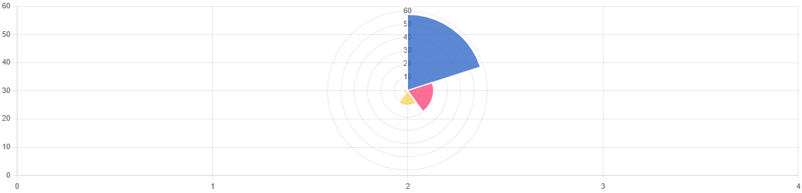

Figure 4: Primary Use of AI among Students
Students utilise AI as a personalised "bridge" to grasp complex academic concepts—a motivation that far eclipses other functional uses, such as direct assistance with assignment drafting (21.51%), grammatical refinement (11.83%), or the rapid summarisation of lengthy texts (2.15%). These statistics suggest that AI is being deployed as a secondary instructional layer designed to mitigate perceived gaps in the traditional pedagogical experience. Rather than serving as a simple shortcut, the technology functions as a scaffold for understanding the dense academic lexicon inherent in the Faculty of Arts and Humanities [11, 22].

Narrative Insight: AI as a "Psychological Safety Net"
Qualitative accounts illuminate the human drive behind these statistical figures, positioning AI as a "psychological safety net" within an environment that students often perceive as high-stakes and intellectually exposing. In disciplines where theoretical jargon can be intimidating, such as Development Studies, AI acts as a non-judgemental, "always-on" tutor. One student participant articulated this emotional dimension during an FGD:
"The classroom can be frightening, and from time to time you don't want to disclose that you're lost. AI doesn't judge. It diminishes my initial anxiety when beginning an intricate module mainly because I know I can request it to break down the jargon into simple language of my choice."
This narrative underscores that AI adoption is frequently an emotional response to academic pressure. By providing a private, risk-free space for students to grapple with difficult material, the technology mitigates the fear of social or academic failure. In this context, AI transitions from a digital tool to a supportive partner, assisting students in navigating the transition from initial confusion to conceptual clarity without the perceived "stigma" of seeking remediation in a public forum [16, 32].
By acting as a buffer against academic anxiety, AI supports the Hedonic Motivation and Performance Expectancy constructs of the UTAUT2 framework, ensuring that students remain resilient in the face of rigorous intellectual demands [26].

The "Turnitin Trap" and the Architecture of Ethical Panic
A striking finding of this study is the high concentration of negative externalities within the domain of emotional wellness. The study found that the most significant perceived adverse consequences are centred on reduced peer-study effort (35.88%) and academic integrity stress (23.66%).
Additionally, concerns regarding academic risk—specifically the acquisition of "hallucinated" or incorrect information—accounted for 19.08% of responses, while a growing dependence on AI for fundamental writing tasks was cited by 15.27% of the cohort. Collectively, these metrics underscore that the adverse effects of AI are not merely technical but are deeply rooted in the erosion of individual cognitive effort and the escalation of psychological strain regarding institutional standing [3, 15].

Narrative Insight: Algorithmic Judgement and the "Policy Vacuum"
The qualitative data reveals a recurring theme of "Turnitin Anxiety," where students report a persistent state of "ethical panic." In this state, academic integrity software—originally intended as a deterrent for plagiarism—is perceived as an opaque and punitive force that fails to distinguish between generative assistance and genuine human effort. A student in the Department of Development Studies remarked:
"Even when I have written the work myself... the wait for that Turnitin report is always taxing. I feel like I am being judged by an algorithm that doesn't recognise my voice. It is an incessant weight on my mental health."
This psychological burden is significantly exacerbated by a perceived "policy vacuum." The study found that 33.72% of students remain unaware of the university’s official AI policy. While interviews with faculty confirm that a formal policy framework has been ratified, the lack of effective dissemination has created a critical gap in student awareness.
This ambiguity forces students to navigate a "digital frontier" where they utilise AI tools out of academic necessity, yet exist in perpetual fear of retroactive punishment [16, 21]. This lack of clear ethical boundaries transforms a potentially constructive technology into a source of chronic "integrity stress," ultimately undermining the mental resilience that Zimbabwe’s Education 5.0 philosophy seeks to cultivate.

VII. CONCLUSION
This study concludes that Artificial Intelligence within the Zimbabwean higher education sector has transcended its status as a mere functional tool to become a transformative social actor. Quantitatively, the findings establish AI as a vital "psychological safety net," providing a non-judgemental, "always-on" instructional layer that assists 61.29% of students in navigating intimidating academic concepts. In this capacity, AI functions as a crucial mediator of academic anxiety, fostering a sense of conceptual security in high-stakes environments.
However, this technological affordance is accompanied by a significant "Comprehension Paradox." Qualitatively, the research observes a pervasive state of "ethical panic", where the mandate for algorithmic efficiency inadvertently silences the internal cognitive "struggle" essential for authentic intellectual maturity. The ease of AI-mediated synthesis risks fostering an "intellectual crutch" phenomenon, potentially eroding the very critical reflexivity that higher education seeks to cultivate.
Ultimately, the study highlights that if AI integration remains confined within an institutional "policy vacuum", its efficiency gains will be overshadowed by a burgeoning "digital divide in wellness." To fully realise the human-centric objectives of Zimbabwe’s Education 5.0 philosophy, Midlands State University and similar institutions must transition toward a "Reasoning Age" framework. Such a framework must ensure that technological innovation serves to augment, rather than replace, the student’s mental resilience and their capacity for independent, critical enquiry. The future of the Zimbabwean academy depends on a balanced, human-centred approach where AI is managed not as a threat to integrity, but as a constructive partner in the pursuit of cognitive excellence.

VIII. CONTEXT-SPECIFIC RECOMMENDATIONS

Cultivating Ethical AI Literacy
Institutional leadership must pivot the AI discourse from administrative regulation to classroom integration. Rather than focusing exclusively on the "detection" of AI-generated content, universities should cultivate "Ethical AI Literacy" through targeted workshops that demystify institutional policies. Providing students with clear, transparent boundaries will effectively replace the pervasive fear of the "Turnitin Trap" with a confident, principled partnership between the learner and the machine.

Restoring the "Pedagogy of the Struggle"
Current pedagogical models should be reimagined to prioritise the process of enquiry over the final academic product. By reintroducing viva voce (oral) examinations, in-class writing tasks, and reflective learning journals, educators can encourage students to reclaim the cognitive "heavy lifting" that AI frequently seeks to bypass. This ensures that while technology provides a scaffold, the human mind remains the primary architect of knowledge and critical synthesis.

Digital Wellness as a Core Institutional Competency
University wellness centres must begin to treat "techno-stress" and "algorithmic anxiety" as legitimate psychological experiences requiring clinical attention. Student support services should integrate Digital Wellness into their existing mental health frameworks. By helping students navigate a landscape where machine intelligence is a constant—and occasionally overwhelming—companion, institutions can safeguard the emotional resilience essential for long-term academic success.

IX. ETHICAL CONSIDERATIONS
- Ethical Approval: This research was conducted under the rigorous oversight of the Midlands State University Research Ethics Committee (Reference: 2025-EC2834-01R). All procedures were designed to ensure the highest respect for participant dignity and intellectual property.
- Informed Consent: Participation was approached as a collaborative engagement; all students and lecturers provided written informed consent prior to data solicitation, acknowledging their absolute right to withdraw from the study at any juncture without prejudice.
- Conflict of Interest: The authors declare no competing interests, financial or otherwise. This enquiry was driven solely by a commitment to advancing the understanding of the human impact of emerging technologies within the Global South.

X. DATA AVAILABILITY STATEMENT
In the interest of academic transparency and the advancement of digital humanities research, the quantitative datasets supporting these findings are available from the corresponding author upon reasonable request. To safeguard the personal narratives, unique digital footprints, and privacy of the participants, the qualitative transcripts and recordings remain strictly confidential.

REFERENCES
[1] Government of Zimbabwe. (2026). Digital learning leadership and the fourth industrial revolution: A strategic framework for Zimbabwean higher education. Ministry of Higher and Tertiary Education, Innovation, Science and Technology Development.
[2] Crawford, J. (2025). Epistemic parochialism: Single institution studies in the age of Artificial Intelligence large language models. Journal of University Teaching and Learning Practice, 22(7), 1–17.
[3] Lindebaum, D., & Fleming, P. (2024). ChatGPT undermines human reflexivity, scientific responsibility and responsible management research. British Journal of Management, 35(2), 566–575.
[4] Khalid, S. (2025). Ethical concerns of generative AI in assignments. Journal of Academic Integrity, 12(4), 201–218.
[5] Government of Zimbabwe. (2024). National Artificial Intelligence policy: Driving technological utility and academic output. Ministry of Information Communication Technology, Postal and Courier Services.
[6] Ministry of Higher and Tertiary Education, Innovation, Science and Technology Development. (2020). Education 5.0: The philosophy for Zimbabwe's higher education transformation.
[7] Wang, L., & Wang, L. (2025). Intelligent evaluation method of students' mental health based on Internet of Things. IoT and Big Data Technologies for Health Care, 521, 213.
[8] Larson, R. W., et al. (2002). Continuity, stability, and change in daily emotional experience across adolescence. Child Development, 73(4), 1151–1165.
[9] Khan, G. M., Ali, Z., & Khalid, A. (2025). The impact of artificial intelligence based personalized learning on students motivation and self-regulated learning. Review of Applied Management and Social Sciences, 8(4), 1633–1644.
[10] Huma, T., et al. (2025). Investigating the impact of AI-driven feedback systems on student autonomy and self-directed learning. Social Science Review Archives, 3(4), 2169–2179.
[11] Achuthan, K. (2025). Artificial intelligence and learner autonomy: A meta-analysis of self-regulated and self-directed learning. Frontiers in Education, 10, 1738751.
[12] Crawford, J., Cowling, M., & Allen, K. A. (2025). Conceptualising artificial intelligence as an apprentice. In Handbook of Artificial Intelligence in Higher Education (pp. 67–75). Edward Elgar Publishing.
[13] Izak, M., et al. (2025). Generative artificial intelligence and learning: At the dawn of idiocracy?. Management Learning, 56(3), 407–415.
[14] Barros, A. (2025). The atlas of AI: Power, politics, and the planetary costs of artificial intelligence. Academy of Management Learning & Education.
[15] Alghamdi, L. H., & Alghizzi, T. M. (2025). Educators’ reflections on AI-automated feedback in higher education: A structured integrative review of potentials, pitfalls, and ethical dimensions. Frontiers in Education, 10, 1704820.
[16] Christodoulou, E., & Zembylas, M. (2026). Artificial intelligence as a site of global educational governance: The case of UNESCO. Journal of Education Policy, 1–24.
[17] Salimi, F. (2025). Aligning policy and practice: The World Bank’s approach to EdTech in Sub-Saharan Africa. Policy Futures in Education, 23(6), 1134–1156.
[18] Miller, T. (2019). Explanation in artificial intelligence: Insights from the social sciences. Artificial Intelligence, 267, 1–38.
[19] McDonald, N., et al. (2025). Generative artificial intelligence in higher education: Evidence from an analysis of institutional policies and guidelines. Computers in Human Behavior: Artificial Humans, 3, 100121.
[20] Popenici, S. A., & Kerr, S. (2017). Exploring the impact of artificial intelligence on teaching and learning in higher education. Research and Practice in Technology Enhanced Learning, 12(1), 22.
[21] Crawford, J., et al. (2023). Artificial intelligence and authorship editor policy: ChatGPT, Bard Bing AI, and beyond. Journal of University Teaching and Learning Practice, 20(5), 1–11.
[22] Saleh, E. H. (2025). Empowering learners: Exploring teaching strategies, AI integration, and motivation tools for fostering autonomous learning in higher education. East Journal of Human Science, 1(6), 14–34.
[23] Amiri, S. M. H. (2025). The digital divide revisited: Connectivity, devices, and the hidden barriers to global EdTech equity. Indonesian Journal of Innovation and Applied Sciences (IJIAS), 5(3), 254–267.
[24] Zawacki-Richter, O., et al. (2019). Systematic review of research on artificial intelligence applications in higher education—where are the educators?. International Journal of Educational Technology in Higher Education, 16(1), 39.
[25] McDonald, N., et al. (2025). AI in educational equity and student mental resilience. Computers in Human Behavior: Artificial Humans, 4, 100125.
[26] Venkatesh, V., Thong, J. Y., & Xu, X. (2012). Consumer acceptance and use of information technology: Extending the unified theory of acceptance and use of technology. MIS Quarterly, 36(1), 157–178.
[27] Creswell, J. W., & Inoue, M. (2025). A process for conducting mixed methods data analysis. Journal of General and Family Medicine, 26(1), 4–11.
[28] Younas, A., Fàbregues, S., & Creswell, J. W. (2023). Generating metainferences in mixed methods research: A worked example in convergent mixed methods designs. Methodological Innovations, 16(3), 276–291.
[29] Baker, R. S., Martin, T., & Rossi, L. M. (2016). Educational data mining and learning analytics. The Wiley Handbook of Cognition and Assessment, 379–396.
[30] Cheng, Y. P., et al. (2024). Innovative Technologies and Learning. Springer.
[31] Miller, T. (2019). Explanation in artificial intelligence: Insights from the social sciences. Artificial Intelligence, 267, 1–38.
[32] Oben, A. I., et al. (2025). Teaching with Generative Artificial Intelligence (GenAI): Should educators trust AI to guide student learning?. Innovations in Education and Teaching International, 1–14.
[33] Crawford, J., et al. (2023). Artificial intelligence and authorship editor policy: ChatGPT, Bard Bing AI, and beyond. Journal of University Teaching and Learning Practice, 20(5), 1–11.

