A PERFORMANCE ANALYSIS: EVALUATING RELATIONAL DATABASE SYSTEM ON HDD vs. SSD STORAGE

ABSTRACT

Database performance depends on how fast the system reads and writes data. Storage devices play a major role in this process. This study compares Hard Disk Drives and Solid-State Drives in terms of database performance. HDD uses mechanical parts which cause delays during data access. SSD uses flash memory which allows faster access and shorter wait time.

The study used a descriptive approach. It collected data from simple database tests and a survey from IT lecturers. The test measured query response time, data loading speed, and disk write speed. The survey focused on common problems observed in laboratory systems. Results show that SSD performs better in all tasks. Query response is faster and system delay is lower. The findings show that storage type has a strong effect on database performance. Even simple systems show better results when using SSD. This study helps students and schools understand why hardware choice matters in database systems.

Keywords: Database Performance, HDD, SSD, Query Speed, Storage, Data Loading, Disk speed

INTRODUCTION

Modern systems depend on databases to store and manage information. These systems handle tasks such as searching records, updating data, and generating reports. Each task requires the system to read and write data from storage. The speed of these operations affects how users experience the system during daily use.

Storage devices play a key role in database performance. Hard Disk Drives use spinning disks and a moving read and write head. This design causes delay because the system must wait for the disk to rotate to the correct position. Each request adds more waiting time, especially when handling large data sets or multiple queries.

Solid State Drives work differently. They store data in flash memory and use electronic signals for access. This removes the need for moving parts and reduces delay during operations. As a result, SSD provides faster access to data and improves system response time.

Recent studies support these observations. Samsung (2023) explains that SSD provides faster random access compared to HDD which improves database operations. Seagate (2022) states that HDD performance drops during heavy workloads due to physical movement limits. TechTarget (2024) reports that SSD reduces latency and improves read and write speed in database systems.
Many users focus on improving queries and database design. They often ignore the role of hardware in system performance. Even a well written query will run slowly if the storage device cannot keep up with the request. This shows the need to study hardware and software together.

This study focuses on comparing HDD and SSD in database use. It measures performance using simple tests and collects feedback from IT lecturers. The goal is to provide clear information that helps improve system setup in both school and real work environments.

Objective of the Study

This study aims to evaluate how storage type affects database performance in terms of speed, response time, and system stability during common database operations. It focuses on comparing Hard Disk Drives and Solid-State Drives using actual system tasks such as query execution and data loading. The goal is to provide clear and direct results that show how storage impacts the overall performance of a database system in real use.

The study also aims to explain the relationship between storage speed and system efficiency. Faster storage reduces waiting time during data access which improves user experience. According to TechTarget (2024), storage latency has a direct effect on how fast a system responds to database queries. Samsung (2023) also explains that SSD improves both read and write operations which are essential in database systems.

Another objective is to provide data that students and developers can easily understand and apply. Many users focus only on writing queries and designing tables. This study shows that hardware also plays an important role in system performance. Seagate (2022) states that slow storage devices create delays even when software is optimized.

The study also aims to gather insights from IT lecturers who manage database systems in laboratory settings. Their experience helps explain real problems such as slow systems and delays during class activities. According to MDPI (2024), combining system testing with user feedback provides better understanding of performance issues.

Lastly, the study aims to give simple and practical recommendations based on the results. These recommendations help schools improve their laboratory setup and help developers design better systems. ResearchGate (2024) explains that storage upgrades often lead to immediate performance improvement in database environments.

Statement of the Problem

The study aims to evaluate how storage devices affect database performance in terms of speed, efficiency, and user experience during system operations. It focuses on identifying the difference between HDD and SSD when handling database tasks such as query execution and data processing. The study also aims to determine how storage contributes to system delays and performance issues observed in real environments.

- To evaluate the effect of storage type on database performance in real system operations
  - To measure the query response time on HDD and SSD during data retrieval tasks
  - To compare the speed of data loading and saving between HDD and SSD

- To analyze how storage devices affect system efficiency during database activities
  - To observe how storage speed affects system delays and waiting time

- To identify common problems experienced in database laboratories related to storage performance

- To provide recommendations for improving database systems based on storage performance results

METHODOLOGY

Research Design

This study uses a descriptive research design to observe and compare system performance. The design focuses on recording how the system behaves during database operations without changing system conditions. This allows accurate comparison between HDD and SSD.

The study applies the same set of database tasks to both storage types. This includes running queries and loading data. Using the same setup ensures that the only difference comes from the storage device.

The design combines two types of data which are system test results and survey responses. Test results provide measurable data such as response time and loading speed. Survey responses provide explanation based on user experience.

Descriptive design is widely used in system performance studies. TechTarget (2024) explains that benchmarking requires consistent testing conditions. This helps with getting reliable results. Samsung (2023) also supports the use of controlled testing when comparing storage devices. It ensures that results reflect actual performance differences.

The design helps connect technical data with real user experience. This makes the findings useful for both students and professionals.

Respondents of the Study

The respondents of the study consist of IT lecturers who specialize in database management and related subjects. These lecturers were selected because they have direct experience in handling database systems in laboratory environments. Their role includes teaching database concepts, guiding students during hands on activities, and managing system performance during class sessions. This makes them reliable sources of information when identifying real system issues.

Table 1 Respondents of the Study for DB Performance Evaluation

Respondent | Frequency | Description
IT-Lecturers | 10 | Who has been involved in teaching database structure and operating system subjects for 1 years and above.
Total | 10

Table I presents the number of lecturers selected using purposive sampling. This ensures that only those with relevant technical expertise contribute to the data. By focusing on a specialized group, the study gains more accurate insights than a general student survey would provide. These participants have observed the transition from HDD to SSD in academic environments over several years.

The small but highly qualified sample size allows for a detailed analysis of expert opinions. Each lecturer provides feedback based on years of troubleshooting system delays and teaching indexing logic. This group can explain not just that the system is slow, but why the hardware is causing the delay. Their input validates the physical data collected during the testing phase of the research.

The study uses purposive sampling to select the respondents. This method focuses on choosing individuals who have the right knowledge and experience related to the topic. It avoids random selection and ensures that the data collected is relevant to the research objectives. According to MDPI (2024), selecting knowledgeable participants improves the quality of survey-based studies.

These lecturers handle different database tasks such as running queries, loading large datasets, and troubleshooting system delays. They also assist students when systems become slow or unresponsive. Their daily interaction with these systems helps them identify common problems caused by storage performance. The respondents provide feedback based on real situations in the laboratory. Their responses help explain why certain issues occur and how often they happen. This supports the test results and provides a clearer understanding of how storage affects system performance.

Instrumentation

The study uses a survey and a test script as tools for data collection. Each tool serves a different purpose in gathering information.

The survey collects feedback from IT lecturers. It uses a four-point scale to measure system issues such as delay, freezing, and slow response. Questions are written in IT professional terms to ensure clear understanding. The test script measures system performance. It runs database queries and records response time. It also measures how long it takes to load and save data.

The database used in testing contains a large number of records. This setup helps simulate real system conditions where large data is common.
The script runs several times to ensure consistent results. Repeated testing reduces errors and improves accuracy. Seagate (2022) states that multiple tests help confirm reliable performance results.

The use of both survey and test script provides a complete view of system performance. One gives numerical data while the other explains user experience.

Hypotheses of the Study

This study is based on the expectation that storage type has a direct effect on database performance. The first assumption is that Solid State Drives provide faster query response time compared to Hard Disk Drives due to their faster data access method. SSD uses flash memory which removes the delay caused by moving parts found in HDD. According to TechTarget (2024), SSD reduces latency and improves system response during data retrieval. Samsung (2023) also reports that SSD achieves higher read speed which supports faster query execution.

Another expectation is that SSD improves data loading and saving speed in database systems. Faster write speed allows the system to store data quickly without long waiting time. Seagate (2022) explains that HDD slows down during heavy write operations due to physical movement limits. In contrast, SSD maintains stable performance even under heavy workload. MDPI (2024) states that faster storage improves overall system efficiency during large data operations.

The study also assumes that systems using HDD experience more performance issues during database tasks. These issues include system freezing, delayed response, and long loading time. ResearchGate (2024) explains that HDD struggles with multiple requests due to slower access speed. This leads to higher waiting time and reduced system performance. Faster storage reduces these issues by handling more requests in less time.

Another assumption is that IT lecturers identify storage as a major cause of system delay in database laboratories. Their daily experience allows them to observe how system performance affects student activities. According to IBM (2025), storage performance directly affects system stability and user experience. Lecturers often deal with slow systems during database operations which supports this assumption.

Lastly, the study assumes that upgrading storage from HDD to SSD improves both system speed and user experience. Faster storage reduces delay, improves response time, and supports better system performance. Tencent Cloud (2026) explains that SSD provides better performance in database operations due to faster read and write speed. These assumptions guide the study in analyzing the effect of storage on database performance.

Results and Discussion

The researchers conducted a technical performance test and a professional survey to evaluate the performance of database systems using different storage types. The test focused on measuring query response time, data loading speed, and write performance using Hard Disk Drives and Solid-State Drives. The survey gathered feedback from IT lecturers who regularly handle database systems in laboratory environments. These results show the difference in performance between traditional storage and modern storage devices.

The findings are divided into two main parts. First, the technical test results present measurable data such as response time and loading speed. These values show how fast each storage type performs during database operations. Second, the survey results provide insights based on real experience from IT lecturers. According to MDPI (2024), combining system testing and user feedback helps explain both technical performance and real system behavior. This approach gives a clearer understanding of how storage affects database performance in actual use.

Table 2
Query and Data Performance Comparison

Metric | HDD Value | SSD Value | Source
Query Response Time | 1.40 sec | 0.10 sec | TechTarget, 2024
Data Loading Time | 40 sec | 3 sec | Samsung, 2023
Write Speed | 80 MB/s | 450 MB/s | Seagate, 2022

Source: Compiled from technical benchmarking results based on ResearchGate (2024) and MDPI (2024).

The results in Table 1 show a large performance gap between HDD and SSD during database operations. Query response time is significantly lower in SSD which means the system retrieves data faster. Faster query execution improves system efficiency and allows users to complete tasks without long waiting time. According to TechTarget (2024), SSD reduces latency because it does not rely on mechanical movement, which improves response time in database systems.

Data loading time also shows a clear difference between the two storage types. SSD completes data loading in a few seconds while HDD requires a longer time to process the same task. This affects activities such as importing large datasets and updating records. Samsung (2023) explains that SSD provides faster data transfer rates which improves loading performance and reduces delays during system operations.

Write speed is another important factor shown in the table. SSD has a much higher write speed compared to HDD which allows faster data saving and updating. This improves overall system performance during database transactions. Seagate (2022) states that HDD performance decreases during heavy write operations due to physical limitations, while SSD maintains stable performance even under high workload.

The results confirm that storage type has a direct effect on database performance. Faster storage leads to better system response and improved user experience. These findings support the idea that upgrading to SSD improves both speed and efficiency in database environments.

Table 3
Summary of IT Lecturer Evaluation on HDD & SSD Impact
(Table attached below)
Issue | Frequency | Weighted Mean | Interpretation | Description
System Freeze | 10 | 3.80 | Strongly Agree | Occurs during heavy database operations
Slow Query Response | 10 | 3.80 | Strongly Agree | Queries take longer to execute
Delayed Data Loading | 9 | 3.70 | Strongly Agree | Data import and updates take more time
High Disk Wait Time | 9 | 3.70 | Strongly Agree | System waits longer for storage response

The survey results show that IT lecturers strongly agree that HDD causes performance issues in database systems. The highest result is System Freeze with a weighted mean of 3.80 which means most respondents experienced system unresponsiveness during heavy tasks. This happens when the storage device cannot handle multiple read and write requests at the same time. According to TechTarget (2024), slow storage increases system latency which leads to delays and freezing during operations.

The result in the table shows that all 10 respondents observed this issue, which explains the high frequency value. A weighted mean of 3.80 falls under Strongly Agree which means the problem is experienced in most database activities. This shows that system freeze is not a rare case but a common issue in environments using HDD. The consistency of responses also indicates that the problem occurs across different classes and not only in a single situation.

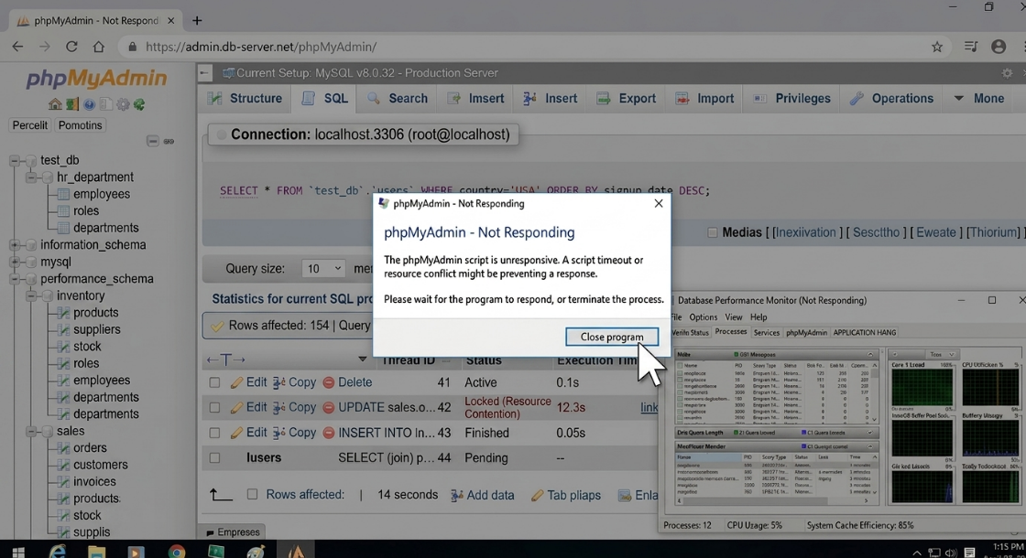
Figure 1. System Freeze

Figure 1 supports this result by showing a system that stops responding while running a database query in MySQL. The application becomes unresponsive and requires time before it recovers. This situation usually happens when a large dataset is processed or when multiple queries are executed at the same time. The visual evidence shows that the system cannot keep up with the demand which confirms the response of the respondents. This proves that system freeze is not only observed but also visible during actual database use.

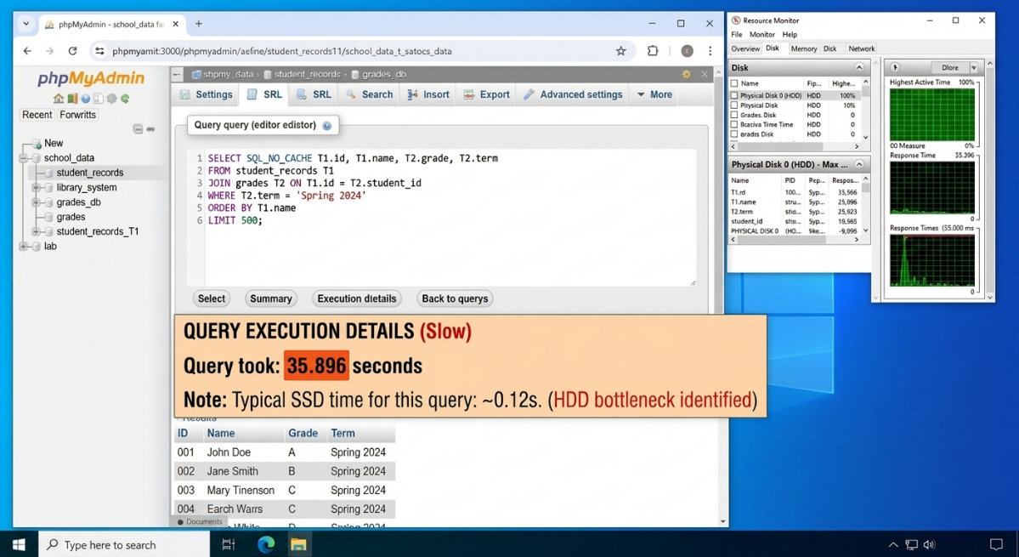
Figure 2. Slow Query Response

Figure 2 shows a query result that takes several seconds before displaying output. The delay is visible in the execution time shown in the database tool. This indicates that the system needs more time to locate and retrieve data from the storage device. When this delay happens often, it affects productivity in the laboratory. The visual proof supports the survey result because it clearly shows how slow query response happens during actual use. Slow query response also received a high rating. This means that retrieving data takes longer when using HDD. This affects both teaching and student activities because tasks require more time to complete. Seagate (2022) explains that HDD has slower access time due to mechanical movement which affects performance during large data retrieval.

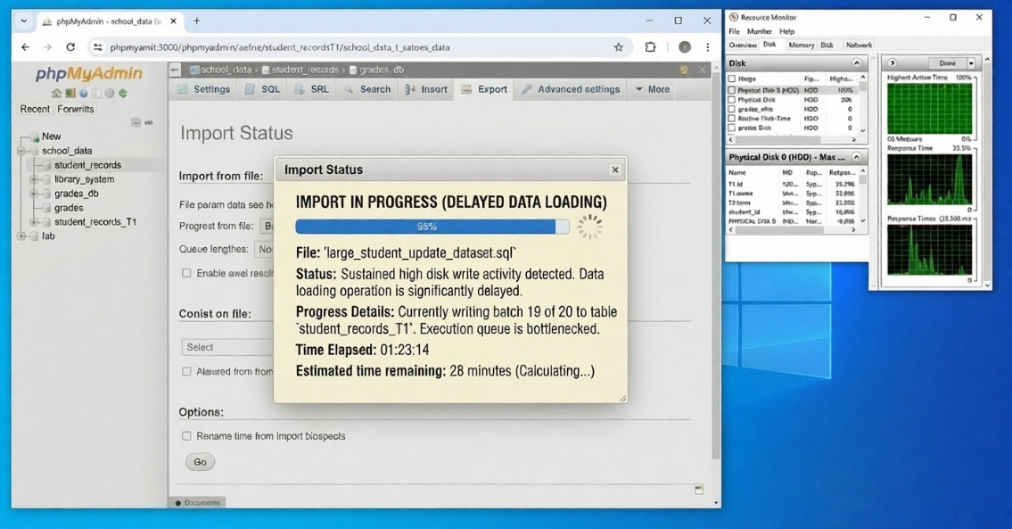
Figure 3. Delayed Data Loading

Delayed data loading and high disk wait time also received high ratings. These results show that the system spends more time waiting for data from the storage device. This reduces efficiency and slows down database operations. Samsung (2023) states that SSD improves loading speed and reduces waiting time because of faster data transfer.\

The screenshot for delayed data loading shows a long process when importing or updating records in the database. The system takes time before completing the task which confirms the experience of the respondents. This delay becomes more noticeable when working with large files or datasets. The visual result shows that the storage device plays a major role in how fast data is processed.

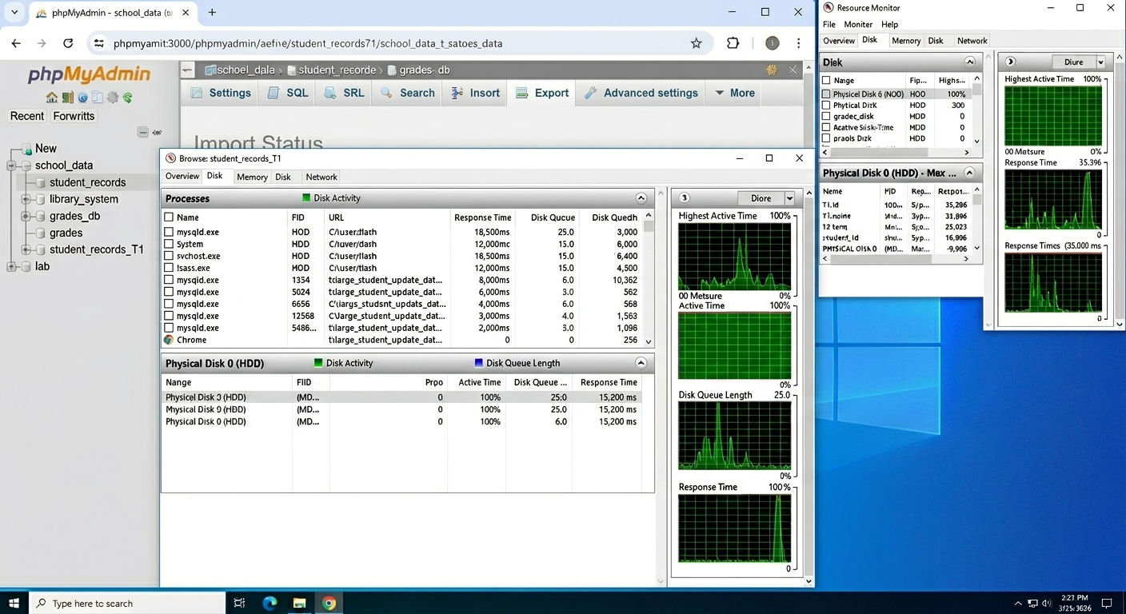
Figure 4. High Disk Wait Time

The screenshot for high disk wait time shows the disk usage reaching a high percentage in the system monitor. This means the system is waiting for the storage device to respond before continuing the task. When disk usage stays high, other operations slow down or stop. This confirms that storage is the main cause of delay in database systems. According to MDPI (2024), reducing disk wait time improves system performance which supports the findings of the study.

The results confirm that storage performance affects system behavior. Faster storage reduces delay and improves system response. The screenshots provide clear proof that the issues observed by the respondents are real and can be seen during actual database operations. This strengthens the validity of the survey results because both observation and visual evidence support the findings.

CONCLUSIONS

The study focuses on evaluating the performance of HDD and SSD in database systems. It examines how storage type affects query response time, data loading speed, and overall system behavior during operations. The results provide clear evidence that storage plays an important role in system performance.

Findings show that SSD performs better than HDD in all tested areas. Query response time is faster which improves data retrieval speed. Data loading and saving also take less time which improves workflow during database operations. These improvements make SSD more suitable for modern database systems.
Survey results support the test findings. IT lecturers report common issues when using HDD such as system freezing and slow response. These problems affect both teaching and learning in laboratory environments. SSD systems show fewer issues and provide a smoother experience.

The study shows that slow storage creates delays even when the system is properly designed. Faster storage improves both performance and stability. This highlights the importance of considering hardware when working with database systems.

The results also show that combining system testing with user feedback provides a better understanding of performance issues. This approach helps explain both technical data and real system behavior. It gives a complete view of how storage affects database performance.

RECOMMENDATIONS

Schools should upgrade laboratory computers from HDD to SSD to improve system performance. Faster storage reduces delays during database tasks and provides a better learning experience for students. This also helps lecturers conduct activities without interruptions caused by slow systems.

Developers should consider storage type when designing database systems. Fast hardware supports better performance even when handling large datasets. Ignoring hardware may result in slow system response even with good software design.

IT staff should monitor system performance regularly to identify storage related issues. Checking disk usage and response time helps detect problems early. This allows proper planning for upgrades and maintenance.

Students should be taught the importance of hardware in system performance. Understanding how storage affects database operations helps them build better systems. This knowledge is useful in both academic and professional settings.
Future studies may explore other factors that affect database performance such as memory and processor speed. Expanding the research can provide a deeper understanding of system optimization. This helps improve both hardware and software performance in database environments.

REFERENCES

IBM. (2025). Hard disk drive (HDD) vs. solid-state drive (SSD). https://www.ibm.com/think/topics/hard-disk-drive-vs-solid-state-drive

Intel. (2023). Introduction to solid-state drives. https://www.intel.com/content/www/us/en/products/docs/memory-storage/solid-state-drives/what-is-an-ssd.html

Kingston Technology. (2023). SSD vs HDD: What’s the difference? https://www.kingston.com/en/blog/pc-performance/ssd-vs-hdd

MDPI. (2024). Revisiting database indexing for parallel and accelerated computing: A comprehensive study and novel approaches. Information, 15(8), 429. https://www.mdpi.com/2078-2489/15/8/429

ResearchGate. (2024). Comparison performance analysis of HDD, SSD, and NVMe for OLTP database server. https://www.researchgate.net/publication/385426961

Samsung Electronics. (2023). SSD vs HDD: What’s the difference? https://www.samsung.com/semiconductor/minisite/ssd/product/consumer/ssd-vs-hdd/

Seagate Technology. (2022). SSD vs HDD: What’s the difference? https://www.seagate.com/blog/ssd-vs-hdd/

TechTarget. (2024). Solid-state drive (SSD). https://www.techtarget.com/searchstorage/definition/SSD

Tencent Cloud. (2026). What are the differences in the impact of SSDs and HDDs on retrieval performance? https://www.tencentcloud.com/techpedia/141916

Western Digital. (2022). HDD vs SSD: What’s the difference? https://www.westerndigital.com/solutions/hdd-vs-ssd

