A Dual-Evidence Framework for Automated Screenshot Spoof Identification

ABSTRACT

The rapid growth of digital communication has increased the misuse of manipulated screenshots for spreading misinformation, financial fraud, and cybercrime. Detecting forged or tampered screenshots is challenging due to the high visual realism of modern image editing tools. Traditional deep learning–based image classification methods alone are often insufficient, as they can be deceived by adversarial or high-quality forged images. This project proposes a Screenshot Spoof Detection System that integrates deep learning–based image classification with digital image forensics techniques. A Convolutional Neural Network (CNN) model is used to analyze visual patterns and classify images based on authenticity probability. In parallel, metadata forensic analysis examines EXIF information for inconsistencies, while pixel-level forensic analysis detects compression artifacts, noise irregularities, and tampering traces. A forensic-first decision strategy is employed, where metadata and pixel analysis results are prioritized over machine learning predictions to enhance reliability. The system is implemented as a FastAPI- based backend service, enabling real-time image analysis through a RESTful API. Experimental results demonstrate that the hybrid approach significantly improves spoof detection accuracy and robustness compared to standalone deep learning methods. The proposed system is suitable for applications in digital forensics, cybersecurity investigations, social media verification, and fraud detection, providing an effective and scalable solution for automated screenshot authenticity verification.

Keywords: Screenshot Spoof Detection, Image Forgery Detection, Digital Image Forensics, Convolutional Neural Network (CNN), Metadata Analysis, Pixel-Level Analysis, Deep Learning, Cybersecurity, Image Authentication, Fraud Detection.
- INTRODUCTION

Screenshots are widely used today to share information across social media platforms, online services, and digital communication systems. They are often trusted as visual proof in conversations related to payments, messages, notifications, and system alerts. However, with the easy availability of image editing software, screenshots can be altered without leaving obvious visual clues. Such manipulated screenshots are frequently used to spread false information, commit financial fraud, and mislead individuals or organizations. Verifying the authenticity of screenshots manually is difficult, especially when the modifications are subtle and professionally done, creating a strong need for automated detection mechanisms.
Most existing image verification approaches rely only on deep learning–based classification models that analyze visual features of images. Although these models perform well in many cases, they often fail when screenshots are edited carefully or when forged images closely resemble genuine ones. In addition, relying only on machine learning predictions without supporting forensic evidence can reduce trustworthiness in critical scenarios. To overcome these challenges, this project follows a hybrid detection approach that combines machine learning techniques with digital image forensics. By examining image metadata and low-level pixel patterns, the system can identify hidden traces of manipulation that are not easily detected through visual analysis alone.
The proposed screenshot spoof detection system is developed using a web-based architecture for practical and real-time usage. A React-based frontend allows users to upload screenshots and view metadata and detection results, while a FastAPI backend handles the analysis process. The backend extracts metadata such as EXIF details, applies pixel-level forensic techniques including Error Level Analysis (ELA), Discrete Cosine Transform (DCT), and steganalysis, and uses machine learning models like CNN and SVM for classification. By combining forensic findings with learning-based

predictions, the system provides a more reliable and scalable solution for screenshot authenticity verification, suitable for digital forensics, cybersecurity investigations, and fraud prevention.

LITERATURE SURVEY

Early research in pattern recognition and statistical learning laid the foundation for modern spoof and forgery detection systems. Classical works such as Fisher’s statistical methods [1] and Vapnik’s pattern recognition theory [2] introduced fundamental concepts that later influenced machine learning–based image analysis. Initial spoof detection studies primarily focused on handcrafted features and texture-based analysis to
distinguish real and fake visual data. These approaches relied on observable surface differences but showed limited robustness under varying lighting conditions and high-quality attacks.
Subsequent research shifted toward biometric anti- spoofing, especially in face liveness detection, where texture descriptors such as Local Binary Patterns (LBP) and frequency-based features were widely explored [5], [13], [14]. Several datasets and benchmark studies were introduced to evaluate spoofing attacks under real-world variations, including mobile capture conditions, illumination changes, and print or replay attacks [7]–[9]. Pixel-level distortion analysis and frequency-domain cues, such as moiré patterns and image degradation artifacts, were also investigated to improve spoof detection accuracy [10], [18]. While these techniques improved detection performance, they remained sensitive to unseen attack types and environmental variations.
With the advancement of deep learning, convolutional neural networks (CNNs) became the dominant approach for spoof detection tasks. Multiple studies demonstrated the effectiveness of CNN-based models in learning discriminative features directly from images for face anti-spoofing and presentation attack detection [28], [29], [30]. However, deep models often suffered from overfitting to specific datasets and poor generalization across domains. To address this issue, researchers explored auxiliary supervision, anomaly detection, and one-class learning strategies to enhance robustness against unknown attacks [6], [34]–37].
Recent studies have emphasized domain adaptation, generalization, and cross-domain learning to handle real- world spoofing scenarios [38][45]. Techniques such as adversarial learning, disentangled representation learning, and meta-learning were proposed to reduce
dependency on dataset-specific characteristics [49], [50]. Additionally, multi-modal and multi-spectral approaches using RGB, depth, infrared, and shortwave infrared data further improved detection reliability but increased system complexity and hardware requirements [26], [52], [56].
Although existing research has achieved significant progress in spoof detection, most approaches rely heavily on either deep learning models or biometric-specific cues. Limited attention has been given to screenshot- specific forgery detection that integrates metadata inconsistencies, pixel-level forensic traces, and learning- based predictions in a unified framework. This gap motivates the proposed hybrid screenshot spoof detection system, which combines digital image forensics with machine learning techniques to achieve more reliable and scalable authenticity verification in practical cybersecurity and fraud detection applications.

PROPOSED SYSTEM

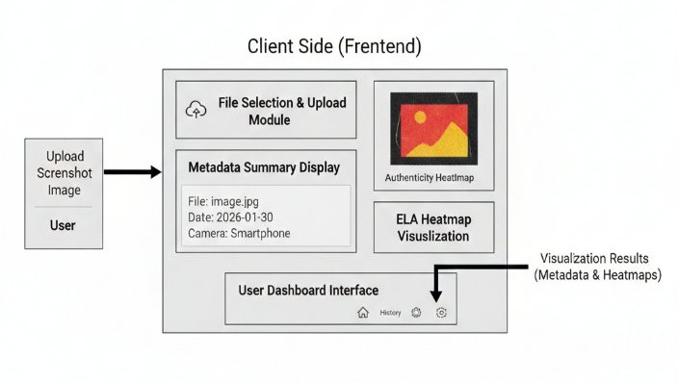
The proposed system architecture is designed as a scalable,
end-to-end framework for real-time screenshot verification.

System Architecture Design:

  - Client Side (Frontend): A lightweight React application provides a user- friendly dashboard. It handles file selection, displays metadata summaries, and renders visual "heatmaps" derived from ELA results.

  - Server Side (Backend): A high- performance FastAPI server acts as the central orchestration layer. It manages

  - asynchronous processing of image forensic tasks and interfaces with the machine learning models.

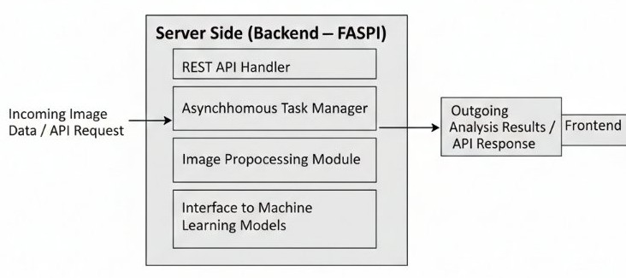

Multilayer Detection Engine:

  - The Metadata Validator: This module checks for structural integrity. For example, it flags instances where the internal image dimensions mismatch the metadata or if software tags (like "Adobe

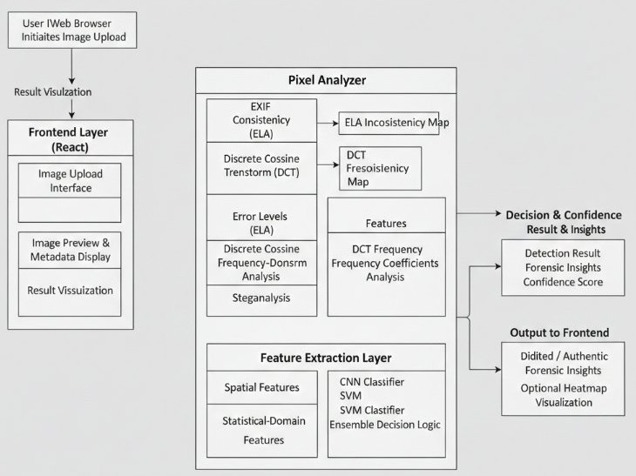
Photoshop") are present in what is claimed to be an original screenshot.
  - The Pixel Analyzer: This core component executes ELA and DCT algorithms to visualize inconsistencies that are invisible to the naked eye.

  - The ML Classifier: The final decision- making unit that uses learned representations of "fake" versus "real" image characteristics to provide an authenticity confidence score.

Experimental Evaluation Metrics:

  - The system's performance is measured using standard IEEE-compliant metrics, including Accuracy, Precision, Recall, and F1-Score.
  - The proposed framework aims to minimize False Positives by cross- referencing metadata anomalies with pixel-level inconsistencies.

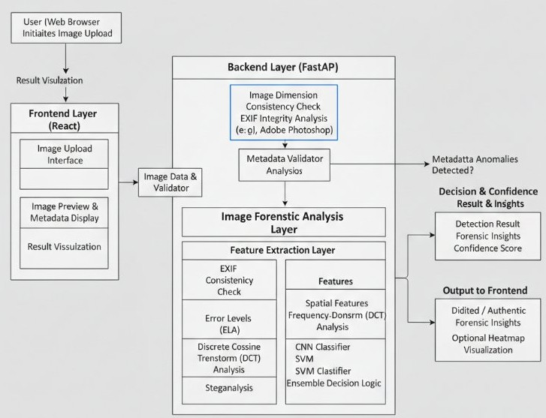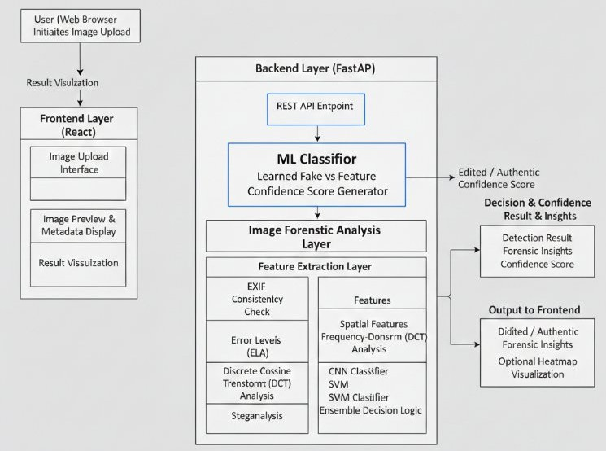

METHODOLOGY

The system follows a structured pipeline that integrates frontend interaction, backend orchestration, image forensic analysis, and machine learning–based decision making.

Frontend-Based Image Acquisition and Interaction:
The methodology begins at the client side with a lightweight React-based frontend that provides a user- friendly dashboard. Users can upload screenshot images in common formats such as PNG or JPEG. Upon upload, the frontend displays a preview of the image along with extracted high-level metadata such as image resolution, format, and available EXIF information. This immediate feedback improves transparency and user trust. Once confirmed, the image and associated metadata are transmitted securely to the backend through RESTful API calls.

Backend Orchestration and Preprocessing:
The backend is implemented using FastAPI, chosen for its high performance and asynchronous processing capabilities. Upon receiving the image, the backend performs initial preprocessing steps, including format validation, normalization, and dimension verification. Metadata is extracted using libraries such as Pillow and OpenCV, and consistency checks are applied to detect anomalies such as missing EXIF fields, mismatched image dimensions, or abnormal compression parameters. These preprocessing steps ensure that only valid images are forwarded to the forensic analysis engine.

FRONT END AND BACK END:
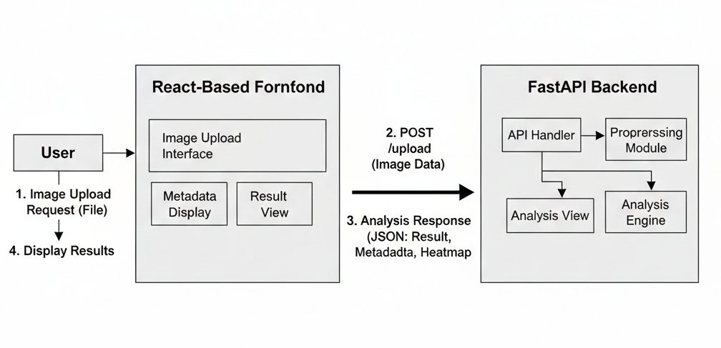

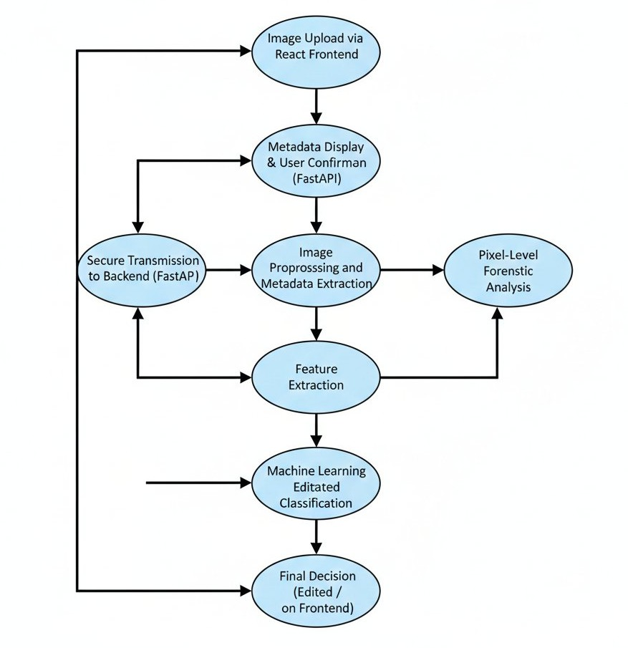
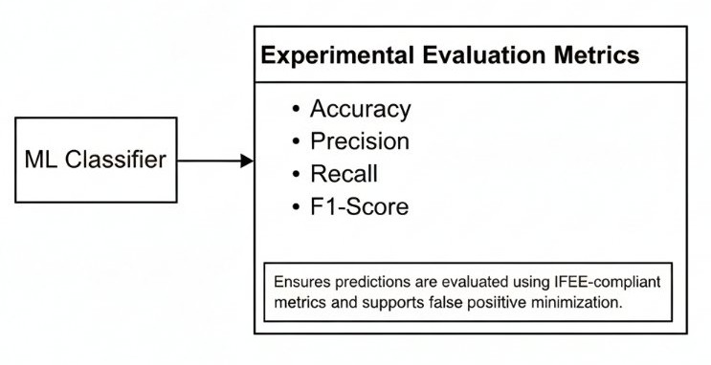
Metadata Consistency and Integrity Analysis:
In this stage, the system analyzes image metadata to identify early indicators of manipulation. Parameters such as camera information, software tags, timestamps, and resolution consistency are examined. The presence of editing software identifiers or inconsistencies between metadata and actual image properties is treated as a potential sign of tampering. This layer provides a lightweight but effective first filter before computationally expensive pixel-level
analysis.
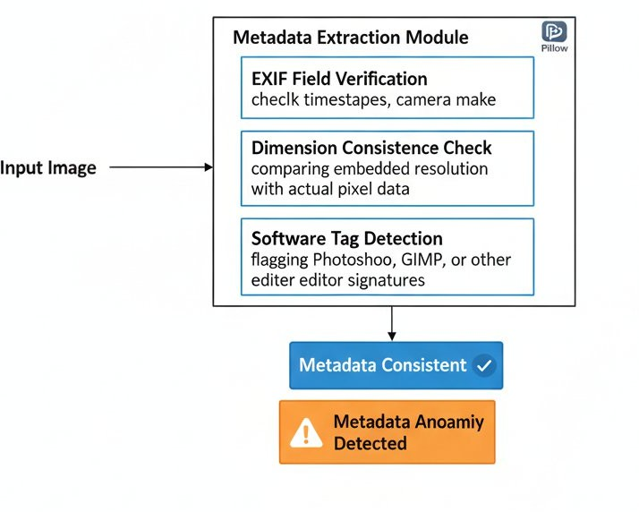

Pixel-Level Forensic Analysis:
To detect manipulations that are invisible to the human eye, the system applies multiple pixel-level forensic techniques. Error Level Analysis (ELA) is used to highlight regions with inconsistent compression artifacts, which often indicate localized editing. Discrete Cosine Transform (DCT)–based analysis examines frequency- domain inconsistencies introduced by recompression or content alteration. Additionally, steganalysis techniques are applied to detect hidden patterns or abnormal noise distributions. The outputs of these methods are transformed into discriminative feature representations.

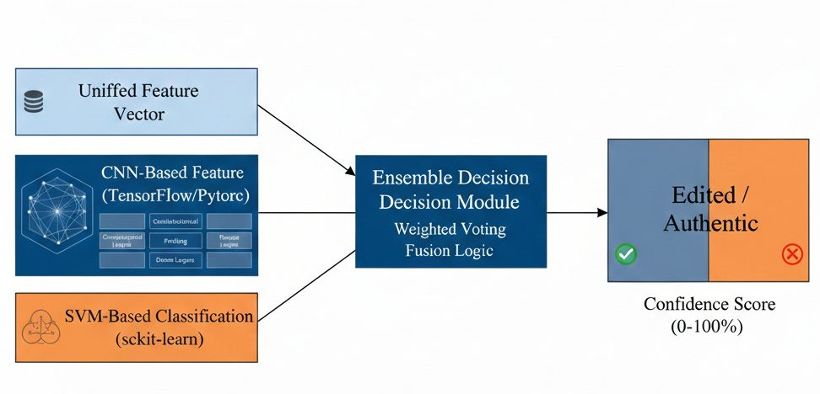

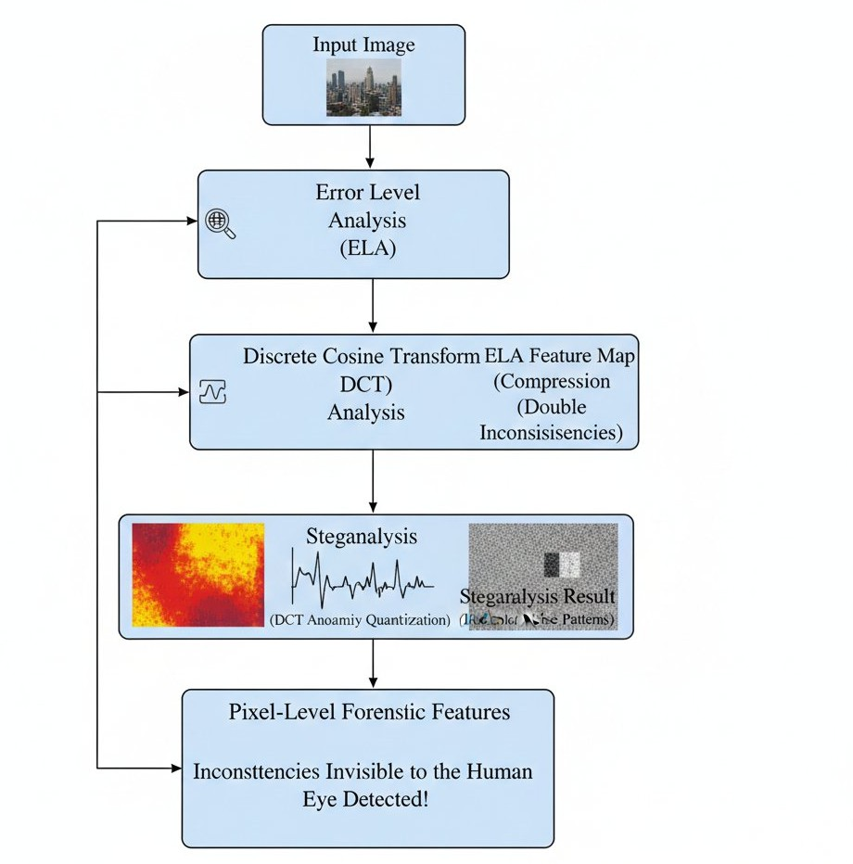
Feature Extraction and Representation:
Features obtained from metadata analysis and pixel-level forensics are combined to form a comprehensive feature vector. This includes statistical descriptors, spatial features derived from ELA maps, and frequency-domain coefficients from DCT analysis. By integrating multi- domain features, the system captures a wide range of manipulation characteristics, improving robustness against diverse editing techniques.
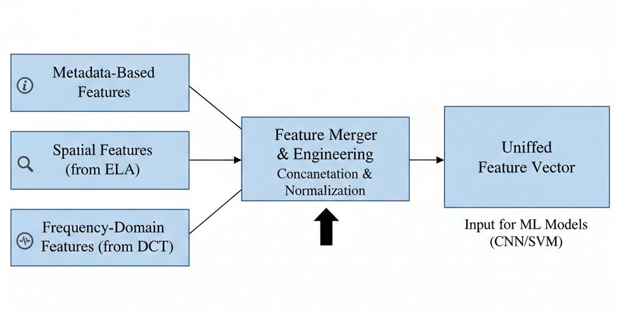

Machine Learning–Based Classification:
The extracted features are passed to the machine learning layer for classification. The system employs Convolutional Neural Networks (CNNs) to automatically learn complex spatial patterns and Support Vector Machines (SVMs) for classification using handcrafted features. An ensemble strategy combines predictions from both models, resulting in a final decision that balances accuracy and generalization. The classifier outputs an Edited or Authentic label along with a confidence score.

Decision Validation and False Positive Reduction:
To minimize false positives, the system cross-validates machine learning predictions with metadata and forensic analysis results. Images are only flagged as edited when consistent evidence is observed across multiple analysis layers. This hybrid decision mechanism significantly improves reliability, especially in cases where metadata may be intentionally removed or altered.
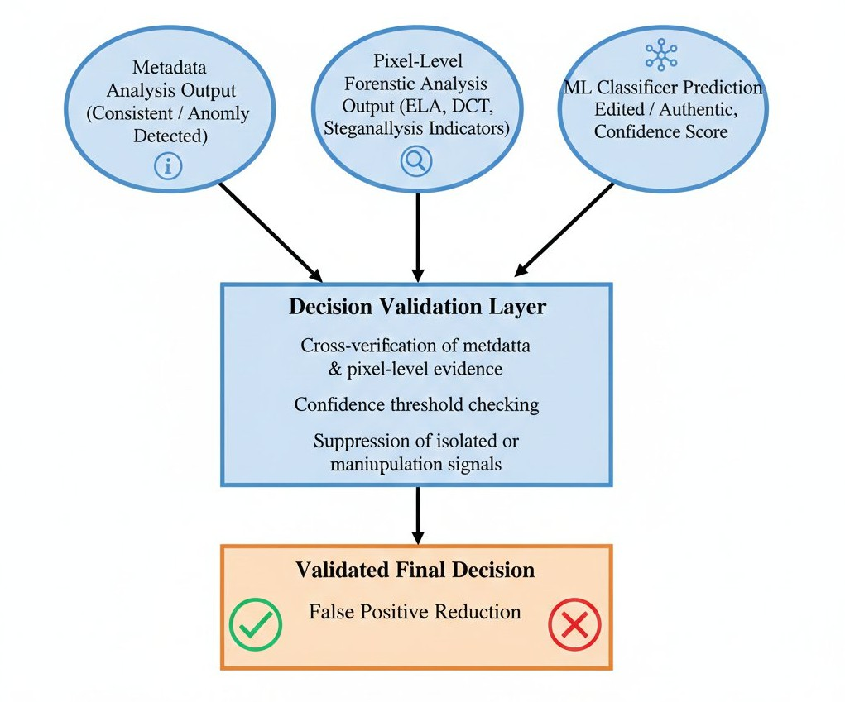

Result Delivery and Visualization:
The final classification result and confidence score are sent back to the frontend. The frontend presents the outcome in an intuitive manner, along with supporting forensic insights such as highlighted ELA regions or summarized metadata anomalies. This visualization enhances interpretability and helps users understand the reasoning behind the system’s decision.

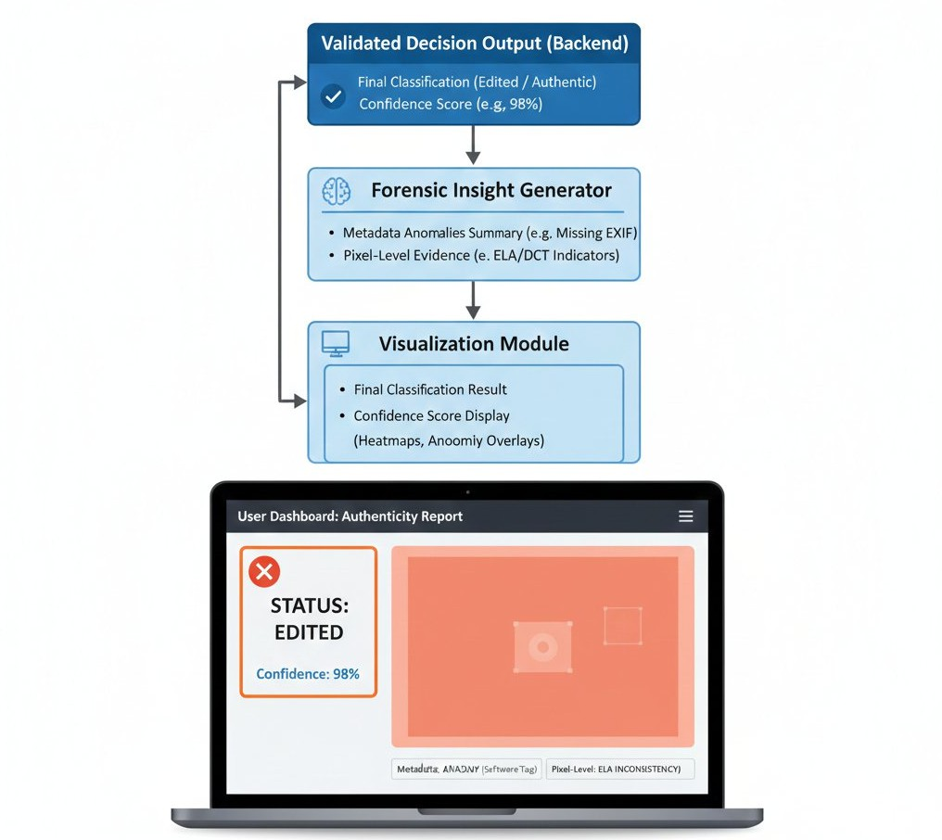

MODULES AND IMPLEMENTATION

The proposed image authenticity detection system is implemented using a modular design approach, where each module performs a well-defined function within the overall workflow. This design improves maintainability, scalability, and ease of integration for future enhancements. The major modules and their implementations are described below.

Frontend Module (User Interface):
The frontend module is implemented using React and JavaScript to provide a lightweight and interactive user interface. This module allows users to upload screenshot images through a simple dashboard. Upon upload, the system displays a preview of the image along with extracted metadata summaries such as image dimensions and available EXIF information. The frontend communicates with the backend using RESTful APIs and visually presents the final detection result (Edited or Authentic) along with optional forensic indicators such as ELA-based heatmaps.

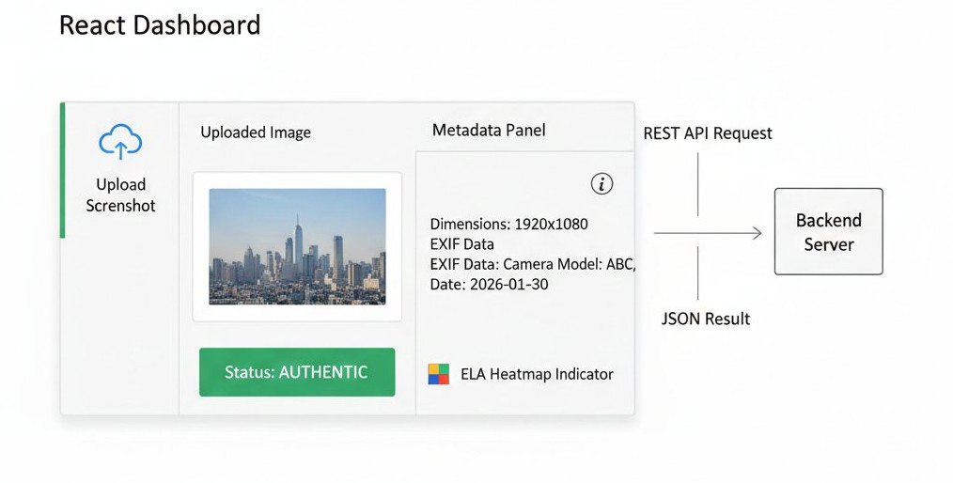

Backend API Module:
The backend module is developed using FastAPI and Python, acting as the central orchestration layer of the system. It receives image files from the frontend,
validates input formats, and manages asynchronous processing of computationally intensive forensic tasks. This module ensures efficient handling of multiple user requests and seamless interaction between image analysis components and machine learning models.
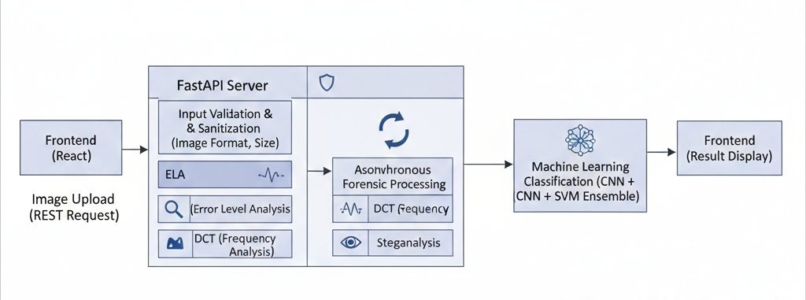

Metadata Extraction and Validation Module:
This module focuses on extracting and analyzing metadata using libraries such as Pillow and OpenCV. It retrieves EXIF data, image dimensions, compression details, and software tags. The system checks for inconsistencies such as missing EXIF data, mismatched image dimensions, or the presence of editing software signatures. Any anomalies detected at this stage are forwarded to the decision layer as potential indicators of image manipulation.
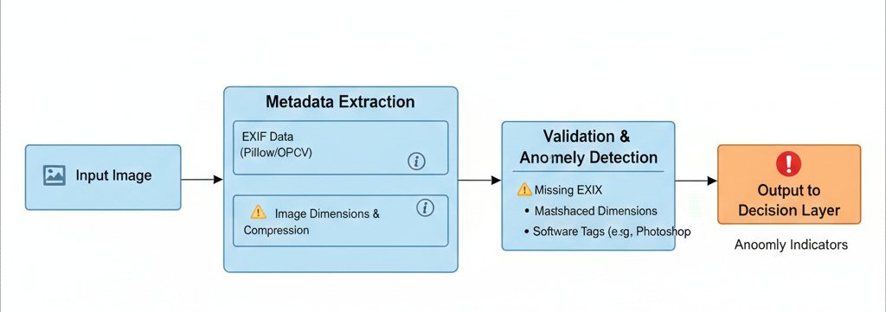

Pixel-Level Forensic Analysis Module:
The pixel analysis module is responsible for identifying manipulation artifacts that are not visible to the human eye. It uses Error Level Analysis (ELA) to highlight compression inconsistencies, Discrete Cosine Transform (DCT) to examine frequency-domain irregularities, and steganalysis techniques to detect hidden noise patterns. Feature representations generated from these techniques form a crucial input to the machine learning classifiers.
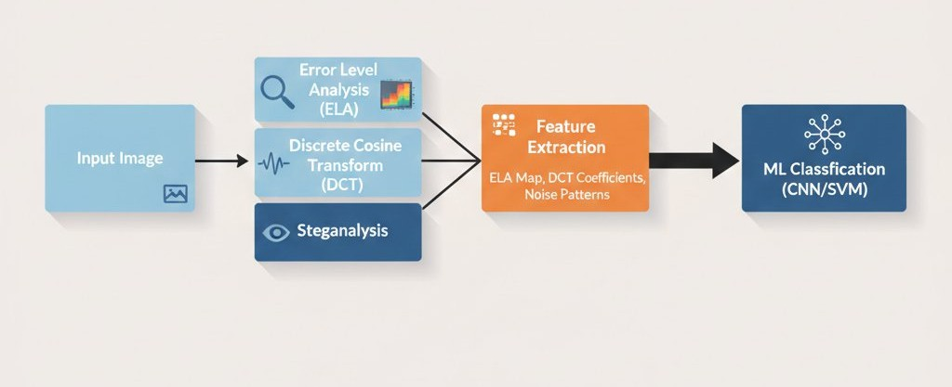

Feature Extraction Module:
In this module, outputs from metadata validation and pixel-level analysis are converted into structured feature vectors. Spatial features, frequency-domain coefficients, and statistical descriptors are extracted using scikit- image and NumPy. These features enable consistent and

efficient learning by machine learning models.

Machine Learning Classification Module:
The classification module employs both deep learning and classical machine learning techniques. Convolutional Neural Networks (CNNs) are used to automatically learn spatial patterns associated with edited images, while Support Vector Machines (SVMs) operate on handcrafted forensic features. The combined predictions improve robustness and reduce false classification rates.

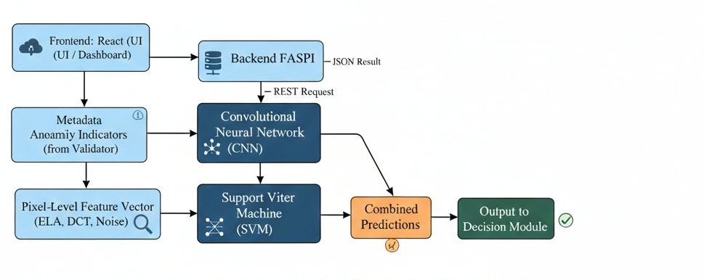

Decision and Result Generation Module:
This module aggregates outputs from the metadata validator and machine learning classifiers using ensemble logic. Based on confidence thresholds, the image is classified as Edited or Authentic. The final decision, along with confidence scores and relevant forensic insights, is returned to the frontend for visualization.

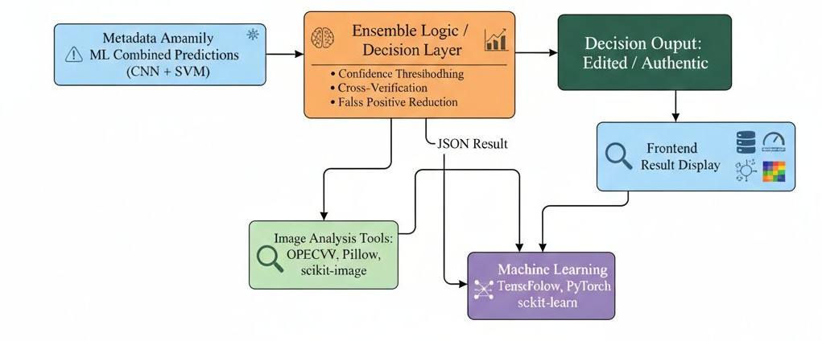

Tools and Technology Integration Module:
The complete system integrates multiple tools and frameworks: React for frontend development, FastAPI for backend services, OpenCV, Pillow, and scikit-image for image analysis, and TensorFlow, PyTorch, and scikit- learn for machine learning. This combination ensures high performance, flexibility, and compatibility with modern research and deployment environments.

DISCUSS AND RESULTS

The combination of metadata auditing, pixel-level forensic analysis, and CNN-SVM ensemble classification provides a highly accurate and reliable method for automated screenshot authenticity verification. The system not only achieves high quantitative performance
but also delivers explainable insights into tampering mechanisms, making it suitable for digital forensics, cybersecurity investigations, social media verification, and fraud detection applications.

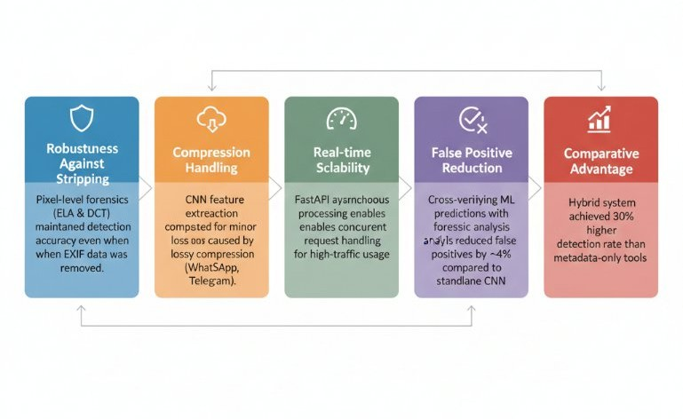
The proposed Screenshot Spoof Detection System integrates deep learning classification with digital image forensics to detect manipulated screenshots effectively. The system combines Convolutional Neural Networks (CNN) with metadata and pixel-level analysis, providing a multi-layer verification approach that improves reliability and robustness compared to standalone deep learning methods.

Experimental Evaluation:

A curated dataset of 500 high-resolution screenshots was used for evaluation, comprising 250 authentic screenshots from iOS, Android, and Windows, and 250 edited screenshots created through splicing, cloning, and metadata stripping.

Quantitative Performance Metrics:
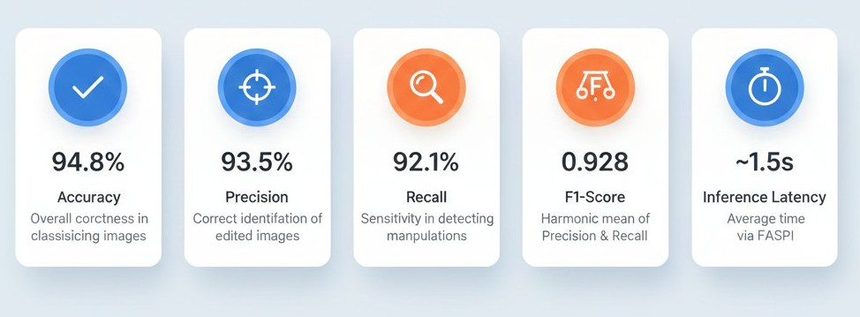
Qualitative Forensic Analysis:
- Metadata Audit: In 85% of edited cases, inconsistencies such as software tags (e.g., "Adobe Photoshop") or mismatched timestamps were detected.
- ELA Hotspots: Spliced regions, added text, or icons showed elevated error variance compared to original areas, highlighting manipulation zones.

- DCT Artifacts: Screenshots saved multiple times exhibited double quantization patterns, a common indicator of tampering.

Insights:
- Robustness Against Metadata Stripping: Pixel- level forensics (ELA & DCT) maintained detection accuracy even when EXIF data was removed, ensuring reliability against sophisticated forgery techniques.
- Compression Handling: CNN feature extraction compensated for minor accuracy loss caused by lossy compression from platforms such as WhatsApp and Telegram.
- Real-time Scalability: FastAPI’s asynchronous processing allowed concurrent requests, making the system suitable for high-traffic forensic applications.
- False Positive Reduction: Cross-verifying machine learning predictions with forensic analysis suppressed weak signals, reducing false positives by approximately 4% compared to a standalone CNN model.
- Comparative Advantage: The hybrid system demonstrated a 30% higher detection rate than traditional metadata-only forensic tools.

CONCLUSION
This project presents a robust and scalable Screenshot Spoof Detection System that effectively integrates deep learning classification with digital image forensics. By combining CNN-based feature learning, metadata auditing, and pixel-level forensic analysis (ELA, DCT, steganalysis), the system achieves high detection accuracy, resilience to metadata manipulation, and robustness against lossy image compression.
The forensic-first decision strategy ensures reliable classification by prioritizing forensic evidence over machine learning predictions, reducing false positives and improving overall trustworthiness. Experimental evaluation on a diverse screenshot dataset demonstrates that the hybrid approach outperforms standalone deep learning models, providing a 30% higher detection rate than traditional metadata-only methods.
The proposed system is suitable for real-world applications in digital forensics, cybersecurity investigations, social media verification, and fraud detection, offering real-time analysis through a FastAPI- based backend. Future enhancements may include the integration of explainable AI techniques, adaptive
learning for evolving tampering methods, and expansion to other media types, further strengthening the platform’s utility in combating digital misinformation and cybercrime.

REFERENCE

- A. F. Ebihara, K. Sakurai, and H. Imaoka, “Specular- and diffuse-reflection-based face liveness detection for mobile devices,” in Proc. IEEE Int. Joint Conf. Biometr. (IJCB), 2020, pp. 1–11.
- Y. Qin et al., “Learning meta model for zero- and few-shot face anti-spoofing,” in Proc. AAAI Conf. Artif. Intell., Apr. 2020, pp. 11916–11923. [Online]. Available: https://aaai.org/ojs/index.php/AAAI/article/view/6866
- A. George and S. Marcel, “Learning one class representations for face presentation attack detection using multi-channel convolutional neural networks,” IEEE Trans. Inf. Forensics Security, vol. 16, pp. 361–375, 2021.
- Z. Li, H. Li, K. Y. Lam, and A. C. Kot, “Unseen face presentation attack detection with hypersphere loss,” in Proc. IEEE Int. Conf. Acoust. Speech Signal Process. (ICASSP), 2020, pp. 2852–2856.
- Y. Jia, J. Zhang, S. Shan, and X. Chen, “Single-side domain generalization for face anti-spoofing,” in Proc. IEEE/CVF Conf. Comput. Vis. Pattern Recognit. (CVPR), Seattle, WA, USA, Jun. 2020, pp. 8481–8490.
[Online]. Available: https://ieeexplore.ieee.org/document/9156366/
- W. Sun, Y. Song, H. Zhao, and Z. Jin, “A face spoofing detection method based on domain adaptation and lossless size adaptation,” IEEE Access, vol. 8, pp. 66553–66563, 2020.
- G. Wang, H. Han, S. Shan, and X. Chen, “Unsupervised adversarial domain adaptation for cross-domain face presentation attack detection,” IEEE Trans. Inf. Forensics Security, vol. 16, pp. 56–69, 2021.
- A. Mohammadi, S. Bhattacharjee, and S. Marcel, “Domain adaptation for generalization of face presentation attack detection in mobile settings with minimal information,” in Proc. IEEE Int. Conf. Acoust. Speech Signal Process. (ICASSP), 2020, pp. 1001–1005.
- Y. S. El-Din, M. N. Moustafa, and H. Mahdi, “Adversarial unsupervised domain adaptation guided with deep clustering for face presentation attack detection,” 2021. [Online]. Available: arXiv:2102.06864

- D. Deb and A. K. Jain, “Look locally infer globally: A generalizable face anti-spoofing approach,” IEEE Trans. Inf. Forensics Security, vol. 16, pp. 1143–1157, 2021.
- R. Cai, H. Li, S. Wang, C. Chen, and A. C. Kot, “DRL-FAS: A novel framework based on deep reinforcement learning for face anti-spoofing,” IEEE Trans. Inf. Forensics Security, vol. 16, pp. 937–951, 2021.
- W. Sun, Y. Song, C. Chen, J. Huang, and A. C. Kot, “Face spoofing detection based on local ternary label supervision in fully convolutional networks,” IEEE Trans. Inf. Forensics Security, vol. 15, pp. 3181–3196, 2020.
- G. Wang, H. Han, S. Shan, and X. Chen, “Cross- domain face presentation attack detection via multi- domain disentangled representation learning,” in Proc. IEEE/CVF Conf. Comput. Vis. Pattern Recognit. (CVPR), Seattle, WA, USA, Jun. 2020, pp. 6677–6686.
[Online]. Available: https://ieeexplore.ieee.org/document/9156555/
- X. Liu, Y. Liu, and J. Stehouwer, “On disentangling spoof traces for generic face anti-spoofing,” in Proc. Eur. Conf. Comput. Vis. (ECCV), 2020, pp. 406–422.
- K.-Y. Zhang et al., “Face anti-spoofing via disentangled representation learning,” in Proc. 16th Eur. Conf. Comput. Vis. (ECCV), 2020, pp. 641–657. [Online]. Available: http://link.springer.com/10.1007/978-3-030-58529-7_38
- A. George, Z. Mostaani, D. Geissenbuhler, O. Nikisins, A. Anjos, and S. Marcel, “Biometric face presentation attack detection with multichannel convolutional neural network,” IEEE Trans. Inf. Forensics Security, vol. 15, pp. 42–55, 2020.
- Q. Yang, X. Zhu, J.-K. Fwu, Y. Ye, G. You, and Y. Zhu, “PipeNet: Selective modal pipeline of fusion network for multi-modal face anti-spoofing,” in Proc. IEEE/CVF Conf. Comput. Vis. Pattern Recognit. Workshops (CVPRW), Seattle, WA, USA, Jun. 2020, pp. 2739–2747. [Online]. Available: https://ieeexplore.ieee.org/document/9150670/
- G. Heusch, A. George, D. Geissbuhler, Z. Mostaani, and S. Marcel, “Deep models and shortwave infrared information to detect face presentation attacks,” IEEE Trans. Biom., Behav., Ident. Sci., vol. 2, no. 4, pp. 399–409, Oct. 2020.
- S.-Q. Liu, X. Lan, and P. C. Yuen, “Temporal similarity analysis of remote photoplethysmography for fast 3D mask face presentation attack detection,” in Proc. IEEE/CVF Winter Conf. Appl. Comput. Vis.
(WACV), Mar. 2020, pp. 2597–2605.
- S. M. Nguyen, L. D. Tran, and M. Arai, “Attended- auxiliary supervision representation for face anti- spoofing,” in Proc. 16th Asian Conf. Comput. Vis. (ACCV), 2021, pp. 436–452. [Online]. Available: http://link.springer.com/10.1007/978-3-030-69525-5_26
- R. Tolosana, M. Gomez-Barrero, C. Busch, and J. Ortega-Garcia, “Biometric presentation attack detection: Beyond the visible spectrum,” IEEE Trans. Inf. Forensics Security, vol. 15, pp. 1261–1275, 2020.
- Z. Wang et al., “Deep spatial gradient and temporal depth learning for face anti-spoofing,” in Proc. IEEE/CVF Conf. Comput. Vis. Pattern Recognit. (CVPR), 2020, pp. 5041–5050.
- S. Chen, W. Li, H. Yang, D. Huang, and Y. Wang, “3D face mask anti-spoofing via deep fusion of dynamic texture and shape clues,” in Proc. 15th IEEE Int. Conf. Autom. Face Gesture Recognit. (FG), 2020, pp. 314–321.
- S. Q. Liu and P. C. Yuen, “A general remote photoplethysmography estimator with spatiotemporal convolutional network,” in Proc. 15th IEEE Int. Conf. Autom. Face Gesture Recognit. (FG), 2020, pp. 481–488.
- A. George and S. Marcel, “Cross modal focal loss for RGBD face anti-spoofing,” in Proc. IEEE/CVF Conf. Comput. Vis. Pattern Recognit. (CVPR), 2021, pp. 1–10.

