Small Ruminant (Goats and Sheep) challenges under traditional management in Central Equatorial State, Juba, South Sudan

ABSTRACT

The objectives of this study were to quantify and assess the challenges that facing small ruminant (Goats and Sheep) under traditional management in Juba condition and its environment period of six months (May-October). Of the year Chemical analyses of feed (pasture) were carried out in laboratories in ARC Wad- Medani, Sudan. To identifies the nutritional status of the pasture. The result revealed that nutrient composition differed with time. Pasture composition and were significantly (P≤ 0.05) differed with time. Information has been collected from different communities in Juba area regarding nutrition, management, political instability, civil conflicts, diseases and poor record keeping by stakeholder. The information derived from this study will serve as baseline for small ruminant animals (Goats and Sheep) nutrition status, management challenges that faced small scale small ruminant keepers in Juba area. The study recommended that, the challenges faced small ruminants should be addressed. Among these are the need to understand, through research, and efficient management system

Keywords: South Sudan (Juba); Small ruminants; Challenges and management.

- INTRODUCTION

South Sudan is a land locked country located in East Africa. It’s bordered to the north by the republic of Sudan, to the east by Ethiopia, and to the south by Uganda, Kenya, DRC and CAR to the west. The recent population was approximated to be 12.7million.
Small ruminant production has a significant socioeconomic and environmental role worldwide. Traditionally, small ruminants are reared under grazing systems where the more productive lands are used to feed cows, and secondarily sheep. Goats have occupied poor lands, mountainous regions and arid and semi-arid zones. These elements are mainly responsible for the worldwide differential distribution of sheep and goats and their breeds. lores, J.; , et al., 2006; pp. 291–299.

The demand for goat meat is very high especially in rural areas where it often commands higher market price than beef (Odeyinka, 2000).The meat from goat is preferable to those from other animal species because of its flavor, tenderness and palatability (Idiong and Orok, 2008). They are indispensable in marriage and religious rites. Their products such as meat are not subjected to the religious taboos unlike pork and beef to Muslims and Hindus as respectively (Chenyambuga et al., 2014). Their milk is said to be better compare to other milk such as cow for people suffering from lactose intolerance which is common among adult in sub-Saharan Africa (Haelein, 2004).
Rangelands are native vegetation environments with heterogeneous vegetation cover including grasses, creepers, shrubs and trees. These ecosystems have served as a source of food for livestock for centuries. In many parts of the world, these systems provide the main forage resource for traditional livestock.

However, commonly most people consider rangelands as a “waste-land” because its conditions are unfit for many human agricultural activities. Over 200 plant species have been reported to possess feeding potential for domestic ruminants. However, coping with such a level of heterogeneity may not represent an easy task for sheep and goats, given that, on a daily basis, they are confronted with the challenge of establishing a feeding strategy through the selection of various plants containing different arrays of nutrients and plant secondary compounds (PSC) in different concentrations. The three main type of goats in the Sudan can be described as the Nubian, Sudan Desert and Nilotic.
The two largest ethnic groups are the Dinka and Nuer. These people are agropastoralists who rely heavily on cattle and other livestock for their social and economic well-being in the low-lying areas of southern Sudan (flat grassland and woodland, and transected by substantial river systems that flow into the White Nile). Catley, A., et al., 2001. 51(3-4): p. 161-181

The importance of good plane animal nutrition the adequate supply of safe and quality feed is important for maintaining animal welfare and productivity. This is also important to increase the production and access of safe animal source protein to livestock producing households and consumers.

The plane of livestock nutrition strongly affects animal health since the nourishment of an animal determines its immune system and ability to fight diseases. A malnourished animal is physically weak and morbid and readily succumbs to the effects of diseases and parasites. The right feed and feeding system are thus essential for sustaining the desired state of animal health, reproduction and production.

Livestock diseases pose a serious threat to animal and human health and reduce productivity. Baigo, A.F. 2013: p. 20.

In economic terms, nutritionally sound and efficient feeding systems could bring enormous economic benefits as the cost of feed in livestock produced for selling account for about 70 percent of the total livestock production expenses. In South Sudan, livestock production is largely subsistence-oriented with heavy reliance on rangeland forages and crop residues as source of livestock diet.

Rangelands, which contribute to the largest share of livestock feed, undergo marked seasonal fluctuation in forage production. When such seasonal forage availability coincides with prolonged periods of feed deficits, it causes hidden but glaring economic losses to subsistence pastoral and agro-pastoral systems; undernourished animals take longer to reach sexual maturity, milk production and reproduction plummet, and morbidity and mortality rise in extreme circumstances.

The negative consequences of the unstable supply of livestock feed on the production of livestock products, notably milk, is particularly critical as it compromises the health and productive capacity of livestock keeping communities and the country’s population at large. Lack of access to animal source food causes stunting and wasting in children, and micronutrient deficiencies in pregnant and nursing women.

Main source of livestock feed Grassland forages In South Sudan, grasslands account for over 62 percent of the country’s total land cover (Land Cover Atlas South Sudan, 2011).
Rangelands provide the main forage resource for livestock in many parts of the world, but maintaining long-term productivity and providing sufficient income for the rancher remains a challenge. One key issue is to maintain the rangeland. Accatino, F.; Sabatier, et al., 2014, 8, 1272–1281

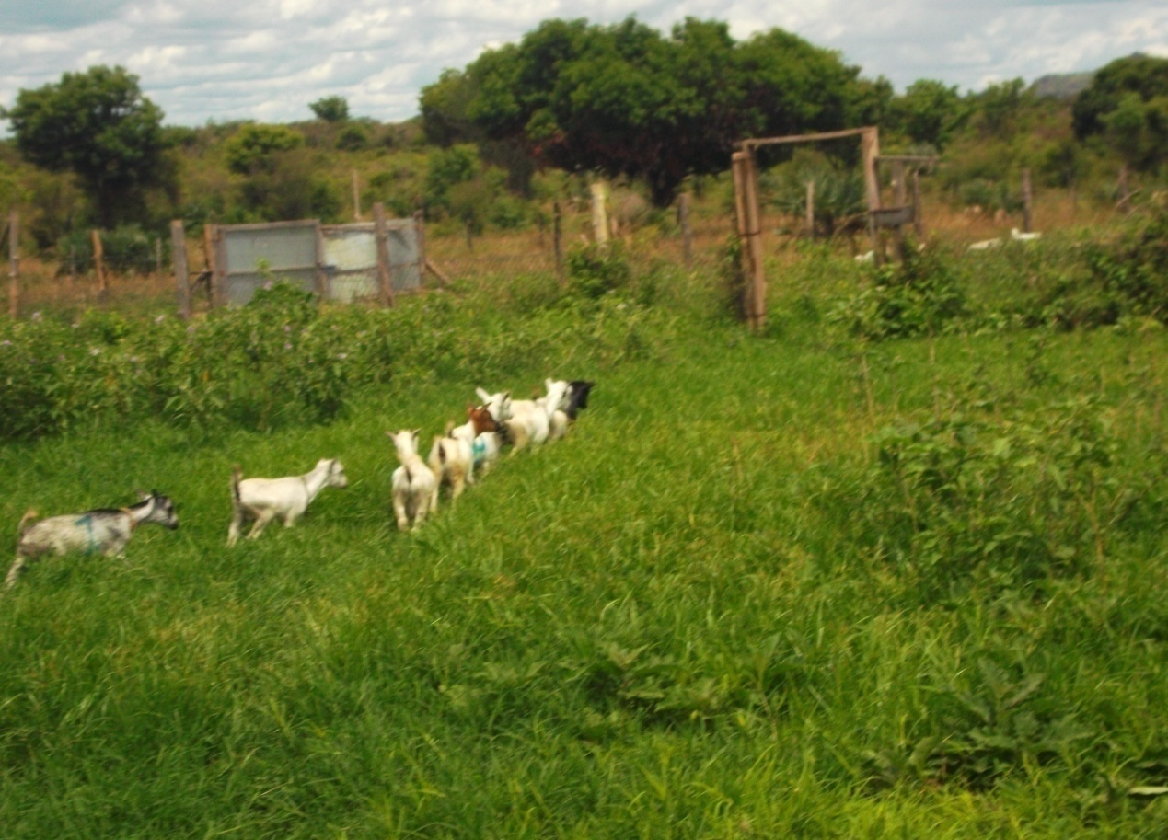
Plate ( 1) Range land in Mafao Farm, (Central Equatorial State 2016). Juba

- MATERIALS AND METHODS

2.1 Study Area
The study was conducted in Juba Area Juba County Central Equatorial State. Juba is the capital city of the Republic of South Sudan. Juba has a tropical wet and dry climate and as it lies near the equator, temperatures are hot year-round.

2.2 Determination of Dry Matter (DM)

Botanical composition was identified in where samples were subjected to identification of different species. Dry matter was obtained for the samples in the beginning, mid and the end of season. According to (AOCA, 1990), then weighted after that the DM was estimated by the difference of fresh weight and that of dried weight. Mean was calculated for each stage of the season.

2.3 Feed Estimation

The quantity of feed was estimated from the natural pasture using quadrate thrown in different direction, started from week zero till the end of the experimental period of six months (May-October) and average quantity was determined.

  - Data Collection and Analysis

Secondary data were collected from reviewed journals, records, websites and books Data were managed and analysed using Statistical Package for Social Sciences (SPSS) software was used for data analysis. Data gathered in the field and the results of chemical composition of the pasture were entered into the software in a coded format and stored. The program was subsequently used to generate descriptive statistics of the variables presented. Also, a one-way ANOVA

- RESULT AND DISCUSSION

Table 1. Chemical Composition of Pasture
Time | Chemical composition
Time | DM% | CP% | CF% | ASH% | EE% | NFE%
Beginning of season | 45.0 | 14.35 | 29.5 | 8.75 | 1.10 | 46.30
Mid of season | 60.5 | 12.50 | 31.5 | 8.90 | 1.10 | 46.00
End of season | 75.5 | 12.22 | 32.5 | 9.00 | 0.65 | 45.63
General mean | 60.30 | 13.02 | 31.17 | 8.88 | 0.95 | 45.97

The CP content was higher in the beginning of rainy season (May and June) compared to the end of rainy season (September and October). The same trend of variation was observed for dry matter and CP content which, decreased as grazing season advanced. This is in line with results of (Carcia et al., 1995), noted that DM intake and digestible dry matter increased with CP content of the herbage. Avondo and Bordonaro (2002) suggested that a pasture constrains potential ingestion when the CP content is below 16% of DM.
The major constraints that affecting the Performances of sheep and goats are diseases, inadequate feeding during dry season, management, political instability represent in civil conflict lack of record keeping

- RECOMMENDATIONS

- Traditional management under Natural grazing animals should be supplemented with some feed with highly nutritive value

- There is a need of adequate planning and pasture management during periods of dry season.

- More researches needed on native pasture from the quality point view in area study

- Further investigation on evaluating other parts of pasture species and animal
Feeding and their management
- There is a high need for veterinary services by government, NGOs and the private sector

REF.

-AOAC. (1990). Official methods of analysis of Association of Official Analytical Chemists (16th edition), Washington, DC

-Avondo, B. and Marletta. (2002). A simple model to predict the herbage intake of grazing dairy ewes in semi-extensive Mediterranean systems. Livestock Production Science. 73. 275-283.

-Baigo, A.F. 2013: p. 20. Healthy animals for healthy people

-Carcia, P., Alba, L., Alvarez, C., Rochha, R.R. and Blas, J.C. (1995). Predication of the nutrition value of Lucerne hay in diets for growing rabbits. Animal Feed Science Technology 54:33-44.

-Catley, A., et al., Participatory diagnosis of a chronic wasting disease in cattle in southern Sudan. Preventive Veterinary Medicine, 2001. 51(3-4): p. 161-181.

-Chenyambuga and Lekule, F.P. (2014). Breeding preferences and breeding practices for goats in agro-pastoral communities of semi-arid and sub-humid areas in Tanzania. Livestock Research for Rural Development 26(6): 117.

-Deb Hovell, F.V., Torres-Acosta, J.F.J., Ayala-Burgos, A., Eds.; Nottingham University Press: Nottingham, UK, 2006; pp. 291–299.

-F. Accatino, R Sabatier, C De Michele, D Ward… - Animal, 2014 - cambridge.org
-FAO, 2011 Land Cover Atlas of South Sudan
-Haelein. (2004). Goat milk in human nutrition small ruminant. Res.15:155-163.

-Idiong and Orok, E.J. (2008). Acceptability of some fodder plants by West African
Dwarf goats. Journal of Agriculture, Technology, Business and Applied
Sciences, 1 (1): 33 – 37.

-lores, J.; Vermont, R.; Kantún, J. 2006 Leguminosae diversity in the Yucatán peninsula and its importance for sheep and goat production.

-Odeyinka. (2000). Feeding behaviour and diet selection by West African Dwarf
goats. Arch. Tierz., Dummerstorf 43 (1): 57 – 61.

