Community Perceptions and Traditional Knowledge of Bidens pilosa in Malawi: Nutritional, Medicinal, and Economic Dimensions

Abstract
Bidens pilosa L. (Blackjack) is an indigenous plant widely distributed across Sub-Saharan Africa, traditionally valued for its nutritional and medicinal properties yet often dismissed as a weed (FAO, 2012; Pillai et al., 2020). Despite growing scientific evidence of its pharmacological potential (Pillai et al., 2020; Zhang et al., 2019), little is known about how local communities perceive and utilize this plant within their traditional knowledge systems. This study investigated household perceptions and traditional knowledge of Bidens pilosa in rural and peri-urban Malawi, employing a mixed-methods design that combined household surveys, in-depth interviews, and focus group discussions. Quantitative data were analyzed using descriptive statistics, chi-square tests, and Principal Component Analysis (PCA), while qualitative data underwent thematic analysis. Findings revealed high awareness and consistently positive perceptions of Bidens pilosa, particularly regarding its medicinal and nutritional relevance. PCA identified two dominant components—medicinal–health and economic–nutraceutical—explaining 72.2% of the variance. Perceptions varied significantly across gender, education, occupation, and cooperative membership, with women and cooperative members expressing stronger positive views. Qualitative narratives underscored the plant’s cultural integration in food preparation, traditional healing, and income generation. The study concludes that Bidens pilosa is deeply embedded in community knowledge and valued for its multifunctional benefits. These insights highlight its potential role in nutrition programs, primary healthcare, conservation initiatives, and smallholder commercialization strategies across Sub-Saharan Africa.

Keywords: Perception, Knowledge, Nutrition, Medicine, Economic value

Introduction
Indigenous plants play a critical role in sustaining food security, healthcare, and rural livelihoods across Sub-Saharan Africa (FAO, 2012). Among these, Bidens pilosa L.—commonly known as Blackjack—remains paradoxically underutilized despite its resilience, nutritional value, and long-standing medicinal applications (Pillai et al., 2020; Zhang et al., 2019). Belonging to the Asteraceae family, Bidens pilosa thrives in diverse climatic conditions and has been recognized by the Food and Agriculture Organisation of the United Nations as both edible and medicinal (FAO, 2012). Across Africa, Asia, and South America, the plant has historically been employed to treat ailments ranging from malaria and respiratory infections to skin conditions, owing to its rich composition of flavonoids, phenolics, alkaloids, and terpenoids with antioxidant, antimicrobial, and anti-inflammatory properties (Chen et al., 2018; Silva et al., 2014).

Although laboratory research has demonstrated its pharmacological potential (Chen et al., 2018; Silva et al., 2014), the socio-cultural aspects of Bidens pilosa have been largely neglected in studies conducted in Sub-Saharan Africa. In particular, there is a lack of understanding regarding how rural and peri-urban households understand and perceive its nutritional, medicinal, and economic significance, as well as how traditional knowledge shapes its cultivation, consumption, and commercialization (Pillai et al., 2020). This deficiency hinders the incorporation of Bidens pilosa into national initiatives aimed at enhancing food and nutrition security, primary healthcare, and rural enterprise development. In Malawi, where indigenous vegetables play a crucial role in household diets and livelihoods, there is a notable scarcity of systematic evidence concerning community perceptions of Bidens pilosa.

This study addresses this gap by examining traditional knowledge and perceptions of Bidens pilosa among farming households in Lilongwe District, Malawi. Guided by a conceptual framework linking knowledge systems, perceptions, and socio-demographic characteristics, the research explores how communities value the plant across nutritional, medicinal, and economic dimensions. By combining quantitative and qualitative approaches, the study provides a nuanced understanding of how perceptions shape utilization and highlights pathways for integrating Bidens pilosa into sustainable development initiatives.

Literature Review

Nutritional and Medicinal Value of Bidens pilosa
Bidens pilosa L. has long been recognized as a multipurpose indigenous plant with both nutritional and medicinal applications. Phytochemical analyses reveal that the plant contains flavonoids, phenolics, alkaloids, and terpenoids, compounds associated with antioxidant, antimicrobial, anti-inflammatory, and anticancer properties (Chen et al., 2018; Silva et al., 2014). Laboratory studies demonstrate its efficacy against bacterial and fungal infections, as well as its potential to enhance immune function and promote digestive health (Zhang et al., 2019). In traditional medicine, Bidens pilosa has been widely used to treat malaria, respiratory ailments, wounds, and skin conditions across Africa, Asia, and South America (Pillai et al., 2020).

Socio-Cultural Dimensions of Indigenous Plant Use
Despite its pharmacological promise, Bidens pilosa is often dismissed as a weed in Sub-Saharan Africa (FAO, 2012). This reflects a broader trend where indigenous vegetables are undervalued compared to exotic crops, despite their cultural integration into diets and healthcare practices (Maseko et al., 2017). Traditional knowledge systems, transmitted intergenerational, play a crucial role in shaping perceptions of indigenous plants. Communities often associate Bidens pilosa with child nutrition, household food preparation, and primary healthcare, underscoring its embeddedness in local cultural practices (Mwangi & Kimathi, 2018).

Economic and Commercial Potential
Beyond its nutritional and medicinal roles, Bidens pilosa holds economic potential. Pillai et al. (2020) argue that its cultivation could support nutraceutical industries and herbal tea production, creating opportunities for smallholder farmers. Countries such as Nigeria, Benin, and Zimbabwe have already initiated small-scale cultivation for medicinal purposes (FAO, 2012). Integrating Bidens pilosa into commercialization strategies could contribute to rural income generation, job creation, and food security (Zhang et al., 2019).

Research Gaps
Although pharmacological research is well established, studies focusing on socio-cultural aspects and perceptions are still limited. The majority of current research emphasizes laboratory examinations of phytochemical composition and antimicrobial properties (Chen et al., 2018; Silva et al., 2014). There are few comprehensive studies of community-level knowledge, perceptions, economic significance, or cultural appreciation of Bidens pilosa in Sub-Saharan Africa. This deficiency hinders its incorporation into national nutrition and healthcare strategies. In Malawi, where indigenous vegetables play a crucial role in household diets, there is a notable lack of empirical data regarding perceptions of Bidens pilosa, thereby underscoring the necessity for the current study.

Methodology
Study Area
The research was conducted in Lilongwe District, Malawi, across four Extension Planning Areas (EPAs): Chitsime, Mkwinda, Ngwangwa, and Ukwe. These sites were purposively selected to capture both rural and peri-urban contexts, enabling comparative analysis of community perceptions. Lilongwe, as the capital city, presents significant potential for commercialization of indigenous plants such as Bidens pilosa (Agricultural Extension Development Office, 2024).

Study Design
A cross-sectional mixed-methods design was employed to integrate quantitative and qualitative approaches. This design allowed for simultaneous collection of survey data and qualitative narratives, enhancing validity through triangulation (Creswell & Plano Clark, 2018). Quantitative data provided measurable patterns of knowledge and perception, while qualitative interviews and focus group discussions (FGDs) contextualized these findings within traditional knowledge systems.

Sampling Techniques
The sample size was determined using Yamane’s (1967) formula, based on a known farming household population of 126,473, with a 5% margin of error. A total of 400 households were randomly selected proportionally across the four EPAs: Chitsime (21.6%), Mkwinda (21.8%), Ngwangwa (32%), and Ukwe (24.6%). Randomization was achieved using Microsoft Excel’s random function, ensuring representativeness and minimizing bias. For qualitative data, six key informants were purposively selected until saturation was reached. Additionally, eight FGDs were conducted (two per EPA), each comprising 8–10 participants, with attention to gender balance to capture diverse perspectives (Guest, Bunce, & Johnson, 2006).

Data Collection
Quantitative data were collected using a semi-structured questionnaire programmed in Kobo Toolbox and administered via tablets and smartphones. Perceptions were measured on a five-point Likert scale ranging from strongly disagree (1) to strongly agree (5), developed from preliminary field discussions and ethnobotanical literature (Bernard, 2017). Socio-demographic data were also captured.

Qualitative data were gathered through semi-structured interviews and FGDs guided by checklists. These explored traditional knowledge transmission, cultural valuation, and household utilization of Bidens pilosa.

Data Management and Analysis
Quantitative data were cleaned, coded, and analyzed using SPSS version 27 and Microsoft Excel. Descriptive statistics summarized socio-demographic characteristics and knowledge levels. ANOVA tests assessed differences in perceptions across demographic groups. Principal Component Analysis (PCA) with varimax rotation was conducted in JMP 18.1 to identify latent components of perception, following suitability checks with the Kaiser–Meyer–Olkin (KMO) measure and Bartlett’s Test of Sphericity (Tabachnick & Fidell, 2019). Reliability was confirmed with Cronbach’s alpha (α = 0.945), indicating excellent internal consistency (Nunnally & Bernstein, 1994).

Qualitative data were transcribed verbatim and analyzed thematically using NVivo 14. Coding was iterative, with sub-themes synthesized into overarching themes (Braun & Clarke, 2006). Triangulation of quantitative and qualitative findings enhanced validity and provided a comprehensive understanding of community perceptions.

Results
Socio-Demographic Characteristics
The survey covered 400 households, with 72% female and 28% male respondents. Most households were led by males (73.5%), and the majority of participants had completed primary education (87%). Agriculture was the main livelihood activity (86.3%), followed by casual labor (7.2%) and business (6.5%). Over half of the respondents (54.3%) were members of agricultural cooperatives. The average age was 40 years, and nearly all respondents identified as Chewa (99%). These characteristics mirror the socio-economic profile of smallholder households in Malawi (Agricultural Extension Development Office, 2024).

Figure 1: Demographic Data
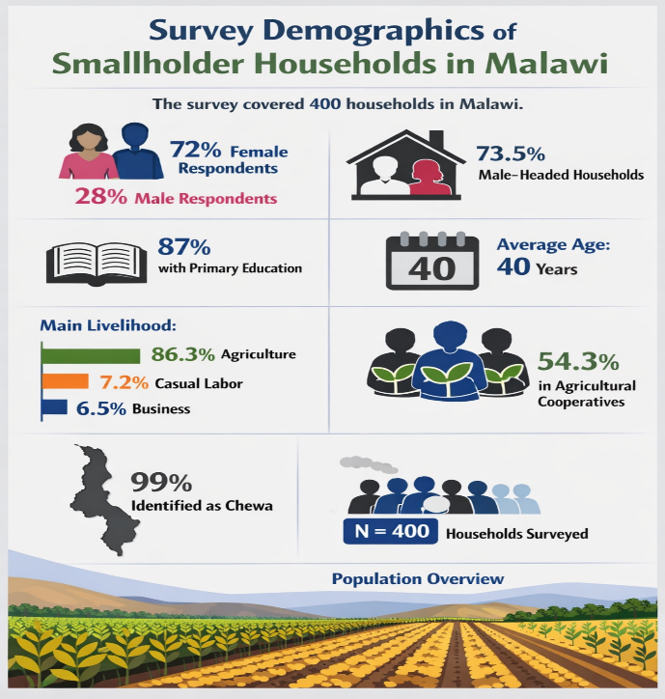

Traditional Knowledge of Bidens pilosa
Awareness of Bidens pilosa was nearly universal (96%), with 75% recognizing its nutritional value and 66.3% acknowledging its medicinal role in combating infections. Focus group discussions revealed that communities view the plant both as a vegetable (“relish”) and as medicine. Respondents emphasized its role in addressing malnutrition, particularly among children, and its use in treating ailments such as malaria, wounds, ulcers, and reproductive health issues. Knowledge transmission was largely intergenerational, underscoring the cultural embeddedness of Bidens pilosa (Mwangi & Kimathi, 2018).

Figure 2: Community Knowledge and Perceptions of Bidens Pilosa

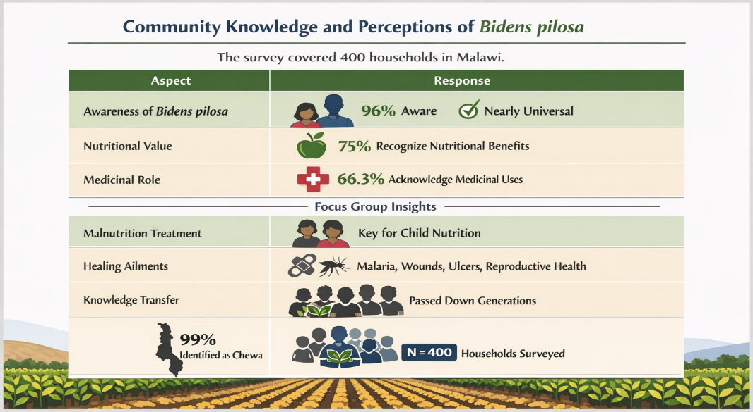

Perceptions of Nutritional, Medicinal, and Economic Potential
Perceptions were overwhelmingly positive across all dimensions. Respondents strongly agreed that Bidens pilosa supports immune function (mean = 4.11), combats infections (mean = 4.11), improves skin health (mean = 4.10), and promotes digestive health (mean = 4.04). Economic perceptions were also favorable, with high agreement on its potential for local drug development (mean = 4.10), income generation (mean = 4.14), and contribution to food security (mean = 4.08). Overall, 71.5% of respondents expressed positive perceptions, confirming the plant’s multifunctional value.

Figure 3: Perceptions of Nutritional, Medicinal, and Economic Potential of Bidens pilosa
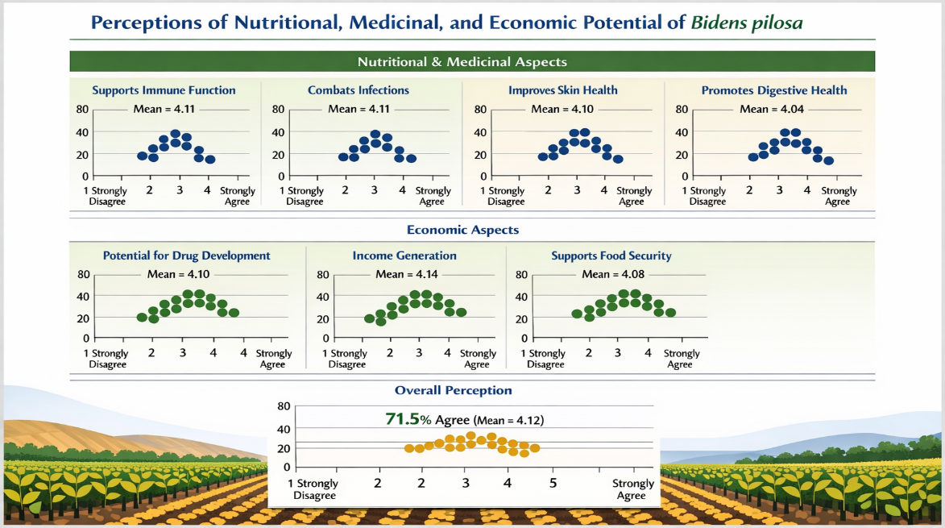

Socio-Demographic Differences in Perceptions
Significant differences emerged across gender, education, occupation, and cooperative membership. Women expressed stronger positive perceptions than men, reflecting their central role in food preparation and child nutrition. Respondents with primary education held more favorable views than those with secondary education, suggesting that traditional knowledge may be more deeply retained among less formally educated groups. Cooperative members demonstrated significantly higher positive perceptions, likely due to peer learning and exposure to agricultural training (Guest et al., 2006).

Principal Component Analysis (PCA)
PCA revealed a two-component structure explaining 72.2% of the variance. The first component (medicinal–health) captured perceptions related to immune support, infection management, and skin healing. The second component (economic–nutraceutical) encompassed perceptions of commercialization, income generation, and nutraceutical potential. This dimensionality highlights the dual role of Bidens pilosa as both a health resource and an economic opportunity.

Discussion
Integration of Traditional Knowledge and Modern Evidence
The findings confirm that Bidens pilosa is deeply integrated into community knowledge systems in Malawi. Traditional uses for nutrition and medicine align with laboratory evidence of its phytochemical properties (Chen et al., 2018; Silva et al., 2014). This convergence underscores the importance of bridging indigenous knowledge with scientific validation to strengthen its role in healthcare and nutrition programs.

Gendered Dimensions of Perception
Women’s stronger positive perceptions reflect their responsibility for household food preparation and child health. This finding resonates with broader literature on gendered roles in indigenous plant utilization (Maseko et al., 2017). Policy interventions should therefore prioritize women’s involvement in awareness campaigns, cultivation initiatives, and commercialization strategies.

Education and Cooperative Membership
The inverse relationship between formal education and positive perceptions suggests that traditional knowledge may be undervalued in more formalized contexts. Cooperative membership, however, enhances perceptions by facilitating peer learning and market exposure. Strengthening cooperative structures could therefore be a key pathway for scaling Bidens pilosa commercialization and integrating it into rural enterprise development (Pillai et al., 2020).

Economic and Policy Implications
The economic potential of Bidens pilosa—including nutraceutical production, herbal teas, and drug development—offers opportunities for smallholder farmers and rural enterprises. Countries such as Nigeria and Zimbabwe have already initiated small-scale cultivation for medicinal purposes (FAO, 2012). Malawi could leverage similar strategies to integrate Bidens pilosa into national food security and healthcare policies, contributing to Sustainable Development Goals (SDGs) on health, nutrition, and livelihoods.

Novelty of Findings
Unlike previous studies that focused primarily on pharmacological properties (Zhang et al., 2019), this research provides systematic evidence of community perceptions and traditional knowledge. By combining quantitative and qualitative approaches, the study highlights how socio-demographic factors shape the valuation of Bidens pilosa. This perception-based evidence is novel and critical for designing culturally sensitive interventions that promote indigenous plants in sustainable development.

Conclusion
This study shows that Bidens pilosa is much more than a neglected weed; it is a valued, culturally significant, multifunctional plant used by rural and peri-urban households in Malawi for its nutritional, medicinal, and economic benefits. Community perceptions were highly positive, with women and cooperative members showing especially strong support, reflecting their key roles in food preparation, child nutrition, and agricultural innovation. Principal Component Analysis identified two main dimensions—medicinal–health and economic–nutraceutical—highlighting the plant's importance as both a health resource and a livelihood tool.

The novelty of this research lies in its systematic documentation of community perceptions and traditional knowledge, complementing existing laboratory-based evidence of Bidens pilosa’s phytochemical and pharmacological properties (Chen et al., 2018; Silva et al., 2014). By bridging indigenous knowledge with empirical analysis, the study provides critical insights for integrating Bidens pilosa into national strategies for food security, primary healthcare, and rural enterprise development.

Policy implications are clear: nutrition programs should incorporate Bidens pilosa to combat malnutrition, particularly among children; healthcare initiatives should recognize its role in traditional healing practices; and commercialization strategies should leverage its potential for nutraceuticals and herbal products to generate rural income. Cooperative structures offer a promising pathway for scaling awareness, cultivation, and market access.

Future research should focus on three areas: (1) clinical validation of community-reported medicinal uses to strengthen integration into healthcare systems; (2) economic feasibility studies on commercialization pathways, including value chain development; and (3) conservation strategies to ensure sustainable management of Bidens pilosa as demand increases.

Ultimately, this study positions Bidens pilosa as a sustainable tool for advancing food security, health, and livelihoods in Malawi and across Sub-Saharan Africa, contributing directly to the achievement of Sustainable Development Goals on nutrition, health, and poverty reduction.

References
- Agricultural Extension Development Office. (2024). Household population statistics for Lilongwe District. Lilongwe: Ministry of Agriculture.
- Braun, V., & Clarke, V. (2006). Using thematic analysis in psychology. Qualitative Research in Psychology, 3(2), 77–101.
- Chen, Y., Zhang, W., & Li, X. (2018). Phytochemical and pharmacological properties of Bidens pilosa: A review. Journal of Ethnopharmacology, 219, 45–58.
- Creswell, J. W., & Plano Clark, V. L. (2018). Designing and conducting mixed methods research (3rd ed.). Thousand Oaks, CA: Sage.
- FAO. (2012). Edible indigenous plants and their role in food security. Rome: Food and Agriculture Organization of the United Nations.
- Food and Agriculture Organization of the United Nations (FAO). (2012). Edible indigenous plants and their role in food security. Rome: FAO.
- Guest, G., Bunce, A., & Johnson, L. (2006). How many interviews are enough? An experiment with data saturation and variability. Field Methods, 18(1), 59–82.
- Maseko, T., Ncube, B., & Moyo, M. (2017). Indigenous vegetables and food security in Sub-Saharan Africa: A review. African Journal of Agricultural Research, 12(4), 271–280.
- Mwangi, S., & Kimathi, M. (2018). Traditional knowledge and utilization of indigenous vegetables in Kenya. International Journal of Food Science and Nutrition, 3(2), 89–97.
- Nunnally, J. C., & Bernstein, I. H. (1994). Psychometric theory (3rd ed.). New York: McGraw-Hill.
- Pillai, P., Nair, R., & Joseph, J. (2020). Economic and medicinal potential of Bidens pilosa: Prospects for nutraceutical development. African Journal of Plant Science, 14(3), 56–67.
- Silva, R., Santos, F., & Almeida, M. (2014). Antimicrobial and anti-inflammatory activities of Bidens pilosa extracts. Phytomedicine, 21(2), 123–130.
- Tabachnick, B. G., & Fidell, L. S. (2019). Using multivariate statistics (7th ed.). Boston: Pearson.
- Yamane, T. (1967). Statistics: An introductory analysis (2nd ed.). New York: Harper & Row.
- Zhang, L., Wang, H., & Zhou, Y. (2019). Traditional uses and modern pharmacological insights on Bidens pilosa. Frontiers in Pharmacology, 10, 1234.

