Patient–Provider Communication Quality and Provider Loyalty Intentions in an Urban Nigerian Sample: Findings From an Exploratory Cross-Sectional Study
Abstract
This is a cross-sectional study on patients/provider seeking behaviours across various communities in Nigeria. Ironically, Africa's diverse healthcare landscape entertains some kind of dynamism that is causing more harm to patience. The poor healthcare in African and the prevalence of unethical practices has become an issue to researchers are struggling to tackled. The death toll in recent time resulting from poor communication channels in most hospitals in Nigeria is mid-blowing and ridiculous. The quality of these interactions often determines the success of public health interventions. It is therefore implied that without concise, clear communication between patients and medical practitioners, there will be poor or mediocre delivery of health services, thereby reducing the overall vitality of the patient. This study seeks to evaluate the patients’ own perception of the patient-doctor communication experience within selected hospitals across four key regions in the Federal Republic of Nigeria: Jos, Abuja, Nasarawa, and Niger. A combination of qualitative and quantitative research methods is carried out on the sample size across the public and private healthcare facilities in the selected states. Communication protocols that are key in the study include active listening, empathy, clarity of instructions, and involvement in shared decision-making. Addressing these gaps is essential for improving health literacy and patient trust in the Nigerian healthcare settings.

Background: Patient–provider communication is a key determinant of healthcare experience and has been linked to trust, adherence, and continuity of care. Quantitative evidence connecting communication quality to behavioral loyalty outcomes in pluralistic African health systems remains limited.
Keywords: patients-provider, communication, healthcare, urban and pathways.
Objective: To examine the association between perceived communication quality and provider loyalty intentions—trust, willingness to return, and willingness to recommend—in an urban Nigerian sample.
Methods: This exploratory secondary analysis used cross-sectional survey data from 102 respondents reporting a recent illness episode. Complete-case multivariable analyses included 110 observations for trust and loyalty outcomes where communication, provider type, and outcome data were non-missing; sample size varied slightly by outcome. Communication quality was measured with a five-item composite score covering listening, respect, explanation clarity, opportunity for questions, and language concordance. Logistic regression models estimated odds ratios (ORs) and 95% confidence intervals (CIs) for each outcome, adjusted for first-contact provider group.
Results: The communication scale showed excellent internal consistency (Cronbach’s α=0.92). Higher communication quality was associated with greater odds of trust (aOR 5.64, 95% CI 2.83–11.25), willingness to return (aOR 3.94, 95% CI 2.19–7.10), willingness to recommend (aOR 2.96, 95% CI 1.78–4.93), and endorsement of all three outcomes (aOR 3.42, 95% CI 1.95–6.00).
Conclusion: In this small, predominantly young, tertiary-educated, student-heavy urban sample, perceived communication quality was associated with provider loyalty intentions. These findings are exploratory and hypothesis-generating. Larger, more representative studies are needed to confirm the relationship and assess whether communication-focused interventions can improve continuity of care in pluralistic systems.
Introduction
Patient–provider communication is a core component of patient-centered care and a major determinant of how people experience healthcare encounters. Prior work has shown that clinician communication can shape trust, understanding, adherence, decision quality, and ongoing engagement with care [1,2]. In health systems where people can seek care from multiple provider types, communication may also affect whether patients remain with a provider, return for follow-up, or recommend that provider to others.
These questions are particularly relevant in low- and middle-income countries with pluralistic health systems. In Nigeria, patients frequently navigate public facilities, private clinics, pharmacies, patent and proprietary medicine vendors (PPMVs), and home-based self-treatment. Pharmacies and PPMVs are especially important as first-contact providers because they are convenient, visible, and often less procedurally burdensome than formal facilities [4]. In such settings, loyalty is not merely an attitudinal construct: it can function as a proxy for patient retention and continuity in a fragmented provider market.
Although communication has been widely studied globally, much African work has focused on satisfaction, service responsiveness, or broader patient-centered care rather than explicitly linking communication quality to loyalty-type behaviors such as trust, return intentions, and recommendation [3,5,6]. This distinction matters because loyalty outcomes capture whether communication may influence real-world care navigation beyond immediate encounter satisfaction.
The present study addresses that gap using survey data from an urban Nigerian sample. The analysis asks whether perceived patient–provider communication quality is associated with three loyalty intentions—trust, willingness to return, and willingness to recommend—and whether these associations persist after adjustment for first-contact provider type. Given the sample design and size, the study is framed explicitly as exploratory and hypothesis-generating.
Methods
Design and parent survey: This study is a secondary analysis of a cross-sectional survey originally developed to characterize recent illness experiences, care-seeking pathways, and perceptions of providers in Nigeria. The parent dataset was not designed specifically as a communication study, which is important when interpreting residual confounding and construct coverage.
Sampling and setting: Respondents were recruited through urban convenience channels, including student-linked and community distribution pathways. The resulting sample is heavily weighted toward young, tertiary-educated, student-affiliated respondents living in urban settings. Because the survey was not designed as a population-representative household sample, the present analysis should be read as reflecting a literate urban subgroup rather than the broader Nigerian population.
Eligibility and analytic sample: The descriptive dataset included 102 respondents who reported a recent illness episode within the prior six months. Communication analyses used all available complete cases for each outcome. The largest complete-case analytic set comprised 110 respondents with non-missing communication, provider-group, and outcome data. The number of observations varied slightly across trust, return, and recommend models because of item-specific missingness.
Measures: Communication quality was assessed using five 1-to-5 items asking whether the provider listened carefully, treated the respondent with respect, explained the illness and treatment clearly, allowed questions, and used a language the respondent understood. The composite communication score was calculated as the respondent-level mean of the five items, so the regression coefficient represents the odds ratio associated with a one-point increase in average communication quality on the original five-point scale.
Outcome variables: Three primary binary outcomes were defined from provider-loyalty items: trust in the provider, willingness to return to the same provider, and willingness to recommend the provider to others. Each was dichotomized as positive for ratings of 4 or 5 and negative otherwise. A fourth exploratory composite outcome was defined as endorsing all three loyalty outcomes simultaneously.
Covariates: The main covariate was first-contact provider group, categorized as formal facility, pharmacy/PPMV, or self-treatment. Because the sample size was modest relative to the number of potential confounders, models were intentionally parsimonious. This decision reduces overfitting risk but leaves residual confounding by demographic and illness-severity factors possible.
Statistical analysis: Internal consistency of the communication scale was assessed using Cronbach’s alpha. Logistic regression estimated adjusted odds ratios (aORs), 95% confidence intervals, and p values for each outcome with communication score entered as a continuous predictor and provider group included as an adjustment variable. As a simple robustness check, models additionally adjusted for sex and age group yielded similar communication coefficients. No formal sample-size calculation was performed because this was a secondary exploratory analysis.
Results
The communication-analysis sample was strongly skewed toward females (73/110, 66.4%), respondents aged 18–24 years (76/110, 69.1%), tertiary education (89/110, 80.9%), student status (73/110, 66.4%), and urban residence (88/110, 80.0%). First-contact care most commonly occurred at a formal facility (71/110, 64.5%), followed by pharmacy/PPMV (31/110, 28.2%) and self-treatment (8/110, 7.3%) (Table 1).
The communication-quality composite performed well psychometrically in this sample (Cronbach’s α=0.92). Mean scores for the individual items ranged from 3.61 to 4.06, with the highest mean observed for understandable language and the lowest for clear explanation (Table 2).
Loyalty intentions were common but not universal. Trust in provider was endorsed by 67/110 respondents (60.9%), willingness to return by 72/110 (65.5%), willingness to recommend by 59/110 (53.6%), and the composite all-three-positive outcome by 53/110 (48.2%) (Table 3).
In provider-adjusted logistic regression, communication quality was associated with higher odds of all four loyalty outcomes (Table 4). Per one-point increase in communication score, the adjusted odds ratio was 5.64 (95% CI 2.83–11.25) for trust, 3.94 (95% CI 2.19–7.10) for willingness to return, 2.96 (95% CI 1.78–4.93) for willingness to recommend, and 3.42 (95% CI 1.95–6.00) for endorsing all three outcomes.
The direction and magnitude of the communication coefficients remained similar in simple sensitivity checks adding sex and age-group indicators, suggesting that the observed association is not solely an artifact of provider-type adjustment. Nonetheless, all estimates should still be interpreted as exploratory because the sample remains small and highly selected.
Table 1. Analytic sample characteristics (communication analysis sample, n=110)
Characteristic | n (%)
Female | 73 (66.4)
Male | 35 (31.8)
Age 18–24 years | 76 (69.1)
Age 25–34 years | 15 (13.6)
Age ≥35 years | 15 (13.6)
Tertiary education | 89 (80.9)
Student | 73 (66.4)
Urban residence | 88 (80.0)
Formal facility first contact | 71 (64.5)
Pharmacy/PPMV first contact | 31 (28.2)
Self-treatment first contact | 8 (7.3)
Percentages are based on the complete-case communication analysis sample. Small amounts of item-specific missingness explain why the analytic n varies slightly across some outcome models.
Table 2. Communication quality scale performance and item summary
Item | Mean | SD
Provider listened carefully | 3.77 | 1.22
Provider treated me with respect | 3.90 | 1.19
Provider explained illness/treatment clearly | 3.61 | 1.28
Provider allowed me to ask questions | 3.78 | 1.29
Provider used a language I understood | 4.06 | 1.19
Composite communication score | 3.83 | 1.06
Internal consistency of the five-item communication scale was excellent (Cronbach’s α=0.92). The composite score was entered as a continuous predictor in regression models.
Table 3. Provider loyalty outcomes in the analytic sample
Outcome | Positive n (%)
Trust in provider (rating 4–5) | 67 (60.9)
Would return to same provider (rating 4–5) | 72 (65.5)
Would recommend provider to others (rating 4–5) | 59 (53.6)
All three outcomes positive | 53 (48.2)
The composite loyalty outcome required a positive response on trust, return, and recommend items simultaneously.
Table 4. Adjusted associations between communication quality and loyalty outcomes
Outcome | n | Events | Adjusted OR* | 95% CI | p value
Trust | 110 | 67 | 5.64 | 2.83–11.25 | <0.001
Return | 111 | 73 | 3.94 | 2.19–7.10 | <0.001
Recommend | 111 | 60 | 2.96 | 1.78–4.93 | <0.001
All three positive | 110 | 53 | 3.42 | 1.95–6.00 | <0.001
*Adjusted for first-contact provider group. Odds ratios represent the association with a one-point increase in the mean communication-quality score.
Figure 1. Predicted probability of loyalty outcomes across the communication-quality scale
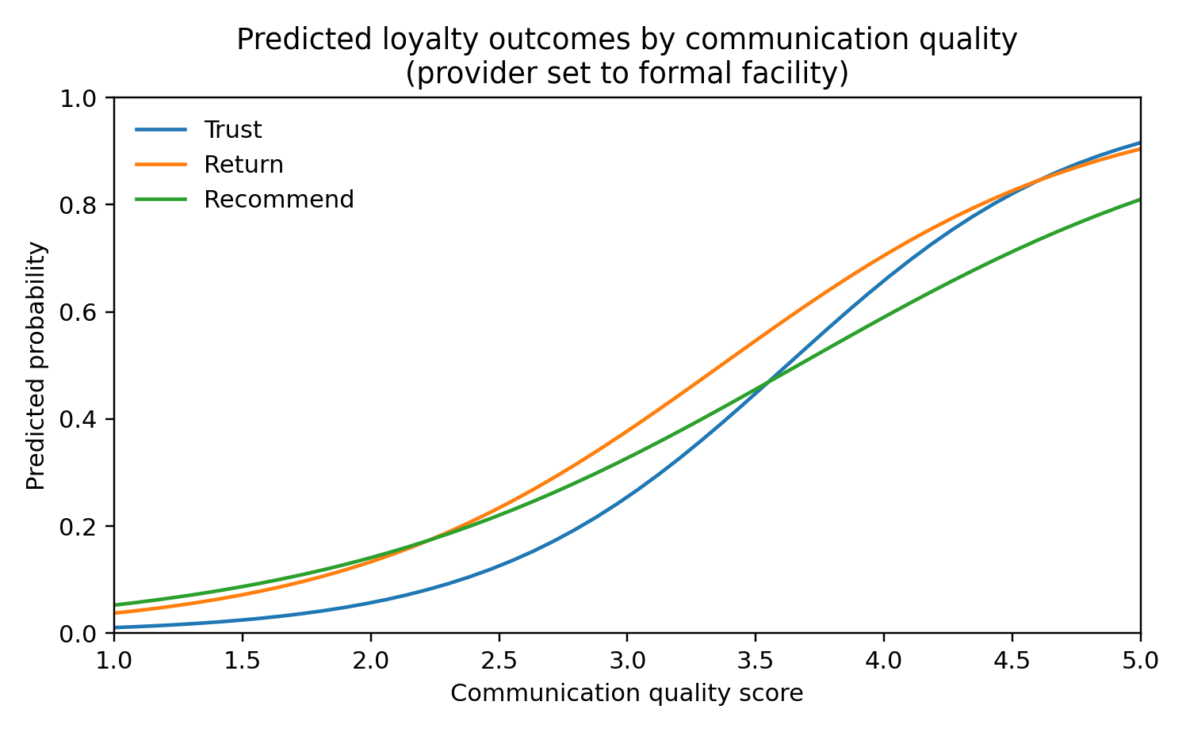
Predicted probabilities are shown from provider-adjusted logistic models with provider group fixed at formal facility for visualization. The upward trajectories across all three outcomes indicate that higher communication-quality scores were associated with higher predicted probabilities of trust, willingness to return, and willingness to recommend.
Figure 2. Forest plot of adjusted odds ratios for the communication-quality score
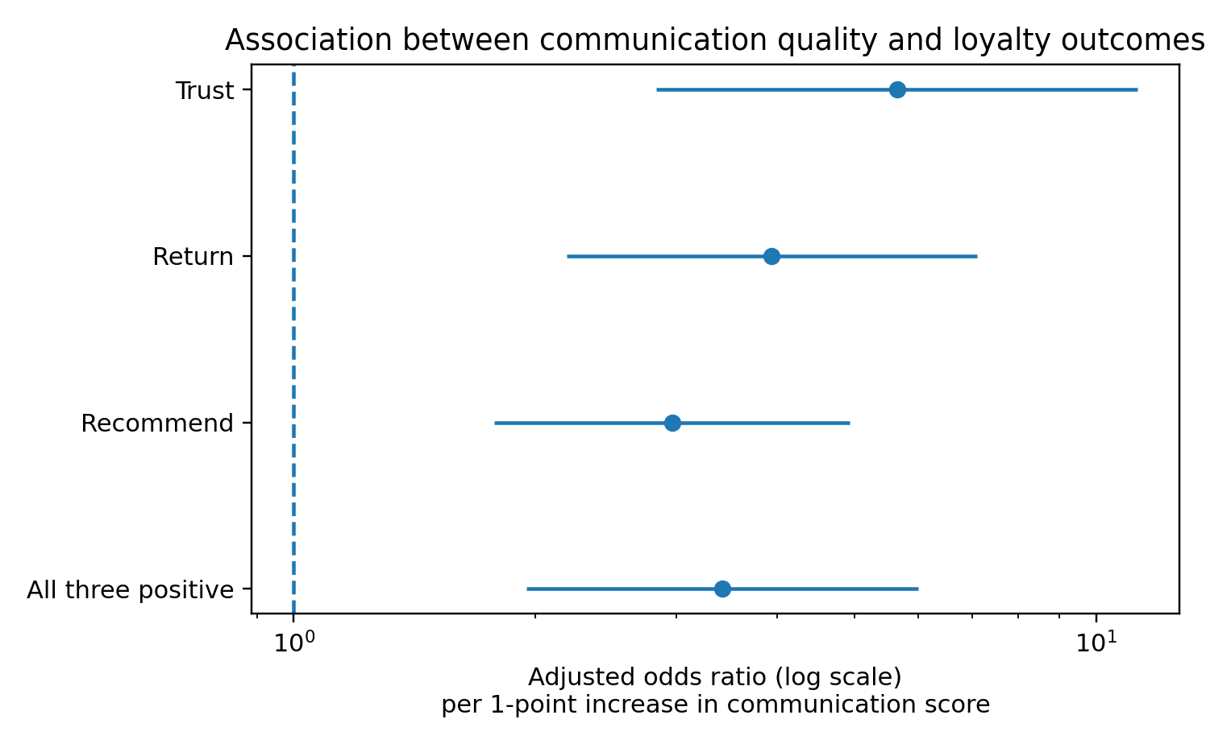
The forest plot summarizes the adjusted association between a one-point increase in communication score and each loyalty outcome. The x-axis uses a log scale. All point estimates exceed 1.0, indicating a consistent positive association across outcomes.
Discussion
This exploratory analysis suggests a potentially important association between perceived patient–provider communication quality and provider loyalty intentions in this urban Nigerian sample. Across all modeled outcomes, respondents who rated communication more highly were more likely to trust the provider, say they would return, and say they would recommend the provider to others.
The consistency of the association across trust, return, recommend, and the all-three-positive outcome is notable. In pluralistic health systems, loyalty intentions are behaviorally meaningful because patients can often choose among multiple providers for subsequent care. Communication may therefore function not only as a marker of encounter quality but also as a retention signal that shapes future care navigation.
The pattern was strongest for trust and willingness to return, and somewhat smaller for recommendation. One plausible explanation is that trust and return intentions are more directly tied to the interpersonal encounter itself, whereas recommendation may also depend on factors not measured here, including perceived technical quality, cost, convenience, or the respondent’s concern for how others will evaluate the recommendation.
These findings align with established communication theory. Street and colleagues proposed that clinician–patient communication can improve health outcomes through pathways that include trust, shared understanding, decision quality, and therapeutic alliance [1]. The present results are consistent with that model in a pluralistic LMIC care environment, although they do not establish causality. They also fit within patient-centered care frameworks emphasizing respect, explanation, and understanding as core dimensions of healthcare quality [2,5].
The analysis also has contextual relevance. Reviews of patient–provider interactions in sub-Saharan Africa highlight persistent gaps in patient-centeredness and communication quality [3,5]. In Nigeria, where pharmacies and PPMVs are central access points [4], interpersonal communication may plausibly influence whether patients continue with a provider or seek care elsewhere. This manuscript cannot test that longitudinal pathway directly, but it provides a quantitative signal that the communication–loyalty link is worth examining in larger studies.
Alternative explanations remain possible. Patients who already trust providers may rate communication more positively, creating reverse-causation or halo effects. Better clinical outcomes may also color perceptions of communication. In addition, because the parent survey was not designed exclusively for communication research, some relevant confounders—particularly illness severity, technical quality of care, and prior provider familiarity—were not fully measured.
Limitations
The study’s primary limitation is the sample. This was a small, highly selected, convenience-based urban sample dominated by young, tertiary-educated, student-affiliated respondents. It should not be interpreted as representative of the broader Nigerian population or even of all urban Nigerians.
Second, the analysis is cross-sectional and based on self-report, so causality cannot be inferred. Communication may shape loyalty, but loyal patients may also perceive communication more favorably. Recall and social-desirability biases are possible.
Third, although the communication scale had excellent internal consistency in this sample, the study does not establish full psychometric validation beyond internal reliability. The composite should therefore be interpreted as a coherent scale for this dataset rather than as a universally validated instrument.
Fourth, the multivariable models were intentionally parsimonious. While this helped preserve stability in a modest sample, it leaves residual confounding possible because demographic and health-status factors were not included in the primary adjusted models. Sensitivity checks adding sex and age group did not materially change the communication coefficient, but those checks do not eliminate unmeasured confounding.
Finally, because this was a secondary analysis of a broader care-seeking survey, the dataset was not purpose-built to test all communication pathways or loyalty mechanisms. The findings should therefore be interpreted as exploratory and hypothesis-generating rather than confirmatory.
Conclusion
In this small, predominantly young urban Nigerian sample, perceived patient–provider communication quality was associated with provider loyalty intentions, including trust, willingness to return, and willingness to recommend. These exploratory findings support the hypothesis that communication may be an important factor in patient retention and continuity of care within pluralistic systems. Confirmation in larger, more representative, and longitudinal studies is needed.
Declarations
Ethics approval and consent to participate was obtained
Consent for publication: Not applicable.
Funding: No external funding was declared for this manuscript.
Competing interests: The author declares no competing interests.
Author contribution: Chioma Njoku conception, data collection, manuscript drafting and interpreted
Adeline Shuri Clinton, data collection, data analysis, interpretation and manuscript review
Elvis Tamo Achu supervision and manuscript review.
Correspondence: Chioma Njoku
References
1. Street RL Jr, Makoul G, Arora NK, Epstein RM. How does communication heal? Pathways linking clinician-patient communication to health outcomes. Patient Educ Couns. 2009;74(3):295-301. doi:10.1016/j.pec.2008.11.015.
2. Epstein RM, Street RL Jr. The values and value of patient-centered care. Ann Fam Med. 2011;9(2):100-103. doi:10.1370/afm.1239.
3. Camara BS, Belaid L, Manet H, Kolie D, Guillard E, Bigirimana T, Delamou A. What do we know about patient-provider interactions in sub-Saharan Africa? A scoping review. Pan Afr Med J. 2020;37:88. doi:10.11604/pamj.2020.37.88.24009.
4. Beyeler N, Liu J, Sieverding M. A systematic review of the role of proprietary and patent medicine vendors in healthcare provision in Nigeria. PLoS One. 2015;10(1):e0117165. doi:10.1371/journal.pone.0117165.
5. Okeny PK, Pittalis C, Monaghan CF, Brugha R, Gajewski J. Dimensions of patient-centred care from the perspective of patients and healthcare workers in hospital settings in sub-Saharan Africa: a qualitative evidence synthesis. PLoS One. 2024;19(4):e0299627. doi:10.1371/journal.pone.0299627.
6. Kruk ME, Gage AD, Arsenault C, Jordan K, Leslie HH, Roder-DeWan S, et al. High-quality health systems in the Sustainable Development Goals era: time for a revolution. Lancet Glob Health. 2018;6(11):e1196-e1252. doi:10.1016/S2214-109X(18)30386-3.

