Engineering Technology in Renewable Energy: A Comprehensive Review of Solar, Wind, and Hybrid System

Abstract
Nigeria’s electricity sector continues to experience persistent challenges including inadequate supply, fragile grid infrastructure, fuel dependency, and exposure to economic and climatic shocks. At the same time, the country is endowed with vast renewable energy resources and stands at a critical juncture in its energy transition. This paper examines emerging renewable energy technologies and strategic pathways for building resilient power systems in Nigeria. Drawing on synthesized evidence from peer-reviewed literature, international policy reports, and energy transition frameworks, the study explores advances in solar, wind, hybrid systems, digitalisation, energy storage, and hydrogen technologies. It further discusses strategic pathways such as distributed generation, smart grid deployment, institutional reforms, and long-term transition planning. The paper argues that integrating emerging technologies with coherent policy, robust governance, and inclusive planning is essential for developing a resilient renewable-based power system capable of supporting Nigeria’s socio-economic development and climate goals.
Keywords
Emerging technologies, Energy transition, Engineering Technology, Renewable energy, smart grids, Nigeria
1. Introduction
Electricity supply remains one of the most critical constraints to Nigeria’s economic growth and social development. Despite an installed grid capacity of approximately 13GW, effective available generation typically averages below 5GW due to gas supply limitations, aging infrastructure, hydrological variability, and transmission bottlenecks (International Renewable Energy Agency (IRENA, 2023). Consequently, households and industries rely heavily on diesel and petrol generators, resulting in high energy costs, environmental degradation, and reduced economic competitiveness. Globally, energy systems are undergoing rapid transformation driven by declining renewable energy costs, technological innovation, and the urgency of climate change mitigation. For Nigeria, this transition presents a strategic opportunity to diversify its energy mix, enhance system resilience, and expand access to affordable electricity. Emerging renewable energy technologies, when integrated with modern grid infrastructure and enabling policy frameworks, can address long-standing structural weaknesses in the power sector (Ogbonnaya et al., 2019). This paper examines emerging technologies and strategic pathways for resilient renewable power systems in Nigeria. By synthesising insights from technology reviews, national energy roadmaps, and energy transition literature, the study provides a comprehensive perspective on how Nigeria can strengthen power system resilience while advancing sustainable development objectives.

Figure 1: Overview of Nigeria’s electricity sector showing installed generation capacity, effective available power, transmission and distribution constraints, and reliance on diesel and petrol generators.

2. Power System Resilience and Energy Transition
Power system resilience refers to the ability of an electricity system to anticipate, absorb, adapt to, and recover from disruptions such as equipment failures, fuel supply shocks, cyber threats, and extreme weather events. In renewable-dominated systems, resilience is closely linked to system flexibility, diversity of energy sources, decentralisation, and digital control capabilities (Khan & Kumar, n.d.).
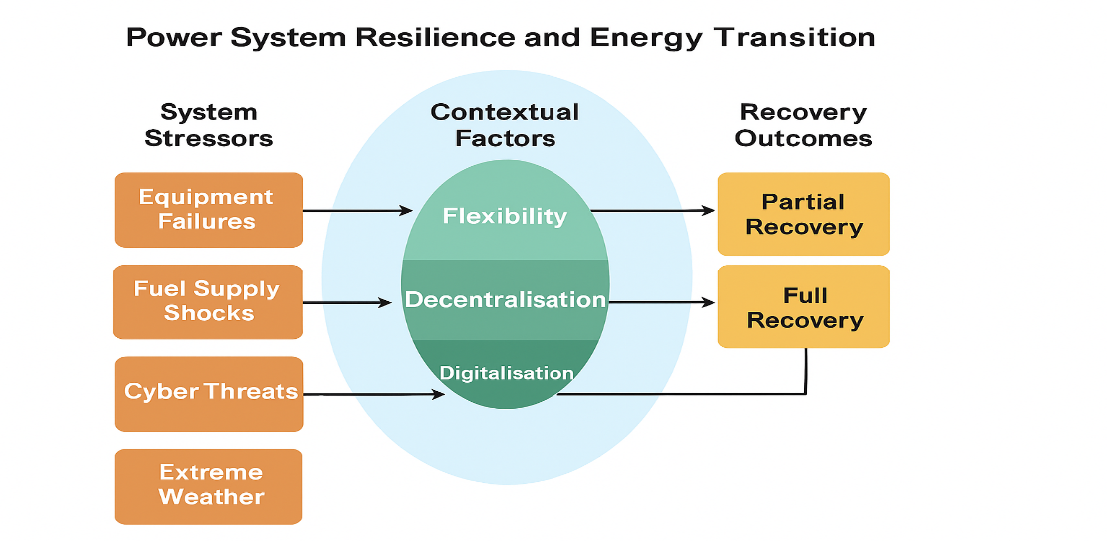
Figure 2: Conceptual framework of power system resilience illustrating system stressors, resilience attributes (flexibility, decentralisation, digitalisation), and recovery outcomes within the energy transition context. Energy transition frameworks emphasise that resilience is not achieved through technology deployment alone, but through coordinated progress in infrastructure development, policy design, governance, and human capacity building (Su’ait et al., 2025). For developing countries such as Nigeria, resilience-oriented transitions must also prioritise affordability, inclusiveness, and local capacity development.
3. Emerging Renewable Energy Technologies Relevant to Nigeria
3.1 Solar Energy Technologies
Nigeria possesses one of the largest solar energy potentials in Africa, with average solar irradiation levels between 1,600 and 2,200 kWh/m² annually. The intensity of solar radiation is well distributed within the country Akinbulire et al, (2014). During the day it is estimated Nigeria receives about 4.851 x 1012 kWh of energy from the sun, which is equivalent to about 1.082 million tons of oil per day. While domestic consumption of oil is 297 thousand barrel per day. When we change barrels into tones we see very exiting number; 297000 barrels = 47219.2281 tons. It is obviously seen that domestic demand for oil can be substituted by solar energy Aydogun et al, (2001).

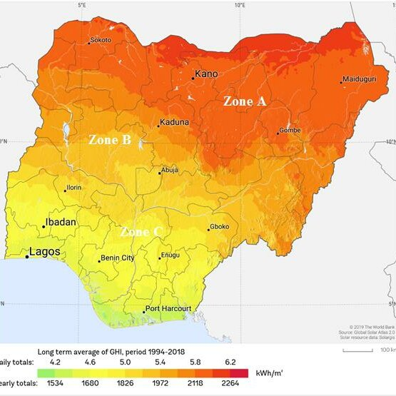
Figure 3: Spatial distribution of annual solar irradiation across Nigeria, highlighting regions with high photovoltaic deployment potential. (Diyoke et al 2023)The technical potential for solar photovoltaic deployment is estimated at about 210 GW, assuming limited land utilisation (IRENA, 2023). Advances in solar technologies, including bifacial modules, tracking systems, and emerging materials such as perovskite solar cells, are improving conversion efficiency and reducing lifecycle costs (Su’ait et al., 2025).
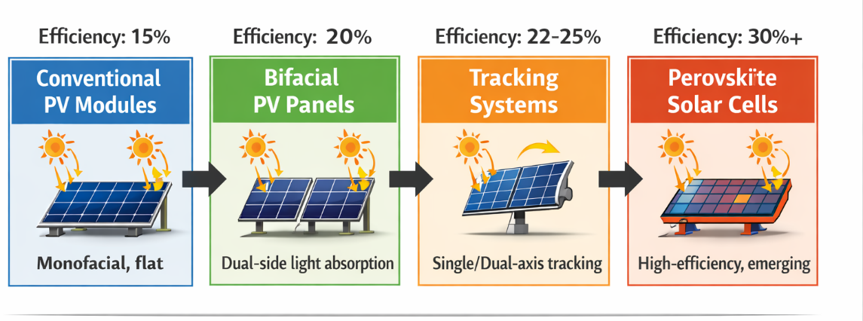
Figure 4: Evolution of solar photovoltaic technologies from conventional modules to advanced systems including bifacial panels, tracking technologies, and emerging perovskite solar cells.Artificial intelligence and machine learning applications are increasingly used for solar resource forecasting, performance optimisation, and fault detection. These digital tools enhance predictability and facilitate the integration of large-scale and distributed solar systems into the grid (Khan & Kumar, n.d.). Solar PV systems combined with battery storage are particularly suitable for Nigeria’s off-grid and mini-grid markets.
3.2 Wind Energy and Hybrid Systems
Nigeria’s wind energy potential is moderate but geographically significant, particularly in northern and coastal regions. The estimated technical onshore wind potential is approximately 3.2 GW (IRENA, 2023). Technological improvements in turbine design, power electronics, and condition monitoring systems have enhanced reliability and reduced operational challenges. Hybrid renewable energy systems that combine wind, solar, and energy storage offer enhanced resilience by smoothing variability and improving supply reliability. Such systems are well suited for rural electrification, industrial clusters, and critical infrastructure, where uninterrupted power supply is essential (Ogbonnaya et al., 2019).
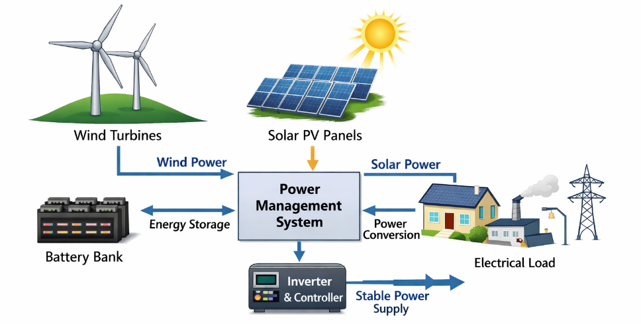
Figure 5: Schematic configuration of a hybrid renewable energy system integrating wind turbines, solar photovoltaic modules, battery energy storage, and power management systems for enhanced supply reliability.

3.3 Digitalisation, Artificial Intelligence, and Digital Twins
Digitalisation is transforming power system planning and operation through real-time monitoring, predictive maintenance, and advanced control. Internet of Things (IoT) devices, smart meters, and supervisory control systems improve grid visibility and reduce technical and non-technical losses. Digital twin technology enables virtual modelling of power systems, allowing operators to test scenarios, identify vulnerabilities, and optimise system performance before physical implementation (Khan & Kumar, n.d.).For Nigeria, digital technologies present opportunities to modernise grid operations, enhance transparency, and improve the integration of variable renewable energy sources.

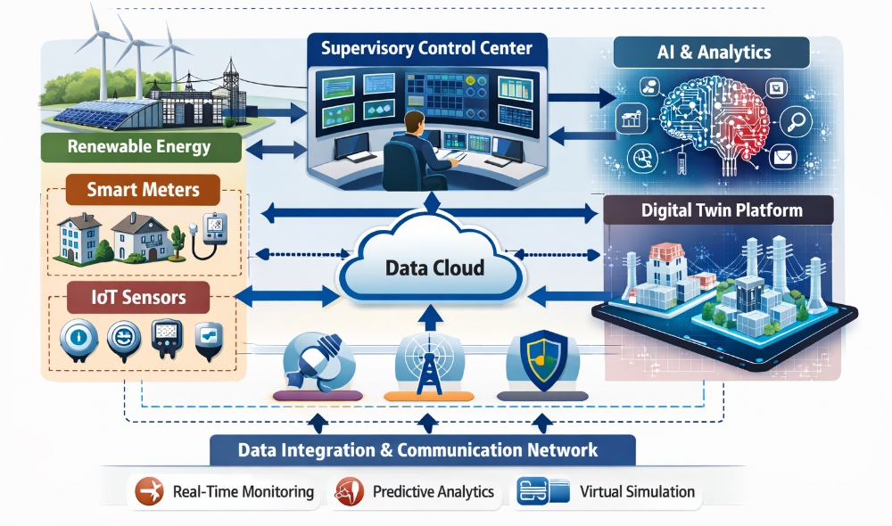
Figure 6: Digitalised power system architecture showing the integration of smart meters, IoT sensors, supervisory control systems, artificial intelligence analytics, and digital twin platforms.
3.4 Energy Storage Technologies
Energy storage is a cornerstone of resilient renewable power systems. Battery energy storage systems, pumped hydro storage, and emerging long-duration storage technologies provide balancing services, frequency regulation, and backup power (Lui, 2024). Advances in lithium-ion, sodium-ion, and supercapacitor technologies are improving performance while reducing costs (Su’ait et al., 2025).In Nigeria’s context of frequent outages, coupling storage with renewable generation can significantly reduce reliance on diesel generators for households, healthcare facilities, and small businesses.

Table 1: Comparison of Major Energy Storage Technologies
Technology | Typical Power Rating | Energy Duration | Response Time | Round-Trip Efficiency | Cycle Life | Key Resilience Contribution
Pumped Hydro Storage (PHS) | 100 MW – 2 GW | Hours – Days | Minutes | 70–85 % | 30–60 years | Long-term energy balancing, load levelling, support during prolonged renewable intermittency
Lithium-Ion Battery (Li-ion BESS) | kW – 100+ MW | 1–8 hours | Milliseconds – Seconds | 85–95 % | 3,000–10,000 cycles | Fast frequency regulation, peak shaving, microgrid support
Flow Battery (Vanadium, Zinc-Bromine) | 100 kW – 100 MW | 4–12+ hours | Seconds | 60–80 % | 10,000–20,000 cycles | Medium-duration energy storage, renewable smoothing
Supercapacitors (Ultracapacitors) | kW – MW | Seconds | Milliseconds | 90–95 % | >100,000 cycles | Power quality, bridging short transients, stabilizing voltage
Flywheel Energy Storage | kW – Tens of MW | Seconds – Minutes | Milliseconds – Seconds | 85–90 % | >20,000 cycles | Fast grid stabilization, frequency regulation, short-term bridging
Compressed Air Energy Storage (CAES) | 100 MW – 300+ MW | Hours – Tens of hours | Minutes | 40–70 % | 20–30 years | Long-duration storage, load leveling, renewable integration
Superconducting Magnetic Energy Storage (SMES) | kW – 100 MW | Seconds | Milliseconds | ~95 % | >50,000 cycles | Instantaneous power support, voltage and frequency stability

3.5 Hydrogen and Emerging Energy Hybrid
A typical hybrid system combines two or more energy sources, from renewable energy technologies such as PV-panels, wind or small-hydro turbines; and from conventional technologies usually diesel Generator sets. In addition, it includes power electronics and electricity storage bank. (Pratik Prajapati and R.P.Sukhadiya ;2018).. Renewable hydrogen produced via electrolysis using renewable electricity is increasingly recognised as a strategic energy carrier for long-term storage and sector coupling. Hydrogen can support decarbonisation of hard-to-abate sectors and provide seasonal energy storage (Ogbonnaya et al., 2019; Su’ait et al., 2025). Although hydrogen deployment in Nigeria remains nascent, it represents a long-term opportunity within a resilient energy transition pathway.
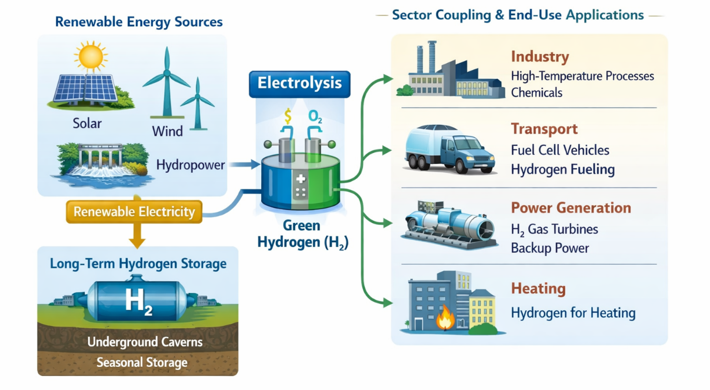
Figure 8: Role of renewable hydrogen in a resilient energy system, illustrating electricity-to-hydrogen conversion via electrolysis and end-use applications including long-term storage and sector coupling.
4. Strategic Pathways for Resilient Renewable Power Systems in Nigeria
4.1 Distributed Generation and Mini-Grids
Distributed renewable energy systems, including solar home systems and mini-grids, are central to improving electricity access and resilience in Nigeria. These systems reduce dependence on centralised infrastructure and provide scalable, cost-effective solutions for rural and peri-urban communities (IRENA, 2023).
Table 2: Comparison between Centralised Grid-Based Electricity Supply and Distributed Renewable Energy Systems, Highlighting Resilience and Access Advantages of Decentralised Generation
Aspect | Centralised Grid-Based Electricity Supply | Distributed Renewable Energy Systems (DRES)
Generation Location | Large, centralised power plants (thermal, hydro, nuclear) | Small-to-medium scale renewable generators (solar PV, wind, small hydro) close to consumption points
Transmission & Distribution | Long high-voltage transmission lines; large-scale distribution network | Localised distribution; minimal long-distance transmission
Infrastructure Investment | High capital cost upfront; economies of scale | Lower incremental investment; modular and scalable
Flexibility & Adaptability | Low; centralised plants are less responsive to rapid load changes | High; can integrate variable renewable sources and storage
Reliability & Resilience | Susceptible to cascading failures; single-point disruptions affect large regions | Highly resilient due to decentralisation; microgrids can operate independently
Energy Access | Often limited in remote or rural areas due to high transmission costs | Can provide off-grid or mini-grid solutions
Environmental Impact | High fossil fuel dependency; large carbon footprint | Low-carbon or zero-emission generation
Maintenance & Operation | Centralised management; professional staff required | Distributed management; can be community-operated

4.2 Grid Modernisation and Smart Grids
Nigeria’s transmission network is constrained by limited wheeling capacity and frequent system disturbances. Smart grid technologies, advanced metering infrastructure, and grid automation are essential for integrating higher shares of renewable energy and enhancing system stability (IRENA, 2023).
4.3 Policy, Regulatory, and Financial Frameworks
Effective policy and regulatory frameworks are critical for accelerating renewable energy deployment. Instruments such as renewable energy auctions, feed-in tariffs, concessional financing, and risk-mitigation mechanisms can attract private investment and reduce project costs (IRENA, 2023; Lui, 2024).
4.4 Capacity Building and Institutional Strengthening
Human capital development, local manufacturing, and institutional capacity building are vital for sustaining advanced renewable technologies. Energy transition strategies emphasise education, skills development, and governance reforms to ensure long-term system resilience and social acceptance (Su’ait et al., 2025).
5. Implications for Sustainable Development and Climate Goals
Resilient renewable power systems contribute directly to Nigeria’s sustainable development objectives by improving energy access, reducing emissions, and enhancing economic productivity. Under the Transforming Energy Scenario outlined by IRENA, renewable energy could supply about 47% of Nigeria’s energy mix by 2030 and 57% by 2050, with lower cumulative investment costs and substantial emissions reductions compared to existing policy pathways (IRENA, 2023).
6. Conclusion
Emerging renewable energy technologies provide a credible pathway for addressing Nigeria’s long-standing power sector challenges. Advances in solar, wind, hybrid systems, digitalisation, energy storage, and hydrogen technologies, when aligned with distributed generation, smart grid deployment, and enabling policy frameworks, can significantly enhance power system resilience. This paper demonstrates that a holistic and inclusive energy transition strategy is essential for building a resilient renewable power system capable of supporting Nigeria’s development aspirations and climate commitments.

References
(1) T.O. Akinbulire, Oluseyi,T.O. and Babatunde, O.M (2014): ‘Techno-economic and environmental evaluation of demand side management techniques for rural electrification in Ibadan, Nigeria’, Int. J Energy Environ Eng. 5(132): 1 – 11.
(2) O.Aydogan , HasanY.and Ozgur S. (2001): ‘Wind energy utilization in a house inIzmir, Turkey’, International Journal of Energy Research, Vol. 25, pp. 253-261.
(3) C. Diyoke, N.,Ugochukwu & U., Kenneth, (2023). A comprehensive analysis on the grid- tied
solar photovoltaic for clean energy mix and supply in Nigeria’s on-grid power. Journal of Energy
Systems.7.117. 10.30521/jes.988844.International Renewable Energy Agency. (2023). Renewable
energy roadmap Nigeria. IRENA
(4) R. Lui, . (2024). Renewable energy: Emerging technologies and innovations to reduce climate
change.UNICEF Office of Innovation. Ogbonnaya, C., Abeykoon, C., Damo, U. M., & Turan, A. (2019). The
current and emerging renewable energy technologies for power generation in Nigeria: A review. Thermal
Science and Engineering Progress, 13, 100390. https://doi.org/10.1016/j.tsep.2019.100390
(5) P. Prajapati, R.P.Sukhadiya ;(2018).Review and Simulation of Solar-Wind Hybrid System With Smart Grid
Integration. International Journal of Creative Research Thoughts (IJCRT) www.ijcrt.org
pg617-621.
(6) M.S. Su’ait, L.N.Ahmad, & K.Sopian, K. (2025). Introduction to renewable energy technologies and
energy transition strategies. Solar Energy Research Institute (SERI), Universiti Kebangsaan Malaysia;
Department of Mechanical Engineering, Universiti Teknologi Petronas.
(7)S.C. Bhattacharyya,(2013). Energy access problem and the role of renewable energy technologies. Energy
Policy, 61, 5–13. https://doi.org/10.1016/j.enpol.2013.06.001
(8)International Energy Agency (IEA). (2022). Renewables 2022 – Analysis and forecast to 2027. IEA.
https://www.iea.org/reports/renewables-2022
(9)International Renewable Energy Agency (IRENA). (2021). Renewable energy and resilience. IRENA.
https://www.irena.org/publications
(10) International Renewable Energy Agency (IRENA). (2022). Renewable energy: A key enabler of resilient
energy systems. IRENA.
(11) H.Lund., P.A.Østergaard, D. Connolly, & B.V. Mathiesen, (2015). Smart energy and smart energy systems. Energy, 93, 1–11. https://doi.org/10.1016/j.energy.2015.09.083
(12) REN21. (2023). Renewables 2023 global status report. REN21 Secretariat.
https://www.ren21.net/reports/global-status-report/
(13)World Bank. (2021). Decentralized energy solutions for rural development. World Bank.
https://www.worldbank.org/en/topic/energy/publication

