Global Trends in Strawberry (Fragaria × ananassa) Bioactive Compounds Research: A Bibliometric Analysis

ABSTRACT

This research aims to analyze the development and research trends related to phenolic compounds and anthocyanins in strawberries. A comprehensive bibliometric approach regarding research trends, collaboration patterns, and scientific evolution based on visualization in strawberry bioactive compound research from 2005 to 2025 was employed. Data were collected from 185 reputable scientific publications and analyzed using VOSviewer software. The analysis revealed exponential growth in publication volume and peak research activity. Results demonstrated that the dominant keywords were ”strawberry,” ”phenolic compounds,” and ”anthocyanins,” which formed three major research clusters. Recent trends indicate an increased focus on bioavailability, biosynthesis, and sensory properties. Furthermore, the close interconnection between fermentation, probiotics, and antioxidant activity reveals a new direction in functional food research. This study provides a comprehensive overview of the intellectual structure and research development trajectory, as well as future research opportunities in the development of strawberry-based products with high health value. Post-harvest technologies such as fermentation, probiotic development, and functional food production provide a strategic roadmap for researchers in recent findings. This bibliometric analysis offers valuable insights for researchers, policymakers, and industrial stakeholders in formulating future research priority strategies and understanding the global scientific landscape of strawberry bioactive compound research.

Keywords: Strawberry, phenolic compounds , Anthocyanins and Antioxidant Activity, Bibliometric
Analysis, VOSviewer

INTRODUCTION

Strawberry (Fragaria × ananassa) is one of the fruits rich in bioactive compounds, particularly phenolic compounds and anthocyanins, which function as natural antioxidants (Hoang, Dao, and Lam 2023). Beyond its organoleptic appeal, strawberry has emerged as a functional food because the concentration of these bioactive compounds has been widely associated with various health benefits, such as anti-inflammatory effects, anti-obesity properties, and protection against chronic diseases (Basu et al., 2021). The bioactive compound content of strawberry includes anthocyanins (which provide its distinctive red color), polyphenols, ellagic acid, flavonoids, and various phenolic acids, each of which contributes to different biological activities (Lopes-da-Silva et al., 2019).

In recent years, strawberry-related research has developed rapidly, encompassing various aspects such as antioxidant activity, bioavailability, fermentation, and applications in functional food production (Zhang et al., 2023). However, the increasing number of publications has made it difficult to comprehend the overall pattern of scientific development. The interest of the scientific community in strawberry bioactive compounds is influenced by several interconnected factors (Ramlal & Quan, 2025). Substantially, this is driven by increased consumer demand for fruit-based functional foods, growing evidence of chronic disease prevention potential, advances in analytical chemistry and identification methodologies, and expanded research funding in nutrition science and natural product chemistry (Khan et al., 2022).

Bibliometric analysis is an effective method for identifying research trends, scientific collaboration,
and the structure of knowledge in a given field (Donthu et al., 2021). With the assistance of VOSviewer software, keyword network visualization can provide insights into the relationships between research topics (Yeung et al., 2018). This bibliometric analysis examines global trends in strawberry bioactive compound research from 2005 to 2025, encompassing more than 185 publications from various leading scientific journals and international
research databases. The importance of this research lies in the role of strawberry in chronic disease prevention and long-term health benefits. This expanding research requires systematic evaluation of the scientific landscape to identify emerging trends, research gaps, and collaboration patterns. The integration of bibliometric analysis with network visualization tools offers unprecedented capacity to understand the complex research ecosystem and identify major knowledge clusters (Yeung et al., 2018). Previous bibliometric studies have examined various aspects of strawberry fruit research, nutrition science, and natural product chemistry; however, comprehensive bibliometric analysis specifically focused on strawberry bioactive compound research remains limited (Zhang et al., 2023). This gap represents a significant opportunity to synthesize existing knowledge and provide evidence-based guidance for future research priorities. Advanced analytical techniques and network visualization methods for mapping the intellectual structure of this research domain provide essential tools for advancing the field.

MATERIALS AND METHODS

Data Sources

Scientific literature was systematically retrieved from Scopus, PubMed, and Web of Science databases. Bibliographic data were collected from the ScienceDirect scientific database using the keywords ”strawberry functional beverages and bioactive compounds” (Zhang et al., 2023). These databases were selected due to their comprehensive coverage of peer-reviewed literature, including journals, conference proceedings, and reviews. A bibliometric approach was applied within a publication time range of 20 years (2005 to 2025). The retrieved data were subsequently exported in RIS format and imported into VOSviewer software version 1.6.20. Data were visualized according to overlay visualization functions within VOSviewer. Inclusion criteria required publications to have explicit focus on strawberry species or Fragaria genus, investigation of bioactive compounds or their properties, original research data or systematic review methodology, and availability of full text (Ikhsan et al., 2026).

Data Extraction and Analysis

Data extraction and analysis were performed by gathering information from available scientific literature, including titles, abstracts, keywords, and relevant articles. Following data extraction, analysis was conducted to comprehend and interpret the collected data. Analysis was performed using the co-occurrence method to analyze the frequency of keyword appearance and how keywords were interconnected within individual publications (Yeung et al., 2018). Overlay visualization methodology was applied, mapping keywords based on temporal dimensions using color gradients to visualize topic evolution. Parameters utilized for the results included publication trends, analysis of contributing publishers, keyword co-occurrence networks, and overlay visualization. Data quality assurance encompassed verification of extracted information against original sources and cross-validation across databases.

Term Map and Network Visualization

VOSviewer employs VOS (Visualization of Similarities) mapping methodology, which creates two-dimensional maps wherein the distance between network elements represents their relationships or similarities. VOSviewer is software designed to analyze and visualize bibliometric data from databases in the form of words appearing in titles, abstracts, and keywords from scientific literature. Two visualization methods were applied in the network maps. First, visualization was based on keyword relationships using the co-occurrence method with minimum co-occurrence of keywords threshold (Chaudhary et al., 2025). Second, visualization employed temporal trends indicated by color gradients ranging from blue to yellow across the period from 2016 to 2026 (10-year span). Data visualization was presented in bubble map format, where each bubble represents a word or phrase appearing in the literature. The color of the bubbles indicates the citation frequency per publication containing that term. The distance between two bubbles indicates how frequently both terms co-occur (Yeung et al., 2018).

RESULTS AND DISCUSSION

Publication Trends

Recent research data were collected and recorded as of March 6, 2026, from the Scopus database. A total of 185 literature sources were obtained following screening of 272 publications concerning strawberry functional beverages and bioactive compounds, originating from 25 publishers. Figure 1 presents publication trends over the 20-year study period. The observed publication trends demonstrated fluctuating patterns from 2005 to 2025, with publication numbers on strawberry bioactive compounds in functional beverages varying annually. Most notably, publication volume increased significantly in 2020 compared to previous years, indicating intensified research interest in this field (Zhang et al., 2023). This surge reflects the growing recognition of strawberry bioactive compounds' potential in functional food development and chronic disease prevention.

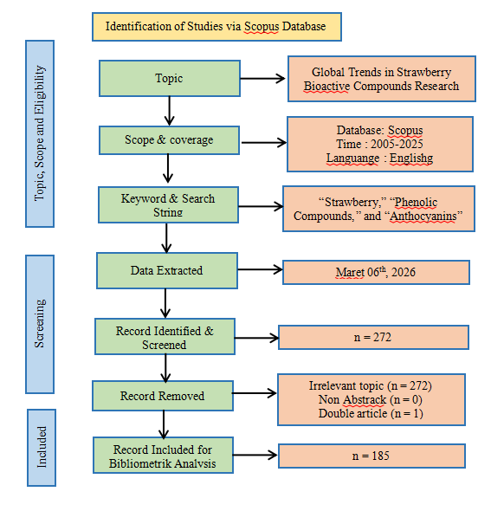
Fig. 1. Flow diagram of the search strategy

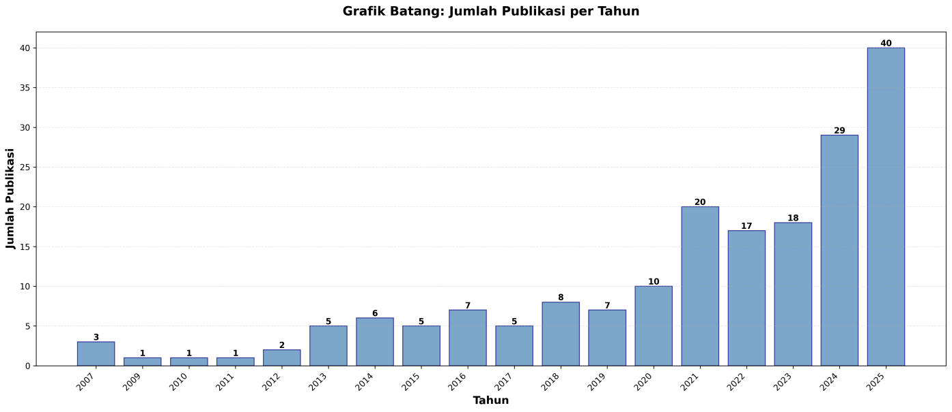

Fig 2. Publikasi Trend Strawberry Bioactive Compounds Research

Overall, the publication trend has increased sharply over time. Research has evolved from compound identification to product application. The publication trend analysis presented in Figure 2 demonstrates an analysis spanning from 2007 to 2025. The very low publication rate during the initial phase (2007–2012) indicates that research on strawberry bioactive compounds was still limited and had not yet gained widespread attention. The early growth phase (2013–2016) witnessed gradual increases due to growing emphasis on health and nutrition. The fluctuating phase (2017–2019) represented a transition period, wherein research continued to develop but remained unstable. The surge phase (2020–2025) demonstrates rapid growth and strong global interest. The peak in 2025 indicates that research on strawberry bioactive compounds has now become an important topic in the fields of functional food, nutrition, and health.

Analysis of Top Contributing Publishers
The concept network visualization presented in Figure 1 demonstrates the complexity and interdisciplinarity of research on strawberry bioactive compounds. The nodes with the highest frequency of occurrence occupy central positions within the network, comprising "strawberry," "phenolic compounds," and "anthocyanins." The most productive publisher is Elsevier through the journal Food Chemistry, with a total of 16 publications addressing strawberry bioactive compounds and antioxidant properties (Rodríguez-Cortina Hernández-Carrión, 2025). Among the 25 identified publishers, three publishers account for the highest number of publications. Knowledge of publishers that have issued substantial scientific literature on strawberry bioactive compounds is essential for facilitating research development in the future (Ikhsan et al., 2026). The publishers and their respective publication counts are presented in Table 1.
Table 1. Top Contributing Publishers

No | Nama Penerbit | Jumblah Publikasi
1 | Jurnal Food Chemistry | 16
2 | Jurnal Food Research International | 15
3 | Jurnal LWT-Food Science and technology | 12

Keyword co-occurance network dan overlay

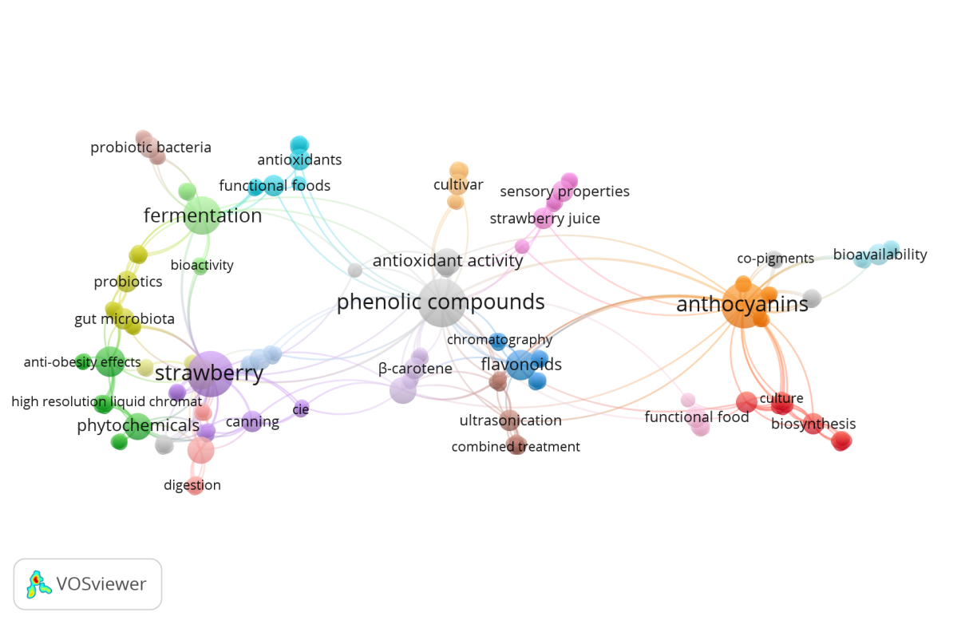

Fig 3. Keyword co-occurrence network

Based on visual analysis of the network map generated using VOSviewer, several major trends emerge in publications on strawberry bioactive compounds research. The concentration of highly interconnected primary keywords includes probiotic bacteria, antioxidants, fermentation, sensory properties, bioactivity, gut microbiota, and phenolic compounds. This indicates that current research is focused on health effects and the utilization of probiotic microorganisms in strawberry processing, as well as on measuring the antioxidant activity of bioactive compounds in strawberries (Yang et al., 2021). A distinct cluster with food biotechnology themes, including fermentation and biosynthesis, is associated with enhanced nutritional value and secondary metabolite activity. Additionally, trends in the application of advanced techniques—such as ultrasonication, high-resolution liquid chromatography, and integrated approaches—to enhance the bioavailability of key bioactive compounds are particularly prominent.

These developments indicate a shift in focus toward cutting-edge food processing technologies aimed at improving the quality and functional benefits of strawberry juice (Chaudhary et al., 2025). Health-related keywords such as anti-obesity effects, gut microbiota, and probiotics suggest that research on strawberry bioactive compounds is increasingly directed toward understanding clinical and pharmacological mechanisms. Node coloration depicts distinct cluster groupings, while connecting lines represent the strength of relationships between concepts. The identification and quantification of anthocyanin constitutes a central network node, representing the primary pigment responsible for strawberry fruit coloration. This research foundation extends into clusters addressing biological mechanisms such as antioxidant activity. These clusters demonstrate that the majority of research focuses on strawberries' capacity to neutralize free radicals and emphasizes the health benefits of antioxidants (Ziena, 2025).

According to the network map, a significant shift has occurred from basic science toward food technology applications. During the initial period (2016-2019), the literature was dominated by keywords related to extraction, chemical structure identification, and in vitro activity testing. However, approaching and following 2020, new nodes with warm or bright coloration emerged, including fermentation, probiotics, and functional food. Chemical components such as phenolic compounds, flavonoids, anthocyanins, and β-carotene, combined with techniques such as ultrasonication and biosynthesis, support bioavailability and the quality of functional foods (Lopes-da-Silva et al., 2019). Probiotic bacteria, antioxidants, and functional food represent the primary focus concerning the sensory properties of strawberry juice and antioxidant activity (Ikhsan et al., 2026). Fermentation processes, bioactivity, and gut microbiota influence the anti-obesity effects of strawberries, with phytochemical content analyzed using high-resolution liquid chromatography (Ramlal & Quan, 2025)

The bibliometric shift observed herein reflects the application of food science principles. Although strawberries contain high levels of antioxidants, the bioavailability (absorption within the human body) of phenolic compounds and anthocyanins is naturally very low (Lopes-da-Silva et al., 2019). The emergence of fermentation and probiotic keywords indicates that addressing this bioavailability challenge has become the primary focus of contemporary research (Liu et al., 2024). Strawberry fermentation using lactic acid bacteria (LAB) or Bifidobacterium can scientifically enhance the phenolic profile through enzymatic mechanisms that cleave glycosidic bonds in anthocyanins, thereby generating new bioactive metabolites that synergize with the original strawberry compounds (Hoang et al., 2023). Furthermore, the integration of strawberries into functional food applications demonstrates that modern research extends beyond laboratory investigations to the stage of product development, including fermented strawberry beverages, probiotic strawberry yogurt, and nutritional supplements. This expansion opens substantial business opportunities for the food and health industries (Martínez-Las Heras et al., 2021).

The temporal overlay analysis presented in Figure 4 provides dynamic insights into how research focus has shifted over the past decade (Zhang et al., 2023). The color map in the figure demonstrates a temporal gradient spanning the period from 2016 to 2026. Darker colors, specifically blue and green, represent the most dominant topics at the beginning of the 2016 period, indicating that these research areas have been pursued over an extended timeframe. Conversely, brighter colors, particularly yellow, represent topics currently trending as the field approaches 2026 on the network map. Overall research development trends focus on advancing strawberries as a functional food with health potential through diverse scientific approaches and food processing technologies (Granato et al., 2020) .The foundational phase (2016-2020) was dominated by yellow and light green keywords centered on phenolic compounds and anthocyanins, with publications focusing on basic extraction methods, phytochemical profile identification, and in vitro activity testing. The application and innovation phase (2021-2026) demonstrates a marked shift with the emergence of dark blue nodes associated with fermentation, functional foods, and advanced processing technologies. Recent research increasingly focuses on strategies to preserve the bioavailability of bioactive compounds (Martínez-Las Heras et al., 2021).

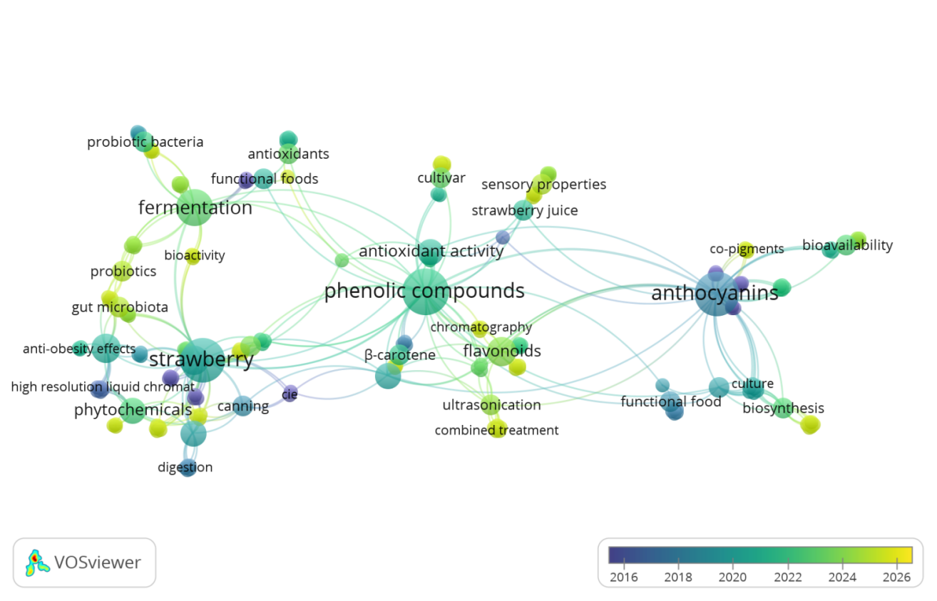

Gambar 4. Keyword Co-Occurance Overlay

CONCLUSION
This bibliometric review examines strawberries as bioactive compounds through a comprehensive assessment and quantification of scientific literature characteristics, including scientific publications, citations, author collaborations, research networks, and emerging trends. Data were obtained from the ScienceDirect database covering the period between 2005 and 2025. According to VOSviewer visualization results, research trends evident in the global literature analysis appear throughout the period from 2016 to 2026 (Zhang et al., 2023). Publication output increased from 2020 onward, with a decline observed in 2019, reaching a maximum of 16 publications in 2025. The Journal of Chemistry emerged as the most productive publisher during this period.
Strawberry research is dominated by three primary themes: phenolic compounds, anthocyanins, and functional foods. The main research pillar focuses on relationships associated with antioxidant activity. Recent trends indicate an increased emphasis on bioavailability and health applications through microbiological approaches and the development of commercially viable, fruit-based functional food products (Khan et al., 2022). Phenolic compounds have emerged as a central focus of research due to their strong association with antioxidant activity, while anthocyanins have advanced toward molecular studies and nutritional applications. A significant paradigm shift in research methodology—from basic chemical characterization toward bio-transformation technology—is evidenced by the increasing prominence of keywords such as fermentation, probiotics, and functional foods, thereby opening substantial opportunities for innovative product development. Future research is recommended to integrate multidisciplinary approaches to enhance the added value of strawberries as a functional food source (Martínez-Las Heras et al., 2021).

REFERENCES
- Basu, A., Nguyen, A., Betts, N. M., & Lyons, T. J. (2021). Strawberries and cardiovascular health: A review of the evidence. Nutrients, 13(3), 1–18. https://doi.org/10.3390/nu13030809
- Chaudhary, K., Khalid, S., AlMasoud, N., Alomar, T. S., Ansar, S., Ghazal, A. F., Aït-Kaddour, A., & Aadil, R. M. (2025). Impact of ultrasonication, ozonation, and their combination on the preservation of novel clean-label functional drink of strawberry-cantaloupe incorporated with Spirulina platensis and orange peel extracts. Journal of Food Processing and Preservation
- Donthu, N., Kumar, S., Mukherjee, D., Pandey, N., & Lim, W. M. (2021).
How to conduct a bibliometric analysis: An overview and guidelines. Journal of Business Research, 133, 285–296. https://doi.org/10.1016/j.jbusres.2021.04.070
- Granato, D., Barba, F. J., Kovačević, D. B., Lorenzo, J. M., Cruz, A. G., & Putnik, P. (2020).
Functional foods: Product development, technological trends, efficacy testing, and safety. Trends in Food Science & Technology, 102, 93–110. https://doi.org/10.1016/j.tifs.2020.06.012
- Hoang, S. H., Dao, H., & Lam, E. (2023). A network pharmacology approach to elucidate the anti-inflammatory effects of ellagic acid. Journal of Biomolecular Structure and Dynamics, 41(7), 2240417. https://doi.org/10.1080/07391102.2023.2240417
- Ikhsan, M. H., Putri, S. A., & Herlina, T. (2026). Anthocyanins from Rosaceae fruits: Diversity, bioactivity, and potential as natural colorants. Food Chemistry: X, 20, 100894. https://doi.org/10.1016/j.fochx.2025.10089
- Khan, S., Rahman, S., Yu, Z., & Zeng, X. (2022).
Trends in functional food consumption and development: A global perspective. Journal of Food Science, 87(3), 1023–1036. https://doi.org/10.1111/1750-3841.16045
- Liu, M., Liu, J., & Xu, Y. (2024). Functional properties, structural characteristics, and anti-complementary activities of two degraded polysaccharides from strawberry fruits. International Journal of Biological Macromolecules, 253, 127180. https://doi.org/10.1016/j.ijbiomac.2023.127180
- Lopes-da-Silva, F., et al. (2019). Anthocyanins: Stability and bioavailability. Food Research International, 120, 681–694. https://doi.org/10.1016/j.foodres.2018.11.045
- Martínez-Las Heras, R., et al. (2021). Fermented strawberry products: Optimization and bioactive properties. LWT-Food Science and Technology, 145, 111297. https://doi.org/10.1016/j.lwt.2021.111297
- Ramlal, A., & Quan, P. W. (2025). Impact of biophysicochemical factors on micropropagation, haploidy and doubled haploidy in strawberry (Fragaria sp.): A critical revisit. Current Plant Biology, 34, 100299. https://doi.org/10.1016/j.cpb.2025.100299
- Rodríguez-Cortina, A., & Hernández-Carrión, M. (2025). Amazonian fruits in Colombia: Exploring bioactive compounds and their promising role in functional food innovation. Journal of Food Composition and Analysis, 134, 106040. https://doi.org/10.1016/j.jfca.2024.106040
- Yang, W., Liu, S., & Ma, X. (2021). Chemical composition, sensory profile and antioxidant capacity of low-alcohol strawberry beverages fermented with Saccharomyces cerevisiae and Torulaspora delbrueckii. LWT– Food Science and Technology, 146, 111459. https://doi.org/10.1016/j.lwt.2021.111459
- Yeung, A. W. K., et al. (2018). Visualization of scientific literature using VOSviewer: A bibliometric analysis. Scientometrics, 115(2), 919–932. https://doi.org/10.1007/s11192-018-2746-9
- Zhang, Y., Chen, X., Gao, Y., & Zhang, H. (2023). Global trends and prospects of anthocyanins research: A bibliometric analysis (2003–2022). Frontiers in Nutrition, 10, 1156242. https://doi.org/10.3389/fnut.2023.1156242
- Ziena, A. H. (2025). Evaluation of quality attributes, antioxidant activity, and phytochemical content of functional canned whole strawberries (Fragaria × ananassa) as influenced by sweetening medium, heat treatment, and storage. Applied Food Research, 5(1), 101006. https://doi.org/10.1016/j.afres.2025.101006

