Between Home and Restaurant: Living Conditions, Work Patterns, and Family Health among Minang Migrant Entrepreneurs in Kuala Lumpur

ABSTRACT : This community service paper discusses a field-based engagement program conducted with the Minang Saiyo Community in Kuala Lumpur, a group of Indonesian Minang migrant families who have developed livelihoods as restaurant entrepreneurs in Malaysia. The program addressed the close relationship between domestic living conditions, restaurant-based work patterns, and family health in migrant working households. Many participants experience overlapping functions between home, business, storage, rest, and childcare, creating environmental challenges related to hygiene, ventilation, spatial comfort, safety, and healthy daily routines. The community service activities were designed and delivered by experts in building engineering and architecture, who introduced practical knowledge on healthy living environments for working families. The activities included observation of housing and workplace conditions, participatory discussion sessions, environmental health education, and technical guidance on simple spatial improvements. Particular attention was given to natural ventilation, lighting quality, sanitation awareness, safe circulation, waste handling, moisture control, and the separation of clean and service areas between domestic and food-business functions. The team also provided recommendations for low-cost environmental adjustments that could be implemented gradually within rented or limited spaces. The program found that participants responded positively to applied, context-sensitive guidance that connected health, family well-being, and spatial arrangement. This activity shows that community service in the fields of architecture and building engineering can make a meaningful contribution to strengthening healthy living practices among migrant entrepreneur families. It also highlights the importance of spatial literacy as part of community empowerment in urban migrant settings.

Keywords - healthy living environment, migrant working families, community service, Minang entrepreneurs; spatial health education

INTRODUCTION

Migration is not only a movement of people across borders, but also a reconfiguration of everyday life, work, family routines, and domestic space. In many urban migrant settings, housing functions far beyond shelter alone. It becomes a place of economic survival, family care, storage, rest, and social reproduction. For migrant families who run small food businesses, the boundary between home and workplace is often blurred, creating a spatial condition in which domestic and productive functions overlap on a daily basis. This overlap is especially significant in dense urban environments, where limited space, rental arrangements, and economic pressure shape how families organize their living and working environments. Housing, therefore, must be understood as a central social determinant of health, well-being, and everyday resilience (Bentley et al., 2025; The Human Right to Adequate Housing, n.d.; WHO Housing and Health Guidelines, n.d.).

A growing body of literature shows that poor housing conditions are closely associated with adverse physical and mental health outcomes. Inadequate ventilation, crowding, moisture, poor sanitation, unsafe circulation, and low indoor environmental quality can increase health risks, reduce comfort, and weaken daily functioning, particularly in households where several activities occur within the same limited space. The World Health Organization emphasizes that unsafe and substandard housing contributes directly to health burdens and highlights crowding, indoor environmental hazards, and injury risks as core concerns in healthy housing policy. Reviews on housing and health similarly show that ventilation, dryness, thermal comfort, and freedom from hazards are fundamental characteristics of healthy housing (Bentley et al., 2025; Niza et al., 2024).

These concerns become more acute in migrant contexts. Recent reviews indicate that migrant and refugee populations are disproportionately affected by housing inequality, including overcrowding, insecure tenure, inadequate ventilation, and poor neighborhood conditions, all of which can influence respiratory health, psychosocial well-being, and family stability. Housing insecurity among migrant populations is not only a technical or economic issue, but also a health equity issue. For low-wage and self-employed migrant households, healthy living cannot be separated from the quality of the spaces they inhabit and adapt. In urban migrant life, the dwelling frequently becomes a hybrid space where care, labor, food preparation, and recovery from work occur simultaneously (Rana et al., 2025; Eshetu et al., 2026).

This condition is highly relevant to the Minang migrant community in Kuala Lumpur. Many members of this community have built their livelihoods through restaurant entrepreneurship, often involving long working hours, family-based labor, and close integration between residence and business activity. In such circumstances, the spatial arrangement of the living environment affects not only comfort but also hygiene, rest patterns, childcare, household safety, and health behavior. When areas for cooking, storage, circulation, sleeping, and family interaction are insufficiently organized, the household may experience cumulative environmental stress. Research on home-based work has shown that the home can serve as an important site of income generation, yet this also creates spatial pressures and competing demands between productive and domestic uses. This is particularly important in households with constrained resources, where spatial adjustment takes place incrementally and pragmatically rather than through formal design intervention (Wagemann et al., 2024; Gough & Kellett, 2001; Reuschke, 2016)

Within this context, community service in the fields of architecture and building engineering can make a practical contribution. Rather than treating health only as a medical matter, this approach understands family well-being as strongly shaped by environmental conditions and spatial literacy. Healthy living practices depend not only on awareness, but also on the ability to recognize how ventilation, lighting, sanitation, moisture control, circulation, and zoning between clean and service areas influence daily life. Technical guidance that is simple, low-cost, and adapted to rented or limited spaces is therefore highly relevant for migrant entrepreneur families. Such an approach connects built environment knowledge with community empowerment and makes architecture more directly useful in everyday settings (WHO Housing and Health Guidelines, n.d.; Niza et al., 2024; Osibona et al., 2021).

This paper presents a community service program conducted with the Minang Saiyo Community in Kuala Lumpur, focusing on the relationship between living conditions, restaurant-based work patterns, and family health among Minang migrant entrepreneurs. The program combined field observation, participatory discussion, environmental health education, and technical guidance on simple spatial improvements. The paper aims to describe the environmental challenges identified in the community, explain the forms of intervention delivered by the team, and reflect on how spatially informed community service can strengthen healthy living practices among migrant working families. In doing so, the paper argues that spatial literacy is an important dimension of community empowerment in urban migrant settings.

METHODOLOGY

This community service program employed a participatory, field-based, and problem-oriented approach to address the relationship between living conditions, restaurant-based work patterns, and family health among Minang migrant entrepreneur families in Kuala Lumpur. The methodological design was not intended as an experimental intervention, but as an applied community engagement model that combined environmental observation, participatory discussion, health-oriented education, and technical guidance on feasible spatial improvement. Such an approach is consistent with community-based and participatory public health practice, which emphasizes local relevance, contextual understanding, and practical problem solving through collaboration with community members (Indicators, Guidance and Tools, n.d.).
Study setting and community partner
The activity was conducted in Kuala Lumpur, Malaysia, with members of the Minang Saiyo Community, a migrant community consisting largely of Indonesian Minang families whose livelihoods are closely connected to restaurant entrepreneurship. In this setting, the dwelling and the workplace are often functionally interrelated, either physically or operationally, through cooking support, storage, rest, childcare, and family labor arrangements. Because housing conditions are increasingly recognized as an important determinant of health, examining these hybrid domestic-work environments is methodologically relevant for community service in architecture and building engineering (Housing, n.d.; Housing Impacts Health, n.d.).

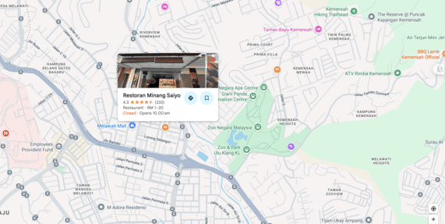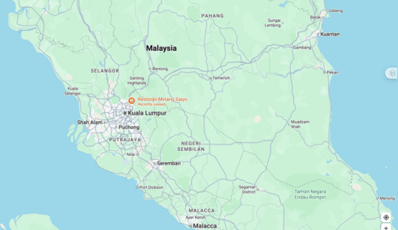
Figure 1. Spatial location of the Minang Saiyo Community and the PKM activity site in Kuala Lumpur, Malaysia
Figure 1 presents the geographical context of the community service program. The left panel identifies the local site of the Minang Saiyo Community and its restaurant-based activity setting within Kuala Lumpur, while the right panel places the site within the wider regional geography of Malaysia. The figure provides spatial context for understanding the living and working environment of the migrant community.

Service approach
The program used a participatory environmental health approach. This means that the team did not position the community merely as recipients of information, but as active participants in identifying environmental problems, discussing daily routines, and reflecting on realistic solutions. The approach was chosen because practical interventions related to healthy housing are more likely to be meaningful when they are adapted to actual patterns of use, economic limitations, and spatial constraints. WHO housing guidance also stresses that healthy housing interventions should be grounded in real housing conditions and applied through practical and context-sensitive actions (WHO Housing and Health Guidelines, n.d.).

Stages of implementation
The methodology was implemented in four main stages.

1. Preliminary identification
The first stage involved preliminary identification of the community context, including the general profile of participants, the characteristics of their living and working environments, and the main environmental issues affecting daily family life. At this stage, the team mapped recurrent concerns such as overlapping domestic and business functions, ventilation limitations, storage congestion, sanitation risks, circulation problems, and the management of clean and service areas. This stage was important because housing-related health risks are often cumulative and linked to multiple environmental factors rather than a single issue (Anyanwu & Beyer, 2024).

2. Field observation
The second stage consisted of direct field observation of selected living and working environments used by the participating families. Observation focused on practical spatial and environmental indicators, including:
- natural ventilation and air movement,
- access to daylight and lighting quality,
- cleanliness and sanitation,
- moisture and signs of dampness,
- waste handling practices,
- circulation safety,
- storage organization, and
- separation between domestic, food preparation, and service-related activities.

These indicators were selected because ventilation, crowding, environmental safety, and other indoor housing conditions are widely recognized as core components of healthy housing. Reviews on housing and indoor environmental quality also emphasize that air quality, thermal comfort, safety, and environmental performance shape occupant well-being and health outcomes (World Health Organization et al., 2018).

3. Participatory discussion and educational sessions
The third stage involved participatory discussion sessions with community members. These sessions were used to explore everyday routines, identify points where family health and spatial conditions intersected, and discuss common challenges experienced in combining home life with restaurant-based work. The educational component introduced practical principles of a healthy living environment, including the importance of air circulation, lighting, sanitation, waste control, moisture reduction, and safer movement within limited spaces. This stage also encouraged participants to connect environmental conditions with family well-being, not only in physical terms but also in relation to comfort, rest, and daily caregiving. Environmental health education is particularly useful when technical knowledge needs to be translated into simple, behavior-linked, and spatially understandable actions (World Health Organization et al., 2018).

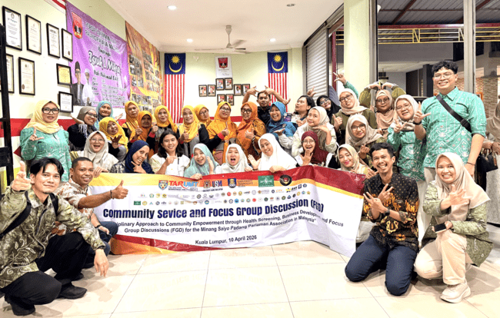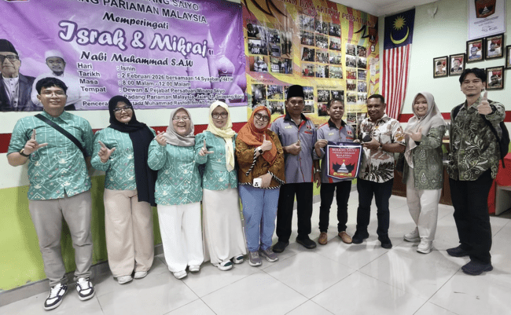
Figure 2. Participatory discussion and educational session with the Minang Saiyo Community in Kuala Lumpur
Figure 2, shows the participatory discussion and educational session conducted with members of the Minang Saiyo Community in Kuala Lumpur. The activity brought together the community and the service team in a shared forum to discuss everyday living conditions, health-related environmental challenges, and practical strategies for improving healthy living environments. The session reflects the collaborative and community-centered approach of the program.

4. Technical guidance and contextual recommendations
The fourth stage involved the delivery of simple technical guidance based on the observed conditions and discussion results. Recommendations were designed to be:
- low-cost,
- realistic for rented or limited spaces,
- gradual in implementation, and
- easy to maintain by families.
Examples of guidance included improving cross-ventilation where possible, reorganizing storage to reduce congestion, separating clean and service zones more clearly, improving the use of natural light, reducing dampness, improving waste placement, and clarifying circulation paths for safer movement inside constrained spaces. This step reflects the practical orientation of community service in architecture and building engineering, where environmental improvement does not necessarily require large-scale redesign but can begin with incremental spatial adjustments. Evidence on healthy housing supports the value of practical interventions that reduce exposure to hazards and improve basic indoor environmental quality (World Health Organization et al., 2018).

Data collection techniques
Although this paper is framed as a community service report rather than a full empirical research article, the documentation of the activity drew on several forms of field-based evidence:
- direct observation notes,
- participatory discussion records,
- visual documentation,
- facilitator reflections, and
- participant responses during the sessions.
These materials were used to identify common patterns rather than to produce statistical generalization. The aim was to generate an applied understanding of environmental health issues in the community and to document how participants responded to architecture-based guidance. This is appropriate for community-engaged interventions, where practical relevance and contextual interpretation are often more important than controlled measurement alone (World Health Organization et al., 2018; Anyanwu & Beyer, 2024).

Analytical approach
The analytical process used in this paper was descriptive and interpretive. Observational findings and participant responses were organized into thematic categories related to healthy living environments, such as ventilation, sanitation, spatial overlap, circulation, waste handling, and comfort. These categories were then interpreted in relation to the community’s everyday living and working patterns. The purpose of the analysis was not to test a hypothesis statistically, but to explain how environmental conditions shaped daily family health practices and how the PKM intervention responded to these conditions. This descriptive-interpretive approach is suitable for community service writing because it allows the paper to clearly connect context, action, and practical outcomes (World Health Organization et al., 2018).

Ethical and practical considerations
The activity was conducted with respect for participant comfort, voluntary involvement, and contextual sensitivity. Because the target community included migrant families managing both livelihood and household responsibilities, the team prioritized respectful communication and practical recommendations rather than intrusive assessment. The intervention was educational and supportive in nature, focusing on empowerment through applicable knowledge. This is important in community-based settings, especially where participants face spatial constraints, economic limitations, and housing insecurity (Li & Liu, 2018; World Health Organization et al., 2018).

RESULTS

The community service activity revealed that the daily lives of Minang migrant entrepreneur families in Kuala Lumpur were strongly shaped by the overlap between domestic space and restaurant-based work. As already indicated in the draft abstract, the observed environments frequently combined functions of residence, business support, storage, rest, and childcare within limited or rented spaces, creating practical challenges related to hygiene, ventilation, spatial comfort, safety, and healthy routines. This confirms that, in migrant working households, the home cannot be understood only as a place of shelter, but as a hybrid environment where productive and reproductive activities are continuously negotiated. That pattern is consistent with broader work on housing and home-based work, which shows that domestic space often absorbs economic activity when formal separation between home and workplace is limited (Wagemann et al., 2024).

Environmental conditions identified in the field
The first major result of the activity was the identification of recurring environmental issues affecting the quality of daily living. Field observation and discussion suggested that the most visible concerns were limited air circulation, uneven lighting conditions, storage congestion, weak zoning between clean and service areas, and the coexistence of work-related and family functions in the same spatial setting. These findings are important because indoor environmental quality is closely linked to occupant well-being, comfort, and health. Reviews on indoor environmental quality emphasize that air quality, thermal conditions, and visual comfort are not secondary matters, but central components of healthy living environments (Al horr et al., 2016).

Ventilation emerged as one of the most relevant practical issues. In constrained living environments where cooking, resting, and family interaction occur in close proximity, insufficient air movement may intensify discomfort, odors, humidity, and perceived uncleanliness. The WHO Housing and Health Guidelines identify housing conditions such as crowding and other substandard environmental characteristics as major health concerns and emphasize the importance of healthy housing conditions in reducing preventable health burdens (World Health Organization et al., 2018). In the present PKM context, ventilation was not discussed as a technical building-performance issue alone, but as part of everyday family health, rest quality, and domestic comfort.

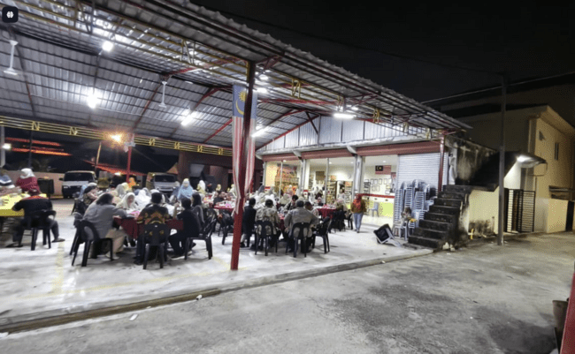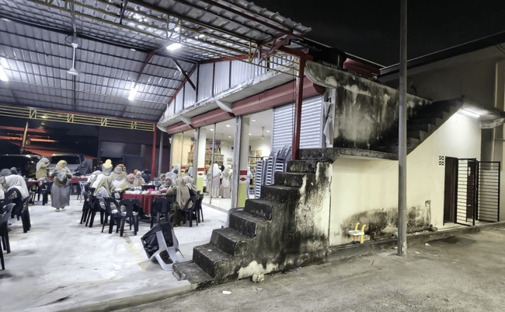
Figure 3 Restaurant-based activity setting of the Minang Saiyo Community in Kuala Lumpur
Figure 3, shows the physical setting of the Minang Saiyo Community’s restaurant-based environment in Kuala Lumpur. The images illustrate the open dining area, the main building structure, and the adjoining stair access, highlighting how commercial, social, and support functions are closely integrated within a limited space. This setting reflects the spatial overlap between livelihood activities and everyday family-based use in the migrant community.

Another recurring result concerned the lack of clear functional separation between household life and restaurant-related support activities. In several cases, storage, food-related preparation support, circulation, and family routines appeared closely interwoven. This does not necessarily indicate disorder in a moral sense, but rather spatial adaptation under conditions of limitation. The literature on home-based work is useful here because it explains that households often reorganize space incrementally in response to livelihood demands, especially when work and family survival are deeply connected (Wagemann et al., 2024). The Minang migrant setting reflects this logic of adaptation. Space is not simply occupied, but continuously adjusted to serve multiple needs at once.

Health and family well-being as spatially mediated issues
A second important result was the recognition, among participants, that environmental conditions influence family well-being more directly than they had previously articulated. During the educational and discussion sessions, participants responded positively to explanations linking layout, ventilation, sanitation, moisture control, and circulation safety with daily health and comfort. This matches the draft paper’s initial finding that context-sensitive and applied guidance was well received by the community.

This outcome is significant because it shows the value of spatial literacy in community empowerment. Many household health problems are often discussed only in behavioral terms, while the spatial environment that structures daily behavior receives less attention. Yet housing research consistently shows that poor living conditions shape both immediate and cumulative health risks. The WHO’s housing guidance treats inadequate living conditions as a public health concern, not merely as a matter of household preference (World Health Organization et al., 2018). Likewise, more recent evidence on migrant and refugee populations shows that housing inequalities, including overcrowding, inadequate conditions, and poor environmental quality, are associated with adverse physical and psychosocial outcomes (Rana et al., 2025).

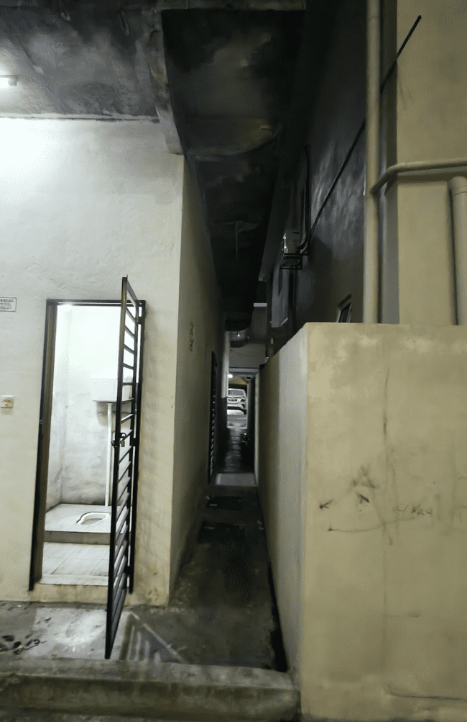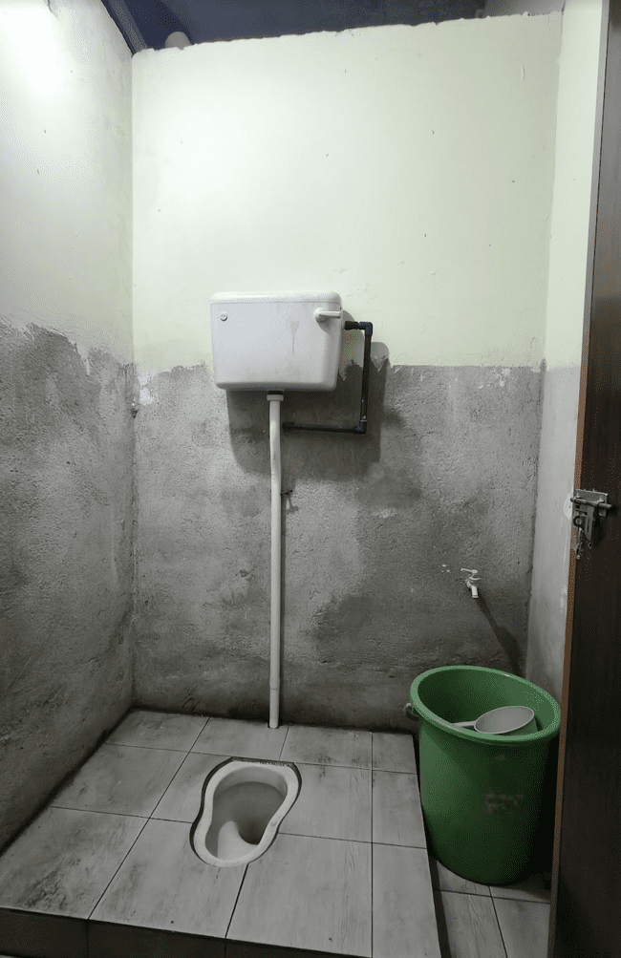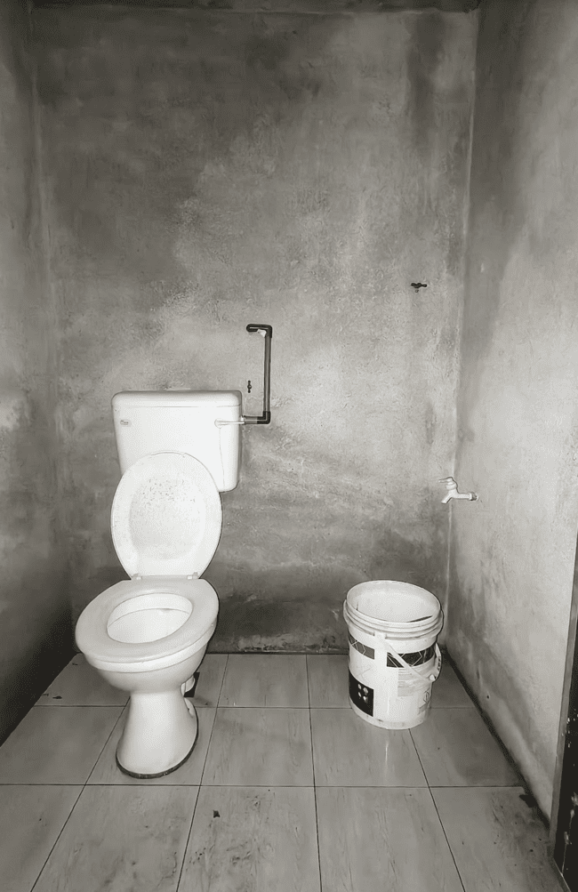
Figure 4. Sanitation and service-area conditions in the observed migrant living environment
Figure 4, shows the sanitation and service-area conditions observed in the migrant living environment, including a narrow circulation passage and toilet facilities. The images highlight basic environmental issues related to hygiene, spatial limitation, surface condition, and the organization of service spaces. These conditions are relevant to the discussion of healthy living environments and family well-being in constrained domestic-work settings.

In the present activity, this broader argument became visible at the micro scale of everyday family life. Participants were not dealing with abstract environmental concepts, but with practical matters such as where air could flow, where waste could be placed, how circulation could be made safer, and how clean and service areas could be better distinguished. These are modest interventions in appearance, but they are meaningful because they translate health into manageable spatial actions. This is especially important for migrant households living in rented or constrained environments, where major physical renovation may not be feasible.

Participant response to architecture-based guidance
A third result was the positive reception of architecture- and engineering-based recommendations when these were delivered in simple, non-technical, and context-sensitive language. The community did not need complex design proposals. What proved useful were practical suggestions that respected the reality of incremental change, limited budgets, and multi-use spaces. Recommendations such as improving cross-ventilation where possible, reorganizing storage, clarifying circulation routes, managing moisture, and separating cleaner household functions from service-related activities were perceived as realistic and applicable. This directly reflects the activity described in the draft abstract, which emphasized low-cost environmental adjustments and gradual implementation.

This finding matters for the discipline. Community service in architecture is sometimes assumed to require physical construction output or formal design products. However, the results of this program suggest a different contribution: the provision of applied environmental knowledge that helps families reinterpret and improve their own living conditions. In that sense, architecture functions not only as a design profession but also as a form of public education. The relevance of this approach is reinforced by research on indoor environmental quality, which shows that relatively basic conditions such as airflow, comfort, and environmental management have substantial implications for human well-being (Al horr et al., 2016).

Reading the Minang migrant household as a hybrid living-work environment
The discussion also points to a broader conceptual issue. The Minang migrant entrepreneur household in Kuala Lumpur should be read as a hybrid living-work environment, not as a conventional dwelling with occasional economic activity. This distinction is important because it changes how problems are interpreted. Congestion, overlapping uses, and unclear zoning are not simply design flaws. They are expressions of economic strategy, family cooperation, and adaptive survival within migrant urban life. Literature on housing and home-based work helps clarify this condition by showing that the coexistence of productive and domestic functions is a structural feature in many contexts, especially where households must secure income through family-based labor (Wagemann et al., 2024).

Seen from this perspective, the PKM intervention was effective not because it imposed an ideal housing model, but because it worked from within the logic of the household itself. The recommendations did not require participants to abandon their existing spatial practices. Instead, they offered ways to refine those practices so that the same limited environment could become healthier, safer, and more manageable. This is an important methodological and practical lesson. For migrant communities, relevance often depends less on technical sophistication than on whether recommendations are compatible with the household’s everyday rhythm.

Broader implications for migrant housing and community service
The findings also support the wider literature that positions housing as a social determinant of health. The observed domestic-work overlap, constrained spatial conditions, and incremental adaptations all point to the need for more integrated approaches to migrant well-being. Healthy family life in migrant communities cannot be separated from questions of housing quality, spatial organization, and environmental safety. This aligns with broader evidence showing that inadequate housing conditions and housing inequality affect migrants disproportionately (Rana et al., 2025).

For PKM practice, the implication is clear. Community service in architecture and building engineering can contribute meaningfully to migrant well-being when it focuses on everyday environmental problems that communities themselves can recognize and improve. The contribution may be modest in material scale, but it is significant in human terms. By helping participants see the connection between space and health, the program strengthened practical awareness that can support gradual change over time.

Synthesis of the main findings
Overall, the activity produced four main findings. First, Minang migrant entrepreneur families experience a strong overlap between domestic and restaurant-related functions in their daily environments. Second, key environmental issues include ventilation, sanitation, storage congestion, circulation safety, and weak separation between clean and service areas. Third, participants responded positively to simple and applicable technical guidance. Fourth, the activity demonstrated that spatial literacy is an important component of community empowerment in migrant urban settings. These findings are consistent with the paper’s initial argument that architecture- and engineering-based community service can make a concrete contribution to healthy living practices among migrant working families.

DISCUSSION

The findings of this community service activity show that the living conditions of Minang migrant entrepreneur families in Kuala Lumpur should be understood as hybrid domestic-work environments rather than as conventional residential settings. In the observed context, the dwelling was closely tied to restaurant-based livelihoods through overlapping functions of storage, food-related support, rest, childcare, and family labor. This pattern is important because it shifts the discussion from housing as a static shelter to housing as an adaptive space shaped by economic necessity and everyday survival. That interpretation is consistent with recent work on housing and home-based work, which argues that domestic space often absorbs productive functions when households rely on flexible, family-centered income strategies (Wagemann et al., 2024).

A central implication of the findings is that family health in migrant communities is spatially mediated. The environmental issues identified during the activity, including weak ventilation, congestion, unclear separation between clean and service areas, sanitation concerns, and constrained circulation, are not minor technical defects. They directly influence comfort, hygiene, rest, and the quality of everyday family routines. This aligns with the WHO Housing and Health Guidelines, which frame housing conditions such as crowding and other substandard domestic environments as public health concerns rather than merely matters of housing preference. WHO also emphasizes that improved housing conditions can reduce disease risks and improve quality of life (World Health Organization et al., 2018).

The discussion also reinforces the importance of indoor environmental quality in community-based housing interventions. Literature on indoor environmental quality consistently shows that airflow, thermal conditions, and visual comfort are strongly associated with occupant well-being and comfort. In the present case, ventilation and spatial organization emerged as especially relevant because they affect daily routines in settings where multiple functions occur in a limited area. The significance of these issues becomes even stronger in households where living and work activities are not clearly separated. In such conditions, the quality of the built environment is inseparable from the quality of everyday life (Al horr et al., 2016).

Another important point is that the observed spatial arrangements should not be read simply as deficiencies. They are also forms of incremental adaptation. Migrant households often reorganize space pragmatically in response to rental limitations, constrained floor area, work intensity, and family needs. This means that overlapping uses, congested storage, or improvised zoning are not merely planning failures, but expressions of how families negotiate livelihood and care under pressure. The literature on home-based work supports this interpretation by showing that the coexistence of productive and domestic functions is a structural feature in many low-resource or transitional urban settings (Wagemann et al., 2024).

From this perspective, the value of the PKM intervention lies in its context-sensitive and non-prescriptive character. The activity did not attempt to impose an idealized housing model. Instead, it worked within the everyday logic of the community and proposed realistic improvements that could be implemented gradually. This is why the participants responded positively to simple recommendations related to airflow, waste handling, storage organization, circulation safety, moisture reduction, and functional separation. In migrant households living in rented or spatially constrained conditions, practical and low-cost guidance is often more meaningful than technically sophisticated but difficult-to-apply design proposals. That approach is consistent with WHO’s broader emphasis on actionable healthy housing measures grounded in actual living conditions (World Health Organization et al., 2018).

The results also suggest that spatial literacy is an important but often overlooked dimension of community empowerment. Participants benefited not only from health-related information, but from being helped to see how everyday environmental conditions shape family well-being. In other words, the intervention translated built-environment knowledge into understandable, manageable actions. This matters because many health challenges in migrant households are framed primarily as behavioral issues, while the physical setting that structures those behaviors receives less attention. By making the spatial dimension visible, the program expanded the community’s capacity to interpret and improve its own environment. This argument is compatible with broader evidence showing that migrant populations are disproportionately affected by housing inequalities and that such inequalities are linked to adverse health outcomes (Rana et al., 2025; Eshetu et al., 2026).

For the field of architecture and building engineering, the discussion points to a broader professional implication. Community service does not always need to produce a building, a renovation project, or a formal design package in order to be meaningful. In this case, the major contribution was the delivery of applied environmental knowledge that enabled families to reinterpret the relationship between space, health, and daily routine. This confirms that architecture can contribute not only through form-making, but also through practical environmental education, small-scale spatial strategy, and empowerment-oriented guidance. In community settings, that role can be highly significant because the cumulative impact of modest adjustments may be substantial over time.

Overall, the discussion confirms four key points. First, the Minang migrant household in Kuala Lumpur operates as a hybrid living-work environment. Second, environmental quality is directly connected to family health and well-being. Third, practical architecture-based guidance is useful when it is simple, contextual, and affordable. Fourth, spatial literacy can function as a form of empowerment for migrant working families. These points strengthen the paper’s main argument that community service in architecture and building engineering can play a concrete role in supporting healthier everyday life in urban migrant settings.

CONCLUSION

This community service activity demonstrated that healthy living among Minang migrant entrepreneur families in Kuala Lumpur is closely connected to the spatial quality of their domestic-work environments. The findings showed that daily life in the Minang Saiyo Community is shaped by the close overlap between residence, restaurant-related support activities, storage, rest, and childcare. Within these hybrid living arrangements, environmental issues such as limited ventilation, insufficient separation between clean and service areas, storage congestion, sanitation concerns, and circulation constraints affect not only physical comfort but also family well-being and everyday health practices.

The program also showed that architecture- and building engineering-based community service can provide a meaningful and practical contribution to migrant family welfare. Through field observation, participatory discussion, environmental health education, and simple technical guidance, the activity helped participants recognize the relationship between space, health, and daily routine more clearly. The positive response from participants indicates that low-cost, context-sensitive, and applicable recommendations are highly relevant for migrant households living in rented or spatially constrained conditions.

An important contribution of this activity lies in strengthening spatial literacy as part of community empowerment. The program confirmed that improving family health does not depend only on behavioral awareness, but also on the ability to understand and manage environmental conditions such as airflow, lighting, moisture, waste placement, and functional zoning within limited spaces. In this sense, the PKM activity did not merely transfer information, but encouraged participants to reinterpret their living environments as spaces that can be improved gradually through realistic adjustments.

Overall, this paper affirms that community service in architecture and building engineering can play a strategic role in supporting healthier living practices among migrant working families. Future programs may expand this model through follow-up assistance, comparative work with other migrant communities, and closer integration between environmental health education and practical spatial intervention. Such efforts would further strengthen the role of applied spatial knowledge in improving quality of life in urban migrant settings.

ACKNOWLEDGEMENTS

The authors would like to sincerely thank the Minang Saiyo Community in Kuala Lumpur, Malaysia, for their generous cooperation, warm hospitality, and active involvement in this community service program. The openness of the participants in sharing their daily realities, challenges, and experiences greatly enriched this activity and made the program both meaningful and contextually grounded.
The authors also express their deep appreciation to all members of the service team and partner institutions for their valuable collaboration, interdisciplinary contributions, and shared commitment to improving healthy living environments for migrant families.
Finally, the authors gratefully acknowledge all institutional and local support that contributed to the successful implementation of this program.

REFERENCES

- Al horr, Y., Arif, M., Katafygiotou, M., Mazroei, A., Kaushik, A., & Elsarrag, E. (2016). Impact of indoor environmental quality on occupant well-being and comfort: A review of the literature. International Journal of Sustainable Built Environment, 5(1), 1–11. https://doi.org/10.1016/j.ijsbe.2016.03.006
- Anyanwu, C., & Beyer, K. M. M. (2024). Intersections among housing, environmental conditions, and health equity: A conceptual model for environmental justice policy. Social Sciences & Humanities Open, 9, 100845. https://doi.org/10.1016/j.ssaho.2024.100845
- Bentley, R., Mason, K., Jacobs, D., Blakely, T., Howden-Chapman, P., Li, A., Adamkiewicz, G., & Reeves, A. (2025). Housing as a social determinant of health: A contemporary framework. The Lancet Public Health, 10(10), e855–e864. https://doi.org/10.1016/S2468-2667(25)00142-2
- Eshetu, H. B., Blackford, K., Lobo, R., Alemu, M. B., Tessema, G. A., & Crawford, G. (2026). Housing Insecurity and Health Outcomes Among Migrants from Culturally and Linguistically Diverse Backgrounds in High-Income Countries: A Scoping Review. Journal of Immigrant and Minority Health, 1–19. https://doi.org/10.1007/s10903-026-01849-4
- Gough, K. V., & Kellett, P. (2001). Housing Consolidation and Home-based Income Generation: Evidence from Self-help Settlements in Two Colombian Cities. Cities, 18(4), 235–247. https://doi.org/10.1016/S0264-2751(01)00016-6
- Housing. (n.d.). Retrieved April 16, 2026, from https://www.who.int/teams/environment-climate-change-and-health/healthy-urban-environments/housing?utm_source=chatgpt.com
- Housing impacts health: New WHO guidelines on housing and health. (n.d.). Retrieved April 16, 2026, from https://www.who.int/news/item/26-11-2018-housing-impacts-health-new-who-guidelines-on-housing-and-health?utm_source=chatgpt.com
- Indicators, guidance and tools. (n.d.). Retrieved April 16, 2026, from https://www.who.int/teams/environment-climate-change-and-health/healthy-urban-environments/housing/indicators-guidance-and-tools?utm_source=chatgpt.com
- Li, J., & Liu, Z. (2018). Housing stress and mental health of migrant populations in urban China. Cities, 81, 172–179. https://doi.org/10.1016/j.cities.2018.04.006
- Niza, I. L., Bueno, A. M., Gameiro da Silva, M., & Broday, E. E. (2024). Air quality and ventilation: Exploring solutions for healthy and sustainable urban environments in times of climate change. Results in Engineering, 24, 103157. https://doi.org/10.1016/j.rineng.2024.103157
- Osibona, O., Solomon, B. D., & Fecht, D. (2021). Lighting in the Home and Health: A Systematic Review. International Journal of Environmental Research and Public Health, 18(2), 609. https://doi.org/10.3390/ijerph18020609
- Rana, K., Kent, J., & Andrew, P. (2025). Housing inequalities and health outcomes among migrant and refugee populations in high-income countries: A mixed-methods systematic review. PubMed. https://pubmed.ncbi.nlm.nih.gov/40121396/?utm_source=chatgpt.com
- Rana, K., Kent, J. L., & Page, A. (2025). Housing inequalities and health outcomes among migrant and refugee populations in high-income countries: A mixed-methods systematic review. BMC Public Health, 25(1), 1098. https://doi.org/10.1186/s12889-025-22186-5
- Reuschke, D. (2016). The importance of housing and neighbourhood resources for urban microbusinesses. Taylor & Francis. https://www.tandfonline.com/doi/abs/10.1080/09654313.2016.1168364
- The human right to adequate housing. (n.d.). OHCHR. Retrieved April 15, 2026, from https://www.ohchr.org/en/special-procedures/sr-housing/human-right-adequate-housing
- Wagemann, E., Maynard, V., & Simons, B. (2024). Housing and home-based work: Considerations for development and humanitarian contexts. Cities, 147, 104833. https://doi.org/10.1016/j.cities.2024.104833
- WHO Housing and health guidelines. (n.d.). Retrieved April 15, 2026, from https://www.who.int/publications/i/item/9789241550376?utm_source=chatgpt.com
- World Health Organization, United States, France, & United States (Eds.). (2018). WHO housing and health guidelines. World Health Organization.

