FEASIBILITY STUDY OF A SELF-CHARGING ELECTRIC VEHICLE USING DYNAMO-BASED ENERGY RECOVERY

Abstract—Electric vehicles (EVs) are being increasingly personalized preference of the eco-friendly alternative to conventional fuel-based transportation. However, battery capacity and charging frequency severely limits their performance. In order to overcome the aforementioned problem, i.e., to reduce the dependency on external electricity supply the authors have carried out a feasibility study of self-charging electric vehicle using dynamo based energy recovery system. As the first method of producing power from regenerative braking, one of the batteries is used to start the motor and once we are running, a dynamo is coupled to the main motor that allows for constant charging of another battery. DC–DC converters are used to regulate this generated energy for safe charging. This is done by using a microcontroller that monitors battery conditions and switches between the batteries accordingly. It can recover partial energy when running, as shown in experimental results. Even if complete self-charging is impossible (due to system losses), the method reduces battery discharge and thus improves overall energy utilization. The system is easy to implement, inexpensive and ideal for low-speed applications.

Index Terms—Electric vehicle, Energy recovery, Dynamo, Dual battery system, Electromagnetic induction

- Introduction:

Adjunctive Guide to the EVs modern used regenerative braking to maximize energy usage. This request of a technique, where the motor as a generator if brakes convert kinetic energy into
power to store in the battery. As helpful as this is to the efficiency, it'll only don't work when your braking, they sometimes take months to in between them are free flow performs, Driving normally. To address this drawback, alternative approaches such as dynamo-based energy harvesting have been investigated; but Output voltage will often be limited by the device In the shown approach, a motor or generator is mechanically coupled to at all wheel allowing for arc lighting machine times during movement. So in order to make– even when the vehicle is running, give works this way. Battery management is another important part of EV performance. The objective is to enhance response Time and time between failure due to a Single battery Stress. In this scheme, one battery
powers while the other one gets charged at sametime. It assist in minimizing deep discharge and work, just donored continuously. In this work, a self-charging EV system based on an energy recovery method based on dynamo is proposed and validated. The system comprises a DC motor and generator, two DC–DC converters, voltage sensors, relay switching and a microcontroller for control and monitoring. The goal is to investigate the potential for sustained energy recovery and its impact on system performance. The prototype reveals that self-charging to a complete extent is not feasible as energy losses throw a hindrance. This method is useful for applications that require continuous operation. Many of these systems do involve appropriate monitoring or control In many cases, since there is no feedback system to follow up on battery condition, it depreciates efficiency. This however does recover a bit of energy the battery loses. This design is inexpensive, uncomplicated, and fits a low-speed application with networking like small electric vehicles and campus transport.

- LITERATURE REVIEW :

Jugen Li and Wang Jiang Mining School of Heavy Industry have recently reviewed energy recovering methods of the is an important area in electric vehicle (EV) study. Regenerative braking is one of the most popular techniques[4],[7]. In this process, the electric motor operates as a generator while braking or slowing down and transforms kinetic energy into electrical energy. The energy is stored in the battery and re-used later. Multiple studies have also highlighted the benefits of regenerative braking for efficiency, particularly in urban environments. Driving where vehicles stop frequently. Though, it has limited efficiency against normal driving conditions as energy recovery happens only upon brake condition. Due to this limitation, researchers have looked at alternative approaches that could produce energy continuously. A specific approach is utilization of a dynamo or generator to recover energy. This is done by mechanically coupling a generator to the motor or wheel[1],[3]. Allowing electrical energy generation during vehicle operation. How this method works is that on electromagnetic induction and permits energy production even in steady state. Some experimental work has showed that this type of system can produce small bits of usable power, sufficient to support small loads or give limited battery charging. These systems are generally primitive and best-suited for low-speed applications.One of the drawbacks of using generator based systems as well. Each motor/generator has a link, can make mega loads on under-superior-speed engine association – Yet in the event that the business design (efficient and effective at all levels) this has to not have an effect.Optimized. Losses can also be those incurred due to friction and misalignment. In many of the reported works, the systems is whether virtually or at a low-end prototype level without true control. Also safe battery overcharging requires good voltage regulation, for which DC–DC converters are frequently used. Another common sub-category of EV systems is battery management. Batteries are expensive and important devices; thus, their appropriate usage has an immediate effect to the performance of the scheme. A dual-battery system wasintroduced to make their more durable and have longer battery life. This suspension and a single battery to fire up the motor.second battery is charged simultaneously. This prevents deep discharge, and keep a balanced flow of energy. By switching between
examples include; lithium-ion or NiCad batteries.relays, or other electronic devices to control specific nodes or groups of nodes on their mesh networks.switches to create very minimal
implementations. This method is useful for applications that require continuous operation.
Many of these systems do include appropriate
monitoring or control. In many cases since there
Have no way to track how well battery condition, it depreciates efficiency. A survey of the literature finds regenerative braking, dynamo-based energy recovery, and dual-battery systems have mostly been assessed in isolation. Most works explore only one or some of these concepts, and the imperative of a few them into a full operational system often lack control/monitoring. This gap drives the powered energy-recovery system integrated with our a dual-battery setup and microcontroller based is used for control in this work. To maximize efficient consumption of energy, and facilitate resilient performance for low-speed electric vehicle applications.. This method is useful for applications that require continuous operation. Many of these systems do involve appropriate monitoring or control. In many cases, since there is no feedback system to follow up on battery condition, it depreciates efficiency. A survey of the literature finds regenerative braking, dynamo-based energy recovery, and dual-battery systems have been primarily evaluated in isolation. Most works consider only one or more of these ideas, and the ones that combine some of them into a complete operational system often lack control/monitoring. This gap drives the current work where we implement a dynamo-based energy recovery system integrated with a dual-battery setup and microcontroller based control has been employed in this work. To optimize energy use and enable stable performance for low-speed electric vehicle applications.

- PROPOSAL SYSTEM:

We propose a self-charging EV architecture based on dynamo-driven energy recovery and dual-battery configuration. Essentially, the focus area for this system is to recoup a fraction of energy while driving and use it as battery during charging thus making the entire process more efficient and reducing the amount of discharge battery. The system is made up of two batteries (Battery-A and Battery-B), a DC motor, generator (dynamo), DC–DC converters, voltage sensors. A switch unit with a relay and a microcontroller to manage it. Battery-A is the main power source to supply energy to the motor and control circuitry. Battery-B, the second battery, acts as a reservoir for energy reclaimed by the generator. In the proposed arrangement, our DC motor is powered by Battery-A for driving the system. The generator is switched up with the motor shaft, meaning on every rotation, the motor rotates and the generator spins as well. Due to electromagnetic induction[6]. The generator converts internal mechanical energy into electrical energy during operation, a process that utilizes the principle of electromagnetic induction. To achieve an output voltage that is properly sized and safe for charging the secondary battery, this generated energy is routed through a rectification & DC–DC conversion stage. It needs DC–DC converters for voltage regulators to keep the system under appropriate charging conditions. The output from the generator can vary according to speed and load, so it must be regulated properly to avoid overcharging or undercharging of the battery. A microcontroller-based. If you like feel free to share it with any one who train up on the data from October 2023. Since the electrical conditions of both batteries fluctuate regularly, voltage sensors constantly check these and feedback measurement data to the controller. The relays switches used for controlling the charging and discharging process which is activated through controller according to the defined threshold values.

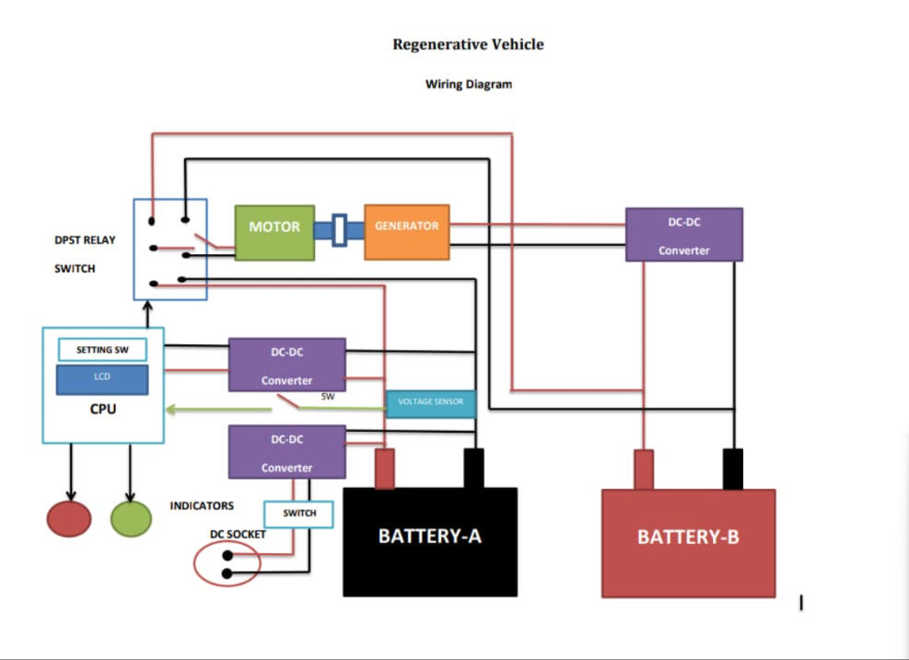
Fig.1.System-Level Diagram

This approach allows one battery to provide power while the other is charged, ensuring non-stop operation. Additionally, the system incorporates a display unit and indication LEDs for real-time feedback about battery status, charging condition, as well as other system operation. It assists in tracking the system's operational and testing performance. Fig. 1 illustrates the functional block diagram of proposed system. 1. It shows the high-level power flow and control hierarchy of the system. Battery-A —> Motor: Battery-A provides energy, the generator then transforms mechanical power into an electric. DC–DC converters regulate the generated energy which is then stored in Battery-B. Control Unit that controls switching and divides the energy to the batteries. Furthermore, this proposed architecture is simple in design, cost-effective and more sensitive for small scale electric vehicle applications. It offers a very practical way to recover some of the useful energy and enhance the energy efficiency

- METHODOLOGY:

This paper discusses the design, realization and implementation of a self-charging electric vehicle model using dynamo-based energy recovery with dual-battery system. We develop the system as a hardware prototype to investigate real-time performance and feasibility.Hardware-wise, it consists of two batteries (battery units), a DC Motor and Generator (dynamo), DC–DC converters, microcontroller unit and voltage sensing circuits, relay-based switching, and display module. TheIt's a layout that allows for both energy generation and consumption to happen at the same time.Battery-A is used as primary power source to drive the DC motor(Read current section in circuit). Motor is coupling mechanically to generator through shaft and belt arrangement. When the motor spins, it drives the generator that provides electrical energy from mechanical energy on the principle of electromagnetic induction. This also points the output energy to the charging part. The only reason for this is that the generator output is not constant and speed-dependent, a DC–DC converter was employed to adjust the voltage[5]. This keeps the generated energy under safe levels prior to charging the second battery (Battery-B). This regulated output is then provided for charging Battery-B. An entire set of the system is controlled and monitored by a microcontroller. Both batteries have poly fuse voltage sensors attached to constantly monitor those batteries' levels.

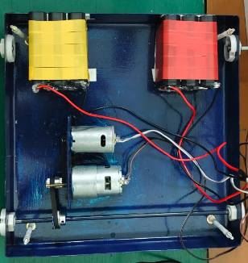
Fig. 2.Hardware Prototype

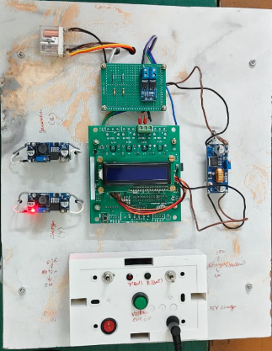
Fig. 3.Control Circuit
The controller processes these values and makes decisions on them according to predefined conditions. The charging and discharging operations are managed by a relay/contactor based switching mechanism between the two batteries.The system can switch operation to Battery-B when the voltage of Battery-A exceeds a certain level. In a similar manner, charging control is performed to preventing overcharging and ensuring system safety. This microcontroller is also connected to an LCD display that displays live data like battery voltage level and system state. It is shown the complete hardware prototype of the systemin Fig. 2 and Fig. 3. Fig. 2 shows the mechanical layout of the motor, generator, and battery connections Fig. The control circuit can be seen in Fig. 3, which consists of a microcontroller, converters, relay modules and display unit. Battery performance and energy recovery are checked with the system operating under various conditions. Voltage is used to analyze charging characteristics and assess system performance. The approach of energy recovery system is experienced comprehensively in a low-speed electric vehicle (LSEV) and continuous output energy recovery methodology highlights the practical implementation.

- RESULT AND DISCUSSION:
A dual-battery configuration and dynamo-based energy recovery mechanism were availed to design, implement, and test the proposed self-charging electric vehicle system. The primary goal of the experiment was to see if the system could recover energy in operation and provide charging of batteries without sacrificing the performance of its own drive motor. Battery-A was used as the power source to run the DC motor and system during testing. When the motor began to turn, the generator attached to the motor shaft also rotated, generating electrical energy through electromagnetic induction. The output, then, was run through a DC–DC converter circuit to regulate the voltage that would be supplied for charging Battery-B.
Indeed, experimental observations confirmed that the generator produces a measurable output voltage during operation. Battery-B was charged slowly according to the rotation speed of the motor. With increased speed, the generator generated at higher voltage, meaning that charging performance was improved. The charging rate was limited at slower speeds, but energy recovery continued to be registered[1]. The testing of the DC motor was carried out without interruption. The switching mechanism was implemented via relay, where the relays could control which battery is to use by controlling the energy flow. When the voltage of the primary battery dropped below a threshold level, the system was able to transfer operation allowing for continuous input with no spontaneous loss. The rest of the powertrain promotes lower CO2 as well, in part because you can drive 76 miles on all-electric range only with the dual-battery setup. load on a single battery. This made the overall system more stable and also reduced deep discharge condition which theoretically should improve battery life. By detecting the battery at maximum, it helped in proper controlling of charging and discharging cycles. And while the system was able to recover energy, it didn't produce enough to fully charge the battery. This is largely due to losses happening in the system, such as friction and energy loss during conversion and transfer. However the recovered energy was enough to slow down the battery discharge process and enhance global energy utilization. In general, the results demonstrate that energy recovery via a dynamo is practical in low-speed electric vehicle applications. It works well under controlled conditions and consequently offers a simple, low-cost means of partial energy recovery.

- CONCLUSION:
This research proposed a dynamo-based energy recovery system comprising dual-battery configuration while electrophysiological characteristics and experimental validation of the self-charging electrical vehicle. The suggested system further proved that mechanic energy from a motor could be conversed into electrical energy and could help charged a secondary battery during work. However, with dual-battery configurations, one battery always provided power while the other recharged. DC–DC converters and a microcontroller based control system kept the operation stable and energy shifted securely. It validated that the recovery and reduced battery discharge rate by prototype setup.
The research found that full, free re-charging would not be capable under expected real-world conditions imposed by intrinsic system losses including mechanical friction and cycle conversion inefficiencies. Nonetheless, recovered energy helps to optimize the use of energy and sustain an extended operation time.The proposed system is low in complexity and cost as well also dedicated to low-speed applications such as small electric vehicles, campus transport and short-distance mobility systems. Future works will emphasize enhancing system efficiency, optimizing the generator configuration, and applying advanced control strategies to energy management

REFERENCES:
[1] H. Prasad, V. Gupta, V. R. Babu, and R. K. Pachauri, “Self power generation in electric vehicles using driving wheel,” in Proc. IEEE Int. Conf. Emerging Technology (INCET), Belgaum, India, 2023, pp. 1–4.
[2] N. Nithya Rani and K. Renganathan, “Self-charging in e-vehicle using two batteries,” in Proc. IEEE Int. Conf. Communication, Computing and Internet of Things (IC3IoT), Chennai, India, 2024, pp. 1–5.
[3] A. M. Imammuddien et al., “Implementation and monitoring of energy harvesting using rectenna, solar and dynamo,” in Proc. IEEE Int. Conf. Advanced Information Scientific Development (ICAISD), 2024, pp. 121–126.
[4] C. C. Chan, “The state of the art of electric, hybrid, and fuel-cell vehicles,” Proceedings of the IEEE, vol. 95, no. 4, pp. 704–718, Apr. 2007.
[5] K. Rajashekara, “Present status and future trends in electric vehicle propulsion technologies,” IEEE Journal of Emerging and Selected Topics in Power Electronics, vol. 1, no. 1, pp. 3–10, Mar. 2013.
[6] M. Ehsani, Y. Gao, S. E. Gay, and A. Emadi, Modern Electric, Hybrid Electric, and Fuel Cell Vehicles, 2nd ed. Boca Raton, FL, USA: CRC Press, 2010.
[7] C. Yang et al., “Regenerative braking system development and perspectives for electric vehicles: An overview,” Renewable and Sustainable Energy Reviews, vol. 198, pp. 1–12, 2024.
[8] S. Senthilkumar et al., “Design and fabrication of self-charging electric vehicle,” International Journal of Innovative Research in Science, Engineering and Technology, vol. 6, no. 6, pp. 1–5, 2017.
[9] D. Linden and T. B. Reddy, Handbook of Batteries, 4th ed. New York, NY, USA: McGraw-Hill, 2011.
[10] J. Larminie and J. Lowry, Electric Vehicle Technology Explained, 2nd ed. Chichester, U.K.: Wiley, 2012.
[11] H. He, R. Xiong, and J. Fan, “Evaluation of lithium-ion battery equivalent circuit models for state of charge estimation,” IEEE Transactions on Power Electronics, vol. 26, no. 12, pp. 457–465, Dec. 2011.
[12] S. Alshahrani, M. Khalid, and M. Almuhaini, “Electric vehicles beyond energy storage and modern power networks,” IEEE Access, vol. 7, pp. 99031–99064, 2019.
[13] M. Etezadi-Amoli, K. Choma, and J. Stefani, “Rapid charge electric vehicle stations,” IEEE Transactions on Power Delivery, vol. 25, no. 3, pp. 1883–1887, 2010.

