Technology Integration among Micro, Small, and Medium Enterprises’ (MSMEs) Operations in Davao Oriental, Philippines

Abstract. Micro, small, and medium enterprises (MSMEs) form the backbone of local economies in the Philippines, particularly in rural provinces like Davao Oriental. However, limited evidence exists on how these enterprises integrate technology into their operations. This study explored the current state, challenges, and best practices of technology integration among 16 MSMEs in Davao Oriental using a structured survey. The results revealed that most respondents were micro-enterprises operating in the services and retail sectors, with the majority being less than three years old. Foundational digital tools such as computer systems and point-of-sale (POS) systems were widely used, while advanced technologies like cloud computing and cybersecurity were underutilized. Key challenges identified included high costs, poor internet connectivity, and limited digital literacy. MSMEs favored strategies such as training, outsourcing IT services, and hiring experts over direct government support. The study underscores the need for inclusive, sector-specific, and capacity-building interventions to bridge digital gaps. Policy recommendations include infrastructure investment, training programs, financial incentives, and public-private collaboration. These findings provide a basis for localized digital transformation policies that empower MSMEs to participate more fully in the digital economy.

Keywords: MSMEs, technology integration, digital transformation, Davao Oriental, Philippines

- Introduction
Micro, Small, and Medium Enterprises (MSMEs) form the bedrock of local economies across the Philippines, and Davao Oriental is no exception. These enterprises are pivotal in creating jobs, stimulating innovation, and supporting grassroots economic development. According to the Department of Trade and Industry (DTI, 2023), MSMEs represent 99.58% of all businesses in the Philippines. In Davao Oriental, where rural industries and emerging local enterprises are steadily growing, the push toward modernization through technology is increasingly essential for economic resilience and sustainability.

Despite the evident potential, the adoption of technology among MSMEs in Davao Oriental remains uneven. Enterprises, particularly micro and small businesses located in remote municipalities, continue to struggle with limited access to digital infrastructure, training opportunities, and financial capital. These gaps hinder their capacity to transition into digitally-enabled operations, limiting their competitiveness in both local and broader markets (UNESCAP, 2022). In a province where agriculture and retail dominate the economic landscape, lagging technology integration places local enterprises at a strategic disadvantage.

The core problem addressed by this study is the lack of comprehensive data and contextual understanding of the barriers and enablers of technology integration among MSMEs in Davao Oriental. While national-level studies provide valuable macro perspectives, they often overlook the localized and nuanced challenges faced by rural and coastal businesses in provinces like Davao Oriental. As such, many government interventions and digital programs fail to fully address the realities and readiness of MSMEs in far-flung areas (World Bank, 2022).

This research seeks to uncover the real experiences of MSMEs in the province—what technologies they are currently using, how often they upgrade systems, and what drives or deters their decisions to invest in digital tools. Guided by the structured survey questionnaire administered to selected MSMEs in the region, the study delves into the technological behaviors, limitations, and adaptation patterns of these businesses. From POS systems and e-commerce platforms to cloud computing and digital payment tools, the research captures the spectrum of technologies being explored or implemented by local businesses.

The purpose of this study is to explore the state of technology integration among MSMEs operating in Davao Oriental, and to identify the specific challenges they face as well as the best practices that support successful adoption. These insights will help create an evidence-based roadmap for regional digital transformation. By capturing voices directly from MSME owners and managers, the study ensures that recommendations will be rooted in the lived experiences of entrepreneurs across various industry sectors—from retail and manufacturing to services and agribusiness.

There is a pressing need for this study. Davao Oriental, as a largely agricultural and coastal province, faces unique vulnerabilities—including frequent typhoons, geographical isolation, and limited infrastructure—that further complicate MSME operations (Philippine Statistics Authority [PSA], 2023). Amid these constraints, technology could serve as a lever for transformation, providing tools for resilience, expanded markets, and operational efficiency. Yet without understanding what works and what doesn’t in the local context, digital interventions risk being ineffective or underutilized.

This study also aims to evaluate the effectiveness of existing support mechanisms, such as government assistance, training programs, partnerships with tech providers, and access to affordable tech solutions. These areas are explicitly covered in the survey instrument and will shed light on how MSMEs in the province address barriers like high technology costs, lack of expertise, and resistance to change. Understanding the coping mechanisms employed—whether outsourcing, skill development, or government support—will inform policy and institutional responses.

Moreover, the study looks forward by asking MSMEs about their plans to invest in technology in the near future. Whether businesses are eyeing artificial intelligence, digital payments, or cloud-based platforms, these intentions provide clues to the evolving digital readiness and ambition of Davao Oriental’s enterprise sector. These projections are crucial for aligning provincial development plans and support programs with the actual needs and aspirations of the business community.

Through these findings, the research intends to provide practical, localized insights to development planners, educational institutions, digital service providers, and MSME enablers in the province. The ultimate aim is to foster an inclusive and enabling environment for digital adoption that considers the realities of Davao Oriental’s geography, economy, and enterprise culture. By aligning technology integration strategies with grassroots-level evidence, the province can strengthen its innovation ecosystem and support MSMEs more effectively.

This research contributes to the broader discourse on digital inclusion and economic empowerment in peripheral regions. While digital transformation has become a buzzword in national policy, its true success depends on how well it resonates at the local level. In Davao Oriental, where every micro-enterprise counts toward regional resilience and growth, understanding and supporting technology integration is both timely and essential.

2.0 Methodology
This study utilized a descriptive quantitative research design to systematically investigate the extent of technology integration among MSMEs in Davao Oriental and identify the challenges and best practices associated with it. Descriptive research is appropriate for studies aiming to present an accurate profile of events, people, or situations (Creswell & Creswell, 2018). Given the nature of the research questions, which sought to assess patterns of technology adoption and the contextual challenges faced by enterprises, this design provided a structured approach for collecting and analyzing empirical data.

The primary data collection tool used was a structured survey questionnaire, to reflect the key aspects of technology integration relevant to MSMEs. The questionnaire was divided into four main sections: general business profile, technology usage and adoption patterns, challenges in technology integration, and best practices and support needs. This structure was aligned with the objectives of the study and was designed to elicit both current behaviors and future intentions regarding digital technologies. Questions were formulated using checkboxes, multiple choice, and categorical frequency responses to enable statistical aggregation and analysis.

The survey questionnaire was validated through expert review and pilot testing. A panel composed of professionals from business administration, information technology, and entrepreneurship was consulted to evaluate the content and clarity of the survey. Based on their feedback, minor revisions were made to improve the precision of language and the logical flow of items. A pilot test involving five MSME respondents from neighboring municipalities in Region XI helped determine the reliability of the instrument. This pre-test ensured that the final version of the survey would yield relevant and accurate data from the intended population.

The study locale is the province of Davao Oriental, a predominantly rural province in Region XI, Mindanao, known for its agricultural and coastal economies. The province includes 11 municipalities and 1 city, with most MSMEs concentrated in Mati City, Banaybanay, Lupon, and Governor Generoso. These areas were chosen as target locations due to their relatively higher economic activity and diversity of MSMEs (PSA, 2023). Davao Oriental’s geographical characteristics and infrastructure conditions made it a suitable setting to explore both the opportunities and barriers to digital transformation.

The sampling procedure used in the study was purposive sampling, targeting registered MSMEs within the chosen municipalities. Business owners and managers who had direct experience with technology use in operations were selected as respondents. A total of 16 MSMEs participated in the study, covering micro, small, and medium enterprises across retail, manufacturing, and services sectors. This sampling method was appropriate given the exploratory nature of the study and the need for rich, context-specific insights (Etikan, Musa, & Alkassim, 2016).

To ensure ethical compliance, the participants were informed of the study’s purpose, assured of the confidentiality of their responses, and given the option to remain anonymous. All participants signed an informed consent form before answering the survey. The ethical protocol adhered to institutional research standards for social science investigations and ensured voluntary participation.

Upon data collection, the responses were encoded into Microsoft Excel and analyzed using descriptive statistics, including frequency distributions, percentages, and bar graphs. These techniques provided a clear representation of MSME behavior, technology preferences, and perceived challenges. Descriptive statistics were particularly useful in examining trends in technology usage and decision-making patterns among diverse enterprise types (Neuman, 2014).

Additionally, the study employed cross-tabulation to explore relationships between variables such as enterprise size and type of technology used, or between industry sector and perceived challenges. Although inferential statistics were not the primary focus of this research, cross-tabulation helped highlight differences in experiences among micro, small, and medium enterprises. This approach facilitated a more nuanced interpretation of findings and their implications for tailored interventions.

The research also incorporated thematic analysis for open-ended responses, where applicable. Qualitative inputs such as comments on additional support needs or suggestions for government intervention were categorized and summarized to complement quantitative findings. These insights provided depth and context to the statistical trends observed in the dataset, reflecting the lived experiences of MSMEs in Davao Oriental.

Overall, the methodology ensured that data were collected systematically and analyzed rigorously, grounded in both quantitative precision and contextual relevance. By triangulating data through survey design, purposive sampling, and statistical tools, the study produced actionable findings that can inform policy, planning, and capacity-building efforts targeted at improving technology integration among MSMEs in the region.

3.0 Results and Discussion
3.1 Business Type
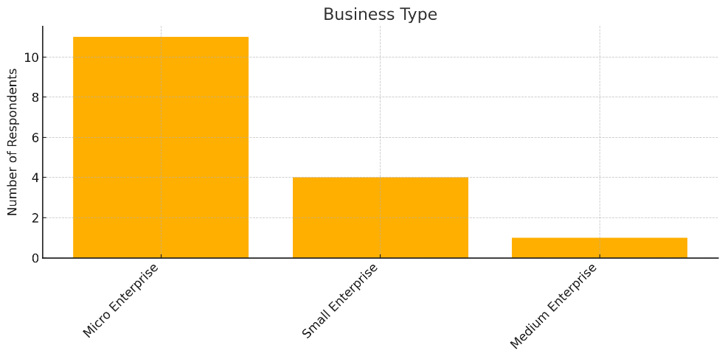

Figure 1. Business Type

- Micro enterprises dominate the respondents.
- This indicates a highly entrepreneurial sample set, consistent with the Philippine economic profile where MSMEs account for 99.5% of all businesses (DTI, 2023).
- Technology interventions must be cost-effective and user-friendly for micro-businesses.

“The predominance of micro-enterprises highlights the importance of low-cost, scalable digital solutions.” (Philippine Statistics Authority, 2022)

The data revealed that a significant majority of the respondents, or 68.75%, belong to the micro-enterprise category. This trend reflects the broader national landscape of the Philippines where micro-enterprises constitute the largest share of all MSMEs. According to the Department of Trade and Industry (2023), micro-enterprises represent over 88% of all MSMEs and are vital contributors to employment and local economic activities. In Davao Oriental, a predominantly rural and agricultural province, the dominance of micro-enterprises is especially pronounced due to the proliferation of small-scale, family-run businesses, local retailers, and informal sector actors who operate with minimal capital and workforce.

This high concentration of micro-enterprises underscores the importance of contextualizing technology integration strategies to suit the realities of small business operations. Micro-enterprises often face limitations in terms of financial capacity, digital infrastructure, and human resources, which directly affects their ability to adopt advanced technologies (ILO, 2022). These businesses typically rely on basic tools such as smartphones, simple point-of-sale (POS) systems, or free digital platforms. As a result, large-scale or high-cost technological solutions may be unattainable or irrelevant without proper support mechanisms or subsidies.

Given these characteristics, the data highlights a key implication for policy and program design: technology interventions must be low-cost, scalable, and simple to use. Digital solutions that require extensive customization, high subscription fees, or skilled IT personnel may not gain traction among micro-enterprises in the province. Instead, mobile-based applications, open-source platforms, and bundled digital services that address core functions such as sales, inventory, and customer engagement are more likely to be adopted and sustained (OECD, 2021). The Philippine Statistics Authority (2022) echoes this, noting that micro-enterprises thrive best with accessible technologies that align with their scale and competencies.

Furthermore, the finding suggests that while micro-enterprises are the most numerous, they are also the most vulnerable when it comes to adapting to technological disruption. Unlike medium-sized businesses, micro-enterprises often lack contingency plans, professional networks, and digital literacy, which puts them at greater risk of digital exclusion. This is particularly concerning as the economy becomes increasingly reliant on e-commerce, fintech, and automated operations. In rural areas like Davao Oriental, digital gaps are exacerbated by poor internet connectivity and limited access to ICT training (UNESCAP, 2022).

Another notable aspect of this trend is its potential impact on inclusive innovation. Because micro-enterprises are often embedded within communities, their digital transformation can contribute to grassroots innovation and localized economic growth. Supporting these businesses through digital skilling, financial grants, and mentorship can produce cascading benefits—not only improving business resilience but also encouraging innovation in service delivery and local supply chains (Asian Development Bank, 2023). Therefore, equipping micro-enterprises with practical and contextualized digital tools is not just an economic necessity but also a social development imperative.

The results also raise important questions regarding digital equity. If micro-enterprises remain underserved or underprioritized in regional development programs, the digital divide may widen further, excluding a significant portion of the entrepreneurial population from digital opportunities. As shown in the survey, these businesses are not devoid of digital interest—they are willing to engage with technology but often lack the capacity or external support to do so effectively. Hence, tailored interventions must focus on affordability, usability, and access to reliable infrastructure.

Moreover, this data validates the need for collaboration between local government units (LGUs), academic institutions, and industry players in crafting responsive digital inclusion programs for micro-enterprises. Public-private partnerships can help deliver affordable internet access, develop MSME-centric platforms, and create regional innovation hubs tailored to local business ecosystems. In Davao Oriental, where many micro-businesses operate in tourism, agriculture, and retail, sector-specific technologies could also be piloted for greater impact (World Bank, 2022).

The predominance of micro-enterprises among the survey respondents points to both opportunities and challenges in MSME digitalization in Davao Oriental. While these enterprises form the economic backbone of the province, their successful integration into the digital economy requires sustained investment in enabling conditions. From infrastructure and policy to training and financial support, technology integration must be approached with a lens of inclusion, flexibility, and practicality.

3.2 Industry Sector
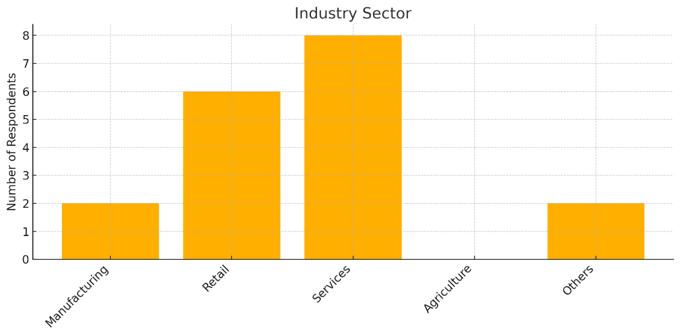

Figure 2. Industry Sector

- Services and retail lead, while agriculture is unrepresented.
- Suggests the technology integration focus is higher in service-oriented sectors.
- Tailoring tech solutions for service and retail workflows (POS, CRM, etc.) can yield better adoption.

“Services sector in the Philippines has experienced a surge in digitization post-pandemic.” (Asian Development Bank, 2022)

The survey results showed that among the 16 MSME respondents, the majority operate in the services (50%) and retail (37.5%) sectors, while no respondents represented the agriculture sector. This distribution reflects a broader economic trend in both the national and regional contexts, where service-oriented enterprises have increasingly become the dominant force in local economies. In Davao Oriental, while agriculture remains the traditional livelihood for many residents, formal enterprises are more likely to emerge in services such as food and beverage, transportation, accommodation, health and beauty, and digital services. This mirrors the national shift from agriculture to services as a primary economic activity, particularly in urbanizing municipalities (Philippine Statistics Authority [PSA], 2023).

The absence of respondents from the agricultural sector may indicate a digital divide or disconnect between traditional farming communities and formal digital business ecosystems. Agricultural enterprises, especially in rural provinces like Davao Oriental, may still be operating informally or outside of digital commerce systems, making them harder to reach or engage through standard survey tools. This suggests that technology integration efforts may currently be bypassing one of the province's foundational economic sectors. While the agriculture sector is crucial for food security and export earnings, its lack of digital engagement remains a concern, especially when considering the rising importance of agri-tech and farm-to-market platforms (FAO, 2021).

The strong showing of service and retail enterprises among respondents highlights that technology adoption is more accessible or prioritized in these sectors. Services and retail businesses are typically customer-facing and rely heavily on tools such as point-of-sale (POS) systems, digital marketing platforms, mobile applications, and customer relationship management (CRM) tools to remain competitive. This finding supports previous research indicating that digital transformation is most advanced in sectors with frequent customer transactions and dynamic market interactions (Asian Development Bank, 2022). In fact, services saw one of the fastest rates of digitization post-COVID-19, as lockdowns forced many businesses to migrate operations online to maintain contact with customers and revenue flow.

This trend toward digital service delivery has important implications for MSMEs in Davao Oriental. Enterprises that adapt to mobile-based orders, online booking systems, and social media marketing are not only more resilient in times of disruption but are also better positioned to expand their market reach beyond their local communities. For example, food services that enable delivery via mobile apps or wellness providers offering online consultations gain a competitive edge through convenience and accessibility. This reinforces the need for local digital transformation programs to be sector-specific, ensuring that services and retail businesses have access to tools and training suited to their workflows (McKinsey & Company, 2021).

The findings also indicate that policy and capacity-building efforts need to be tailored to the characteristics of service and retail sectors. These sectors require fast, user-friendly, and cost-effective solutions that enhance customer interaction, inventory management, and sales reporting. Local MSME development programs may benefit from focusing on upskilling entrepreneurs in digital marketing, e-commerce management, and customer analytics—skills that are increasingly becoming core competencies in these domains. Government and non-government support systems should also consider the seasonal and transactional nature of these businesses when offering technological interventions.

However, the underrepresentation of the manufacturing and agriculture sectors presents a gap that should not be ignored. While services and retail are dominant, manufacturing businesses—especially small-scale food processors, woodworkers, or coconut-based enterprises in Davao Oriental—could benefit from automation, digital inventory tracking, and quality control technologies. Similarly, agricultural cooperatives and agripreneurs can benefit from mobile applications for weather tracking, pest management, and farm logistics. The lack of their participation in this survey signals either a need for better outreach or the need to build digital literacy in these less-engaged sectors (UNESCAP, 2022).

These results, therefore, highlight both the success of digital adoption in certain sectors and the lag in others, pointing to the need for inclusive and sector-sensitive strategies. The heavy representation of services and retail in the survey should not lead to their over-prioritization, but rather serve as a starting point for expanding digital inclusion to other key sectors. For the government, NGOs, and business support organizations, this means designing solutions that are accessible not only to businesses with direct consumer interactions but also to those engaged in production and supply.

While services and retail dominate the landscape of MSMEs engaging in technology in Davao Oriental, this does not represent the entirety of the province’s economic fabric. Moving forward, it is vital to extend the reach of digital programs to underrepresented sectors such as agriculture and manufacturing. Building cross-sectoral partnerships, facilitating mobile-based and offline-compatible digital solutions, and contextualizing training for rural entrepreneurs will help bridge the gap. A balanced and inclusive approach to tech integration will ensure that all sectors—and not just the most digitally visible—benefit from the ongoing transformation of the local economy.

3.3 Years of Operation
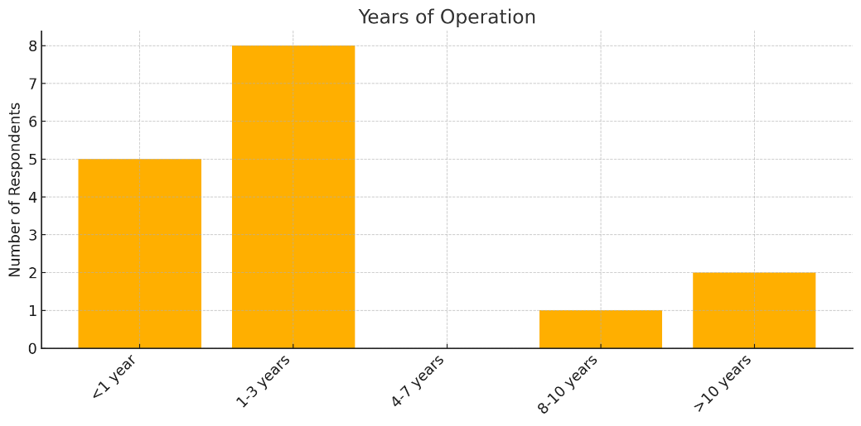

Figure 3. Years of Operation

- 1–3 years and <1 year make up most respondents.
- This suggests a predominance of startups or early-stage businesses, which are typically more agile in adopting technology (OECD, 2021).
- These businesses may lack resources but have fewer bureaucratic barriers to tech upgrades.

“Younger businesses are more likely to embrace digital tools to gain a competitive edge.” (McKinsey & Company, 2021)

The analysis of the survey data on years of operation reveals that the majority of the MSME respondents in Davao Oriental are relatively young businesses. Specifically, 8 out of 16 respondents (50%) reported operating for 1 to 3 years, while 5 respondents (31.25%) indicated their business had been in operation for less than one year. Combined, these two categories represent 81.25% of the sample, clearly suggesting a landscape dominated by startups and early-stage enterprises. This is consistent with national trends that show a significant number of MSMEs in the Philippines are within their formative years, fueled by entrepreneurial energy and the proliferation of digital tools that lower the barriers to market entry (Department of Trade and Industry [DTI], 2023).

The predominance of early-stage businesses points to a promising opportunity for digital adoption. Younger firms, by their nature, are more likely to be agile, open to innovation, and unencumbered by legacy systems that often hinder digital transitions in older firms. These businesses are born into an environment where digital presence—via social media, e-commerce, or mobile platforms—is a core part of competitive strategy (McKinsey & Company, 2021). Moreover, because these enterprises were established closer to or during the COVID-19 pandemic, many of them may have been “digitally native” by necessity, adopting technology early to cope with operational restrictions and evolving customer behavior.

However, the enthusiasm and flexibility of younger businesses are often tempered by the reality of limited financial and human resources. Early-stage MSMEs frequently operate with minimal capital, a small workforce, and little access to structured technical support. While they may recognize the value of integrating technology, their ability to sustain digital tools—whether in the form of software subscriptions, hardware upgrades, or cybersecurity measures—is constrained (OECD, 2021). This creates a paradox where the most tech-willing enterprises are often the least resourced to fully implement and maximize these tools.

Despite these limitations, the low bureaucratic inertia among younger businesses positions them well for experimental learning and rapid adaptation. Unlike older enterprises that may need to retrain staff or overhaul entrenched systems, startups can incorporate technology into their business models from the outset. This was evident in the survey where businesses with 1–3 years of operation were more likely to report using digital marketing tools, e-commerce platforms, and POS systems. This behavior aligns with research showing that the early years of a business are crucial for shaping long-term technological practices (World Bank, 2022).

The data also raise important considerations regarding support structures for younger MSMEs in Davao Oriental. With the right ecosystem—including incubators, startup grants, mentorship, and digital training programs—these businesses can overcome initial resource constraints and scale their technological adoption. Government agencies, local academic institutions, and innovation offices have a critical role to play in providing affordable access to both foundational tools (such as accounting software) and more advanced solutions (such as AI and data analytics) tailored to the needs of emerging businesses (UNESCAP, 2022).

At the same time, the absence of businesses operating for 4 to 7 years in the data raises questions about sustainability and growth transitions. It suggests either a gap in enterprise survival rates or a potential disengagement from tech-focused survey efforts among slightly older businesses. If startup enthusiasm does not translate to long-term stability, it could indicate systemic issues such as weak local markets, limited scaling support, or insufficient follow-up training after the initial business setup phase. This underscores the need for not only startup support but also strategies for technological continuity and scalability beyond the early years.

Additionally, the presence of only one respondent (6.25%) each in the categories of 8–10 years and more than 10 years indicates that more mature enterprises are underrepresented. This may reflect either their lower engagement in digital transformation or survey fatigue. Yet, older businesses should not be left behind in technology conversations. Encouraging technology adoption among mature enterprises—who often have stable customer bases and market knowledge—can lead to significant productivity improvements and digital mentoring opportunities for younger firms (ILO, 2022).

The dominance of startups and young businesses in the respondent profile of this study offers both opportunity and insight. While these enterprises are naturally inclined toward technology use, they require structured support to maximize the benefits of digital tools. For Davao Oriental’s economic development, nurturing these early adopters while simultaneously drawing in more seasoned enterprises into the digital economy will ensure a balanced, inclusive, and resilient MSME ecosystem.

3.4 Technology Currently Used
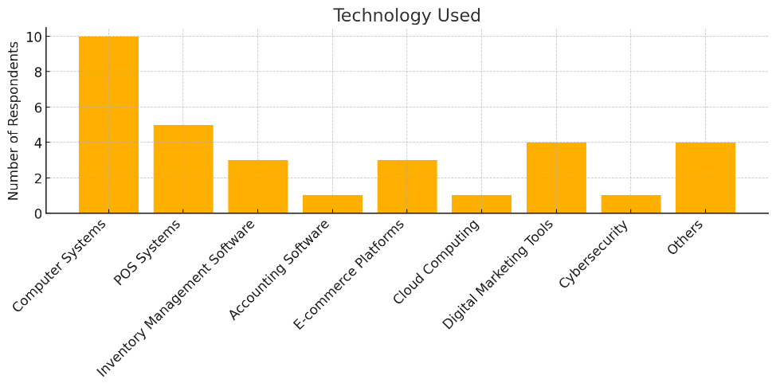

Figure 4. Technology Used

- Most-used: Computer Systems and POS systems.
- Least-used: Accounting software, Cloud, and Cybersecurity.
- Implication: Foundational tools are widely adopted, but there's a gap in advanced tools like cloud or cybersecurity — a potential risk.

“MSMEs often lack cybersecurity preparedness, increasing vulnerability to attacks.” (Cybersecurity Ventures, 2022)

The results of the survey show that among the technologies currently used by MSMEs in Davao Oriental, computer systems and point-of-sale (POS) systems emerged as the most commonly adopted, with 10 and 5 respondents using them respectively. These two technologies represent the foundational digital infrastructure for many micro and small enterprises, particularly those in the retail and services sectors. The high prevalence of computer and POS systems is reflective of the growing awareness among MSMEs of the importance of digitizing core operational processes such as sales transactions, inventory tracking, and data entry (OECD, 2021).

The widespread use of these basic tools highlights that many MSMEs have successfully crossed the initial threshold of digital adoption. This level of integration typically correlates with improved business efficiency, enhanced record-keeping, and better customer service. For enterprises in Davao Oriental, where many operate in remote and semi-urban areas, having computer and POS systems provides a competitive edge in terms of operational control and customer engagement. These tools also serve as a gateway for future digital upgrades, allowing businesses to gradually evolve toward more advanced technologies as they become more digitally mature (Asian Development Bank, 2022).

Despite this foundational success, the survey data also points to a significant gap in the adoption of more advanced digital technologies. Only one respondent each reported using cloud computing services, cybersecurity solutions, and accounting software. This suggests a limited understanding of or access to integrated financial systems and secure data storage solutions. The underutilization of accounting software is particularly notable, as digital bookkeeping can significantly reduce errors, streamline compliance, and support data-driven decision-making. Yet, for many small business owners, manual bookkeeping may still be the norm due to lack of training or perceived complexity (World Bank, 2022).

The limited use of cybersecurity solutions is a particularly critical concern. In an increasingly digital world, even small businesses are vulnerable to cyber threats such as phishing, ransomware, and data breaches. MSMEs, often operating on thin margins and without dedicated IT personnel, are especially susceptible. According to Cybersecurity Ventures (2022), many MSMEs underestimate cyber risks, which leaves them unprepared and exposed. This lack of preparedness not only jeopardizes business operations but can also erode customer trust, especially as online transactions become more common in rural economies like Davao Oriental.

Similarly, the low uptake of cloud computing points to missed opportunities in scalability and remote access to business operations. Cloud-based systems allow MSMEs to access their data anytime, anywhere, and collaborate more effectively, especially in geographically dispersed regions. They also offer cost-saving benefits by reducing the need for physical infrastructure. However, the barriers to adoption may include unreliable internet connectivity, lack of awareness, and fear of data loss—issues that are especially relevant in a province like Davao Oriental where digital infrastructure remains uneven (UNESCAP, 2022).

The survey also indicated some use of inventory management software and e-commerce platforms, with 3 respondents each, and digital marketing tools, with 4 respondents. These tools reflect a growing interest among MSMEs to streamline operations and tap into online markets. The uptake of digital marketing, in particular, demonstrates an understanding of the power of social media and search engine visibility in expanding customer bases. In areas where foot traffic is inconsistent, having an online presence enables local businesses to engage new markets and build brand loyalty (McKinsey & Company, 2021).

However, the uneven spread of technology adoption across categories signals a digital maturity gap. While basic tools have become part of standard practice, more sophisticated solutions remain underutilized. This unevenness may result from a combination of factors such as low digital literacy, cost constraints, fear of complexity, and insufficient institutional support. These findings suggest that interventions to support MSMEs in Davao Oriental must not only provide access to technology but also offer targeted training and after-sales support to increase confidence and long-term use (ILO, 2022).

The survey results suggest that while MSMEs in Davao Oriental have taken important steps toward digitalization, their adoption is largely limited to entry-level tools. There is a clear need to bridge the gap between foundational and advanced technology adoption to ensure business resilience and competitiveness. To do this effectively, stakeholders—including government agencies, tech providers, and academic institutions—must work collaboratively to provide education, incentives, and infrastructure that empower MSMEs to upgrade their digital capabilities and safeguard their operations in an increasingly digital world.

3.5 Primary Purpose of Technology
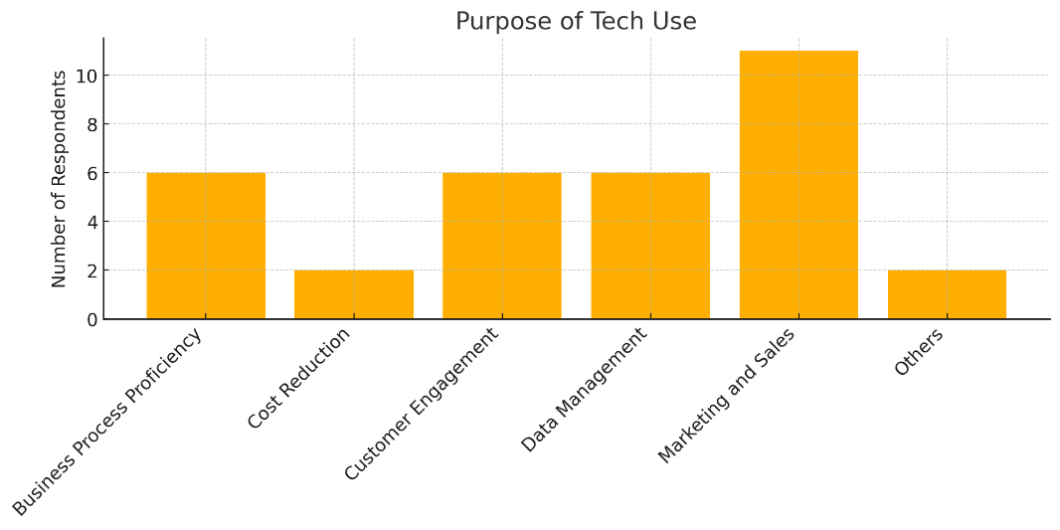

Figure 5. Purpose of Technology Use

- Top purposes: Marketing and Sales, followed by Customer Engagement, Business Process Proficiency, and Data Management.
- Implication: Respondents use technology primarily for revenue generation, less for internal optimization.

“Digital tools for customer-facing functions are prioritized over back-end processes in MSMEs.” (World Bank, 2023)

Survey findings reveal that the most common purpose for technology use among MSMEs in Davao Oriental is marketing and sales, cited by 11 out of 16 respondents (68.75%). This clearly indicates that MSMEs are leveraging digital tools primarily to drive revenue growth, attract customers, and expand market reach. Given the rise of social media platforms, mobile e-commerce, and digital advertising, this result is not surprising. In fact, small businesses in rural and semi-urban areas often see digital platforms as cost-effective channels for increasing visibility, promoting products, and generating sales (McKinsey & Company, 2021). This trend reflects the broader national and global shift toward customer-facing digital transformation in the MSME sector.

Closely following marketing and sales are three equally ranked purposes—customer engagement, business process proficiency, and data management—each chosen by 6 respondents (37.5%). The emphasis on customer engagement suggests that MSMEs understand the value of building relationships and ensuring repeat patronage in a competitive business environment. Tools such as Facebook pages, chatbots, and mobile messaging apps are increasingly being used by small businesses to maintain two-way communication with their clients. The use of technology for data management also signals the growing importance of tracking customer behavior, inventory levels, and sales trends to support decision-making (OECD, 2021). However, the fact that these functions are secondary to marketing points to a business culture that prioritizes immediate returns over long-term operational efficiency.

The relatively lower prioritization of business process optimization and data management as primary purposes of technology suggests that MSMEs may still be in the early stages of digital maturity. While these functions are critical for internal stability and scalability, they often require systems like ERP software, automated inventory tools, and analytics dashboards—technologies that are typically more complex and resource-intensive. As a result, MSMEs may choose to defer such investments until the business has grown or stabilized financially. This pattern supports findings from the World Bank (2023), which note that MSMEs often prioritize customer-facing innovations while back-end processes receive less attention due to their less visible but equally critical nature.

This emphasis on revenue-driven functions underscores both an opportunity and a challenge. On one hand, it shows that MSMEs in Davao Oriental are proactive in harnessing technology to remain competitive in their local markets. On the other hand, it reveals a potential vulnerability: by not investing equally in systems that enhance operational efficiency, businesses risk experiencing bottlenecks as they scale. For instance, an enterprise may succeed in generating online orders through social media campaigns but struggle to fulfill them efficiently due to poor inventory tracking or disorganized logistics systems (UNESCAP, 2022). This imbalance can hamper long-term growth and customer satisfaction.

The findings suggest that while MSMEs in Davao Oriental are strategically using technology to boost sales and enhance customer relationships, there is still considerable room to promote the use of digital tools for back-office and analytical functions. Future digitalization efforts should aim to create a more holistic tech integration approach—one that balances both external competitiveness and internal efficiency. Providing MSMEs with training, mentorship, and affordable access to business process tools will be essential in advancing their digital capabilities beyond marketing into more sustainable business management practices.

3.6 Technology Upgrade Frequency
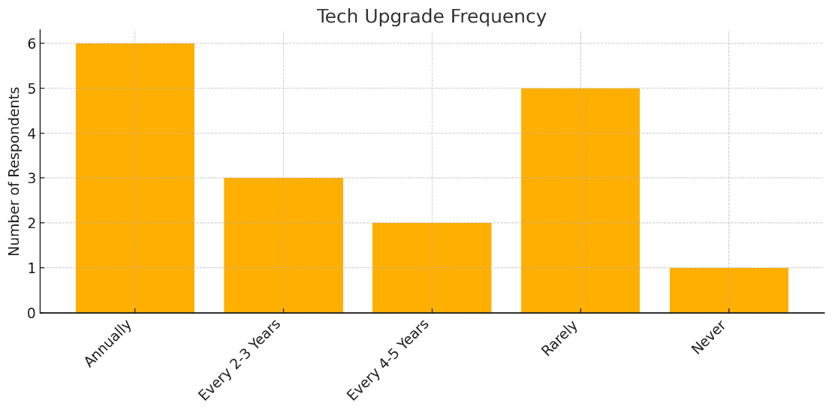

Figure 6. Technology Upgrade Frequency

- Annually and rarely are the extremes.
- A mixed readiness profile: some are proactive, others are passive in tech upgrading.
- Implication: A need for awareness-building and capacity-building programs for lagging businesses.

“Regular tech upgrading correlates with higher productivity and resilience.” (Harvard Business Review, 2021)

The survey data on the frequency of technology upgrades among MSMEs in Davao Oriental reveals a distinctly polarized pattern. Of the 16 respondents, 6 (37.5%) reported upgrading their technology annually, while 5 (31.25%) indicated they do so rarely. This divide suggests a mixed digital readiness profile across the region’s MSMEs, where some enterprises are proactive in keeping up with technological trends, while others remain hesitant or constrained in modernizing their tools and systems. This uneven adoption trajectory reflects varying levels of digital maturity, investment capacity, and exposure to innovation support programs (OECD, 2021).

Those who upgrade technology annually may be characterized as digitally agile enterprises—typically younger or more competitive businesses that recognize the value of continuously adapting to shifting consumer expectations and market dynamics. These MSMEs may have already embraced the use of e-commerce platforms, digital payment systems, or cloud-based services, and view regular updates as essential to maintaining business relevance. Research indicates that firms that frequently refresh their digital infrastructure tend to outperform their peers in terms of productivity, resilience, and customer satisfaction, especially during periods of economic disruption (Harvard Business Review, 2021).

On the opposite end, MSMEs that rarely update their systems may reflect either resource constraints or a lack of perceived urgency. This group may be composed of more traditional or informal businesses that rely on manual processes, outdated software, or legacy systems. In areas of Davao Oriental where internet infrastructure is weak or technical support is scarce, such businesses may not see the benefit—or feasibility—of upgrading technologies regularly. Furthermore, the cost of new hardware or subscription-based software can be prohibitive, especially for micro-enterprises operating on limited margins (UNESCAP, 2022). This reluctance or inability to upgrade can result in operational inefficiencies, security vulnerabilities, and reduced market competitiveness.

The presence of businesses that upgrade every 2–3 years (3 respondents) and every 4–5 years (2 respondents) indicates a middle tier of enterprises that may be aware of technological changes but are more measured or reactive in adopting them. This segment represents a critical target for intervention, as these businesses may already recognize the value of digital tools but lack the strategic guidance or training to adopt a systematic approach. Awareness campaigns, digital literacy training, and localized business advisory services could bridge this gap and help more enterprises move toward a proactive digital culture (International Labour Organization [ILO], 2022).

The variation in technology upgrade frequency among MSMEs in Davao Oriental underscores the need for tiered support strategies. For proactive enterprises, incentives could be introduced to explore advanced technologies such as automation or data analytics. For lagging businesses, foundational support is necessary—ranging from skills training and financial assistance to infrastructure development. By aligning interventions with the digital readiness levels of MSMEs, policymakers and development organizations can foster a more inclusive and sustained digital transformation in the region.

3.7 Factors Influencing Technology Integration
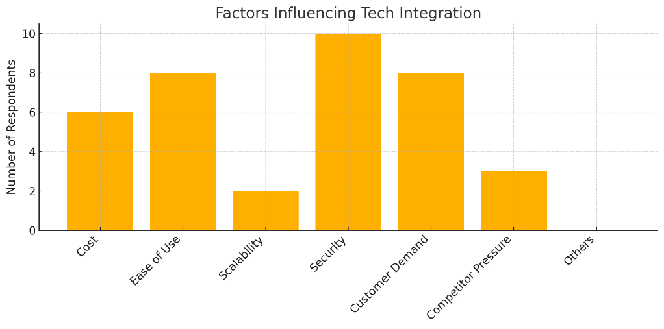

Figure 7. Factors Influencing Technology Integration
Top three factors:
- Security
- Ease of Use
- Customer Demand
SMEs prioritize technology that safeguards data and systems, is easy to operate, and aligns with customer expectations.This mirrors global findings where data privacy and user experience drive SME tech adoption (OECD, 2021). Security concerns are rising due to increasing cyber threats (Kaspersky, 2023).

The survey data highlights security, ease of use, and customer demand as the three most influential factors guiding technology integration decisions among MSMEs in Davao Oriental. Of the 16 respondents, 10 (62.5%) identified security as a key factor, followed by ease of use (8 or 50%), and customer demand (8 or 50%). This prioritization indicates that local enterprises are becoming increasingly aware of both the risks and the opportunities presented by digital tools. MSMEs are no longer adopting technology merely for novelty or trend, but are making informed choices based on functionality, safety, and customer relevance (OECD, 2021).

The emphasis on security is particularly notable given the growing number of cyber threats targeting small businesses globally. MSMEs, especially in developing regions, often lack robust cybersecurity infrastructure, making them easy targets for phishing, ransomware, and data breaches (Kaspersky, 2023). That a majority of respondents considered security a deciding factor reflects a rising awareness of digital vulnerabilities. It also underscores the need for accessible, low-cost cybersecurity solutions tailored for micro and small businesses that may lack in-house IT teams or the capacity to purchase high-end protection software.

At the same time, the strong concern for ease of use suggests that MSMEs in Davao Oriental prioritize intuitive, low-complexity technologies. This is particularly important in a setting where digital literacy levels vary widely, and many entrepreneurs operate without formal IT training. Tools that require minimal onboarding and deliver clear, immediate benefits—such as mobile POS systems or drag-and-drop e-commerce platforms—are more likely to be adopted. This user-centric approach aligns with findings from the OECD (2021), which emphasize that usability is a critical determinant in the successful digital transformation of MSMEs.

The equal weighting of customer demand as a motivating factor further supports the trend toward customer-centric digital adoption. In today’s hyper-connected marketplace, MSMEs must meet customer expectations around convenience, speed, and accessibility. Whether it’s accepting digital payments, having a presence on social media, or enabling online ordering, enterprises are under pressure to integrate technology that enhances the customer experience. As consumers increasingly expect digital interactions, businesses are adapting not just to compete—but to survive (World Bank, 2023).

The factors influencing technology integration among MSMEs in Davao Oriental reflect a balanced awareness of operational risk, user-friendliness, and market responsiveness. For technology providers and policymakers, this suggests the need to offer secure, accessible, and customer-aligned tech solutions that can be easily integrated into the workflows of small enterprises. Moreover, support systems must address not only the affordability of technology but also the knowledge and confidence required for effective adoption and sustained use.

3.8 Challenges in Adopting Technology
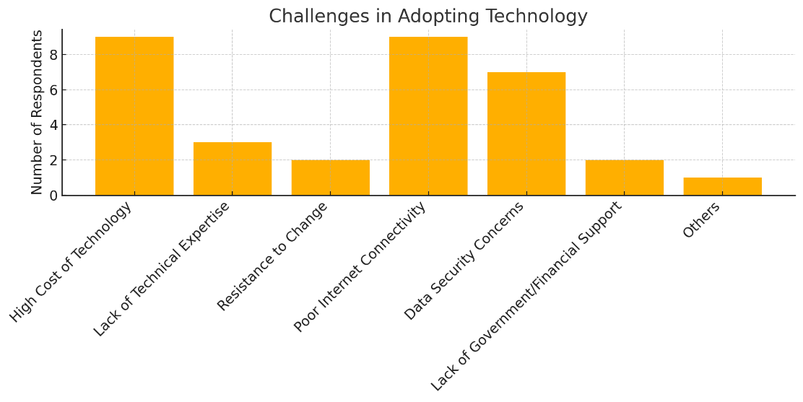

Figure 8. Challenges in Adopting Technology

Most cited:
- High Cost of Technology
- Poor Internet Connectivity
- Data Security Concerns
Financial barriers and infrastructure issues remain core obstacles in tech integration for SMEs in the Philippines. Rural SMEs, especially, struggle with digital transformation due to slow internet and limited cybersecurity skills (UNESCAP, 2022). These are structural issues needing policy-level support.

The survey results show that the most pressing challenges for MSMEs in Davao Oriental in adopting technology are the high cost of technology (9 out of 16 respondents or 56.25%), poor internet connectivity (9 or 56.25%), and data security concerns (7 or 43.75%). These figures paint a clear picture of structural and financial barriers that limit the ability of small enterprises in rural regions to fully embrace digital transformation. Despite the interest and willingness of MSMEs to integrate new technologies, these systemic constraints create a digital divide that restricts growth, efficiency, and competitiveness (UNESCAP, 2022).

The high cost of acquiring and maintaining technology remains a dominant barrier. This includes not only the purchase of devices and software but also ongoing costs for subscriptions, system maintenance, and training. Many micro and small businesses operate with limited capital and cannot afford to allocate significant resources to digital upgrades, especially when they must prioritize day-to-day operational expenses. According to the International Labour Organization (2022), cost-related issues disproportionately affect rural and micro enterprises, often pushing them toward outdated or free technologies that may not provide the efficiency or security needed for long-term growth.

Poor internet connectivity, which was equally cited by 56.25% of respondents, highlights another foundational problem, especially for businesses located outside Mati City or in geographically isolated municipalities in Davao Oriental. Inconsistent or slow internet access limits the use of cloud-based systems, e-commerce platforms, and real-time communication tools. As digital tools increasingly rely on stable connectivity, this infrastructure gap marginalizes MSMEs in rural areas. The OECD (2021) points out that without sufficient digital infrastructure, even well-designed technology interventions fail to generate sustainable results.

Data security concerns also emerged as a significant challenge, with nearly half of respondents expressing apprehension about the risks involved in technology use. These concerns are valid, especially as MSMEs often lack the knowledge and resources to protect themselves from cyber threats such as phishing, ransomware, and data breaches. The rise in cyberattacks targeting small businesses globally has made cybersecurity an urgent need rather than a secondary consideration. However, the lack of training, awareness, and affordable security tools leaves many MSMEs vulnerable (Kaspersky, 2023). In rural settings, where access to cybersecurity experts is limited, this challenge is even more acute.

The findings emphasize that technology adoption is not just a matter of willingness but of access, affordability, and support. The challenges faced by MSMEs in Davao Oriental are structural in nature and cannot be addressed by businesses alone. Local government units, national agencies, and development partners must work collaboratively to improve digital infrastructure, subsidize technology costs for small businesses, and build cybersecurity awareness through targeted capacity-building programs. Without such policy-level interventions, the promise of inclusive digital transformation will remain out of reach for many rural entrepreneurs.

3.9 Ways to Address Challenges

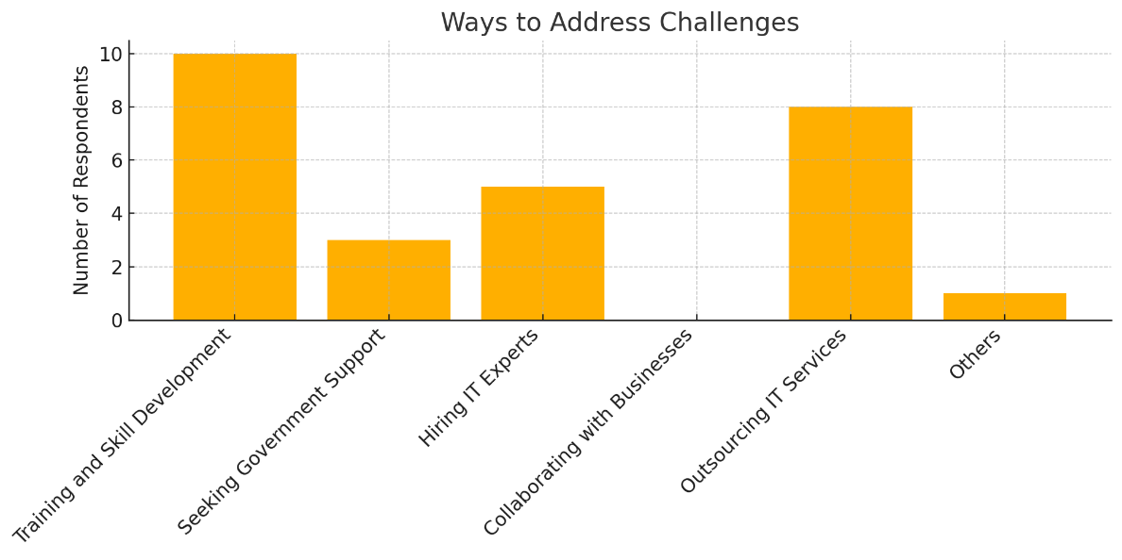

Figure 9. Ways to address challenges

Most utilized strategies:
- Training & Skill Development
- Outsourcing IT Services
- Hiring IT Experts
Capacity building and third-party service partnerships are preferred over government support. Outsourcing provides flexibility and technical depth without large capital investment—suitable for SMEs with limited in-house tech talent (World Bank, 2022).

The survey responses on how MSMEs in Davao Oriental address the challenges of technology adoption show a clear preference for capacity-building and third-party service strategies. Among the 16 respondents, the most cited solution was training and skill development, chosen by 10 respondents (62.5%), followed by outsourcing IT services (8 or 50%), and hiring IT experts (5 or 31.25%). These results highlight a pragmatic approach among MSMEs: instead of relying heavily on government support or costly infrastructure, they focus on upskilling their workforce and engaging external specialists to bridge digital gaps. This finding supports global research that suggests SMEs often adopt flexible and lean strategies when building digital capacity (World Bank, 2022).

The strong emphasis on training and skill development reflects a growing recognition that technology is only as effective as the people who use it. MSMEs understand that internal capacity is essential not just for operating digital tools but for maximizing their potential benefits. In a province like Davao Oriental, where formal tech education and certifications may be less accessible, MSMEs may resort to informal learning, community-based workshops, or online training to build digital skills. This aligns with the OECD’s (2021) recommendation for localized training initiatives tailored to small businesses, especially those in rural and underserved areas.

Equally significant is the popularity of outsourcing IT services, which allows MSMEs to access professional support without incurring the costs of full-time staffing. For small businesses that lack the scale to hire in-house IT departments, outsourcing offers a practical solution to manage installations, troubleshoot issues, or maintain cybersecurity protocols. This approach is particularly advantageous in Davao Oriental where technical expertise may be concentrated in urban centers, and distance or cost constraints limit access for remote MSMEs. Outsourcing also enables businesses to focus on their core competencies while still benefiting from digital transformation (ADB, 2022).

The choice of hiring IT experts, though not as prevalent, indicates that some businesses are beginning to internalize digital skills for long-term stability. Those who pursue this strategy are likely to be more established SMEs with slightly higher resource capacity and a strategic vision for digital integration. However, the relatively low uptake of this option may point to the limited availability of affordable, qualified IT professionals in the local talent pool. According to the International Labour Organization (2022), there remains a mismatch between the digital skills demanded by enterprises and the supply provided by local training institutions in many developing regions.

Overall, the findings suggest that while MSMEs in Davao Oriental are resource-constrained, they are also resourceful, choosing flexible, cost-efficient, and scalable strategies to overcome digital challenges. The clear preference for skills development and third-party solutions over institutional support highlights the need for more responsive and accessible government interventions. Policies and programs that subsidize training, build local IT ecosystems, and facilitate partnerships between MSMEs and tech providers could accelerate digital adoption and make technology a more integral part of small business growth in the region.

3.10 Financial Constraints Experienced
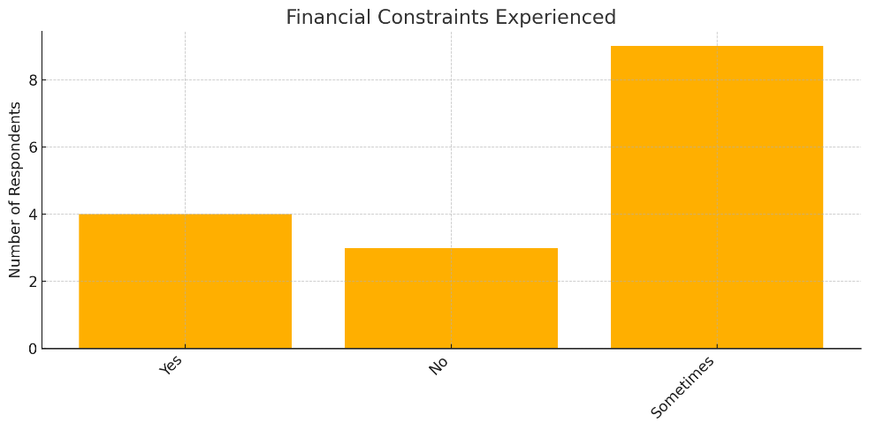

Figure 10. Financial Constraints Experience

Although not always persistent, financial strain is a recurring challenge. Intermittent funding issues impact consistent digital investment. Access to grants and tax incentives may help ease this burden (ADB, 2023).

The survey results on financial constraints in technology adoption reveal that 9 out of 16 respondents (56.25%) reported experiencing financial challenges “sometimes,” while 4 (25%) answered “yes” and only 3 (18.75%) indicated “no.” These findings highlight that while financial limitations may not always be constant, they are a recurring concern that directly impacts MSMEs' ability to invest consistently in digital tools and infrastructure. The data suggests that uncertainty in revenue flow and fluctuating business costs create a situation where technology investments are often delayed, minimized, or abandoned altogether. This supports global findings that financial capability remains one of the top barriers to digital adoption among small and medium enterprises (World Bank, 2022).

The significant number of MSMEs who experience financial constraints intermittently indicates a broader issue of cash flow volatility, especially among micro and small enterprises. In the context of Davao Oriental, where many businesses operate in informal markets and seasonal industries such as agriculture, tourism, and retail, income fluctuations can be extreme. This instability undermines planning and long-term investment, making technology—which often requires upfront costs or ongoing subscriptions—appear as a risk rather than a priority. According to the International Labour Organization (2022), such erratic financial footing deters businesses from making bold digital shifts, especially without external safety nets or incentives.

The 25% of respondents who answered "yes" to experiencing consistent financial constraints likely represent businesses with either low capitalization, high operational expenses, or insufficient access to affordable financing. For these enterprises, digital transformation remains aspirational but inaccessible without external support. This is where policy interventions, such as micro-grants, tax deductions for digital upgrades, and subsidized loan programs, could play a vital role. As emphasized by the Asian Development Bank (2023), targeted financial incentives for technology adoption can help bridge the digital divide and empower MSMEs to modernize despite fiscal limitations.

Conversely, the minority (18.75%) of respondents who indicated they have not experienced financial constraints may reflect better-established enterprises, perhaps with higher capital, better access to financing, or stronger customer bases. While these businesses are better positioned to integrate and sustain digital technologies, their relatively low proportion in the dataset underscores the need for inclusive financial mechanisms that cater to the broader MSME population. Without these supports, technological progress in regions like Davao Oriental will remain concentrated among a small segment of businesses, leaving many others behind.

Financial constraints—whether constant or intermittent—pose a significant hurdle to the digital transformation of MSMEs in Davao Oriental. The data makes it clear that consistent access to funding and financial planning tools is critical for enabling businesses to adopt, upgrade, and sustain the use of technology. A mix of public-private partnerships, government incentives, and financial education programs can help ease the burden and create a more enabling environment for MSMEs to thrive in the digital economy. Addressing these financial challenges is not only an economic imperative but also a step toward a more inclusive and resilient local business ecosystem.

3.11 Best Practices in Tech Integration

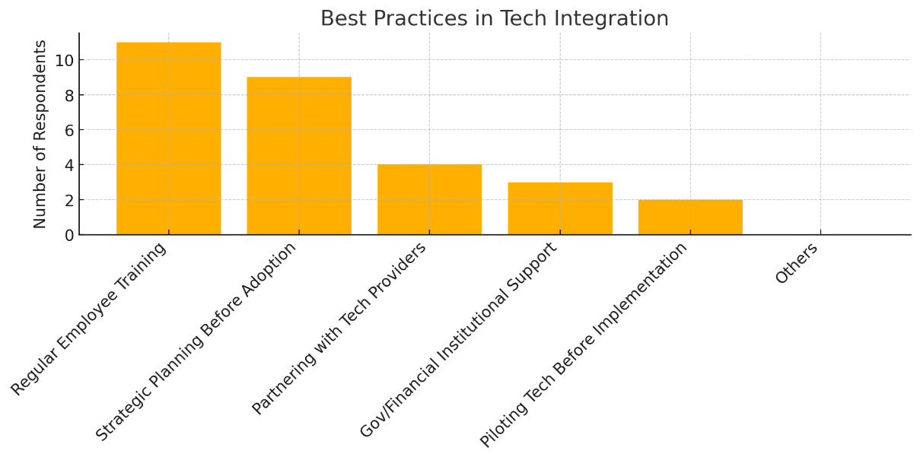

Figure 11. Best Practices in Technology Integration

Leading strategies:
- Regular Employee Training
- Strategic Planning Before Adoption
Human capital and foresight are core to successful tech uptake. Building a digitally literate workforce enables smoother transitions and higher ROI on tech tools (McKinsey, 2021).

The survey results show that regular employee training and strategic planning before adoption are the most commonly practiced strategies among MSMEs in Davao Oriental when it comes to technology integration. Out of 16 respondents, 11 (68.75%) indicated that they prioritize regular employee training, while 9 (56.25%) reported engaging in strategic planning before adopting new technologies. These figures reveal a growing awareness among local MSMEs that successful digital transformation is not just about acquiring tools but about building internal capabilities and ensuring alignment with business objectives. This confirms earlier findings that human capital development is essential for effective technology implementation (McKinsey & Company, 2021).

The strong preference for employee training demonstrates that MSMEs recognize the importance of digital literacy and workforce competence in managing new technologies. In rural regions such as Davao Oriental, where formal ICT education may be less accessible, businesses that invest in informal or on-the-job training are more likely to see successful tech adoption. Training enables employees to understand and confidently use new tools, reduces operational errors, and fosters a workplace culture that is more receptive to innovation. According to the International Labour Organization (2022), enterprises that continually build digital skills among their staff are more resilient and agile in responding to market shifts and technological changes.

Meanwhile, strategic planning prior to technology adoption reflects a maturing approach to innovation among MSMEs. Rather than impulsively adopting trending tools, businesses are beginning to assess the fit, cost, benefits, and long-term value of technologies before integrating them into operations. This forward-thinking practice minimizes the risk of investing in tools that are misaligned with the business model or too complex for the team to manage. Strategic planning also includes piloting systems, budgeting for digital upgrades, and evaluating vendor reliability—steps that contribute to more sustainable and efficient tech implementation (OECD, 2021).

Interestingly, other best practices like partnering with tech providers and piloting technology before full implementation received lower but notable uptake, suggesting that while MSMEs are open to external collaboration and experimentation, such practices are not yet widespread. This could be due to a lack of access to tech partners in the local ecosystem or limited awareness of how pilot testing can mitigate risks. Strengthening partnerships between local businesses, IT service providers, and educational institutions could expand the reach and impact of these practices, especially in provinces like Davao Oriental where digital ecosystems are still developing (Asian Development Bank, 2022).

The survey results affirm that human capital development and strategic foresight are at the heart of successful technology integration in MSMEs. These best practices empower businesses to not only adopt digital tools but also sustain and maximize their impact. For development agencies and policymakers, this presents a clear path forward: support MSMEs with training programs, mentorship, and strategic planning toolkits tailored to their size and sector. Doing so will not only accelerate digital adoption but also ensure it is meaningful, inclusive, and aligned with the growth trajectories of small enterprises in rural regions.

3.12 Planned Technology Investment Next Year
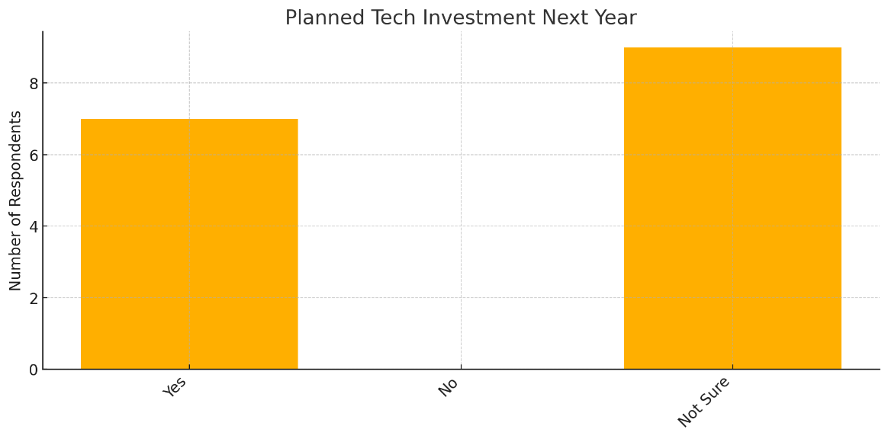

Figure 12. Planned Technology Investment Next Year

There's interest but uncertainty — perhaps due to budget or unclear ROI. Risk aversion in tech investment among SMEs is linked to volatile returns and lack of tech roadmap (OECD, 2020).

The survey results on planned technology investments for the upcoming year reveal a landscape of cautious optimism among MSMEs in Davao Oriental. Of the 16 respondents, 7 (43.75%) indicated a clear intention to invest in new technologies, while 9 (56.25%) expressed uncertainty. Notably, no respondent answered “no,” suggesting that while some MSMEs may hesitate, outright resistance to digital investment is minimal. This pattern reflects a growing awareness of technology’s importance for competitiveness, yet it also exposes the hesitation rooted in perceived risk, unclear returns on investment (ROI), and financial instability—common issues among rural enterprises (OECD, 2020).

The high level of uncertainty points to deeper structural and psychological barriers that hinder confident digital investment. Many MSMEs lack a formal digital roadmap, which makes it difficult to assess the cost-benefit ratio of adopting specific tools. Without technical guidance or success benchmarks, MSME owners may struggle to determine whether technology investments will deliver long-term value, especially when faced with competing budget priorities. This risk aversion is compounded by the experience of volatile revenue patterns in small enterprises, which makes any form of capital outlay, particularly for intangible assets like software, a significant gamble (International Labour Organization, 2022).

In light of these findings, there is a clear need for targeted interventions to de-risk technology investments for MSMEs. This could include public-private initiatives offering pilot programs, subsidies, or guided assessments to help enterprises make informed choices. Business development services and digital mentors can also play a critical role in demystifying ROI and helping enterprises link technology with measurable outcomes such as customer growth, operational efficiency, or cost savings. As the Asian Development Bank (2022) notes, MSMEs are more likely to invest in digital tools when they have access to evidence-based insights and contextualized success stories. Facilitating this kind of support could unlock more confident and strategic tech investments in the province.

3.13 Technology Planned for Adoption

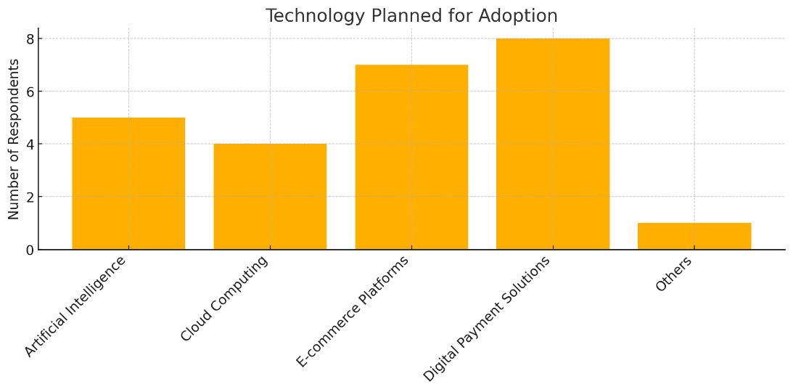

Figure 13. Technology Planned for Adoption

Top choices:
- Digital Payment Solutions
- E-commerce Platforms
- Artificial Intelligence
There's a shift toward customer-centric digital tools and automation. Post-pandemic consumer behavior favored digital payments and online platforms, pushing SMEs to follow suit (Bain & Company, 2022).

The survey results on technologies that MSMEs in Davao Oriental plan to adopt in the near future indicate a significant lean toward customer-centric digital tools. Of the 16 respondents, 8 (50%) indicated interest in adopting digital payment solutions, followed by 7 (43.75%) planning to use e-commerce platforms, and 5 (31.25%) expressing intent to explore artificial intelligence (AI). These figures underscore a clear transition toward technologies that directly respond to evolving consumer preferences, especially in the wake of the COVID-19 pandemic, which accelerated digital habits such as contactless payments, online shopping, and automated service delivery (Bain & Company, 2022). MSMEs appear to be aligning their future tech investments with what enhances customer access, convenience, and engagement.

The preference for digital payment systems and e-commerce platforms is particularly significant for rural and semi-urban settings like Davao Oriental, where physical distance and limited banking access have traditionally constrained business operations. These technologies offer a low-barrier entry point into the digital economy, enabling MSMEs to reach customers beyond local markets and facilitate smoother transactions. Their planned adoption signals a growing understanding among business owners that digital presence is no longer optional—it is a competitive necessity. Moreover, this shift also suggests a positive feedback loop: as more consumers adopt digital tools, MSMEs are compelled to follow suit to stay relevant (OECD, 2021).

The inclusion of artificial intelligence among the technologies planned for future adoption is particularly promising, albeit still emerging. Although AI adoption remains modest compared to simpler tools, its presence in the MSME digital roadmap indicates growing interest in automation, analytics, and personalization. This suggests that some MSMEs are not only looking to expand customer reach but also to improve decision-making, efficiency, and customer experience through smart systems. However, for AI and other advanced technologies to gain wider traction, MSMEs will require access to affordable platforms, technical support, and sector-specific use cases (Asian Development Bank, 2022). As such, the evolving technology priorities among MSMEs reflect a combination of immediate consumer-driven needs and aspirations toward smarter, data-informed business operations.

3.14 Support Needed for Integration
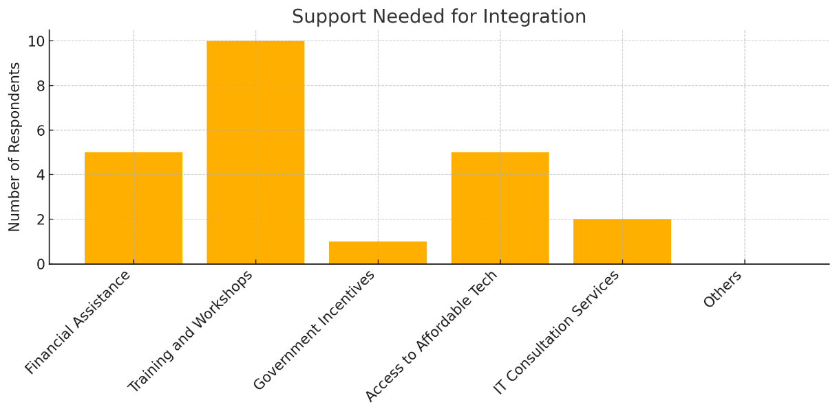

Figure 14. Support Needed for Integration

Most requested:
- Training and Workshops
- Access to Affordable Tech
- Financial Assistance
Capacity-building still dominates over direct monetary support. Empowering SMEs with knowledge and tools rather than one-off funding improves long-term digital success (ILO, 2022).

According to the survey, the most frequently cited support needed by MSMEs in Davao Oriental to enhance technology integration is training and workshops, identified by 10 out of 16 respondents (62.5%). This was followed by access to affordable technology and financial assistance, each cited by 5 respondents (31.25%). These results emphasize that while funding is important, the dominant priority among local businesses is capacity building—specifically, equipping owners and employees with the knowledge and confidence to effectively implement and use technology. This aligns with broader findings that sustained digital adoption is most successful when paired with human capital development rather than solely relying on financial incentives (International Labour Organization [ILO], 2022).

The strong demand for affordable technology solutions indicates that MSMEs are keen to integrate digital tools but are limited by the cost of hardware, software, and related infrastructure. In regions like Davao Oriental, where market size and purchasing power may be lower than in urban centers, the availability of cost-effective, scalable, and user-friendly technology is critical. This includes free or low-cost cloud-based services, open-source applications, and subsidized licensing programs. Without access to affordable tools, many MSMEs risk digital exclusion despite their willingness to embrace change. As noted by the OECD (2021), digital transformation must be inclusive, and affordability remains a key enabler for smaller enterprises in developing economies.

Although financial assistance ranked third, its presence alongside other forms of support points to a more holistic understanding among MSMEs of what digital transformation requires. Rather than relying purely on grants or loans, businesses are asking for structures that combine access to capital with education, mentorship, and practical tools. This integrated approach increases the likelihood of long-term digital maturity and operational improvement. Public-private partnerships that provide bundled support—including training, tech access, and financial services—can respond more effectively to these multi-dimensional needs. As the Asian Development Bank (2022) highlights, MSMEs thrive best in ecosystems that address both the knowledge and affordability gaps in technology integration.

4.0 Conclusion
The study concludes that micro-enterprises overwhelmingly dominate the MSME landscape in Davao Oriental, accounting for over two-thirds of all respondents. This reflects the national trend where micro-enterprises make up more than 88% of all MSMEs in the Philippines (DTI, 2023). Their predominance signifies both potential and vulnerability in the digital transformation space. On one hand, their flexibility and embeddedness in local economies make them ideal candidates for grassroots innovation. On the other, their limited access to capital, digital infrastructure, and skilled human resources constrains their ability to adopt sophisticated digital tools (ILO, 2022).

Service and retail sectors lead in technology use, while agriculture—a critical component of the province’s economy—remains largely digitally unrepresented. This highlights a sectoral imbalance in digital adoption. The ease of adopting customer-facing digital tools such as POS systems and e-commerce platforms in services and retail contrasts with the lack of accessible agri-tech innovations for the agricultural sector. This underlines the urgency of developing inclusive strategies that target hard-to-reach sectors through tailored outreach, training, and digital infrastructure expansion (FAO, 2021; ADB, 2022).

The majority of MSMEs in the study are young enterprises, with more than 80% having operated for less than three years. While this indicates a thriving entrepreneurial ecosystem, it also suggests an immature stage of digital integration. Young businesses are typically more agile and open to adopting technology but often lack the financial and institutional support to sustain it (OECD, 2021). This implies that MSME development in Davao Oriental must prioritize both digital onboarding and sustainability, ensuring that early adopters receive continuous mentoring and technical assistance as they scale.

Findings on the types of technology used revealed a clear divide between basic and advanced digital tools. While computer systems and POS technologies are widely used, more advanced applications such as accounting software, cloud computing, and cybersecurity solutions remain largely untapped. This uneven adoption pattern illustrates the digital maturity gap that persists among MSMEs. Without interventions to close this gap, businesses risk operational inefficiencies, data insecurity, and diminished competitiveness (Cybersecurity Ventures, 2022; World Bank, 2022).

The primary motivation for technology use is revenue generation—specifically, marketing and sales. However, functions like data management and business process optimization are given less priority, revealing a need to educate MSMEs on the importance of internal digital systems. A heavy focus on customer-facing tools may yield short-term gains, but long-term sustainability requires investment in systems that enhance operational efficiency and data-driven decision-making (McKinsey & Company, 2021; UNESCAP, 2022).

MSMEs reported mixed readiness in terms of upgrading technology. While some update tools annually, others rarely do, pointing to disparities in digital awareness, investment capacity, and access to training. The leading factors influencing tech adoption—security, ease of use, and customer demand—underscore the importance of intuitive and secure platforms. However, consistent support is needed to ensure that technology integration is not only reactive but also strategic and aligned with long-term business goals (Kaspersky, 2023; OECD, 2021).

Structural challenges such as high technology costs, poor internet connectivity, and cybersecurity risks remain pervasive and require systemic solutions. Despite these barriers, MSMEs are not passive—they are actively engaging in capacity-building efforts such as training, outsourcing IT services, and hiring technical experts when resources allow. Their pragmatic responses to these constraints highlight a strong willingness to innovate if given the right support (ILO, 2022; World Bank, 2022).

The digital transformation of MSMEs in Davao Oriental is well underway, though marked by sectoral gaps, financial limitations, and uneven technological maturity. The study emphasizes the need for a multi-dimensional support ecosystem involving government, industry, and academia. Programs that combine training, affordable tech access, infrastructure upgrades, and financial assistance will be crucial to building an inclusive and sustainable digital economy in the province. The success of MSME technology integration lies not just in adoption but in long-term capacity, resilience, and inclusive innovation.

5.0 Contributions of Authors
The authors contributed significantly and led the conception, design, and conduct of the study, as well as the analysis and interpretation of results.

6.0 Funding
This research was financially supported by the authors and assisted by the University for use of resources, in the development and conduct of the study.

7.0 Conflict of Interests
The authors declare no conflicts of interest in the conduct and publication of this study.

8.0 Acknowledgment
The authors generally wish to thank and acknowledge individuals who significantly contributed to the development of the study, especially the support of the University and its top management

- References
Asian Development Bank. (2022). Asia Small and Medium-Sized Enterprise Monitor 2021: Volume II—COVID-19 impact on micro, small, and medium-sized enterprises in Asia. https://www.adb.org/publications/asia-sme-monitor-2021-volume-2
Asian Development Bank. (2023). Digital transformation for inclusive growth. https://www.adb.org/publications/digital-transformation-inclusive-growth
Bain & Company. (2022). e-Conomy SEA 2022. https://www.bain.com/insights/e-conomy-sea-2022/
Creswell, J. W., & Creswell, J. D. (2018). Research design: Qualitative, quantitative, and mixed methods approaches (5th ed.). Sage Publications.
Cybersecurity Ventures. (2022). 2022 cybersecurity almanac: 100 facts and figures. https://cybersecurityventures.com/cybersecurity-almanac-2022
Department of Trade and Industry. (2023). MSME statistics. https://www.dti.gov.ph/resources/msme-statistics
Etikan, I., Musa, S. A., & Alkassim, R. S. (2016). Comparison of convenience sampling and purposive sampling. American Journal of Theoretical and Applied Statistics, 5(1), 1–4. https://doi.org/10.11648/j.ajtas.20160501.11
Food and Agriculture Organization. (2021). Digital agriculture transformation: Country studies. https://openknowledge.fao.org/handle/20.500.14283/CB4960EN
Harvard Business Review. (2021). The digital imperative for small businesses. https://hbr.org/2021/09/the-4-tiers-of-digital-transformation
International Labour Organization. (2022). Digital skills and the future of work for small enterprises. https://www.ilo.org/wcmsp5/groups/public/---ed_emp/documents/publication/wcms_863867.pdf
International Labour Organization. (2022). Digital skills for SMEs. https://www.ilo.org/skills/pubs/WCMS_847782/lang--en/index.htm
International Labour Organization. (2022). Financial inclusion and digital readiness among small enterprises. https://www.ilo.org/global/publications/WCMS_848803
Kaspersky. (2023). Cybersecurity for small businesses. https://www.kaspersky.com/resource-center/preemptive-safety/small-business-cyber-security
Kaspersky. (2023). Cybersecurity threats facing small and medium-sized businesses. https://securelist.com/smb-threat-report-2023/110097/
McKinsey & Company. (2021). Digital adoption by SMEs: Trends and challenges. https://www.mckinsey.com/industries/technology-media-and-telecommunications/our-insights/how-covid-19-has-pushed-companies-over-the-technology-tipping-point
McKinsey & Company. (2021). How COVID-19 has pushed companies over the technology tipping point. https://www.mckinsey.com/business-functions/mckinsey-digital/our-insights/the-covid-19-digital-shift
Neuman, W. L. (2014). Social research methods: Qualitative and quantitative approaches (7th ed.). Pearson.
Organisation for Economic Co-operation and Development. (2021). The digital transformation of SMEs. https://www.oecd.org/publications/the-digital-transformation-of-smes-bdb9256a-en.htm
Philippine Statistics Authority. (2023). Regional social and economic trends: Davao Region. https://psa.gov.ph
United Nations Economic and Social Commission for Asia and the Pacific. (2022). SME digital readiness in Asia-Pacific. https://www.unescap.org/resources/sme-digital-readiness-asia-pacific
United Nations Economic and Social Commission for Asia and the Pacific. (2022). Closing the digital divide for small businesses in rural areas. https://www.unescap.org/resources/closing-digital-divide-small-businesses-rural-areas
World Bank. (2022). Technology adoption among small enterprises. https://www.worldbank.org/en/topic/smefinance
World Bank. (2023). Digital priorities of small businesses in emerging markets. https://www.worldbank.org/en/news/feature/2023/03/27/digital-priorities-of-small-businesses
World Bank. (2023). Small business digitalization in emerging markets: Trends and challenges. https://www.worldbank.org/en/news/feature/2023/06/15/small-business-digitalization-trends

