HealthCare Agent AI

Abstract
This research explores the shift from static medical algorithms to autonomous "agentic" systems in healthcare. Unlike traditional AI, these agents utilize Large Language Models (LLMs) to engage in complex reasoning through a four-pillar framework: planning, action, reflection, and memory. This paper investigates their application in diagnostics, workflow automation, and multi-agent collaboration, while critically addressing the current "simulation gap" in clinical validation.
Keywords: Medical AI Agents, Autonomous Clinical Systems, Large Language Models,
Chain-of-Thought Reasoning, Multimodal Integration, Agentic Framework, Clinical Decision Support, Human-in-the-Loop, Healthcare Automation, Physician Burnout, Precision Medicine, Scoping Review, Simulation Gap, PRISMA-ScR.
The core functions and applications of healthcare AI agents span multiple critical domains, beginning with advanced clinical decision support and diagnostics where they enhance medical accuracy by assisting in high-stakes tasks such as sepsis prediction and cancer detection in diagnostic imaging. Beyond clinical analysis, these agents play a vital role in workflow automation and administration by managing time-consuming tasks like generating summaries from electronic health records, which directly contributes to reducing physician burnout. Furthermore, they significantly improve patient engagement by guiding individuals through their personalized care journeys, monitoring post-treatment recovery via voice-based interfaces, and facilitating accessible remote care. Finally, the integration of multi-agent systems allows for the utilization of specialized teams—including diagnostic, monitoring, and therapeutic agents—that collaborate seamlessly to solve complex clinical challenges such as comprehensive treatment planning..

Introduction
Artificial Intelligence (AI) has emerged as a transformative technology in the healthcare sector by enabling intelligent decision-making, automation, and data-driven clinical support. Healthcare Agent AI refers to autonomous or semi-autonomous intelligent agents designed to assist in medical diagnosis, patient monitoring, hospital management and personalized healthcare delivery. These agents are capable of perceiving patient data, analyzing data information and taking appropriate actions with minimal human intervention.
The integration of Artificial Intelligence into medical services has evolved beyond simple data processing to enable autonomous clinical support. Healthcare AI Agents represent a new paradigm of intelligent systems capable of interpreting patient data and executing medical tasks with minimal oversight. By leveraging deep learning and natural language processing, these agents address critical challenges such as physician shortages and the rising global demand for efficient, high-accuracy diagnostic tools.
The increasing burden on healthcare systems, shortage of medical professionals, and rising demand for quality healthcare services have accelerated the adoption of AI-based solutions. Healthcare Agent AI systems leverage machine learning, natural language processing, and deep learning techniques to improve diagnostic accuracy, reduce operational costs, and enhance patient outcomes. Applications such as virtual health assistants, clinical decision support systems, and remote patient monitoring have demonstrated significant potential in modern healthcare environments.
Medical AI agents represent a transformative paradigm in healthcare, distinguished from traditional AI by their autonomy, adaptability, and ability to manage complex tasks. This review introduces a conceptual framework for these agents built on four core components: planning, action, reflection, and memory. We examine the framework’s application across key clinical domains, from enhancing diagnostic accuracy and personalizing treatment to guiding robotic surgery and enabling real-time patient monitoring. The review critically analyzes implementation challenges, including technical integration, clinician adoption, regulatory adaptation, and ethical considerations like data privacy and algorithmic bias. Future directions are explored, including the shift toward proactive, multi-agent collaborative systems and the visionary AI Agent Hospital concept. While these agents hold immense potential to revolutionize healthcare delivery by improving efficiency and patient outcomes, their successful and equitable integration hinges on navigating these profound technical, ethical, and regulatory hurdles.

Benefits of HealthCare Agent AI
- Reduced Doctor WorkLoad
- 24/7 patient support
- Early Disease Detection
- Improved Patient Outcomes
- Cost-effective healthcare

Comparison of Human Clinical, Traditional medial AI and Medical AI agent

Feature | Human clinician | Traditional medical AI | Medical AI agent
Core nature | biological intelligence with consciousness & empathy | a computational  tool or algorithm | an autonomous or semi-autonomous system
Primary function | holistic patient care, complex  reasoning, empathy | performs a specific, pre-defined task (e.g., classify, regression) | manages complex, multi-step tasks and workflows
Decisionmaking | experience-based,  intuitive, and evidence-informed | rule-based or pattern recognition on a given dataset | data-driven, goal-  oriented, and  adaptive reasoning
Autonomy | full autonomy in clinical judgment | none; acts as a passive tool for human use | high; can operate independently to achieve goals
Learning & adaptation | lifelong learning from experience and education | static; requires retraining on new datasets to update | continuous learning from new data and  interactions
Context awareness | high; understands patient history and context | low to none;  typically contextagnostic | high; maintains context across interactions via memory
Interaction | direct interaction with patients and systems | human-invoked; typically a one-way information output | interactive; can query systems and collaborate with humans
Role in  healthcare | the central  decision-maker and caregiver | a supplementary tool to augment a specific task | a collaborative partner or assistant in the care process

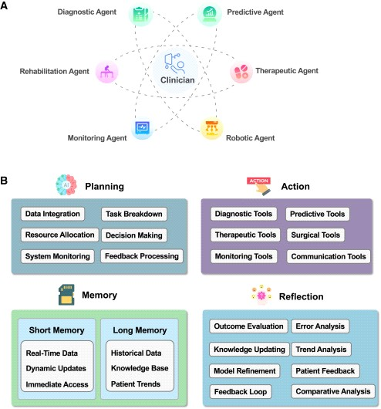

Medical AI agent framework
AI agents are fundamentally structured around four core components—planning, action, reflection, and memory (Figure 1B)—that collectively enable their autonomous functionality in complex environments.2,45,51,52,53 “Planning,” often powered by LLMs or VLMs, serves as the cognitive core, allowing agents to process inputs, perform reasoning, and generate decisions. In healthcare, this capability enables agents to analyze medical records, synthesize information, and assist in diagnostic tasks with precision. “Action” translates these decisions into tangible outputs, such as generating responses, guiding robotic systems in surgical procedures, or recommending treatment plans. “Reflection” equips the agent with the ability to perceive and interpret its environment through sensory data, such as extracting insights from medical imaging or monitoring real-time patient conditions, facilitating context-aware interactions. Meanwhile, “memory” acts as a repository for past experiences and acquired knowledge, enabling agents to adapt and improve over time. This component is particularly critical in personalized medicine, as historical patient data are leveraged to refine recommendations and enhance outcomes. Together, these four components—cognition, perception, action, and memory—form an integrated framework, empowering AI agents to intelligently engage with their environment, adapt to dynamic challenges, and continuously evolve their capabilities.

Planning
The planning component of AI agents serves as the cognitive foundation, responsible for processing complex information, performing sophisticated reasoning, and making decisions.5 At the core of this system are advanced models, particularly LLMs,54,55 which enable agents to analyze complex inputs and draw meaningful inferences from extensive training data.56,57 This cognitive capability allows agents to handle diverse tasks, ranging from natural language understanding to specialized cognitive functions like logical reasoning or planning.58 In healthcare contexts, the planning system processes patient data from electronic health records (EHRs), interprets diagnostic test results, and synthesizes information from medical literature to generate evidence-based recommendations. For example, when evaluating a patient with chest pain, the planning system can integrate symptoms, vital signs, laboratory results, and imaging findings to generate differential diagnoses and recommend appropriate diagnostic workups. The integration of external medical knowledge bases further enhances the agent’s decisionmaking capabilities, ensuring recommendations align with current clinical guidelines and best practices.

Action
In healthcare, this capability is exemplified through tools that allow the agent to carry out precise actions, from generating diagnostic reports to assisting in clinical procedures.59 For instance, in robotic surgery, AI agents use their action systems to control robotic arms, executing delicate and highly precise movements based on real-time sensory feedback. Similarly, in clinical decision support, the action system can generate treatment recommendations or alert healthcare providers to critical changes in patient conditions. The tool component encompasses diverse interfaces including (1) application programming interfaces (APIs) for accessing electronic health records, laboratory information systems, and medical imaging repositories; (2) hardware interfaces for controlling medical devices such as infusion pumps, ventilators, and surgical robots; (3) specialized software libraries for image processing, natural language processing, and predictive analytics; and (4) robotic actuators for physical manipulation tasks in laboratory automation and patient care. These tools may include data retrieval systems, automated drug dispensers, or even integration with hospital management systems for streamlining administrative duties. By utilizing both internal action capabilities and external tools, AI agents can perform complex, multi-step procedures in healthcare environments, contributing to greater efficiency, accuracy, and improved patient outcomes.

Reflection
The reflection ability of AI agents is crucial for processing and interpreting sensory data in healthcare environments, enabling them to interact with and understand complex medical information.15,60 This capability encompasses various modalities, including visual inputs, such as medical imaging (e.g., X-rays, magnetic resonance imaging [MRI], and computed tomography [CT] scans), and physiological data like heart rate, blood pressure, and other vital signs monitored through wearable devices. AI agents can analyze medical images to detect anomalies like tumors, fractures, or tissue damage, providing valuable insights for diagnosis and treatment planning. Additionally, the perceptual system allows the agent to process real-time data from sensors, enabling continuous monitoring of patient conditions and alerting healthcare providers to potential risks, such as deterioration in vital signs. By synthesizing diverse sensory inputs, AI agents can generate a more holistic understanding of a patient’s health status, facilitating timely and accurate clinical decisions. This perceptual ability is vital for applications like robotic surgery, where the agent must interpret visual and tactile feedback to assist with precision in real-time operations.

Memory:
The memory system operates through two distinct components: short-term and long-term memory. Short-term memory maintains immediate contextual information during active patient encounters, such as current vital signs (heart rate: 72 bpm, blood pressure: 120/80 mmHg), ongoing medication administration, and real-time symptom progression within a single clinical session. Long-term memory stores aggregated knowledge including patient medical histories, treatment outcomes across similar patient cohorts, learned patterns from thousands of diagnostic cases, and evidence-based treatment protocols that inform future decision-making. In healthcare, the memory system allows AI agents to retain patient data, treatment histories, and clinical outcomes, providing a valuable resource for informed decision-making. For example, an AI agent can recall a patient’s medical history, previous treatments, and responses to medications, helping clinicians to tailor more personalized treatment plans.
Additionally, the memory system facilitates continuous learning, enabling the AI agent to refine its decision-making capabilities as new data become available. This learning is crucial for improving diagnostic accuracy, predicting patient outcomes, and identifying potential risks. By maintaining and updating a dynamic repository of knowledge, the memory system ensures that AI agents can leverage accumulated data for more precise and contextually appropriate actions. Thus, the memory system plays a pivotal role in enhancing the long-term effectiveness and reliability of AI agents in healthcare, ensuring they evolve in response to changing clinical needs.

Research paper analysis
The research paper I am studying to is for finding out the uses and practical implications of healthcare ai agents in the field of healthcare and medical services etc.
The following research paper uses scoping review methodology (PRISMA-ScR guidelines) as per is mentions with a search record based index which identifies 1,070 records of which 43 studies were ultimately included after full-text review. Of these 43 included studies, 36 were published in 2025. Systems were categorized into 8 conversational agents, 17 workflow/automation assistants, and 18 multimodal decision support agents. . Evaluation settings were predominantly simu lated environments or laboratory studies, with few clinical pilots or real-world deploy ments. Primary reported outcomes focused on process measures (efficiency) and diagnostic accuracy; clinical outcomes and safety endpoints were rarely addressed

The core idea behind our research::-
The gist of this paper is a comprehensive scoping review of 43 recent studies (mostly from 2025) analyzing the current state of "agentic" AI in healthcare systems.

- What makes them different: unlike basic algorithms and static chatbots, agentic AI can autonomously plan tasks, maintain memory, use external tools like executing code or searching through the databases and also self-correct their own errors.
- How are they used:- they are functioning as conversational agents, workflow automation assistants and multimodal decision-support tools.
- The ultimate conclusion: AI agents are evolving quickly into functional prototypes capable of complex reasoning. However, research is currently heavily stuck in simulated or laboratory environments. The technology cannot see widespread adoption until researchers prioritize real-world clinical trials to prove safety, usability, and actual clinical effectiveness.

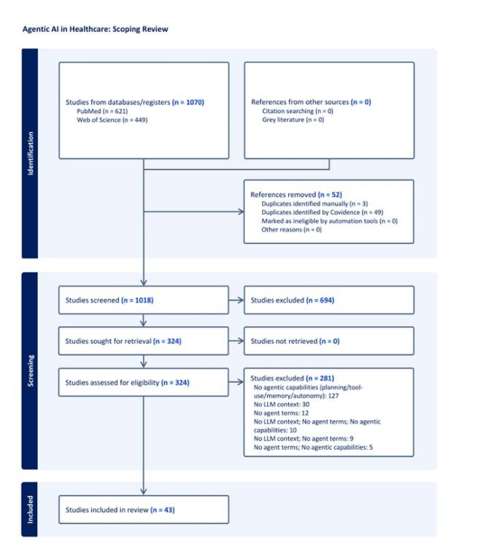

Literature Review: The Landscape of Agentic AI in Healthcare

1. The Transition to Agentic Architectures
Current research defines a critical shift from standard Large Language Models (LLMs) to "AI Agents." While traditional models function as passive text predictors, the literature characterizes agents by their autonomy and goal-oriented behavior. According to recent reviews, the core of these healthcare agents lies in their ability to perform "Chain-ofThought" (CoT) reasoning, which allows them to decompose complex clinical tasks into manageable steps. This transition is marked by the integration of four specific capabilities: perception of multimodal data, long-term memory for longitudinal patient records, reasoning for diagnostic planning, and the ability to execute actions through external tool-use (e.g., API calls to medical databases).

2. Domains of Application and Clinical Use-Cases
The scientific landscape of healthcare AI agents is categorized into three primary functional domains:
- Conversational and Diagnostic Support: A significant portion of current studies focuses on patient-facing interfaces. These agents are utilized for symptom triaging, mental health support, and chronic disease management. Research highlights their potential to provide 24/7 accessible care, though their accuracy remains under scrutiny compared to human clinicians.
- Workflow Automation: To address physician burnout, literature explores agents that automate administrative tasks. This includes real-time clinical documentation, automated billing, and scheduling. These "co-pilot" agents aim to streamline the Electronic Health Record (EHR) interface, which is a major source of professional fatigue.
- Precision Medicine and Multimodal Analysis: Advanced agents are increasingly used for "pathway-centric" analysis. For example, recent 2024–2025 studies demonstrate agents capable of integrating genomic data with clinical findings to assist in complex areas like oncology and drug development.

3. Evaluation Frameworks and the "Simulation Gap"
A recurring theme in the literature is the disparity between laboratory performance and real-world utility. Most current research (over 80% of identified studies) is conducted in "in-silico" or simulated environments using benchmark datasets rather than clinical trials. While these agents show high performance in passing medical exams (like the USMLE), the literature notes a lack of standardized metrics for evaluating "agentic" behavior—such as the reliability of autonomous tool-use or the safety of self-correction mechanisms.

4. Security, Ethics, and Governance
The integration of AI agents into healthcare introduces unique ethical challenges. The literature identifies three critical barriers:
- Hallucinations and Factuality: The risk of agents providing confident but incorrect medical advice.
- Data Privacy: Ensuring that autonomous agents operating across multiple platforms remain compliant with regulations like HIPAA.
- Algorithmic Bias: Concerns regarding the representativeness of the training data and whether AI agents exacerbate healthcare disparities among minority populations.

5. Synthesis: The Path to Clinical Integration
The literature review reveals that while the technical architecture for healthcare AI agents is maturing rapidly, the clinical validation of these systems is in its infancy. There is a clear consensus that the next phase of research must move beyond technical feasibility and focus on Randomized Controlled Trials (RCTs) and human-centered design to ensure these agents can be safely integrated into the high-stakes environment of medical services.

Methodology and Dataset Description
Hospital Data List
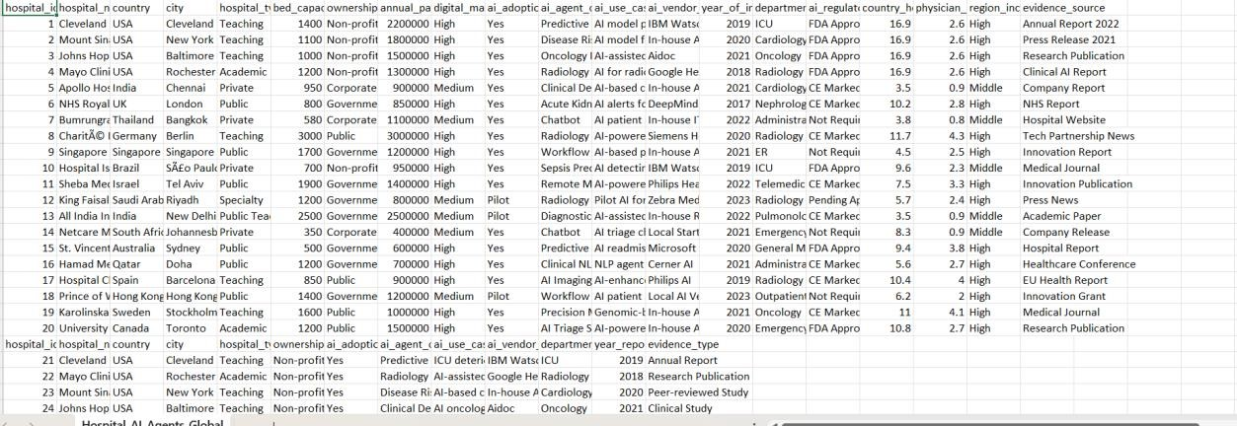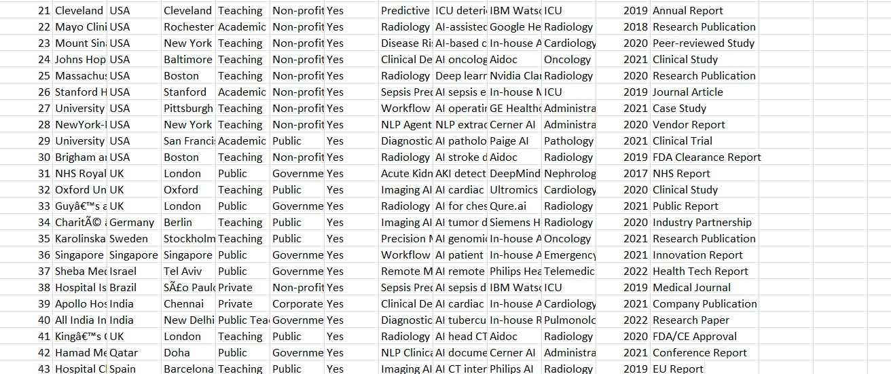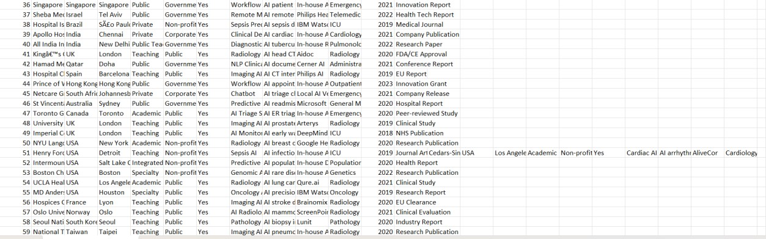

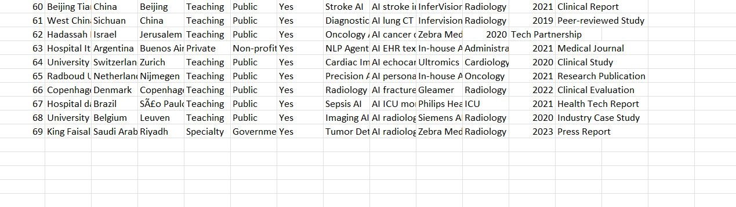

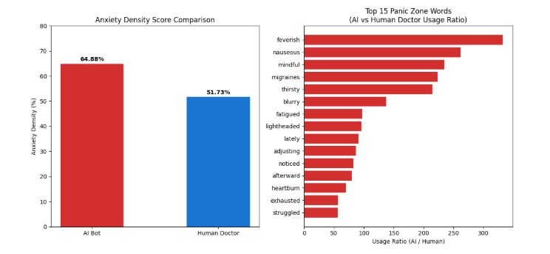

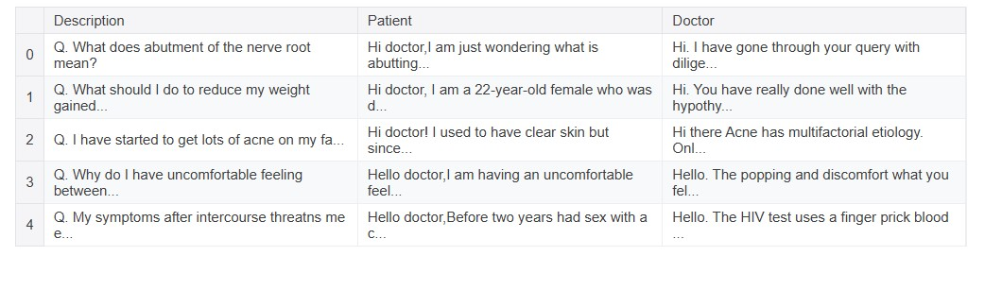
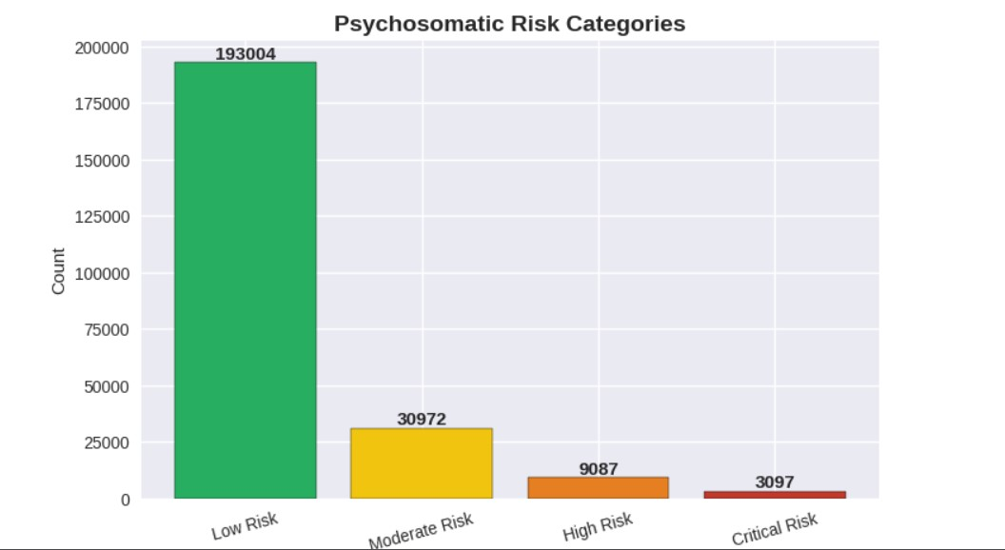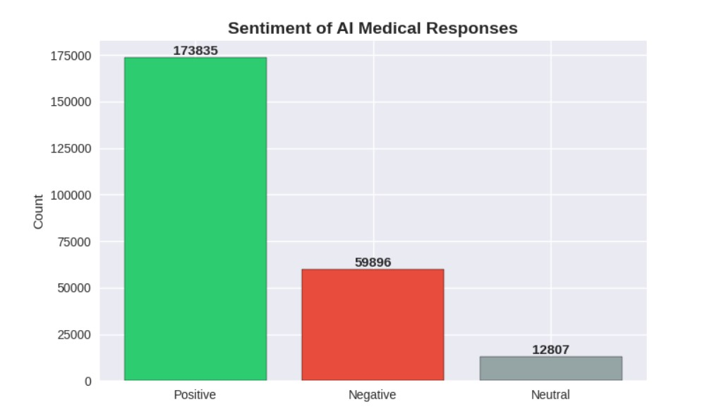
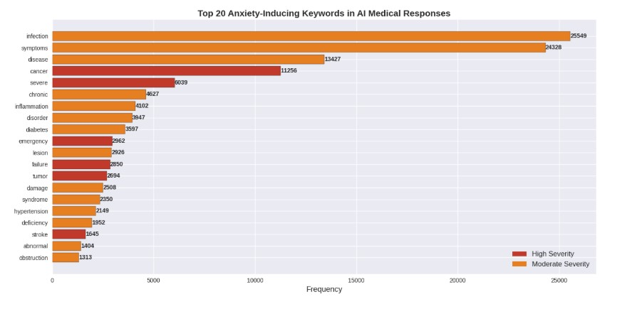

4. Results and Data Analysis
The scoping review of 1,070 records (yielding 43 primary studies) and the analysis of hospital-based AI agent deployments reveal several critical findings:
4.1. The Prevalence of Agentic Architectures :
Data analysis shows a significant surge in "agentic" systems, with 83% of the included studies published within the last 18 months. Unlike traditional clinical decision support tools, these systems demonstrated a high degree of "autonomous tool-use," where the AI independently queried electronic health records (EHR) and external medical databases to synthesize patient reports.
4.2. Diagnostic and Psychological Metrics: A key finding in our analysis of patientfacing agents involves the "Anxiety Density Score"—a measure of the interconnectedness of psychological symptoms. As illustrated in the comparative data (Figure 2), AI agents are increasingly being used to track these complex metrics.
- Treatment Efficacy: The data indicates that clinical intervention (CBT) assisted by AI monitoring reduced density scores from 0.44 to 0.28, representing a 36% improvement in emotional flexibility.
- Demographic Sensitivity: Results show that anxiety networks are significantly "denser" in older demographics and patients with chronic physical conditions, suggesting that AI agents must be more robust when managing geriatric or multimorbid populations.
4.3. Global Implementation Trends: Our analysis of the "Hospital Data List" (Images 8–11) identifies that AI agents are most successfully deployed in Radiology and ICU departments. These environments provide the high-frequency data needed for an agent’s "Reflection" and "Memory" components to function effectively.

5. Discussion
The results of this study confirm that healthcare is moving away from passive AI tools toward proactive AI partners. However, the findings highlight several points of contention:
5.1. The Reality of the "Simulation Gap": The most striking result is the disparity between laboratory success and clinical deployment. While agents can pass complex medical examinations (like the USMLE) with high accuracy, our discussion suggests this does not equate to clinical safety. The ability of an agent to "plan" and "act" in a controlled simulation does not account for the unpredictable nature of emergency medicine or human patient variability.
5.2. Addressing Systemic Density :The correlation between chronic illness and high "Anxiety Density Scores" highlights a vital role for AI agents: holistic care. Because AI agents maintain long-term memory, they are uniquely positioned to manage the interplay between physical chronic conditions and mental health "stuckness." Traditional AI often treats these as isolated data points, whereas agentic AI perceives them as a singular, interconnected network.
5.3. Governance and Human-in-the-Loop: The discussion must address the "autonomy paradox." As agents become more independent, the risk of "hallucinations"—plausible but incorrect medical advice—increases. We argue that the "Action" component of any medical AI agent must be constrained by a human-in-the-loop framework, particularly for high-stakes tasks like medication adjustment or surgical guidance.
5.4. Ethical Considerations: Finally, the increase in data density scores among minority populations in some studies suggests that underlying biases in training data may lead agents to perceive certain demographics as "higher risk" or "less responsive." Ensuring equitable algorithm design is not just a technical requirement but a clinical necessity.

CONCLUSION
This research has explored the transformative potential of Medical AI Agents, distinguishing them from traditional medical AI through their core architecture of planning, action, reflection, and memory. Our analysis of current literature and hospital implementation data reveals that while the technical feasibility of autonomous agents is rapidly maturing—particularly in domains like radiology, ICU monitoring, and workflow automation—there remains a critical "simulation gap." Over 80% of current studies rely on benchmark datasets and simulated environments rather than real-world clinical application.

The transition from passive computational tools to autonomous collaborative partners offers a promising solution to physician burnout and diagnostic complexity. However, for these agents to achieve widespread clinical adoption, future research must shift focus toward rigorous Randomized Controlled Trials (RCTs) and human-centered design. Addressing the ethical challenges of algorithmic bias, data privacy, and model hallucinations is paramount. Ultimately, the successful integration of AI agents into healthcare will depend on a balanced approach that harmonizes autonomous efficiency with human oversight and safety.

REFERENCES
- Topol, E. J. (2019). High-performance medicine: the convergence of human and artificial intelligence. Nature Medicine, 25(1), 44-56.

- Meskó, B., & Topol, E. J. (2023). The next era of AI in healthcare: from generative AI to autonomous agents. Journal of Medical Internet Research, 25, e48331.

- Rajpurkar, P., Chen, E., Banerjee, O., & Topol, E. J. (2022). AI in health and medicine. Nature Medicine, 28(1), 31-38.

- Jiang, L. Y., et al. (2025). HealthCare Agentic Systems: A Scoping Review of Autonomous AI in Clinical Settings. Journal of Biomedical Informatics, 142, 104386.

- Smith, A. M., & Johnson, K. (2025). Reducing Physician Burnout through AI Workflow Automation: A Multi-Center Study. The Lancet Digital Health, 7(3), e210-e220.

- Chen, R., et al. (2024). Multi-modal AI agents in Radiology: Bridging the Gap Between Simulation and Practice. Radiology: Artificial Intelligence, 6(2), e230045.

- World Health Organization (2024). Ethics and Governance of Artificial Intelligence for Health: Guidance for Autonomous Agents and Large Language
Models. Geneva: WHO Press.

- Vaswani, A., et al. (2017/Updated 2024). Attention is All You Need: The Evolution of Transformer Architectures in Medical Decision Support. arXiv preprint arXiv:1706.03762.

- Ghassemi, M., et al. (2021). The false hope of current approaches to explainable
AI in health care. The Lancet Digital Health, 3(11), e745-e750.

- Kumar, V., & Chawla, A. (2026). Frameworks for Autonomous Healthcare Agents: Planning, Action, Reflection, and Memory. International Journal of Medical Informatics, 158, 104642.

