A rare case of Steakhouse syndrome or Backyard barbecue syndrome in an 84-year old man in Enugu, South-east Nigeria—case report.

Key words: steak-house , oesophageal impaction, meat, endoscopic retrieval, case report
Abstract
Steakhouse syndrome or backyard barbecue syndrome is an acute oesophageal food impaction¹. The most common type of esophageal food-related foreign body is the meat bolus, which is frequently associated with underlying esophageal stenosis².
It is very common in elderly patients³. This syndrome can be caused by various aetiologies: oesophageal mechanical narrowing due to esophageal carcinoma, diverticulum, hiatal hernia, or eosinophilic esophagitis; or esophageal dysmotility diseases such as achalasia, diffuse oesophageal spasm, and oesophagogastric junction outflow obstruction⁴.
Case presentation
Here in we present an 84year old university don who presented in the endoscopy unit with an 8-hour history of food impaction in the oesophagus following ingestion of meat in a party organized at his village. There was associated history of odynophagia, dysphagia to both solids and liquids, sialorrhoea but no cough, breathlessness, vomiting, fever, loss of consciousness nor chest squeezing sensation.
Also no history of regurgitation, slow reflux, rapid weight loss nor chest/epigastric pain.
He had similar oesophageal food impaction in the oesophagus few years ago but no intervention was done as there was disimpaction while awaiting therapeutic oesophagogastroduodenoscopy (OGD) procedure for endoscopic retrieval.
He is known to have hypertension and regular with his medications but not known to have diabetes.
There is no history of significant alcohol consumption and does not take tobacco in any form. No previous history of weight loss, dysphagia nor odynophagia.
On examination, he was in moderate distress, afebrile to touch, anicteric, no cyanosis, not pale, capillary refill was prompt, moderately dehydrated, no digital clubbing , leg oedema and no peripheral lymphadenopathy.
Cardiovascular system:
Pulse 80/m, moderate volume and regular with locomotor brachialis, no radio-radial nor radio-femoral asynchrony.
Blood pressure-- 130/90 mmHg
Jugular venous pulsation was not raised.
Apex at 5th left intercostal space midclavicular line, not heaving.
First and second heart sounds only.
Abdomen:
Full and moves with respiration, no areas of tenderness, liver span—about 11cm. No palpable organomegaly and no ascites. Digital rectal examination was not done.
Assessment:
An assessment of Steakhouse or Backyard barbecue syndrome was made.
For the above he was rushed to the Endoscopy unit where urgent interventional oesophagogastroduedunoscopy was done for possible endoscopic retrieval of foreign body.
Oesophagogastroduodenoscopy findings—oesophageal impaction of about 10-15cm long, about 15cm from the incisor teeth, containing swallowed meat. Oesophageal mucosa was reddish, oedematous with mild erosions with meat stuck to the mucosa. Oesophageal rings were seen at the lower 3rd of the lumen.
Foreign body retrieval was done with grasping forceps under direct vision.
Some of the stuck meat were removed endoscopically, the rest were pushed down to the stomach mucosa.
Patient was advised for repeat upper gastrointestinal endoscopy and barium swallow, after one month, also to minimize or avoid meat consumption and to always reduce bolus of food to be swallowed while eating.
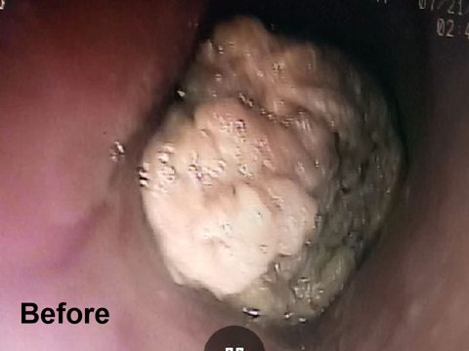

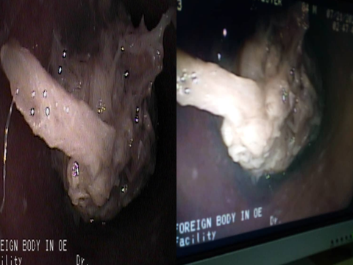

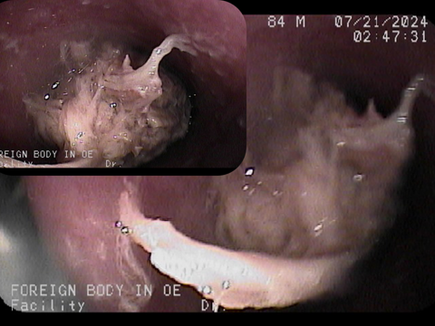

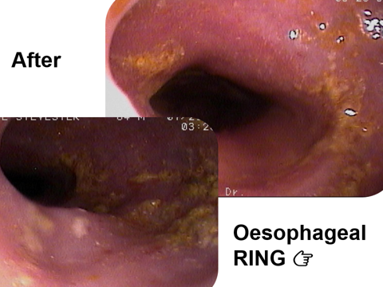

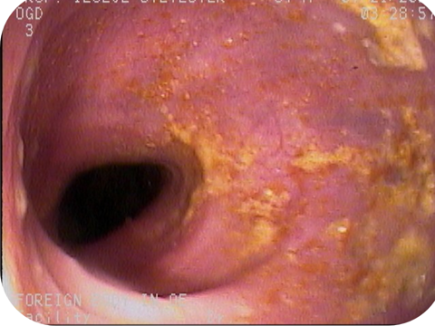

Literature review

Steakhouse syndrome also known as backyard barbecue syndrome is an acute oesophageal impaction occurring mostly in the elderly leading to oesophageal obstruction due to improperly chewed meat⁵.
The incidence was approximately 6–14% and the
most common episodic dysphagia in adults in India⁶. In a number of cases, the
aetiology is not known, it is seen more frequently in
patients with motility disorder in the lower oesophageal sphincter
and in alcoholics.
In another case report from Turkey, Cikman et al. described a patient presented
with acute esophageal obstruction who turned out to have a
meat bolus obstructing distal esophagus upon endoscopy⁷.
Enomoto et al reported a case of steakhouse syndrome complicating into an oesophageal ulcer⁸
A common anatomic abnormality leading to meat impaction of the esophagus is hiatal hernia, which is often associated with a ring or stricture. Intermittent dysphagia is a predisposing factor. Many patients either have no teeth or use dentures⁹. Esophageal stenosis is usually found in adults suffering with steakhouse syndrome, but occasionally the syndrome occurs in the absence of any underlying organic abnormality¹⁰
Common associated disorders include reflux esophagitis with stricture, hiatal hernia, oesophageal rings and postoperative strictures at anastomotic sites. Malignant stenoses have been very rarely described¹¹. Oesophageal rings were seen endoscopically in the index patient.
Inadequate mastication of food especially meat due to lack of teeth, hurried swallowing and feeling too embarrassed to spit out a large piece of gristle could be associated¹². Dysphagia, odynophagia, neck pain and substernal chest pain mimicking myocardial infarction following ingestion of large meat may develop¹³.

Endoscopic retrieval is the current management procedure of choice. Smooth muscle relaxant properties of glucagon had been employed to facilitate endoscopic retrieval previosly¹⁴.
The preferred method of removal of oesophageal foreign bodies is extraction with the flexible endoscope. This may be accomplished in both adults and children with the use of conscious sedation rather than general anesthesia¹⁵. Adherence to the general principles of foreign body removal and proper preparation result in successful removal rates as high as 98%, with minimal or no complications¹². Surgical removal via external approach is rarely indicated except in the event of perforation or other complications¹⁵
Stadler J et al reported on 28 instances of acute food impaction in the esophagus documented in 26 patients over a period of 5 years¹⁶. In all patients the impacted bolus was successfully removed without complication using a flexible endoscope¹⁶
In the index patient, endoscopic retrieval with grasping forceps proved very effective.
In conclusion, steakhouse or backyard barbecue syndrome, common in the elderly, should be managed endoscopically and further evaluations are necessary for possible underlying conditions.

Conflicting interests
There are no conflicting interests.
Patient’s consent
Re: A rare case of Steakhouse or Barbecue backyard syndrome, in an 84vear old man, in Enugu, Southeast Nigeria. by Promise U Asogwa, Gideon E Anigbo,Eunice C Eze.


I hereby give my consent for the above paper, written by the above listed authors, to be submitted for journal publication.

Prof S O Iloeje.

Patient’s perspective
The patient affirmed the endoscopic retrieval relieved his symptoms completely and he has been carrying out his daily activities uneventfully.
Ethical approval
Ethical approval was not obtained as this is a case report.
Authors’contribution
Promise Udoka Asogwa
Gideon Ekene Anigbo
Eunice Chidimma Eze
All the authors contributed maximally in preparing the manuscript
Funding Declaration
There was no funding.

Request for a waiver
I request that a waiver be granted in terms of the cost for publication of this case report.

References
1.Kita K, Nagatsuma M, Fujinami H, Yamashiro S. Steakhouse syndrome: A case report. January 2011.General Medicine 12(2): 83-84.DOI:10.14442/general.12.83
2. Chae SH et al. Two cases of steakhouse syndrome associated with nutcracker esophagus. Dis Esophagus. 2002; 15(4):330-3. doi: 10.1046/j.1442-2050.2002/ 0027.x.
3.Enomoto S, Nakazawa K, Ueda K, et al. Steakhouse syndrome causing large esophageal ulcer and stenosis. World J Gastrointest Endosc. 2011;3(5):101‐104.
4. Shikino K and Ikusaka M. Steakhouse syndrome. Clin Case Rep. 9(6): 2021, June. doi: 10.1002/ccr3.4329
5. Balakrishna AK, Ramely R, Zakaria A D, MdHashim M N, Wan Zain W Z. A nice meal turns dangerous: Steakhouse syndrome. November 2020. Indian Journal of Case Reports 6(11): 667-66.DOI:10.32677/IJCR. 2020.v06.i11.020
6. Lin K, Patel P, Wen Liauw MX, Phyu Hlaing P, Yoe L. Dysphagia with Schatzi Rings or Steakhouse syndrome. Better to scope than to watch. Journal of Gastroenterology, Pancreatology and Liver Disorders. 2018: 6(3); 1-3.
7. Çıkman Ö, Taş Ş, Kiraz H, Özkan ÖF, Adam G, Karaayvaz M. A rare reason or cause of oesophageal obstruction: Steakhouse syndrome. Eastern Journal of Medicine. 2016. 21: 50-1.
8. Enomoto S et al. Steakhouse syndrome causing large esophageal ulcer and stenosis. World J Gastrointest .Endosc 2011May 16; 3(5): 104.doi: 10.4253/wjge.v3.i5.101
9. Hargrove MD, Boyce HW. Meat Impaction of the Esophagus. Arch Intern Med. 1970;125(2):277–281. doi:10.1001/archinte.1970.00310020083008
10.Yang SY et al. A case of steakhouse syndrome wassociated with Nutcracker oesophagus with lower oesophageal sphincter muscle thickening. Korean J Neurogastroenterol Motil. 2005 Ded; 11(2):166-169.
- 11. Choi JD, Moon JH, Lee MS, Kim JH, Cho SW and Shim CS. 4 Cases of Steakhouse syndrome of the oesophagus. Korean J Gastrointest Endosc.1992; 12(1):19-23.
- 12. Nakari A, Anka AT. Steakhouse syndrome: case report and review of management options. The Nigerian Journal of Otorhinolaryngology. 2006; 3(2): 91-93.
13. Oesophageal Food Bolus Obstruction (steakhouse syndrome). http://ncemi.org / Cse/Cse 0602.htm accessed October 2005.
14. Stephen WT, Dean DTM, Glen AL, Stanley MC, Roscoe EM, William JC. Oesophageal Food impaction: Treatment with Glucagon. Radiology 1983; 149: 401-403.
cause of esophageal obstruction: Steakhouse syndrome. Eastern Journal Of
Medicine. 2016;21:50-1
15. Brady PG. Oesophageal foreign bodies. Gastroenterol Clin North Am 1991; 20(4): 691-701.
16. Stadler J, Holscher AH, Feussner H, Dittler J, Siewert JR. The “steakhouse syndrome” primary and definitive diagnosis and therapy. Surg endosc 1989; 3(4): 195-8.



.

.

