Bibliometric Study: Volatile Compounds in Oyster Mushrooms Based on GCMS Analysis

ABSTRACT
Oyster mushrooms (Pleurotus ostreatus) are a functional food commodity with high nutritional value, bioactive compounds, and a distinctive aroma that significantly influences sensory quality and consumer acceptance. This distinctive aroma is primarily formed by volatile compounds, particularly C8 compounds such as 1-octen-3-ol and 3-octanone, which have been widely identified using Gas Chromatography Mass Spectrometry (GCMS). This study aims to analyze the development of scientific publications on volatile compounds in oyster mushrooms based on GCMS analysis through a bibliometric approach using Scopus data from 2007–2026. The analysis was conducted based on the number of publications per year, journal sources, keyword co-occurrence, and network visualization using VOSviewer software. The results show a significant increase in the number of publications, especially in 2024, reflecting the increasing scientific attention to the study of aroma, flavor, sensory quality, and bioactive potential of oyster mushrooms. Keyword analysis shows a close relationship between the terms volatile compounds, aroma, flavor, umami, and bioactive compounds and oyster mushrooms, indicating that current research focuses on the identification and characterization of volatile components as determinants of the mushroom's distinctive aroma. The overlay also shows that recent research trends are moving toward more specific and applicable topics, such as GCMS based flavor analysis, evaluation of volatile compound changes due to processing, and utilization of cultivation substrate waste to support food sustainability. This provides an overview of the development and direction of research on volatile compounds in oyster mushrooms and reinforces the urgency of research related to volatile compound profiles as a basis for the development of functional foods and metabolomic studies of mushroom based foods.

Keywords: oyster mushroom, volatile compounds, GCMS, bibliometrics, VOSviewer

INTRODUCTION
Mushrooms are a horticultural commodity that plays a crucial role in meeting global food needs due to their nutritional value, functional properties, and high economic potential. In recent years, mushroom consumption has continued to increase in line with growing public awareness of healthy foods and alternative plant-based protein sources. Of the many edible mushroom species, oyster mushrooms (Pleurotus ostreatus) are among the most widely cultivated commodities worldwide (Drezek et al., 2025). This is due to their relatively simple cultivation techniques, relatively high productivity, and ability to grow on lignocellulosic substrates such as rice straw and sawdust (Karmani et al., 2022). Furthermore, oyster mushrooms also have high economic value and are widely used in the food industry.

Oyster mushrooms are known to have high nutritional content, such as protein, dietary fiber, vitamins, minerals, and various bioactive compounds that can provide numerous health benefits. Beyond nutritional content, important factors that can determine the quality of oyster mushrooms are their aroma and flavor characteristics. Aroma is a sensory parameter that significantly influences consumer acceptance of a food product. In oyster mushrooms, the distinctive aroma originates from the presence of volatile compounds, namely C8 compounds, such as 1-octen-3-ol, 3-octanone, 3-octanol, and 1-octen-3-one, which significantly contribute to the distinctive aroma of oyster mushrooms (Koutrotsios et al., 2021).

The presence of volatile compounds in oyster mushrooms not only plays a role in the formation of sensory properties but is also linked to certain biological activities. Several studies have shown that volatile compounds produced by oyster mushrooms have antibacterial, antioxidant, and other potential bioactive activities. For example, (Beltra et al., 1997) reported that compounds such as 1-octen-3-ol and 3-octanone exhibit antibacterial activity against several types of bacteria. Therefore, the volatile compounds in oyster mushrooms are not only important for sensory quality. This finding is supported by other research, which states that the main volatile compounds in oyster mushrooms are also associated

with antioxidant activity and antimicrobial potential (Zhang et al., 2008). To determine the types of volatile compounds present in oyster mushrooms, analysis was conducted using the GCMS method.

Gas Chromatography Mass Spectrometry (GCMS) is widely used to identify compounds in food due to its high sensitivity, selectivity, and accuracy in separating and identifying compounds, even at low concentrations. According to Tagkouli et al. (2021), the GCMS method has proven effective for analyzing changes in the composition of volatile compounds in oyster mushrooms and evaluating the effect of cultivation substrate type on aroma profiles. Furthermore, other studies have shown that this method is capable of identifying changes in volatile compounds in fresh conditions, during ripening, and after processing, making it highly relevant in research on the quality and flavor characterization of oyster mushrooms (Zhang et al., 2008).

With the increasing number of scientific publications related to oyster mushrooms, GCMS analysis, and volatile compounds, an approach capable of systematically and quantitatively mapping the development of the literature is needed. One method that can be used is bibliometric analysis. This bibliometric analysis can be used to evaluate publication patterns, keyword developments, author collaboration networks, journal sources, and the direction of research development in a scientific field (Klarin, 2024). Bibliometric studies on the topic of volatile compounds in oyster mushrooms using GCMS are still very limited, even though this approach is crucial for identifying dominant research focuses and opportunities for future research development. Therefore, this study aims to conduct a bibliometric study of volatile compounds in oyster mushrooms using GCMS analysis to provide an overview of research developments and a scientific basis for further research in food technology and metabolomics.

MATERIALS AND METHODS

Data Sources
Literature data on volatile compounds in oyster mushrooms were obtained from the Scopus database. References on the analysis of volatile compounds in oyster mushrooms using GCMS were taken from the Scopus database because it has more comprehensive data. The keywords used in the Scopus database were "oyster mushroom" OR "volatile compounds" OR "GCMS." The scientific literature searched contained one of these keywords, terms, or phrases in the title, abstract, article, or keywords. The scientific literature used was from the last 20 years (2007-2026) and was limited to publications in English.

Data Extraction and Analysis
Data extraction and analysis were carried out by collecting information from existing scientific literature, including titles, abstracts, keywords, and relevant articles. After data extraction, analysis was conducted to understand and analyze the collected data. The collected literature was saved in ".RIS" format. The data was then exported to Vosviewer version
1.6.20 for further bibliometric analysis (van Eck and Waltman, 2020). Parameters used for the results included publication trends, contributing publisher analysis, keyword co-occurrence networks, and overlays.

Term maps

VOSviewer is software used to analyze and visualize bibliometric data from databases in the form of words appearing in titles, abstracts, and keywords of selected literature. The data visualization takes the form of a bubble map, where each bubble represents a word or phrase appearing in the literature. The color of the bubble indicates the number of citations per publication containing that word. The distance between two bubbles indicates how frequently the two words appear together (Yeung, 2018).

RESULT AND DISCUSSION

Publication trends

The latest research data was collected and stored as of April 15, 2026, from the Scopus database. A total of 735 literature sources were obtained after screening 1,109 publications on volatile compounds in oyster mushrooms from 25 publishers. Figure 1 shows publication trends over the past 20 years. The observed publication trends cover the past 20 years, from 2007 to 2026. A significant increase in the number of publications occurred in 2024. This may be due to the increasing research trends in functional foods, flavor analysis, and developments in GCMS instrument technology. In recent years, oyster mushrooms have been widely studied as a functional food ingredient due to their bioactive compounds, nutritional value, and potential health benefits. Furthermore, numerous studies have addressed the identification of active aroma components and volatile changes due to heating and storage (Xie et al., 2024). Meanwhile, in terms of research methods, the increase in publications is also influenced by the increasing number of studies conducted using Gas Chromatography Mass Spectrometry (GCMS) technology, which can separate and identify complex volatile compounds. This technological advancement enables more accurate and comprehensive aroma profile analysis, thus accelerating the development of research related to oyster mushroom volatile compounds..
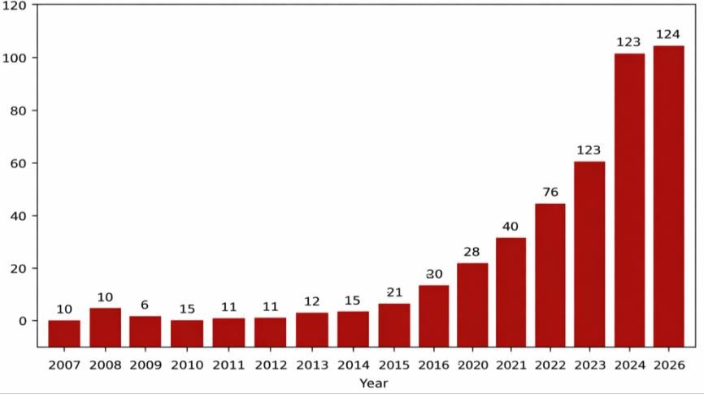
Fig. 1. Publication trends on volatile compounds in oyster mushroom

Analysis of Top Contributing Publishers
The most productive publisher is Elsevier/Journal of Ethnopharmacology, with a total of 735 publications on volatile compounds in oyster mushrooms. Among the 25 publishers, three have the highest number of publications, which has produced a significant amount of scientific literature on volatile compounds in oyster mushrooms, which can facilitate future research development. A table of publishers and their number of publications can be seen in Table 1.

Table 1. Top Contributing Publishers

No | Nama Penerbit | Jumlah Publikasi
1 | Jurnal Food Chemistry | 83
2 | JurnalTrends in Food Science & Technology | 38
3 | Jurnal Food Research International | 36

Keyword co-occurrence network and overlay
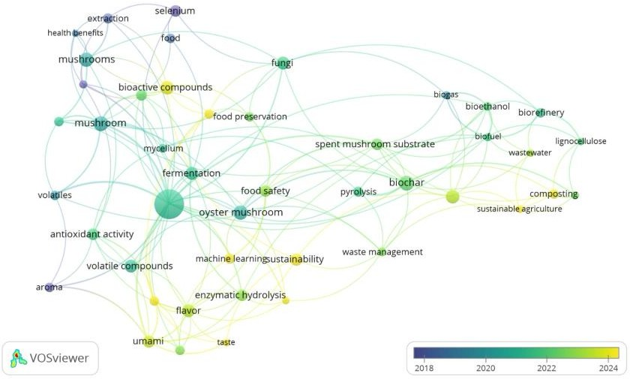
Fig. 2. Keyword co-occurrence network
The white oyster mushroom (Pleurotus ostreatus) is a popular edible mushroom commodity that has long been recognized and utilized as a functional food ingredient by people in various countries. In addition to its high nutritional value, this mushroom is also known to possess various health benefits, such as boosting the immune system, antioxidant activity, antimicrobial, anti-inflammatory, antidiabetic, and antitumor and anticancer potential. These benefits are closely related to its bioactive compounds, such as β-glucans, polysaccharides, proteins, bioactive peptides, phenolic compounds, flavonoids, ergothioneine, ergosterol, B-complex vitamins, and essential minerals, which play a role in providing the white oyster mushroom with biological activity and functional properties (Sharma et al., 2021). Furthermore, the β-glucans contained in Pleurotus ostreatus are known to possess immunomodulatory and anti-inflammatory activities that play a crucial role in enhancing the body's immune response (Rolin et al., 2019).

Based on Figure 2, each circle represents a keyword, while the circle size indicates the number of occurrences of the word in the analyzed document collection. According to Van Eck, the larger the circle, the higher its weight or frequency of occurrence in bibliographic data. Furthermore, connecting lines between circles indicate co-occurrence, while the distance between circles indicates the degree of topical proximity; the closer the distance, the more frequently the two terms appear together in a single document.

The figure shows that keywords such as volatile compounds, aroma, flavor, umami, and volatiles are located around the main term "oyster mushroom." This indicates that research in this field has focused heavily on the characteristics of aroma, flavor, and volatile compounds in oyster mushrooms. The correlation between keywords demonstrates that the study of volatile components is directly related to the sensory quality and consumer acceptance of several types of mushroom products. Furthermore, the occurrence of terms such as antioxidant activity, bioactive compounds, and health benefits indicates that research is not only highlighting sensory properties but also the potential of oyster mushrooms as functional food ingredients and their various health benefits.

This image analysis uses an overlay visualization mode, indicated by a color gradient from blue to yellow on a scale of 2018–2024. Blue indicates topics that were more researched in the early period, while green to yellow indicate newer and emerging topics. Keywords such as sustainability, biochar, composting, and sustainable agriculture, which tend to be yellowish green, indicate recent research trends that are starting to move towards the utilization of waste from mushroom substrates and a sustainable approach to such research. Meanwhile, terms related to volatile compounds, flavor, and umami also show relatively new colors, indicating a growing interest in aroma and volatile compound analysis in recent years. These findings demonstrate the development of research directions from basic aspects of mushrooms to the sustainable utilization of products and waste, making it relevant as a basis for conducting research on the profile of volatile compounds in oyster mushrooms using GCMS.

CONCLUSION
Based on the results of a bibliometric study of scientific publications on volatile compounds in oyster mushrooms (Pleurotus ostreatus) based on GCMS analysis in Scopus from 2007–2026, it can be concluded that research on the volatile compound profile of oyster mushrooms shows significant development and is receiving increasing attention in the field of food science and technology, especially in the characterization aspects of aroma, flavor, and potential bioactive compounds. The increase in the number of publications, especially in 2024, indicates that the analysis of volatile compounds using the GCMS method is becoming an increasingly important approach in evaluating the sensory and chemical quality of oyster mushrooms. The relationship between keywords such as volatile compounds, aroma, flavor, umami, and bioactive compounds with oyster mushrooms means that the current focus of research is directed towards identifying volatile components that play a role in the formation of distinctive aromas and their potential for development as functional foods. Thus, the results of this study support the urgency of thesis research that focuses on the analysis of volatile compound profiles in oyster mushrooms using GCMS. This also shows that the research has a strong scientific basis, follows the latest research standards, and has the potential to contribute to the development of the quality of oyster mushroom-based food products..

REFERENCES
- Beltran-Garcia, M. J., Estarron-Espinosa, M., & Ogura, T. (1997). Volatile compounds secreted by the oyster mushroom (Pleurotus ostreatus) and their antibacterial activities. Journal of Agricultural and Food Chemistry, 45(10): 4049–4052. https://doi.org/10.1021/jf960876i.
- Drężek, J., C Możejko-Ciesielska, J. (2025). Production of β-glucans by Pleurotus ostreatus: Cultivation and genetic background. International Journal of Molecular Sciences, 26(19): 9703. https://doi.org/10.3390/ijms26199703
- Karmani, M., Subramaniam, G., Sivasamugham, L. A., Cheng, W. H., & Wong, L. S. (2022). Effects of different substrates on the growth and nutritional composition of Pleurotus ostreatus: A review. Journal of Experimental Biology and Agricultural Sciences, 10(3): 481–486. https://doi.org/10.18006/2022.10(3).481.486
- Klarin, A. 2024. How to conduct a bibliometric content analysis: Guidelines and contributions of content co-occurrence or co-word literature reviews. International Journal of Consumer Studies. 48(2):1-18
. https://doi.org/10.1111/ijcs.13031.
- Koutrotsios, G. (2021). Volatile profiling of Pleurotus eryngii and Pleurotus ostreatus mushrooms cultivated on agricultural and agro-industrial by-products. Foods, 10(6), 1287. https://doi.org/10.3390/foods10061287.
- Rolin, C. K., Bzducha-Wróbel, A., Włodarczyk, K., dan Janiszewska-Turak, E. (2019). Immune-modulating activities of glucans extracted from Pleurotus ostreatus and Pleurotus eryngii. Journal of Functional Foods. 54: 81–91. https://doi.org/10.1016/j.jff.2018.12.034.
- Sharma, A.,and Tripathi, A. (2021). Biological activities of Pleurotus spp. polysaccharides: A review. Journal of Food Biochemistry. 45(6): 13748. https://doi.org/10.1111/jfbc.13748
- Tagkouli, D., Bekiaris, G., Pantazi, S. (2021). Volatile Profiling of Pleurotus eryngii and Pleurotus ostreatus Mushrooms Cultivated on Agricultural and Agro-Industrial By-Products. Foods, 10(6): 1287. https://doi.org/ 10.3390/foods10061287.
- Van Eck, N.J., Waltman, L., 2020. VOSviewer. Leiden University, Leiden.
- Xie L, Guo S, Rao H, Lan B, Zheng B, Zhang N. (2024). Characterization of Volatile Flavor Compounds and Aroma Active Components in Button Mushroom (Agaricus bisporus) across Various Cooking Methods. Foods. 23;13(5):685. https://doi.org/10.3390/foods13050685.
- Yeung, A. W. K. (2018). Visualization of co-occurrence relationships in bibliometric analysis using VOSviewer. Scientometrics.
- Zhang, Z.M., Wu,W.W., and Li, G.K.(2008). A GCMS study of the volatile organic composition of straw and oyster mushrooms during maturity and its relation to antioxidant activity. Journal of Chromatographic Science, 46(8):690-696. https://doi.org/10.1093/chromsci/46.8.690.

