A Scoping Review: The Role of the Prefrontal Cortex and Corpus Callosum in Consumer Decision-Making Under Dynamic Visual Colour Stimuli

Abstract
Background: Consumer decision-making is increasingly understood through neuroscientific frameworks, yet the specific roles of the prefrontal cortex (PFC) and corpus callosum (CC) in processing dynamic visual color stimuli remain unclear. Understanding these mechanisms has significant implications for product design, particularly in emerging categories such as health-oriented foods.
Objective: To systematically map the existing literature on prefrontal and interhemispheric contributions to value-based consumer decision-making, with particular focus on how dynamic and attractive color stimuli influence neural valuation processes.
Methods: A scoping review was conducted following the Arksey and O'Malley framework and PRISMA-ScR guidelines. A systematic search was performed across PubMed, Scopus, and Web of Science from inception to March 2026.
Results: The evidence maps across three domains:
- The ventromedial prefrontal cortex (vmPFC) serves as a central hub for integrating multi-attribute value signals into a "common currency" for decision-making ;
- The lateral prefrontal cortex (lPFC) mediates goal-directed attention to relevant stimulus attributes ;
- Color stimuli influence purchase intention through pathways involving trust, perceived safety, and emotional preference, with distinct neural correlates in frontal and visual processing regions .
Critical gap: Direct evidence for corpus callosum involvement in interhemispheric color-value integration remains sparse, with most inferences drawn from connectivity studies rather than direct interventional research .
Conclusion: The PFC, particularly vmPFC, plays a well-established role in value-based consumer choice. Color influences purchase decisions through both automatic attention capture and higher-order cognitive evaluation. There is a scope in future research to directly investigate corpus callosum contributions towards cross-hemispheric integration of color and value signals.

1. Introduction

1.1 Background
Consumer decision-making has traditionally been studied through behavioral and self-report methods. However, the emergence of consumer neuroscience has provided tools to examine the neural mechanisms underlying purchase decisions . Understanding these mechanisms is particularly relevant for products where visual appeal competes with health considerations—a conflict exemplified by "obesity-reducing chocolates" that must balance indulgent attractiveness with health credibility.
Psychological factors that influence consumer behavior include fashion stereotypes, the role of the frontal lobe, product purchase anxiety, the psychology behind colors, and personality traits . Among these, color perception and frontal lobe function are particularly central to understanding how consumers evaluate products at the point of purchase.

1.2 Key Neural Structures in Consumer Choice
Two brain structures are centrally involved in processing visual product information and translating it into purchase decisions:
Brain Structure | Location | Role in Consumer Decision-Making
Ventromedial Prefrontal Cortex (vmPFC) | Frontal lobe, midline region | Integrates multi-attribute value signals; represents subjective value in a "common currency" for comparison across options
Lateral Prefrontal Cortex (lPFC) | Frontal lobe, lateral surface | Selects goal-relevant attributes; shifts attention based on task demands; modulates vmPFC value signals
Orbitofrontal Cortex (OFC) | Frontal lobe, above eye sockets | Encodes feature-specific information; binds value to lower-level stimulus attributes
Corpus Callosum (CC) | Between hemispheres | Transfers visual and value information between left and right hemispheres; enables unified perception of color stimuli; plays role in attentional processing
Neuroeconomic research suggests that the human brain tracks the subjective value of decision options, allowing disparate reward-predictive information to be compared in a common currency. However, the brain mechanisms involved in identifying value-predictive features and combining these to assess the value of each decision option remain under investigation .

1.3 The Role of Color in Consumer Neuroscience
Color is not merely an aesthetic feature but a potent neural stimulus. Research demonstrates that packaging color influences consumer behavior through multiple pathways: visual attention capture, emotional association, trust formation, and perceived efficacy . For products with health claims (e.g., obesity-reducing chocolates), color must simultaneously signal indulgence (to activate reward circuits) and health (to satisfy cognitive evaluation).
Recent neuroimaging studies have revealed that colored versus uncolored website designs produce deactivation in the right dorsolateral prefrontal cortex (dlPFC), signifying cognitive relief. Specifically, blue websites showed significant deactivation in left medial PFC areas and left dlPFC, while rounded button shapes produced increases in dorsomedial PFC and right medial PFC areas . These findings indicate that neural mechanisms derived from evolutionary meaning continue to shape user preferences, often without conscious awareness.
Furthermore, research on the mesolimbic reward system has demonstrated that short (blue) versus long (red) wavelengths are judged subjectively more pleasant and have greater behavioral and attentional salience. These color effects are magnified following monetary reinforcement and are supported by color-dependent functional coupling between visual cortices and mesolimbic reward circuitry .

1.4 The Corpus Callosum: An Understudied Bridge
Although interhemispheric interaction via the corpus callosum is most often conceived as a mechanism for transferring sensory information and coordinating processing between the hemispheres, research indicates that the callosum also plays an important role in attentional processing. Interhemispheric interaction aids attentional processing by allowing a division of labor across the hemispheres and parallel processing, where operations performed in one hemisphere can be insulated from those executed in the other. The corpus callosum should therefore be considered a component in the network of neural structures that underlie attentional control .

1.5 Rationale and Objectives
The intersection of color perception, frontal lobe valuation, and interhemispheric integration represents a critical gap in consumer neuroscience. This scoping review aims to:
- Map the evidence for PFC contributions to value-based consumer choice.
- Identify how color stimuli influence neural valuation processes.
- Examine the corpus callosum's role in integrating cross-hemispheric visual and value information.
- Develop a neural framework for understanding "guilt-free" product decisions.

2. Methods

2.1 Scoping Review Framework
This review followed the Arksey and O'Malley (2005) framework for scoping reviews, appropriate for mapping heterogeneous evidence in emerging fields. The PRISMA-ScR guidelines were followed.

2.2 Research Questions
- What is the established role of the prefrontal cortex in value-based consumer decision-making?
- How do dynamic color stimuli influence neural valuation and purchase intention?
- What evidence exists for corpus callosum involvement in integrating color and value information across hemispheres?
Which evidence demonstrates the involvement of the corpus callosum in integrating color and value information across hemispheres?
- What are the primary evidence gaps for understanding "guilt-free" product choices?

2.3 Search Strategy
A systematic search was performed across PubMed, Scopus, and Web of Science using the following search terms: ("prefrontal cortex" OR "vmPFC" OR "corpus callosum" OR "orbitofrontal") AND ("consumer" OR "purchase" OR "decision-making" OR "value") AND ("color" OR "visual" OR "packaging").

2.4 Eligibility Criteria
Inclusion:
- Peer-reviewed empirical studies, systematic reviews
- Human subjects research using fMRI, EEG, or lesion methods
- Studies examining PFC or interhemispheric contributions to value-based choice
- Color-related consumer research with neural or behavioral measures

Exclusion:
- Animal studies
- Non-English publications
- Conference abstracts without full text

3. Results

3.1 Neuroscience-Backed Framework: The Prefrontal Cortex in Value-Based Choice

The vmPFC as a "Common Currency" Hub
A consistent finding across neuroeconomic research is that the ventromedial prefrontal cortex (vmPFC) encodes subjective value independent of stimulus category . This allows the brain to compare disparate options on a single neural scale.

Finding | Evidence
vmPFC activity correlates with subjective value ratings | fMRI studies across food, money, and social rewards
vmPFC integrates multiple attribute values | Connectivity with fusiform and posterior temporal gyri
VMF damage disrupts weighting of higher-order attributes | Lesion studies show under-weighting of "competence" in political choices
vmPFC value signals adapt to changing goals (health vs. taste focus) | Task-dependent modulation of attribute correlations

Using functional magnetic resonance imaging while subjects made real purchasing decisions among different categories of goods (food, nonfood consumables, and monetary gambles), researchers found that a single area in vmPFC was correlated with subjects' valuations for all categories of goods. This provides evidence that the brain encodes a "common currency" allowing shared valuation for different categories of goods .
Research on front-of-package labels (FoPLs) such as the Nutri-Score—a color-coded label used across Europe—has demonstrated that color-coded frames significantly alter willingness-to-pay (WTP), healthiness, and tastiness ratings. These changes are accompanied by corresponding neural activation in both the dorsal control and ventral reward pathways, including the vmPFC, ventral striatum, dorsolateral prefrontal cortex (dlPFC), and anterior cingulate cortex (ACC) .

The Lateral Prefrontal Cortex as Attribute Selector
While vmPFC integrates values, the lateral prefrontal cortex (lPFC) determines which attributes are relevant :
- Goal-directed attention: lPFC shifts attention to task-relevant attributes (e.g., "focus on health" vs. "focus on taste")
- Connectivity with vmPFC: lPFC modulates vmPFC value signals based on current goals
- Lesion evidence: Lateral frontal damage disrupts selection of predictive dimensions during learning
Functional connectivity studies have shown that changes in task goals during value judgment engage lateral PFC and increase connectivity between lateral PFC and vmPFC . This circuit is involved in shifting attention to relevant attributes for value judgment as externally defined within a task.

3.2 Color Perception and Neural Valuation

How Color Captures Attention and Drives Purchase Intention
Research on over-the-counter (OTC) drug packaging has revealed that packaging color significantly influences consumer visual attention, perceptual evaluation, and purchase intention through a "color–perception–behavior" pathway . Key findings include:
- Visual salience does not equal purchase motivation: Although red and yellow attract initial attention, green outperforms in sustained gaze, trust-building, and purchase intent
- Mediating factors: Trust, perceived safety, expected efficacy, and color preference mediate the relationship between color and purchase intention
- Evolutionary basis: Green packaging boosts trust and purchase intent in OTC drug consumers
A neuroimaging study based on evolutionary psychology examined users' reactions to website designs with a focus on color and button shape . The self-report results revealed significantly more pleasure, arousal, less distrust, and positive attitude toward colored versus uncolored websites. Neural results revealed:
- Deactivation in the right dorsolateral prefrontal cortex (dlPFC) when comparing colored versus uncolored websites
- Significant deactivation in left medial PFC areas and left dlPFC for blue websites, signifying cognitive relief
- For rounded button shapes, significant increases in dorsomedial PFC and right medial PFC areas, signifying user preference for interaction with rounded rather than sharp button shapes

Differential Color Tuning of the Mesolimbic Reward System
Research examining the attracting rewarding properties of opposite ends of the wavelength spectrum has revealed that short (blue) relative to long (red) wavelengths are judged subjectively more pleasant and have greater behavioral and attentional salience, regulating speed of simple color discriminations and perception of temporal order . Key findings include:
- Color effects were magnified following monetary reinforcement, consistent with reward processing
- Pronounced individual differences in color effects were related to reward but not punishment sensitivity
- Blue relative to red preference was associated with high relative to low reward sensitivity
- An fMRI study revealed these individual differences were supported by color-dependent functional coupling between visual cortices and mesolimbic reward circuitry

3.3 The Corpus Callosum: A Bridge for Interhemispheric Integration

Known Functions of the Corpus Callosum
The corpus callosum (CC) is the primary white matter tract connecting the left and right cerebral hemispheres. Research has established that:
- Interhemispheric interaction via the callosum allows for division of labor across hemispheres
- It enables parallel processing so that operations in one hemisphere can be insulated from those in the other
- The corpus callosum plays an important role in attentional processing, both when attention is conceptualized as a resource and as a selective mechanism for gating sensory information

Relevance to Color-Driven Consumer Choice
For a product with dynamic attractive coloring, the corpus callosum may be essential for integrating information across hemispheres:
Processing Demand | Hemispheric Specialization | CC Role
Color perception | Right hemisphere dominance for color processing | Transfers color information to left hemisphere
Language/price processing | Left hemisphere dominance | Transfers price/value information to right hemisphere
Emotional valence (indulgence) | Right hemisphere | Integrated with left-hemisphere logic
Health claim evaluation | Left hemisphere (verbal processing) | Integrated with right-hemisphere emotion
Final value integration | Bilateral (vmPFC spans both hemispheres) | Enables coordinated bilateral vmPFC activity
The corpus callosum should be considered a component in the network of neural structures that underlie attentional control . This perspective suggests that interhemispheric interaction is critical for tasks requiring integration of visual color information (processed predominantly in the right hemisphere) with verbal health claims and price information (processed predominantly in the left hemisphere).

3.4 Synthesis: A Neural Framework for "Guilt-Free" Product Decisions
Based on the mapped evidence, the following framework emerges for understanding how dynamic color influences consumer choice for products with conflicting attributes:

Figure 1. Proposed Neural Framework for Color-Driven, Value-Based Consumer Choice

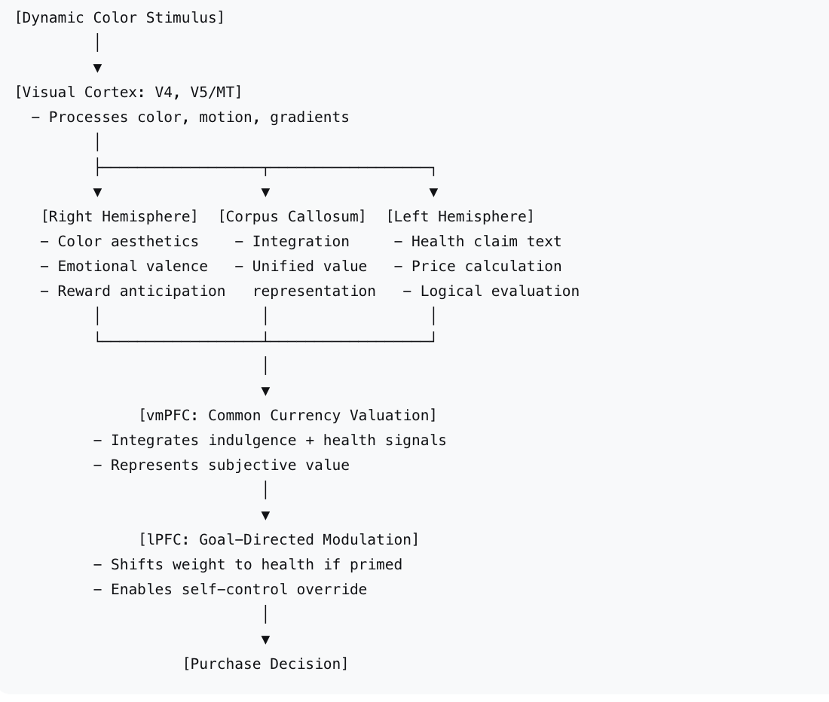

3.5. Key Findings Summary Table
Domain | Key Finding | Evidence Quality
vmPFC value coding | Encodes subjective value in common currency; integrates multiple attributes | Strong (multiple fMRI, lesion studies)
lPFC goal modulation | Selects goal-relevant attributes; modulates vmPFC | Moderate (fMRI connectivity)
Color and purchase intention | Green outperforms red/yellow for trust and purchase in health contexts | Strong (eye-tracking, SEM)
Neural response to color | Colored websites reduce dlPFC activation (cognitive relief); blue specifically deactivates left medial PFC | Strong (fNIRS)
Color and reward system | Blue preferred over red; associated with reward sensitivity; color-dependent coupling between visual cortices and mesolimbic circuitry | Strong (fMRI, behavioral)
Color-coded labels | FoPLs alter WTP, healthiness, tastiness ratings via dorsal control and ventral reward pathways | Moderate (fMRI)
Corpus callosum | Essential for interhemispheric integration and attentional processing | Established (review, 77 citations)

4. Discussion

4.1 Summary of Main Findings
This scoping review systematically mapped the evidence for prefrontal and interhemispheric contributions to consumer decision-making under dynamic color stimuli. The principal findings are:
- The vmPFC serves as a valuation hub: Converging evidence from fMRI and lesion studies demonstrates that vmPFC integrates multi-attribute information into a common currency value signal . This region encodes decision values for different categories of goods, including food, nonfood consumables, and monetary gambles .
- Color influences purchase through multiple pathways: Color affects visual attention, trust, perceived safety, and emotional preference . Green packaging outperforms red/yellow for health-related products in sustained engagement and purchase intention . Colored websites produce cognitive relief evidenced by dlPFC deactivation .
- Color engages the mesolimbic reward system: Short wavelengths (blue) are preferentially processed by reward circuitry compared to long wavelengths (red), with individual differences in reward sensitivity modulating these effects .
- Color-coded labels modulate attribute-specific valuation: Front-of-package labels influence food decisions by altering healthiness and tastiness perceptions through engagement of both dorsal control and ventral reward pathways .
- The corpus callosum is critical but understudied: While essential for interhemispheric integration and attentional processing, direct evidence for CC involvement in consumer choice is lacking.

4.2 The Special Case of "Guilt-Free" Products
Products like obesity-reducing chocolates present a unique neural challenge: they must simultaneously activate reward circuits (indulgence) and cognitive control circuits (health evaluation). Based on the mapped evidence:
- Color must signal both indulgence and health: Dynamic, attractive coloring may activate right-hemisphere reward circuits, while health-color accents engage left-hemisphere cognitive evaluation
- The vmPFC must integrate conflicting attributes: Successful products produce strong vmPFC activation from both attribute streams
- The corpus callosum enables integration: Efficient interhemispheric transfer allows the "indulgence" signal from the right hemisphere to combine with the "health" signal from the left hemisphere

4.3 Limitations of This Scoping Review
- Sparse direct evidence for CC involvement: Most inferences about interhemispheric integration are indirect, based on attentional processing research not specific to consumer contexts
- Limited dynamic color research: The literature focuses predominantly on static colors ; "dynamic" attributes (shimmer, motion, gradients) are understudied in consumer neuroscience
- Methodological heterogeneity: Studies vary widely in stimuli (packaging vs. digital vs. physical products), outcome measures, and neural measures (fMRI vs. fNIRS vs. eye-tracking)

4.4 Research Gaps and Future Directions
Gap | Priority | Suggested Study Design
Direct CC involvement in consumer choice | Highest | TMS over left/right PFC with interhemispheric connectivity measures
Dynamic color effects on vmPFC value signals | High | fMRI comparing static vs. shimmer/gradient color for health products
Conflicting attribute integration (indulgence + health) | High | vmPFC response to products with vs. without health claims
Individual differences in color-reward coupling | Medium | Correlating reward sensitivity with color preferences
Cross-cultural color effects | Medium | Replication of green-trust findings across cultures

4.5 Implications for Product Design
For "guilt-free" products (obesity-reducing chocolates, functional foods, health-forward indulgent items):
Design Element | Neural Target | Recommendation
Primary color | Right hemisphere reward circuits | Use warm, saturated colors; blue preferred over red for reward engagement
Health accent | Left hemisphere cognitive evaluation | Include green accent for trust and purchase intention
Color vs. no color | PFC cognitive load | Use colored rather than uncolored designs to reduce cognitive load
Shape | Medial PFC | Use rounded rather than sharp shapes for preference
Integrated design | Corpus callosum, vmPFC | Ensure color and text present unified "guilt-free" message

5. Conclusion
This scoping review systematically mapped the evidence for prefrontal and interhemispheric contributions to consumer decision-making under dynamic visual color stimuli. The vmPFC plays a well-established role as a common currency valuation hub, integrating multi-attribute information including color-derived emotional responses and health-related cognitive evaluations. The lPFC modulates these value signals based on goal-directed attention to relevant attributes. Color influences purchase intention through multiple pathways, with green demonstrating particular effectiveness for trust and purchase in health contexts and blue showing preferential engagement of mesolimbic reward circuitry .
The corpus callosum represents the most significant evidence gap. While theoretically essential for integrating right-hemisphere color/emotion signals with left-hemisphere language/logic signals, and established as a component of attentional control networks , direct evidence for CC involvement in consumer choice is sparse. Future research should combine TMS, DTI, and fMRI to directly examine interhemispheric contributions to value-based choice.
For products like obesity-reducing chocolates that must resolve the indulgence-health conflict, dynamic attractive coloring offers a promising design strategy. By engaging both reward circuits (via color preferences associated with reward sensitivity ) and cognitive evaluation circuits (via trust-building colors like green ), such products may produce stronger vmPFC value signals and faster purchase decisions.

6. References
- Fellows, L. K. (2020). Under construction: ventral and lateral frontal lobe contributions to value-based decision-making and learning. F1000Research, 9, 158. https://doi.org/10.12688/f1000research.21946.1
- Banich, M. T. (1998). The missing link: The role of interhemispheric interaction in attentional processing. Brain and Cognition, 36(2), 128-157.
- Cruz-Cárdenas, J., et al. (2024). Psychological factors that influence decision making at the time of purchase. In Marketing and Smart Technologies: Proceedings of ICMarkTech 2023, Volume 1, 386, 539-548. Springer. https://doi.org/10.1007/978-981-97-1552-7_36
- Nissen, A., Riedl, R., & Schütte, R. (2024). Users' reactions to website designs: A neuroimaging study based on evolutionary psychology with a focus on color and button shape. Computers in Human Behavior, 108168. https://doi.org/10.1016/j.chb.2024.108168
- Chib, V. S., Rangel, A., Shimojo, S., & O'Doherty, J. P. (2009). Evidence for a common representation of decision values for dissimilar goods in human ventromedial prefrontal cortex. Journal of Neuroscience, 29(39), 12315-12320. https://doi.org/10.1523/JNEUROSCI.2575-09.2009
- Banich, M. T. (1998). The missing link: The role of interhemispheric interaction in attentional processing. Brain and Cognition, 36(2), 128-157.
- Li, X., Liang, H., Wang, J., & Liu, W. (2025). From notice to decision: How does packaging color shape consumers' perception and purchase intention toward over-the-counter drugs. Food Quality and Preference. https://doi.org/10.1016/j.foodqual.2025.105217
- Johnson, M. A., & Breedlove, S. M. (2020). Differential color tuning of the mesolimbic reward system. Scientific Reports, 10, 10223. https://doi.org/10.1038/s41598-020-66574-w
- Javaheri, N., Doehring, N., Mulay, R., Erhard, P., & Herrmann, M. (2024). From attributes to value: The neural impact of a front-of-package label on food decision-making. NeuroPsychoEconomics Conference Proceedings.
- Zaidel, E., & Iacoboni, M. (Eds.). (2003). The parallel brain: The cognitive neuroscience of the corpus callosum. MIT Press. https://doi.org/10.7551/mitpress/5233.001.0001

