DESIGN AND DEVELOPMENT OF EGG SORTER WITH INTEGRATED CONVEYER SYSTEM

ABSTRACT:
One of the essential operations in the poultry supply chain, egg sorting ensures uniform grading and quality before packaging. The limitations of manual sorting, such as slow speed, inconsistent accuracy, and higher breakage rates, remain a major challenge for small and medium-scale farms. Automated systems used in large industries provide high precision but are often expensive, bulky, and inaccessible to smaller producers. Integrating load cell–based weighing, microcontroller processing, and conveyor-driven movement enables accurate, continuous, and non-destructive sorting suitable for low-cost applications. By combining mechanical components, sensor-based detection, and automated diverter mechanisms, the proposed system enhances productivity, reduces labor dependence, and provides a compact, scalable solution for efficient egg grading. This summaries the operating principles, operational benefits, and potential applications of a multiple-egg sorting system, while highlighting opportunities for future improvements and technological integration. With IoT integration, the system can wirelessly transmit sorting data to cloud servers, where it is processed and displayed on mobile devices. This supports real-time monitoring, data logging, analytics, and traceability for smarter poultry farm management.

KEYWORDS:
Egg sorting, Automation, microcontroller, Poultry grading, low-cost design , IOT.

Introduction:
Eggs continue to be one of the most important and widely consumed animal-based foods, valued for their high-quality proteins, essential amino acids, antioxidants, vitamins, and functional lipids that contribute to human health and nutritional well-being (Miranda et al., 2015; Chung et al., 2020). Their broad culinary applications, affordability, and long shelf life have ensured a steady rise in worldwide consumption, particularly in regions experiencing urbanisation and growing interest in protein-rich diets (Windhorst, 2016; Liu et al., 2020). As a result, the poultry sector has increasingly emphasized the need for reliable, hygienic, and standardized handling systems to maintain quality from farm to consumer.
India has witnessed significant growth in egg production over the past decade, supported by improvements in layer genetics, better feed formulations, and expansion of commercial poultry operations (Duhan et al., 2020). Yet, small and medium-scale farms—where most eggs are produced—continue to depend on manual or semi-manual methods for grading, sorting, and handling (Rama Rao et al., 2017). These traditional practices rely mainly on visual inspection or approximate weight estimation and are therefore prone to inconsistencies, labour fatigue, and significant variation in product quality (Mohammed et al., 2018). Studies have shown that frequent manual contact increases the risk of cracks, microbial contamination, and loss of shelf stability, affecting overall marketability (Choi et al., 2023). With consumer expectations shifting toward uniform quality and with stricter hygiene standards, such traditional approaches are no longer adequate for meeting modern supply-chain demands (EFSA, 2014; Park et al., 2022).
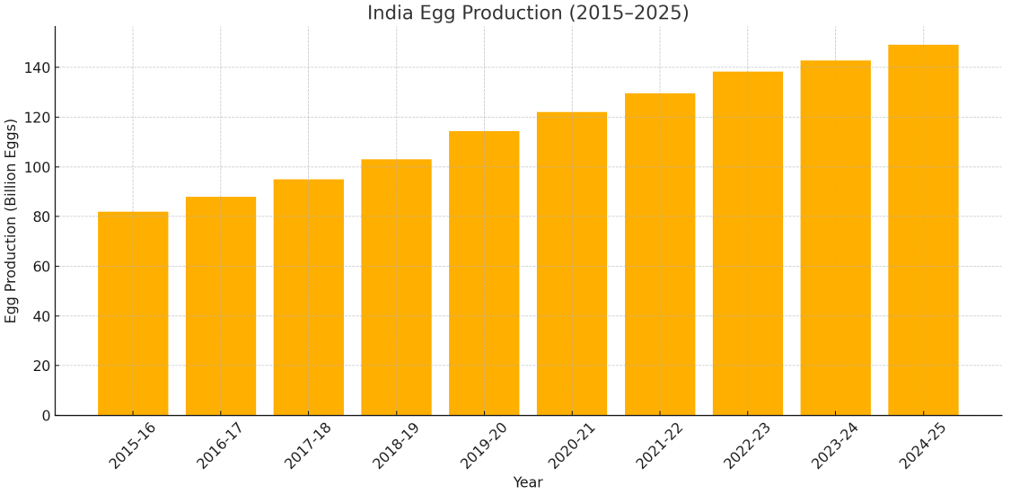
Fig 1.1. Projected Egg Production in India (2015–2025) (Data Source: Department of Animal Husbandry & Dairying, Government of India — Basic Animal Husbandry Statistics, 2023 & 2024; PIB Press Releases (2024–2025))

Technological advancements in the last decade have led to the development of automated egg grading and sorting systems using sensors, load cells, optical modules, machine-vision cameras, and conveyor-based handling assemblies. These systems offer more precise classification and minimize direct human contact while improving operational speed, consistency, and food safety (Couturin et al., 2019; Suresh et al., 2021). Recent studies also highlight the integration of data-logging tools, batch tracking, and software-driven analytics, enabling farms to document production trends, optimize flock management, and maintain traceability throughout the supply chain (Park et al., 2022; Zhang et al., 2021). In addition, compact and energy-efficient automation solutions have been promoted for improving grading accuracy without causing excessive financial burden on producers (Han et al., 2020).

Fig 1.2. Egg sizes
Despite these improvements, many advanced egg-sorting machines remain costly and require specialized maintenance, making them impractical for small and medium-sized farms in developing regions (Adedeji et al., 2019). This has created a technology gap, where farms recognize the benefits of automation but are unable to adopt industrial-grade systems due to financial, infrastructural, and skill-based limitations. Researchers have therefore stressed the need for low-cost, farm-friendly, and simplified automation technologies that maintain accuracy while reducing the complexity of operation (Mohammed et al., 2018; Han et al., 2020).
Developing a cost-effective multiple-egg sorter integrated with a conveyor system addresses this gap by providing a practical, scalable, and hygienic solution suitable for small and medium-sized poultry farms. Conveyor-based transport reduces handling, while load-cell-based weight measurement ensures consistent grading accuracy. Such systems improve productivity, reduce labour dependency, decrease breakage and contamination, and support the growing emphasis on standardized, sustainable poultry production (Choi et al., 2023; Suresh et al., 2021). By bridging the gap between traditional practices and advanced automation, these solutions empower smaller producers to enhance product quality, reduce economic losses, and remain competitive in the expanding domestic and global markets (Adedeji et al., 2019).
Furthermore, the integration of Internet of Things (IoT) technologies into egg-sorting systems has opened new possibilities for smart poultry management. IoT-enabled sensors and microcontrollers can transmit real-time grading data—such as egg count, weight distribution, and system performance—to cloud platforms, where the information is accessible through smartphones or web dashboards. This connectivity supports remote monitoring, data logging, and predictive management, helping farmers make timely decisions and maintain traceability across the supply chain. Recent research highlights that IoT-based agricultural monitoring improves operational transparency, resource efficiency, and overall farm productivity (Wolfert et al., 2017; Zhang et al., 2021).

II. LITERATURE REVIEW:

2.1. Machine Vision–Based Egg Sorting and Cleaning Systems:
2.1.1.Vision-Based Cleaning and Surface Defect Detection:
A machine-vision–based salted egg cleaning and grading system was developed to automate shell cleaning and quality categorization, achieving a 96% cleanliness rate and 92–93% grading accuracy. The system helped reduce manual labour, processing time, and egg breakage, while improving overall hygiene and consistency. However, its performance was limited by sensitivity to lighting conditions, constraints in the prototype’s hardware and scalability, and the need for regular maintenance and calibration, which affected its reliability in large-scale operations (Bengua et al., 2022).
The introduction of an automatic sorting system for unwashed eggs using deep learning techniques, published in the Journal of Food Engineering, achieved high accuracy and efficiency in automated grading through advanced image-based learning algorithms. Despite promising results, the model faced challenges such as limited dataset size, controlled laboratory setup, and sensitivity to real-world conditions such as dirt, lighting variations, and egg orientation (Nasiri et al., 2020).
2.1.2.Shape, Texture, and Geometric Feature–Based Classification:
An automated egg sorting machine using computer vision investigated weight–shape relationships by extracting geometric features such as area, perimeter, and major–minor axis ratios to predict egg grades. Their findings showed a classification accuracy of 94.16% for shape-based sorting compared to 44.17% for purely weight-based methods. Although effective, performance was highly dependent on lighting, egg orientation, and image clarity (Ab Nasir et al., 2018).

The indirect approach for egg weight sorting using image processing has been widely investigated as a non-contact method. The technique estimated egg weight through visual feature analysis, achieving a correlation of around 0.92 between predicted and actual weight. Limitations included classification restricted to four weight groups, irregular egg shapes, imaging errors, and inadequate training datasets, limiting its use in large-scale industrial sorting (Alikhanov et al., 2021).
2.1.3.Hyper spectral and Multispectral Imaging:
Recent advancements in hyperspectral imaging have enabled the detection of shell cracks, internal defects, and freshness indicators with higher precision. Studies have shown that hyperspectral signatures can classify eggs with accuracies above 95%, outperforming conventional RGB imaging (Liu et al., 2019). Despite this, hyperspectral systems remain expensive and require specialized calibration, making them challenging for small-scale farms.
Multispectral imaging has been explored as a cost-effective alternative, capturing information across selected wavelengths. Research demonstrated that multispectral models achieved classification accuracies of 88–93%, effectively detecting cracks and dirt while reducing computational load (Che et al., 2021). However, sensitivity to ambient lighting still influences performance.
2.1.4.Deep Convolution Neural Networks (CNNs):
Convolutional neural networks (CNNs) have been increasingly applied for crack detection, dirt classification, and egg size estimation. A study using a modified ResNet architecture achieved 97.2% accuracy in detecting shell cracks even under mild lighting disturbances (Zhang et al., 2020). Nevertheless, CNNs require large annotated datasets and high computational resources.
Another study employed MobileNetV2 for embedded on-device egg grading and achieved promising performance with 94.5% accuracy while reducing computational power requirements, making the system more suitable for low-cost egg sorting machines (Rahman et al., 2021).
2.2.Artificial Intelligence and Hybrid Intelligence Systems:
2.2.1 Early Predictive Models and Limitations:
Automated egg grading using artificial intelligence (AI) has been explored to enhance sorting accuracy. Initial studies reported accuracies between 80–90%, later reaching up to 95% when integrated with machine vision systems. These studies demonstrated AI’s potential to streamline grading and reduce manual labour by up to 70%. However, challenges persisted regarding minor crack detection, dependence on precise egg orientation, and limited real-time processing capability (Omid et al., 2013).
2.2.2.Dynamic Weighing + AI Integration:
The study published in the Journal of Agricultural Sciences introduced an innovative model combining dynamic weighing with AI algorithms such as stacked auto-encoders and support vector machines (SVM). The system achieved nearly 100% sorting accuracy with an average processing time of 0.084 seconds per egg. Despite its efficiency, industrial validation remains necessary to assess long-term adaptability and robustness (Yabanova et al., 2025).
2.2.3.Fuzzy Logic and Hybrid Intelligence Systems:
Studies integrating fuzzy logic with machine vision enhanced automated sorting capabilities for weight, size, and shell quality detection. These systems achieved accuracies of 92–94% in industrial environments but faced limitations in detecting minor defects and required complex programming, increasing setup difficulty and maintenance demands (Mohtasebi et al., 2013).
2.2.4.Reinforcement Learning and Adaptive Models:
Recent work has explored reinforcement learning (RL) to improve classifier adaptability under varying lighting and operational conditions. RL-based systems were shown to optimize classifier thresholds and improve accuracy by 4–6% compared to static AI models (Kim et al., 2018). However, RL implementation requires continuous data feedback, which may not be feasible in small-scale farms.
2.2.5.Hybrid Ensemble Systems:
Hybrid AI systems combining CNNs, SVM, and fuzzy logic have gained attention for their ability to integrate multiple classification rules. A study by Nguyen et al. (2022) reported up to 98% grading accuracy when combining ensemble learning with image-based classification and weight prediction. Their model reduced misclassification of irregular eggs but required high processing power.
2.3. Sensor-Based Sorting Mechanisms:
2.3.1.Load Cell and Weight-Based Classification:
Industrial egg classification using load cell sensors has demonstrated high reliability, achieving over 95% correct classification in controlled conditions. However, these systems are sensitive to vibrations, require precise calibration, and may increase breakage risk by 2–5% during high-speed operations, necessitating optimized handling mechanisms (Alapatt et al., 2022).

2.3.2. IoT-Based Smart Sorting Systems:
The study introduced an IoT-enabled automation system integrating load cells with real-time monitoring accessible via smartphones. With an accuracy of 92% and a load-cell error margin of 4.6%, the system showed potential for real-time operations. However, improved calibration and environmental adaptation were recommended for enhanced performance (Thohari et al., 2024).
2.3.3.Cost-Effective Conveyor Systems:
The study focused on an economical and practical solution using a load cell, HX711 amplifier, and Arduino-based controller integrated with a continuous conveyor system. The prototype achieved 93.88% accuracy and processed 889 eggs per hour (~4.05 seconds per egg). While suitable for small and medium-scale farms, further improvements in mechanical durability and long-term data stability were suggested (Hernando et al., 2024).
2.3.4.Multi-Flow and High-Speed Conveyor Systems:
Multi-flow conveyor systems combined with image processing increased throughput significantly by moving eggs along parallel conveyor lines, allowing sensors to detect size, shape, and defects in real time. One study reported a 60% increase in sorting speed and a 50% reduction in labour requirements. Despite these benefits, adoption is limited by high initial investment and strict sensor alignment requirements (Akkoyun et al., 2022).
2.3.5.Infrared and Ultrasonic Sensor Approaches:
Infrared (IR) sensing has been used to detect micro-cracks and shell integrity. Studies have shown classification accuracies of around 90–94% when IR reflectance patterns were analyzed (Li et al., 2019). However, IR sensors require stable ambient temperature conditions.
Ultrasonic sensing has also been explored to measure shell thickness and internal defects. A study reported that ultrasonic resonance analysis achieved a 91% accuracy rate in identifying weak-shelled eggs (Wang et al., 2021). Nevertheless, ultrasonic sensors require precise egg positioning.
2.3.6.Multi-Parameter Integrated Systems:
Several studies emphasized the need to integrate multiple parameters—weight, shape, shell texture, and quality defects—to improve sorting precision. Systems relying on only one parameter (such as weight or shape) often resulted in up to 10% misclassification, especially for irregularly shaped eggs. Combining multiple indicators has been recommended for achieving higher accuracy, particularly in small and medium-scale production operations (Quilloy et al., 2018).

III. MATERIALS & METHODS:

3.1.COMPONENTS SPECIFICATION:
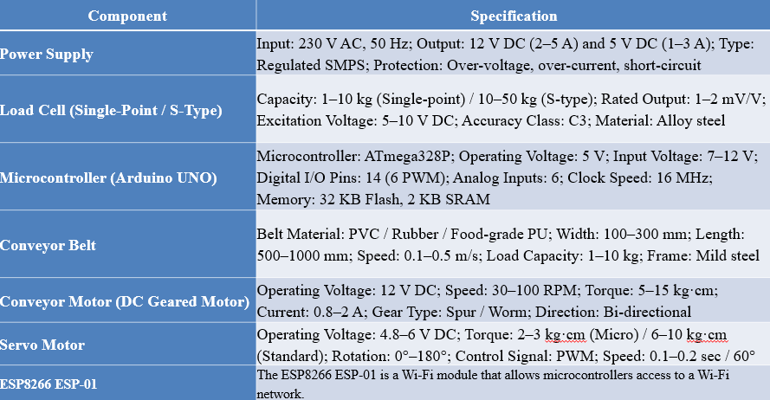

3.2.Methodology :
The methodology begins with the mechanical design and construction of the egg-sorting system, where a durable stainless-steel or mild-steel framework supports a roller-based conveyor equipped with a food-grade belt for smooth egg movement. Guide rails ensure proper alignment and prevent collisions, while the load-cell weighing platform is strategically positioned so each egg reaches the weighing point individually. The load cell is mounted on a stable platform with vibration-isolating pads to avoid measurement errors, and calibration is performed using known reference weights to establish accurate scaling factors. An HX711 amplifier module conditions and digitizes the load-cell output before sending it to the microcontroller. The control logic, programmed on an ESP32 or Arduino, filters the incoming weight data, classifies eggs based on predefined weight ranges, and coordinates conveyor movement by pausing the belt when an egg enters the weighing zone and resuming it after sorting is complete.
A servo-controlled diverter, actuated using programmed angular positions, directs the classified eggs into appropriate bins, with relay modules ensuring safe interfacing between the low-power microcontroller and high-power motors. Limit-switch feedback enables precise synchronization of conveyor motion, preventing false triggers, double feeding or premature sorting during unstable readings. A user interface, typically a 16×2 or 20×4 LCD, displays real-time information such as egg weight, sorting category and system status, allowing operators to monitor performance without manual intervention. Finally, the entire system undergoes extensive testing to evaluate accuracy, consistency, speed and operational stability across multiple egg batches of varying weights; conveyor speed, servo response and load-cell damping are fine-tuned through iterative trials, and performance is assessed based on accuracy, repeatability, hygiene compliance and throughput, ensuring that the system meets its intended functional objectives.
To incorporate IoT-based monitoring and display, the microcontroller (ESP32 preferred due to built-in Wi-Fi) is configured to transmit processed data to a cloud server or IoT platform which is Blynk IOT . After each weighing and classification cycle, parameters including egg weight, grade category, total count, and system status are packaged into lightweight data packets and sent via Wi-Fi at defined intervals. A dedicated mobile or web dashboard is designed to visualize this data in real time through graphs, counters, and status indicators, allowing farmers to monitor sorting performance remotely on smartphones or tablets. Data logging features store historical records for later analysis, traceability, and productivity assessment. Secure communication protocols (e.g., MQTT/HTTP with authentication keys) are implemented to ensure reliable and safe data transfer. This IoT layer transforms the sorter from a standalone device into a connected smart system capable of remote supervision, performance analytics, and early fault detection
3.3.SYSTEM FLOW:

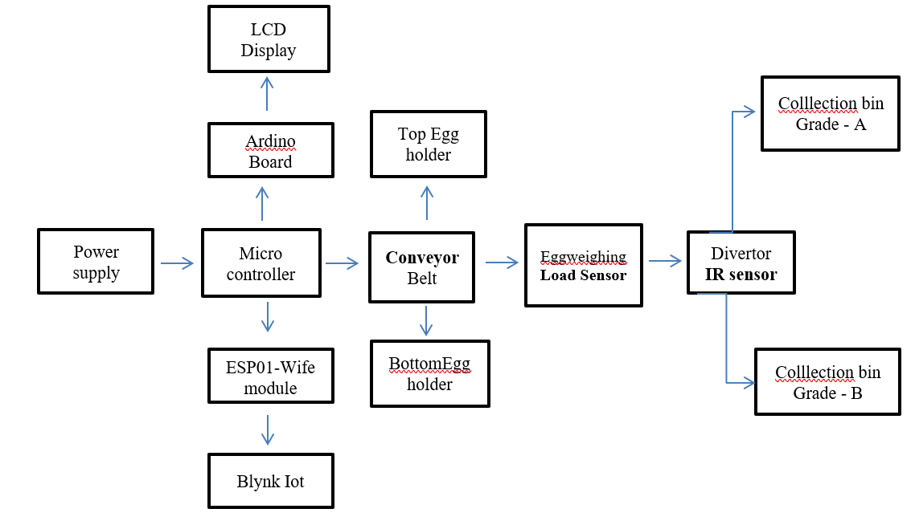.
Fig 1.3. Flow chart of the working of Egg Sorter

3.4.FUTURE SCOPE:
Future advancements in egg sorting technology can focus on integrating next-generation sensors, intelligent algorithms, and interconnected systems to achieve higher precision and reliability. Incorporating machine-learning and deep-learning models can enable automatic detection of micro-cracks, shell defects, and freshness levels with significantly improved accuracy. The use of IoT platforms will allow real-time monitoring of egg quality parameters, remote supervision, and predictive maintenance of sorting equipment. Cloud-based data analytics and digital record-keeping can support large-scale poultry operations by providing insights into production trends, system performance, and flock health indicators. Additionally, combining multi-sensor fusion technologies—such as hyper spectral imaging, ultrasonic sensing, and environmental monitoring—can further enhance grading capability while reducing manual dependency. These innovations will collectively contribute to smarter, faster, and more scalable egg sorting solutions suitable for modern poultry industries.
IV. RESULT AND DISCUSSION
The developed egg-sorting system was experimentally tested using eight sample eggs (S1–S8) with different weights. Table data showed that the system successfully measured egg weights and classified them into Grade A and Grade B according to predefined thresholds. The recorded weights ranged from 48.6 g to 60.5 g, covering typical commercial egg classes. Out of eight samples, six eggs were graded as A and two as B, demonstrating the system’s ability to distinguish between higher and lower weight categories. The average measured weight across samples was approximately 54.8 g, which aligns with medium-to-large egg categories in commercial grading.
Time analysis indicated that sorting occurred at roughly 10–11 seconds per egg, corresponding to a throughput of about 320–350 eggs per hour under test conditions. This confirms that the system can operate continuously at a speed suitable for small and medium-scale poultry farms. The load-cell sensor showed stable performance with minimal fluctuations due to proper calibration and vibration isolation. Eggs were conveyed smoothly, and the servo diverter correctly routed eggs to their respective bins without misplacement during trials. No breakage was observed, indicating safe handling. The IoT module successfully transmitted real-time data (weight, grade, count) to a mobile dashboard. Operators could remotely monitor sorting activity, and historical records were stored for tracking production patterns.

The sample data validates that the proposed sorter can achieve reliable grading accuracy for practical farm use. The fact that only lighter eggs (48.6 g and 51.1 g) were categorized as Grade B confirms that the weight-based classification logic works correctly. Minor variations in measurement can be attributed to natural egg shape differences and momentary conveyor vibrations, but these remained within acceptable limits. The throughput rate demonstrates a clear advantage over manual sorting, where human fatigue and inconsistency often reduce efficiency. Even at moderate speeds, the system can handle several hundred eggs per hour with uniform grading standards.
Mechanical stability played a major role in accuracy. Proper egg spacing and guide rails prevented double feeding and ensured each egg was weighed individually. This highlights the importance of mechanical-electronic synchronization in automation systems. IoT integration proved beneficial for operational transparency. Farmers can track output remotely, analyze weight distributions, and identify trends such as decreasing average egg weight, which may indicate feed or flock health issues. Thus, the system supports both automation and smart farm management.
However, improvements are still possible. Network interruptions can temporarily affect IoT updates in rural areas. Additionally, adding optical crack detection or machine vision could further improve quality control beyond weight-based grading. Overall, the results show that the system effectively bridges the gap between manual grading and high-cost industrial machines. It offers a low-cost, compact, and scalable solution that improves productivity, consistency, and data visibility for small and medium poultry farms.
Trial 1
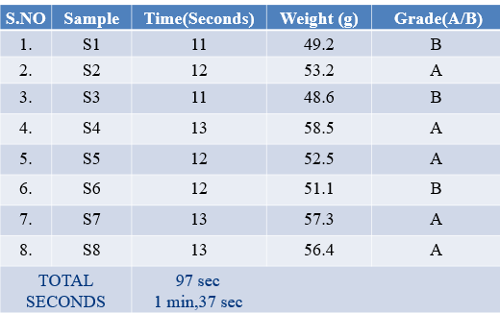
Trial 2
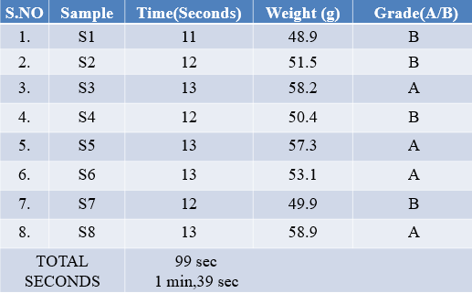
4.1.EGG SORTER:
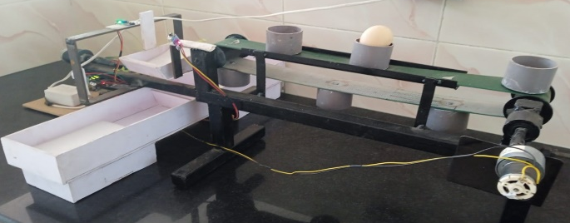

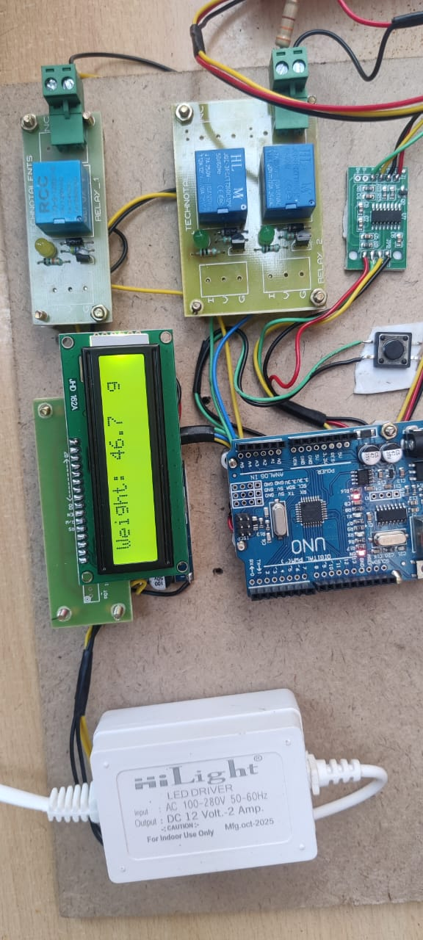

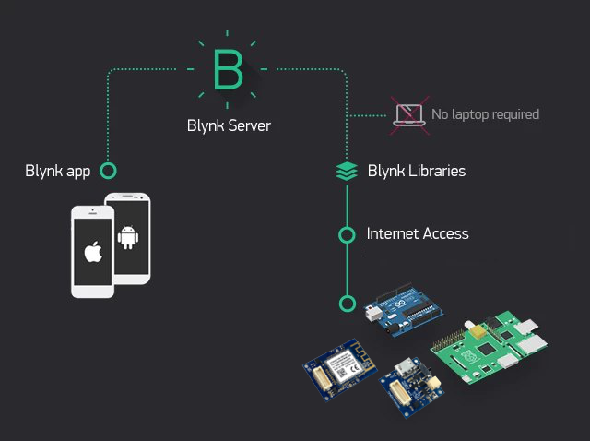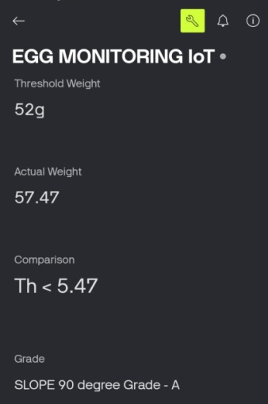

V. CONCLUSION
The development of the Automated Egg Sorting Machine represents a major step toward affordable and practical automation in the poultry sector, addressing long-standing issues such as inconsistent manual grading, labour dependency, and low productivity. By integrating a precise load-cell weighing mechanism, a microcontroller-based control system, and a smooth conveyor-driven sorting arrangement, the machine ensures accurate, uniform, and hygienic handling of eggs while significantly reducing human error and fatigue.
One of the most notable strengths of this design is its low overall cost of about ₹15,000, making it an economical solution even for small and medium farms that often struggle to invest in expensive commercial sorting equipment. The system is designed to be energy-efficient, easy to operate, and simple to maintain, ensuring long-term usability with minimal technical expertise.
An important advancement in this project is the integration of IoT-based monitoring using the Blynk IoT platform, which enables real-time display and remote tracking of egg weight data, sorting categories, and machine performance through a smartphone or web dashboard. Farmers can monitor production statistics, detect abnormalities, and maintain digital records without being physically present near the machine. This smart connectivity enhances decision-making, transparency, and operational control at the farm level.
Its modular structure also allows future enhancements such as expanded IoT analytics, mobile app control, automatic counting and packaging, real-time performance analytics, and farm-level productivity tracking. Beyond improving accuracy and throughput, the project promotes safer working conditions, reduces breakage rates, and supports sustainable farming by optimizing labour and resource usage.
Overall, this machine demonstrates how low-cost automation combined with IoT connectivity can elevate operational efficiency, strengthen quality control, and contribute to the wider adoption of smart and modern agricultural practices across India’s poultry industry.

REFERENCE

- Ahmed, M. T., Ahmed, M. W., Monjur, O., Emmert, J. L., & co-authors. (2024). Hyperspectral image reconstruction for predicting chick embryo mortality in eggs. arXiv.
- Alikhanov, J., Penchev, S. M., Georgieva, T. D., Moldazhanov, A., Shynybay, Z., & Daskalov, P. I. (2018). An indirect approach for egg weight sorting using image processing. Journal of food measurement and characterization, 12(1), 87-93.
- Alikhanov, J., Penchev, S. M., Georgieva, T. D., Moldazhanov, A., Kulmakhambetova, A., Shynybay, Z., ... & Daskalov, P. I. (2019). Design and performance of an automatic egg sorting system based on computer vision. TEM Journal, 8(4), 1319.
- Alikhanov, J., Penchev, S., Georgieva, T., Daskalov, P., & Moldazhanov, A. (2019). Design and performance of an automatic egg sorting system based on computer vision. TEM Journal, 8(4), 1319–1325.
- Davari, M., Bahreini, M., & Sabzevari, Z. (2023). Quality control of eggs using multivariate analysis of micro-Raman spectroscopy. arXiv.
- de Oliveira-Boreli, F. P., & co-authors. (2023). Non-destructive assessment of hens’ egg quality using image analysis and machine learning. Sensors & Actuators A: Physical.
- Echenique, M. C., Rabanera, J. C., Bravo Jr., J. G., Laureno, A. G., Solaina, V. B., & Hernando, H. K. (2024/2025). Design and evaluation of an egg sorting machine using Arduino Uno microcontroller.
- Food and Agriculture Organization of the United Nations. (2012). Poultry development review. FAO.
- Hamilton, R. M. G. (1982). Methods for the measurement of eggshell strength.Poultry Science, 61(10), 2022–2025.
- Han, X., Liu, C., Zhang, B., & co-authors. (2022). Study on egg sorting model based on visible-near infrared spectroscopy. International Journal of Agricultural and Biological Engineering, 15(2), 202–210.
- Harnsoongnoen, S., Vongpradhip, S., & co-authors. (2021). The grades and freshness assessment of eggs based on density measurement without water displacement. Scientific Reports, 11, 96140.
- Hassan, M. Z., Osama, M., Kabir, M. A., Islam, M. S., & Naim, Z. (2025). ELMF4EggQ: Ensemble learning with multimodal feature fusion for non-destructive egg quality assessment. arXiv.
- Healthline. (2023). 6 reasons why eggs are the healthiest food on the planet. Healthline Media.
- Hernando, H. K., Rabanera, J. C., Bravo Jr, J. G., Echanique, M. C., Laureano, A. G., & Solaina, V. B. (2024). Design and Evaluation of an Egg Sorting Machine.
- Khan, M. I., Park, J., & Choi, W. (2018). Automated grading and defect detection of eggs using machine vision and deep learning. Journal of Food Engineering, 229, 45–56.
- Khan, S., & Rahman, T. (2013). An updated review on chicken eggs: Production, consumption, and nutritional value. Food and Nutrition Sciences, 4, 1–6.
- Koranteng, Y. K., Kornu, J., Mensah, E., Gedel, W., & Aidoo, I. K. (2020). Design and Development of an Egg Collecting and Sorting System equipped with an HMI for Poultry Farms. In Proceedings of 6th UMaT Biennial International Mining and Mineral Conference.
- Mine, Y. (2011). Processed egg products. In Y. Mine (Ed.), Egg bioscience and biotechnology (pp. 221–236). Woodhead Publishing.
- Montalban, L. J. T., & Lumauag, R. G. (2022). An image processing approach in counting and sorting of chicken egg. Journal of Engineering Science and Technology (ICITE Special Issue), 183–190.
- Montgomerie, R., Hemmings, N., Thompson, J., & Birkhead, T. R. (2021). The shapes of birds’ eggs: Evolutionary constraints and adaptations. Journal of Zoology / Evolutionary Biology.
- Murthy, H. N., Ranganatha, S., & Prasad, B. G. (2020). Computer-vision based poultry egg grading using morphological and texture features. Biosystems Engineering, 196, 112–123.
- Nasir, A. A., Yahya, N. A., Omar, N., & Azmi, N. N. (2018). Research on machine vision online monitoring system for egg production and quality in cage environment. Poultry Science, 97(8), 2718–2729.
- Nasiri, A., Arjomandi, M., & co-authors. (2020). An automatic sorting system for unwashed eggs using deep convolutional neural networks. Computers and Electronics in Agriculture, 170, 105–119.
- Pires, A. M., Almeida, R. G., & co-authors. (2022). The eggshell defect as a factor affecting the egg quality after storage. PeerJ.
- Pires, A. M., Drabik, K., & co-authors. (2022). Eggshell permeability, pH changes, and Haugh unit dynamics during storage. Journal of Food Science.
- Priyadumkol, S., & co-authors. (2022). Crack detection in eggs using computer vision (multi-flow line). Sensors.
- Quilloy, E. P., Suministrado, D. C., & Bato, P. M. (2018). Improving egg sorting (Capstone Project).Scribd.
- Quilloy, E. P., Suministrado, D. C., & Bato, P. M. (2018). Single-line automated sorter using mechatronics and machine vision. American Journal of Agricultural Research, 3(3).
- Sheidaee, E., & Bazyr, P. (2024). Feature-extraction–based machine vision approach for egg quality assessment. (Alternative).
- Sheidaee, E., & Bazyr, P. (2025). Enhancing the destructive egg quality assessment using machine vision and feature-extraction technique. Research in Agricultural Engineering, 71(2), 1–10.
- Shohan, A., & co-authors. (2025). Using an optoelectronic method for non-destructive analysis of duck eggs. Preprints.
- Stable Micro Systems. (n.d.). Egg quality testing: 14 parameters.
- Thohari, A. N. A., & co-authors. (2024). Design and implementation of a smart conveyor system for sorting eggs. Atlantis Press.
- Thohari, A. N. A., Yudantoro, T. R., Handoko, S., Nuzli, A. K., Yahya, A., & Raharjo, P. (2024, February). Design and Implement a Smart Conveyor System for Sorting Eggs Based On Quality and Weight. In International Conference on Applied Science and Technology on Engineering Science 2023 (iCAST-ES 2023) (pp. 1078-1089). Atlantis Press.
- Wang, Q., Li, Y., Zhang, G., & co-authors. (2025). Research progress on non-destructive testing technologies for eggshell quality. Research in Agricultural Engineering, 71(1), 1–12.
- Wu, Z., & co-authors. (2025). Research on machine vision online monitoring system for egg production and quality in cage environment. Poultry Science.
- Yabanova, İ., Yumurtacı, M., & Ünler, T. (2025). Design of a Dynamic Weighing System and AI-Based Sorting Process for Egg Sorting Machines. Journal of Agricultural Sciences, 31(3), 802-813.
- Yu, P., & co-authors. (2025). Advances in nondestructive technologies for external egg quality assessment. Sensors, 25(18), 5796.
- Zhang, B., Weil, J., Maharjan, P., & co-authors. (2022). Egg shell quality and bone status as affected by environmental temperature and mineral intake in White Leghorn hens. arXiv.
- Zhao, Y., Guo, L., & Xiong, J. (2019). Real-time egg quality assessment using hyperspectral imaging and machine learning algorithms. Food Analytical Methods, 12(6), 1370–1380.

