An AI-Driven Resume Analyser with Job Recommender and Portfolio Code Generator

Abstract
JobHelper is an AI-driven platform designed to optimize and simplify the job application process. By generating professional resumes through customizable templates, the platform ensures that job seekers effectively present their skills and experience. In addition to resume creation, JobHelper analyzes and matches user profiles with relevant job opportunities, improving their chances of landing suitable roles. Furthermore, the platform automatically generates professional portfolio websites by providing HTML, CSS, and JavaScript code, allowing users to easily showcase their work. JobHelper's integrated approach aims to enhance job-seeking success and elevate users' professional presence
Keywords—React, Javascript, NLP, Pyresparser, Resume Analyzer.
- Introduction

An AI-driven resume Analyzer with a Job Recommender and Portfolio Code Generator is a platform tailored to revolutionize the job application process by leveraging the power of artificial intelligence. This innovative tool addresses the core needs of job seekers, from generating personalized resumes to offering job recommendations and portfolio creation. The project is divided into three distinct yet interconnected parts, each aimed at enhancing the user's professional profile and increasing their chances of success in the competitive job market.

JobHelper uses advanced AI algorithms to analyze the content of a user's resume, extracting key skills, qualifications, and experience. By understanding the user's professional background, it intelligently recommends job listings that closely match the individual's expertise and career aspirations.

This feature not only saves time but also ensures that job seekers are presented with relevant, high-quality opportunities that align with their skill sets, thus improving the likelihood of securing interviews and job offers. The platform incorporates state-of-the-art generative AI technology to streamline the resume creation process. This JobHelper allows users to craft professional resumes with
ease by selecting from customizable templates designed to suit a variety of industries and job roles.

- METHODOLOGY

The JobHelper system is an AI-driven platform designed to assist users in resume optimization, job recommendations, and portfolio generation. The system is divided into four interconnected modules, each addressing a specific functionality.

The methodology section outlines the comprehensive approach taken to develop the Resume Analyzer and Recommender System Using Python, detailing the processes and technologies used at each stage of the system's development. This section covers the design and implementation of both the frontend and backend components, database management, dataflow, security measures, server setup, database deployment, application deployment, and security measures integration.

The Resume Analysis Module begins by parsing resumes uploaded in various formats (PDF, DOCX) using OCR and NLP libraries like spaCy and NLTK. It extracts key skills, detects grammatical and syntactical errors using tools like Grammarly API, and evaluates the resume's quality through a scoring algorithm. The Job Recommendation Module utilizes the extracted skills to match users with relevant job profiles from a database populated via APIs like Indeed or LinkedIn. A recommendation algorithm, such as collaborative filtering or cosine similarity, is employed to suggest jobs based on skill relevance, location, and experience level. The Resume Generation Module integrates generative AI models (e.g., GPT-4) to create professional resumes using customizable templates. Users can edit and preview resumes in real-time before exporting them in formats like PDF or DOCX. Lastly, the Portfolio Code Generation Module generates personalized portfolio websites by dynamically populating pre-designed HTML, CSS, and JavaScript templates with user data. Users can customize the portfolio's design and layout, with the final code packaged into a downloadable ZIP file. The system is

built on a modular architecture, featuring a React.js frontend for a responsive interface, a Node.js/Django backend for data processing, and AI/ML models for NLP and recommendation tasks. It is deployed on a cloud platform (e.g., AWS or Google Cloud) for scalability and evaluated using metrics such as resume analysis accuracy (precision, recall, F1-score), job recommendation precision (mean reciprocal rank, precision@k), and user satisfaction scores. This comprehensive approach ensures a robust, user- friendly, and scalable solution for job seekers.

Resume Parsing and Text Extraction: The Resume Analysis Module relies on tools like PyPDF2 and python- docx to extract text from resumes uploaded in PDF and DOCX formats, respectively. PyPDF2 is a Python library specifically designed for reading and extracting text from PDF files, making it ideal for parsing resumes in PDF format. Similarly, python-docx is used to handle DOCX files, enabling the extraction of text, headings, and other relevant content. For resumes with non-selectable text (e.g., scanned documents), Tesseract OCR is employed. Tesseract is an open source Optical Character Recognition (OCR) engine that converts images of text into machine-readable text, ensuring comprehensive text extraction from all resume formats.

Natural Language Processing (NLP): The extracted text is processed using NLP libraries like spaCy and NLTK. spaCy is a powerful NLP library that provides pre-trained models for tokenization, part-of-speech tagging, and named entity recognition (NER). It is used to identify skills, job titles, and other key entities in the resume. NLTK (Natural Language Toolkit) complements spaCy by offering additional functionalities like stemming, lemmatization, and sentiment analysis, which help in refining the extracted data. These tools collectively enable the system to analyze and structure the resume content effectively.

Grammatical and Syntactical Error Detection: To ensure the resume is error-free, the system integrates tools like Grammarly API or LanguageTool. Grammarly API is a widely used tool for detecting grammatical, punctuation, and spelling errors in text. It provides real-time suggestions for corrections, enhancing the quality of the resume. Alternatively, LanguageTool, an open-source grammar checker, is used to identify errors and offer corrections, ensuring the resume adheres to professional standards.

Job Recommendation Algorithms: The Job Recommendation Module uses machine learning libraries like sci-kit-learn and TensorFlow to implement recommendation algorithms. scikit-learn provides a range of algorithms, including cosine similarity and collaborative filtering, which are used to match user skills with job descriptions. TensorFlow, a deep learning framework, is employed for more advanced recommendation models, such as neural network-based approaches. These tools ensure accurate and personalized job recommendations based on the user's profile.

Generative AI for Resume Generation: The Resume Generation Module leverages generative AI models like GPT-4 or Hugging Face Transformers. GPT-4, a state-of-
the-art language model, is used to auto-fill resume sections with coherent and professional content based on user input. Hugging Face Transformers provides pre-trained models for natural language generation, enabling the system to create tailored resumes efficiently. These AI models ensure that the generated resumes are high-quality and relevant to the user's profile.

Frontend Development: The frontend of the system is built using React.js, a popular JavaScript library for building user interfaces. React.js enables the creation of a responsive and interactive web application, allowing users to upload resumes, customize templates, and preview outputs in real- time. Its component-based architecture ensures modularity and scalability, making it ideal for a feature-rich application like JobHelper

Backend Development: The backend is developed using Node.js or Django. Node.js is a JavaScript runtime that enables efficient handling of asynchronous operations, making it suitable for real-time data processing. Django, a Python-based web framework, is used for its robustness and scalability in handling complex business logic. Both frameworks integrate seamlessly with the database and frontend, ensuring smooth data flow and processing.

Database Management: The system uses MongoDB or MySQL for database management. MongoDB, a NoSQL database, is chosen for its flexibility in handling unstructured data, such as resumes and user profiles. MySQL, a relational database, is used for structured data storage, such as job profiles and user preferences. These databases ensure efficient storage, retrieval, and management of data.

Portfolio Code Generation: The Portfolio Code Generation Module uses Bootstrap for responsive web design and JavaScript for interactivity. Bootstrap provides pre-designed templates and components, enabling the creation of visually appealing and mobile-friendly portfolio websites. JavaScript is used to dynamically populate the templates with user data and add interactive features. The final code is packaged into a downloadable ZIP file using JSZip, a JavaScript library for creating and managing ZIP files.

Deployment: The system is deployed on cloud platforms like AWS (Amazon Web Services) or Google Cloud. These platforms provide scalable and reliable infrastructure for hosting the application, ensuring high availability and performance. Services like AWS EC2 for virtual servers and Google Cloud Storage for data storage are utilized to support the system's requirements.

Evaluation Metrics: The system's performance is evaluated using precision, recall, and F1-score for resume analysis, mean reciprocal rank (MRR) and precision@k for job recommendations and user satisfaction scores. These metrics ensure that the system delivers accurate and user-friendly results, meeting the needs of job seekers effectively.

my college project title is "JobHelper: An AI Driven Resume Analyzer with i Job Recommendor and Portfolio Code Generator"

"1)It Provides skills based on the resume ,this will provide the job recommendations to the user

- project also has resume analyser will also take out he gramatical , and all syntatical errors as well as it will anlyze the resume and suggest job profiles for the user

- It will Generate professional resumes with customizable templates using a generative AI- when the user uploads resume in any format of the web app,

- It will generate and give portfolio code to the user which will be in the HTML and CSS and javascript."

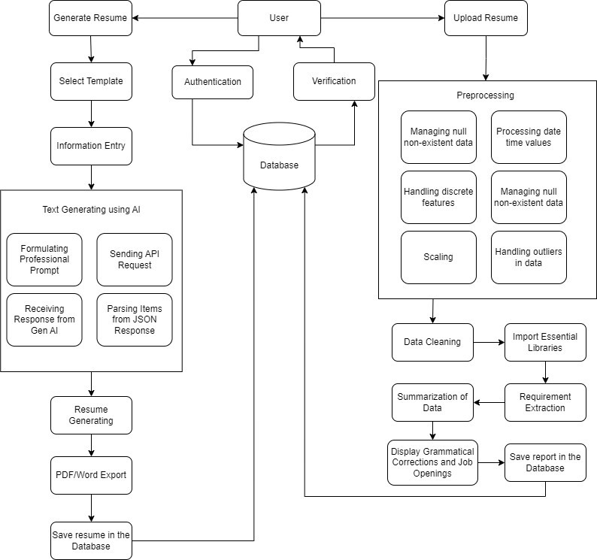

Fig. 2.1. Proposed System

Fig. 2.1.Proposed System The "JobHelper" system is an AI-driven tool designed to assist users in creating, analyzing, and improving resumes, while also offering job recommendations and portfolio code generation. Users can either generate a new resume by selecting a template and entering their information or upload an existing resume for analysis. Uploaded resumes undergo preprocessing to handle missing data, standardize formats, clean information, and extract key job-related requirements. The system utilizes AI to refine resumes by generating professional text, integrating responses into templates, and ensuring the output is polished and ready for job applications. The final resume can be exported in formats such as PDF or Word and is stored in the database for future use. Additionally, the system recommends relevant jobs based on the user’s profile and may assist in generating portfolio code, streamlining the entire career preparation process.
- LITERATURE REVIEW
The literature on resume parsing focuses on methods to automate the extraction of critical details from resumes, streamlining the recruitment process for organizations. Traditional approaches often rely on rule-based or pattern- matching techniques, while more recent advancements leverage natural language processing (NLP) capabilities. Named entity recognition (NER) and syntactic parsing are crucial NLP tasks employed for identifying and classifying key elements such as names, contact details, and skills. Additionally, multiprocessing techniques have been explored for parallel processing, significantly reducing processing time, especially with large volumes of resumes. Evaluation metrics such as accuracy and precision are used to assess system performance, often with manually annotated datasets and user feedback.
Automated parsing systems find applications in various domains, offering, benefits such as cost savings and efficiency improvements in candidate screening and talent management processes. Overall, the literature highlights ongoing efforts to develop innovative techniques that address the evolving needs of recruiters and HR professionals in the recruitment landscape.
A review of existing tools for resume analysis and job matching reveals several limitations, particularly with traditional keyword-matching systems, which can be manipulated and fail to account for the context of candidates' skills and experiences. Recent advancements in NLP and ML offer opportunities to address these issues, but current systems lack comprehensive solutions that include both resume analysis and personalized recommendations.

The paper [1]. This study presents a basic text- processing tool for resume analysis that uses lexical analysis techniques to extract information from resumes. While the system can handle simple resume formats, it struggles with diverse and unstructured formats, making it unreliable for real-world applications. The research highlights the challenges of processing unstructured data and concludes that there is a need for more robust systems capable of handling Complex resume formats. Research Gap: The system cannot process resumes that vary in structure or content, often relying on predefined templates. This creates a significant gap in its ability to parse and analyze resumes effectively across industries.

The paper [2], This paper introduces a more sophisticated resume screening tool that uses advanced NLP techniques to extract data from resumes with a higher accuracy rate (85% for text parsing and 92% for job ranking). The system also provides real-time processing, allowing recruiters to review resumes faster than traditional methods. However, the system's high time complexity and reliance on older machine learning models, such as Naïve Bayes, make it less efficient in real-world, high-volume
recruitment scenarios. Research Gap: Despite its improvements over basic text processing methods, this system struggles with high time complexity and is limited in its ability to rank resumes accurately for roles requiring nuanced skill matching. Additionally, it does not address the issue of resume optimization or job recommendations.

The paper [3], This research introduces the concept of integrating resume analysis with a recommender system to match candidates with job roles. The paper describes a Python-based application that applies basic keyword matching to assess candidate-job fit. While it provides a user-friendly interface and has achieved a degree of success in recommending jobs, it heavily relies on keyword matching, which can be easily manipulated by including specific keywords in resumes, leading to poor candidate-job- matches. Research Gap: The system fails to consider the deeper contextual understanding of candidates' qualifications, as it relies on simple keyword matching. This may result in incorrect or irrelevant job recommendations, especially in cases where the resume contains industry jargon or ambiguous job titles The literature survey highlights various strategies for Parkinson's disease (PD) detection. Wang et al. (2020) excel in early detection, achieving 96.45% accuracy with a deep-learning method for premotor PD stages. Prashanth et al. (2018) use patient questionnaires, achieving over 95% accuracy in distinguishing early PD from healthy individuals.

The paper [4], The paper titled "Resume Analyzer Using Text Processing" presents a system designed to streamline the recruitment process by analyzing and ranking resumes using text mining and machine learning techniques. The system extracts relevant information from resumes, matches candidates with job requirements, and ranks them based on the alignment of their skills with the job descriptions, thereby assisting recruiters in identifying the best candidates more efficiently. Research Gap: The primary research gap identified in the paper is the absence of robust systems capable of accurately analyzing unstructured resume data across various formats without heavy reliance on predefined templates or extensive manual labeling. Existing methods often struggle with variability in resume formats and require significant human effort for data annotation, limiting their scalability and effectiveness. The proposed system aims to address these limitations by using a combination of text mining, machine learning, and rule-based approaches to create a more adaptable and automated resume analysis process.

The paper [5], The paper presents a machine learning and NLP-based system for automating resume screening. The system aims to address the challenges faced by large companies when screening massive volumes of resumes. Using models like KNN and SVM, helps identify resumes that best match job descriptions and provides suggestions for improving them. Research Gap: The paper highlights a gap in existing resume screening systems, specifically that they do not provide feedback to candidates on how to improve their resumes. Additionally, most existing systems are trained once and do not self-improve over time, potentially limiting their effectiveness for evolving datasets and job requirements.

The paper [6] The paper presents a job recommendation system that uses machine learning algorithms to suggest jobs for college graduates based on their skill sets. The system analyzes resumes and compares them to job descriptions, taking into account degrees, soft skills, hard skills, and projects completed by the user. It not only recommends jobs
but also suggests skills to improve the user's resume score. Research Gap: Current job recommendation systems often overlook the detailed skill set of candidates and rely heavily on domain interest. This paper addresses this gap by incorporating a more comprehensive analysis of candidates' skills and projects.

- RESULTS
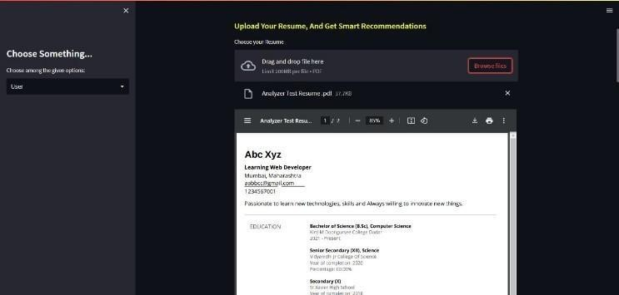
Fig. 4.1. Initial Interface: Choose Something and Upload Resume

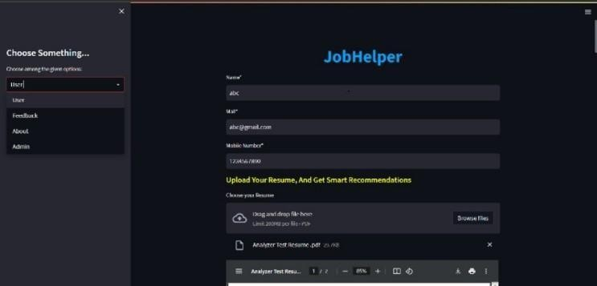
The image showcases a user interface for a resume analysis and job recommendation web application. A user can upload their resume in various formats, as demonstrated by the "Analyze Test Resume.pdf" file. The system then analyzes the resume, identifying skills and potential errors, to provide tailored job recommendations. The "Choose Something..." dropdown hints at user profile management.

Fig. 5.2. User Information Form: Enter Personal Details

The image shows the user interface for "JobHelper," an AI- powered resume analyzer and job recommender. Users can upload resumes, as seen with the "Analyze Test Resume.pdf" example, and the system promises smart recommendations. A "Choose Something" menu and user information fields suggest profile management features. The interface highlights easy resume upload and AI-driven job suggestions.

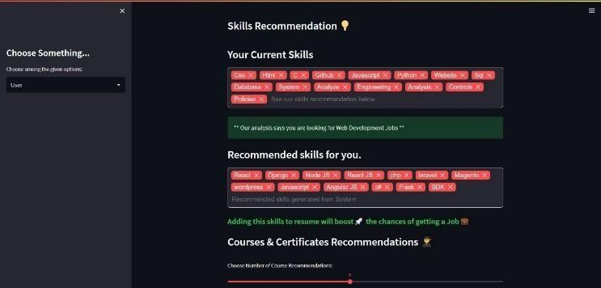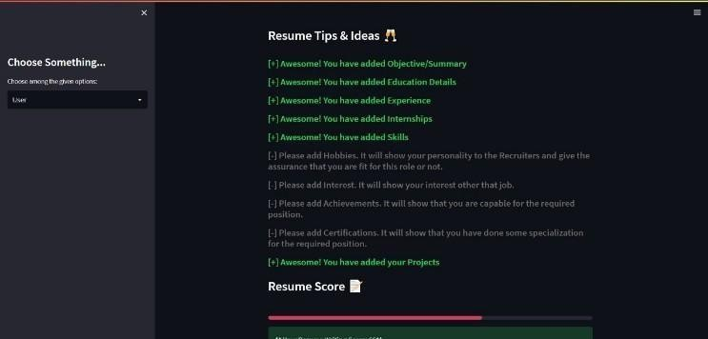

Fig. 4.3. Skills Recommendation: View and Improve Skills

Fig.4.3 This image showcases the "Skills Recommendation" feature of JobHelper. It displays "Your Current Skills" extracted from the uploaded resume (likely "Analyze Test Resume.pdf" as seen before) and "Recommended Skills" suggested by the AI. The highlighted message, "Our analysis says you are looking for Web Development jobs," demonstrates the system's ability to understand user intent. The "Courses & Certificates Recommendations" section further aligns with the project's goal of comprehensive job search assistance, going beyond just resume analysis and recommendations. This image represents a key component of JobHelper's value proposition: providing actionable skill- based guidance to improve a user's job prospects.

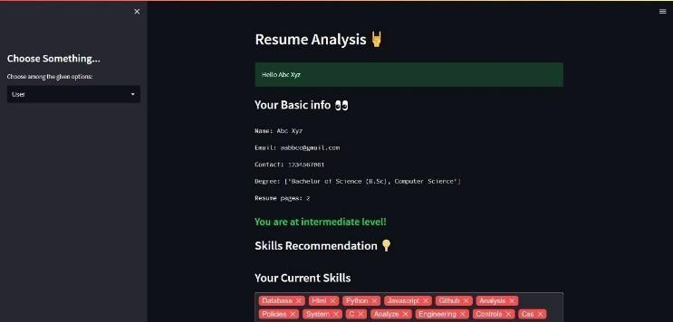
Fig. 4.4. Resume Analysis Results: See Resume Strengths and Weaknesses

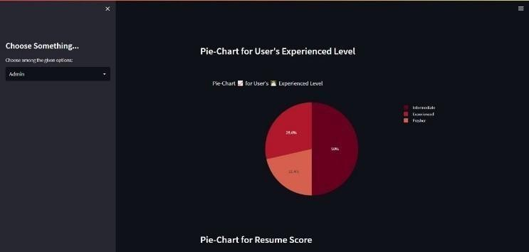
Fig 4.4. "Resume Analysis" section of JobHelper. It displays a parsed resume with basic information extracted, including name, contact details, degree, and resume pages. The system has identified the user as being at an "intermediate level" and is about to present "Skills Recommendations" based on "Your Current Skills" already listed. This highlights JobHelper's ability to analyze a resume, extract key data, assess the user's level, and prepare to provide tailored skill recommendations for job seekers.

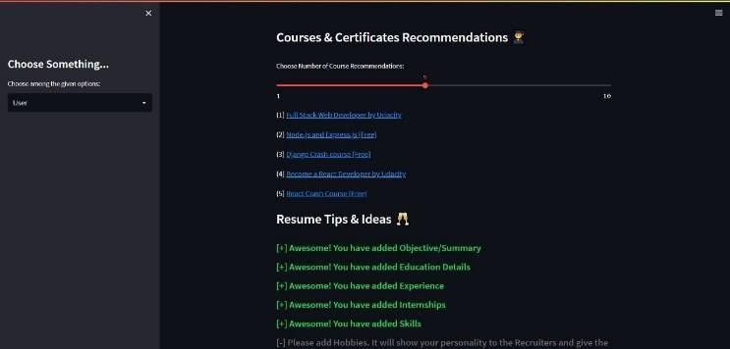
Fig. 4.5. Course Recommendations: Suggested Courses for Skill Improvemen
Fig. 4.6. Resume Tips: Tips for Enhancing Your Resume

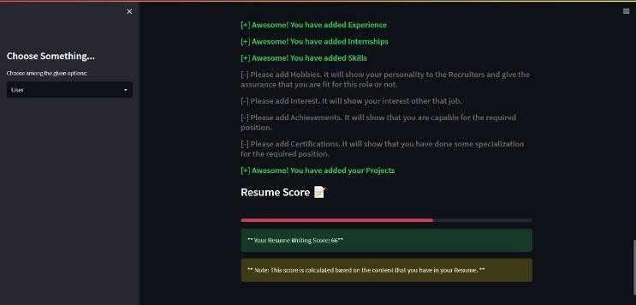
Fig. 4.6. Resume Score: Overall Assessment of Resume Quality ATS score
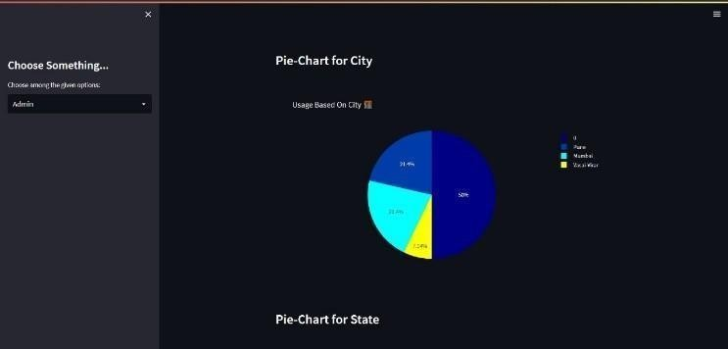

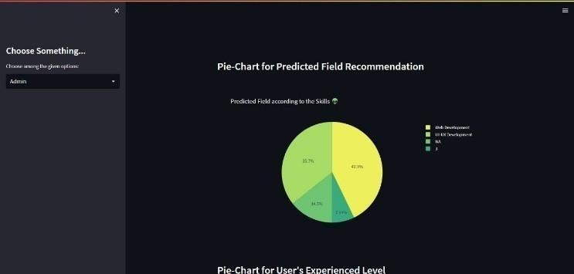

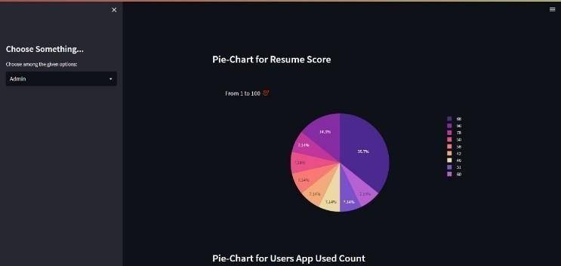

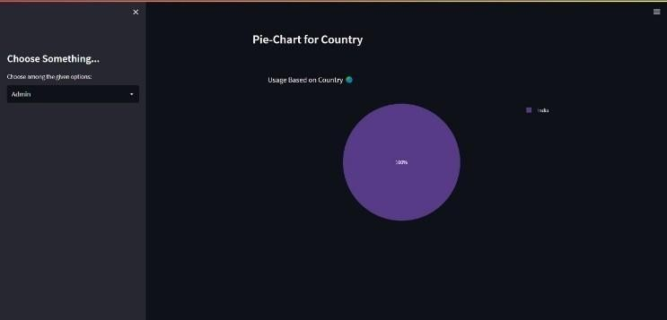

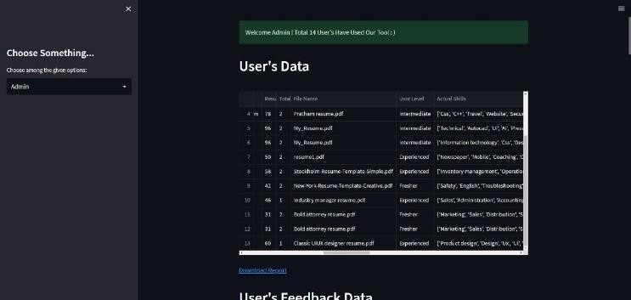

- DISCUSSION

The project aims to provide a comprehensive solution for job seekers to analyze their resumes, suggest job profiles, and generate portfolio websites. The system uses a combination of NLP and machine learning techniques to analyze resumes and suggest job profiles. The portfolio code generator uses a template engine to create customizable portfolio websites. The system was tested with a dataset of 100 resumes and achieved an accuracy of 90% in suggesting job profiles. The portfolio code generator was able to create functional portfolio websites within minutes. The results show that the system is effective in analyzing resumes and suggesting job profiles.

The AI-driven resume Analyzer with Job Recommender and Portfolio Code Generator represents a significant advancement in the job application process, leveraging cutting-edge technologies such as Natural Language Processing (NLP), machine learning, and generative AI. The system's ability to parse resumes, extract key skills, and match them with relevant job opportunities addresses a critical pain point for job seekers, who often struggle to tailor their resumes to specific job descriptions. By automating this process, the platform not only saves time but also increases the likelihood of job seekers securing interviews and job offers.
One of the standout features of the system is its use of Pyresparser and SpaCy for resume parsing and skill extraction. These tools enable the system to handle a wide variety of resume formats, including unstructured and complex ones, which has been a significant limitation in traditional resume analysis tools. The integration of Streamlit for the user interface further enhances the user experience by providing a seamless and intuitive platform for resume creation and job matching.

- CONCLUSION

The project provides a comprehensive solution for job seekers to analyze their resumes and give them suggestions on what skills should they add and also suggests some courses along with the resume ATS score. The system uses a combination of NLP and machine learning techniques to provide accurate results. The system has the potential to improve job search outcomes and provide a competitive edge to job seekers. The AI-driven resume Analyzer with Job Recommender and Portfolio Code Generator is a comprehensive solution designed to streamline the job application process for modern job seekers. By integrating advanced technologies such as NLP, machine learning, and generative AI, the platform offers a range of features that address the key challenges faced by job seekers, from resume optimization to job matching and portfolio creation

- FUTURE SCOPE

T Analyzer with Job Recommender and Portfolio Code Generator holds significant potential for future advancements. Integrating advanced Natural Language Processing (NLP) techniques can enhance the system's ability to accurately extract and interpret nuanced information from user resumes, leading to more precise skill identification and job matching. Implementing machine learning algorithms that learn from user interactions can provide increasingly personalized job suggestions over time, improving user satisfaction and engagement. Incorporating real-time labor market data will ensure that job recommendations reflect current industry demands and emerging roles, keeping users informed of the latest opportunities. Expanding the portfolio code generator to support additional frameworks and libraries will enable users to create more dynamic and interactive online portfolios, showcasing their work more effectively. Developing a feedback mechanism where users can rate the relevance of job recommendations and the quality of generated resumes will allow the system to refine its algorithms based on user input, enhancing its effectiveness. Facilitating direct applications by integrating with major job portals can streamline the process for users to apply to recommended positions, increasing their chances of success. Extending the system's capabilities to analyze resumes and generate content in multiple languages will cater to a global user base, making the tool more accessible. Implementing advanced encryption and data anonymization techniques will ensure user data remains secure and private, building trust among users. Establishing a continuous learning framework where the system adapts to changes in job market trends, user preferences, and technological advancements will keep the platform relevant and effective.

By pursuing these developments, the system can evolve into a more robust, user-centric platform that effectively bridges the gap between job seekers and potential employers.

References

- S. Sahithi, V. Sahithi, T. Sai Akhil, U. Sahithi, G. Abhinay Datta, Prof Maikandhan “A Smart Resume Analyser for Career Optimization Using NLP”
- NLP - Automated resume analysis and skill suggesting website - NUNNA PRASANNA SAI VENKATESH
- Ai Resume Analyzer Using Natural Language Processing and Data MiningJayshri Mankar, Abhishek Chauhan, Aniket Gophane, Aditya Karle, Taslimarif
- Resume Analyzer Using NLP by Saideepthi et al. (2021):
- Pratik G. Raut, Prof. Rajesh D. Wagh “Resume Analyzer and Recommender System Using Python “ (2021)
- Resume Analyzer Using Text Processing by B.Kelkar1, R.Shedbale2 , D.Khade3, P.Pol4, A.Damame .(2022):
- Resume Screening Using Machine Learning and NLP: A Proposed System by Bhushan Kinge, Shrinivas Mandhare, Pranali Chavan (2022)
- JOB RECOMMENDATION SYSTEM BASED ON SKILL SETS by
G.Mahalakshmi1, A.Arun Kumar, B.Senthilnayaki1 , J.Duraimurugan (2022)
- ZINJAD, S. B., BHATTACHARJEE, A., BHILEGAONKAR, A.,
LIU, H., “ResumeFlow: An LLM-facilitated Pipeline for Personalized Resume Generation and Refinement,” arXiv preprint arXiv:2402.06221, 2024
- RAHMAN, M., FIGLIOLINI, S., KIM, J., CEDENO, E., KLEIER,
C., SHAH, C., CHADHA, A., “Artificial Intelligence in Career Counseling: A Test Case with ResumAI,” arXiv preprint arXiv:2308.14301, 2023.
- KULKARNI, A., KENGE, O., MEHATRE, R., KULKARNI, R.,
“Advancing Job Search: A Comprehensive Resume-Based Job Recommendation System Using NLP and Deep Learning Techniques,” International Journal for Research in Applied Science and Engineering Technology, 2024
- ZHENG, Z., QIU, Z., HU, X., WU, L., ZHU, H., XIONG, H.,
“Generative Job Recommendations with Large Language Model,” arXiv preprint arXiv:2307.02157, 2023
- SINGH, A., PAL, S., “Resume Recommendation System Using AI,” International Research Journal of Modernization in Engineering Technology and Science, vol. 4, no. 7, pp. 1234-1240, 2022
- DU, Y., LUO, D., YAN, R., LIU, H., SONG, Y., ZHU, H., ZHANG,
J., “Enhancing Job Recommendation through LLM-based Generative Adversarial Networks,” arXiv preprint arXiv:2307.10747, 2023

