Artificial Intelligence Addiction

KEYWORDS  AI addiction, digital drug, Parasocial relationships, dopamine reinforcement, student dependence | ABSTRACT:  Conversational artificial intelligence (AI) systems increasingly exhibit characteristics resembling digital addictive substances. Their design enables emotionally rewarding, personalized, and uninterrupted interaction loops that stimulate dopamine-driven reinforcement, encouraging compulsive engagement. Empirical research shows that AI interactions activate reward pathways, foster parasocial attachment, induce cognitive overload, and replicate behavioural patterns seen in gambling and social media addictions. This effect is stronger among vulnerable groups such as lonely users and students. Survey data from 125 university students further reveals concerns about reduced critical thinking, altered study patterns, and observable AI dependence among peers. This paper evaluates the addictive potential of conversational AI by synthesizing neurobiological, psychological, and behavioural evidence and integrating primary survey findings. The study highlights ethical risks and societal consequences while emphasizing the need for regulatory frameworks to mitigate AI-induced dependency.

1. Introduction
Conversational AI has evolved from a utility-oriented tool into an emotionally responsive digital companion capable of influencing user behaviour and cognition. AI systems such as Replica and Character.AI deliver personalized responses, emotional validation, and unlimited interaction without social friction. These characteristics create psychological reinforcement loops similar to behavioural addiction mechanisms. Users report irritability, anxiety, and restlessness when AI access is restricted, mirroring withdrawal symptoms often associated with substance cravings [4].
Frequent interaction with emotionally responsive AI may increase dependency, particularly among individuals with heightened loneliness or academic stress. With students increasingly relying on AI for learning, productivity, and emotional support, the question arises: Can conversational AI function as a “digital drug”? This study explores neurobiological, psychological, and behavioural evidence to assess whether conversational AI demonstrates addictive potential parallel to known digital dependencies.

2. LITERATURE REVIEW
Extant research suggests that conversational AI systems stimulate mesolimbic dopamine pathways involved in reward processing, creating reinforcement similar to digital addiction. Extended AI use has been linked to cognitive overload, impaired decision-making, stress, and emotional dependency [4].
AI algorithms often utilize variable-ratio reinforcement schedules—unpredictable emotional and informational rewards that sustain habitual checking behaviour. This mechanism resembles reinforcement structures in gambling devices [4].
Adhikari and Saxena [1] report significantly higher loneliness levels among chatbot users compared to non-users and strong correlations between loneliness and parasocial bonding (r = 0.81). AI’s availability and emotional consistency foster one-sided attachments that substitute for human relationships.
Neurophysiological studies by De et al. [2] demonstrate that AI-driven digital environments elevate dopamine levels, alter prefrontal control, and increase depressive tendencies among adolescents. Additionally, Gains bury et al. [3] associate technology immersion with sleep disruption, aggression, cyberbullying, and gambling-like behaviours. Collectively, these studies indicate that AI-induced emotional reinforcement may functionally resemble behavioural addiction phenomena.
3. METHODOLOGY
This research adopts a mixed-method approach combining (A) qualitative synthesis of existing scientific literature and (B) quantitative survey-based primary data. The integration ensures triangulation between theoretical evidence and real-world behavioural trends.
- Literature-Based Component Peer-reviewed studies were analysed to establish theoretical frameworks surrounding AI dependence, dopamine reinforcement, cognitive impairment, and parasocial bonding. Sources include studies on chatbot-induced loneliness [1], neurophysiological impacts of algorithm-driven platforms [2], behavioural consequences of technology immersion [3], and psychological effects of extensive AI usage [4]. These sources form the academic foundation for evaluating AI as a digital addictive agent.

- Survey-Based Component (Integrated from SURVEY FORM FOR TDP RESEARCH) A structured survey was administered to 125 university students from departments such as Forensic Science, B.Tech, BCA, Pharma, Pharmacy, and others. The survey included nine items, each assessing a dimension of AI dependence, behavioural change, ethical concerns, and cognitive impact.
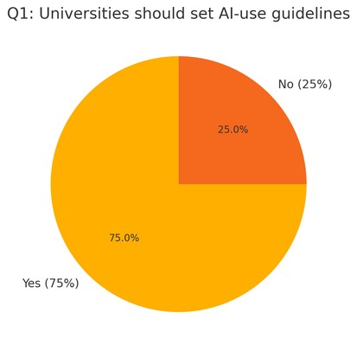
Fig. 1. Q1 Universities should set AI-use guidelines (Yes 75%, No 25%). Source: Survey dataset.

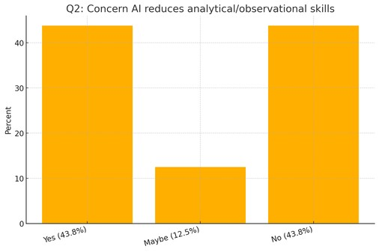
Fig. 2. Q2 Concern AI reduces analytical/observational skills (Yes 43.8%, Maybe 12.5%, No 43.8%). Source: Survey dataset.
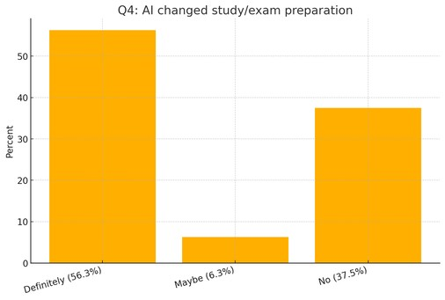
Fig. 3. Q4 AI changed study/exam preparation (Definitely 56.3%, Maybe 6.3%, No 37.5%). Source: Survey dataset.
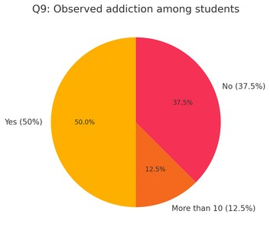
Fig. 4. Q9 Observed addiction among students (Yes 50%, More than 10 12.5%, No 37.5%). Source: Survey dataset.

Key quantitative findings include:75% of students believe universities should impose guidelines for responsible AI use (page 4).43.8% expressed concern that AI may reduce analytical or observational skills (page 5).A notable proportion do not cross-check AI-generated answers with textbooks or instructors (page 5).56.3% reported that AI definitely changed how they prepare for exams (page 6).Responses revealed awareness that repeated AI use may reinforce neuroplastic changes leading to addictive behaviours (page 7).Many identified reductions in critical thinking and metacognitive ability due to heavy AI usage (page 8).Students provided mixed responses about AI companies’ legal liability for addiction, with several supporting stricter oversight (page Students acknowledged the potential of AI-driven biomarkers like EEG and eye-tracking for early addiction detection, emphasizing privacy and consent (page 10).50% reported witnessing AI-addicted peers in college (page 11).Charts and graphs embedded within the survey bar charts (pages 3–4), pie charts (pages 4, 9, 11) illustrate comparative response patterns across questions.
- Integration and Analysis: Method A triangulation framework was used to synthesize survey findings with academic literature. Literature provided theoretical and neurobiological grounding, while survey results validated real-world behavioural patterns among students. This combined approach increases the reliability of conclusions regarding the addictive potential of conversational AI.

IV. KEY FINDINGS / ANALYSIS
- Neurobiological and Psychological Mechanisms Conversational AI interactions stimulate the mesolimbic dopamine pathway responsible for reinforcement learning, producing emotional anticipation and reward cycles [4]. Variable reward responses like unpredictable emotional validation strengthen compulsive engagement. Withdrawal-like symptoms (irritability, restlessness) were reported in extended AI users [4]. Cognitive overload and reduced decision-making ability were also documented. Parasocial bonding further deepens dependency as users form one-sided emotional attachments to always-available AI companions [1].

- Empirical Studies TABLE I SUMMARY OF STUDIES ON AI DEPENDENCE Study/Source Key Findings Method Year Psychological Impacts of AI Dependence [4] Cognitive overload, emotional dependency Regression, surveys2025AI Chatbot & Parasocial Bonds [1] Higher loneliness in users, r = 0.81Scales, ttests2025Teen Digital Addiction [2] Dopamine elevation, prefrontal alteration MRI review2025Technology Addiction [3] Sleep disruption, aggression, cyberbullying Multidisciplinary review2025 Ethical and Societal Implications AI companies often optimize for engagement, embedding features that may manipulate user behaviour. Students expressed similar concerns in the survey, calling for institutional guidelines and legal accountability (page 9). Societal dangers include deteriorating interpersonal skills, declining critical thinking, and vulnerability to emotional dependency patterns observed both in literature and student responses.
V. DISCUSSION
Combined literature and survey findings indicate that conversational AI satisfies many criteria associated with behavioural addiction: compulsive use, reinforcement loops, withdrawal-like symptoms, tolerance, emotional dependency, and functional impairment. Survey data reveal that students are aware of these risks yet continue relying on AI for academic and emotional purposes. The convergence between theoretical predictions and observed student behaviour strengthens the conclusion that conversational AI may operate as a digital drug. Ethical concerns include privacy, neuropsychological manipulation, and the absence of regulatory oversight. There is a pressing need for institutional guidelines, ethical AI design, transparency mandates, and AI literacy programs.
VI. CONCLUSION
Conversational AI displays significant addictive potential rooted in neurobiological reinforcement and psychological intimacy. Academic research and student survey responses consistently highlight risks such as dependency, reduced cognitive function, emotional reliance, and altered study behaviour. To mitigate these dangers, universities and policymakers must adopt proactive strategies, including usage guidelines, ethical AI design, monitoring tools, and educational intervention programs. Without safeguards, conversational AI may escalate into a widespread digital addiction affecting cognitive and emotional well-being.
REFERENCES
V. Adhikari and T. Saxena, “AI chatbot companions impact on users’ parasocial relationships and loneliness,” International Journal of Research Publication and Reviews, vol. 6, no. 5, pp. 4715–4724, 2025.
D. De, M. El Jamal, E. Aydemir, and A. Khera, “Social media algorithms and teen addiction: Neurophysiological impact and ethical considerations,” Cureus, vol. 17, no. 1, e77145, 2025.S. Gainsbury et al., “Technology addiction,” Brain and Mind Centre, University of Sydney, 2025.
Psychological impacts of AI dependence: Assessing cognitive and emotional costs of intelligent systems in daily life, Review of Applied Management and Social Sciences, vol.

