EmotiPot: A Machine-Learning Enhanced Smart Plant System with Visual Diagnosis, Predictive Navigation, and Affective Feedback Urban Plant Care

Abstract— Many plant owners struggle to maintain healthy plant growth because they rely on manual observation and inconsistent care. Problems such as unnoticed leaf discoloration, wilting, poor light placement, and lack of personalized guidance may lead to plant stress and delayed intervention. To address these concerns, this study developed the EmotiPot system, a smart plant pot integrated with an Android mobile application for real-time plant monitoring and care support. The system combines a MobileNetV2-based Convolutional Neural Network (CNN) for image classification, sensor-based monitoring, content-based filtering for personalized care recommendations, and a sliding-window trend-based method for assisted mobility. The CNN model was trained using 7,830 plant images classified into six categories: blackspots, cancer, greening, healthy, not plant, and wilting. The study followed a developmental research design using the Agile Scrum approach in building and testing the system. Results from the updated model showed a validation accuracy of 93.17%, indicating that the CNN was effective in classifying plant conditions. The system also successfully interpreted soil moisture and light readings, generated suitable care recommendations based on active thresholds, and supported manual and automatic movement toward better light conditions with ultrasonic-based obstacle detection. Overall, the EmotiPot system was able to meet its intended functions and showed potential as a practical and intelligent tool for supporting plant care through real-time monitoring, diagnosis, and guided decision-making.

Keywords: EmotiPot, Plant Health Monitoring, Convolutional Neural Network (CNN), Internet of Things (IoT), Smart Plant Care

I. INTRODUCTION

In recent years, technological innovations have continued to transform the way everyday tasks are managed and improved through automation, intelligent monitoring, and data-driven decision-making. The growing use of artificial intelligence, Internet of Things (IoT), and mobile technologies has opened new opportunities for developing systems that can assist individuals in monitoring conditions, interpreting real-time data, and responding more effectively to changing environments. These developments are not only visible in industrial and commercial applications but are also becoming increasingly relevant in small-scale and personal settings such as home gardening and plant care. As more people become interested in keeping plants indoors and outdoors, the need for practical, accessible, and responsive plant care systems also continues to increase.
Many plant owners today enjoy caring for plants because it brings life to their spaces and creates a more pleasant and relaxing environment. However, maintaining healthy plant growth is not always easy. Whether plants are placed indoors or outdoors, owners often depend on manual observation and routine checking to assess their condition. This becomes difficult for individuals with busy schedules, limited experience in gardening, or inconsistent care habits. Important signs of plant stress such as leaf discoloration, wilting, insufficient light exposure, or poor soil condition may not be noticed immediately. As a result, plant health problems may worsen before the owner is able to take proper action.
Traditional plant care methods usually rely on guesswork and do not provide a clear way to detect early signs of stress or determine whether the plant is receiving enough moisture and light. In many indoor settings such as apartments, dormitories, and study spaces, plant placement is often limited, which makes it harder to provide ideal growing conditions. Because of this, plant owners may struggle to make timely and informed decisions regarding watering, light exposure, and other care practices. These limitations highlight the need for a smart plant care system that goes beyond simple observation by combining visual diagnosis, environmental monitoring, and adaptive recommendations.
To address these concerns, this study developed the EmotiPot system, a smart plant pot integrated with an Android mobile application for real-time plant monitoring and care support. The system combines image-based diagnosis, sensor-based monitoring, recommendation generation, and assisted mobility to help users better understand their plant’s condition. It uses a Convolutional Neural Network (CNN) to classify captured plant images into six classes: healthy, greening, cancer, blackspots, wilting, and not plant.
After the diagnosis, the application suggests threshold values for moisture and sunlight based on the latest plant condition. The user may choose to use these suggested thresholds or manually override them by selecting custom values inside the application. The system then reads the current soil moisture and light data from the sensors and uses these inputs together with the diagnosis result and selected thresholds to generate personalized care recommendations. These recommendations are produced through a content-based filtering approach, which compares the plant’s current condition with stored recommendation features and presents the most suitable suggestions based on the plant’s needs. In this way, the system does not only show sensor readings but also helps the user understand what actions may be needed to support healthier plant growth.
The system also includes both manual and automatic movement features. In manual mode, the user can control the movement of the planter through the arrow buttons in the mobile application. In auto mode, the system checks recent light readings and compares them with the selected sunlight threshold to decide whether the EmotiPot should move toward a brighter area or remain in place. During movement, the ultrasonic sensor is used to detect nearby obstacles and help support safe navigation. Through these features, EmotiPot provides a more practical and adaptive approach to plant care by combining plant diagnosis, environmental monitoring, intelligent recommendations, and assisted mobility in one system.

1.2 Significance of the Study
The following are the individuals who will benefit from this study, as it introduces an innovative way to care for plants through smart technology:
- Environment advocates. The EmotiPot supports the global movement toward green living by encouraging indoor and outdoor gardening and responsible technology use. With its low-power components and focus on promoting healthy plant growth, the system aligns with goals of biodiversity conservation, air quality improvement, and smart home integration advancing sustainability efforts at the micro level.
- For Families. EmotiPot adds a touch of life and emotional connection to home environments. The use of visual emotional responses from the plant system encourages children and parents alike to engage in plant care as a shared experience. It can foster responsibility in young family members while also creating a more relaxing, natural atmosphere indoors.
- For farmers. EmotiPot provides a practical and efficient solution for monitoring the health of their plants and crops. The system focuses on essential environmental factors such as soil moisture, temperature, and light intensity (lux) to help ensure optimal growing conditions. By providing real-time data and analysis, EmotiPot allows farmers to make informed decisions and take timely actions to maintain healthy crops. Its smart features aim to reduce manual monitoring efforts, improve productivity, and make farm management easier and more reliable, especially for those managing wide or multiple areas of cultivation.
- Future researchers. This study lays the groundwork for future innovations in smart agriculture and emotion-aware systems. EmotiPot’s integration of machine learning for plant stress detection, predictive navigation, and affective interfaces offers a rich starting point for extending intelligent feedback mechanisms in other IoT systems. Researchers can use this foundation to explore deeper learning models, expand sensor arrays, or develop adaptive learning systems for other plant species and use cases.
- For students. EmotiPot serves as a powerful tool for environmental education and science learning. By combining agriculture, IoT, and artificial intelligence, it introduces students to interdisciplinary STEM concepts. The visual feedback system makes it easier to teach plant health, sustainability, and digital innovation, making EmotiPot a practical learning resource for modern classrooms promoting hands-on, eco-conscious education.

1.3 Scope and Delimitation
This study focuses on the development of EmotiPot, a smart plant pot integrated with an Android mobile application for plant monitoring and care support. The system uses a CNN model to classify captured plant images into six classes: healthy, greening, cancer, blackspots, wilting, and not plant. It also uses a soil moisture sensor and an LDR sensor to monitor environmental conditions, while an ultrasonic sensor is used to help support safer movement during navigation. The mobile application allows users to capture plant images, view sensor readings, select or override threshold values, receive care recommendations, and control the movement of the planter. The system also includes a trend-based auto navigation feature that helps the planter move toward brighter areas when light conditions remain below the selected threshold.
However, this study has several limitations. EmotiPot is designed to monitor only one plant at a time and is limited to flat and manageable surfaces. Its navigation does not include advanced pathfinding and only supports simple movement decisions with obstacle detection. The system also does not include plant species recognition, so the recommendations are based only on the diagnosis result, sensor readings, and selected threshold values. In addition, the CNN model only analyzes visible image features and may not fully distinguish real plants from artificial or similar-looking objects. Since the system uses Bluetooth communication, it is limited to short-range local connection and does not include Wi-Fi, cloud storage, or remote monitoring. Because of these limitations, the findings of the study apply mainly to the developed EmotiPot prototype and its intended testing conditions.

II. METHODOLOGY

This study used a developmental research design to develop and evaluate the EmotiPot system, a smart plant pot integrated with an Android mobile application for plant monitoring and care support. The study followed the Agile Scrum approach so the system could be designed, tested, and improved in smaller stages. The EmotiPot system combines image-based diagnosis, real-time sensor monitoring, recommendation generation, and assisted mobility. It uses a Convolutional Neural Network (CNN) for plant image classification, a content-based filtering approach for plant care recommendations, and a sliding-window trend-based binary classification method for automatic movement toward better light conditions. The system also uses Bluetooth communication between the Android application and the ESP32 for real-time local data exchange.
The data used in the study came from four main sources: plant image data for CNN training, soil moisture readings, LDR light readings, and ultrasonic distance readings for obstacle detection. The mobile application was used as the main interface where users can capture plant images, view sensor readings, choose suggested thresholds or manually override them, receive care recommendations, and control the movement of the EmotiPot. The system was tested in a controlled setting to evaluate how well each feature worked based on the intended functions of the prototype.

2.1 System Overview

The EmotiPot system was designed as a smart plant care platform that combines hardware and software components into one working prototype. The hardware side includes the ESP32 microcontroller, soil moisture sensor, LDR sensor, ultrasonic sensor, motor driver, and mobility components. The software side includes the Android mobile application and the CNN model used for plant image classification.
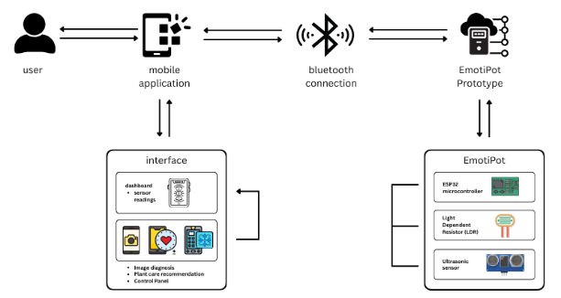

Figure 1. System Architecture

2.2 Convolutional Neural Network (CNN)
For the diagnosis feature, the study used a MobileNetV2-based Convolutional Neural Network. Based on the updated training setup, the model used 7,830 total images divided into six classes: blackspots, cancer, greening, healthy, not plant, and wilting. The dataset was automatically divided using an 80/20 split, resulting in 6,264 training images and 1,566 validation images. All images were resized to 224 × 224 pixels. The model was trained using a batch size of 32 for 20 epochs. It used the Adam optimizer, sparse categorical crossentropy as the loss function, and accuracy as the main training metric. After training, the model was saved and converted into TFLite format for deployment in the mobile application.
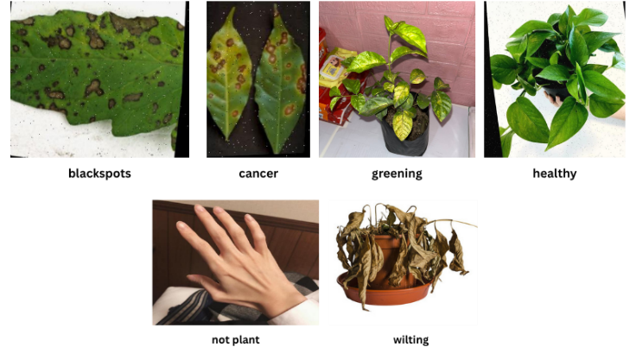

Figure 2. Sample Plant Image Classes

2.3 Content-Based Filtering Implementation
For the recommendation feature, the study used a content-based filtering approach. The system analyzes the diagnosis result, current soil moisture reading, current light reading, and active threshold values selected in the application. After diagnosis, the application may suggest threshold values for moisture and sunlight, but the user may also manually override them. Soil moisture readings were converted into percentage values, while LDR readings were interpreted into light categories (low, medium, and high). These inputs were compared with stored recommendation features so the system could show the most relevant care suggestions.

2.4 Sliding-Window Trend-Based Binary Classification
For the movement feature, the study used a sliding-window trend-based method. The system continuously reads recent light values from the LDR sensor and compares them with the selected sunlight threshold. If the light remains below the threshold and the trend shows that the light is not improving, the system triggers automatic movement. The ultrasonic sensor is used to detect nearby obstacles and support safer movement. The application also includes manual controls for direct movement of the planter.

III. RESULTS AND DISCUSSIONS

This chapter presents the results of the EmotiPot system after the development and testing of its major features. The purpose of this chapter is to show how well each module of the system performed based on the intended objectives of the study. The discussion is organized according to the three main functions of the system: image-based diagnosis, personalized recommendation generation, and trend-based assisted movement.

3.1 Results
3.1.1 CNN Image Classification Results

The results of the CNN model showed that the diagnosis feature was able to classify plant images effectively. The MobileNetV2-based model was trained using 7,830 total images, with 6,264 used for training and 1,566 used for validation. The model was trained for 20 epochs using a batch size of 32, and the final validation accuracy reached 93.17%. These results show that the model was able to correctly classify most of the validation images.

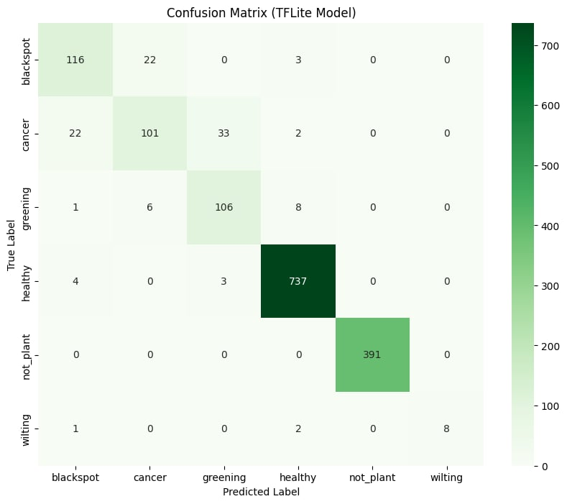

Figure 3. Confusion Matrix

Based on the confusion matrix, the model performed best on the healthy and not plant classes. The healthy class recorded 737 correct predictions, while the not plant class recorded 391 correct predictions. The blackspots, cancer, and greening classes also produced many correct predictions, although some misclassifications occurred between visually similar unhealthy classes. The wilting class recorded fewer samples but was still identified correctly in most cases. These results show that the CNN model was effective enough to support the diagnosis feature of the EmotiPot application.

3.1.2 Recommendation Results

The recommendation feature was able to interpret soil moisture and light readings and generate care suggestions based on the diagnosis result and active threshold values. The application was also able to show suggested threshold values after diagnosis while still allowing the user to manually override them. This made the recommendation feature more flexible and more useful for actual plant care. The system did not only display raw sensor readings, but also translated them into clearer plant care guidance.
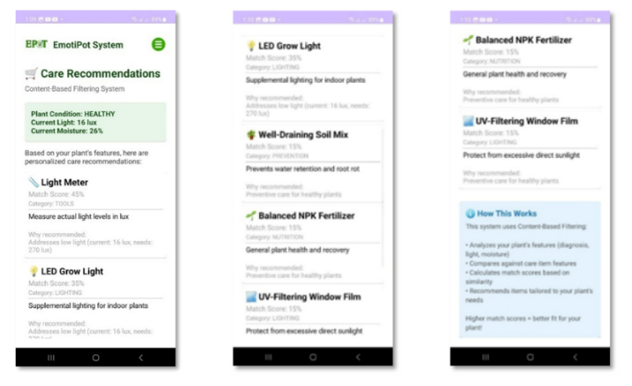

Figure 4. Recommendation Output Screenshot

3.1.3 Movement Results
The movement feature showed that the EmotiPot was able to respond to low-light conditions and move toward better light when needed. The sliding-window trend-based method correctly triggered movement when the light stayed below the selected threshold and did not improve over time. The movement was done in short controlled bursts, while the ultrasonic sensor helped stop unsafe forward movement when obstacles were detected. These results show that the EmotiPot was able to support both manual and automatic movement within the limits of the prototype.
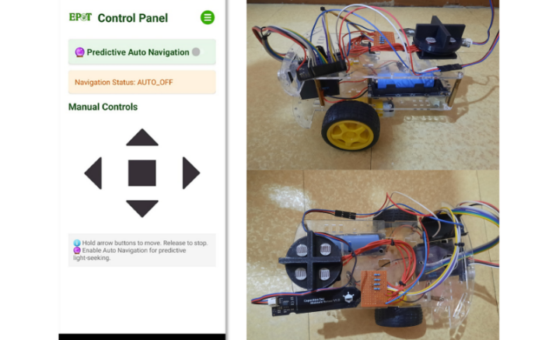

Figure 5. Navigation Output and Prototype

Overall, the results showed that the EmotiPot system was able to meet the main objectives of the study. The diagnosis module classified plant images effectively, the recommendation module generated suitable care suggestions, and the movement module supported light-seeking behavior with safer navigation. These findings show that the EmotiPot prototype has potential as a practical tool for plant monitoring and care support.

IV. CONCLUSIONS AND RECOMMENDATIONS
This chapter presents the conclusions and recommendations based on the results of the study. It summarizes the main findings that show how the EmotiPot system supports plant monitoring and care through image-based diagnosis, sensor-based monitoring, recommendation generation, and assisted mobility.

4.1 Conclusions

Problem 1: How can the system detect the condition of the plant through image-based diagnosis?

The results show that the EmotiPot system was able to detect plant condition through its CNN-based diagnosis feature. The MobileNetV2-based model was trained using 7,830 plant images divided into six classes: blackspots, cancer, greening, healthy, not plant, and wilting. Based on the updated training results, the model reached a validation accuracy of 93.17%, which shows that it was able to correctly classify most of the validation images. The confusion matrix also showed strong performance, especially in the healthy and not plant classes. These results confirm that the diagnosis module was effective in classifying plant images and can support early identification of plant condition in the mobile application.

Problem 2: How can the system provide personalized plant care recommendations?

The results show that the EmotiPot system was able to provide plant care recommendations by analyzing the diagnosis result together with real-time soil moisture readings, light readings, and active threshold values. Through the content-based filtering approach, the system was able to generate care suggestions that matched the plant’s current condition. The application also allowed the user to use suggested threshold values or manually override them, which made the recommendation feature more flexible. These results confirm that the recommendation module was able to support users by translating plant condition and sensor data into clearer and more useful plant care guidance.

Problem 3: How can the system support movement toward better light conditions?

The findings show that the EmotiPot system was able to respond to low-light conditions through its sliding-window trend-based movement feature. The system monitored recent LDR readings and compared them with the selected sunlight threshold. When the light remained below the threshold and the trend showed that the light was not improving, the system correctly triggered movement toward brighter areas. The ultrasonic sensor also helped support safer movement by detecting nearby obstacles. These results confirm that the movement module was able to support simple light-seeking behavior within the limits of the prototype.

In conclusion, the results show that the EmotiPot system was able to meet the main objectives of the study. The system successfully combined image classification, sensor monitoring, recommendation generation, and assisted mobility in one Android-connected prototype. The diagnosis module was effective in classifying plant images, the recommendation module provided suitable plant care suggestions, and the movement module supported light-seeking behavior with safer navigation. Although the system still has limitations such as single-plant monitoring, short-range Bluetooth communication, no plant species recognition, and simple mobility only, the results show that EmotiPot has potential as a practical smart plant care tool for monitoring and supporting plant health.

  - Recommendations
Based on the results of the study, the following recommendations are presented:
- It is recommended to expand the CNN dataset by adding more plant images, especially for classes with fewer samples such as wilting, to further improve classification performance and reduce misclassification between visually similar unhealthy classes.
- It is recommended to improve the recommendation module by adding more plant care items, richer plant condition rules, and more detailed explanations so the application can provide more complete guidance to users.
- It is recommended to add plant species recognition in future versions of the system so that the recommendations can become more specific and better matched to the actual plant type.
- It is recommended to improve the movement feature by adding more advanced navigation methods, stronger obstacle handling, and better route control so the system can operate more safely in more complex environments.
- It is recommended to enhance the communication and monitoring features of the system by adding Wi-Fi connectivity, cloud storage, and remote access for longer-range monitoring and control.
- It is recommended to conduct further testing using more plant types, more varied environmental conditions, and longer actual use periods to better evaluate the reliability and practicality of the system.
- It is also recommended that future researchers use the EmotiPot system as a basis for improving smart plant care systems that combine artificial intelligence, IoT, recommendation systems, and mobility features.

REFERENCES

- Adla, S., Santhi, C., & Newlands, N. K. (2024). Impact of calibrating a low-cost capacitance-based soil moisture sensor on AquaCrop model performance. Journal of Environmental Management, 364, 120248.
https://doi.org/10.1016/j.jenvman.2024.120248
- Ahmed, A. A., & Reddy, G. H. (2021). A mobile-based system for detecting plant leaf diseases using deep learning. AgriEngineering, 3(3), 478–493.
https://doi.org/10.3390/agriengineering3030032
- Guo, C., Pleiss, G., Sun, Y., & Weinberger, K. Q. (2017). On calibration of modern neural networks. In D. Precup & Y. W. Teh (Eds.), Proceedings of the 34th International Conference on Machine Learning (Proceedings of Machine Learning Research, Vol. 70, pp. 1321–1330). PMLR. On Calibration of Modern Neural Networks.
- Kulmány, I. M. (2022). Calibration of an Arduino-based low-cost capacitive soil moisture sensor. Journal of Hydrology and Hydromechanics, 70(2), 138–147.
https://doi.org/10.2478/johh-2022-0014.
- University of Melbourne. (n.d.). Light and moisture requirements for indoor plants. Sustainable Campus.
https://sustainablecampus.unimelb.edu.au/__data/assets/pdf_file/0005/2839190/Indoor-plant-workshop-Light-and-Moisture-Requirements.pdf
- van der Waa, J., Schoonderwoerd, T., van Diggelen, J., & Neerincx, M. A. (2020). Interpretable confidence measures for decision support systems. International Journal of Human-Computer Studies, 144, Article 102493.
https://doi.org/10.1016/j.ijhcs.2020.102493

