LIFE CYCLE ASSET INTEGRITY MANAGEMENT STRATEGY OF AGING CRUDE OIL PIPELINES
Abstract
This study developed an asset integrity management strategy to ensure continuous safe operation of the 24in Trans-Niger pipeline case-study till its design end-of-life in 2025 and life-extension thereafter, despite low flow conditions and associated ongoing Microbiologically Induced Corrosion (MIC). The case-study for the work is a 24inches by 55km carbon steel oil pipeline which was commissioned in 1995 to evacuate production from four (4) flow-stations to an export terminal. In the course of the work, a critical analysis of the current pipeline integrity management system (PIMS) in place against industry best practices was carried out. A Corrosion Management System (CMS) for the pipeline asset was developed by defining a company-wide corrosion policy for this pipeline, conducting a corrosion risk assessment for the threat of low flow conditions, carrying out a Failure Mode and Effect Analysis for low flow condition, proposing an Integrity Management Team and developing a roadmap for the execution of the proposed Integrity Management System. Both quantitative & qualitative data were employed in carrying out the study scope of work. Quantitative data used in the study included: pipeline design/as-built data, inspection & monitoring data, historical production data, and pipeline integrity management system. While qualitative data was derived from interviews and discussions with pipeline integrity and operations personnel. From the analysis conducted, a goal of zero corrosion leaks on the 24in Trans-Niger pipeline would be achieved through the Corrosion Management Strategy managed by the Head of Pipeline Integrity. The output of the FMEA rated the criticality of failure mode as high due to the product of the susceptibility of failure and Asset, Environment, and reputation consequence. An essential component of the CMS is the CMS execution team composition and their interdependencies, as CMS execution requires team effort with clear responsibilities and accountabilities. This study concluded that Asset Integrity Management without following best practice or industry standard methodology is grossly ineffective and would lead to dire consequences as in the case of the 24in Trans-Niger pipeline case-study with its failure in 2018.
Keywords: Asset integrity; Asset management; Aging pipelines; Life cycle management.
Introduction
Portraying the significant capacity of flowlines, Kishawy and Gabbar (2010) compared it to that of a human vein and said: "Pipelines work as veins serving to bringing life-necessities like water or petroleum gas and to remove life by-products like sewage". "Also, they are viewed as the most preferred method of transportation of oil and gas in huge amounts". Oil and gas are frequently packed in regions other than where they would be required. Pipelines transport hydrocarbons over significant distances, from creating wells and districts to send out terminals, processing plants, and fuel stations. All things considered, pipelines are viewed as the most affordable and proficient method for huge scope fluid transportation for crude raw petroleum and flammable gas (Ilman, 2014) and are intended for the protected evacuation of estimated hydrocarbon volumes (creation profile) over their plan life (ordinarily 30years) at suggested stream speeds > 1m/s (Henkes, 2014). The working state of pipelines decides the plan and the management technique of the pipeline framework. As per Gabbar and Kishawy (2011), the framework to be set up relies upon whether the pipeline would be exposed to high pressure/high temperature or low tension/low temperature in activity.
Pipelines as a method for offtaking oil-based goods is associated with risk and difficulties. Pipelines come up short in activity due to imperfections like breaks, corrosions, scratches, punctures, and so on, prompting harm and holes on the pipeline coming about to tremendous downtime, cost, and natural dangers. These issues have immense natural, financial, wellbeing and security impacts on the pipeline operators and host networks the same. Awful inland and seaward mishaps credited to pipeline failures are main issues for operators, controllers, and general society (Peekema, 2013). On many events they have brought about loss of lives for workers and host networks with more than 2500 lives lost in a span of last 10 years (Okoli, 2019). During the lifecycle of a pipeline, there are significant changes to forecast volumes due to decline in reservoir performance, shortage of reservoir discoveries, divestment of production assets, etc. The pipeline asset could be exposed to “low flow” condition (flow velocity <1m/s), which in aging pipelines become the precursor to asset failure due to microbiologically induced corrosion (MIC). The MIC can be aggravated by under-deposit corrosion, which is characterised by settling of suspended solids and precipitated phases (especially water accumulation at low spots) at the bottom of the pipeline (Moloney, 2017).
The Nigerian oil & gas industry is threatened by the impact of low flow conditions to asset integrity due to oil reservoir decline and lack of “big” reservoir finds due to insufficient funding caused by the sharp drop in oil prices since the Covid-19 pandemic (Petroleum Economist, 2020). OPEC, in its 2019 annual statistical bulletin stated that Nigeria’s crude oil reserves stood at 37.453 billion barrels in 2017 and 2016; 37.062 billion barrels in 2015 and 37.448 billion barrels in 2014 (ASU, 2019). On February 20, 2020, the Department of Petroleum Resources (DPR), were taken on record by The Economic confidential (2020) as saying in 49years, it is expected that the Nigeria oil reserves would be significantly depleted. Both reports allude to the issue of low investments in the Nigerian Oil and gas industry which would in turn drive a downturn in exploration which is required in increasing reserve volumes. Probably the most serious issue confronting the pipeline business is the way that the world's pipeline framework is maturing. As indicated by Achebe et al. (2012), 41% of Nigeria's pipeline network is over 30 years of age. The vast pipelines joined with their different scope of activities, sizes, materials, age, and natural impacts add to the perils related with the pipeline business. Regularly, these combined risks make oil and gas pipeline security an exceptionally complicated process. Interestingly, a study conducted in 2011 (Okoro, 2011) arrived at a projected production profile (captured in Figure 1) for the Nigerian Oil and Gas industry using the Hubbert’s oil prediction model which seem to agree with more recent predictions. This study developed an asset integrity management strategy to ensure continuous safe operation of the 24-inch pipeline case-study till its design end-of-life in 2025 and life-extension thereafter, despite low flow conditions and associated ongoing MIC.
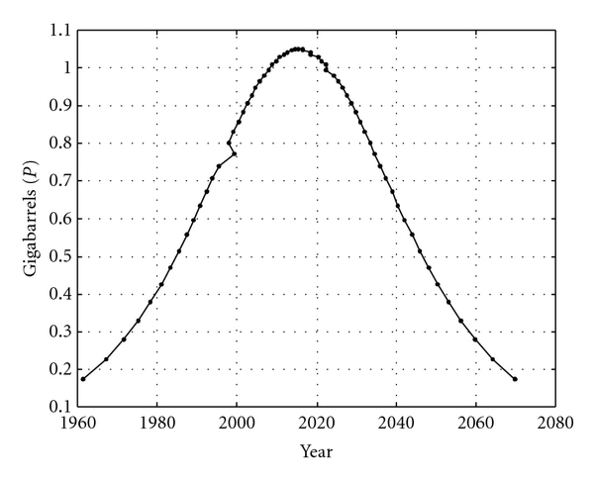
Figure 1: Hubbert's oil production curve showing Nigeria's likely oil peak (Okoro, 2011)
From figure 1 above, it can be predicted that with steady decline in reserves, the industry would operate aging assets in low flow conditions which would require smart asset integrity management strategies to ensure continued safe & profitable operations.
Studies have been conducted to understand the mechanism and impact of microbiologically induced corrosion (MIC) on production assets as well as the various kinds of operational flow conditions and impact on production assets (Askari, 2019). But this study looked at establishing the relationship between low flow conditions and MIC & other associated integrity threats, as well as propose a management system which would ensure the operation of the pipeline asset through its lifecycle and the possibility of a life extension.
Methodology
DATA
Both quantitative & qualitative data were employed in the execution of the methodology expanded below. Quantitative data used in fulfilling individual objectives included the following:
- Pipeline design/as-built data – Such as the pipeline dimensions (wall-thickness, nominal pipe size, length, and profile of the pipeline) and other design information including pipeline design envelope (pressure, flowrate & temperatures) gotten through desktop study from pipeline as-built documents and other records from the company. This data was used in understanding the as-built conditions of the pipeline, the current risks to the pipeline for data capture and integrity and benchmark of the entire study.
Table 1 Case Study Pipeline as-built data
S/N | PIPELINE PARAMETERS | DATA
1. | Installation year | 1995
2. | Pipe length | 55km
3. | Pipe diameter | 24 inches
4. | Wall thickness | 10.31mm
5. | Pipeline pressure limit | 12 bar
6. | Temperature limit | 35⁰C
7. | Pipe material | Carbon Steel
8. | External Coating | Polyethylene
9. | Insulation | None
10. | Flow rate/ Recommended velocity | >0.5m/s

Table 2 Case Study Pipeline expected fluid content
S/N | PIPELINE FLUID CONTENT | VALUES
1. | Oil condensate | 21,000 bls/day
2. | Water | 18,000 bls/day
3. | Bicarbonates | 122 ${mgCaCO}_{3}/$day
4. | Sand and Silt | None

- Inspection & Monitoring data – this data was gotten using desktop review from the company’s pipeline pigging records, intelligent pigging reports & water sampling results. Information on the existing maintenance and operation activities, corrosion damage and defect characterization within the pipeline was used for risk quantification and assessment with corresponding activities or mitigations set to ensure a lower risk of asset failure.

Figure 2: 24in pipeline case-study historical pigging debris load (2003 – 2017)
- Historical production data – Twenty-five (25) years production data gotten from the company’s Production Management Centre database through desktop analysis and was aggregated and used in correlating the impact of flowrate on flow velocity and therefore established the risk of low flow for the pipeline case-study.

Figure 3: 24in pipeline case-study historical production rate against velocity (1997 – 2018)
- Pipeline Integrity Management System – this was achieved through a desktop review of suite of documents showing the current PIMS as used for the management of the pipeline case-study including organizational structure/communications & job competence profiles and Operations & Maintenance procedures & activities which served as a benchmark, reviewed to identify gaps.
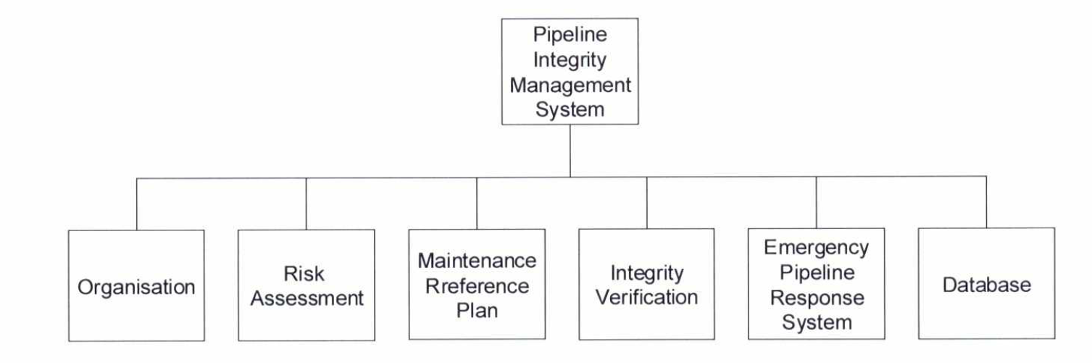
Figure 4: Pipeline integrity management system (Shell Petroleum Development Company, 2014)
Qualitative data was derived from interviews and engagement with pipeline integrity and operations personnel as summarized in the table below:
Table 3: Comparison between Pipeline Integrity Management System in Place and Best Practices
S/N | PIMS STRUCTURE ANALYSED | PIMS IN PLACE | SHORT FALLS FROM BEST PRACTICES | BEST PRACTICES
1 | Frequency of risk assessment updates | A generic FMEA was developed during the design stage | no further risk assessment is carried out except during a management of change process of which the risks identified and eventually treated are risks associated with the change rather than general pipeline risks or threats that could lead to failure | General pipeline risks or treats are to be identified and mitigated
2 | Poor deviations management | Deviations from the MRP timelines were not properly managed | Poor execution of the MRP, inability to perform deviations and poor closeout of existing deviations | Where the MRP activities are not met within a stated timeline, it is to be managed through the process of deviation which would highlight the risks associated with deferring the activity, stated mitigations to managing said risks and a recovery plan to ensure the execution of the activities.
3 | Lack of a Corrosion Management System | The CMS is lacking within the overall PIMS in place | there is no focused attention on the management of corrosion risks | A detailed CMS should be put in place, within the PIMS to mitigate all corrosion associated risks.

The 5-why tool (see table 4 below) was deployed to ascertain the root cause of these shortfalls and possible improvements.
Table 4: 5-Why Analysis for identified PIMS shortfalls
CORROSION MANAGEMENT SYSTEM
To address the objective of the development of a corrosion management system for the 24inches by 55km pipeline case-study, the following strategy was adopted. Several sub-objectives were satisfied in the following order and as in the figure below

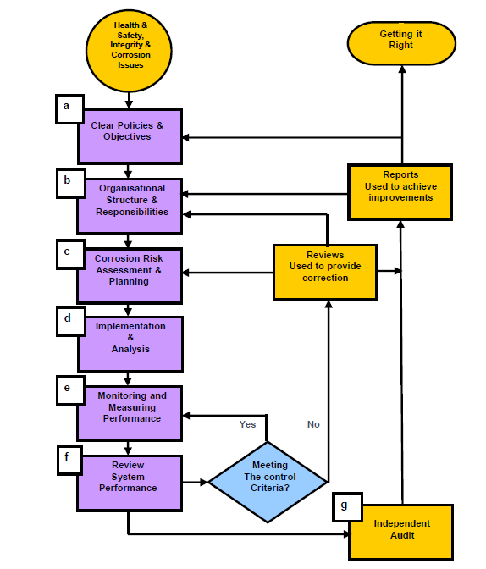
Figure 5: Corrosion Management System Decision Tree
- Define a Corrosion Policy
Based on the guidelines of Energy Institute, a corrosion policy is an integral part of the policy for integrity management. Hence, to fulfil this objective, a literature review of the integrity management policy documented in the HSSE & SP control framework of the company. In alignment to the company policy on integrity management, a corrosion management policy was proposed for the 24in Trans-Niger pipeline case-study based on the Energy Institute framework as below (publishing.energyinst.org/topics/process-safety):
- Defined WHO within the organization would deliver CMS.
- WHAT the expectations and objectives of the CMS are.
- WHERE this CMS would relate to – in this case the 24in pipeline case study.
- WHY this CMS is important to the organization.
- HOW the CMS would be implemented.
- Conduct an FMEA with a Corrosion Risk Assessment
In assuring the process of the need to adapt the corrosion management system to providing mitigation for the risk of low flow in the 24in Trans-Niger pipeline case-study, Failure Modes, and Effects Analysis (FMEA) for low flow was developed as below:
- Failure mode was defined as low flow.
- The effect of the failure mode was stated.
- The probable causes of low flow as identified from RCAs and failure investigations highlighted in the introduction of this report were documented on the FMEA template.
- The assessment methodology for low flow impact on the asset was also highlighted.
- Possible controls & mitigations for this failure mode were included in the template and subsequently on the corrosion management guide to be described in subsequent sections.
- A corrosion risk assessment was carried out and stated on the template as well. The FMEA described above was populated on a table as shown in Table 4:
Table 4: FMEA Template
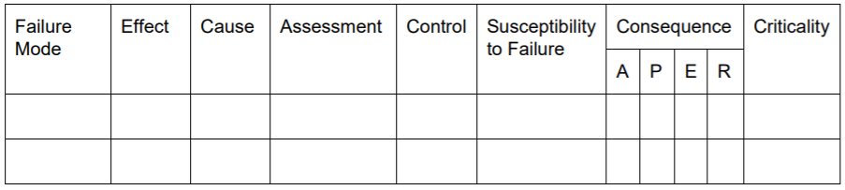
- Carry out corrosion risk assessment
To fully populate the FMEA table, a corrosion risk assessment (CRA) was conducted, to assure the business of the risk rating of the failure mode already defined. Risk is generally expressed as a product of the probability and consequence of failure. The CRA was carried out using S-Risk Based Inspection Criticality Matrix (Figure 2) below which is aligned to the API RP 580 methodology for Risk Based Inspection (api.org). This tool helped in readily quantifying the risk of low flow against the metrics of cost of Asset protection, People safety, Environmental preservation, and reputation of company.

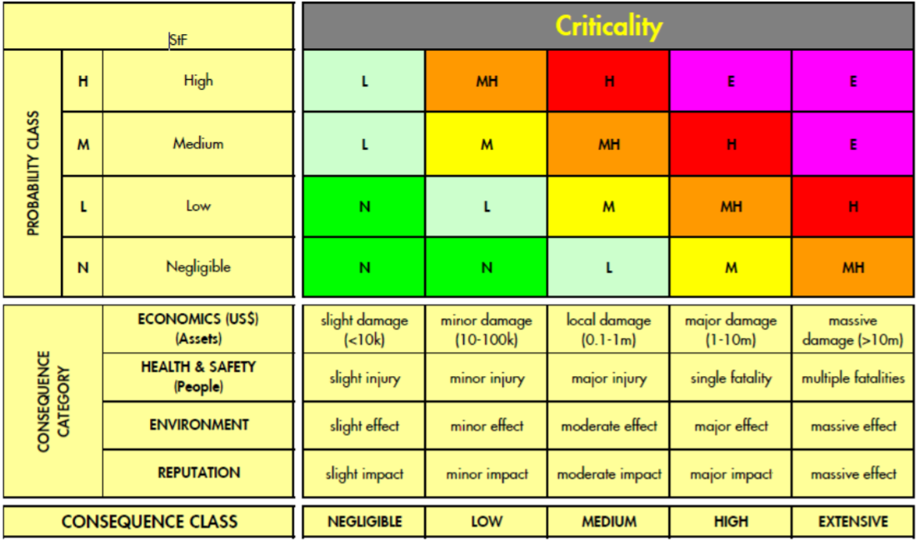
Figure 6: S-RBI criticality matrix (Shell, 2019)
- Propose an Integrity Management Team Composition
To fulfil this objective, a review of the current organizational structure set-up to manage the asset as documented in the existing Pipeline Integrity Management System was carried out. Comparing it to requirements of the Energy Institute guideline as well as the requirements of the CMS being developed, a Responsible-Accountable-Support-Consult-Inform chart (RASCI), which identifies all action parties, activities/scope of work and team’s interdependencies in delivering the requirements of this CMS.
All objectives satisfied in the preceding sections were put together into the Corrosion Management Guide (CMG), which puts all the CMS results in a format that can be easily reviewed, executed, and monitored.
In this case, all results already gotten were documented under the following columns:
- Defined corrosion loop & Sub-system, which is the pipeline case-study.
- Description of the pipeline case-study, in terms of material of construction, coating, wall-thickness and other physical properties of the asset.
- A threat column had low flow specified. Under this column, the probability of failure was highlighted as well.
- A barriers column was generated, which captured data on the type of barrier originally planned into the asset during construction to mitigate the failure mode. In addition, the current status of the barrier was defined based on the current state of the pipeline asset and the justification for the status was stated as well.
- The Integrity Operation Window was populated primarily with process parameters (minimum, maximum & actual) – flow temperature, pressure, water & oil flowrate, and flow velocity were populated on a separate column.
- Proposed monitoring frequency and location based on the corrosion Risk assessment carried out in previous section.
- A Maintenance Reference Plan (MRP) was identified and captured to ensure maintenance of integrity of the pipeline asset as well as to ensure life extension of the asset. Every MRP activity underwent an Impact – Cost/Effort criticality assessment based off the matrix represented in Figure 3. Depending on which of the quadrants the activity falls into would determine if such an activity should be implemented immediately, implemented if practicable, implemented as a form of continuously improving the system or an activity should be abandoned.
- A last column was generated to capture management actions for the maintenance of the CMG and hence the CMS. Therefore, this column highlighted Key Performance Indicators (KPI), key action owners to respond to possible excursions and the actions expected to be taken to revert the system back to its original configuration.
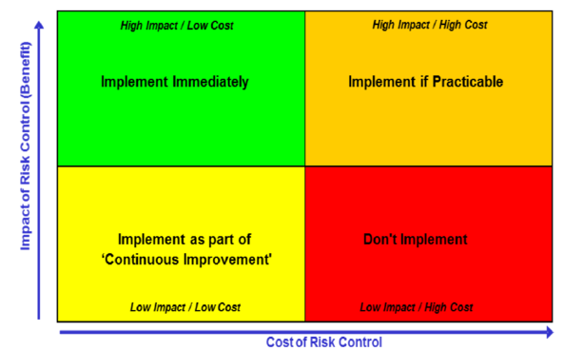
Figure 7: Impact – Cost/Effort Matrix (Shell, 2019)
- Integrity Management Execution Roadmap
To develop a roadmap which would help manage the introduction of the CMS into the system in a manner which would allow for quick adoption and execution required, a literature review of the two leading change management models, namely, the bridges model postulated by Williams Bridges (wmbridges.com) and the eight (8) steps change model by John Kotter (kotterinc.com/8-steps-process-for-leading-change/).
Based off the review, the following were developed to generate the roadmap:
- A proposed change management team composition to drive adoption of the CMS for this specific asset and similar assets across the organization.
- A Gantt chart was developed highlighting various diverse company-wide engagements of various stakeholders. This Gantt chart also highlighted proposed timelines for achieving key milestones of the launch.

RESULTS & DISCUSSIONS

DEFINE A CORROSION POLICY
Based on the asset integrity policy of the company to “keep their asset safe and know it” (Shell 2019), the corrosion policy for this proposed CMS is, based on known impact of corrosion on asset integrity, a goal of zero corrosion leaks on the 24in Trans-Niger pipeline would be achieved through the Corrosion Management Strategy managed by the Head of Pipeline Integrity, who would ensure the following:
- All pipeline integrity activities are carried out in accordance with the CMS.
- Resources (human, tools, equipment) are adequately managed to ensure the execution of the CMS.
- The CMS is to be regularly reviewed by a multi-disciplinary team quarterly, while an audit is to be carried out on the entire process bi-annually.

CONDUCT A FMEA WITH A CORROSION RISK ASSESSMENT
At the conclusion of the FMEA for low flow failure mode, the output of the exercise is captured below (see also Table 5):
The output of the FMEA rated the criticality of failure mode as high due to the product of the susceptibility of failure and Asset, Environment and reputation consequence based on the S-RBI tool (directindustry.com) (Figure 2).
Find below the justifications for the susceptibility and consequence levels chosen for each parameter:
- The susceptibility for failure was assumed ‘High’ on the basis that a failure due to this mode had already occurred on the case-study pipeline and is currently a prevailing failure mode.
- The consequence of failure on the asset was rated medium because the direct cost for repairs of damage & environment clean-up was circa $1mln for the failure currently investigated.
- The consequence of failure on people was rated negligible, as there was no direct impact of the current failure of the pipeline on the health & safety of personnel. The consequence of failure for environment was rated medium because the failure of the pipeline led to spills, circa 3000 barrels which damaged vegetation and required clean up to remediate. In addition, there were complaints received from the surrounding communities along the pipeline Right-of-Way.
- The consequence on reputation was ranked a medium as well, as the community and Government regulators were aware of the failure in addition to the attention the failure and ongoing repair works received in national media.
The criticality of a ‘High’ for this failure mode means a detailed investigation of the failure mode is to be implemented and the CMS executed immediately.

PROPOSE AN INTEGRITY MANAGEMENT TEAM COMPOSITION
An essential component of the CMS is the CMS execution team composition and their interdependencies, As CMS execution requires team effort with clear responsibilities and accountabilities. A team composition (see Table 6) has been proposed by this study based on analysis of the current work system in place, with gaps identified to ensure all aspects of the CMS is duly attended to.
Based on the composition, find below the team definition, roles & responsibilities:
The Pipeline Integrity Team – This team led by the Head, Pipeline Integrity is accountable for the performance of the PIMS, and the CMS proposed. On this role the Head would lead the team to drive the development and execution of all pipeline integrity activities & tasks tabulated in the RACI above (analyst-zone.com/techniques/rasci-chart) and more to ensure the integrity of the pipeline is maintained and business objectives satisfied. The pipeline integrity engineer would be the focal point of the 24in Trans-Niger pipeline case-study and would be responsible for the approval of integrity activities & inspection recommendations, interface management of all support teams, management of all integrity documentation & database, change management on the asset, review of integrity data and effective communication of results.
The Engineering Discipline Team – acts as custodian to all engineering standards, codes and best practices used within the organization. For the delivery of the CMS, support would be gotten from the Production Chemistry, Process Engineering, Materials & Corrosion Engineering and Pipeline Engineering sub-teams.
- Materials & Corrosion Engineering – They are custodians of all corrosion engineering and inspection & monitoring related codes & standards as well as the corrosion models of all assets, providing technical authority oversight on all corrosion related activities. The material & corrosion engineer would management the execution of inspection requests, analysis, and reporting of inspection & corrosion modelling results. In the same light, the Technical Authority for Materials & Corrosion would be involved in the evaluation of the effectiveness of the CMS with respect to corrosion management for the asset. This would involve activities like attending all strategic reviews & audits, provision of technical advice on corrosion issues and approves technical deviations related to corrosion prevention over the course of executing the CMS.
- Pipeline Engineering – They are the custodians of all pipelines related codes and standards, providing technical authority oversight on all pipeline activities especially in resourcing of critical pipeline integrity roles.
- Process Engineering – This team is the custodian of all codes and standards related to the process & flow assurance of the flow-station producing into the pipeline. They would provide all information and data on the facilities upstream the pipeline.

- Production Chemistry – This team is responsible for chemical management system which includes chemical & chemical vendor qualifications, dosage rates, monitoring of chemical usage and chemical treatment performance measurements.
Production Operations Team - This team provides oversight to the management of the entire upstream production process. This involves, plant performance management and monitoring.
The final CMS output is the Corrosion Management Guide (CMG) (assetintegrityengineering.com) which comprises of three main sections (see Tables 7 – 12).
The first section is the threat and barrier section (Table 7); the properties of the asset, the threat considered (low flow), the barriers/mitigations & their status are highlighted. For our case-study, most of the barriers are ineffective in mitigating the known threat of low flow (reasons highlighted).
The Integrity Operating Window of the pipeline containing the current state of the pipeline (Tables 8 – 9) shows that the pipeline is being operated outside expected production rate limits at circa 39kbbls /day gross, which is less than the volume required to achieve flow velocities > 0.5m/s.
The aim of the IOW column is to allow for monitoring, failures occur assets when operated outside stated design limits. Data gathering is to begin on all parameters immediately.
In addition to the IOW monitoring, key integrity actions have been identified for integrity assurance for the asset (see table 10 – 12). Based on the current state of the asset, there are actions required to be carried out to assure integrity despite ongoing low flow condition, actions have been articulated as part of the Maintenance Reference Plan. In addition, all Key Performance Indicators – leading and lagging that would be monitored to ensure that the state of the system remains visible enough to manage excursions through the clearly identified action parties are identified.

Table 5: FMEA Worksheet
Table 6: Responsible – Accountable – Support - Consult – Inform (RASCI) chart of team composition
Table 7: Threats & Barriers table of the CMG for low flow condition of the 24” Pipeline
Table 8: 24in Trans-Niger Pipeline integrity operating window

Table 9: 24in Pipeline integrity operating window contd.

Table 10: 24in Trans-Niger Pipeline Maintenance Reference Plan and KPIs

Table 11: 24in Pipeline Maintenance Reference Plan and KPIs Contd.

Table 12: 24in Trans-Niger Pipeline Maintenance Reference Plan and KPIs Contd.

INTEGRITY MANAGEMENT EXECUTION ROADMAP
A roadmap details the activities to be executed to achieve set objectives. The overall aim of ensuring the 24” pipeline is operated through to its end-of-life and beyond would be ensured through the execution of the technical roadmap in Table 13. A change roadmap was also created based on Kotter’s 8-steps (airiodion.com/john-kotter-change-model/) and Bridges Change management models (wmbridges.com), to ensure that the CMS is setup to drive a cultural change in the way of working; from undocumented processes, to processes properly documented, made visible and transparent for the organization. These roadmaps would become templates that would ensure that this entire CMS process can be replicated across other pipeline assets.

Table 13: Technical Roadmap for the Asset Integrity Management of the 24” Pipeline
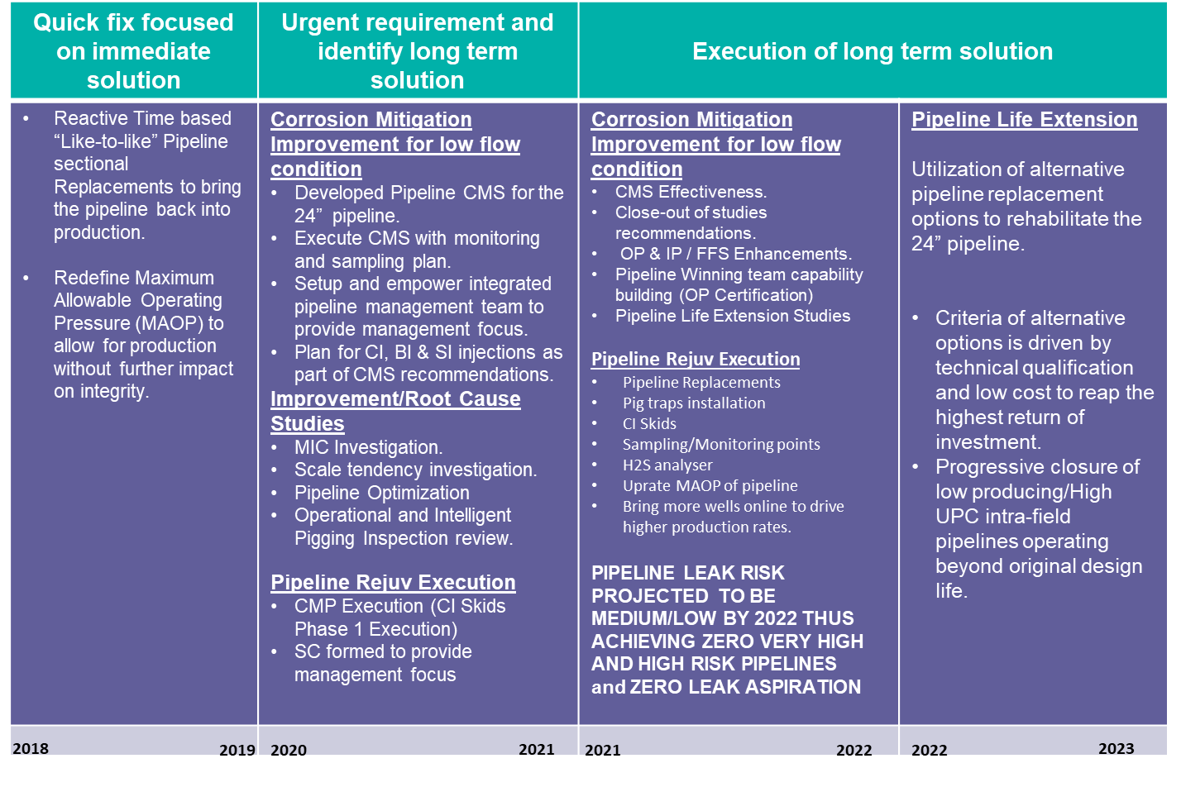

Table 14: Asset Integrity Change Management Roadmap for the 24” Pipeline
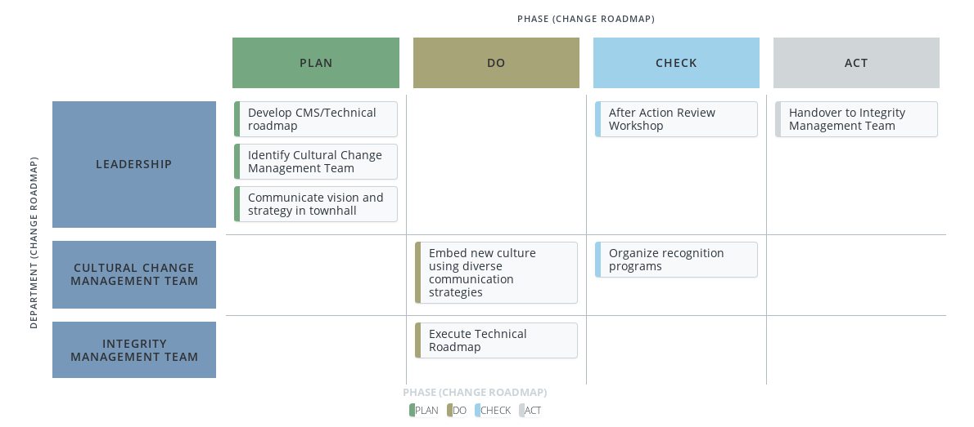

Conclusion
The 24in Trans-Niger pipeline is a critical asset for the company as it was designed to evacuate circa 100 kbopd from four (4nos.) production facilities; if the pipeline is not in operation, that translates to a huge economic loss for the company & Nation (more than N8 million daily). This economic viability of the 24in pipeline is similar for pipeline assets generally. Pipelines as critical economic infrastructure need to be preserved effectively over their designed life cycle, to ensure that business & organizational objectives are met. To maintain the integrity level required to meet business goals is the principal aim of Asset Integrity Management. This study concludes that Asset Integrity Management without following best practice or industry standard methodology is grossly ineffective and would lead to dire consequences as in the case of the 24in Trans-Niger pipeline case-study with its failure in 2018. The Energy Institute Guidance on Corrosion Management in Oil and Gas Processing facilities premised on the Plan – Do – Check – Act model, provides a method for ensuring the management of an asset in a visible, transparent, and auditable manner, which ensures that extant threats do not lead to sudden & unexpected asset failures.
References
Achebe, C.H. Uche, U.C. and Anisiji, O.E. (2012). Analysis of Pipelines Failures in the Oil and Gas Industry in the Niger Delta Area of Nigeria. Proceedings of the International Multi Conference of Engineering and Computer Scientists (IMECS), Hog Kong, 14-16 March.
ASU, F. (2019). Punchng. [Online]. Available at: https://punchng.com/nigerias-crude-oil-reserves-fall-to-36-97-billion-barrels/ [Accessed 22 February 2021].
Gabbar, H.A. and Kishawy, H.A. (2011). Framework of Pipeline Integrity Management. International Process Systems Engineering, 1, 215-236. https://doi.org/10.1504/IJPSE.2011.041560
HENKES, R. (2014). Guidelines for the Hydraulic Design and Operations of Multiphase Flow Pipeline Systems, Netherlands: Shell.
ILMAN, M. (2014). Analysis of Internal Corrosion in Subsea Oil Pipeline. Case Studies in Engineering Failure Analysis, 2(1), pp. 1-8.
Kishawy, H.A. and Gabbar, H.A. (2010). Review of Pipeline Integrity Management Practices. International Journal of Pressure Vessel and Process Piping, 87, 378-380. https://doi.org/10.1016/j.ijpvp.2010.04.003
MOLONEY, B. B. A. J. (2017). Under-Deposit Corrosion. In: Trends in Oil and Gas Corrosion Research and Technologies. Texas: Elsevier Ltd, pp. 363-383.
Okoli, A.C. (2019) Oil Pipeline Vandalism in the Niger Delta: Need Greed and Grievance Factor. Accord/Conflicts Trends Magazine, Issue 2, 12-19.
OKORO, U. B. A. A. O. I. (2011). A Prediction on Nigeria's Oil Depletion Based on Hubbert's Model and the Need for Renewable Energy, s.l.: R.M Barragan.
Peekema, R.M. (2013). Causes of Natural Gas Pipeline Explosive Ruptures. Journal of Pipeline Systems Engineering and Practice, 4, 74-80. https://doi.org/10.1061/(ASCE)PS.1949-1204.0000116
SHELL NIGERIA (2020). Shell Nigeria. [Online] Available at: https://www.shell.com.ng/about-us/who-we-are.html). [Accessed 10 March 2021].

