A STUDY ON THE EFFECTIVENESS OF THE RECORD TO REPORT PROCESS FOR ACCURACY AT METAYB
ABSTRACT
This study analyzes the effectiveness of the Record to Report (R2R) process in ensuring financial accuracy at METAYB using a descriptive research design and primary data collected through questionnaires. It focuses on key areas like invoice processing, GRN verification, payments, reconciliation, and reporting. Statistical tools such as percentage analysis, correlation, and Chi-square tests reveal a strong positive relationship between structured financial processes and accurate reporting. The findings highlight that automation, internal controls, and regular reconciliation improve reliability, while minor issues like approval delays and documentation mismatches still exist. Overall, strengthening controls and adopting automation can enhance R2R effectiveness.

KEYWORDS: Record to Report (R2R), Financial Accuracy, Invoice Processing, Goods Receipt Note (GRN), Payment Processing, Financial Reporting.
INTRODUCTION
In today’s fast-paced business environment, financial accuracy, accountability, and timely reporting are essential for organizational success. The Record-to-Report (R2R) process involves capturing, validating, reconciling financial transactions, and generating accurate reports for stakeholders. It includes key activities such as reconciliations, vouching, verification, documentation, and reporting, ensuring compliance and transparency.
Modern organizations use ERP systems like SAP to automate processes and improve efficiency, but the effectiveness of R2R also depends on strong internal controls, skilled employees, and proper documentation. This study focuses on areas such as purchase orders, GRN accuracy, vouching, and verification. An efficient R2R process enhances decision-making by providing reliable financial insights, while weaknesses can lead to errors, delays, and compliance issues.

COMPANY PROFILE – METAYB
Metayb is a technology and analytics-focused company based in Chennai, Tamil Nadu. The company was established with the aim of helping businesses adapt to digital transformation smoothly and efficiently. Metayb provides consulting services, automation solutions, and enterprise technology support to organizations across different industries. The main focus of the company is to deliver practical and value-driven solutions that improve business performance and support better decision-making.
Metayb specializes in areas such as Artificial Intelligence (AI), Data Analytics, Intelligent Automation, ERP implementation and support, Cloud computing, and Cybersecurity. By combining technology with business knowledge, the company helps organizations simplify complex processes and improve operational efficiency. Its solutions are designed to enhance productivity, accuracy, and overall governance within client organizations.
The company’s core values include:
- Customer focus and accountability
- Integrity and transparency
- Continuous learning and innovation
- Commitment to quality and excellence
These values guide the company’s operations and shape its work culture.

NEED OF THE STUDY
- The primary objective of this study is to evaluate the effectiveness of the Record-to-Report (R2R) process in ensuring accurate, timely, and reliable financial reporting. It examines how the R2R framework supports financial statement preparation, maintains data integrity, and ensures compliance with accounting standards and internal policies.
- The study also identifies gaps and inefficiencies in key areas such as PO processing, GRN recording, invoice vouching, and verification procedures. Additionally, it highlights the importance of proper documentation, internal controls, and validation processes in preventing errors and ensuring transparency, accountability, and reliable financial data.

OBJECTIVES OF THE STUDY
- To understand the overall structure of the Record-to-Report (R2R) process in organizations.
- To examine the role of Purchase Order (PO) processing in ensuring financial accuracy within the R2R cycle.
- To analyze the importance of Goods Receipt Note (GRN) in maintaining proper financial records.
- To evaluate the effectiveness of invoice vouching and verification procedures in the R2R process.
- To study the role of proper documentation in supporting financial reporting.

SCOPE OF THE STUDY
- The study focuses on the Record-to-Report (R2R) process and its effectiveness in organizations.
- It covers key transactional components such as PO processing, GRN creation, vouching, verification, and documentation.
- The research is limited to finance professionals and staff involved in the R2R process.
- It includes both primary data (surveys) and secondary data (literature, company documents).

LIMITATIONS OF THE STUDY
- The study is specific to one organization and may not represent all industries.
- Time constraints restricted extensive data collection and deeper analysis.
- Responses from employees may be subjective and influenced by personal experience.
- Limited access to internal financial records may affect the depth of interpretation

REVIEW OF LITERATURE
1) Putri and Rahmanida (2022), in their study on accounting information systems and financial accuracy, examined how structured systems influence reporting quality. Using qualitative analysis, the study found that integrated accounting systems improve transaction recording and reduce errors. The research emphasized that proper system design enhances R2R accuracy and financial reliability.
2) Simarmata et al. (2023), in their study “Improving Financial Reporting Accuracy,” explored factors affecting financial data quality. Using case-based research, the study found that internal controls, audits, and communication significantly improve reporting accuracy. The research highlighted that strong controls are essential for effective R2R processes.
3) García (2023), in the study “Process Mining in Invoice Management,” analyzed invoicing processes using SAP data. Using process mining techniques, the study found that analyzing transaction patterns improves invoice processing efficiency and accuracy. The research emphasized that data-driven monitoring strengthens financial reporting systems.
4) Şen (2023), in the study on AI in fraud detection and accounting systems, explored automation in financial monitoring. Using analytical models, the study found that AI-based systems detect anomalies and improve transaction accuracy. The study emphasized that automation enhances R2R reliability and reduces fraud risks.
RESEARCH METHODOLOGY
RESEARCH DESIGN:
Descriptive Research Design is employed in this study. This research design focuses on observing, describing, and documenting the characteristics of a population or phenomenon without manipulating any variables. The main objective is to answer questions such as "What?", "Who?", "Where?", and "How many?" rather than exploring the causes behind certain behaviors or outcomes.
SAMPLE DESIGN:
This study used a non-probability sampling approach, selecting employees who were readily available and willing to participate within the hospitality organizations. Though not fully randomized, this method enabled efficient data collection from relevant staff within the given time and resources.

POPULATION AND SAMPLE SIZE:
The population for this study consists of 113 employees working in various capacities in organizations. Based on Cochran, the sample size has been determined as 113 respondents. Sample size is crucial for ensuring the reliability, validity, and generalizability of the study results.
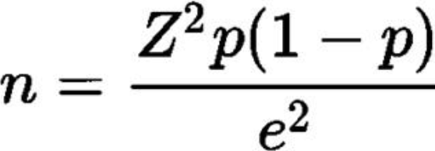
SOURCES OF DATA:
- Primary Data: Primary data is collected using a structured questionnaire designed with a 5-point Likert scale. Primary data refers to information gathered directly from respondents through surveys, interviews, or observations. This type of data is considered authentic and reliable as it reflects
- Secondary Data: Secondary data is collected from research journals, articles, and publications. This includes pre-existing data collected by other researchers for different studies. Secondary data helps in providing context, identifying trends, and supporting the analysis without the need for additional data collection.
TOOLS USED

1. Spearman Rank Correlation
Measures the strength and direction of a monotonic relationship between two ranked variables.
Used when data is ordinal or not normally distributed.
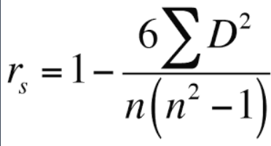

2. Mann-Whitney U Test
A non-parametric test used to compare differences between two independent groups.
It checks whether one group tends to have higher values than the other.
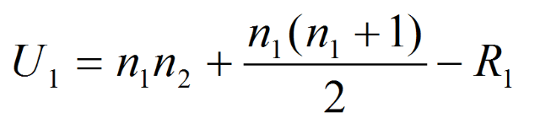

3. Chi-square Test
Used to test the association between two categorical variables.
Compares observed frequencies with expected frequencies.
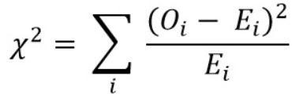

4. One-Way ANOVA
Compares the means of three or more independent groups.
Determines if at least one group mean is significantly different.
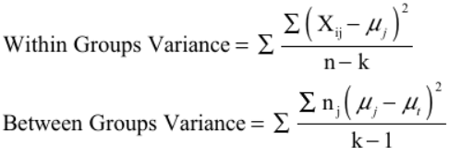

5. Regression Analysis
Examines the relationship between dependent and independent variables.
Used for prediction and estimating impact of variables.
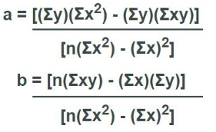

SUMMARY OF FINDINGS
- 48.6% of the respondents belong to the age group of 31–40 years, followed by 43.5% in the 20–30 age group.
- 62.8% of the respondents are Male.
- 46.9% of the respondents are Undergraduates and 46.9% are Postgraduates.
- 74.3% of the respondents belong to the Finance department.
- 47.8% of the respondents have 1–3 years of work experience.
- 45.1% of the respondents are in the Executive level.
- Majority of respondents agree that R2R processes contribute to effective financial management.
- One-way ANOVA results show a significant difference between work experience and R2R contribution to financial management (p = 0.035), indicating that experience level influences employees’ perception of R2R effectiveness.
- Mann-Whitney U test indicates no significant difference between gender and proper recording of GRN (p = 0.157), suggesting that gender does not influence accuracy in GRN recording.
- Chi-square analysis shows no significant association between educational qualification and invoice vouching and verification procedures (p = 0.558), implying that employees across different educational levels follow similar practices in invoice verification within the R2R process.
- Spearman correlation analysis shows a weak positive but insignificant relationship between PO approval process and proper GRN recording (r = 0.124, p = 0.192), indicating that improvements in PO processes alone may not strongly impact GRN accuracy.

SUGGESTIONS
- Improve training and awareness programs on R2R processes to enhance accuracy and efficiency.
- Strengthen PO approval procedures to ensure better coordination with GRN recording.
- Implement standardized documentation practices to improve financial reporting accuracy.
- Provide more practical exposure and guidance for employees with less work experience.
- Encourage the use of automated systems to reduce manual errors in invoice verification and vouching.
- Conduct regular audits and reviews to ensure compliance with financial procedures.
- Promote cross-department collaboration (Finance, Accounting, Audit, Operations) for better process integration.
- Focus on continuous improvement of internal controls within the R2R cycle.
- Implement automation for Proof of Payment (POP) to automatically generate and send PO copies via email to concerned departments and vendors.
- Introduce PFI (Proforma Invoice) automation to streamline approval workflows and reduce manual delays.
- Enable automated invoice matching (3-way matching: PO, GRN, Invoice) to improve accuracy and minimize discrepancies.
- Develop a real-time tracking system for invoices and payments to monitor status and avoid delays.

CONCLUSION
The study aimed to analyze the effectiveness of the Record-to-Report (R2R) process in ensuring financial accuracy within the organization. The findings reveal that most employees have a clear understanding of R2R activities and acknowledge their importance in financial management.
The statistical analysis highlights that work experience plays a significant role in influencing the contribution of R2R processes, while demographic factors such as gender and education do not show significant differences or associations with key process outcomes. Additionally, the relationship between PO approval and GRN recording is positive but not statistically significant, indicating scope for process improvement.
Overall, the study concludes that while the R2R process is functioning effectively, enhancing process integration, employee training, and documentation practices can further improve financial accuracy and organizational performance.

BIBILIOGRAPHY
BOOKS REFERRED
  - “Research Methodology: Methods and Techniques” – C.R. Kothari & Gaurav Garg
  - “Research Methodology in Management” – R. Panneerselvam
  - “Quantitative Techniques for Decision Making” – N. D. Vohra
JOURNALS REFERRED
- Putri, R., and Rahmanida, R. (2022), “Accounting Information Systems and Financial Accuracy: Improving Reporting Quality Through System Integration,” ResearchGate Publication.
- Simarmata, J. et al. (2023), “Improving Financial Reporting Accuracy Through Internal Controls and Audit Practices,” Research Study.
- García, M. (2023), “Process Mining in Invoice Management: Enhancing Efficiency Using SAP Data,” Computers Journal, Vol. 13, Issue 10.
- Şen, C. (2023), “Artificial Intelligence in Fraud Detection and Accounting Systems,” Journal of Information and Economic Research.
- Akbar, M. (2023), “Role of Accounting Information in Decision Making and Financial Accuracy,” Research Publication.
- Rosmala, D. (2024), “Digital Accounting Transformation and Its Impact on Financial Reporting Efficiency,” Research Study.
- Rinaldi, F. (2024), “Integrated Accounting Systems and Financial Accuracy: A System-Based Approach,” Research Publication.
- Zhang, Y. et al. (2024), “Robotic Process Automation in Financial Accounting Processes,” Applied Mathematics and Nonlinear Sciences.
- Das, S. (2024), “AI-driven Automation in Accounting: Improving Invoice Processing and Reconciliation,” International Journal of Novel Research and Development.

WEBSITES REFERRED
- www.researchgate.net
- www.mdpi.comwww.ijnrd.org
- www.amns.sciendo.com
- www.growthmarketreports.com

