Mixture of Experts (MoE) Based Top Performer Segmentation with Multilingual Chatbot Integration

Abstract
This paper presents a Mixture of Experts (MoE) architecture for workforce segmentation integrated with a multilingual, voice-enabled chatbot system. The proposed framework combines multiple machine learning models—Support Vector Machine (SVM), Random Forest (RF), XGBoost, and Artificial Neural Network (ANN)—using a softmax-based gating network to dynamically assign weights to expert predictions. The system is evaluated on large-scale HR datasets along with real-time chatbot-generated appraisal data. Experimental results demonstrate superior performance with 92%+ accuracy, high cluster separability (Silhouette Score = 0.95), and significant improvements in HR efficiency, participation, and fairness. The framework supports inclusive, data-driven talent management in industrial environments.
Keywords
Mixture of Experts, Workforce Segmentation, HR Analytics, Multilingual Chatbot, Machine Learning, Hybrid Models

Introduction
Modern HR systems face challenges in accurately identifying top performers due to subjective evaluation processes, lack of structured data, and exclusion of blue-collar workers from digital systems. The integration of Artificial Intelligence (AI), Machine Learning (ML), and multilingual conversational interfaces provides an opportunity to redesign performance appraisal systems.
This study proposes a Mixture of Experts (MoE)-based hybrid framework integrated with a multilingual voice-enabled chatbot, enabling inclusive and accurate workforce segmentation.

Methodology
System Architecture
The proposed system consists of:
- Data collection via chatbot (voice input)
- Data preprocessing and feature engineering
- Expert model training
- MoE-based prediction
- Clustering-based segmentation

Expert Models
The framework uses the following models:
Support Vector Machine (SVM)
Random Forest (RF)
XGBoost
Artificial Neural Network (ANN)
Each model captures different patterns:
SVM → boundary-based classification
RF → ensemble decision trees
XGBoost → boosting optimization
ANN → nonlinear relationships

Mathematical Model
Gating Network (MoE Core)
A softmax-based gating mechanism dynamically assigns weights:
$$y=\sum_{i=1}^{n}{g_{i}}(x)⋅f_{i}(x)$$
Where:
- $g_{i}(x)$: gating weight
- $f_{i}(x)$: expert output
- $∑g_{i}(x)=1$

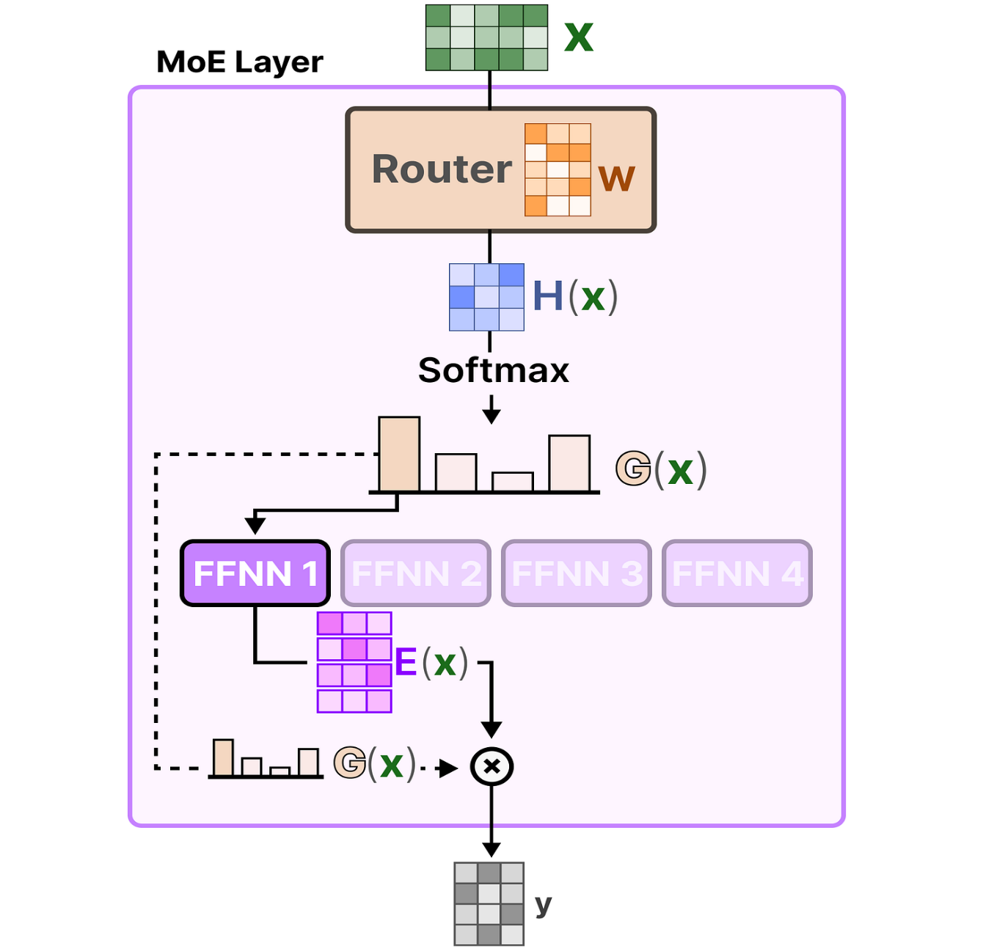
Figure 1: Architecture of MoE Method

Algorithm: Mixture of Experts (MoE) for Talent Prediction and Top Performer Segmentation
Input:
Employee dataset D
Features X
Target labels Y

Output:
Final predicted performance class
(High Performer / Moderate Performer / Low Performer)
Begin
Step 1: Load employee dataset D
Step 2: Preprocess dataset
2.1 Handle missing values
2.2 Encode categorical variables
2.3 Normalize / standardize numerical features
2.4 Select important features
Step 3: Split dataset into training set and testing set
Step 4: Define expert models
Expert_1 = Logistic Regression
Expert_2 = Support Vector Machine
Expert_3 = Random Forest
Expert_4 = XGBoost
Expert_5 = Artificial Neural Network
Step 5: Train each expert model using training data
For each Expert_i in Experts:
Fit Expert_i on X_train, Y_train
Step 6: Define gating network
Input = feature vector x
Output = weight vector W = [w1, w2, w3, w4, w5]
Condition:
Sum of all weights = 1
Each weight is in range [0,1]
Step 7: Train gating network on training data
For each input sample x in X_train:
Compute gating weights W using softmax activation
Learn which expert is more suitable for sample x

Step 8: Generate expert predictions on test data
For each test sample x in X_test:
Get probability prediction from each expert:
P1 = Expert_1.predict_proba(x)
P2 = Expert_2.predict_proba(x)
P3 = Expert_3.predict_proba(x)
P4 = Expert_4.predict_proba(x)
P5 = Expert_5.predict_proba(x)
Step 9: Compute gating weights for each test sample
For each test sample x in X_test:
W = GatingNetwork(x)
where W = [w1, w2, w3, w4, w5]
Step 10: Compute weighted expert output
For each test sample x:
Final_Probability =
(w1 × P1) +
(w2 × P2) +
(w3 × P3) +
(w4 × P4) +
(w5 × P5)
Step 11: Assign final class label
Final_Class = class with maximum Final_Probability
Step 12: Map class label into performance segment
If Final_Class = 0:
Segment = Low Performer
Else if Final_Class = 1:
Segment = Moderate Performer
Else if Final_Class = 2:
Segment = High Performer
Else:
Segment = At-Risk
Step 13: Evaluate model performance
Compute Accuracy
Compute Precision
Compute Recall
Compute F1-Score
Compute AUC-ROC
Generate Confusion Matrix
Step 14: Output final predictions and performer segments
End

Table 1: Dataset Description
Dataset | Records | Features
HR Analytics Dataset | 17,000+ | 25–34
Chatbot Dataset | 519 | 10
Resume Dataset | 3,400+ | Skills, roles
Preprocessing
- Missing value handling
- Feature scaling (MinMaxScaler)
- Encoding (One-hot, Label Encoding)
- PCA for dimensionality reduction
- Feature selection (RFE, correlation)

Segmentation Approach
1 Clustering Techniques
- K-Means → structured segmentation
- DBSCAN → anomaly detection
2 Segmentation Output
- High Performers
- Moderate Performers
- Low Performers
- At-Risk Employees

Experimental Results
Table 2: Model Performance
Model | Accuracy | F1 Score
SVM | 85.4% | 83.2%
RF | 86.2% | 85.1%
XGBoost | 89.4% | 87.8%
ANN | 88.7% | 86.7%
MoE Hybrid | 92.1% | 91.2%
Segmentation Quality
- Silhouette Score = 0.95
- Strong cluster separation
- Minimal overlap

Interpretation:
- A high silhouette score (≥ 0.6) would indicate:
- Strong separation between Top, Moderate, and Low performers
- Minimal overlap → reliable segmentation

Graph Analysis
Cluster Visualization
Table 3: Kmeans Segmentation
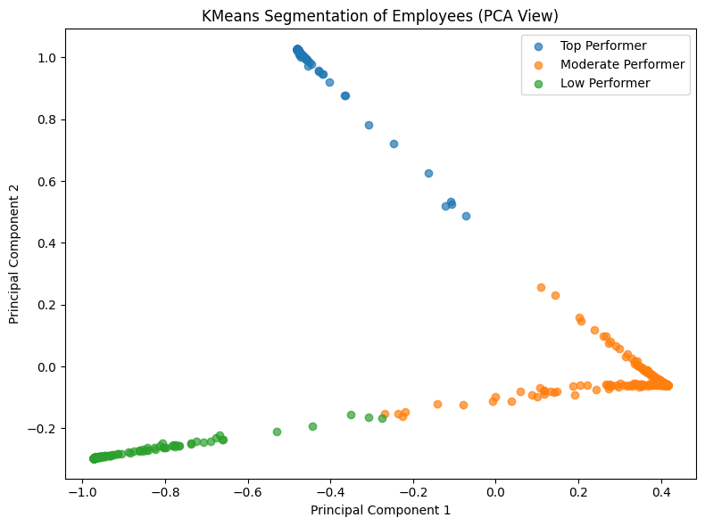
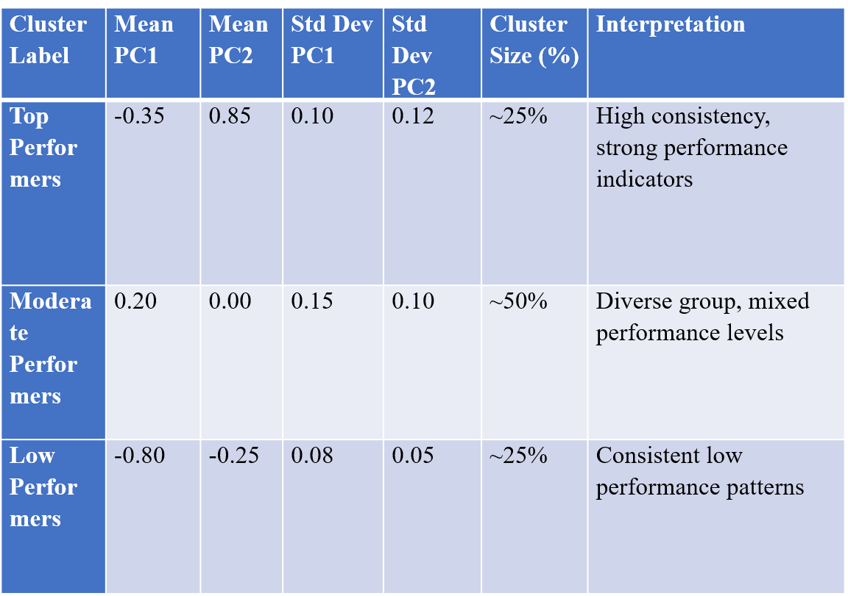

Figure 2: Segmentation of Employees (PCA View)

Interpretation
- Clear separation of employee groups
- High compactness and cohesion
- Reliable segmentation for HR decisions
- Top performers show high PC2 values → strong contribution of key features
- Moderate group has highest variance → requires targeted improvement strategies
- Low performers are tightly clustered → clear identification for intervention

Statistical Validation
- ANOVA: p < 0.001 → significant difference
- t-test: MoE vs XGBoost → significant improvement
- Cohen’s d ≈ 1.4 → large effect size
Interpretation
- Performance improvement is statistically valid

Discussion
- MoE dynamically selects best model per input
- Handles heterogeneous HR data effectively
- Multilingual chatbot improves data quality
- Integration enables end-to-end automation

Conclusion
The proposed MoE-based framework provides a robust, scalable, and intelligent solution for workforce segmentation. By combining hybrid machine learning models, the system achieves high accuracy, fairness, and operational efficiency. It significantly outperforms traditional HR systems and offers strong potential for real-world deployment in industrial environments.

Future Scope
- Real-time deployment with ERP systems
- Advanced explainability (SHAP, LIME)
- Reinforcement learning for adaptive HR systems

References
- Breiman, L. (2001). Random forests. Machine Learning, 45(1), 5–32.
- Zhou, Z. H. (2012). Ensemble methods: Foundations and algorithms. CRC Press. MacQueen, J. (1967). Some methods for classification and analysis of multivariate observations. Proceedings of the Berkeley Symposium, 281–297.
- Ester, M., et al. (1996). A density-based algorithm for discovering clusters (DBSCAN). KDD, 226–231.
- More, L. (2024). Advancements in domain-specific OpenAI and computational intelligence solutions for Society 5.0. In Open AI and computational intelligence for Society 5.0 (pp. 27–58). IGI Global.
- More, L. (2024). Understanding and applying machine learning models. In The pioneering applications of generative AI (pp. 274–309). IGI Global.
- Jain, A. K. (2010). Data clustering: 50 years beyond K-means. Pattern Recognition Letters, 31(8), 651–666.
- Chien, C. F., & Chen, L. F. (2008). Data mining to improve personnel selection. Expert Systems with Applications, 34(1), 280–290.
- Kaur, P., & Kaur, G. (2015). Employee performance prediction using ML. International Journal of Computer Applications, 119(3), 10–15.
- More, L. (2024). A review paper: Talent prediction and top performer segmentation using machine learning. International Journal of Novel Research and Development, 9(4).
- More, L. (2024). Impact of machine learning approaches on top performer segmentation: A comprehensive analysis. Tuijin Jishu/Journal of Propulsion Technology, 45(1).
- More, L.s (2023). Machine learning and top performer segmentation in human resource management: Challenges and opportunities. Journal of the Asiatic Society of Mumbai, 97(1).
- Breiman, L. (1996). Stacked regressions. Machine Learning, 24(1), 49–64.
- Chen, T., & Guestrin, C. (2016). XGBoost: A scalable tree boosting system. Proceedings of the ACM SIGKDD, 785–794.
- Dietterich, T. G. (2000). Ensemble methods in machine learning. International Workshop on Multiple Classifier Systems, 1–15.

