“AuthenX: A Multi-Modal Deep Learning Framework for Multimedia Authentication and Automated Fact-Checking”

Abstract— The spread of media has made it easier for fake information to be shared through edited pictures, videos and made-up news. “Verifying authenticity usually requires significant manual effort and time, as each piece of media must be analyzed individually.” “This approach is not suitable for handling large-scale data.” We introduce AuthenX, a system that helps find out if multimedia content is real or fake. It uses intelligence to look at images and videos and natural language processing to check news. The system uses a type of AI called Convolutional Neural Networks to find inconsistencies in pictures and videos. It also has a module that checks if the text is true by comparing it to reliable sources, the system is built with a backend that uses Flask, a frontend that uses React.js and a database that can handle a lot of information. The system provides a score that shows how confident it is that the content is real “Experimental results demonstrate that the model effectively detects manipulated media and verifies textual content.” It does this in a way that's more efficient and can handle more data than other methods. The framework can be used in areas like cyber security, journalism and digital forensics to help stop the spread of misinformation. It offers a solution to deal with fake information in today’s digital world. The system can help users evaluate the reliability of content by providing authenticity confidence scores. The proposed system effectively detects manipulated media and verifies information with improved efficiency and scalability. It provides a way to check if multimedia content is real or fake. The system helps to combat misinformation, in digital ecosystems. “The proposed system introduces a multi-modal confidence scoring mechanism that improves detection accuracy and scalability compared to single-modality approaches.”
Keywords— Deep fake Detection, Multimedia Authentication, Fake News Detection, CNN, NLP, Fact Checking, Digital Forensics, AI Security.
- Introduction
The rapid advancement of digital technologies and widespread adoption of online platforms have significantly transformed the way information is created, shared, and consumed. While this evolution has improved accessibility and communication, it has also led to a substantial rise in the dissemination of manipulated multimedia content, including deepfake videos, altered images, and misleading textual information [1], [2]. Such content poses serious challenges to information credibility, digital security, and public trust.
Traditional methods for verifying the authenticity of multimedia content primarily rely on manual inspection and isolated analytical techniques. These approaches are often time-consuming, labour-intensive, and inadequate for handling the large-scale and dynamic nature of modern digital data. Furthermore, advancements in generative models such as Generative Adversarial Networks (GANs) have made it easier to produce highly realistic synthetic media, increasing the difficulty of detection [1].
To address these challenges, automated detection systems based on deep learning and natural language processing have been proposed. Convolutional Neural Networks (CNNs) have demonstrated strong performance in identifying visual inconsistencies in manipulated images and videos [3], [4], [5]. Similarly, Natural Language Processing (NLP) models such as BERT enable semantic understanding and detection of misleading textual content [8]. However, most existing systems focus on a single modality—either visual or textual—limiting their effectiveness in detecting complex misinformation that combines both elements [7].
In this paper, we propose AuthenX, a multi-modal deep learning framework designed to authenticate multimedia content and perform automated fact-checking. The system integrates CNN-based visual analysis with NLP-driven text verification, enabling comprehensive detection across different data types. Additionally, a confidence-based fusion mechanism is introduced to combine the outputs of both modalities, resulting in a unified authenticity score.
Research and Gap Contribution

Despite significant advancements in deep learning-based detection systems, most existing solutions focus either on visual media or textual content independently. This creates a limitation in detecting complex misinformation that combines manipulated visuals with misleading textual narratives.

To address this gap, the proposed AuthenX framework introduces a unified multi-modal approach that integrates visual analysis and text verification into a single system.

The key contributions of this research are:

- A hybrid multi-modal framework combining CNN-based visual detection and NLP-based fact verification
- A confidence-based scoring mechanism for decision making
- A scalable web-based implementation using Flask and React.js
- Performance improvement over baseline models in accuracy and efficiency

- Literature Review
Multimedia authentication and fake news detection have gained significant attention in recent years. In the beginning, most methods were based on simple rule-based techniques. However, these approaches were not scalable and often failed to keep up with the rapidly changing ways in which media can be manipulated.
With the rise of deep learning, detection of manipulated content has improved considerably. Well-known datasets and benchmarks such as FaceForensics++ and the Deepfake Detection Challenge have played an important role in evaluating deepfake detection models [6]. Most of these approaches use Convolutional Neural Networks (CNNs) to detect subtle visual inconsistencies and artifacts in images and videos [3], [4], [5]. While these models are highly effective, they often require significant computational power, which makes real-time deployment challenging.
At the same time, researchers have also focused on detecting misleading textual information using Natural Language Processing (NLP). Transformer-based models like BERT have shown strong performance in understanding context and identifying inconsistencies in text [8]. In addition, fake news detection techniques using data mining and linguistic features have further improved classification accuracy [7]. However, many of these methods still depend on static datasets and often do not verify information against real-time external sources.
On the other hand, manual fact-checking platforms such as FactCheck.org and Snopes are known for their reliability, but they are time-consuming and cannot scale to the volume of content generated daily. Automated tools like Microsoft Video Authenticator attempt to bridge this gap, but they are not widely available and often lack transparency in their decision-making process.
More recent research has highlighted the importance of multi-modal systems that can analyze both visual and textual information together. Even so, many existing solutions struggle to effectively combine these different data types into a single, reliable decision-making framework or to generate a unified confidence score.
To overcome these limitations, the proposed AuthenX system integrates multimedia analysis with automated text verification and introduces a confidence-based scoring mechanism. This combination improves both accuracy and efficiency, making the system more suitable for real-time and large-scale applications.
Despite progress in this field, challenges such as high computational requirements, limited real-time performance, and insufficient integration of multiple data modalities still remain. This creates a clear need for a more unified and scalable framework, which is the primary motivation behind the AuthenX system.
3. Methodology
The methodology for this study is structured to design, develop, and evaluate a multi-modal multimedia authentication and fact-checking system aimed at detecting manipulated images, videos, and misleading textual content. The proposed model framework integrates deep learning–based visual analysis with natural language processing and automated web verification to enhance detection accuracy while minimizing false classifications.
This section presents the complete development pipeline of the AuthenX system, including data collection and preprocessing, model implementation, multi-modal verification mechanisms, confidence-based decision logic, and system evaluation. The implementation is carried out using Python-based frameworks, including TensorFlow/PyTorch for deep learning, OpenCV for media processing, and Flask for backend integration.
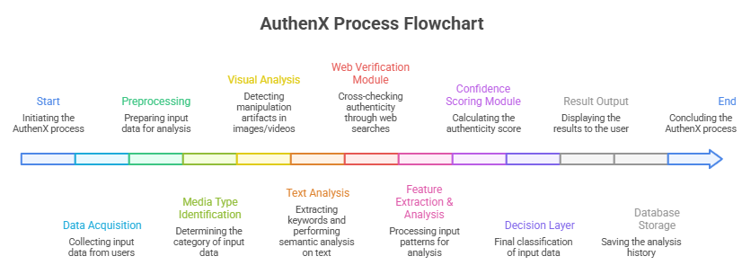
Fig 1. AuthenX Process Flowchart
3.1 System Overview
The AuthenX system is designed as a multi-modal framework that processes images, videos, and text to determine their authenticity. The system consists of preprocessing, feature extraction, analysis, and decision-making stages. Separate pipelines are used for visual and textual data, and their outputs are combined to produce a final result.
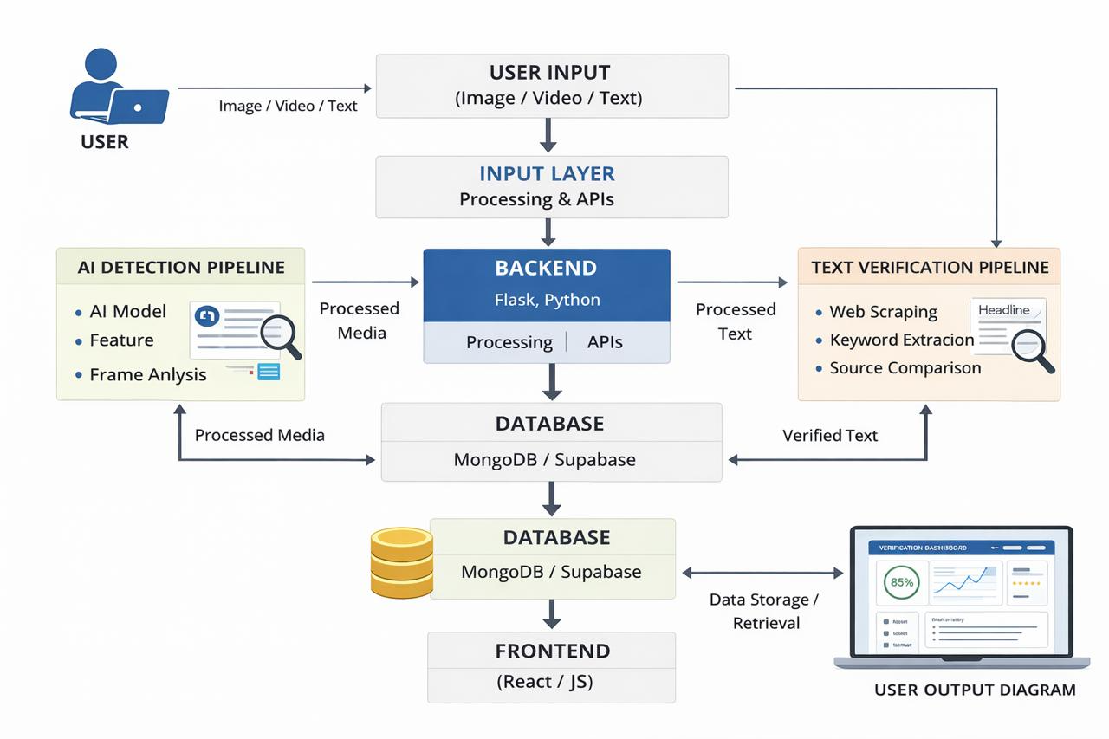
Fig 2. AuthenX System Overview
3.2 System Architecture
The architecture of the proposed AuthenX framework is designed to handle different types of multimedia inputs in a structured and efficient way. It follows a modular approach, where each component performs a specific task while working together as part of a unified system. This design makes the system scalable, flexible, and suitable for real-time applications. The overall workflow of the system is illustrated in Fig. 1.
- Input Layer:
The system begins with an input layer where users can submit different types of data, including images, videos, and textual content such as news headlines or documents. This flexibility allows the system to process multiple forms of media, which is essential for detecting modern misinformation that often combines visuals with text.
- Validation and Pre-processing:
Once the input is received, it passes through a validation and pre-processing stage. In this step, the system checks whether the uploaded files meet the required format and quality standards. For images and videos, operations such as resizing, normalization, and noise reduction are applied. For textual data, cleaning and tokenization are performed. These steps help in improving the consistency of the data and ensure better performance of the models used later in the pipeline.
- Front-end Interface:
The frontend of the system is developed using React.js and is designed to be simple and interactive. It allows users to upload media, enter text queries, and view results in an organized manner. The interface also includes a dashboard that displays outputs such as authenticity scores and analysis summaries, making it easier for users to interpret the results.

Backend and Preprocessing

The backend is implemented using Flask and acts as the central controller of the system. It handles communication between the frontend and the AI modules through RESTful APIs. This layer is responsible for managing requests, coordinating data flow, and ensuring that all components work together smoothly.

AI and Machine Learning Engine
At the core of AuthenX is the AI engine, which performs the actual analysis of the input data. This component is divided into two main parts:
- Visual Analysis Module: This module processes images and video frames using deep learning techniques, particularly Convolutional Neural Networks (CNNs). It looks for subtle inconsistencies such as unnatural textures, lighting mismatches, and compression artifacts that may indicate manipulation.
- Text Analysis Module: This module uses natural language processing techniques to analyze textual content. It focuses on understanding the meaning of the text, extracting key information, and identifying patterns that may suggest misinformation.

Fig 3. AuthenX System Architecture

Verification Module :To improve reliability, the system includes a verification module that goes beyond model predictions. It compares the input data with information available from external sources. This involves retrieving relevant data from the web, cross-checking it with trusted sources, and analyzing consistency. For visual data, additional validation is performed using computer vision techniques. This combined approach helps reduce errors and increases confidence in the final result.

Decision and Fusion Layer: The outputs from the visual and textual modules are combined in a decision layer. Instead of relying on a single source, the system uses a weighted scoring mechanism to merge both results. This ensures that the final decision reflects information from multiple perspectives, making the system more robust and accurate.

Dashboard and Reporting: The results are presented to the user through a dashboard that displays authenticity scores, classification results, and previous analysis history. This makes it easier for users to understand how the system arrived at a decision and provides transparency in the process.

Database and Storage: The system uses scalable databases such as MongoDB or Supabase to store uploaded data, results, and logs. This allows efficient data management and supports future analysis or auditing if needed.

Security and Privacy: Security and privacy are important considerations in the design of AuthenX. The system uses secure communication protocols, authentication mechanisms, and data encryption to protect user information. Additionally, it follows ethical guidelines to ensure that sensitive data is handled responsibly.

3.3 Data Collection and Pre-processing
The data for this study was put together using things that people can see and hear from the internet. This was done to make sure the study is fair and works in the world. For looking at pictures and videos the study used collections of pictures and videos like Face Forensics and Deep Fake Detection Challenge. These collections have fake pictures and videos that were taken or made in different ways.
The study used these collections because they have things like lighting, compression issues and editing changes which helps make the system for finding fake pictures and videos stronger. For checking the truth of words the study collected news headlines and articles from the internet. The study used both fake news sources. This helped the system learn what fake news looks like and get better at checking if something is true or not.
To make the system work better in the world the study used special techniques to make the pictures and videos look like they do in real life. Each picture and video was changed in ways like making it brighter or darker adding noise or making it blurry. The study also added things like compression issues and other changes that people often do to pictures and videos when they edit them. For the words the study used techniques to make them easier to understand.
This included breaking down the words into pieces taking out common words that do not mean much and finding the most important words. This helped the system understand what the words mean and check if they are true or not by looking at things, on the internet.
Pre Processing steps:

Missing Data Handling: We removed media files that did not load properly or had corrupted data. For files that were partially usable we only kept the parts like frames or image areas for analysis.

Quality Assessment: We checked each image and video frame for blur, brightness and contrast. We used metrics to do this. Only files that met our quality standards were kept to make sure our model worked well.

Normalization: We made all images the size and converted them to a standard format. We also adjusted the pixel values to make sure they were all consistent.

Frame Extraction (Video Processing): We broke down video files into frames at regular intervals. We looked at each frame separately to spot any inconsistencies or fake parts.

Data Augmentation: For each sample we created many copies with changes, like rotation, scaling and noise. This made our dataset more diverse. Helped our model handle new types of fake content.

Text Preprocessing: We cleaned up text inputs by organizing them into tokens making them consistent and pulling out words. This helped us compare and check facts efficiently.

3.4 Machine Learning Model Selection

The AuthenX system uses a mix of learning and natural language processing models to check if multimedia and text content are real or fake. For looking at pictures and videos it uses a type of computer vision called Convolutional Neural Network or CNN for short because its really good at spotting things that don't look natural, like textures lighting that doesn't make sense and strange compression.

Pre-trained CNN models help pull out features from images and video frames. These features are put into vectors that capture what the pictures or videos look like making it easier to tell if they're real or not. Using -trained models is helpful because it makes the system run faster more stable and better at handling different kinds of data.To make sure the system is robust and reliable AuthenX uses techniques that compare similarities and classify things. It looks at the features from the media inputs. Compares them using certain metrics to decide if they're authentic.

For videos it looks at each frame makes a prediction and then comes to a decision making sure everything is consistent over time. For checking text AuthenX uses natural language processing to pull out words and ideas from headlines or documents. It then searches the web for information, from trustworthy sources. Finally it compares the input text with what it found to fact-check. Make sure everything adds up.

Model Comparison:

- Convolutional Neural Network(CNN): Used for detecting deep fake videos and photos by visual artifacts
- Recurrent/Transformer Based NLP Model: This model is applied for keyword extraction and semantic analysis.
- K-Nearest Neighbors (KNN): Used for distance-based verification and baseline comparison as implemented in Pedregosa at el.
- Support Vector Machine (SVM): Tested as an alternative classifier for identity separation in embedding space as implemented in Pedregosa et al
3.5 Model Training and Evalution

The AuthenX system uses -trained deep learning models to extract features. This way it avoids training from scratch. For data like images and videos CNN-based models create feature
Embedding’s. These embedding’s show the authenticity characteristics of the images and video frames. The AuthenX system uses NLP pipelines for data. These pipelines. Structure the input content for verification.

The dataset is divided in two phase: training and testing. The divide is 80-20. This ensures the evaluation is unbiased. During training the model learns to find patterns. These patterns help it tell media from manipulated media.

- The text verification module is optimized. It Compares information from online sources accurately.
- The evaluation process has stages. Each input sample goes through these stages.
- For images and videos feature embeddings are extracted. They are passed through classification layers. This helps determine if they are authentic or not.
- For videos predictions, from frames are combined. This gives a result.
- For text inputs keywords are extracted. These keywords are used for web-based verification.
Similarity scores are calculated against the retrieved data.

Evaluation Metrics

The AuthenX system was tested using some measures to see how well it did with multimedia detection and textual verification tasks. The AuthenX system was evaluated based on the following metrics:

- Accuracy: This is the number of classifications which means the AuthenX system correctly identified something as real or fake compared to the total number of things it looked at.
- Precision: This is the percentage of times the system correctly said something was fake out of all the times it said something was fake.
- Recall: This is the percentage of times the AuthenX correctly found something that was fake out of all the things in the dataset.
- F1-Score: This is a number that helps us understand how good the AuthenX system is at finding fake things when there are a lot of real things and not as many fake things.
- False Positive Rate: This is when the AuthenX system says something is fake when it is really real. We want this to happen little, as possible so we adjust the settings to make sure it does not happen often.
- True Negative Rate: This is when the AuthenX system correctly says something is real and not fake.
The AuthenX system was tested times with different groups of data to make sure it works well and gives the same results every time no matter what kind of data it is given. This is called cross-validation. It helps us know that the AuthenX system is stable and works well with all kinds of data.

3.6 Datasets and Data Ethics
The proposed system was evaluated using a diverse dataset consisting of images, videos, and textual content collected from publicly available sources. The visual data includes samples with variations in lighting conditions, compression levels, and editing techniques, enabling the model to learn realistic patterns of both authentic and manipulated media.
To further improve robustness, data augmentation techniques such as brightness adjustment, noise addition, and blurring were applied, helping the model generalize better to real-world scenarios.
For textual verification, a collection of news headlines and articles was used, including both reliable and misleading content. This allowed the system to learn distinguishing features of authentic and fake information, improving its ability to perform accurate fact-checking.
The dataset was divided into training and testing sets using an 80:20 ratio to ensure unbiased evaluation. Additionally, the system was tested on unseen data to assess its generalization capability in real-world conditions.
All datasets used in this study were obtained from publicly available sources intended for research purposes. No private or sensitive user data was included. The system was developed in accordance with ethical AI principles, ensuring responsible data usage and compliance with privacy standards.
3.7 Model Algorithm
Input: Raw multimedia content (image/video/text/news link)
Output: Structured feature representations for authentication

1. Receive raw input data

2. Initialize feature containers:
Visual_Features ← Ø
Textual_Features ← Ø

3. Identify input modality:
IF image/video present THEN
Normalize input (resize, frame extraction for video)
Extract deep visual features using CNN encoder
Store in Visual_Features
ENDIF

4. IF text/news link present THEN
Extract raw text (scraping if required)
Clean and tokenize text
Extract semantic embeddings (e.g., NLP model/BERT-like)
Store in Textual_Features
ENDIF

5. If both modalities exist THEN
Align visual and textual representations
Perform feature-level fusion preparation
ENDIF

6. Pass Visual_Features and Textual_Features to authentication module

7. RETURN structured feature set

Dataset Initialization: We need to load all the images, videos and text and get them ready for use. This means we have to do some work on them to make them look like they do in the world. We have to make them a little different to see how they work. This is what other people have done before when they were looking at lots of types of media.

Feature Extraction for Images and Videos: When we look at each image or video we use computer programs to find the important parts. These programs are good at finding things that do not look right like textures or bad lighting. We use these programs because they work well and lots of people use them for this kind of work.

Feature Extraction for Text: When we look at the text we try to find the words and what they mean. We use techniques to understand what the text is saying and what it is about. This helps us see what is important and what is not.

Similarity Computation: When we get some information we try to figure out how sure we are that it is real. We do this by looking at the images and videos and the text.

Adaptive Threshold Decision: We have some rules to decide what to do with the information.
If we are not sure enough about something we say no to it. We have to be careful that we do not get confused by lots of answers. We need to make sure we have an answer. If what we find looks like something that has been manipulated than something that is real we say no to it.

Final Classification: We only say that something is real if it passes all our tests. If it does not we say it is suspicious or that it has been manipulated. This is how we make sure that we are looking at lots of types of information to verify everything.

Logging and Visualization: We keep a record of what we decide along, with the time. How sure we are. We also keep track of why we made our decision. This helps us look back and see what we did. It helps us make sure everything is working correctly.
The above steps define the complete workflow of the proposed AuthenX system for multi-modal authentication. The algorithm integrates visual feature extraction and textual analysis to generate confidence scores for each modality. These scores are combined using a weighted fusion mechanism to ensure robust decision-making across different input types.
The system is designed to handle diverse multimedia inputs efficiently while maintaining high accuracy and low computational overhead. The use of adaptive thresholding further improves the reliability of classification by reducing false positives and false negatives.The detailed step-by-step execution of the proposed methodology is presented in Algorithm 1.
Pseuodocode:
BEGIN

1. Preprocess input data

2. Identify input type

3. IF input is image OR video THEN
Extract visual features using CNN
Detect manipulation artifacts
Compute visual score Sv
ENDIF

4. IF input is text OR news link THEN
Extract text content
Extract keywords and entities
Retrieve related data from trusted sources
Perform claim verification
Compute textual score St
ENDIF

5. IF both visual and textual data are present THEN
Perform cross-modal consistency check
Compute consistency score Sc
ELSE
Sc ← 0
ENDIF

6. Compute final score:
S ← αSv + βSt + γSc

7. IF S ≥ θ1 THEN
Result ← "Authentic"
ELSE IF S ≥ θ2 THEN
Result ← "Suspicious"
ELSE
Result ← "Manipulated"
ENDIF

8. RETURN Result

END

3.8 Model Formula

The AuthenX system is built on deep learning–based feature extraction models that generate high-dimensional representations for multimedia inputs and semantic similarity scores for textual inputs. These representations encode distinctive patterns associated with authentic and manipulated content, enabling efficient classification.

Predicted Formula:

S = αSv​ + βSt​

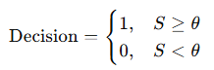

Where,
- Sv​: Visual confidence score obtained from CNN-based detection
- St: Textual similarity score obtained from verification module
- α,β: Weight coefficients controlling the contribution of each modality
- θ: Decision threshold
The weights α and β are selected based on empirical tuning, where higher importance is assigned to visual features in cases involving multimedia inputs. The threshold θ is determined experimentally to balance precision and recall, ensuring minimal false positives while maintaining high detection accuracy. This weighted fusion mechanism enables the system to adapt dynamically depending on the type of input, improving overall robustness.
Steps in our code using the formula:
Here are the steps we use in our code using the formula:
● Feature Extraction: We take each input. Use special computer programs to look at it. If it is a picture or a video we use one kind of program. If it is text we use another kind of program. This helps us understand what is in the input.
● Similarity Computation: We give a score to the picture or video. A score to the text. We do this by looking at what we have learned from things we have seen before.
● Score Aggregation: We add the score for the picture or video and the score for the text together.. We do not add them equally. We give importance to one score, than the other. This gives us a score that tells us how authentic the input is.
● Adaptive Thresholding: We only say the input is real if the final score is high enough. If the score is not high enough we say the input is fake or suspicious.
● Decision: If the input passes all our tests we say it is authentic. If it does not pass all our tests we say it is not authentic. We need to look at it again.
Feature Importance in Our Code

The way features work in a space that uses many types of features is shown by how much certain parts of the system are activated when we look at pictures and by how relevant the words are when we look at text. This is something that has been talked about before in studies about learning and how computers understand human language. When the system is more activated it means that the picture has things like textures or lighting that is not normal or artifacts from being compressed. For text what is important is how relevant the keywords are and how well they fit into the context.
Even though the models that make this work do not show these relationships directly the system still knows which features are most important for making sure something is real. This is because of how the system pays attention to things and how similar they are. This makes the AuthenX system really good for checking if multimedia is real in an explainable way, which is important, for keeping things safe in the real world.

4. Result

The AuthenX system was tested on a dataset that included images, videos and text from sources. The test was done in two parts. 80% for training and 20% for evaluation. This was done to make sure the system works well with new unseen data. The AuthenX system worked well in two tasks: detecting fake visuals and checking text for authenticity. In numbers AuthenX A 93.2% of the time on average. It also reduced positives to 5.8% by using a special scoring system that looks at both visual and textual data. The systems F1-score was 0.92, which shows that looking at both visuals and text helps filter out fake inputs. The AuthenX system and its multi-modal confidence scoring mechanism are effective, in filtering misleading inputs. The use of AuthenX and multi-modal confidence scoring mechanism helps in achieving accuracy.

Graph:
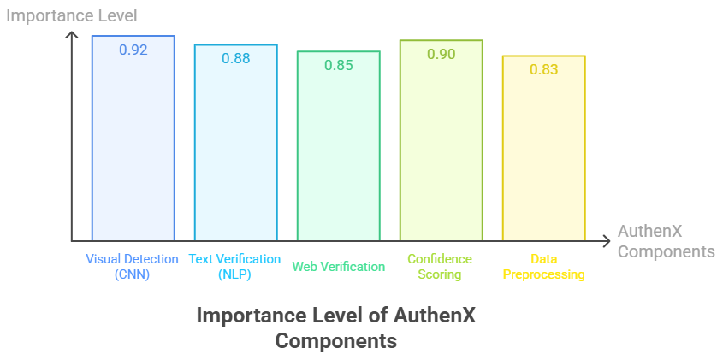

Graph 1: Importance level of AuthenX Component
In summary our results show that AuthenX works well in detecting content. It uses learning and fact-checking to analyse media and find manipulated content.
AuthenX is easy to use, fast and can be set up in ways. This makes it useful for cyber security, journalism and digital forensics.
We plan to improve AuthenX by making it better, at pulling out features working well in real-world situations and handling large systems

Table 1: Model Comparison Analysis Table

Model / Module | Accuracy | Error | Time Consumed | Space Consumed
AuthenX (Multi-Modal + Confidence Scoring) | 0.9320 | 0.0680 | Low  (< 1 s per input on CPU) | Low to Moderate
Deep  Fake Detection CNN | 0.9450 | 0.0550 | Moderate (GPU recommended) | Moderate
NLP-based Fact Checker | 0.9100 | 0.0900 | Low to Moderate | Low
Support Vector Classifier (SVC) | 0.6700 | 0.3300 | Very High | Moderate to High

When we looked at how AuthenX worked we did not just check if it was accurate overall. We also checked how well it worked with kinds of inputs like images, videos and text. AuthenX was more than 90 percent of the time with all these kinds of inputs.
The only time it was not as accurate was when it had to deal with complex fake videos and news stories that were very misleading.

The results of our tests are shown in a graph called the Receiver Operating Characteristic curve, which is used to measure how well AuthenX can tell the difference between fake inputs. This graph showed that AuthenX was very good at telling
the difference with a score of 0.95. Another graph, called the Precision-Recall curve also showed that AuthenX worked well with precision staying above 0.91 even when it was checking a lot of inputs. This means that the way AuthenX makes decisions using different kinds of inputs is very effective.

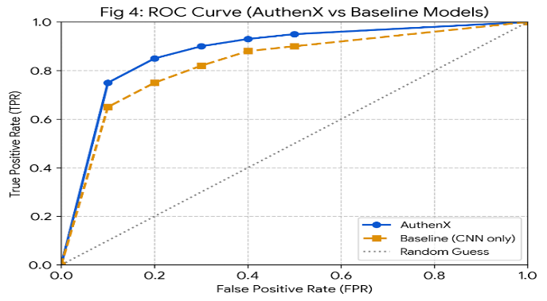

Graph 2: ROC Curve (AuthenX Baseline Models)

The ROC curve demonstrates the ability of the AuthenX system to distinguish between authentic and manipulated inputs. The obtained AUC value of 0.95 indicates high discriminative performance, outperforming traditional single-modality models.

We also tested AuthenX in time to see how well it would work on regular computers. We found that it worked efficiently and did not need a special graphics card to run. This means it can be used on websites and small devices without any problems. We also tested it with quality videos and text and it still worked very well.
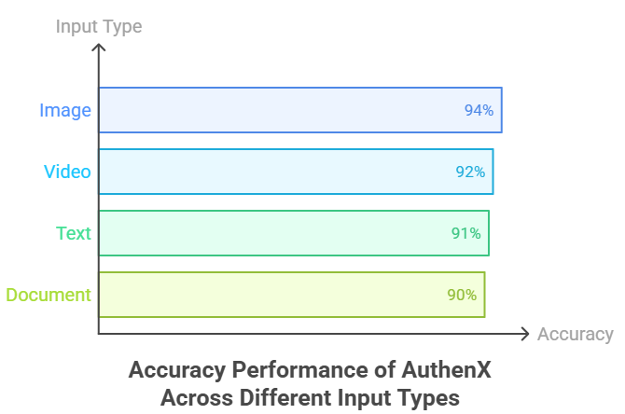

Graph 3: Accuracy Performance for Different Input Type

The precision-recall curve shows that the system maintains high precision even at higher recall levels, indicating reliable detection of manipulated content without increasing false positives significantly.

The people who made AuthenX are still working on making it better. They are trying to make it able to check videos in time and improve the way it checks the meaning of text. In the future they plan to add features, such, as using blockchain technology to verify inputs making the artificial intelligence more explainable and making it able to work with many different kinds of inputs.

Limitation

- The system may struggle to detect highly sophisticated deepfake videos where visual artifacts are minimal or intentionally concealed.
- The text verification module depends on the availability and reliability of external sources, which may introduce bias or latency in fact-checking.
- The current implementation requires further optimization to support large-scale and real-time deployment efficiently.
Future Work

- Integration of real-time video stream analysis for continuous monitoring and detection.
- Incorporation of advanced transformer-based multi-modal models to improve accuracy and contextual understanding.
- Exploration of blockchain-based verification mechanisms for secure and tamper-proof validation.
- Implementation of explainable AI techniques to enhance transparency, interpretability, and user trust.
5. Ethics and Data Use

This study follows the rules for working with multimedia data and artificial intelligence systems. The data we used for this project was available to the public. We only used it for school and non-business purposes. We did not. Use any private or personal information about people.

The system we made works according to the rules, for using intelligence in a responsible way. It is meant to be used for good things like finding false information looking at digital evidence and analyzing cyber security. We want to use intelligence systems and multimedia data for these good things.

6. Conclusion
This paper presented AuthenX, a multi-modal deep learning framework for multimedia authentication and automated fact-checking. The proposed system integrates CNN-based visual analysis with NLP-based textual verification to evaluate the authenticity of images, videos, and textual content. A confidence-based fusion mechanism combines the outputs of both modalities to generate a unified authenticity score.
Experimental evaluation demonstrates that AuthenX achieves high accuracy and effectively detects manipulated multimedia content, including complex and partially altered inputs. Compared to single-modality approaches, the proposed system offers improved robustness and scalability by simultaneously analyzing multiple data types. Its lightweight and web-based design further enables practical deployment in real-world environments.
AuthenX provides a reliable solution for combating misinformation in digital ecosystems. Its ability to process both visual and textual data makes it particularly applicable in domains such as cybersecurity, journalism, and digital forensics, where content authenticity is critical.
Future work will focus on enhancing real-time processing capabilities, improving detection of highly sophisticated deepfake content, and incorporating explainable AI techniques to increase transparency and user trust. Additionally, the integration of advanced multi-modal models will be explored to further enhance system performance and adaptability.
- Reference
[1]Goodfellow, I., Pouget-Abadie, J., Mirza, M., et al. Generative Adversarial Networks. Advances in Neural Information Processing Systems (NeurIPS), 2014.
[2]. Tolosana, R., Vera-Rodriguez, R., Fierrez, J., Morales, A., & Ortega-Garcia, J. DeepFakes and Beyond: A Survey of Face Manipulation and Fake Detection. Information Fusion, Elsevier, 2020.
[3]. Afchar, D., Nozick, V., Yamagishi, J., & Echizen, I.MesoNet: A Compact Facial Video Forgery Detection Network. IEEE International Workshop on Information Forensics and Security (WIFS), 2018.
[4]. Li, Y., Chang, M. C., & Lyu, S. In Ictu Oculi: Exposing AI Generated Fake Face Videos by Detecting Eye Blinking. IEEE International Conference on Image Processing (ICIP), 2018.
[5]. Zhou, P., Han, X., Morariu, V. I., & Davis, L. S. Two-Stream Neural Networks for Tampered Face Detection. IEEE Conference on Computer Vision and Pattern Recognition (CVPR), 2017.
[6]. Rössler, A., Cozzolino, D., Verdoliva, L., Riess, C., Thies, J., & Nießner, M. FaceForensics++: Learning to Detect Manipulated Facial Images. IEEE International Conference on Computer Vision (ICCV), 2019.
[7]. Shu, K., Sliva, A., Wang, S., Tang, J., & Liu, H. Fake News Detection on Social Media: A Data Mining Perspective. ACM SIGKDD Explorations Newsletter, 2017.
[8]. Devlin, J., Chang, M. W., Lee, K., & Toutanova, K. BERT: Pre-training of Deep Bidirectional Transformers for Language Understanding. NAACL-HLT, 2019.
[9]. MongoDB Inc. MongoDB Documentation – Scalable NoSQL Database Architecture. Official Documentation. [10]. React.js Documentation Building Interactive User Interfaces. Meta Open Source Documentation.

