" EXPLORING THE TRANSFORMATIVE ROLE OF GENERATIVE ARTIFICIAL INTELLIGENCE IN CREATIVE INDUSTRIES: BRIDGING ART AND CODE "

Abstract
Generative Artificial Intelligence (GenAI), which refers to models capable of creating original outputs such as text, images, audio, 3D content, and code, is transforming creative industries at a rapid pace. This paper examines the influence of key generative approaches—including Generative Adversarial Networks (GANs), Variational Autoencoders (VAEs), autoregressive language models, diffusion models, and multimodal systems—on workflows in areas such as art, design, animation, music, marketing, and software development. It outlines the study’s objectives and scope, and discusses underlying architectures, operational processes, and the necessary hardware and software infrastructure. In addition, the paper explores practical applications, advantages, and major challenges, including technical limitations, ethical concerns, and economic implications. The study concludes by proposing practical strategies for individuals and organizations to adopt GenAI responsibly, ensuring that innovation is balanced with the preservation of human creativity and broader societal values.

1. Introduction
Generative Artificial Intelligence (GenAI) refers to a class of machine learning systems designed to learn the underlying patterns and probability distributions within large datasets and generate new, original outputs that resemble the learned data. Unlike earlier procedural or rule-based systems, which relied on predefined instructions and offered limited flexibility, modern GenAI leverages deep learning techniques to produce highly realistic, diverse, and controllable content. Significant advancements in this field include models such as Generative Adversarial Networks (GANs), Variational Autoencoders (VAEs), autoregressive transformer-based models, and diffusion models. These technologies have enabled breakthroughs across multiple domains, including image and video synthesis, natural language generation, music composition, 3D modeling, and automated code generation. Additionally, multimodal models now integrate different data types—such as text, images, and audio—allowing for more complex and context-aware creative outputs.
The adoption of GenAI is fundamentally transforming creative industries. Traditional workflows that once depended entirely on human effort are evolving into hybrid human–AI collaborations. In these systems, AI tools assist with idea generation, rapid prototyping, and content variation, while also automating repetitive or time-intensive tasks. This shift not only increases efficiency and scalability but also expands the creative possibilities available to artists, designers, developers, and marketers. At the same time, the growing integration of GenAI introduces new considerations, including questions of authorship, originality, intellectual property rights, and ethical use. As a result, there is an increasing need for responsible implementation frameworks that balance technological advancement with human creativity, cultural values, and professional integrity.
2. Literature Review
Generative Artificial Intelligence (GenAI) has emerged as a transformative field within machine learning, driven by advancements in deep learning architectures capable of generating high-quality and diverse content. One of the foundational contributions to this domain is the work of Ian Goodfellow et al. (2014), who introduced Generative Adversarial Networks (GANs). GANs employ a dual-network architecture consisting of a generator and a discriminator, enabling the creation of realistic synthetic data, particularly in image generation tasks. Building upon probabilistic modeling approaches, Diederik P. Kingma and Max Welling (2014) proposed Variational Autoencoders (VAEs), which provide a structured latent space representation for generating new data samples. VAEs have been widely used in applications requiring controlled and interpretable data generation. A major breakthrough in sequence modeling came with the introduction of the Transformer architecture by Ashish Vaswani et al. (2017). Transformers utilize attention mechanisms to capture long-range dependencies in data, forming the foundation for modern autoregressive language models such as GPT (Radford et al., 2018). These models have significantly advanced natural language understanding and generation capabilities. More recently, diffusion-based models have gained prominence due to their ability to generate high-fidelity outputs. Jonathan Ho et al. (2020) introduced Denoising Diffusion Probabilistic Models, which iteratively refine noise into structured data, achieving state-of-the-art performance in image synthesis. Further advancements in multimodal learning have been demonstrated through models like DALL·E (Ramesh et al., 2021–2022) and CLIP (Radford et al., 2021), which integrate text and image understanding to enable text-to-image generation and cross-modal reasoning. Additionally, improvements in GAN architectures, such as StyleGAN proposed by Tero Karras et al. (2019), have enhanced the realism and controllability of generated images. Beyond technical developments, ethical considerations surrounding AI have been explored by Nick Bostrom and Eliezer Yudkowsky (2014), emphasizing the societal implications, risks, and governance challenges associated with advanced AI systems. In addition to academic contributions, practical implementations and widespread adoption of GenAI have been supported by open-source platforms such as Hugging Face and frameworks like PyTorch. Recent research presented at leading conferences, including NeurIPS, CVPR, and ICML, continues to drive innovation in generative modeling techniques. Overall, the literature highlights rapid progress in generative models, from foundational architectures to advanced multimodal systems, alongside growing attention to ethical, legal, and practical considerations. These developments collectively underpin the transformative role of GenAI across creative industries, enabling new forms of human–AI collaboration while raising important questions about responsible use.
.
3. Objectives
- To understand key generative AI models and their output mechanisms.
- To examine GenAI integration in art, media, and software workflows.
- To identify essential hardware and software requirements.
- To assess benefits and associated risks of GenAI adoption.
- To suggest ethical and effective implementation practices.
- To highlight future research and innovation opportunities.

4. Scope
This study examines the transformative role of Generative Artificial Intelligence (GenAI) within creative industries, with a focus on both technological foundations and practical applications. The scope includes key creative domains such as visual arts, graphic design, animation, film VFX, music composition and production, creative writing, advertising and marketing, game asset creation, and code generation. It analyzes how GenAI is being integrated into these areas to enhance creativity, efficiency, and innovation. From a technological perspective, the study covers major deep learning–based generative approaches, including Generative Adversarial Networks (GANs), diffusion models, transformer-based architectures, Variational Autoencoders (VAEs), and multimodal systems. It explores how these models function and contribute to content generation across different formats.
The study also emphasizes practical aspects, including the required technology stack, deployment strategies, real-world applications, and industry use cases. In addition, it evaluates the benefits of GenAI—such as improved productivity, accessibility, and scalability—alongside key challenges, including bias, intellectual property concerns, and ethical implications. General policy and ethical considerations related to responsible AI adoption are also addressed. However, the scope is limited in certain areas. It does not include detailed mathematical derivations or low-level theoretical proofs of machine learning models. Additionally, it excludes enterprise-specific procurement processes and does not provide an exhaustive analysis of jurisdiction-specific copyright laws, focusing instead on broad legal principles and considerations. Overall, the study aims to provide a balanced and application-oriented understanding of GenAI’s impact on creative industries while maintaining clarity and relevance for researchers, practitioners, and industry stakeholders.

5. Technologies Used
- This study examines the principal technologies that enable Generative Artificial Intelligence (GenAI), focusing on widely adopted model families and supporting development ecosystems.
- At the core are generative model architectures. Generative Adversarial Networks (GANs) employ a dual-network design—comprising a generator and a discriminator—to produce highly realistic images, making them suitable for tasks such as style transfer and image enhancement. Variational Autoencoders (VAEs) utilize probabilistic latent representations, allowing controlled data generation and smooth transitions between generated samples.
- Transformer-based autoregressive models, including GPT-style architectures, are central to text and code generation and have also been adapted for other modalities. In parallel, diffusion models have gained prominence for their ability to generate high-quality visual outputs through iterative noise reduction, particularly in text-to-image synthesis.
- The study also considers multimodal systems, which integrate multiple data forms—such as text, images, and audio—to produce context-aware outputs. Additionally, neural audio models support the generation of music and speech, while neural rendering and 3D techniques, including radiance field methods and mesh-based approaches, enable the creation of realistic 3D assets and visual environments.
- From an implementation standpoint, widely used frameworks and libraries include PyTorch, TensorFlow, and JAX. High-level tools such as Hugging Face Transformers and diffusion libraries simplify model development and deployment. Domain-specific platforms like Unity and Unreal Engine further support integration into gaming and visual effects pipelines.
- Supporting infrastructure plays a crucial role in practical deployment. This includes data processing pipelines, annotation tools, synthetic data generation methods, and model serving systems such as TorchServe and NVIDIA Triton Inference Server. Additionally, MLOps frameworks are essential for managing the lifecycle of models, ensuring scalability, reliability, and continuous improvement.
- Overall, these technologies collectively form a robust ecosystem that enables the development, deployment, and scaling of generative AI solutions across diverse creative and technical domains.

6. Working of Generative Artificial Intelligence Systems
Generative Artificial Intelligence (GenAI) systems operate through a structured sequence of processes that enable machines to learn patterns from data and generate new, meaningful outputs. The workflow can be theoretically understood as follows:
- Data Acquisition and Preparation: The process begins with the collection of large and relevant datasets specific to the target domain, such as text, images, audio, or code. This data undergoes preprocessing steps including cleaning, normalization, transformation, and encoding. For textual data, tokenization techniques are applied, while visual data may be converted into feature representations or latent encodings. These steps ensure that the data is suitable for effective model training.
- Model Learning and Optimization: At this stage, a suitable generative model is selected and trained to learn the underlying distribution of the input data. Different model families follow distinct learning paradigms. For instance, adversarial models learn through competition between networks, probabilistic models focus on latent variable representation, sequence models predict data in a stepwise manner, and diffusion-based approaches iteratively refine noisy inputs. The training process involves optimizing objective functions to minimize error and improve the model’s ability to generate realistic outputs.
- Conditional Guidance and Control Mechanisms: To produce context-specific outputs, generative models incorporate conditioning mechanisms. These may include textual prompts, categorical labels, stylistic inputs, or other guiding signals. Conditioning allows the system to align generated outputs with user intent and enhances controllability over the generation process.

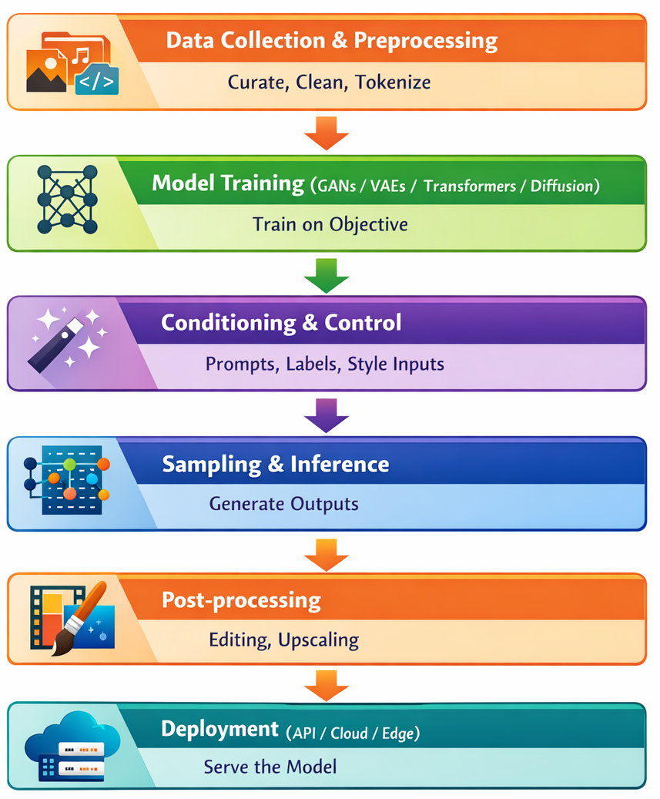
Fig: Functional Flow of Generative Artificial Intelligence Systems

- Output Generation (Inference Phase): Once trained, the model enters the inference phase, where it generates new data samples. This is achieved through sampling strategies that introduce controlled randomness, ensuring diversity while maintaining coherence with learned patterns. The generation process varies depending on the model type but generally involves iterative or sequential prediction.
- Refinement and Post-processing: The generated outputs are often refined to enhance quality and usability. Post-processing may include filtering, correction, scaling, or integration with other tools. In many applications, human intervention plays a role in validating and improving the final output, ensuring it meets desired standards.
- System Deployment and Integration: Finally, the generative model is deployed for practical use. This may involve integration into applications, platforms, or services through APIs or cloud-based infrastructure. Depending on the use case, deployment can occur on high-performance computing systems or optimized edge devices for real-time interaction.
In essence, Generative AI systems function by learning data distributions, applying structured training methodologies, and generating outputs through guided inference mechanisms. This theoretical framework highlights the interaction between data, models, and deployment environments, forming the foundation for practical applications across various creative and technical domains.

7. Applications
- Visual Arts and Design: In visual arts and design, GenAI facilitates the creation of concept art and mood boards from textual inputs, while also supporting image transformation techniques such as style adaptation, restoration, and content-aware editing. It further enables rapid development of visual assets, including logos, posters, and layout compositions, thereby accelerating the design process.
- Animation, Film, and VFX: Within animation, film, and visual effects (VFX), generative models assist in producing digital environments, textures, and background elements. They contribute to crowd simulation, frame interpolation, and resolution enhancement, while also automating labor-intensive processes such as rotoscoping. Additionally, textual descriptions can be transformed into visual storyboards, aiding in previsualization and planning.
- Music and Audio: In the domain of music and audio, GenAI supports the composition and arrangement of musical pieces, as well as the synthesis of realistic instrument sounds. It is also applied in sound design for generating effects and adaptive audio, particularly in interactive environments. Voice synthesis technologies further enable the generation of speech with controlled characteristics, subject to ethical considerations.
- Writing and Content Creation: For writing and content creation, generative systems assist in producing written material such as scripts, articles, and marketing content. They are capable of summarizing large volumes of text and enabling localization through translation combined with stylistic adaptation, thereby improving communication across different audiences.
- Advertising and Marketing: In advertising and marketing, GenAI enables the rapid generation of creative campaign materials and multiple design variations. It supports personalized content delivery at scale, allowing organizations to tailor visuals and messaging to individual user preferences, and enhances experimentation through automated content variations.
- Game Development: In game development, generative techniques are used for procedural content creation, including levels, environments, textures, and character interactions. They also support the generation of dialogue for non-player characters and assist in rapid prototyping of gameplay mechanics through automated code generation.
- Software Development: Within software development, GenAI contributes to code generation, intelligent autocompletion, and automated documentation. It further aids in improving software quality by suggesting refactoring strategies and generating test cases, thereby enhancing development efficiency and reliability.
- Architecture and Product Design: In architecture and product design, generative systems assist in conceptualizing innovative designs and prototypes. They provide suggestions for materials and structural configurations, while also enabling immersive visualization of three-dimensional models and environments through advanced rendering techniques.

8. Benefits
- Generative Artificial Intelligence (GenAI) offers significant advantages across creative and technical domains by enhancing efficiency, accessibility, and innovation.
- One of the primary benefits is the substantial improvement in speed and productivity. GenAI systems enable rapid idea generation and content creation, significantly reducing the time required for repetitive and labor-intensive tasks. This allows professionals to focus more on refinement and strategic aspects of their work.
- Another key advantage is the increased accessibility of creative tools. With the support of GenAI, individuals without advanced technical or artistic expertise can produce high-quality outputs, thereby lowering traditional barriers to entry and broadening participation in creative fields.
- GenAI also enables personalized content generation at scale. It allows organizations to dynamically tailor content—such as advertisements, music, or narratives—to individual user preferences, enhancing user engagement and experience.
- In terms of economic impact, GenAI contributes to cost efficiency by reducing the resources required for initial drafts, prototypes, and large-scale content production. This optimization enables human experts to allocate their efforts toward higher-value creative and decision-making tasks.
- Additionally, the technology fosters the emergence of new creative forms and expressions. It supports the development of hybrid and interactive media, where algorithmic processes play a central role in shaping artistic outputs and experiences.
- Finally, GenAI acts as a tool for creative enhancement, assisting professionals by generating ideas, offering variations, and expanding the range of possible solutions. This collaboration between human creativity and machine intelligence leads to more diverse and innovative outcomes.
- Overall, these benefits highlight the transformative potential of GenAI in redefining how creative work is produced and experienced.

9. Future Scope of Generative Artificial Intelligence in Creative Industries
- The future of Generative Artificial Intelligence (GenAI) is expected to bring significant advancements that will further reshape creative and technical domains.
- One key direction is the development of high-fidelity multimodal systems, where a single model can seamlessly integrate and generate content across text, video, audio, and 3D formats. This convergence will enable more unified and efficient creative workflows.
- Another important trend is real-time content generation, driven by improvements in hardware and optimization techniques. Low-latency cloud systems and on-device processing will allow interactive applications such as live digital art, gaming, and immersive media experiences.
- Advancements are also anticipated in model controllability and interpretability. Improved representation techniques will enable users to guide outputs more precisely while gaining better insight into how models generate results, increasing reliability and trust.
- From an environmental perspective, there will be a stronger focus on sustainable AI practices. Techniques such as model compression, efficient architectures, and energy-aware computing will help reduce the computational cost and carbon footprint associated with large-scale models.
- The evolution of legal and ethical frameworks will play a crucial role in shaping the future of GenAI. Clearer guidelines regarding intellectual property, dataset transparency, and content authenticity—supported by watermarking and metadata tracking—will become essential for responsible use.
- The growing adoption of GenAI will also encourage human–AI collaboration, leading to new professional roles where individuals focus on directing, refining, and curating AI-generated outputs rather than producing everything manually.
- In addition, emerging creative economies are expected to develop around AI-generated content. New marketplaces, licensing models, and monetization strategies will enable creators to distribute and profit from generative assets in innovative ways.
- Finally, GenAI is likely to enhance education and accessibility, acting as an intelligent assistant for learning creative skills and programming. Adaptive and interactive systems will make high-quality education more widely available, supporting skill development across diverse user groups.
- Overall, these future directions highlight the expanding potential of GenAI to drive innovation, improve accessibility, and redefine the relationship between technology and human creativity.

10. Conclusions
Generative Artificial Intelligence (GenAI) should be understood not as a substitute for human creativity, but as a powerful tool that enhances and extends it. By automating routine processes and accelerating idea generation, GenAI enables individuals and organizations to focus on higher-level creative thinking and innovation. Its true value lies in supporting new forms of expression while improving efficiency across creative workflows. At the same time, the adoption of GenAI must be approached with careful consideration of ethical, legal, and societal implications. Issues such as data ownership, content authenticity, and potential workforce disruption require proactive and responsible management to ensure sustainable and fair use of the technology. To effectively leverage GenAI, organizations should begin with targeted pilot initiatives, establish clear data governance and ethical guidelines, and invest in upskilling their workforce to adapt to evolving roles. Additionally, building efficient and scalable technological infrastructure will be essential for long-term integration. The future of GenAI depends on achieving a balance between technological advancement and human values, where innovation is guided by responsibility, and creativity remains at the core of all applications.

11. References
[1] I. Goodfellow, J. Pouget-Abadie, M. Mirza, B. Xu, D. Warde-Farley, S. Ozair, A. Courville, and Y. Bengio, “Generative adversarial nets,” in Advances in Neural Information Processing Systems (NeurIPS), 2014.
[2] D. P. Kingma and M. Welling, “Auto-encoding variational Bayes,” in International Conference on Learning Representations (ICLR), 2014.
[3] A. Vaswani, N. Shazeer, N. Parmar, J. Uszkoreit, L. Jones, A. N. Gomez, Ł. Kaiser, and I. Polosukhin, “Attention is all you need,” in Advances in Neural Information Processing Systems (NeurIPS), 2017.
[4] J. Ho, A. Jain, and P. Abbeel, “Denoising diffusion probabilistic models,” in Advances in Neural Information Processing Systems (NeurIPS), 2020.
[5] A. Radford, K. Narasimhan, T. Salimans, and I. Sutskever, “Improving language understanding by generative pre-training,” OpenAI, 2018.
[6] A. Ramesh, P. Dhariwal, A. Nichol, C. Chu, and M. Chen, “Zero-shot text-to-image generation,” in International Conference on Machine Learning (ICML), 2021.
[7] A. Radford, J. W. Kim, C. Hallacy, A. Ramesh, G. Goh, S. Agarwal, G. Sastry, A. Askell, P. Mishkin, J. Clark, G. Krueger, and I. Sutskever, “Learning transferable visual models from natural language supervision,” in International Conference on Machine Learning (ICML), 2021.
[8] T. Karras, S. Laine, and T. Aila, “A style-based generator architecture for generative adversarial networks,” in IEEE Conference on Computer Vision and Pattern Recognition (CVPR), 2019.
[9] N. Bostrom and E. Yudkowsky, “The ethics of artificial intelligence,” in The Cambridge Handbook of Artificial Intelligence, K. Frankish and W. M. Ramsey, Eds. Cambridge: Cambridge University Press, 2014.
[10] D. P. Kingma and J. Ba, “Adam: A method for stochastic optimization,” in International Conference on Learning Representations (ICLR), 2015.
[11] I. Goodfellow, Y. Bengio, and A. Courville, Deep Learning. Cambridge, MA: MIT Press, 2016.
[12] M. Abadi et al., “TensorFlow: Large-scale machine learning on heterogeneous systems,” 2016.
[13] A. Paszke et al., “PyTorch: An imperative style, high-performance deep learning library,” in Advances in Neural Information Processing Systems (NeurIPS), 2019.
[14] J. Devlin, M. Chang, K. Lee, and K. Toutanova, “BERT: Pre-training of deep bidirectional transformers for language understanding,” in NAACL-HLT, 2019.
[15] T. Brown et al., “Language models are few-shot learners,” in Advances in Neural Information Processing Systems (NeurIPS), 2020.
[16] A. Radford et al., “Language models are unsupervised multitask learners,” OpenAI, 2019.
[17] R. Rombach, A. Blattmann, D. Lorenz, P. Esser, and B. Ommer, “High-resolution image synthesis with latent diffusion models,” in IEEE Conference on Computer Vision and Pattern Recognition (CVPR), 2022.
[18] P. Dhariwal and A. Nichol, “Diffusion models beat GANs on image synthesis,” in Advances in Neural Information Processing Systems (NeurIPS), 2021.
[19] A. Nichol and P. Dhariwal, “Improved denoising diffusion probabilistic models,” in International Conference on Machine Learning (ICML), 2021.
[20] A. Oord et al., “WaveNet: A generative model for raw audio,” in SSW, 2016.
[21] B. Poole et al., “On variational autoencoders and their applications,” in ICLR Workshops, 2016.
[22] B. Mildenhall et al., “NeRF: Representing scenes as neural radiance fields for view synthesis,” in European Conference on Computer Vision (ECCV), 2020.
[23] K. He, X. Zhang, S. Ren, and J. Sun, “Deep residual learning for image recognition,” in IEEE Conference on Computer Vision and Pattern Recognition (CVPR), 2016.
[24] A. Dosovitskiy et al., “An image is worth 16x16 words: Transformers for image recognition at scale,” in International Conference on Learning Representations (ICLR), 2021.
[25] J. Jumper et al., “Highly accurate protein structure prediction with AlphaFold,” Nature, vol. 596, pp. 583–589, 2021.

