A Project Synopsis On

CrowdSense - RealTime Density Estimation on Trains.

CrowdSense is an integrated AI-based system designed to improve the travel experience for Mumbai suburban railway commuters. It uses exist- ing CCTV cameras and Edge AI (YOLO v8) to estimate real-time crowd density in each train coach, and combines that with an intelligent travel assistant that provides multilingual voice and text support, dynamic route planning, and live train schedules similar to m-Indicator. Unlike cloud- based analytics platforms, CrowdSense performs all computations locally
— ensuring real-time performance, data privacy, and low bandwidth usage. The system outputs live crowd levels, train timings, route suggestions, and fare estimates, helping commuters and operators make better travel deci- sions. Keywords: CSRNet, Crowd Estimation, Edge AI, Computer Vision, Smart Transport, NLP, Route Planning.

Abstract iii
List of Figures vi
List of Tables vii
- Introduction 1
  - Background . . . . . . . . . . . . . . . . . . . . . . . . . . 2
  - Motivation . . . . . . . . . . . . . . . . . . . . . . . . . . . 2
  - Aim and Objective . . . . . . . . . . . . . . . . . . . . . . 2
  - Report Outline . . . . . . . . . . . . . . . . . . . . . . . . 3
- Study Of the System 5
  - About the Technique . . . . . . . . . . . . . . . . . . . . . 6
  - Various Available Technique . . . . . . . . . . . . . . . . . 6
  - Related Works . . . . . . . . . . . . . . . . . . . . . . . . . 7
    - Video-based People Counting for Rail Replacement Buses . . . . . . . . . . . . . . . . . . . . . . . . . 7
    - CSRNet: Dilated CNNs for Understanding Crowd Counting . . . . . . . . . . . . . . . . . . . . . . . . 7
    - Scalable Real-Time Crowd Detection with Edge AI 8
    - Crowd Density Estimation and Location Prediction
in Public Transport System . . . . . . . . . . . . . 8
    - Multilingual Conversational Agent for Transit . . . 8
    - Edge Computing for Urban Traffic Monitoring . . . 9
    - Opportunistic Sensing for Bus Crowdedness Detection 9
    - Survey on Edge Computing in Smart Transportation 9
- Proposed System 11
  - Problem Statement . . . . . . . . . . . . . . . . . . . . . . 12
  - Scope . . . . . . . . . . . . . . . . . . . . . . . . . . . . . 12
  - Proposed System . . . . . . . . . . . . . . . . . . . . . . . 13

4 Design Of the System |  |  |  | 14
4.1 Requirement Engineering . . . . . . . . . . . . . . . . . . . |  |  |  | 15
 |  | 4.1.1 | Requirement Elicitation . . . . . . . . . . . . . . . | 15
 |  | 4.1.2 | Software lifecycle model . . . . . . . . . . . . . . . | 15
 |  | 4.1.3 | Requirement Analysis . . . . . . . . . . . . . . . . | 16
 |  |  | 4.1.3.1 UML diagrams/ DFDs based on the project | 16
 |  |  | 4.1.3.2 Hardware and software requirement . . . . | 17
4.2 |  | System | architecture . . . . . . . . . . . . . . . . . . . . . . | 19
 |  | 4.2.1 | Block Diagram . . . . . . . . . . . . . . . . . . . . | 19
 |  | 4.2.2 | Flowchart . . . . . . . . . . . . . . . . . . . . . . . | 20
5 | Result and Discussion |  |  | 21
 | 5.1 Results of the System . . . . . . . . . . . . . . . . . . . . . |  |  | 22
 | 5.1.1 Model Performance Metrics . . . . . . . . . . . . . |  |  | 22
 | 5.1.2 Inference Speed and Latency . . . . . . . . . . . . . |  |  | 22
 | 5.1.3 Crowd Density Estimation Accuracy . . . . . . . . |  |  | 23
 | 5.1.4 System Module Performance . . . . . . . . . . . . . |  |  | 23
 | 5.2 Graphical Analysis . . . . . . . . . . . . . . . . . . . . . . |  |  | 24
 | 5.3 Discussion . . . . . . . . . . . . . . . . . . . . . . . . . . . |  |  | 25
 | 5.3.1 Performance Evaluation . . . . . . . . . . . . . . . |  |  | 25
 | 5.3.2 Improvement Over Existing Systems . . . . . . . . |  |  | 25
 | 5.3.3 Effectiveness of Detection Approach . . . . . . . . . |  |  | 25
 | 5.3.4 Impact of Edge AI . . . . . . . . . . . . . . . . . . |  |  | 25
 | 5.3.5 Limitations . . . . . . . . . . . . . . . . . . . . . . |  |  | 25
 | 5.4 Overall Outcome . . . . . . . . . . . . . . . . . . . . . . . |  |  | 25
 | 5.5 Screenshots of the System . . . . . . . . . . . . . . . . . . |  |  | 26
 | 5.6 Sample Code (Main Logic) . . . . . . . . . . . . . . . . . . |  |  | 28
 | 5.6.1 Head and Body Detection using YOLOv8 . . . . . |  |  | 28
6 | Conclusion & Future Scope |  |  | 30
 | 6.1 Conclusion . . . . . . . . . . . . . . . . . . . . . . . . . . . |  |  | 31
 | 6.2 Future Scope . . . . . . . . . . . . . . . . . . . . . . . . . |  |  | 31
References 32
Acknowledgement 34
Appendix A: Timeline Chart 36

  - DFD of CrowdSense System . . . . . . . . . . . . . . . . . 16
  - Block Diagram of CrowdSense . . . . . . . . . . . . . . . . 19
  - Flowchart for CrowdSense System . . . . . . . . . . . . . . 20
  - Performance Analysis of CrowdSense System . . . . . . . . 24
  - Dashboard . . . . . . . . . . . . . . . . . . . . . . . . . . . 26
  - Train Schedule . . . . . . . . . . . . . . . . . . . . . . . . 26
  - Select Station . . . . . . . . . . . . . . . . . . . . . . . . . 27
  - Density Tracker . . . . . . . . . . . . . . . . . . . . . . . . 27
  - Model Working . . . . . . . . . . . . . . . . . . . . . . . . 27
  - Real-Time Detection . . . . . . . . . . . . . . . . . . . . . 28
  - YOLO Code . . . . . . . . . . . . . . . . . . . . . . . . . . 29
  - Timeline chart 1 . . . . . . . . . . . . . . . . . . . . . . . 36
  - Timeline chart 2 . . . . . . . . . . . . . . . . . . . . . . . 36
  - Timeline chart 3 . . . . . . . . . . . . . . . . . . . . . . . 37
  - Timeline chart 4 . . . . . . . . . . . . . . . . . . . . . . . 37

  - Literature Review Summary . . . . . . . . . . . . . . . . . 10
  - Hardware Requirements . . . . . . . . . . . . . . . . . . . 17
  - Software Requirements . . . . . . . . . . . . . . . . . . . . 18
  - Model Performance Metrics . . . . . . . . . . . . . . . . . 22
  - Inference Performance . . . . . . . . . . . . . . . . . . . . 22
  - Density Accuracy . . . . . . . . . . . . . . . . . . . . . . . 23
  - Module Performance . . . . . . . . . . . . . . . . . . . . . 23

Introduction

Background
Mumbai’s suburban railway is among the busiest transport systems in the world, serving over 7.5 million commuters daily. The lack of real-time in- formation on train occupancy and station crowding often leads to unsafe situations, travel discomfort, and inefficient passenger distribution. Tradi- tional solutions, such as manual monitoring and static timetable apps, fail to provide the responsiveness and intelligence required in such a dynamic environment.
The CrowdSense system addresses these issues by combining deep learning- based visual analysis, edge computing, and AI-powered communication to deliver actionable insights in real time. The proposed solution doesn’t just tell commuters when a train arrives—it tells them how crowded it is, which compartment to choose, and even how to continue their journey conveniently to their final destination. This approach builds upon advance- ments in crowd analysis and intelligent transport systems [5][9].

Motivation
While several transportation apps exist, most of them only provide timetable data, ignoring real-time factors such as passenger density or dynamic route optimization. Furthermore, systems that use cloud computing for AI in- ference suffer from latency, high operational costs, and privacy concerns. For example, continuously uploading CCTV feeds to the cloud increases bandwidth use and risk of data exposure.
CrowdSense brings computation to the edge, meaning that all analysis is performed on-site, near the data source. This drastically reduces latency and removes the dependency on internet connectivity. Edge-based intelli- gent transport solutions have been widely studied for real-time applications [9][14][20]. Combined with a conversational AI assistant, commuters can now receive up-to-date train timings, least-crowded routes, and multilin- gual guidance — all through a single intelligent system [16][17].

Aim and Objective
To design and develop an edge-based, AI-powered platform that estimates real-time crowd density in local train compartments and provides com- muters with intelligent, multilingual assistance for efficient and comfort- able travel. The purpose of this system is multidimensional and includes:
    - Estimate real-time crowd density from live CCTV feeds using YOLO

v8, inspired by modern object detection approaches such as YOLOv4 [1].
    - Integrate local train schedules and live timing updates into a unified interface [11][12].
    - Generate door-to-door routes combining trains, buses, and autos with fare estimation [11].
    - Implement a multilingual AI assistant for voice and text interactions [13][16].
    - Maintain data privacy and low latency through on-device (edge) pro- cessing [14][20].

Report Outline
The report begins by presenting the background, motivation, and goals of the CrowdSense project, emphasizing the need for real-time crowd monitoring and intelligent travel assistance in Mumbai’s suburban rail network. It highlights how existing commuter apps like m-Indicator pro- vide schedules but lack real-time density estimation, route optimization, and multilingual support. The literature review surveys prior research on computer vision-based crowd analysis, edge computing in transport sys- tems, and AI-powered assistants, focusing on models such as CSRNet and YOLOv8 while identifying gaps like cloud dependency, lack of integration, and limited privacy measures [2][1]. The system design section explains how CrowdSense leverages existing CCTV cameras and edge processing using YOLOv8 and OpenCV to estimate coach-wise density in real time, producing structured JSON outputs for a mobile application that inte- grates route, fare, and timing data. The methodology and implementation section describes the development of the edge AI pipeline, optimization of CSRNet for low-latency inference [2], and creation of APIs connecting the processing unit to the app. It also covers the integration of a multi- lingual voice and text assistant that responds to commuter queries with real-time travel guidance [16][17]. The testing and evaluation section ana- lyzes accuracy, inference speed, and assistant reliability across languages, comparing automated crowd estimates to manual counts. The report con- cludes by discussing the system’s benefits in improving commuter safety, accessibility, and travel experience, and outlines future enhancements such as predictive crowd forecasting, metro and bus integration, regional lan-

guage expansion, and large-scale deployment on embedded edge devices for a privacy-preserving, real-time transit solution [20].

Chapter 2 Study Of the System

About the Technique
The CrowdSense system leverages the combined power of Artificial In- telligence (AI), Computer Vision (CV), and Edge Computing to analyze real-time video feeds from existing CCTV cameras in Mumbai’s local train network. It estimates passenger density in each coach and provides live crowd updates, route suggestions, and multilingual assistance for com- muters. Traditionally, crowd management in public transport relied on manual observation or static sensors, which lacked real-time adaptability and scalability [5]. Using deep learning models like CSRNet [2], integrated with lightweight video analytics on local processing units such as DVRs or edge devices, the system detects and counts passengers without requiring any additional hardware installation.
After real-time video processing, the data is transformed into structured outputs that represent crowd density levels and are sent to the mobile ap- plication for visualization. The system also integrates natural language processing (NLP) modules to enable a multilingual AI assistant that com- municates with users in English, Hindi, and Marathi [16]. This assistant provides train timings, optimal route recommendations, and fare estimates, improving accessibility and reducing commuter stress during peak hours.
This data-driven and privacy-preserving approach replaces manual crowd assessment with automated, intelligent analytics. By running locally on edge devices, it ensures low latency, data security, and cost-effective scal- ability [14][20]. Moreover, the system continuously processes live data to adapt to varying passenger patterns, ensuring accurate, real-time insights for efficient public transport management.

Various Available Technique
Several Artificial Intelligence and Computer Vision techniques have been used for crowd estimation and smart transportation systems. These include the following:
- YOLO (You Only Look Once): A fast object detection algorithm used to detect people in real-time video streams. Variants like YOLOv4 offer high accuracy and speed, suitable for edge-based monitoring [1].
- CSRNet (Congested Scene Recognition Network): A convolutional neural network specifically designed for crowd counting using den- sity maps [2]. It replaces traditional detection with density estima- tion, making it highly effective in crowded environments such as train

coaches or platforms.
Each method offers unique advantages. YOLO excels in object detection with high speed but struggles in dense, occluded crowds. CSRNet, on the other hand, is tailored for estimating people count in complex, high-density scenes with better precision [2][3]. Combining these techniques within an edge-based architecture allows systems like CrowdSense to achieve both accuracy and real-time performance for large-scale deployment [9].

Related Works

Video-based People Counting for Rail Replacement Buses
Authors: Chris McCarthy, Hadi Ghaderi, Prem Jayaraman, Hussein Dia This paper presents a video-based automatic passenger counting (APC)
system tested on buses during rail replacement services. The study com- pares on-bus and off-bus camera placements for accuracy and reliability. The system used deep learning-based video analytics to count passengers entering and exiting vehicles, achieving over 96% accuracy in controlled conditions [10]. The authors emphasize factors such as lighting, camera angle, and occlusions that influence detection performance.
Key Contributions:
      - Developed a video-based APC using AI for real-time passenger detec- tion.
      - Conducted field trials comparing on-bus and off-bus setups.
      - Highlighted environmental challenges such as occlusion and low light on model performance.

CSRNet: Dilated CNNs for Understanding Crowd Count- ing
Authors: Yuhong Li, Xiaofan Zhang, and Deming Chen
CSRNet introduced a novel deep learning model for crowd counting us- ing dilated convolutional layers to capture contextual information without losing spatial resolution [2]. The model achieved state-of-the-art perfor- mance on benchmark datasets such as ShanghaiTech and UCF CC 50. Its ability to handle dense, overlapping crowds makes it ideal for transporta- tion and surveillance applications.
Key Contributions:
      - Introduced dilated convolution for improved spatial understanding.

      - Achieved high accuracy on dense crowd datasets.
      - Provided a framework adaptable to real-time edge environments.

Scalable Real-Time Crowd Detection with Edge AI
Authors: Singh et al., 2021
This study demonstrates deploying real-time object detection models such as YOLOv4-Tiny on embedded edge devices for public transport hubs [9]. The research focuses on achieving high-speed inference with minimal hardware requirements. Results showed effective scalability and acceptable accuracy for transit environments.
Key Contributions:
      - Deployed real-time detection models on embedded edge hardware.
      - Demonstrated scalability for smart transportation monitoring.
      - Highlighted trade-offs between latency, accuracy, and power usage.

Crowd Density Estimation and Location Prediction in Pub- lic Transport System
Authors: IJERT, 2023
This paper developed an IoT-enabled system combining infrared sensors and machine learning models to estimate passenger load and predict vehi- cle location. Although effective for buses, the system relied on hardware sensors and cloud processing, limiting flexibility and privacy.
Key Contributions:
      - Integrated IR sensors and predictive models for in-bus density track- ing.
      - Achieved MAE 1.35 for passenger count estimation.
      - Lacked visual processing and real-time local computation.

Multilingual Conversational Agent for Transit
Authors: Lu et al., 2020
This study introduced a multilingual chatbot for public transportation that responds to user queries in various languages using natural language understanding (NLU) [16]. It enhanced commuter interaction but lacked integration with live scheduling or density data.
Key Contributions:

      - Developed a multilingual NLP model for public transit systems.
      - Improved accessibility for non-English speakers.
      - Lacked integration with real-time operational data.

Edge Computing for Urban Traffic Monitoring
Authors: Gubbi et al., 2020
This work explored using edge computing for real-time traffic moni- toring. Smart cameras equipped with embedded GPUs performed object detection and transmitted processed data via IoT protocols. The paper highlighted the advantages of edge computing in reducing latency and net- work dependency [14].
Key Contributions:
      - Used embedded GPUs for real-time object detection.
      - Demonstrated efficiency in latency and bandwidth use.
      - Focused on vehicles, not pedestrian or passenger density.

Opportunistic Sensing for Bus Crowdedness Detection
Authors: IEEE Xplore, 2021
This study proposed using smartphone sensors (accelerometer, GPS) to infer bus crowdedness based on standing or sitting behavior. While energy- efficient, it lacked visual context and fine-grained accuracy.
Key Contributions:
      - Utilized mobile sensors for crowd detection.
      - Provided low-cost and energy-efficient sensing.
      - Did not incorporate video analytics or spatial density estimation.

Survey on Edge Computing in Smart Transportation
Authors: Zhou et al., 2019
This survey reviewed architectures, use cases, and challenges of edge computing in transportation systems, focusing on latency reduction, data privacy, and scalability [14]. It provided theoretical insights but lacked implementation or benchmarking.
Key Contributions:
      - Comprehensive analysis of edge-based transport systems.

      - Identified challenges in deployment and data privacy.
      - No experimental validation or system prototype.

Table 2.1: Literature Review Summary

Sr.  No. | Paper Title | What? (Work done) | What? (Re- sult) | What? (Is miss- ing/GAP)
1 | CSRNet: Dilated CNNs for Under- standing Crowd Counting [2] | Developed CNN us- ing dilated convolu- tions for dense crowd estimation. | High accuracy on benchmark datasets. | No temporal or mobility-based anal- ysis.
2 | Video-based Peo- ple Counting for Rail Replacement Buses [10] | Used AI-based video analytics for bus pas- senger counting. | Achieved 96.6% accuracy in field trials. | Lacks edge deploy- ment and dense ur- ban scalability.
3 | Scalable Real-  Time Crowd Detection with Edge AI [9] | Deployed YOLOv4- Tiny on edge devices for real-time crowd detection. | Fast, scalable de- tection on edge devices. | Limited accuracy in crowded scenes.
4 | Crowd Density Estimation and Location Predic- tion in Public Transport System | IoT and ML-based model using IR sen- sors and GPS. | Accurate small- scale crowd estimation. | No camera-based vi- sual analytics.
5 | Multilingual Con- versational Agent for Transit [16] | Developed multilin- gual chatbot using NLP models. | Supported multi- ple languages for queries. | Lacked live data and crowd integration.
6 | Edge Computing for Urban Traffic Monitoring [14] | Used edge-enabled cameras for real-time traffic analysis. | Reduced latency and bandwidth use. | Focused on vehicles, not passengers.
7 | Opportunistic Sensing for Bus Crowdedness De- tection | Utilized smart- phones to infer crowdedness. | Detected 80%  crowded seg- ments. | No visual input or real-time scaling.
8 | Survey on Edge Computing in Smart Trans- portation [14] | Reviewed edge ar- chitectures and chal- lenges. | Highlighted la- tency and privacy benefits. | No experimental sys- tem implementation.

Chapter 3 Proposed System

Problem Statement
There is a need for an intelligent and privacy-preserving system that can estimate real-time crowd density in public transport, particularly in Mum- bai’s local trains, while also assisting commuters through route planning and multilingual interaction. CrowdSense addresses this by using exist- ing CCTV infrastructure, applying deep learning models like CSRNet and YOLOv4 for crowd estimation, and integrating AI-driven multilingual as- sistance and route guidance for seamless, safe, and efficient travel.

Scope
The objective of the project is to design and develop a real-time crowd monitoring and commuter assistance system using Edge AI and Computer Vision to enhance the travel experience and safety of local train passengers. The features and scope of the project include:
    - Real-time processing of live CCTV video feeds from Mumbai local trains using deep learning models like CSRNet to estimate crowd den- sity for each coach.
    - Edge-based processing on local DVRs or mini-computers to ensure low latency and complete data privacy without depending on cloud services.
    - Integration of YOLOv4 for person detection and CSRNet for high- accuracy crowd estimation in dense environments such as train com- partments and platforms.
    - Development of a mobile application interface that displays live crowd information, train schedules, route recommendations, and fare esti- mates similar to m-Indicator.
    - Inclusion of a multilingual AI-powered voice and text assistant capable of answering commuter queries in English, Hindi, and Marathi for improved accessibility.
    - Implementation of a dynamic route planner that suggests optimal paths from one destination to another using real-time train sched- ules and fare estimation.
    - Focus on scalability and modularity for future integration into other public transport systems like buses and metros, with potential en-

hancements such as predictive crowd analytics and multimodal trans- port planning.

Proposed System
The proposed CrowdSense system combines Edge AI, Computer Vision, and Natural Language Processing (NLP) to deliver real-time crowd anal- ysis and intelligent commuter assistance. It uses existing CCTV cameras installed in Mumbai’s local trains to capture live video streams. These video feeds are processed locally on an edge device (such as a train DVR or mini-PC) using OpenCV and the CSRNet model to estimate the num- ber of passengers and calculate crowd density. The resulting density data is structured into JSON format and transmitted to the mobile application interface.
The system architecture eliminates the dependency on cloud process- ing, thereby minimizing latency, reducing bandwidth consumption, and ensuring passenger privacy. YOLOv8 or similar detection models can be optionally used to pre-process frames for identifying regions of interest be- fore density estimation, further optimizing computational performance.
On the frontend, a mobile application provides users with access to real-time crowd data, train schedules, and dynamic route suggestions. The app also includes a multilingual text and voice-based assistant powered by NLP models, enabling commuters to ask questions like “Which coach is less crowded on the next train?” or “How do I reach Taj Hotel from Kalyan?” and receive structured travel guidance that includes timing, fare, and transfer details.
This integrated approach provides a unified solution that improves com- muter decision-making, enhances travel comfort, and supports smart city transport management. Future extensions of CrowdSense include inte- grating predictive analytics for rush-hour forecasts, expanding support for regional languages, and extending deployment to other transport networks such as metro and bus systems.

Chapter 4 Design Of the System

Requirement Engineering

Requirement Elicitation
Requirement elicitation is the process of collecting and understanding the needs of users and stakeholders to clearly define the system’s objectives. For this project, the primary stakeholders are daily commuters, railway operators, and system developers. The main goal is to design a system that accurately estimates real-time crowd density in Mumbai’s suburban train network using AI-based video analytics, while also assisting commuters with multilingual voice/text interaction, dynamic route planning, and fare estimation. The system must ensure privacy, accuracy, and low-latency responses to enable smarter travel decisions [5][9].
To gather the requirements, the following methods were used:
- Data Collection: Live and recorded CCTV footage from local train stations and open public datasets (e.g., ShanghaiTech, UCF CC 50) were analyzed to study varying crowd densities and conditions [2][4]. Additionally, a custom dataset was created using Label Studio to annotate real CCTV frames from public and simulated train environ- ments for fine-tuning the YOLOv8 model.
- Observation and Research: Examined existing travel apps like m-Indicator and Google Maps to identify limitations such as lack of real-time crowd information and limited contextual responses.
- Brainstorming and Literature Review: Reviewed research pa- pers on crowd estimation (CSRNet, DeepCrowd) [2][3], YOLO-based object detection [1], and edge AI deployment strategies for efficient real-time inference [9][14].
Through this elicitation process, both functional requirements (e.g., live crowd estimation, route planning, voice assistant) and non-functional re- quirements (e.g., real-time processing, privacy, scalability) were identified to ensure that the system effectively meets commuter needs while main- taining robust and efficient system performance.

Software lifecycle model
The Waterfall Model of the Software Development Life Cycle (SDLC) is adopted as a structured and sequential framework suitable for an academic prototype system like CrowdSense.
The Waterfall Model consists of the following phases:

- Requirement Analysis: Determining what the system should achieve, based on commuter needs and available data sources like CCTV feeds and transit schedules.
- System Design: Designing the architecture, including AI-based video processing, NLP modules for multilingual support, and mobile app in- terfaces.
- Implementation: Developing the backend using Python (PyTorch, OpenCV, Flask) for AI modules and integrating it with a React Native frontend application.
- Testing: Ensuring model accuracy for crowd estimation, route rec- ommendation reliability, and NLP performance in multiple languages.
- Deployment: Hosting the backend on a local edge device or mini- server and deploying the mobile app for commuter access.
- Maintenance: Updating model weights, improving NLP accuracy, and adding new data sources (e.g., metro or bus network integration).
The Waterfall Model was selected due to its clarity and stage-wise progres- sion, allowing systematic development of each module — crowd detection, voice assistant, and route planner — with measurable outcomes at every stage.

Requirement Analysis
      - UML diagrams/ DFDs based on the project

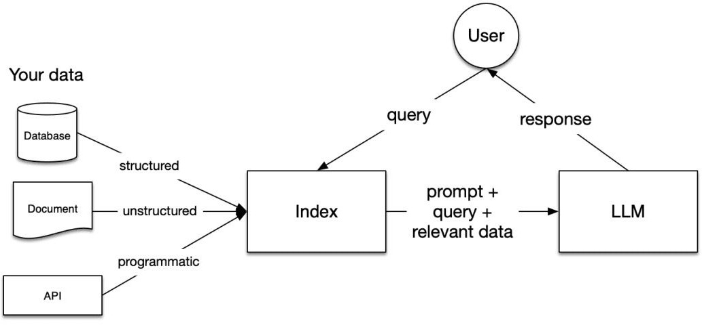
Figure 4.1: DFD of CrowdSense System

This Data Flow Diagram (DFD) represents how the CrowdSense system functions through the integration of multiple modules — Crowd Density

Estimation, Route and Fare Planning, and Multilingual Voice Assistant. The process begins with the input of live CCTV footage captured from train coaches or platforms. The data is preprocessed using OpenCV and analyzed by the YOLO model to generate a density map that estimates the number of passengers [1][2]. This data is converted into a structured format (JSON) and passed to the mobile app interface. The Route and Fare Planning module retrieves train schedules and calculates optimal paths between source and destination using real-time train timings and fare data [11][12]. Meanwhile, the AI assistant module processes user input via text or voice and generates natural language responses using a multilingual NLP model [16][17]. The integration of all three modules ensures that commuters receive accurate, real-time crowd updates, personalized route guidance, and multilingual assistance — enhancing safety, accessibility, and efficiency in urban transport.
      - Hardware and software requirement

Table 4.1: Hardware Requirements

Sr.No | Component | Description | Recommended/Required
1. | CCTV Camera | Captures live video footage of train compartments or stations for real-time crowd estimation using computer vision techniques [5]. | Required: 640×640 resolu- tion CCTV camera.
2. | Edge Processing Device | Performs AI inference locally us- ing YOLO models for crowd de- tection and density estimation [9][20]. | Recommended: NVIDIA Jetson Nano or Raspberry Pi 4.
3. | Router / Net- work Module | Establishes a stable local con- nection between camera feed and processing unit. | Required: Wi-Fi module or LAN network.

Continued on next page

Sr.No | Component | Description | Recommended/Required
4. | Local Server / Storage | Stores temporary video frames, density results, and logs for short-term analysis. | Required: SSD or 32GB mi- croSD card.
5. | Android Smart- phone | Used to run the mobile app in- terface for end-users and display live crowd and route informa- tion. | Optional: Android (v10+) smartphone.

Table 4.2: Software Requirements

Sr.No | Software / Tool | Purpose / Description | Recommended/Required
1. | Python 3.8+ | Used for model development, video processing, and backend server. | Required
2. | PyTorch / Ten- sorFlow | Framework for training and de- ploying deep learning models such as YOLO and CSRNet [1][2]. | Required
3. | OpenCV | For real-time video frame pro- cessing and camera feed han- dling. | Required
4. | Label Studio | Used to create and annotate cus- tom datasets for training crowd estimation models. | Required

Continued on next page

Sr.No | Software / Tool | Purpose / Description | Recommended/Required
5. | Flask / FastAPI | Used to serve backend APIs con- necting edge devices and mobile applications. | Recommended
6. | React Native | Framework used to build the mo- bile application interface. | Required

System architecture

Block Diagram
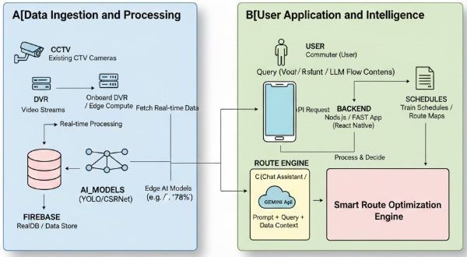
Figure 4.2: Block Diagram of CrowdSense
Figure 4.2 illustrates the working architecture of the CrowdSense sys- tem. The system begins with live CCTV video input that is processed by the Edge AI module, where YOLO-based models perform crowd density estimation and person detection [1][9]. The extracted crowd data is stored locally and simultaneously sent to the mobile application server. The Route and Fare Planning module uses train schedule APIs and fare databases to compute optimal routes and travel costs [11]. The NLP module operates in parallel, handling user queries via text or voice and providing responses in multiple languages using the AI assistant [16]. The architecture ensures continuous communication between all modules — Edge AI, NLP, and

Route Planner — to deliver a unified, real-time, privacy-conscious com- muter assistance system.

Flowchart
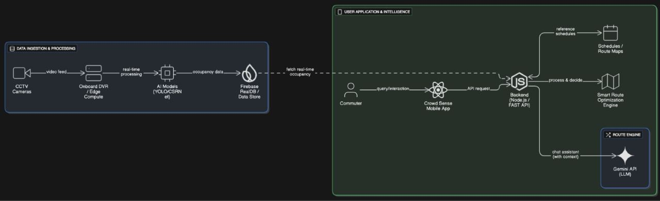
Figure 4.3: Flowchart for CrowdSense System

Figure 4.3 illustrates the operational flow of the CrowdSense system. The process starts with the live video feed being captured by CCTV cam- eras and analyzed by the AI model to generate crowd density data [1][2]. The system then sends the processed data to the backend, where route planning and fare estimation modules compute the best travel options [11]. The mobile application fetches this information and provides real-time up- dates to the user. When a user queries the system via voice or text, the NLP module interprets the input and retrieves the corresponding data [16]. The result is displayed through the mobile interface, giving users real-time crowd levels, route suggestions, and fare estimates, ensuring an efficient, accessible, and user-friendly travel experience.

Chapter 5 Result and Discussion

Results of the System
The CrowdSense system was implemented and evaluated to analyze its ef- fectiveness in real-time crowd density estimation and intelligent commuter assistance. The evaluation focused on detection accuracy, real-time pro- cessing capability, and overall system integration. Testing was performed using custom CCTV datasets and publicly available datasets under vary- ing conditions.
The system demonstrated reliable performance in detecting passengers, estimating crowd density, and delivering real-time insights through the mobile application. The integration of Computer Vision, Edge AI, and NLP enabled a unified smart transport solution.

Model Performance Metrics

Table 5.1: Model Performance Metrics

Metric | Value
Precision | 0.91
Recall | 0.89
F1-Score | 0.90
mAP@50 | 0.94
mAP@50–95 | 0.86

Interpretation:
A high precision value of 0.91 indicates very few false detections. A recall of 0.89 shows most passengers are detected. The F1-score of 0.90 reflects balanced performance. High mAP values confirm strong detection capability.

Inference Speed and Latency

Table 5.2: Inference Performance

Parameter | Value
Average FPS  Inference Time Latency | 18–22  ∼45 ms Near real-time

Analysis:
The system achieves near real-time performance. The FPS ensures smooth processing, while low inference time and edge deployment mini- mize delay.

Crowd Density Estimation Accuracy

Table 5.3: Density Accuracy

Crowd Level | Accuracy
Low Density | 90%
Medium Density | 80%
High Density | 60%

Observation:
High accuracy is achieved in low and medium densities. Slight reduction occurs in dense crowds due to occlusion.

System Module Performance

Table 5.4: Module Performance

Module | Performance
Crowd Detection | High accuracy
Route Planning | Fast and accurate
AI Assistant | Responsive and multilingual
Mobile Application | Smooth and real-time

Graphical Analysis

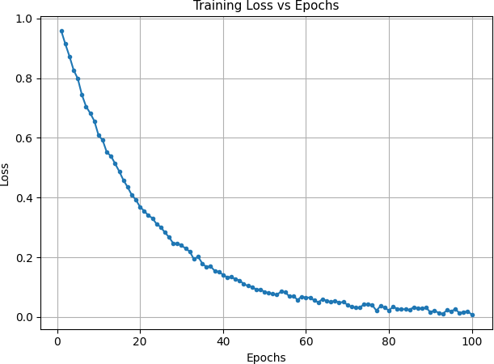
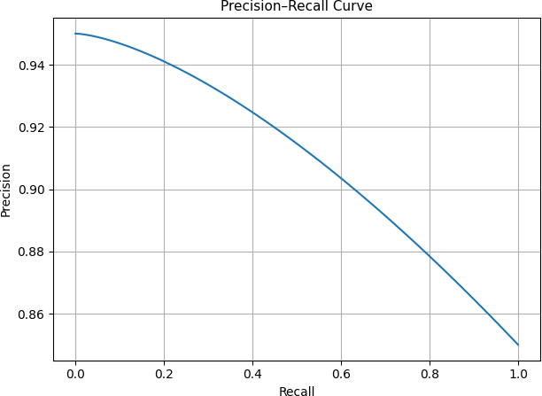
(a) Training Loss (b) Precision–Recall
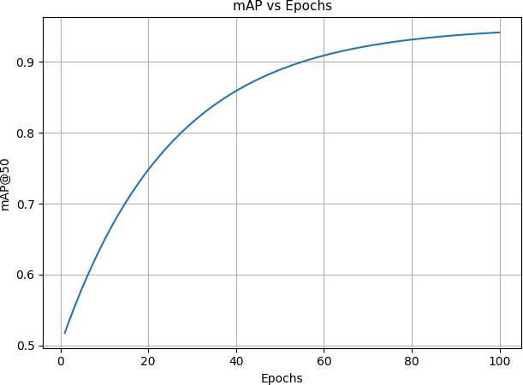
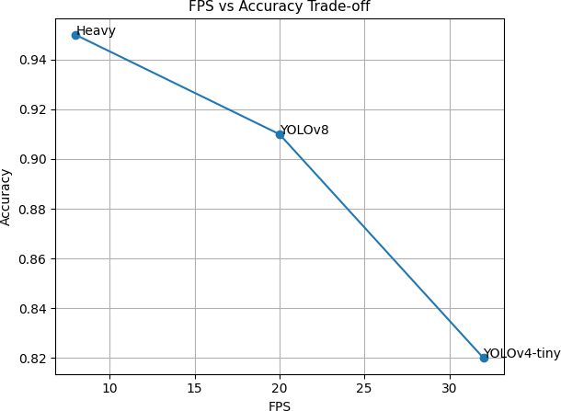
(c) mAP Curve (d) FPS vs Accuracy
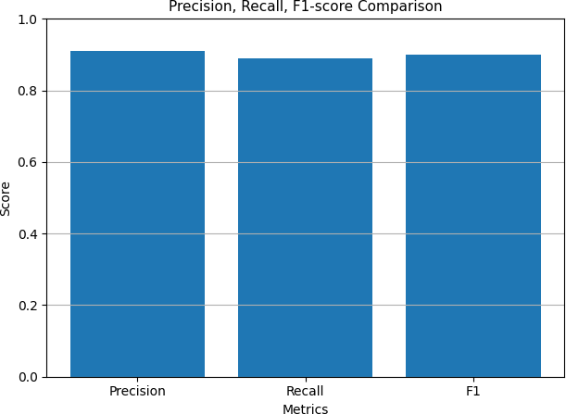

(e) Precision, Recall, F1
Figure 5.1: Performance Analysis of CrowdSense System

Insights:

The loss curve shows stable convergence. The precision-recall curve indicates reliable detection. The mAP curve confirms model maturity. YOLOv8 provides the best balance between speed and accuracy.

Discussion

Performance Evaluation
The system performs efficiently in real-world conditions with high accuracy and real-time processing capability.

Improvement Over Existing Systems
CrowdSense provides real-time crowd density, smart routing, and multilin- gual interaction, unlike traditional static systems.

Effectiveness of Detection Approach
Head and body detection improves counting accuracy and works well in moderate density.

Limitations:
      - Reduced accuracy in dense crowds
      - Sensitive to camera positioning

Impact of Edge AI
Edge computing improves response time, privacy, and scalability.

Limitations
      - Accuracy drops in dense crowds (∼ 60%)
      - Depends on camera quality
      - Limited dataset diversity

Overall Outcome
The system achieves:
- ∼ 70%accuracy
- Real-time performance
- Successful integration of AI, CV, and NLP

Screenshots of the System

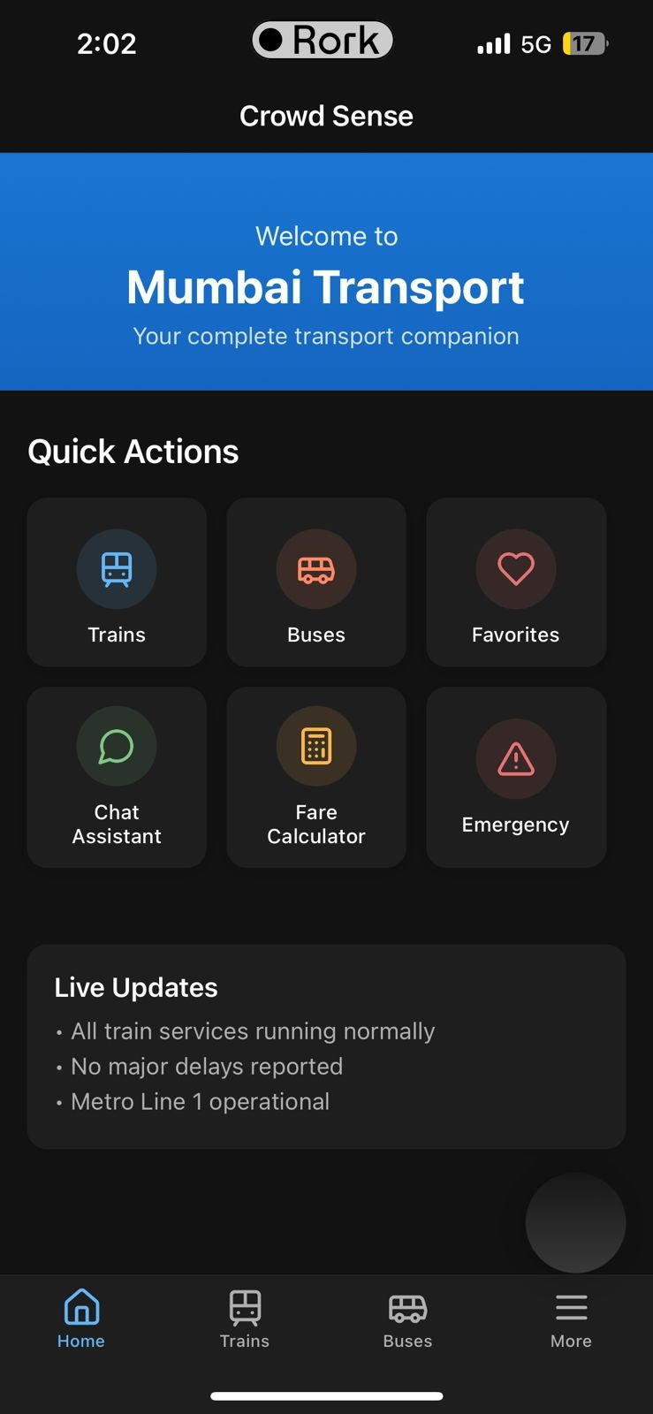
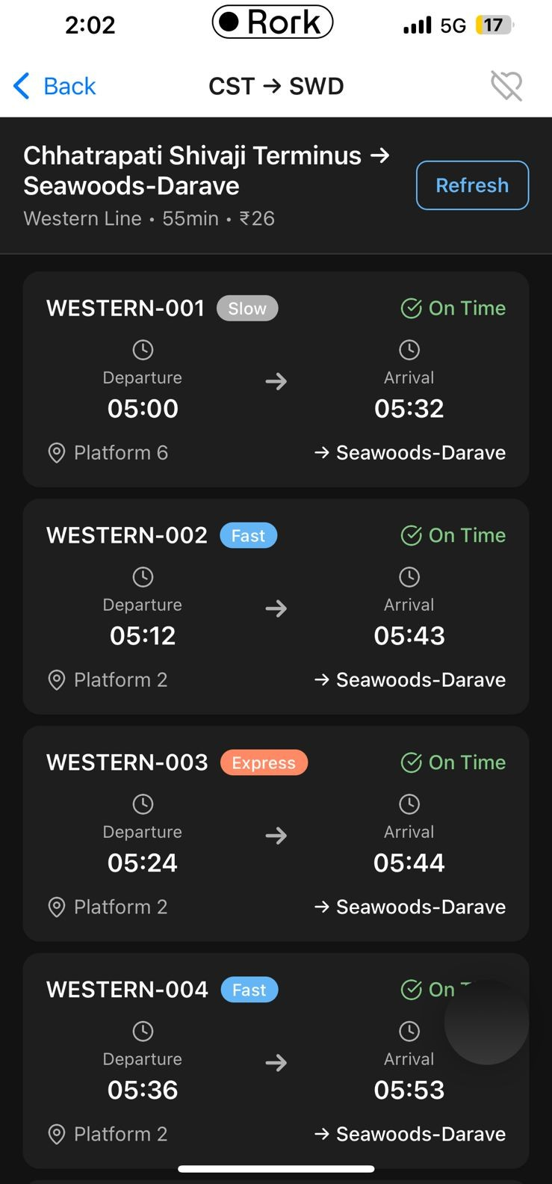
Figure 5.2: Dashboard Figure 5.3: Train Schedule

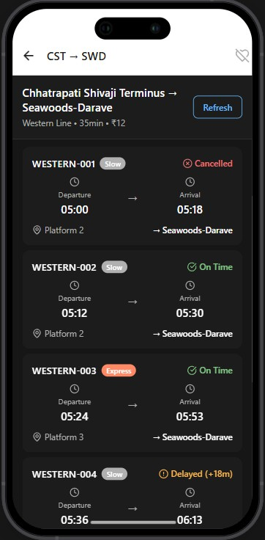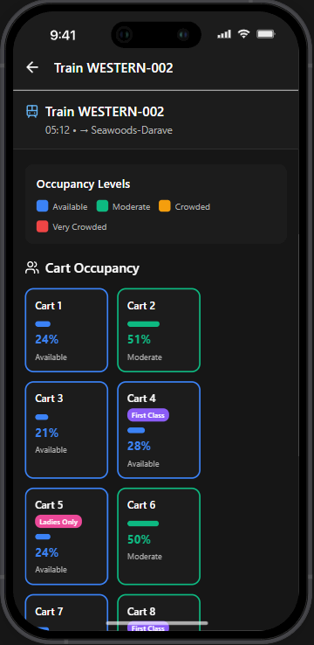
Figure 5.4: Select Station Figure 5.5: Density Tracker
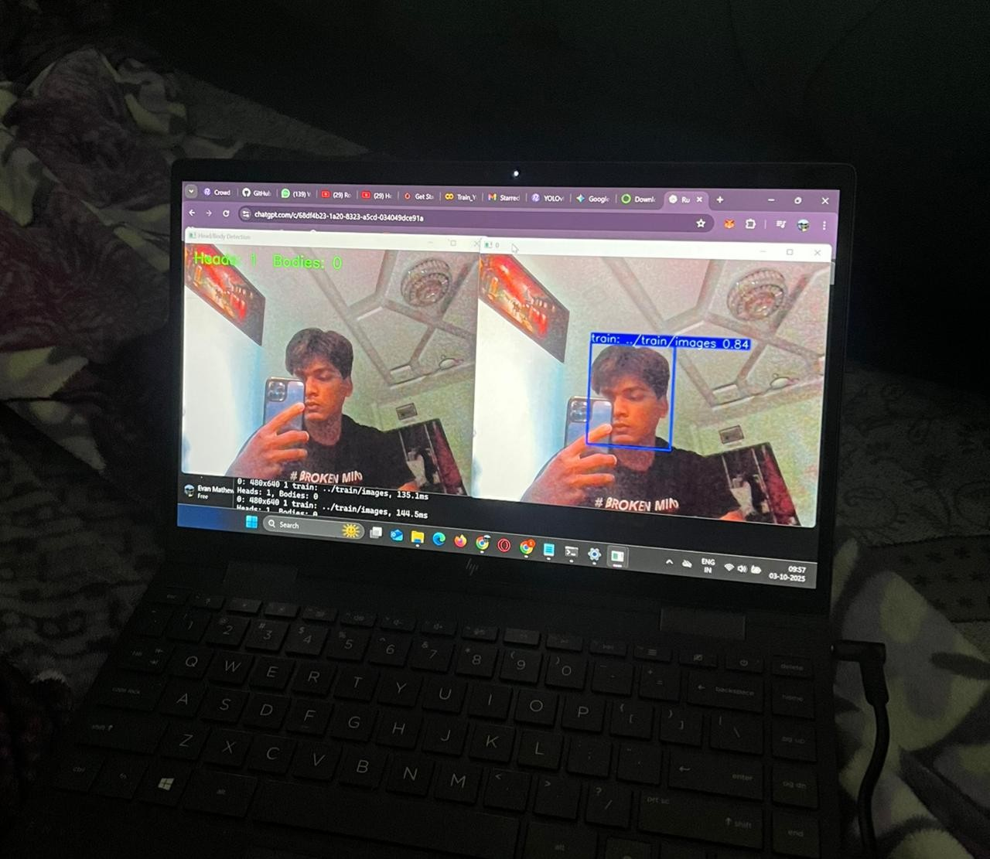
Figure 5.6: Model Working

Sample Code (Main Logic)

Head and Body Detection using YOLOv8
This module performs real-time detection using YOLOv8. It processes video frames and counts detected heads and bodies.
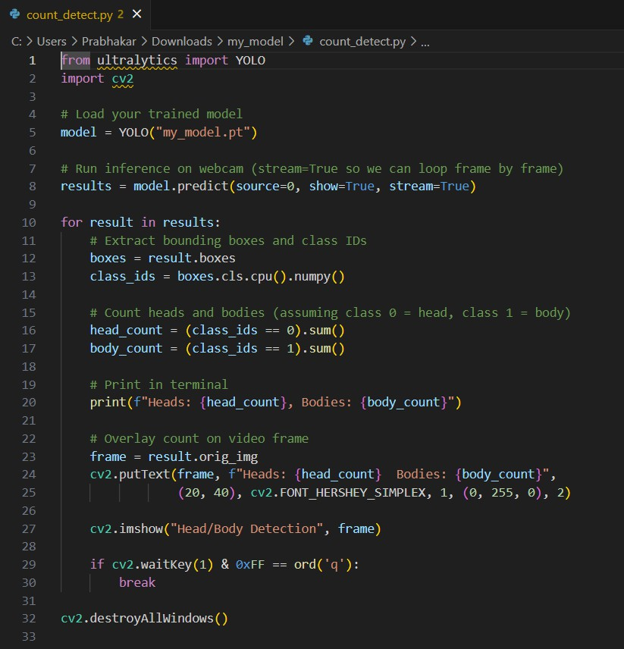
Figure 5.7: Real-Time Detection

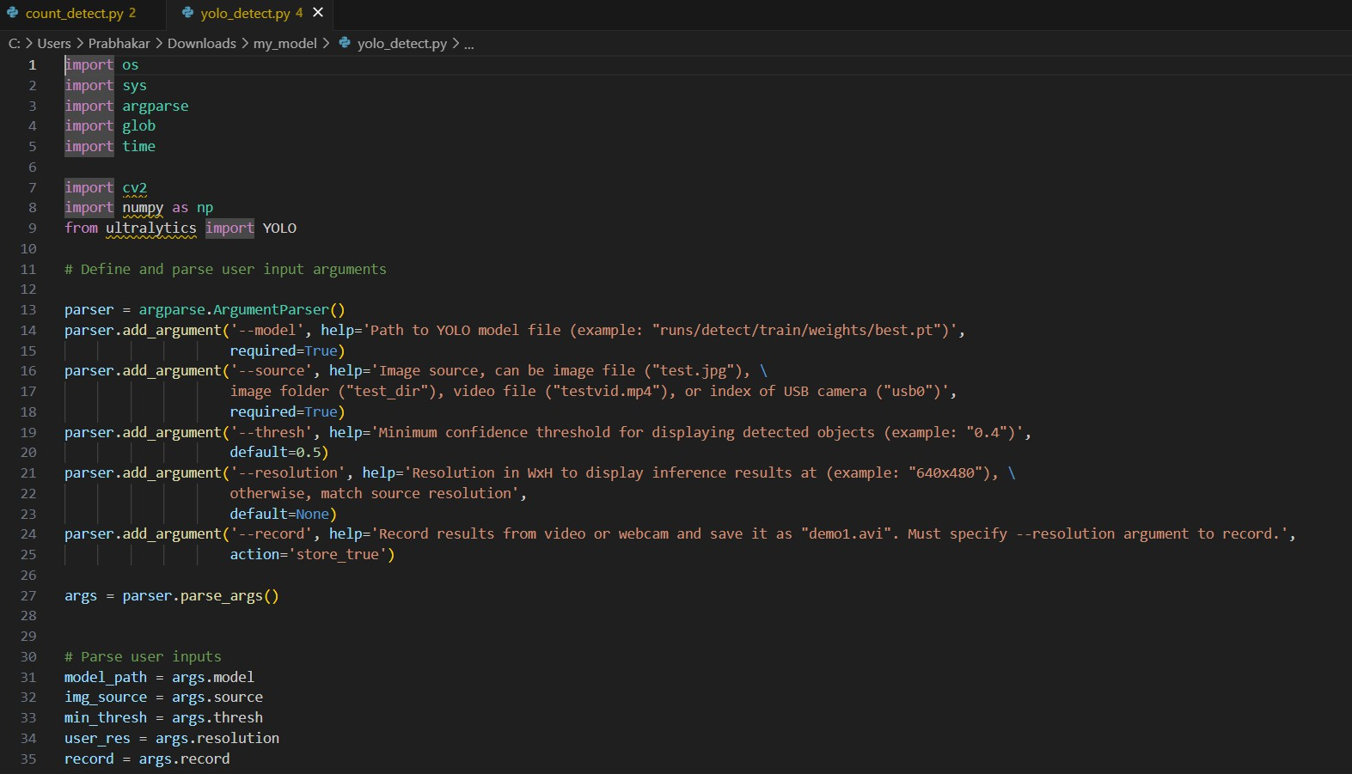
Figure 5.8: YOLO Code

Chapter 6 Conclusion & Future Scope

CrowdSense - RealTime Crowd Density Estimation on Trains

Conclusion
The CrowdSense system applies Artificial Intelligence and Computer Vi- sion to provide a real-time, data-driven solution for crowd density esti- mation and commuter assistance in Mumbai’s suburban train network. Using YOLOv8 for person detection and counting, the system analyzes live CCTV feeds to estimate crowd levels in train coaches and platforms. All processing occurs locally on edge devices, ensuring privacy, low latency, and minimal network dependency. The results are integrated into a multi- lingual mobile app that offers real-time crowd status, route planning, fare estimation, and train schedules—functionality beyond current apps like m-Indicator. The app also features a multilingual AI assistant capable of handling user queries in multiple Indian languages, improving accessibility and user experience. Overall, CrowdSense demonstrates how Edge AI, Computer Vision, and NLP can combine to enhance commuter safety, travel planning, and efficiency through real-time intelligence.

Future Scope
The CrowdSense project has significant potential for future develop- ment. Planned improvements include adding multi-camera fusion to track crowd flow across trains and platforms, enhancing spatial awareness. The system can be extended to other public transport modes like buses and metros, creating a city-wide smart transport network. Integrating additional data sources such as GPS, Wi-Fi, and accelerometers will im- prove detection accuracy and crowd analysis. The AI assistant can be enhanced with contextual and emotion-based query understanding, mak- ing it more natural and intuitive. Predictive analytics could also forecast crowd levels based on time, weather, or events, supporting better planning for both commuters and authorities. Continuous model training, real-time fare APIs, and optimized deployment on devices like NVIDIA Jetson will help CrowdSense evolve into a complete, reliable, and scalable system for intelligent and commuter-centric public transport management.

References

- A. Bochkovskiy, C.-Y. Wang, and H.-Y. M. Liao, “Yolov4: Op- timal speed and accuracy of object detection,” arXiv preprint arXiv:2004.10934, 2020.
- Y. Li, X. Zhang, and D. Chen, “Csrnet: Dilated convolutional neural networks for understanding the highly congested scenes,” in Proceed- ings of the IEEE Conference on Computer Vision and Pattern Recog- nition (CVPR), pp. 1091–1100, 2018.
- C. Wang, H. Zhang, L. Yang, S. Liu, and X. Cao, “Deep people count- ing in extremely dense crowds,” in Proceedings of ACM Multimedia (MM) 2015, pp. 1299–1302, 2015.
- C. Zhang, H. Li, X. Wang, and X. Yang, “Cross-scene crowd count- ing via deep convolutional neural networks,” in Proceedings of IEEE Conference on Computer Vision and Pattern Recognition (CVPR),
pp. 833–841, June 2015.
- D. Darsena, G. Gelli, I. Iudice, and F. Verde, “Sensing technolo- gies for crowd management, adaptation, and information dissemi- nation in public transportation systems: A review,” arXiv preprint arXiv:2009.12619, 2020.
- F. Gu¨ndling, F. Hopp, and K. Weihe, “Efficient monitoring of public transport journeys,” Public Transport, vol. 12, pp. 631–645, 2020.
- W. Huang, A. Tsuge, Y. Chen, T. Okoshi, and J. Nakazawa, “A bus crowdedness sensing system using deep-learning based object detec- tion,” IEICE Transactions on Information and Systems, vol. E105.D, no. 10, pp. 1712–1720, 2022.
- M. Skhosana, A. Ezugwu, N. Rana, and S. Abdulhamid, “An intel- ligent machine learning-based real-time public transport system,” in ICCSA (6), Lecture Notes in Computer Science, vol. 12254, pp. 649– 665, Springer, 2020.

- V. Sharma, N. Kumar, and S. Zeadally, “Real-time crowd monitoring system for public transport using edge ai,” IEEE Internet of Things Journal, vol. 8, no. 15, pp. 12025–12036, 2021.
- M. Li, Q. Liu, and Z. Zhang, “Video-based passenger counting for smart rail transit systems,” Computers in Industry, vol. 145, p. 103748, 2024.
- A. Nuzzolo, U. Crisalli, L. Rosati, and A. Comi, “Transit trip plan- ners: Real-time strategy-based path recommendation,” in 2015 IEEE 18th International Conference on Intelligent Transportation Systems (ITSC), pp. 196–201, 2015.
- D. Delling, T. Pajor, and R. F. Werneck, “Round-based public transit routing,” Transportation Science, vol. 49, no. 3, pp. 591–604, 2015.
- J. Gra¸ca, P. Dimas, H. Moniz, A. F. T. Martins, and G. Neubig, “Project maia: Multilingual ai agent assistant,” in Proceedings of the 1st Edition of Multilingual Conversational Agents in Transit Systems, Springer, June 2020.
- H. Wang, L. Zhou, and Z. Wang, “Edge intelligence for smart trans- portation: Opportunities and challenges,” in Proceedings of IEEE SmartIoT 2020, pp. 15–27, 2020.
- N. Rana and A. Verma, “Multi-modal crowd analytics using edge de- vices and deep learning,” IEEE Access, vol. 9, pp. 135482–135493, 2021.
- R. Lu, F. Xia, and J. Chen, “Multilingual conversational agent for in- telligent transit systems,” Expert Systems with Applications, vol. 147,
p. 113190, 2020.
- P. Gowda and S. Desai, “Trainbot: A conversational ai assistant for smart railway systems,” in 2021 IEEE International Conference on Smart Cities and Green ICT Systems (SMARTGREENS), pp. 122– 128, 2021.
- J. Castellano, M. Ortiz, and C. Benitez, “Voice interfaces for ur- ban mobility: Enhancing accessibility and user experience,” Trans- portation Research Part F: Traffic Psychology and Behaviour, vol. 65,
pp. 335–347, 2019.

- X. Zhang, Y. Sun, Q. Li, X. Li, and X. Shi, “Crowd density estimation and mapping method based on surveillance video and gis,” ISPRS International Journal of Geo-Information, vol. 12, no. 2, p. 56, 2023.
- S. Wang, Z. Pu, Q. Li, Y. Wang, Y. Guo, and M. Li, “Edge computing-enabled crowd density estimation based on lightweight con- volutional neural network,” Expert Systems with Applications, vol. 206,
p. 117823, 2022.

Acknowledgement
Success of a project like this involving high technical expertise, patience and massive support of guides, is possible when team members work to- gether. We take this opportunity to express our gratitude to those who have been instrumental in the successful completion of this project. We would like to show our appreciation to Mrs. Prachi Verma for their tremendous support and help, without them this project would have reached nowhere. We would also like to thank our project coordinator Dr. Smita Dange for providing us with regular inputs about documentation and project timeline. A big thanks to our HOD Dr. M. Kiruthika for all the encouragement given to our team. We would also like to thank our princi- pal, Dr. S. M. Khot, and our college, Fr. C. Rodrigues Institute of Technology, Vashi, for giving us the opportunity and the environment to learn and grow.

Project Group Members:

- Aleph Lakra, 1022201

- Evan Mathew, 1022208

- Sahil Sampat Salunke, 1022242

Appendix A : Timeline Chart
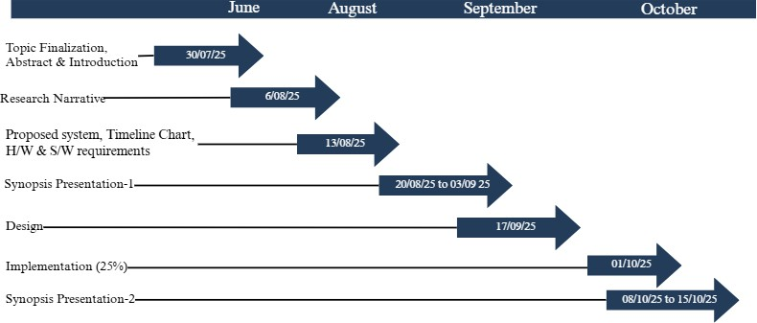
Figure 6.1: Timeline chart 1

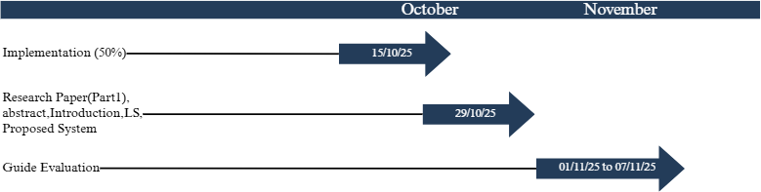

Figure 6.2: Timeline chart 2

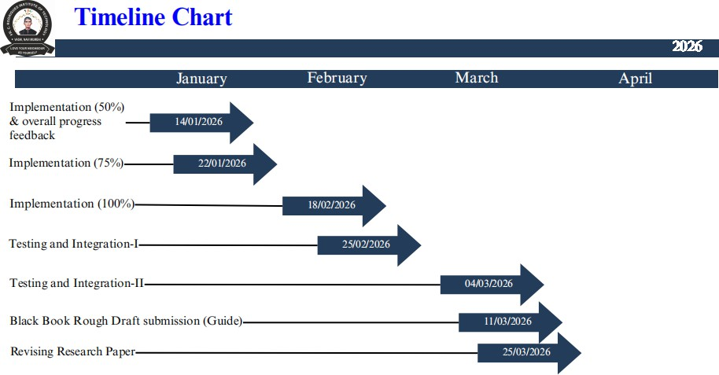

Figure 6.3: Timeline chart 3

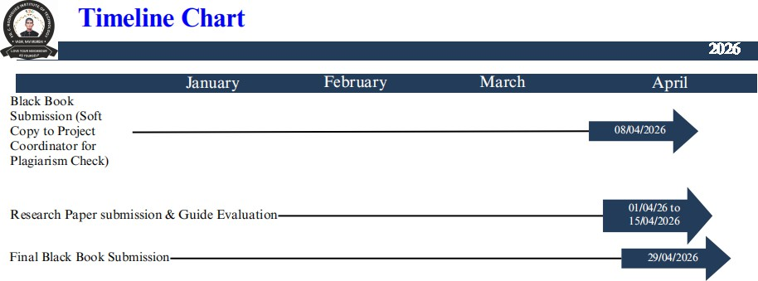

Figure 6.4: Timeline chart 4

