The Structural and Electrical Properties of Carboxymethyl cellulose – Chitosan Composite Films

ABSTRACT
Carboxymethyl cellulose (CMC) is a polysaccharide polymer derived from plant fibrous tissues, while chitosan (CS) is a biopolymer obtained from chitin present in the exoskeletons of crustaceans and insects, as well as fungal cell walls. This study focuses on the synthesis and characterization of CMC, CS, and their composite films (CMC–CS), with emphasis on how material integration influences structural and electrical properties. The films were fabricated using a solution casting technique followed by a triple-cycle freeze-thaw process to enhance structural stability and reduce solubility. Fourier Transform Infrared (FTIR) analysis confirmed successful interaction between the polymers, evidenced by a peak shift to 3346 cm⁻¹ for the CMC-CS composite, indicating strong intermolecular hydrogen bonding between hydroxyl (OH) and amino (NH₂) groups. Additionally, the merging of peaks at 1560 cm⁻¹ suggests electrostatic attraction between the anionic carboxylate groups of CMC and the cationic amino groups of CS. This interactions contribute to improved compatibility and structural integrity of the composite films. Electrical characterization demonstrated that the CMC-CS composite films exhibited the highest electrical conductivity, with conductivity increasing linearly as a function of applied current. In contrast, pure CMC showed the highest resistivity. The enhanced electrical performance of the composite is attributed to synergistic interaction between CMC and CS, which facilitate more efficient charge transport pathways. Overall, the findings indicate that CMC–CS composite films possess promising potential for applications in conductive biopolymer systems, particularly in environmentally friendly and flexible electronic materials.
Keywords: Carboxymethyl cellulose (CMC), chitosan (CS), CMC-CS composite, freeze-thaw process, conductivity

INTRODUCTION
Carboxymethyl cellulose (CMC) known as polysaccharide polymer made of plant fibrous tissues. The properties that are contained in CMC are soluble in water, able in forming film, biocompatible, non-toxic, and many carbon functional groups (Akhlaq et al.,2023). The addition of the carboxymethyl group (CH₂COONA) into the cellulose molecule is the main reason for the production of CMC (Yildirim-Yalcin et al., 2022). Zhao et al (2022) stated CMC also had many active-oxygen containing groups which are carboxyl (C=O) and hydroxyl (OH) that made easier modification when combined with other materials. Beghetto et al (2026) has mentioned CMC can be obtained by etherification of alkali-catalyzed with ethylene oxide and chloroacetic acid. Chitosan (CS) is a biopolymer which is derived from chitin and can be found in crustacean’s exoskeleton such as crab, shrimp, and lobster, insects, and fungi cell walls (Khubiev et al., 2023). CS also can be obtained by partial chitin deacetylation which is made the N-acetyl-glucosamine and D-glucosamine biopolymer (Kumar et al., 2020). Barik et al (2024) mentioned CS had various properties such as biodegradable, biocompatible, non-toxic, hydrophobic that is insoluble in aqueous and organic solvents but soluble in organic and inorganic acids due to the presence of OH groups and reactive amino (NH₂) groups that made solubility of water low. The ability of CS in forming the film was also discovered by previous studies (Zehra et al., 2020 & Kaczmarek-Szczepanska et al., 2025).
The synthesis of carboxymethyl cellulose–chitosan (CMC–CS) composites has been widely reported due to their enhanced structural and functional properties. Previous studies have shown that combining CMC and CS leads to the formation of improved network structures, resulting in greater stability of the composite material (Nguyen et al., 2026). This observation is supported by He et al. (2015), who highlighted that the integration of CMC and CS is an effective approach for strengthening polymer structures. The compatibility between these materials is attributed to their structural similarity, which promotes strong intermolecular interactions. This is further evidenced by the formation of a homogeneous and stable interface without visible phase separation, cracking, or shrinkage when CMC and CS are blended in solution (Li et al., 2023). In addition to structural compatibility, the formation of CMC–CS composites is driven by electrostatic interactions between oppositely charged functional groups. CMC is a naturally occurring anionic polymer due to its carboxylate (–COO⁻) groups, while CS is a cationic polymer containing amino (–NH₂) groups (Muñoz-Tebar et al., 2023). The electrostatic attraction between these functional groups plays a crucial role in maintaining the integrity and stability of the composite structure (Altam et al., 2022; López-Manzanara Pérez et al., 2023). Therefore, this paper aims to describe the preparation of CMC, CS, and CMC–CS composite films, as well as to investigate their structural and electrical properties.

METHODOLOGY

Preparation of CMC film
The preparation of the CMC film was carried out using a solution casting method. First, 4 g of sodium carboxymethyl cellulose was dissolved in 200 ml of distilled water, followed by the addition of 1.2 g of glycerol. This mixture was stirred and heated at 90°C for 20 minutes until homogeneous and transparent solution was obtained as shown in Figure 1(a). Subsequently, 0.75 ml of 1.0 M acid sulphuric was added to the solution under continuous stirring. A glass substrate was then dip-coated in the prepared solution to form a hydrogel layer. The resulting hydrogel was subjected to three freeze-thaw cycles, each consisting of freezing at -17°C for 8 hours followed by thawing at room temperature to Afterward, the hydrogel was rinsed with deionized water to remove any residual acid. Finally, the film was dried at room temperature for two days to obtain an insoluble CMC film.

Preparation of CS film
Briefly, 1 g of CS was dissolved in 100 ml of a 1% (v/v) acetic acid solution and stirred at 80°C for 40 minutes until homogeneous solution was obtained as shown in Figure 1(b). Glycerol was then added as a plasticizer and the mixture was further stirred for an additional hour to ensure uniform dispersion. A clean substrate was subsequently dip-coated in the prepared solution to form a CS hydrogel layer. The resulting hydrogel underwent three freeze-thaw cycles comprising 8 hours of freezing at -17°C and 3 hours of thawing at room temperature to achieve structural stability. Afterward, the hydrogel was rinsed in deionized water to remove any residual acid. Finally, the material was dried at room temperature for two days, yielding a stable and insoluble CS film.

Preparation of CMC-CS film
Preparation of CMC-CS film was synthesized by dissolving 1 g of CS in 100 ml of 1% (v/v) acetic acid and 1 g of carboxymethyl cellulose in 100 ml of distilled water. The CMC solution was then added dropwise into the CS solution and stirred at 80°C for 30 minutes, followed by the addition of glycerol as a plasticizer and an additional hour of stirring. Figure 1 © shows the solution of CMS-CS film. Glass substrates were dip-coated in the resulting mixture to form hydrogels, which were then stabilized through three freeze-thaw cycles comprising 8 hours of freezing at -17°C and 3 hours of thawing at room temperature. To remove any residual acid, the hydrogels were immersed in deionized water three times for 5 minutes each before being dried at room temperature for two days to obtain an insoluble CMC-CS film.

Figure 1. Solution of (a) CMC, (b) CS, and (c) CMC-CS Films
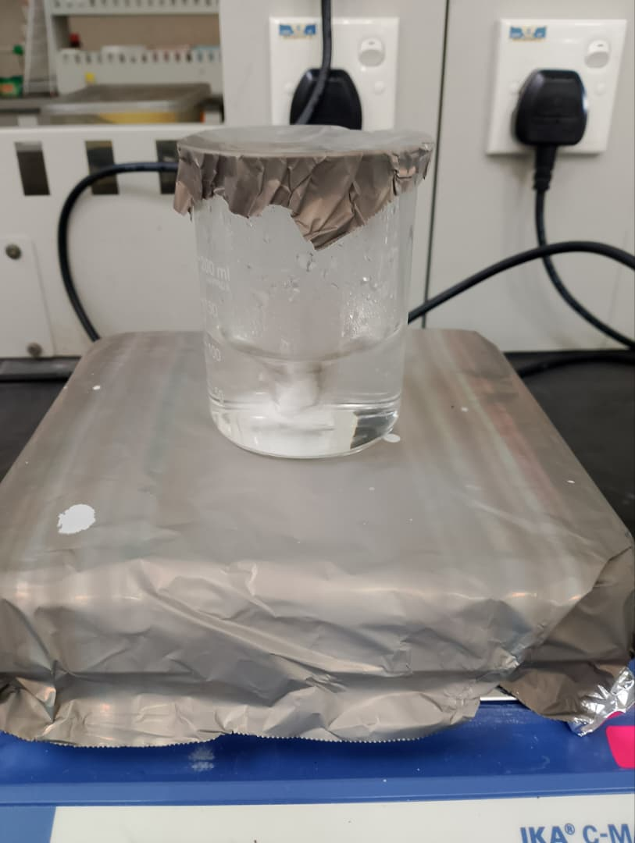 | 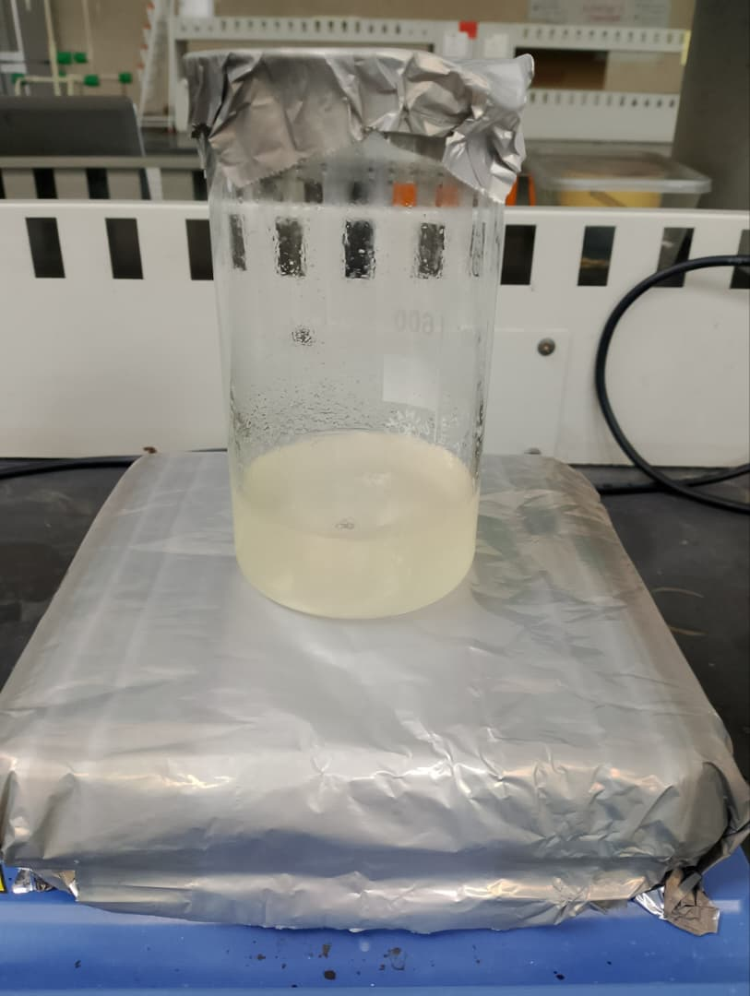 | 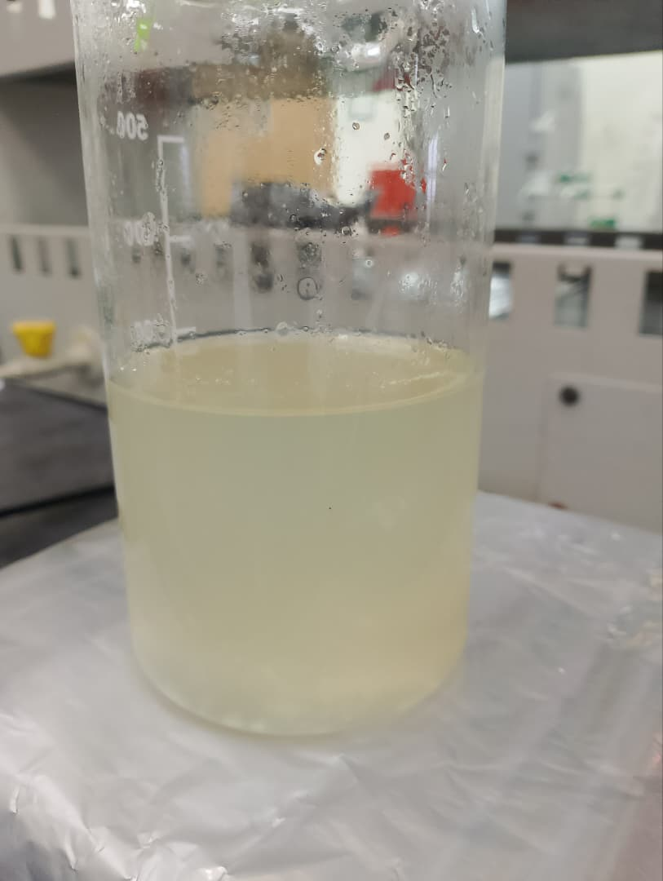
(a) | (b) | (c)

RESULTS AND DISCUSSIONS

Structural Properties
FTIR analysis of CMC, CS, and CMC-CS films have been identified by observing Figure 2. All three samples have shown a deep "valley" centered peak around 3300 to 3400 cm⁻¹ which are 3376 cm⁻¹ for CMC, 3368 cm⁻¹ for CS, and 3346 cm⁻¹ for CMC-CS. Next, the small peaks were appearing around 2850 to 2950 cm⁻¹ for all three materials. Around 1400 to 1650 cm⁻¹, CMC showed a sharp peak near to 1602 cm⁻¹, CS displayed a distinct peak at 1585 cm⁻¹, and CMC-CS indicated the merging or shifting peaks at 1560 cm⁻¹. There are the strongest peaks that have been detected and located near 1030 to 1060 cm⁻¹.
The appearance of deep "valley" peaks represented between the stretching vibration of OH and NH. Wang et al (2021) has reported there was a broad peak appeared in CMC around 3600 to 3200 cm⁻¹ which is at 3270 cm⁻¹ that assigned as stretching vibration of OH. The intermolecular and intramolecular of hydrogen bonding also present (Priyadarshi et al., 2021). CS also showed the broad peak around 3400 to 3100 cm⁻¹ at 3279 cm-¹ which indicated the OH and NH stretching vibration (Riccardo., 2024). Yu et al (2025) mentioned CMC-CS had a broad and intense peak due to containing both OH and NH groups that intermolecular hydrogen bonding occurred. Therefore, the interaction of physical hydrogen bonding became stronger. The peaks located 2850 to 2950 cm⁻¹ represented the stretching vibration of CH in all sample materials (Frick et al., 2017, Lombo Vidal et al., 2020 & Putranti & Nugraheni, 2023). These CH groups came from methyl groups in carboxymethyl side chains of CMC and from any residual acetyl units of CS.
Other than that, the sharp peak of CMC and distinct peak of CS have denoted the appearance of carboxylate (-COO) group and bending of the NH group by the studies of Qin et al (2023) and Stanicka et al (2021). The interaction between negative charge -COO of CMC and positive charge NH of CS has created a polyelectrolyte complex by electrostatic attraction both polymers is a reason of shift wavenumber for CMC-CS. This statement has been proved by the study of Gonzalez et al (2025). The appearance of strongest peaks has been assigned as the presence of C-O-C stretching (Abdulhameed et al., 2019, Tangthuam et al., 2020, Abdou et al., 2024 & Saadi et al., 2025) which the peaks showed maintain in sharp, prominent in composite, and remain intact both CMC and CS.

Figure 2. FTIR Analysis of CMC, CS, and CMC-CS Films
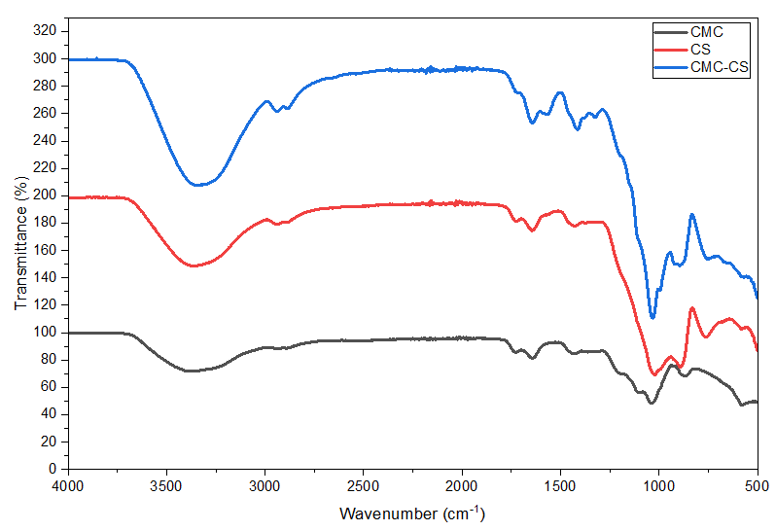

Electrical properties
Resistivity and electrical conductivity of CMC, CS, and CMC-CS films have been determined with applied current of 100, 200, 300, 400, and 500 nA. For resistivity, all sample materials were shown the decreasing pattern according to the increasing current applied as shown in Figure 3. CMC film exhibited the higher resistivity compared to the CS film while CMC-CS had the lowest of resistivity. Meanwhile, Figure 4 shows the electrical conductivity of CMC, CS and CMC-CS composite films. The electrical conductivity represented inversely proportional to the resistivity. The pattern of electrical conductivity increased linearly by enhancing the current. CMC-CS was obtained the highest of electrical conductivity while CMC is lower compared to CS. The value of electrical conductivity was indicated reciprocal or inversely proportional to the value of resistivity (Ali Elgheryani, 2024).
Nasution et al (2018) stated CMC was restricted to the movement of electrons due to property of plasticizer that made less conductive meanwhile the bonding of hydrogen from amino groups and oxygen has formed hydrogen bonding which produced easier for electrons to move and generate the electrical conductivity. Therefore, CMC-CS was the highest electrical conductivity due to intermolecular interaction of hydrogen bonding which enhanced compatibility and led charge transfer became efficient. The formation of hydrogen bonds increased when more hydrophilic functional groups such as OH, COOH, and NH2 (Susi et al., 2025) contained in CMC-CS composite. CMC has combined with poly(Aniline) (PANi), poly(Pyrrole) (PPy), poly(Thiophene) (PTh) (Demirci et al., 2020 & Salem et al., 2023), chromium chloride (CrCl3) (A. Hameed & Hussein, 2024), and graphene nanoplatelet (Mergen & Arda, 2023) which are showed better electrical conductivity than pure CMC. This is because of energy barrier is low that made the charge carriers number to be higher (Alharbi et al., 2023). The previous studies have approved that combination of materials in increasing the electrical conductivity performance is an effective method.

Figure 3. Resistivity of CMC, CS, and CMC-CS Films
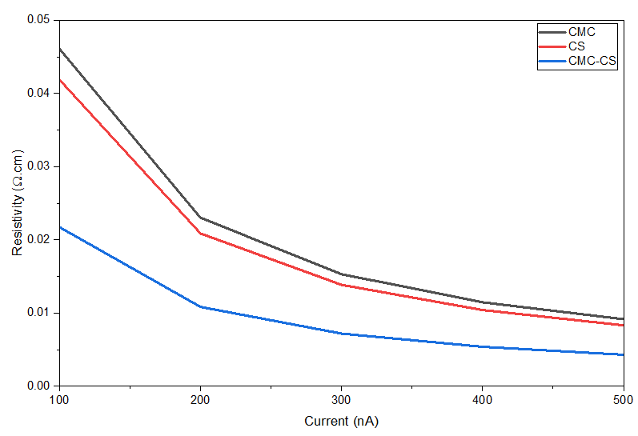
Figure 4. Electrical Conductivity of CMC, CS, and CMC-CS Films
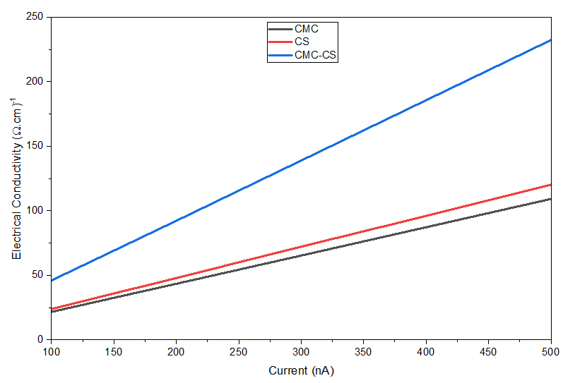

CONCLUSION
CMC, CS, and CMC-CS films was successfully achieved through a controlled freeze-thaw and drying process, resulting in stable and insoluble materials. Structural analysis via FTIR confirmed the presence of key functional groups, with all samples displaying deep "valley" peaks between 3300 and 3400 cm⁻¹ corresponding to OH and NH stretching vibrations. The successful formation of the CMC-CS polyelectrolyte complex was highlighted by the shifting of peaks to 1560 cm⁻¹, driven by the electrostatic attraction between the differently charged polymers. Regarding electrical performance, the CMC-CS composite demonstrated superior properties, achieving the highest electrical conductivity compared to pure CMC and CS films. Experimental data showed that as the applied current increased from 100 to 500 nA, the resistivity of all films decreased, while electrical conductivity increased linearly. Ultimately, the integration of CMC and CS proved to be an effective method for strengthening film structure and enhancing electrical performance due to improved intermolecular hydrogen bonding and efficient charge transfer.

ACKNOWLEDGEMENT

The authors would like to thank Faculty Science and Technology, Universiti Sains Islam Malaysia (USIM) for guidance and providing the facilities for the research work.

REFERENCES
- A. Hameed, N., & Hussein, A. R. (2024). Electrical and Thermal Properties Enhancement of Carboxymethyl cellulose Composite Films Reinforced by Chromium Chloride. Journal of Electrical Systems (JES), 20, 872–876. https://journal.esrgroups.org/jes/article/view/4431/3267
- Abdou, Entesar, El-Hennawi, Heba, & Abdelzaher, K. (2024). Edible coloured printing paste for food packaging materials using carboxymethyl cellulose/chitosan nanoparticles composite as thickeners. Egyptian Journal of Chemistry, 67(9), 637–645. https://doi.org/10.21608/ejchem.2024.298956.9907
- Abdulhameed, A., Mbuvi, H. M., Changamu, E., & Maingi, F. (2019). Microwave synthesis of Carboxymethylcellulose (CMC) from Rice Husk. IOSR Journal of Applied Chemistry, 12(12), 33–42. https://doi.org/https://doi.org/10.9790/5736-1212013342
- Akhlaq, M., Mushtaq, U., Naz, S., & Uroos, M. (2023). Carboxymethyl cellulose-based materials as an alternative source for sustainable electrochemical devices: A Review. RSC Advances, 13(9), 5723–5743. https://doi.org/10.1039/d2ra08244f
- Alharbi, K., Alharbi, W., El-Morsy, M., Farea, M., & Menazea, A. (2023). Optical, thermal, and electrical characterization of polyvinyl pyrrolidone/carboxymethyl cellulose blend scattered by tungsten-trioxide nanoparticles. Polymers, 15(5), 1223. https://doi.org/10.3390/polym15051223
- Ali Elgheryani, N. (2024). Improving the flexibility, electrical conductivity and light absorption of carboxymethylcellulose and Polyvinyl Alcohol Solutions and thin films by the addition of different concentrations of citric a. مجلة العلوم الاساسية و التطبيقية, (18), 67–75. https://doi.org/10.36602/jsba.2024.18.67
- Altam, A. A., Zhu, L., Babiker, D., Yagoub, H., & Yang, S. (2022). Loading and releasing behavior of carboxymethyl cellulose and chitosan complex beads. Progress in Natural Science: Materials International, 32(6), 715–723. https://doi.org/10.1016/j.pnsc.2022.10.003
- Barik, M., BhagyaRaj, G. V. S., Dash, K. K., & Shams, R. (2024). A thorough evaluation of chitosan-based packaging film and coating for food product shelf-life extension. Journal of Agriculture and Food Research, 16, 101164. https://doi.org/10.1016/j.jafr.2024.101164
- Beghetto, V., Conca, S., & Santandrea, D. (2026). Carboxymethyl cellulose-based films for Sustainable Food Packaging: Modification strategies and structure–property relationships. Polymers, 18(5), 552. https://doi.org/10.3390/polym18050552
- Demirci, S., Sutekin, S. D., & Sahiner, N. (2020). Polymeric composites based on carboxymethyl cellulose Cryogel and conductive polymers: Synthesis and characterization. Journal of Composites Science, 4(2), 33. https://doi.org/10.3390/jcs4020033
- Frick, J. M., Ambrosi, A., Pollo, L. D., & Tessaro, I. C. (2017). Influence of glutaraldehyde crosslinking and alkaline post-treatment on the properties of chitosan-based films. Journal of Polymers and the Environment, 26(7), 2748–2757. https://doi.org/10.1007/s10924-017-1166-3
- Gonzalez, A., Ferrante, M., Gende, L., Alvarez, V. A., & Gonzalez, J. S. (2025). Polyelectrolyte complex-based chitosan/carboxymethylcellulose powdered microgels loaded with eco-friendly silver nanoparticles as innovative biomaterials for hemostasis treatments. Polysaccharides, 6(3), 84. https://doi.org/10.3390/polysaccharides6030084
- He, X., Xu, H., & Li, H. (2015). Cr(VI) removal from aqueous solution by chitosan/carboxylmethyl cellulose/silica hybrid membrane. World Journal of Engineering and Technology, 03(03), 234–240. https://doi.org/10.4236/wjet.2015.33c034
- Kaczmarek-Szczepańska, B., Glajc, P., & Zasada, L. (2025). Chitosan-based films with selected moisturizing additives. Engineering of Biomaterials, 09, 1–7. https://doi.org/https://doi.org/10.34821/eng.biomat.173.2025.09
- Khubiev, O. M., Egorov, A. R., Kirichuk, A. A., Khrustalev, V. N., Tskhovrebov, A. G., & Kritchenkov, A. S. (2023). Chitosan-based antibacterial films for biomedical and food applications. International Journal of Molecular Sciences, 24(13), 10738. https://doi.org/10.3390/ijms241310738
- Kumar, S., Mukherjee, A., & Dutta, J. (2020). Chitosan based nanocomposite films and coatings: Emerging Antimicrobial Food Packaging Alternatives. Trends in Food Science &amp; Technology, 97, 196–209. https://doi.org/10.1016/j.tifs.2020.01.002
- Li, L., Baig, M. I., de Vos, W. M., & Lindhoud, S. (2023). Preparation of sodium carboxymethyl cellulose–chitosan complex membranes through sustainable aqueous phase separation. ACS Applied Polymer Materials, 5(3), 1810–1818. https://doi.org/10.1021/acsapm.2c01901
- Lombo Vidal, O., Tsukui, A., Garrett, R., Miguez Rocha-Leão, M. H., Piler Carvalho, C. W., Pereira Freitas, S., Moraes de Rezende, C., & Simões Larraz Ferreira, M. (2020). Production of bioactive films of carboxymethyl cellulose enriched with green coffee oil and its residues. International Journal of Biological Macromolecules, 146, 730–738. https://doi.org/10.1016/j.ijbiomac.2019.10.123
- López-Manzanara Pérez, C., Torres-Pabón, N. S., Laguna, A., Torrado, G., de la Torre-Iglesias, P. M., Torrado-Santiago, S., & Torrado-Salmerón, C. (2023). Development of chitosan/sodium carboxymethylcellulose complexes to improve the simvastatin release rate: Polymer/polymer and drug/polymer interactions’ effects on kinetic models. Polymers, 15(20), 4184. https://doi.org/10.3390/polym15204184
- Mergen, Ö. B., & Arda, E. (2023). Determination of electrical and optical behaviors of carboxymethyl cellulose/graphene nanocomposites. Journal of Materials Science: Materials in Electronics, 34(24). https://doi.org/10.1007/s10854-023-11152-9
- Muñoz-Tebar, N., Pérez-Álvarez, J. A., Fernández-López, J., & Viuda-Martos, M. (2023). Chitosan edible films and coatings with added bioactive compounds: Antibacterial and antioxidant properties and their application to Food Products: A Review. Polymers, 15(2), 396. https://doi.org/10.3390/polym15020396
- Nasution, T. I., Balyan, M., & Nainggolan, I. (2018). Improved lifetime of chitosan film in converting water vapor to electrical power by adding carboxymethyl cellulose. IOP Conference Series: Materials Science and Engineering, 309, 012092. https://doi.org/10.1088/1757-899x/309/1/012092
- Nguyen, A. D., Nguyen, V. N., Tran, V. H., Dinh, H. H., Nguyen, D. S., Nguyen, T. H., Nguyen, V. B., & Wang, S. L. (2026). Chitosan/carboxymethyl cellulose nanocomposites prepared via electrolyte gelation–spray drying for controlled ampicillin delivery and enhanced antibacterial activity. Polymers, 18(3), 319. https://doi.org/10.3390/polym18030319
- Priyadarshi, R., Kim, S.-M., & Rhim, J.-W. (2021). Carboxymethyl cellulose-based multifunctional film combined with zinc oxide nanoparticles and grape seed extract for the preservation of high-fat meat products. Sustainable Materials and Technologies, 29. https://doi.org/10.1016/j.susmat.2021.e00325
- Putranti, L. N., & Nugraheni, P. S. (2023). Effect of carboxymethyl cellulose addition on the characteristic of chitosan-based bioplastic. IOP Conference Series: Earth and Environmental Science, 1289(1), 012038. https://doi.org/10.1088/1755-1315/1289/1/012038
- Qin, S., Sun, H., Wan, X., Wu, Y., Lin, X., Kan, H., Hou, D., Zheng, Z., He, X., & Liu, C. (2023). Carboxymethylcellulose reinforced starch films and rapid detection of spoiled beverages. Frontiers in Bioengineering and Biotechnology, 10. https://doi.org/10.3389/fbioe.2022.1099118
- Riccardo, T. (2024). Chitosan Film Formulations for Food Packaging: A Comparative Study of Acidic and Acid-Free Films. TESI MAGISTRALE IN FOOD ENGINEERING, 1–21. https://www.politesi.polimi.it/retrieve/74953da6-54a1-401f-af25-cbb2e51c06b3/2024_7_Toscani_Tesi.pdf
- Saadi, M., Erouel, M., Tall, A., Haba, S., Bouguila, N., Jaffrezic-Renault, N., & Khirouni, K. (2025). Morphological, optical, and dielectric properties of chitosan biopolymer thin films synthesized by spray pyrolysis. ACS Omega, 10(40), 46384–46392. https://doi.org/10.1021/acsomega.5c00793
- Salem, A. M., Mohamed, A. R., & Yassin, A. Y. (2023). The effect of low concentrations of polypyrrole on the structural, thermal, and dielectric characteristics of CMC/ppy blends. Journal of Materials Science: Materials in Electronics, 34(20). https://doi.org/10.1007/s10854-023-10938-1
- Stanicka, K., Dobrucka, R., Woźniak, M., Sip, A., Majka, J., Kozak, W., & Ratajczak, I. (2021). The effect of chitosan type on biological and physicochemical properties of films with propolis extract. Polymers, 13(22), 3888. https://doi.org/10.3390/polym13223888
- Tangthuam, P., Pimoei, J., Mohamad, A. A., Mahlendorf, F., Somwangthanaroj, A., & Kheawhom, S. (2020). Carboxymethyl cellulose-based polyelectrolyte as cationic exchange membrane for zinc-iodine batteries. Heliyon, 6(10). https://doi.org/10.1016/j.heliyon.2020.e05391
- Wang, M., Jia, X., Liu, W., & Lin, X. (2021). Water insoluble and flexible transparent film based on carboxymethyl cellulose. Carbohydrate Polymers, 255, 117353. https://doi.org/10.1016/j.carbpol.2020.117353
- Yildirim-Yalcin, M., Tornuk, F., & Toker, O. S. (2022). Recent advances in the improvement of carboxymethyl cellulose-based edible films. Trends in Food Science &amp; Technology, 129, 179–193. https://doi.org/10.1016/j.tifs.2022.09.022
- Yu, C., Sun, H., Yao, L., & Weng, Y. (2025). NaOH/Urea-compatible chitosan/carboxymethylcellulose films: Orthogonal optimization of Packaging Properties. Molecules, 30(11), 2279. https://doi.org/10.3390/molecules30112279
- Zehra, A., Wani, S.M., Jan, N. et al. Development of chitosan-based biodegradable films enriched with thyme essential oil and additives for potential applications in packaging of fresh collard greens. Sci Rep 12, 16923 (2022). https://doi.org/10.1038/s41598-022-20751-1
- Zhao, F., Meng, Z., Wang, Z., & Yang, Y. (2022b). A new cellulose-based fluorescent probe for specific and sensitive detection of cu2+ and its applications in the analysis of Environmental Water. Polymers, 14(11), 2146. https://doi.org/10.3390/polym14112146

