DEVELOPMENT OF LOCALIZED CONTEXT-BASED STEM
EDUCATION APPROACH LESSON EXEMPLAR
ON TEACHING SCIENCE 5

Abstract
This study utilized an experimental research design, specifically the one-group pre-test and post-test design, to determine the effectiveness of a localized context-based STEM education lesson exemplar in enhancing the conceptual understanding of Grade V learners at Sultan Naga Dimaporo Memorial Integrated School (SNDMIS), Lanao del Norte. Thirty-six (36) Grade V pupils enrolled during the School Year 2025–2026. A 20-item multiple-choice test aligned with the Grade 5 Science curriculum was administered before and after the intervention. Data were analyzed using frequency and percentage distribution, mean, and the Wilcoxon Signed-Rank Test. Findings showed that pre-test scores were generally low, indicating limited prior understanding of concepts related to the interactions of living and non-living things in estuaries and intertidal zones. After the implementation of the localized STEM lesson exemplar, post-test scores significantly improved. The Wilcoxon test yielded a p-value of 0.000, confirming a significant difference between the pre-test and post-test scores. This proves that the localized context-based STEM approach effectively enhanced the learners’ conceptual understanding. As part of the intervention, pupils engaged in hands-on STEM activities, including the construction of simple environmental prototypes using recyclable materials. Their outputs—evaluated in terms of creativity, functionality, use of recycled materials were scored between 96% and 97% interpreted as “Outstanding” output. The study concludes that integrating localized, real-life contexts into STEM instruction improves academic performance, strengthens problem-solving skills, and environmental awareness among learners.

Keywords: Localized Learning, STEM Education, Contextualization, Conceptual Understanding, Lesson Exemplar.

1. Introduction
STEM education integrates Science, Technology, Engineering, and Mathematics into a unified approach that emphasizes real-world problem-solving and hands-on learning. Rather than treating these disciplines separately, STEM education encourages learners to see their interconnectedness, fostering critical thinking, creativity, collaboration, and innovation. This approach helps develop learners into confident and capable individuals who can apply their knowledge to real-life situations (International Science Teaching Foundation, 2024).
Science education plays a vital role in developing pupils’ critical thinking and understanding of the natural world. However, the Philippines continues to face challenges in student performance. According to recent findings from the Program for International Student Assessment (PISA), Filipino students rank among the lowest in Mathematics, Reading, and Science. The 2022 results revealed that less than a quarter of students achieved minimum proficiency levels, with only slight improvement in science scores compared to 2018 (OECD, 2023).
This persistent low performance highlights the need for innovative teaching strategies. One promising approach is the use of localized context-based instruction, which connects scientific concepts to students’ real-life experiences. Many learners struggle to relate abstract concepts to their daily lives, resulting in poor engagement and understanding (Ascione, 2022). Studies suggest that integrating culturally relevant and local contexts in teaching improves comprehension and participation (Marosi et al., 2021; Holmes et al., 2021).
Furthermore, integrated STEM education enhances higher-order thinking skills and improves academic outcomes, including motivation and achievement (Le et al., 2023). This aligns with Republic Act No. 10533 (Enhanced Basic Education Act of 2013), which emphasizes contextualized and localized learning approaches.
Despite these findings, limited studies have explored the use of localized context-based STEM lesson exemplars in elementary education. Most research focuses on secondary and higher education levels. Thus, this study aimed to develop and evaluate a localized context-based STEM education lesson exemplar for Grade 5 Science at Sultan Naga Dimaporo Memorial Integrated School, particularly focusing on environmental topics such as estuaries and intertidal zones.

2. Research objective
This study aimed to examine the impact of localized context-based STEM education lesson exemplar on the academic performance of Grade 5 pupils in Science subject. Specifically, it sought to determine the demographic profile of the respondents in terms of age, gender, and ethnicity and to assess the students’ pre-test scores before implementing the localized context-based STEM education approach, and to evaluate the students’ post-test scores after implementing the localized context-based STEM education approach, and to examine the impact of localized context-based STEM education approach lesson exemplars on students' academic performance in grade 5 Science.

3. Hypothesis
This study proposed that there is no significant difference between the pre-test and post-test scores of pupils before and after the implementation of the localized context-based STEM education lesson exemplar.

4. Theoretical framework
This study is anchored on the principles of Situated Learning Theory, Contextual Learning Theory, and Social Constructivism Theory, which emphasize that learning occurs best when it is contextualized, socially constructed, and grounded in real-life experiences. These theories support the use of localized and context-based approaches in teaching Science, as they promote meaningful learning, active engagement, and the development of higher-order thinking skills.
The findings support Situated Learning Theory, which posits that learning becomes more effective when it occurs in authentic contexts. By integrating local environmental examples, pupils were able to connect scientific concepts to real-life situations. Similarly, Contextual Learning Theory explains that learners understand better when new knowledge is linked to prior experiences, which enhanced pupils’ engagement and comprehension. Furthermore, Social Constructivism Theory highlights the role of interaction and collaboration in learning, as pupils actively participated in hands-on and inquiry-based activities during the lesson.

5. Research methodology
The study implemented a localized context-based STEM education lesson exemplar designed to make learning more meaningful by connecting Science concepts to the learners’ immediate environment, particularly in topics related to estuaries and intertidal zones. This approach aimed to enhance pupils’ engagement and understanding through real-life applications and hands-on activities. The study utilized a one-group pretest–posttest experimental design to determine the effectiveness of the intervention in improving pupils’ academic performance.
The respondents of the study consisted of thirty-six (36) Grade 5–Einstein pupils from Sultan Naga Dimaporo Memorial Integrated School during the academic year 2025–2026. A purposive sampling technique was employed, where participants were selected based on their enrollment in the identified section and their participation in the Science class where the intervention was implemented. Data were gathered using a validated researcher-made test administered before and after the implementation of the lesson exemplar.
The collected data were analyzed using both descriptive and inferential statistics, including frequency, percentage distribution, and mean to describe pupils’ performance. The Shapiro-Wilk test was used to determine the normality of the data, and since the data did not meet the assumption of normality, the Wilcoxon Signed-Rank Test was applied to determine the significant difference between pre-test and post-test scores. Ethical considerations were observed by securing permission from school authorities and ensuring that participation was voluntary and confidential.

6. Research findings
4.1 Respondent’s Demographic Profile
Table 4.1 shows the frequency and percentage distribution of the respondents according to age. The results indicate that among the thirty-six (36) respondents, thirty-three (33) or 91.67% were 10 years old, two (2) or 5.55% were 11 years old, and only one (1) or 2.78% was 9 years old.
According to Kos (2024), children aged 8–9 years and 11 12 years tend to establish collaborative patterns of interaction. A localized, context-based STEM education approach encourages pupils to work together, supporting student-centered learning. This approach enhances communication skills, collaboration, creativity, and critical thinking. Moreover, Vygotsky’s (1978) social constructivist theory highlights that students learn best when they receive guidance and support from knowledgeable individuals until they can independently master a concept. In addition, peer learning is considered one of the most effective active learning strategies (Hanse, 2022).

Table 4.1 Frequency and Percentage Distribution of the Respondent of the
Demographic Profile in terms of Age (n=36).
Age | Frequency | Percentage
11 | 2 | 5.55
10 | 33 | 91.67
9 | 1 | 2.78

Table 4.2 presents the gender distribution. As seen in the table, twenty-six (26) or 68.42% are female, and twelve (12) or 31.58% are male. This implies a slightly higher participation of female pupils in the study.
The result indicates that there were more female than male participants in the study. This suggests that the findings of the research may reflect more of the female pupils’ learning responses and engagement toward the localized context-based STEM education approach.
Many studies have found no significant differences at all. A few others have found small differences, with boys performing slightly better in math and girls slightly better in reading and literature. Still, other studies have found that the differences are not only small but have also been decreasing in recent years compared to earlier studies (Educational Psychology). Regardless of pupils’ differences, this must not be a hindrance to their learning but an opportunity to enhance their skills through interaction and collaboration with one another. According to Petty (2025), rather than separating pupils by their abilities, it is more 38 effective to use mixed-ability grouping that brings together pupils of varying skill levels to work collaboratively.

Table 4.2 Frequency and Percentage Distribution of the Respondent of the
Demographic Profile in terms of Gender (n=36).
Gender | Frequency | Percentage
Male | 14 | 38.89
Female | 22 | 61.11

Table 4.3. presents the ethnicity distribution. As seen in Table 4.3, twenty two (22) or 61.11% are Meranaw, thirteen (13) or 36.11% are Cebuano, and only one (1) or 2.78% is Maguindanaon. This implies a slightly higher participation of Meranaw pupils in the study.
The dominance of Meranaw pupils in the study suggests that their cultural background may have a stronger influence on the overall learning interactions observed. Furthermore, Socio-Cultural Theory by Lev Vygotsky (Yusof, 2021) emphasizes that learning occurs through interaction within our environment, such as family, peers, and teachers, and that our culture influences our way of thinking, behaviors, and learning. Therefore, the alignment of learning modules with pupils’ cultures is essential to make the lesson relevant to pupils’ lives and experiences.

Table 4.3 Frequency and Percentage Distribution of the Respondent of the
Demographic Profile in terms of Ethnicity (n=36).
Ethnicity | Frequency | Percentage
Cebuano | 13 | 36.11
Meranaw | 22 | 61.11
Maguindanaon | 1 | 2.78

4.2 Pretest and Posttest Gain Scores of the Respondents
The results show a clear improvement in pupils’ performance after the intervention. In the pre-test, most students (58.33%) were only “Fairly Achieved,” with some (25%) in the “Not Achieved” level, indicating limited prior understanding of the science concepts. However, in the post-test, a majority of pupils (69.44%) reached the “Highly Achieved” level, while the remaining (30.55%) were “Moderately Achieved,” with no students in the lower categories. This shift demonstrates that the localized context-based STEM education approach effectively enhanced pupils’ conceptual understanding and engagement by connecting lessons to real-life experiences. This supports the findings of Melvin (2022), which state that when students develop strong connections between their knowledge and real-world contexts, they become more engaged and motivated to learn, as well as the study of Holmes et al. (2021), which found that localized STEM instruction improves academic performance and deepens students’ interest in science.

Table 4.4 Frequency and Percentage Distribution of Respondents’ score in Pre-
test and Post-test (n=36).
Score | Pre-Test |  | Post-Test |  | Interpretation
 | f | % | f | %
16-20 | 2 | 5.56 | 25 | 69.44 | Highly Achieved
11-15 | 4 | 11.11 | 11 | 30.55 | Moderately Achieved
6-10 | 21 | 58.33 | 0 | 0 | Fairly Achieved
1-5 | 9 | 25 | 0 | 0 | Not Achieved

The line graph below presents the pre-test and post-test scores of the respondents. The blue line represents the pre-test frequencies, while the orange line represents the post-test frequencies. The graph clearly illustrates the improvement in pupils’ scores, showing a noticeable difference between their performance before and after the intervention.

Figure. 4.1 Line Graph of Pre-test and Post-test Scores of the Respondents

4.3 Significant Difference of Pre-test and Post-Test Scores of the Respondents
Table 4.5 presents the results of the Wilcoxon Signed Rank Test, which was employed to examine the difference between the pre-test and post-test scores of Grade 5 pupils following the implementation of the localized, context-based STEM education approach in Science. The test resulted in a p-value of 0.000, which is less than 0.05 level of significance. Hence, the null hypothesis of no significant difference between the pre-test and post-test scores is rejected. This finding indicated that pupils obtained significantly higher scores in the post-test than in the pre-test, demonstrating that the localized, context-based STEM education approach had a positive impact on their learning outcomes in Science.
This finding was further supported by Montero and Geducos (2022), whose study demonstrated improved conceptual understanding in learning biology through localized and contextualized learning activities shows that pupils exposed to a localized context-based approach performed better that the control group exposed to the traditional approach. Therefore, it implies that the teaching-learning process becomes more effective when the lessons are related to pupils’ prior knowledge and experiences, making them appreciate their culture as they grasp knowledge from it.

Table 4.5 Significant difference between the respondents’ pre-test and post-
test Score (n=36).
p-value | Level of significant | Decision
*0.000 | 0.05 | Ho rejected
Note: ** significant at 0.05 level
4.6 Evaluation Results of Garbage Collectors Prototype
The prototypes developed by the three groups of Grade 5–Einstein pupils were evaluated by a panel of ten (10) judges to assess the effectiveness and quality of their outputs. The evaluation was based on a rubric consisting of three main criteria: creativity and design (30%), which measured the originality, visual appeal, and innovative use of materials; functionality (40%), which focused on how well the prototype performed its intended purpose and its practicality in real-life application; and environmental purpose (30%), which assessed the relevance of the prototype in addressing environmental concerns, particularly in relation to estuaries and intertidal zones. Each group presented their prototype, demonstrating its features and explaining how it contributes to environmental awareness and protection. The use of multiple evaluators ensured a more objective and reliable assessment of the pupils’ outputs, providing a comprehensive measure of their understanding, skills, and application of the localized context-based STEM education approach.

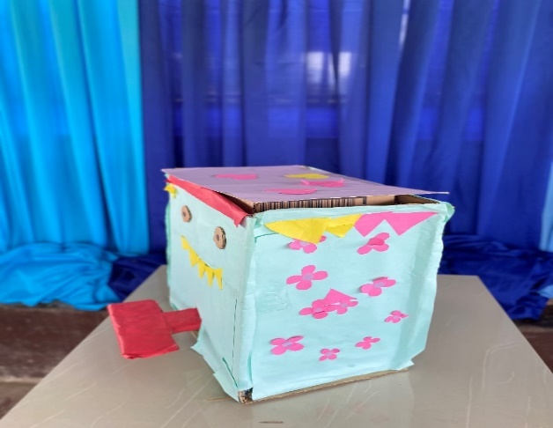
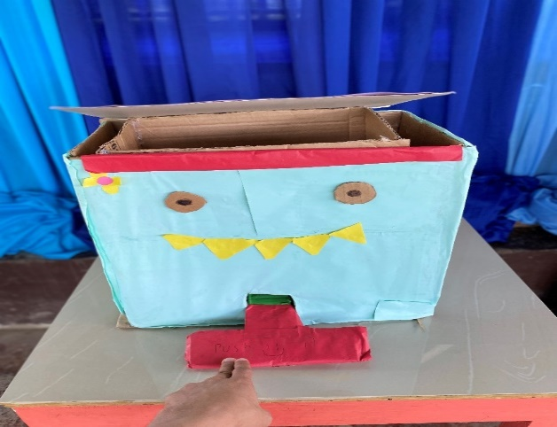
Group 1

Figure 4.12 Group 1 Prototype: Trash Bin
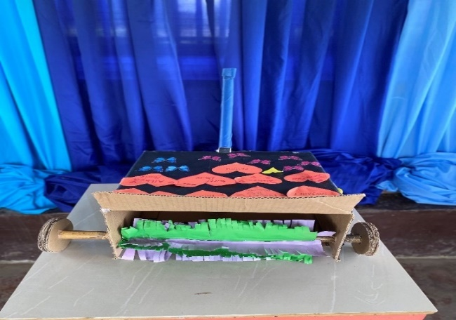
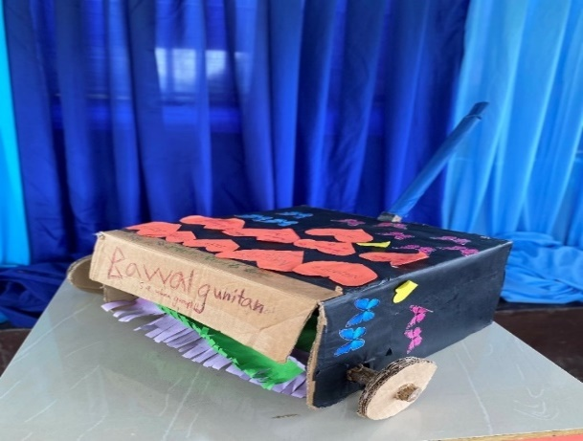
Group 2

Figure 4.13 Group 2 Prototype: Push Dust Bin

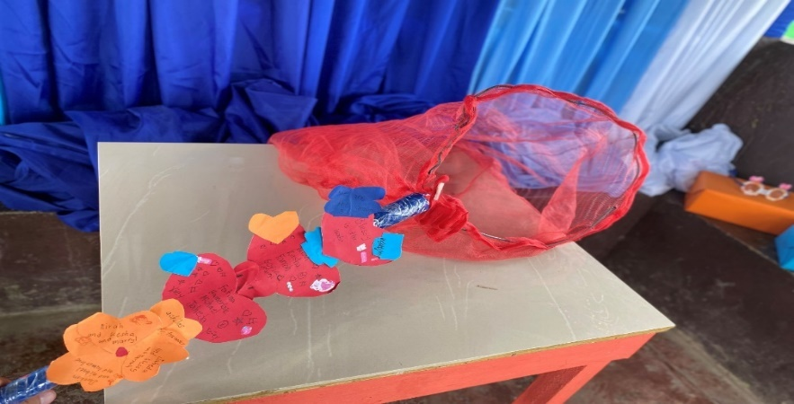
Group 3

Figure 4.14 Group 3 Prototype: Garbage Net

Group 1 earned 96 points in creativity and design, 97 in functionality, and 98 in environmental purpose, for a total of 291 points or 97%. Group 2 earned 95 points in creativity and design, 97 in functionality, and 97 in environmental purpose, totaling 289 points or 96.33%. Group 3 earned 96 points in creativity and design, 96 in functionality, and 96 in environmental purpose, with a total of 288 points or 96%.
These results helped identify the strengths and areas for improvement of each group. Overall, Group 1 achieved the highest score, while Group 2 led Group 3 by a single point. In conclusion, the use of this rubric encouraged pupils to grow, innovate, and further improve their work.

Table 4.6 Evaluation Results of Garbage Collectors Prototype.
Group | Percentage | Description | Verbal Interpretation
Group 1 | 97.00% | Excellent | Outstanding
Group 2 | 96.33% | Excellent | Outstanding
Group 3 | 96.00% | Excellent | Outstanding

7. Discussion
The findings of this study show that the implementation of the localized context-based STEM education lesson exemplar had a positive effect on the academic performance of Grade 5 pupils in Science. Based on the results, most pupils initially demonstrated only an average level of understanding, as seen in the pre-test where the majority fell under the “Fairly Achieved” category, and some were even classified as “Not Achieved.” This indicates that before the intervention, learners had limited comprehension of the concepts related to interactions between living and non-living things.
However, after the implementation of the localized context-based STEM approach, there was a noticeable improvement in pupils’ performance. The post-test results revealed that all pupils moved to higher achievement levels, with the majority classified as “Highly Achieved” and the rest as “Moderately Achieved.” This suggests that connecting the lesson to real-life and familiar environmental contexts helped pupils better understand and retain the concepts being taught.
The statistical analysis further supports this improvement. Since the data did not meet the assumption of normality, the Wilcoxon Signed-Rank Test was used, which showed a significant difference between the pre-test and post-test scores. This confirms that the improvement in pupils’ performance was not due to chance, but rather an effect of the localized context-based STEM education approach.
In addition to academic improvement, the use of localized and hands-on activities allowed pupils to become more engaged in the learning process. By relating Science lessons to their own environment, particularly in estuaries and intertidal zones, pupils were able to see the relevance of what they were learning. This made the lesson more meaningful and easier to understand.
The results also support the idea that learners understand better when lessons are connected to their experiences. This is consistent with the concept of contextualized learning, where students build new knowledge based on what they already know. Moreover, the collaborative and activity-based nature of the lesson encouraged participation and interaction among pupils, which contributed to their improved performance.
Furthermore, the development and evaluation of prototypes demonstrated that pupils were able to apply their knowledge in practical ways. Through this activity, they showed creativity, problem-solving skills, and awareness of environmental issues. This indicates that the localized STEM approach not only improved academic performance but also helped develop important skills needed in real-life situations.
Overall, the findings of the study suggest that the localized context-based STEM education lesson exemplar is an effective teaching strategy in improving pupils’ understanding and performance in Science. By making lessons more relevant, interactive, and connected to real-life situations, pupils become more engaged and are able to learn more effectively.

8. Conclusion
Based on the findings of this study, the following conclusions are drawn: The results revealed that the majority of the respondents were female, Meranaw, and 10 years old. Despite these demographic characteristics, the study found that they did not significantly influence the pupils’ learning in Science. This suggests that the intervention applied in the study was effective regardless of gender, ethnicity, or age, highlighting its suitability for diverse learners. Furthermore, it can be concluded that the pupils’ performance in Science improved significantly when using the localized, context-based STEM education approach. The post-test results show that twenty-five (25) out of thirty-six (36) pupils achieved outstanding scores, and no pupil received a low score. This indicates a clear difference in performance between the pre-test and post-test, demonstrating that the approach effectively enhanced the pupils’ learning outcomes in Science. Moreover, the analysis of the respondents’ pre-test and post-test scores indicated a significant improvement in their performance. The increase in scores from pre-test to post-test demonstrates that the teaching strategies and learning activities employed in the study had a positive impact on the pupils’ understanding 66 and mastery of Science concepts. This improvement reflects not only the effectiveness of the instructional materials and methods but also the pupils’ engagement and active participation in the learning process. The study also confirmed that developing a localized context-based STEM education approach is an effective method that teachers can use in their instruction. Based on the researchers’ observations, the pupils enjoyed learning and engaging in activities using this approach, which contributed to a more meaningful learning experience.

9. Suggestion
Based on the findings of the study, it is recommended that the localized context-based STEM education approach be continuously used in teaching Science, especially in topics that can be easily connected to learners’ real-life environment. Since the results showed improvement in pupils’ performance after the intervention, teachers may adopt this approach to make lessons more meaningful and easier for learners to understand. It is also suggested that teachers be encouraged to design more contextualized and activity-based lessons that involve hands-on tasks and real-life applications to further enhance pupils’ engagement and participation.
In addition, schools may support teachers by providing training, materials, and resources needed to effectively implement localized STEM activities in the classroom. This can help ensure that the approach is applied properly and consistently. Future classroom practices may also include more opportunities for pupils to explore ideas independently, ask questions, and reflect on their learning, as this can help strengthen their critical thinking and problem-solving skills.
Moreover, the development of pupils’ outputs such as prototypes may be improved by giving more time for planning, testing, and revising their work. This will allow learners to be more creative and produce more functional outputs. Lastly, future researchers may conduct similar studies using a larger group of participants or a longer duration of implementation to further examine the effectiveness of the localized context-based STEM education approach in improving academic performance and promoting deeper understanding in Science.

10. Acknowledgement
The authors would like to sincerely thank their thesis adviser and panel members for their guidance, support, and helpful suggestions throughout the completion of this study. Deep appreciation is also extended to the administrators, teachers, and pupils of Sultan Naga Dimaporo Memorial Integrated School for their cooperation and assistance during the conduct of the research.

11. Reference
Abdalla, H., et al. (2024). Culturally responsive teaching: Navigating models and implementing effective strategies. ResearchGate.
Abebe, A., et al. (2022). Effects of context-based approaches on high school students’ epistemological beliefs. International Journal of Environmental & Science Education.
Ascione, L. (2022). Students desperately need to see relevance in their learning. eSchool News.
Barrun, J., et al. (2025). Development and validation of contextualized lessons in science, technology, and society (STS). PEGEM Eğitim ve Öğretim Dergisi.
Chi, C. (2023). Philippines still lags behind world in Math, Reading, and Science PISA 2022. Philstar.
Claridades, K., & Guevarra, P. (2021). Socio-cultural context in localizing a learning module in life science. ResearchGate.
Davtyan, R. (2014). Contextual learning theory. ASEE Zone 1 Conference Proceedings. Gungor, et al. (2023). Perspective of teachers to context-based learning in science education. ResearchGate.
Hansen, J. (2022). Peer learning: Overview, benefits, and models. Western Governors University.
Holmes, K., et al. (2021). Linking K-12 STEM pedagogy to local contexts. Frontiers in Education.
Kos, T. (2024). Enhancing young learners’ peer collaboration. TESOL Quarterly. Le, H. C., Nguyen, V. H., & Nguyen, T. L. (2023). Integrated STEM approaches in K–12 learning. Education Sciences.
Marosi, N., et al. (2021). Culturally relevant pedagogies in science education. Discover Education.
Melvin, M. (2022). Why student-centered learning is important. Prodigy Education.
Montero, J., & Geducos, D. (2022). Improved conceptual understanding through contextualized learning. International Journal of Multidisciplinary: Applied Business and Education Research.
OECD. (2023). PISA 2022 results (Volume I & II): Country notes – Philippines.
Petty, L. (2025). Mixed ability grouping in education. High Speed Training.
Republic Act No. 10533. (2013). The Enhanced Basic Education Act of 2013. Official Gazette.
Saro, J., et al. (2023). Contextualized and localized science teaching materials. ResearchGate.
Science Teaching. (2022). What is STEM education? International Science Teaching Foundation.
Sotero, M., et al. (2020). Local and scientific knowledge in school context. Journal of Ethnobiology and Ethnomedicine.
Villarino, R. T., & Villarino, M. L. (2023). Academic performance of rural junior high school students in biology. ResearchGate.
Yusof, S. (2021). Vygotsky’s sociocultural theory of child development. ResearchGate.

