TITLE:ROLE OF CHEMISTRY IN MEDICINAL PLANT

Abstract:
Chemistry plays a vital role in understanding medicinal plants and their healing properties. It provides the scientific basis for identifying, isolating, and analyzing the active chemical compounds present in plants. These compounds, such as alkaloids, glycosides, flavonoids, tannins, and essential oils, are responsible for the therapeutic effects observed in traditional and modern medicine.
Through chemical analysis, scientists can determine the composition and concentration of these bioactive substances, which is essential for their effective use in healthcare.
The rules and principles of chemistry, including solubility, pH, and chemical reactivity, play an important role in the extraction and purification of medicinal compounds. Organic chemistry helps in understanding the structure, bonding, and functional groups of plant-based molecules, which determine their biological activity and effectiveness.
Chemistry also explains how these compounds interact with the human body. This knowledge is important for ensuring proper dosage, minimizing side effects, and improving the safety of herbal medicines.
In addition, modern analytical techniques such as chromatography and spectroscopy are used to study plant constituents and ensure the quality of herbal products. Thus, chemistry forms the foundation for the study and safe use of medicinal plants.
It also helps in standardizing herbal formulations for consistent results. Chemistry supports the discovery of new drugs from natural plant sources. It improves the effectiveness of traditional medicines through scientific validation.
Therefore, chemistry remains essential in the advancement of medicinal plant research.

🔑 Keywords:
- Medicinal Plants
Plants used for healing and treatment of diseases.
- Chemistry
Science that studies composition, structure, and properties of substances in plants.
- Alkaloids
Nitrogen-containing compounds with strong medicinal effects (e.g., pain relief).
- Flavonoids
Plant compounds with antioxidant and anti-inflammatory properties.
- Glycosides
Compounds that release active substances when hydrolyzed, used in heart medicines.
- Tannins
Polyphenolic compounds with astringent and antimicrobial properties.
- Essential Oils
Volatile aromatic compounds used in therapy, perfumes, and medicines.
- Extraction
Process of separating active compounds from plant materials.
- Purification
Removal of impurities to obtain pure chemical substances.
- Solubility
Ability of a compound to dissolve in a solvent, important for drug preparation.
- PH (Potential of Hydrogen)
Measure of acidity or alkalinity affecting stability and effectiveness of compounds.
- Chemical Reactions
Processes that help in identifying and modifying plant compounds.
- Herbal Medicine
Use of plant-based substances for treatment and health care.
- Drug Development
Process of discovering and creating medicines from plant compounds.
- Quality Control
Ensuring purity, safety, and effectiveness of medicinal plant products.
- Standardization
maintaining consistency in composition and dosage of herbal medicines.
Introduction:-
Medicinal plants have been used from ancient times as an important source of medicine for the treatment of various diseases. The medicinal value of these plants is due to the presence of different chemical compounds in them. These compounds interact with the human body and produce therapeutic effects. The study of these substances is explained through the rule of chemistry in medicinal plants.
Chemistry provides a scientific base for understanding medicinal plants. It helps in identifying active compounds such as alkaloids, flavonoids, glycosides, tannins, and essential oils. These compounds are responsible for various medicinal properties. With the help of chemical methods, scientists can isolate and study these compounds.
The principles of chemistry like solubility, pH, and chemical reactions are important in the extraction and purification of plant compounds. Methods such as distillation and solvent extraction are based on these principles and help in obtaining useful substances.
Chemistry also helps in understanding how plant-based medicines work inside the human body and ensures their safe and effective use. Thus, chemistry plays an important role in the study and application of medicinal plants.
It also supports the development of new drugs from natural plant sources.Chemistry helps in maintaining the quality and purity of herbal medicines.
Therefore, it is essential for modern healthcare and research.

Literature Review:
The study of medicinal plants has been an important area of research for many years. Earlier literature shows that traditional systems of medicine like Ayurveda and Unani relied heavily on plant-based remedies. These systems used natural plants without fully understanding their chemical composition, but they were effective in treating various diseases.
With the advancement of science, researchers began to study the chemical nature of medicinal plants. Literature reveals that scientists identified important bioactive compounds such as alkaloids, flavonoids, glycosides, and tannins, which are responsible for therapeutic effects. These studies helped in explaining the scientific basis of traditional medicines.
Many research works highlight the role of chemistry in the extraction and analysis of plant compounds. Techniques like distillation, chromatography, and spectroscopy have been widely used to isolate and identify active ingredients. These methods improved the quality and effectiveness of herbal medicines.
Recent studies also focus on the standardization and quality control of medicinal plants. Literature shows that maintaining purity and proper dosage is essential for safe use. Researchers have also worked on developing new drugs from plant sources by modifying natural compounds using chemical methods.
Furthermore, modern research emphasizes the importance of phytochemistry, which deals with the study of chemicals derived from plants. It helps in discovering new compounds with potential medicinal value. Many studies also highlight the antioxidant, antimicrobial, and anti-inflammatory properties of plant-based chemicals.
In addition, literature points out the use of advanced technologies such as mass spectrometry and high-performance liquid chromatography (HPLC) for detailed analysis of plant compounds. These techniques allow accurate identification and quantification of bioactive substances.
Researchers are also focusing on the interaction between plant compounds and the human body to understand their mechanism of action. This helps in improving drug design and ensuring better
therapeutic results. Overall, the expanded literature shows that chemistry continues to play a crucial role in the advancement of medicinal plant research and modern healthcare.
Previous Research Work by Scientists (Detailed Summary)
Scientific research on medicinal plants has developed over many years, moving from traditional knowledge to modern chemical analysis. Early scientists mainly focused on observing the effects of plants used in traditional systems like Ayurveda and Unani. Although they did not have advanced tools, they recognized that certain plants could cure diseases, reduce pain, and improve health. This traditional knowledge later became the foundation for scientific research.
With the development of chemistry, scientists began to study the chemical composition of medicinal plants in detail. They identified important bioactive compounds such as alkaloids, flavonoids, glycosides, tannins, and essential oils. These compounds were found to be responsible for various medicinal properties like antimicrobial, anti-inflammatory, antioxidant, and anticancer activities. The discovery of these compounds marked.
A major step in understanding how medicinal plants work.Further research focused on the isolation and purification of these active compounds. Scientists used chemical techniques such as solvent extraction, distillation, crystallization, chromatography, and spectroscopy.
These methods helped in separating pure compounds from complex plant mixtures. By studying their chemical structure and functional groups, scientists could determine how these compounds produce their effects in the human body.
In modern times, research has become more advanced with the use of sophisticated technologies like high-performance liquid chromatography (HPLC), gas chromatography (GC), and mass spectrometry.
These techniques allow precise identification and measurement of even very small quantities of plant chemicals. This has improved the accuracy and reliability of medicinal plant research.
Scientists have also studied the mechanism of action of plant-based compounds. This includes understanding how these substances are absorbed into the body, how they are distributed to different organs, how they are metabolized, and how they are finally excreted. This knowledge is essential for determining the correct dosage and ensuring the safety of herbal medicines.
Another important area of research is drug development. Many modern medicines have been derived from medicinal plants. Scientists modify natural compounds through chemical processes to improve their effectiveness and reduce toxicity. This process helps in creating safer and more powerful drugs. Research also focuses on validating traditional medicinal practices by providing scientific evidence for their use.
In addition, scientists work on the standardization and quality control of herbal medicines. They ensure that plant-based products contain the right amount of active compounds and are free from impurities. This is important for maintaining consistency and safety in medicinal use.

Chemistry of Medicinal Plants
1. Introduction.
The chemistry of medicinal plants involves the study of chemical compounds present in plants and their role in healing and treatment. These plants produce various natural substances that have medicinal value. Understanding their chemistry helps in explaining how these plants cure diseases and promote health.
2. Types of Chemical Compounds
Medicinal plants contain different types of bioactive compounds. Alkaloids are nitrogen-containing compounds that show strong effects on the human. Body. Flavonoids are known for their antioxidant properties. Glycosides help in heart-related treatments. Tannins have astringent properties and are useful in healing wounds. Terpenoids and essential oils have antimicrobial and anti-inflammatory effects.
3. Secondary Metabolites
The chemical compounds found in medicinal plants are mostly secondary metabolites. These are not directly involved in plant growth but help in protection against pests, diseases, and environmental stress. These metabolites are responsible for the medicinal properties of plants.
4. Extraction of Plant Compounds
Chemical principles such as solubility, temperature, and pH are used in the extraction of active compounds. Methods like distillation, infusion, maceration, and solvent extraction are commonly used. These processes help in obtaining pure and useful substances from plants.
5. Analysis and Identification
Modern techniques such as chromatography, spectroscopy, and mass spectrometry are used to identify and analyze plant compounds. These methods help in determining the structure and composition of bioactive substances and ensure their purity and quality.
6. Role of Organic Chemistry
Organic chemistry helps in understanding the structure, bonding, and functional groups of plant molecules. It explains how different compounds react and behave in the human body. This knowledge is important for predicting their medicinal effects.

7. Mechanism of Action
Chemistry explains how medicinal plant compounds work inside the human body. It includes processes like absorption, distribution, metabolism, and excretion. This helps in understanding how these compounds produce therapeutic effects.
8. Drug Development
Many modern medicines are derived from medicinal plants. Chemistry helps in modifying natural compounds to improve their effectiveness and reduce side effects. It also supports the discovery of new drugs.
9. Quality Control and Standardization
Chemistry plays an important role in ensuring the quality and safety of herbal medicines. It helps in maintaining proper concentration, purity, and consistency of plant-based products.
10. Conclusion
The chemistry of medicinal plants provides a scientific understanding of plant-based medicines. It helps in studying, improving, and safely using these natural resources. Thus, it plays a key role in modern healthcare and drug development.

Method:
The method is the detailed practical procedure followed in the study of medicinal plants and their chemical constituents. It begins with the correct identification and authentication of plant species to ensure accuracy in research. Plants are selected based on their traditional uses, availability, and medicinal importance. The required parts such as leaves, roots, stems, bark, flowers, or seeds are collected at the proper stage of growth, as the concentration of active compounds may vary with time and season.
After collection, the plant materials are thoroughly washed to remove dirt and unwanted particles. They are then dried under controlled conditions, usually in shade or at low temperature, to prevent the loss of volatile compounds and degradation of sensitive chemicals. Once dried, the material is ground into a fine powder to increase the surface area, which improves the efficiency of extraction.
The powdered plant material is subjected to extraction using appropriate solvents like water, ethanol, methanol, acetone, or chloroform. The choice of solvent depends on the polarity and solubility of the target compounds.
Extraction methods such as maceration, percolation, infusion, decoction, Soxhlet extraction, and steam distillation are commonly used. These techniques help in dissolving and separating the bioactive compounds from the plant matrix.
After extraction, the mixture is filtered using filter paper or other filtration methods to remove solid residues. The filtrate is then concentrated using evaporation techniques such as water bath or rotary evaporator to obtain a crude extract. This extract contains a mixture of different chemical compounds.
Phytochemical screening is then carried out to detect the presence of important classes of compounds like alkaloids, flavonoids, glycosides, tannins, saponins, phenols, and terpenoids. These tests involve specific chemical reactions that indicate the presence of these compounds through color change orprecipitation.
In addition, preliminary biological tests may be conducted to check activities such as
antimicrobial, antioxidant, or anti-inflammatory effects.
Methodology:
The methodology is the complete scientific framework that guides the research process in medicinal plant chemistry. It includes the planning, design, execution, and interpretation of experiments in a systematic and logical manner. The methodology ensures that the research is carried out in a structured way, making the results reliable and reproducible.
It is based on fundamental principles of chemistry such as solubility, polarity, pH, temperature, and chemical reactivity, which influence the extraction, separation, and analysis of plant compounds.
Advanced analytical techniques like chromatography (Thin Layer Chromatography, High-Performance Liquid Chromatography, Gas Chromatography) are used to separate complex mixtures into individual components. Spectroscopic methods such as UV-visible spectroscopy, Infrared (IR) spectroscopy, and Nuclear Magnetic Resonance (NMR) are used to determine the structure and functional groups of the compounds.

The methodology also includes evaluation of pharmacological properties of plant extracts through various bioassays. These tests help in identifying activities such as antibacterial, antifungal, antiviral, antioxidant, anti-inflammatory, and anticancer effects. This step is important for confirming the medicinal value of the plant compounds.
Quality control and standardization are also key parts of the methodology. Researchers ensure that herbal products have consistent composition, proper concentration of active compounds, and are free from contaminants. This is essential for their safe use in healthcare.

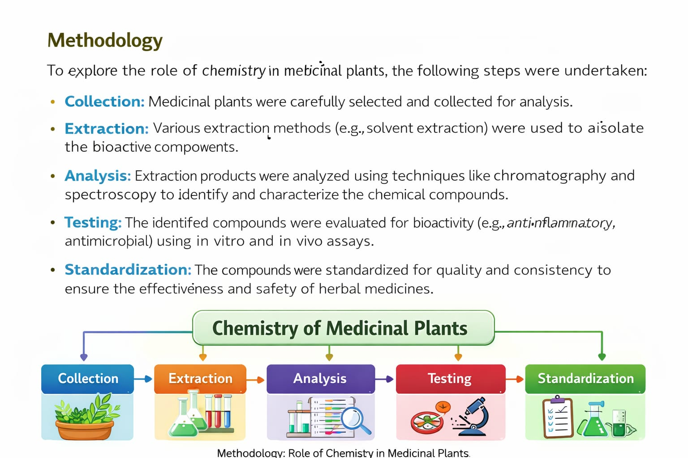

Furthermore, proper documentation, data collection, statistical analysis, and comparison with previous research are included in the methodology.

Discussion: Chemistry of Medicinal Plants
The study of the chemistry of medicinal plants clearly shows that plant-based medicines are highly dependent on the presence of bioactive chemical compounds. Compounds such as alkaloids, flavonoids, glycosides, tannins, and terpenoids play a major role in providing therapeutic effects. The discussion highlights that understanding these compounds through chemical principles is essential for explaining how medicinal plants work in the treatment of diseases.
The use of different extraction methods based on chemical properties like solubility and polarity has proven to be effective in isolating active constituents. It is observed that the choice of solvent and method greatly affects the yield and quality of extracted compounds. Therefore, proper selection of techniques is necessary to obtain accurate and useful results.
Advanced analytical techniques such as chromatography and spectroscopy have improved the identification and structural analysis of plant compounds.
These methods provide precise and reliable data, which is important for the standardization and quality control of herbal medicines. This ensures that plant-based drugs are safe and effective for human use.
The discussion also shows that medicinal plant compounds interact with the human body through various biochemical processes. Understanding their mechanism of action helps in determining proper dosage and reducing side effects. This makes herbal medicines more reliable and acceptable in modern healthcare systems.
Furthermore, the integration of traditional knowledge with modern chemical research has opened new opportunities for drug discovery. Many modern medicines have been developed from plant sources, and ongoing research continues to explore new compounds with potential therapeutic value.
In addition, it is observed that environmental factors such as soil, climate, and season can influence the chemical composition of medicinal plants. This variation affects the quality and effectiveness of plant-based medicines, making standardization an important requirement.
The discussion also highlights the importance of quality control, proper storage, and preservation of medicinal plant materials. Without these measures, the chemical compounds may degrade, reducing their effectiveness.
Moreover, the growing demand for herbal medicines has increased the need for sustainable use of plant resources. Overharvesting of medicinal plants can lead to depletion of natural resources, so conservation and cultivation practices are necessary.
Another important point is that combining medicinal plant research with modern technologies and interdisciplinary studies can improve the discovery of new drugs and enhance healthcare systems.

Conclusion:
In conclusion, the study of the chemistry of medicinal plants plays a vital role in understanding their therapeutic properties and applications. The presence of various bioactive compounds such as alkaloids, flavonoids, glycosides, tannins, and essential oils is responsible for the healing effects of these plants. Chemistry helps in identifying,
extracting, analyzing, and utilizing these compounds in a scientific manner.
The application of chemical principles and modern analytical techniques ensures the quality, purity, and effectiveness of plant-based medicines. It also helps in understanding the mechanism of action of these compounds in the human body, leading to safe and proper use. Furthermore, chemistry supports the development of new drugs from natural sources and validates traditional medicinal practices.
In addition, the role of chemistry is important in standardization, quality control, and preservation of medicinal plant products. It helps in maintaining consistency and safety, which is essential for their acceptance in modern healthcare systems. Chemistry also contributes to sustainable use and conservation of medicinal plants by promoting proper utilization and reducing overexploitation.

Moreover, continuous research in this field opens new opportunities for discovering novel compounds with potential medicinal value. It strengthens the link between traditional knowledge and modern science, making healthcare more effective and accessible.
Finally, the integration of chemistry with other scientific fields such as biology, pharmacology, and biotechnology further enhances the study of medicinal plants. This multidisciplinary approach leads to better innovation, improved drug development, and advanced treatment methods. Thus, chemistry remains a key pillar in the progress and future of medicinal plant science and global healthcare.

Future Scope: Chemistry of Medicinal Plants
The future scope of the chemistry of medicinal plants is extremely wide and continuously expanding due to the increasing global demand for natural, safe, and effective medicines. Medicinal plants are considered one of the richest sources of bioactive compounds, and many of them are still not fully explored. In the future, intensive chemical research will help in discovering new plant-based compounds that can be used for the treatment of various complex and chronic diseases.
One major area of future development is drug discovery and development. Scientists will focus on isolating new chemical molecules from medicinal plants and studying their structure-activity relationships.
These studies will help in designing more powerful drugs with improved efficiency and reduced side effects. Many modern medicines in the future are expected to be derived or inspired by natural plant compounds.
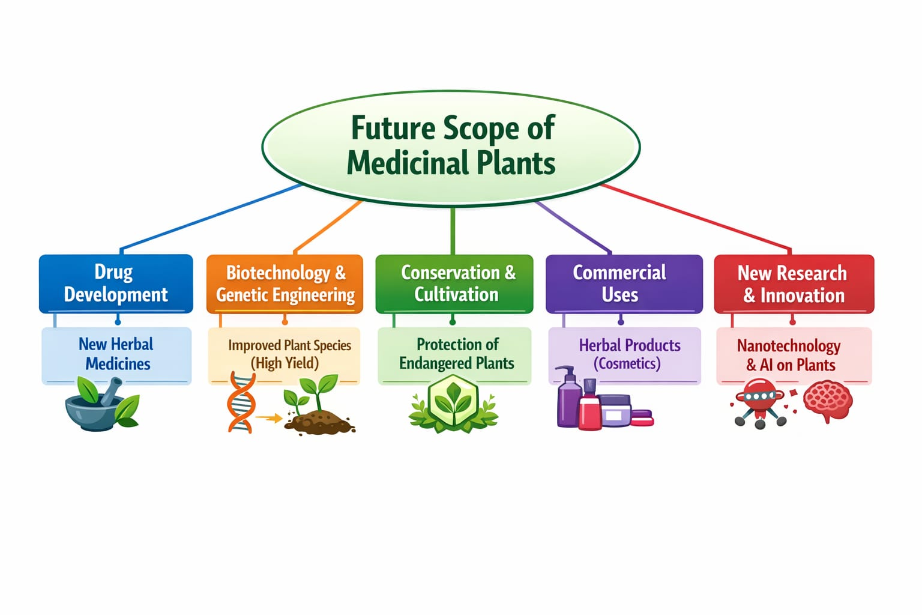
Another important scope is the use of advanced scientific technologies. Techniques such as nanotechnology, biotechnology, artificial intelligence, and computational chemistry will play a major role in medicinal plant research. Nanotechnology will help in targeted drug delivery systems, while Al will assist in identifying potential medicinal compounds faster and more accurately. Biotechnology will enable large-scale production of valuable plant compounds through tissue culture and genetic engineering.
Standardization and quality control will also be a major focus in the future. Chemistry will ensure that herbal medicines meet international quality standards by maintaining proper composition, purity, and dosage. Advanced analytical tools like HPLC, GC-MS, and NMR spectroscopy will be widely used to ensure accuracy and reliability of herbal products.
Sustainability and environmental protection will become increasingly important. Overharvesting of medicinal plants is a serious issue, so future research will focus on conservation strategies, sustainable cultivation, and eco-friendly extraction methods. Green chemistry will play a key role in reducing environmental pollution during processing and production of herbal medicines.
The future will also see strong integration between traditional medicine systems and modern science. Ancient knowledge from Ayurveda, Unani, and other systems will be scientifically validated using chemical research. This will help in building global acceptance of traditional medicinal practices.
Personalized medicine is another emerging area where treatments will be tailored according to an individual's genetic makeup and health condition. Plant-based compounds will be studied for their specific effects on different individuals to improve treatment outcomes.
In addition, interdisciplinary collaboration between chemistry, biology, pharmacology, and data science will accelerate innovation in medicinal plant research. This will lead to faster discovery of new drugs and better understanding of disease mechanisms.

References: Chemistry of Medicinal Plants
The following references are used for the study of the chemistry of medicinal plants and related phytochemical and pharmacognosy concepts. These books and publications provide important information about plant-based compounds, extraction methods, chemical analysis, and medicinal applications of plants.
1. Harborne, J.B. (1998). Phytochemical Methods: A Guide to Modern Techniques of Plant Analysis. Chapman & Hall, London. This book explains modern techniques used in the chemical analysis of plant materials and identification of bioactive compounds.
2. Trease, G.E. & Evans, W.C. (2002). Pharmacognosy. Elsevier Saunders, London. It is a standard textbook that provides detailed knowledge about medicinal plants and their chemical constituents.
3. Kokate, C.K. (2010). Practical Pharmacognosy. Vallabh Prakashan, New Delhi. This book focuses on practical methods used in pharmacognosy and plant analysis.
4. Evans, W.C. (2009). Trease and Evans Pharmacognosy. Elsevier, UK. It gives updated information on medicinal plant chemistry and pharmacological aspects.
5. Dewick, P.M. (2009). Medicinal Natural Products: A Biosynthetic Approach. Wiley. This book explains the biosynthesis and chemical nature of natural plant products.
6. Bruneton, J. (1999). Pharmacognosy, Phytochemistry, Medicinal Plants. Lavoisier Publishing. It provides a detailed study of phytochemistry and medicinal plant properties.
7. Wallis, T.E. (2005). Textbook of
Pharmacognosy. CBS Publishers, India. It includes information on identification and analysis of crude drugs.
8. Tyler, V.E., Brady, L.R., & Robbers, J.E. (1988).
Pharmacognosy. Lea & Febiger, USA. This book explains basic principles of pharmacognosy and
medicinal plant science.
9. World Health Organization (WHO). (2013). Quality Control Methods for Herbal Materials. Geneva. It provides guidelines for quality control and standardization of herbal medicines.
10. Sarker, S.D., Latif, Z., & Gray, A.I. (2006). Natural Products Isolation. Humana Press. This book describes methods for isolation and purification of natural compounds.
11. Kapoor, L.D. (2001). Handbook of Ayurvedic Medicinal Plants. CRC Press. It focuses on traditional medicinal plants used in Ayurveda and their properties.
12. Rangari, V.D. (2013). Pharmacognosy and
Phytochemistry. Career Publications, India. It provides detailed information about plant chemistry and pharmacological uses.
13. Kokate, C.K., Purohit, A.P., & Gokhale, S.B. (2015). Pharmacognosy. Nirali Prakashan, Pune. It is widely used for academic study of medicinal plant chemistry.
14. Ali, M. (2012). Textbook of Pharmacognosy and Phytochemistry. CBS Publishers, India. It covers
both theoretical and practical aspects of plant chemistry.
15. Samuelsson, G. (2004). Drugs of Natural Origin. Swedish Pharmaceutical Press. It explains
natural drug sources and their chemical importance.
These references provide a strong foundation for understanding the chemistry of medicinal plants, their extraction, analysis, and medicinal importance in modern healthcare.

