ABSTRACT
There are myriads of attendance record systems that have been developed using biometrics, face scanners, finger prints technologies, iris scanners etc.; but all those tend to be either very costly to acquire (especially when they have to be duplicated at various classes or points of access), or they require a very high cost of maintenance. In this research work, an attendance management system that uses cutting-edge technologies like smart phone device, Wi-Fi 802.11be and Global Positioning System ( GPS) technology to automate students’ attendance records was proposed. This application initiates Access Point (AP) mode Wi-Fi services for checking attendance of students in which a token is generated only for a person who is closer to the lecturer (the manager). With the token, the smart phone of the student connects to the server and report the attendance, sending the GPS location to the servers as well. The server tracks the GPS location and confirms it is within the location of the learning event. The result shows increase in accuracy of -attendance result and decrease in impersonation as the system validates attendance through users’ identification, location and timestamp during user login and logout. This system is cost effective and proposes an unlimited number of devices can be supported; hence resulting in an enhanced scalability.
Keywords
Wi-Fi 802.11be, AP mode, Attendance Management System, IP Address, GPS

INTRODUCTION
An attendance management system is a record or tool that is used to track and analyze a person's punctuality and regularity status on a daily basis in order to enhance that person's attendance to tasks. Such records contain timing information that is needed for the day to day assessment within an organization. Although there are quite a number of electronic attendance record systems that have been developed other than the manual pen and paper method, they are either cost intensive to acquire and maintain or unsuitable. In an attempt to cushion the effect and resolve these problems, a model of an attendance management system is proposed. This study will automate the act of recording time and attendance in the lecture hall within the academic environment using the recently released Wi-Fi technology, and thereby save cost, man hours and energy.
Table 1: Features of Wireless Fidelity (Wi-Fi) Vs 1 to 7

Wi-Fi Version | Features
Wi-Fi 1 | - IEEE 802.11b standard  - Speed:1, 2 ,5 ,5 and 11 mbps  - Range:38 meters (indoor) and 140 meters(outdoor).
Wi-FI 2 | - IEEE 802.11a standard  - Speed:6, 9, 12, 18, 24, 36 , 48, 56 mbps  - Range:35 meters (indoor) and 120 meters(outdoor).
Wi-Fi 3 | - IEEE 802.11g standard  - Speed: same as supported by Wi-Fi 1 and Wi-Fi 2  - Range: same as supported by Wi-Fi 1 and Wi-Fi 2
Wi-Fi 4 | - IEEE 802.11n standard  - Speed: maximum up to 150 mbps  - Range:70 meters (indoor) and 250 meters(outdoor).
Wi-Fi 5 | - IEEE 802.11ac standard  - Speed: 433 Mbits/sec ( with 80MHz and 1 spatial stream (ss)) 6.933 Gbits/sec (with 160 MHz, 8ss).  - Range:80 meters with 3 antennas
Wi-Fi 6 | - IEEE 802.11ax standard  - Speed: 600.4 Mbits/sec (with 80MHZ, 1SS): 9.6078 Gbits/sec (with 160 MHZ, 8ss)  - Range: Better than Wi-Fi 5 routers as beams forming is supported in Wi-Fi 6 router
Wi-Fi 7 | - IEEE 802.11be standard  - Speed: Up to 46Gbps in optimal conditions, with support for 320 MHz channels and 4K-QAM (Quadrature Amplitude Modulation), which allows for 20% more data throughput than Wi-Fi 6's 1024-QAM.  - Range: Enhanced range through Multi-Link Operation (MLO), which enables simultaneous data transmission across multiple frequency bands (2.4 GHz, 5 GHz, and 6 GHz), improving signal stability and reducing latency (TechRadar)

This model utilizes the latest Wi-Fi 802.11be standard technology, a smart mobile device and a desktop application to conveniently check attendance within a classroom setting. The proposed system consists of the admin or manager’s server (which launches an AP mode Wi-Fi service) for checking attendance of students, and a user/student’s view for students to log into the server using their matriculation number and phone number. The server generates and sends a token to only the student who is close to the lecturer for confirmation. If a student gets the token and keys it, the application automatically reports to the server that the student is present and the time of logging in. Otherwise, the application reports that student is not around. Whereas lecturers have to install a manager version of this smart application, students can optionally install a user version only if it is necessary for them to use add-on functionalities (like customization). It makes use of a Wi-Fi routers operating on the traditional 2.4 GHz band of about 40 meters indoors. It works with intranet rather than internet. The advantages of automating attendance management cannot be overemphasized, as benefits commonly ascribed to automation include, better quality output, increased productivity and reduction of material and man hour wastages among others.
Research Objectives
The aim of this research work is to implement a Wi-Fi enabled attendance management with Wi-Fi intranet connectivity, that will track students participation in various learning experiences they are exposed to. The specific objectives are as follows:

- To automate the act of recording time and attendance in the lecture hall and thereby save cost, man hours and energy.
- To help the manager (the lecturer) to store and retrieve records of students easily and securely.
- To help minimize impersonation in the attendance record, and

LITERATURE REVIEW
According to Vanuatu Primary School Head Teachers' Manual published in 1996, the purpose of school registers and records is to better organize record keeping and ensure there is an efficient system for keeping and passing on information. It manually gives the head teacher, the overall responsibility to keep, check and sign all the registers required. The methods of attendance recording into two kinds: traditional or manual method and automated method. A Traditional time and attendance system is a done-with-one’s-hands register that requires students to fill in the attendance sheets manually with pen and paper. This register is a tool used to record the involvement and regularity of a student to classes in order to ascertain if the student attended all the learning activities they should attend. This type of attendance system suffers problems like missing name, false attendance, missing attendance sheet, and tedious management. Monitoring Student Attendance work by Adjei and Walkley (1997) , they concluded that an electronic monitoring system should be chosen to monitor attendance, and that all staff should be involved.
According to IBM Cloud Education. (2021), automation is a term for technology applications where human input is minimized. Advantages of automation cannot be overemphasized as benefits commonly ascribed to automation include, increased productivity, better quality output, shorter labour workload, improved worker safety, more efficient use of materials, and reduced factory lead times.
Choi, et.al. (2015),took the advantage of the novel Wi-Fi 802.11ax technology while it was still on the oven, to implement an attendance checking system for Wi-Fi networks that supports unlimited number of concurrent connections. The application initiates AP mode Wi-Fi service in which a token is generated only to students that are close to the lecturer. If a student has the token, the smart application will connect and report to attendance server, otherwise, the application will report to the server that the student is absent. The advantage of this system lies in the fact that it supports unlimited number of devices (that is many devices can check the attendance at the same time) by using Wi-Fi scan rather than connect to the manager’s AP enabled smart devices in an enhanced scalability. However, where there is a large class, students can receive the token and check attendance by merely being around the lecture hall.
Kassim et.al (2012), proposed a Web-based student attendance system using RFID technology to prevent errors, save time, and provide online accessibility for lecturers and academic staff to monitor and manage student attendance efficiently, improving teaching quality and student performance tracking.
Banepali et.al (2019), proposed system uses cutting-edge technologies such as smart phones and Wireless Access Point (WAP) to automate student attendance in the classroom settings. The system is implemented in four steps: Wireless Local Area Network (WLAN) formation using Raspberry Pi and smart phones; Received Signal Strength (RSS) threshold determination for each setting; database and web interface implementation using Apache server, MySQL and PHP; and updating the attendance using threshold RSS, Media Access Control (MAC) address, association status of mobile devices and RSS value. The system was tested in several classroom settings including the laboratory room, lecture hall and tutorial room and obtained more than 94% of accuracy in attendance marking for all settings.

Gatsheni et.al (2007), also automated a student class attendance register using radio frequency identification in South Africa. The RFID technology was used in combination with internet hotspot. Information from a student's Identification (ID) card is electronically and automatically collected from either from the student's bag or pocket when the student enters the classroom, the collected student information is then automatically entered into a register. In the Gatsheni et.al study , a RFID Reader was placed near the door, five students with their ID cards based on ISO14443, on entering the classroom, held these cards one after the other at about 100mm or less above the Reader. The Reader was then removed from near the door and the data downloaded from the Reader into the computer via the RS232 interface. From the result of that experiment, all the five different user identification numbers (UID) of the cards were captured in the sequence in which the students entered the classroom. The small RFID range resulted in a queue as each student had to stop and put the tag 100mm or less from the Reader. Even though they later adopted tags based on IS018000, which is a longer range to automate this process, such that a student ID card can be read from a student's pocket as the student walks into the classroom; the transfer data from the Reader to the host was still manual. This resulted in delays in sending the data, human errors, and inconvenience the other lecturers who wanted to download the data later as against the wish of another who wanted that data immediately for other purposes.

Ayop et.al (2018), proposed a QR Code and GPS technology location-aware event attendance system. The system was developed based on two interfaces; the student view which is the smart mobile device App in which the student logs in with the Matriculation number/password, scanning the QR code displayed by the event manager, and the managers’ view, which is the web App used by the admin and which creates an encrypted QR code. From the estimation, the user first of all logs in, then scans the QR code; after scanning the QR code by the student, their current GPS location is captured by device’s location radio and transmitted to the manager for confirmation. The software requirements of the system include Android Studio 3.0 and Android SDK v19 for official IDE development system and mobile application testing respectively. However, the functionality of this system was based on android devices only, it does not support iOS enabled devices.

Juluri (2024), proposed the development of a Bimodal Attendance system using biometrics, specifically facial and fingerprint recognition, to improve traditional attendance systems. The aim of the Bimodal Attendance system is to streamline the process by automating attendance marking through biometric data collection. Tools include a web camera for facial biometrics, the Mantra Fingerprint sensor (MFS100) for fingerprint acquisition, and software like the Dlib package for facial recognition and Scale Invariant Feature Transformation (SIFT) for fingerprint verification. The achievements include real-time attendance marking and a 70% accuracy in identification. However, a potential gap is the relatively moderate accuracy level, which may suggest the need for further refinement or improvement in the system’s effectiveness.

The study done by Çakar et.al (2017), proposes a solution for controlling student attendance in lectures by using a QR code system. It aims at replacing the traditional, time-consuming, and easily abused methods like polling lists. The proposed method involves adding a QR code containing student numbers to student ID cards, which can be scanned using a simple application developed in Delphi Programming Language. The app utilizes a device's camera and works across various platforms, including Android, iOS, Linux, Windows, and macOS. The study highlights the adaptability and low cost of the solution. However, it required educational support, and not compatible with all systems.

Figure 1: Wireless Network Classifications (Adapted by the author from Pakhomova and Nazarova, 2020)

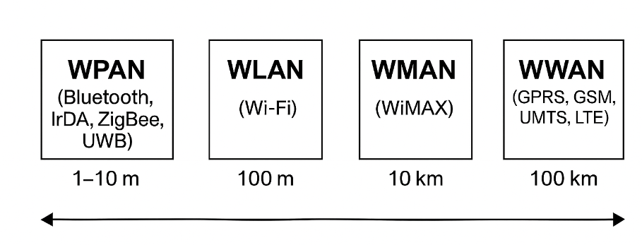

Wireless Personal-Area Networks (WPAN)
The IEEE 802.15 standard (wikipedia, 2024) serves as the foundation for wireless personal area networks . They enable communication inside a very small (10 meters or less) space. Unlike connections made through other wireless networks, WPAN connections require minimal to no infrastructure or direct contact to the outside world. This enables the implementation of compact, affordable, and energy-efficient solutions for a variety of devices, including smartphones and PDAs. Low power requirements and a low bit rate define these networks. Such networks rely on Bluetooth, IrDA, ZigBee, or UWB technology. In terms of applications, Bluetooth is made for cordless devices like a mouse, keyboard, and hands-free headset. IrDA is made for point-to-point connections between two devices for quick data transfers and file synchronization. ZigBee is made for dependable wireless monitoring and control networks.

Wireless Local-Area Network (WLAN)
According to Zenarmor. (n.d.) , wireless Local Area Networks (WLANs) are used mostly in residential, educational, workplace, and computer lab settings. They are intended to give wireless connectivity in locations with a typical range of up to 100 meters. Users are able to move around inside a limited coverage area while remaining connected to the network because of this (IBM Cloud Education, 2021; Banepali 2019). WLANs are based on the IEEE 802.11 standards, which are sold under the name Wi-Fi. Some standards, like HiperLAN, never saw a lot of commercial adoption because of competition. IEEE 802.11 arrived on the market more quickly because it was easier to deploy. For wireless local area networks, there are several different standards under the IEEE 802.11 umbrella. The first widely used standard, IEEE 802.11b, supported data rates of up to 11 Mbps in the 2.4 GHz unlicensed frequency range. Then, the IEEE 802.11g standard was created as the IEEE 802.11b's higher-bandwidth successor. Both 802.11b and 802.11g clients are supported by an IEEE 802.11g access point. Similar to this, a laptop equipped with an IEEE 802.11g card will be able to connect to both new 802.11g and current 802.11b access points. This is due to the fact that 802.11g-based wireless LANs will utilize the same 2.4-GHz range as 802.11b. The IEEE 802.11g wireless link's maximum transfer rate is 54 Mbps, but it will automatically slow down from that speed when the radio signal is weak or when interference is detected.
IEEE WLAN group has developed series of Wi-Fi standards to support various speeds, ranges, frequencies and perhaps strength. The series include 802.11b, 802.11a, 802.11g, 802.11n, 802.11ac and 802.11ax.These series of WLAN standards can be designated as Wi-Fi-1 to Wi-Fi-6 respectively.

Overview of Wi-Fi 7 Standard Network
Wi-Fi 7, also known as IEEE 802.11be, is the next generation of wireless technology, significantly improving on its predecessor, Wi-Fi 6. Wi-Fi 7 and was officially released in early 2024, and it will deliver groundbreaking improvements in speed, capacity, and efficiency, making it ideal for high-demand applications such as virtual reality (VR), augmented reality (AR), 4K/8K streaming, and gaming (TechRadar, 2024)

Key Features of Wi-Fi 7 Standard Network
- Increased Speed: Wi-Fi 7 offers speeds of up to 46 Gbps, thanks to the use of 320 MHz channel bandwidth and 4K-QAM (Quadrature Amplitude Modulation), which boosts data throughput by 20% compared to Wi-Fi 6. This speed enhancement supports bandwidth-intensive applications and significantly reduces latency.
- Multi-Link Operation (MLO): One of Wi-Fi 7's standout features, MLO allows devices to simultaneously transmit data over multiple frequency bands (2.4 GHz, 5 GHz, and 6 GHz). This leads to improved network performance, better reliability, and reduced latency, especially in congested environments.
- Enhanced Spectrum Utilization: By using wider 320 MHz channels, Wi-Fi 7 effectively doubles the bandwidth compared to Wi-Fi 6's 160 MHz channels. This wider bandwidth allows for faster data transmission and improved efficiency in handling multiple devices simultaneously.
- Low Latency: Wi-Fi 7 introduces deterministic latency techniques, which help devices predict and adjust for delays, making it particularly beneficial for real-time applications such as AR/VR and gaming.
- Backward Compatibility: Like previous Wi-Fi versions, Wi-Fi 7 maintains backward compatibility with older Wi-Fi standards, ensuring that older devices can still connect to Wi-Fi 7 networks, although they won't benefit from the new features and speeds.

Router
According to Cloudflare. (n.d.), a router is a device that connects two or more packet-switched networks or subnetworks. It serves two primary functions: managing traffic between these networks by forwarding data packets to their intended IP addresses, and allowing multiple devices to use the same Internet connection. Routers are classified into numerous types, although the majority of them transfer data between LANs (local area networks) and WANs. A LAN is a network of connected devices that is limited to a specified geographic area. A LAN typically requires a single router.
In comparison, a WAN is a massive network that spans a big geographical area. Large organizations that operate in many locations across the country, for example, will require separate LANs for each location, which will connect to the other LANs to form a WAN. A wide-area network (WAN) typically requires numerous routers and switches. A network switch forwards data packets between groups of devices on the same network, whereas a router routes data between networks.

DISCUSSION
The design of the proposed system is illustrated using the diagrams of input design, output design and use case. The input design shows Attendance Update Form (used by already registered users) and Manual Attendance Entry Form (for new users); while the output design shows the Lecture Attendance Table and the Lecture Attendance Summary Table. The scope and high-level functions of this system is described in the Use case diagram. Here, the interactions between the system and its actors are also depicted. Utilize-case diagram also shows what the system does and how the actors utilize it. Entity relationship and Activity diagrams have also been added, to explain how the tools work within the systems.

Input Design
The input form is comprised of two user interface: to take a new attendance login, and to update the existing login details. The Update Attendance Form as shown in figure 2 below, has twelve fields and is used by an existing user to update their existing details. New Attendance Form as shown in figure 3 enables the user to add a new record into the system.

Figure 2: Attendance Update Form (Source: Author, 2025)

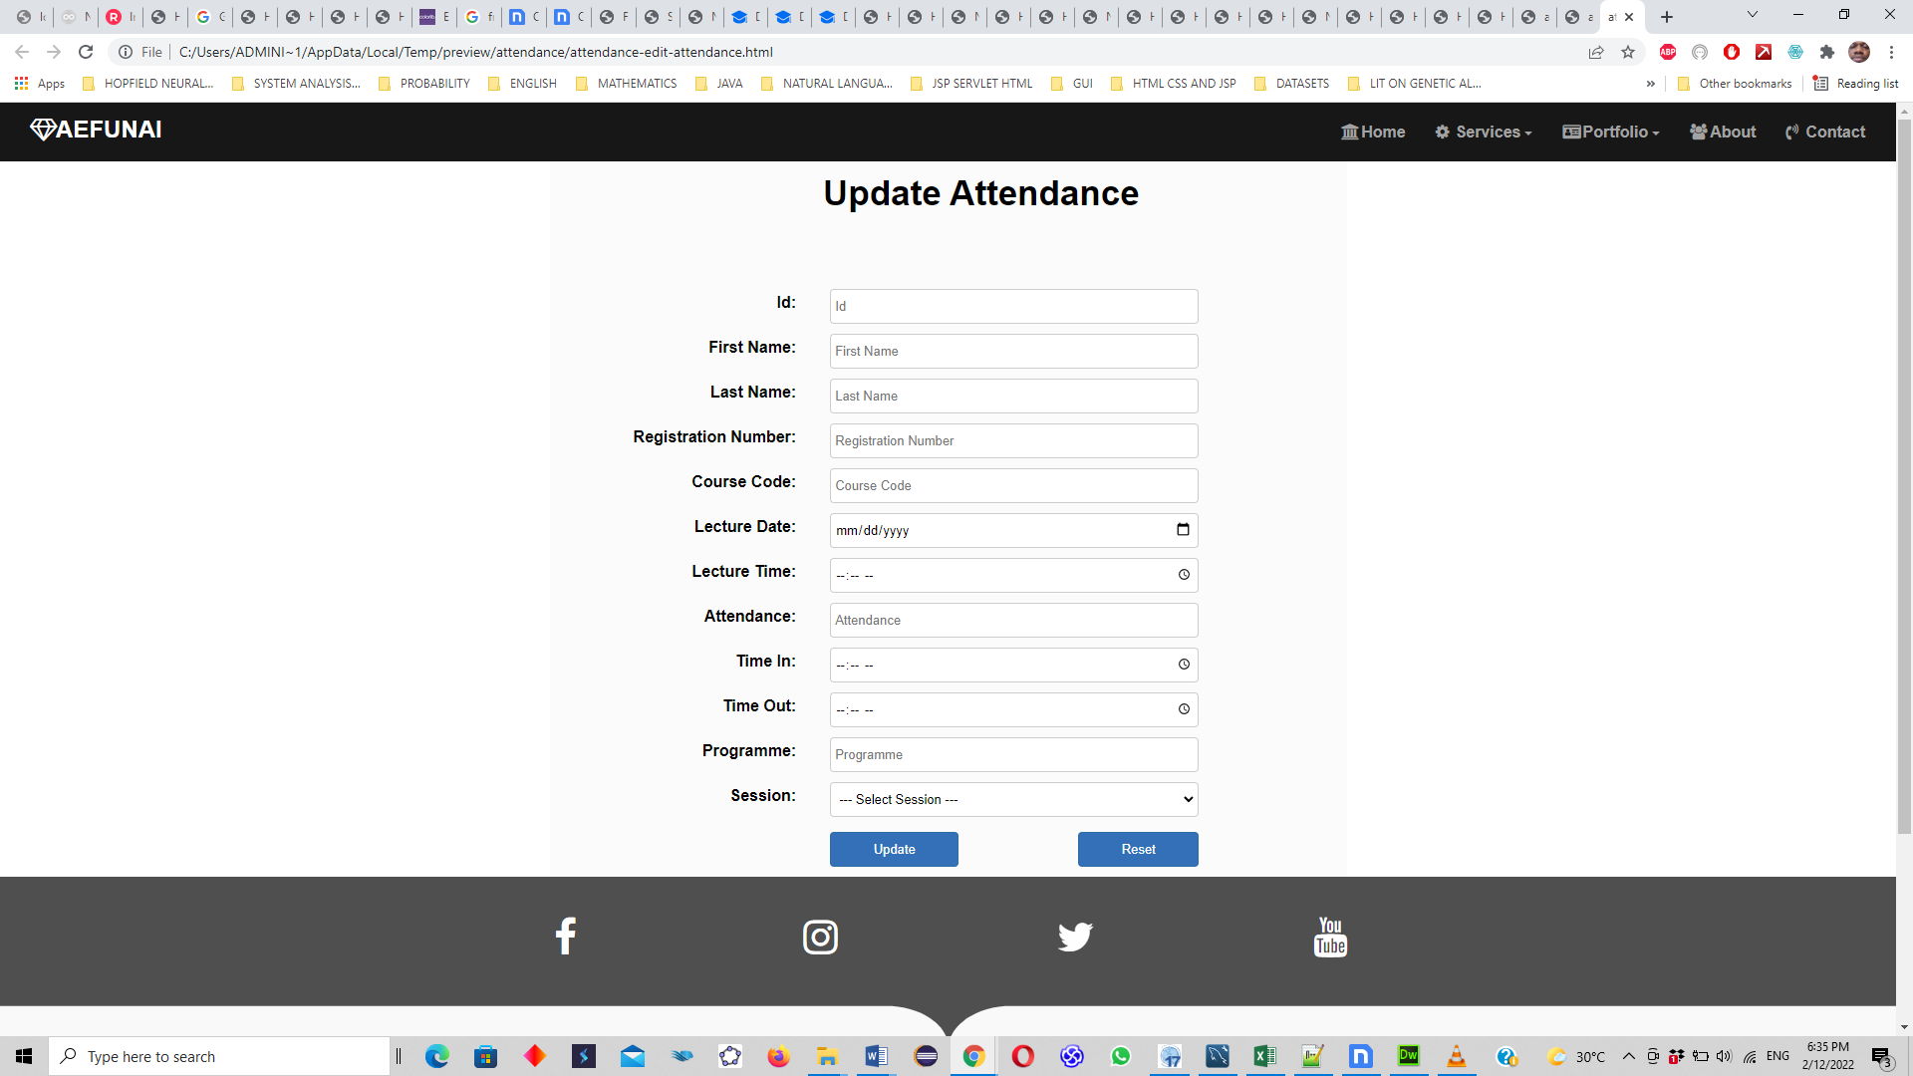

Figure 3: Attendance New Entry Form (Source: Author, 2025)

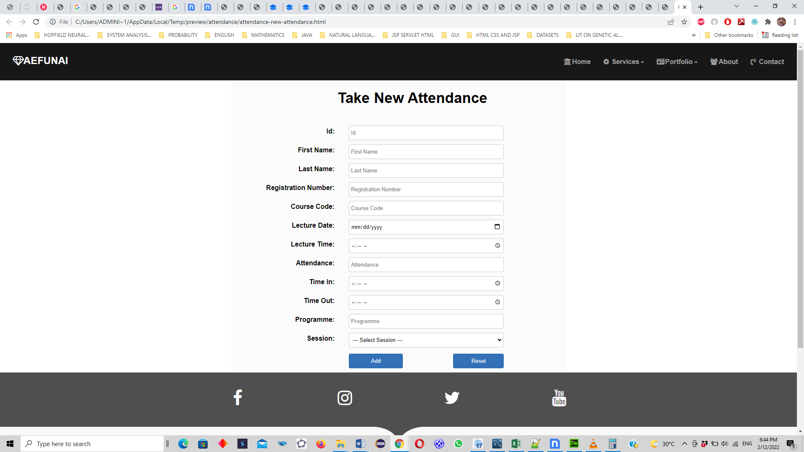

Output Design
The output designs as shown the figures 4 and 5 are the Lecture attendance table and lecture attendance summary respectively. Whereas the lecture attendance table (with fifteen fields) collates every session’s login from the students, the summary table (which contains twelve fields) becomes the vital tool the lecturer uses for decision making- whether or not the student attended the lectures up to the number of times required at the end of the course.

Figure 4: Lecture Attendance Table (Source: Author, 2025)

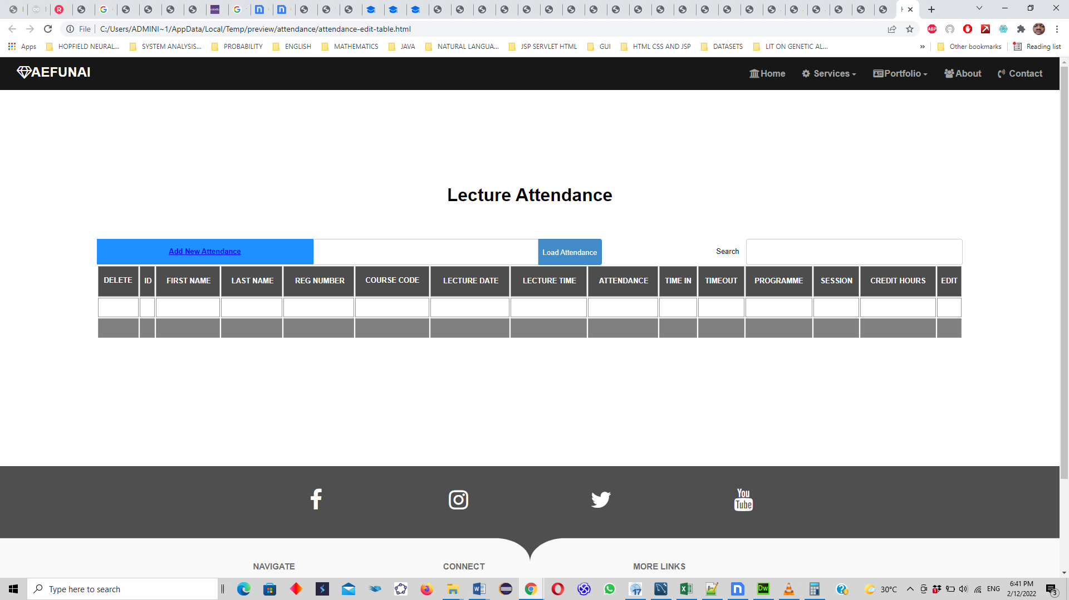

Figure 5: Lecture Attendance Summary Table (Source: Author, 2025)

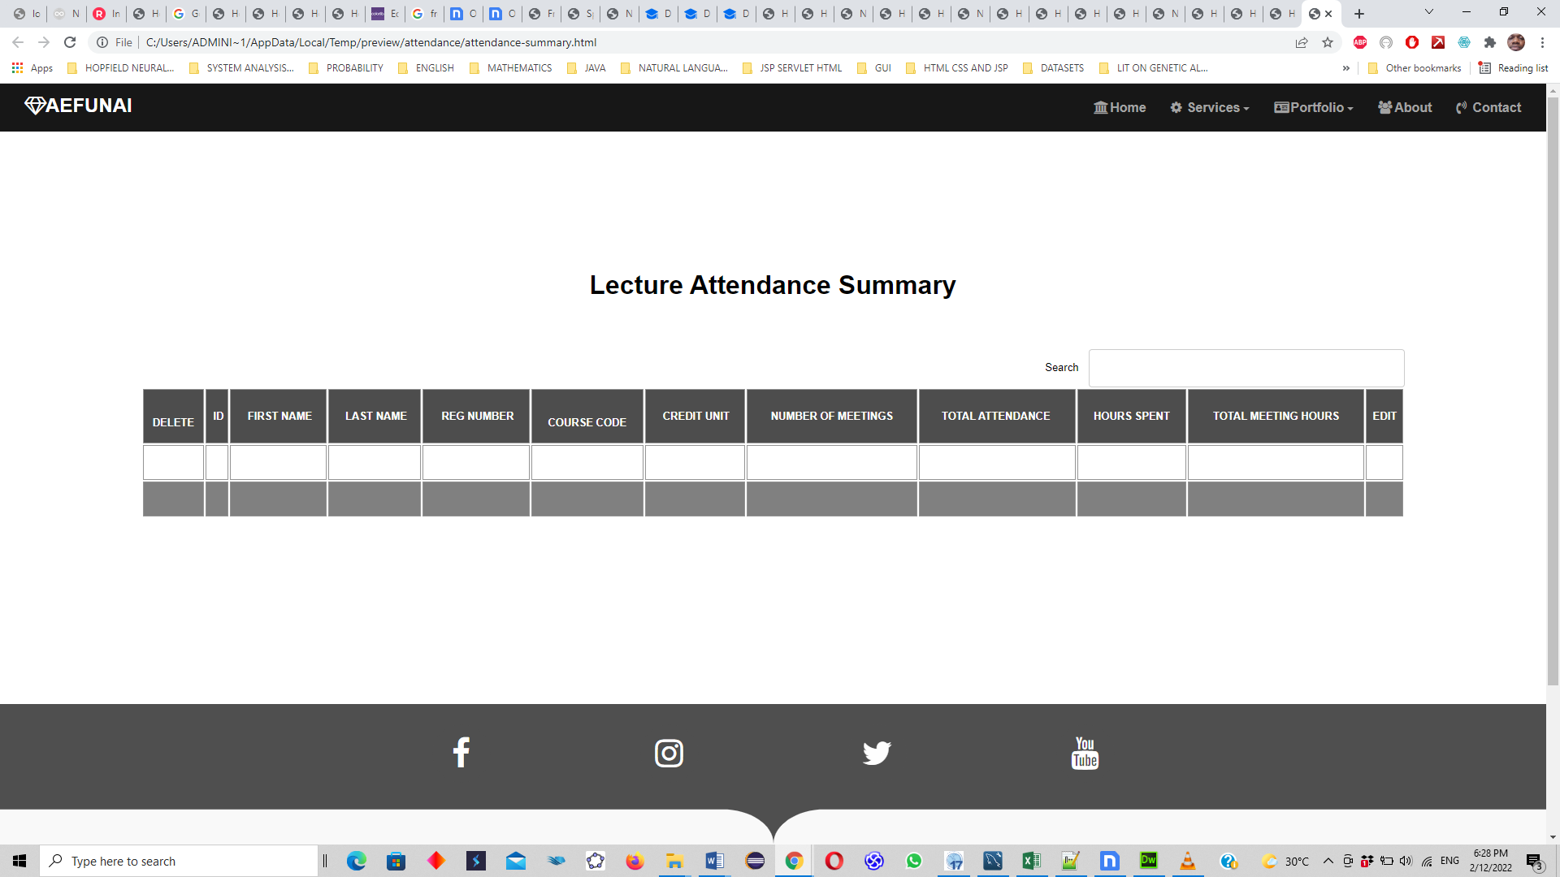

Activity Diagram
The activity diagram in figure 6 below shows at start, that lecture first signs in and opens a session and sends invitation to validate attendance by authenticating with the session’s unique access. They are logged out at the end of the session/ class.

Figure 6: Activity Diagram (Source: Author, 2025)

The use case diagram in figure 7 has four actors: the administrator, the lecturer, the student and the system.
- The administrator plays very active roles to create session, register user, add role, create profile, login, logout and add student.
- The lecturer roles are to add students, create attendance, login and logout.
- The students can only login and logout.
- The system is at the receiving end of the design, to execute the actions of other actors: lecturer and student roles (by extension, add role), edit session, delete session, login and out, computer attendance and statistics etc.

Figure 7: Use Case Diagram (Source: Author, 2025)

RESULTS

The created system is completely responsive and usable on mobile devices, tablets, and with various operating systems. Several advantages include: Wi-Fi based and automated for simple access
- It does not use paper for documenting attendance, which eliminates errors that could occur with paper,
- It is very flexible and dynamic;
- It is also user-friendly and convenient;
- The history of the current and past sessions can be accessed immediately and promptly;
- It forbids user impersonation.

CONCLUSION
This attendance management system offers significant benefits for users, making it an attractive solution. By utilizing smartphone devices, latest Wi-Fi 802.11be, and GPS technology, it automates attendance tracking, eliminating costly biometric systems. The system ensures accurate validation by linking attendance to the student’s location and proximity to the lecturer, improving accountability. It is highly scalable, supporting an unlimited number of devices without significant cost increases. Additionally, its cost-effectiveness, ease of integration with existing infrastructure, and increased full attendance rates make it a practical and economical choice for institutions.

REFERENCES
- Adjei Barwuah, & Walkley, P. (1997). Monitoring student attendance. FEDA (Further Education Development Agency, UK) Paper, ED406548, FE Matters, 1(9). Retrieved from https://www.eric.ed.gov/ERICWebPortal/recordDetail?accno=ED406548
- Ayop, Z., Yee, C., Anawar, S., Hamid, E., & Syahrul, M. (2018). Location-aware Event Attendance System using QR Code and GPS Technology. The Science and Information Organization. https://doi.org/10.14569/ijacsa.2018.090959
- Banepali, A., Kadel, R., Guruge, D. B., & Halder, S. J. (2019). Design and implementation of Wi-Fi based attendance system using Raspberry Pi. 2019 29th International Telecommunication Networks and Applications Conference (ITNAC). https://doi.org/10.1109/itnac46935.2019.90779
- Çakar, F., Ataş, M., Ataş, İ., & Seven, B. (2017, October). Using QR code and mobile device in course attendance controls. Paper presented at the IEC 2017 Conference, Antalya, Turkey.
- Choi, M., Park, J.-H., & Yi, G. (2015). Attendance Check System and Implementation for Wi-Fi Networks Supporting Unlimited Number of Concurrent Connections. International Journal of Distributed Sensor Networks, 11(7), 508698. doi:10.1155/2015/508698
- Cloudflare. (n.d.). What is a router? Cloudflare. Retrieved September 25, 2024, from https://www.cloudflare.com/en-gb/learning/network-layer/what-is-a-route
- Gatsheni, B. N., Kuriakose, R. B., & Aghdasi, F. (2007). Automating a student class attendance register using radio frequency identification in South Africa. IEEE. https://doi.org/10.1109/icmech.2007.4279977.
- IBM Cloud Education. (2021, May 12). What is Business Automation? IBM. Retrieved from https://www.ibm.com/think/topics/business-automation
- Juluri, S. (2024). Smart attendance monitoring system using multimodal biometrics. Kare Publishing. https://doi.org/10.14744/sigma.2024.00030.
- Kassim, Murizah,et al."Web-based student attendance system using RFID technology." Control and System Graduate Research Colloquium (ICSGRC),2012 IEEE. IEEE, 2012.
- Pakhomova, V. M., & Nazarova, D. I. (2020). Organizing wireless network at marshalling yards using the bee method. Science and Transport Progress: Bulletin of Dnipropetrovsk National University of Railway Transport, May 2020. https://doi.org/10.15802/stp2020/204005.
- TechRadar. (2024). Wi-Fi 7: Everything you need to know about the new wireless standard. Retrieved from https://www.techradar.com&#8203;:contentReference[oaicite:0]{index=0}&#8203;:contentReference[oaicite:1]{index=1}.
- Zenarmor. (n.d.). What is a WLAN? A guide about Wireless Local Area Network. Zenarmor. Retrieved October 1, 2024, from https://www.zenarmor.com/docs/network-basics/what-is-wlan.

