Proactive IT network monitoring through log analysis using ML and Open AI

Abstract— This research focused on a machine learning technique ( XGBoost – Extreme Gradient boosting), Transformer models (all-MiniLM-L6-v2 a sentence embedding model developed by Microsoft) based system for proactive network monitoring, perfuming log analysis for real-time anomaly detection and pattern analysis for root cause evaluation. This was to address challenge reacting to problems which leads to business revenue loss and increased idle time for workers when business operations are disrupted. The system makes use of the online NLP model specifically (OPENAI or Cohere), which are inferred for intelligent problem explanation and solution recommendation. The methodologies used was CRISP-DM for Data Science combined with incremental software methodology. The system enables network administrators to identify emerging problems within the network and address them pro-actively through system provided recommendations and anomaly evaluation insights before full negative impact on business operations.

Keywords—Log analysis, Machine learning, Explainable AI, Pattern Analysis, Artificial Intelligence, Natural language processing)

Introduction
In this modern world networks serve as the critical component in communication data exchange and service delivery throughout various industries. Effective and efficient network management has become most vital as networks grow in complexity and scale. Proactive network monitoring is the continuous monitoring and analysis of network performance as well as device behaviour to identify potential issues before they turn into a major failure [1] and reactive monitoring in contrast is triggered in response to an incident after it has occurred [1]. Reaction after a problem has occurred creates many problems and loses but predicting failure can ensure the continuous smooth-running of networks. Machine learning (ML) is an artificial intelligence subset that allows systems to discover patterns from data without being explicitly programmed[2]. .In network monitoring, ML models, including supervised and unsupervised algorithms, are used for the analysis of log data, identifying outliers, and finding patterns that commonly indicate faults or inefficiencies[3]. These models keep improving with more data, thereby presenting a good solution for analysing huge clusters of unlabelled or semi-structured logs generated by network devices.[3].
Anomaly detection refers to finding rare items, events or observations in data that do not conform to expected behaviour or differ significantly from the majority of data [3]. In many ways, an unusual pattern is a derivation from the norm. Therefore, in network log analysis, an event might revolve around any unusual log entry, and anomaly detection looks for those outliers in the data that can signal the occurrence of system failure, security breaches, or performance issues. Pattern detection involves identifying recurring sequences or structures within data. In network operations, this can include recognising common network traffic patterns, log entry sequences, or other repetitive behaviours that can indicate normal or abnormal activity [4].
Pattern analysis is the process of examining data to identify meaningful patterns or trends. It involves using statistical and machine learning techniques to uncover hidden structures and relationships within the data, which can be useful for making predictions, understanding behaviour, and making informed decisions [4]. Artificial intelligence (AI) refers to the simulation of human intelligence in machines that are programmed to think like humans and mimic their actions. It involves the development of algorithms and models that can perform tasks that typically require human intelligence, such as visual perception, speech recognition, decision-making, and language translation[3]. OpenAI is an artificial intelligence research laboratory consisting of the for-profit corporation OpenAI LP and its parent company, the non-profit OpenAI Inc. It is known for developing advanced AI models such as GPT (Generative Pre-trained Transformer) series [1].

Literature review
A log file is data produced automatically when certain events occur in systems, networks, and applications [12]. Security and information technology (IT) operations teams use them to investigate and respond to abnormal system activities [12]. Some examples of log types include audit logs, transaction logs, event logs, error logs, message logs, and security logs.
Current networks and IT systems produce a vast amount of these logs and the continuous operation and uptime of these systems are critical to the success of the current businesses. IT downtime creates a chain reaction, halting productivity and efficiency. Employees struggle to complete tasks, facing obstacles even with simple activities [13]. However, with the lack of an effective system that will parse, analyse, and learn from logs, the business risks of failing to predict future issues and experiencing downtime. And lack of an intelligent solution recommender, administrators face extended, estimated time of resolution [ETR].
There has been a lot of research in anomaly and pattern detection, and advanced techniques in anomaly detection with special emphasis on time series data because of its suitability in log analysis for IT network monitoring. Time series anomaly detection is important in data analysis, focusing on identifying unusual patterns in time series data that significantly differ from expected behaviour [5]. It also breaches the incorporated methods of feature extraction (FE) and dimensionality reduction (DR), such as auto encoders (AEs), to pre-process time series data that are complex and have a good amount of noise. This step is needed to improve the detection of collective-anomalies, which are deviations over time relating to a number of observations [6].
Some researchers have pointed out the exploitation of Process Mining (PM) techniques that can be drawn from time series data and comparison against real-time data for anomaly detection.
[7] proposed a model which is integrated into supervised and unsupervised machine learning techniques with the use of domain knowledge in a very apt manner as far as identifying the anomalous log events is concerned. It can overcome the problems posed by having huge unlabelled data as well as associated log complexity that is important towards being proactive in the monitoring process [7].
Research has been made in applying Open AI on managing tasks in line server, managing security for the system by the AI agent, including going through logs for failed attempts of login and also pointing out the vulnerabilities [8].
Fault management has also been addressed in mobile networks through the use of ML techniques. Supervised learning methods are employed, achieving high accuracy rates of 95% for stationary and 90% for mobile signal level prediction, alongside multi-stage autonomous fault management [3].
Challenges in the field of log analysis based on [9] involve data volume and heterogeneity, privacy and retention policies for log data, cost and timeliness due to large data processing tooling support for developers
Opportunities include machine learning for log recommendation and extracting actionable insights [10]. [11] mentions integration of advanced machine learning techniques for log analysis in the context of anomaly detection and security auditing

Methodology
The methodology that was used in this research was design science research methodology and CRISP-DM data science methodology. It is a specific methodology in which research embraces the designing and development of new or improving existing constructs-artifact-systems or processes and even models, toward solving a real in the world problem. CRISP-DM methodology involved the following stages, Business understanding, Data understanding, Data preparation, Modelling, Evaluation and then deployment
Business Data understanding
Organisations experience longer periods in resolving network problems when network systems go down leading to high losses in revenue and sales and increasing idle time among workers in different departments thereby halting productivity.
Developing a proactive network monitoring system assists administrators to proactively resolve issues before they negatively impact business operations. This system achieves the following: receives logs from networked devices, to predict failures of these devices through log analysis, thereby identifying possible causes using OpenAI API/Cohere, to generate actionable recommendations using the OpenAI API.
Data understanding
In this stage, the principal aim was to understand the log data that is used for training and evaluating the machine learning model. The first step was to collect log data off network devices in syslog format and then store it into batches for processing. Since comprehensive and up-to-date public datasets were not readily available or suitable for the target environment, logs were collected from a live network and further used as templates to simulate log messages issued by different network devices. These logs were then classified, analysed, and used in the log generation tool to generate realistic and diverse log data. The final approach ensured that the data set was pertinent to real-world scenarios, yet it could not claim to be completely exhaustive. These logs include information related to network activities, system events, configuration changes, kernel logs, boot logs and potential fault conditions. Logs were in varying levels of detail.
Data restructuring and template Extraction:
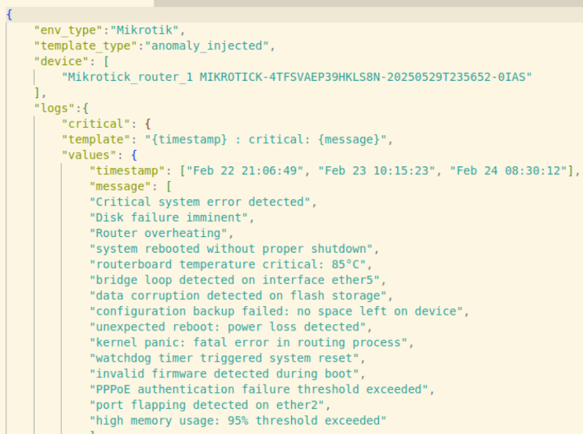
Logs were extracted and categorised to remain with unique logs for templating.

Figure1 Log Templating for Log Generator
Figure1 shows a portion of a log template that was used to generate logs. Numbers were dynamically randomised to simulate a real-world scenario
Data synthesis:
A custom log generator was developed to simulate both normal and anomaly scenarios based on extracted templates
<125>May 27 06:44:02 windows_device_1 WINDOWS-N37CK9HKQ2S2BHR7-20250512T021200-AQ45: Error MEMORY Uncorrectable ECC error on DIMM DIMM_C1. System stability at risk

Figure 2 Generated Log in RFC3164 Format
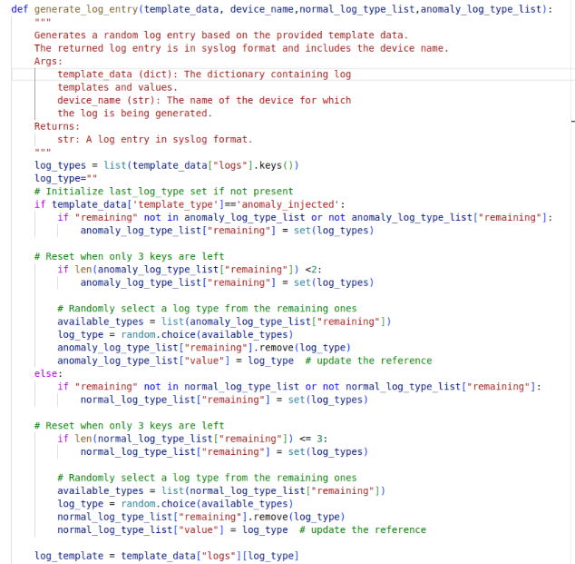
Figure 3 Generate_Log_Entry Function
Figure 3 shows the generate_log_entry function, which was used to generate real world logs from the create log templates and shows a typical generated log in RFC3164 syslog format.
Data quality assessment:
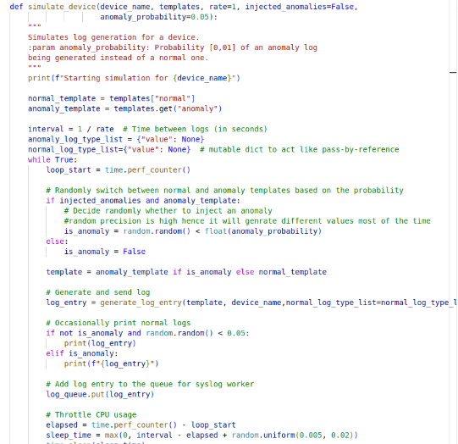
The processed data was evaluated for completeness, ensuring all critical fields were extracted, and for consistency validating that templates and generated logs maintained uniform structure and imbalance thus real anomalies are rare. This was controlled through a controlled generation, by using the probabilistic technique where a probability value for an anomaly to happen is set almost equal for balance training set and it is set at very low for testing.

Figure 4 Code Snippet for Anomaly
Figure 4 shows how the probability technique was used to decide which log should be generated, anomaly or normal.
Data preparation
Comprised of removal of irrelevant log entries, for example, keep system alive messages. Malformed logs were excluded, and time stamps were normalised to a standard format. Timestamp, host, message and text based features were extracted using natural language processing techniques. Logs were labelled through the log generator “normal” for normal logs
Data Modelling
The primary modelling goal was anomaly detection and pattern analysis in relation to anomalies, Modelling involved the following stages, Log parsing, feature extraction,and model training
Log parsing
This step involves splitting a log message into columns through regex matching with reference to the standard syslog format RFC3164 and RFC5424. Figure 5Windows Log event .pre-log parsing process.
Custom Tokeniser: This step involved domain-specific tokenisation to pre-process log messages by extracting critical tokens and semantic units which corresponded to certain network activities in order to optimise feature extraction.
Phraser: detects and groups multi word expressions into single tokens and helps improve downstream tasks.
TF-IDF Vectorizer: Log messages are transformed into numerical feature vectors by employing Term Frequency-Inverse Document Frequency (TF-IDF) method which allows the system to determine the relevance of certain terms within logs in relation to a specific data subset.
Word2Vec Embedding: this is a neural network based technique that learns vector representation of words. Words with similar meanings end up having similar vector representations in the embedding space, the architecture used is Skip-gram which predicts the surrounding context given a word.
Feature Normalisation: The vectors are scaled uniformly to all features to improve functionality and stability of the downstream machine learning model.
Gradient Boosting Model (XGBoost Classifier): The model used as the core classifier for anomaly detection is an XGBoost–based Gradient Boosting Model.

Results
The aim of the research was to design an intelligent network capable of proactive monitoring of network devices by performing log analysis.
The receiving of logs from networked devices was accomplished by implementing a syslog server within the system, whilst prediction of failures was achieved through log analysis- machine learning algorithms involving TF-IDF vectorisation, Word2Vec embedding, normalisation. Finally, training the XGBoost classifier model was used to determine whether the logs were abnormal or not, where, abnormal logs could mean logs indicating an issue that should be addressed immediately. Finding probable causes and recommendations was done using OpenAI or Cohere upon detection of anomalies. The model queries OpenAI or Cohere language model to uncover probable causes from the logs and give recommendations on an action towards the detected problem.

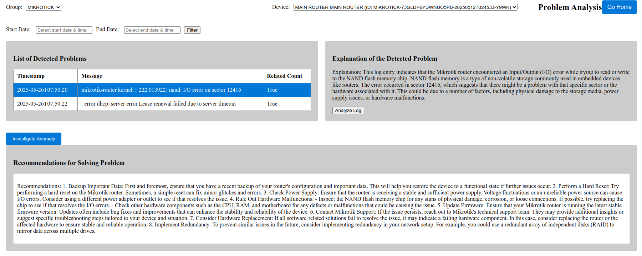
Timestamp | Message
2025-05-26T07:50:20 | mikrotik-router kernel: [ 222.013922] nand: I/O error on sector 12416
2025-05-26T07:50:22 | : error dhcp: server error renewal failed due to server timeout
Explanation: This log entry indicates that the Mikrotik router encountered an Input/Output (I/O) error while trying to read or write to the NAND flash memory chip. NAND flash memory is a type of non-volatile storage commonly used in embedded devices like routers. The error occurred in sector 12416, which suggests that there might be a problem with that specific sector or the hardware associated with it. This could be due to a number of factors, including physical damage to the storage media, power supply issues, or hardware malfunctions..
Recommendations: 1. Backup Important Data: First and foremost, ensure that you have a recent backup of your router's configuration and important data. This will help you restore the device to a functional state if further issues occur. 2. Perform a Hard Reset: Try performing a hard reset on the Mikrotik router. Sometimes, a simple reset can fix minor glitches and errors. 3. Check Power Supply: Ensure that the router is receiving a stable and sufficient power supply. Voltage fluctuations or an unreliable power source can cause I/O errors. Consider using a different power adapter or outlet to see if that resolves the issue. 4. Rule Out Hardware Malfunctions: - Inspect the NAND flash memory chip for any signs of physical damage, corrosion, or loose connections. If possible, try replacing the chip to see if that resolves the I/O errors. - Check other hardware components such as the CPU, RAM, and motherboard for any defects or malfunctions that could be causing the issue. 5. Update Firmware: Ensure that your Mikrotik router is running the latest stable firmware version. Updates often include bug fixes and improvements that can enhance the stability and reliability of the device. 6. Contact Mikrotik Support: If the issue persists, reach out to Mikrotik's technical support team. They may provide additional insights or suggest specific troubleshooting steps tailored to your device and situation. 7. Consider Hardware Replacement: If all software-related solutions fail to resolve the issue, it may indicate a failing hardware component. In this case, consider replacing the router or the affected hardware to ensure stable and reliable operation. 8. Implement Redundancy: To prevent similar issues in the future, consider implementing redundancy in your network setup. For example, you could use a redundant array of independent disks (RAID) to mirror data across multiple drives.

Figure 5 Analysis of Anomaly
Figure 5 is the system analysing a detected anomaly and giving an explanation of what the anomaly means, together with the recommendation of what should be done to mitigate or resolve the detected problem.

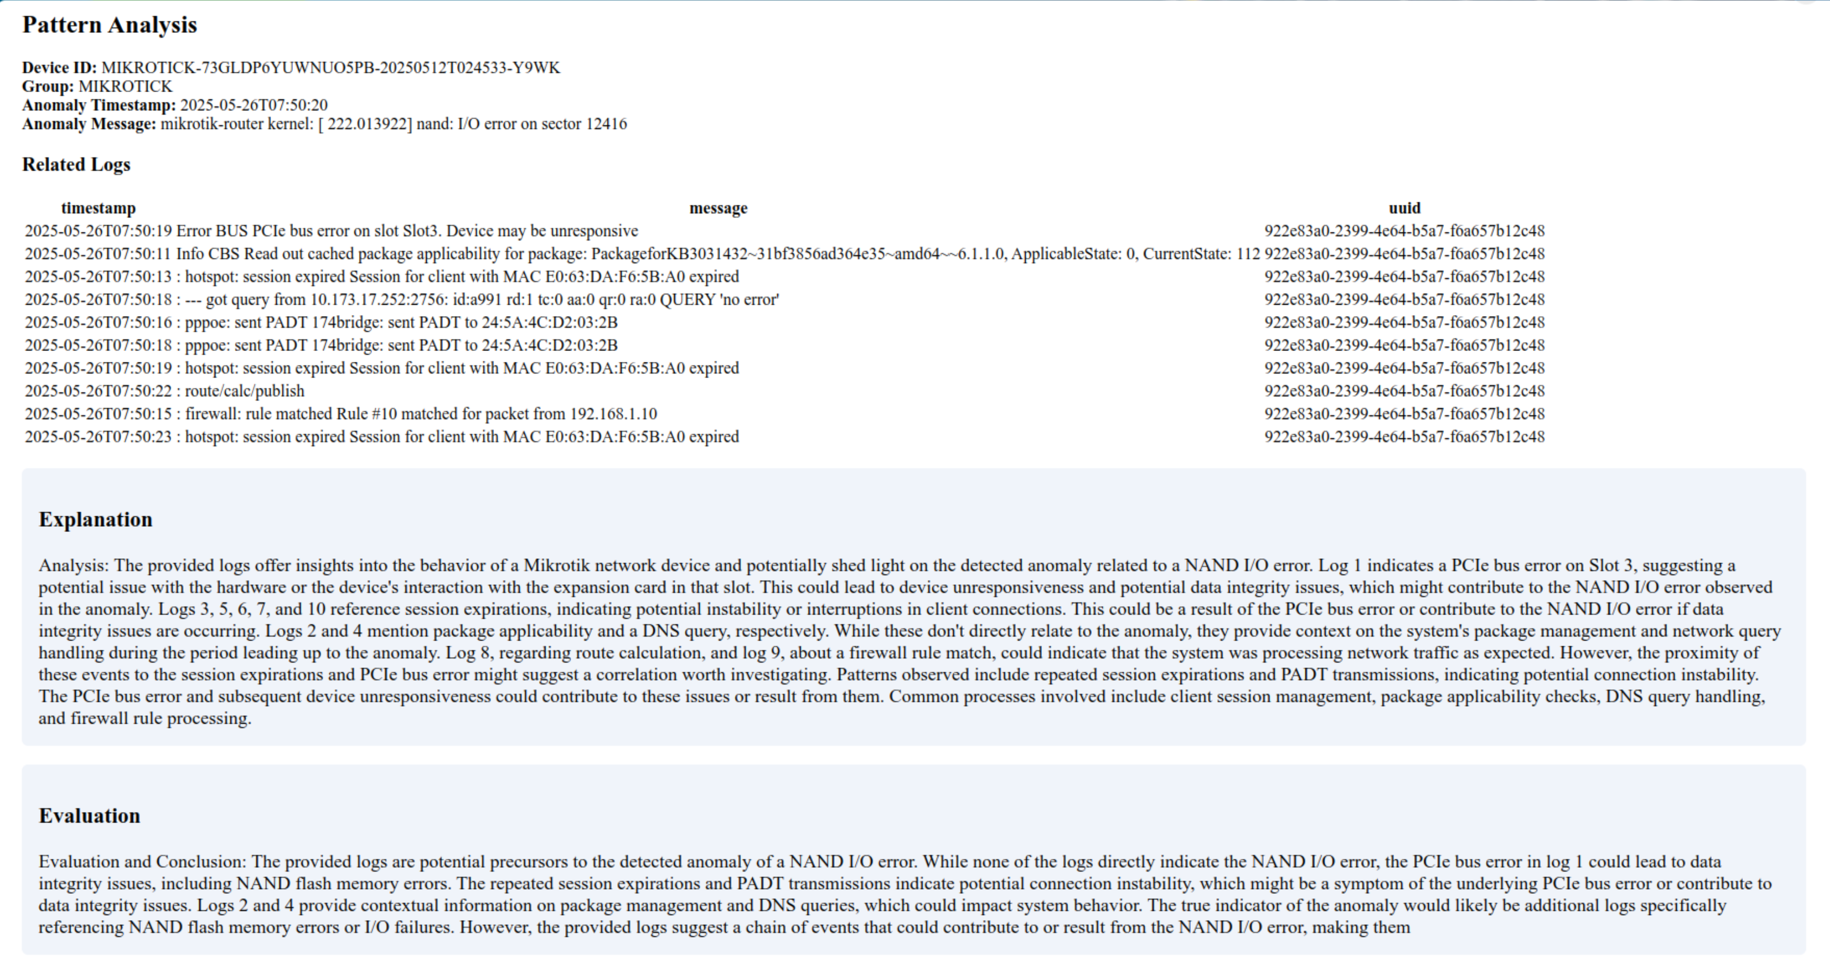
timestamp | message | uuid

2025-05-26T07:50:19 | Error BUS PCIe bus error on slot Slot3. Device may be unresponsive | 922e83a0-2399-4e04-b5a7-f6a057b12c48

2025-05-26T07:50:11 | Info CBS Read out cached package applicability for package: PackageforKB3031432~31bf3856ad364e35~amd64~~6.1.1.0, ApplicableState: 0, CurrentState: 112 | 922e83a0-2399-4e64-b5a7-f6a657b12c48

2025-05-26T07:50:13 | hotspot: session expired Session for client with MAC E0:63:DA:F0:5B:A0 expired | 922e83a0-2399-4e04-b5a7-f6a657b12c48
Analysis: The provided logs offer insights into the behavior of a Mikrotik network device and potentially shed light on the detected anomaly related to a NAND I/O error. Log 1 indicates a PCIe bus error on Slot 3, suggesting a potential issue with the hardware or the device's interaction with the expansion card in that slot. This could lead to device unresponsiveness and potential data integrity issues, which might contribute to the NAND I/O error observed in the anomaly. Logs 3, 5, 6, 7, and 10 reference session expirations, indicating potential instability or interruptions in client connections. This could be a result of the PCIe bus error or contribute to the NAND I/O error if data integrity issues are occurring. Logs 2 and 4 mention package applicability and a DNS query, respectively. While these don't directly relate to the anomaly, they provide context on the system's package management and network query handling during the period leading up to the anomaly. Log 8, regarding route calculation, and log 9, about a firewall rule match, could indicate that the system was processing network traffic as expected. However, the proximity of these events to the session expirations and PCIe bus error might suggest a correlation worth investigating. Patterns observed include repeated session expirations and PADT transmissions, indicating potential connection instability. The PCIe bus error and subsequent device unresponsiveness could contribute to these issues or result from them. Common processes involved include client session management, package applicability checks, DNS query
Evaluation and Conclusion: The provided logs are potential precursors to the detected anomaly of a NAND I/O error. While none of the logs directly indicate the NAND I/O error, the PCIe bus error in log 1 could lead to data integrity issues, including NAND flash memory errors. The repeated session expirations and PADT transmissions indicate potential connection instability, which might be a symptom of the underlying PCIe bus error or contribute to data integrity issues. Logs 2 and 4 provide contextual information on package management and DNS queries, which could impact system behavior. The true indicator of the anomaly would likely be additional logs specifically referencing NAND flash memory errors or I/O failures. However, the provided logs suggest a chain of events that could contribute to or result from the NAND I/O error, making them.
handling, and firewall rule processing.
Figure 6 Pattern Analysis
Figure 6 shows the pattern analysis results, where the administrator is able to see the logs that could have been related to the anomaly within the defined time period of 10 minutes before and after the log was logged by the system. This results in the ability to identify the root cause of the problem than just knowing what can be done or should be done
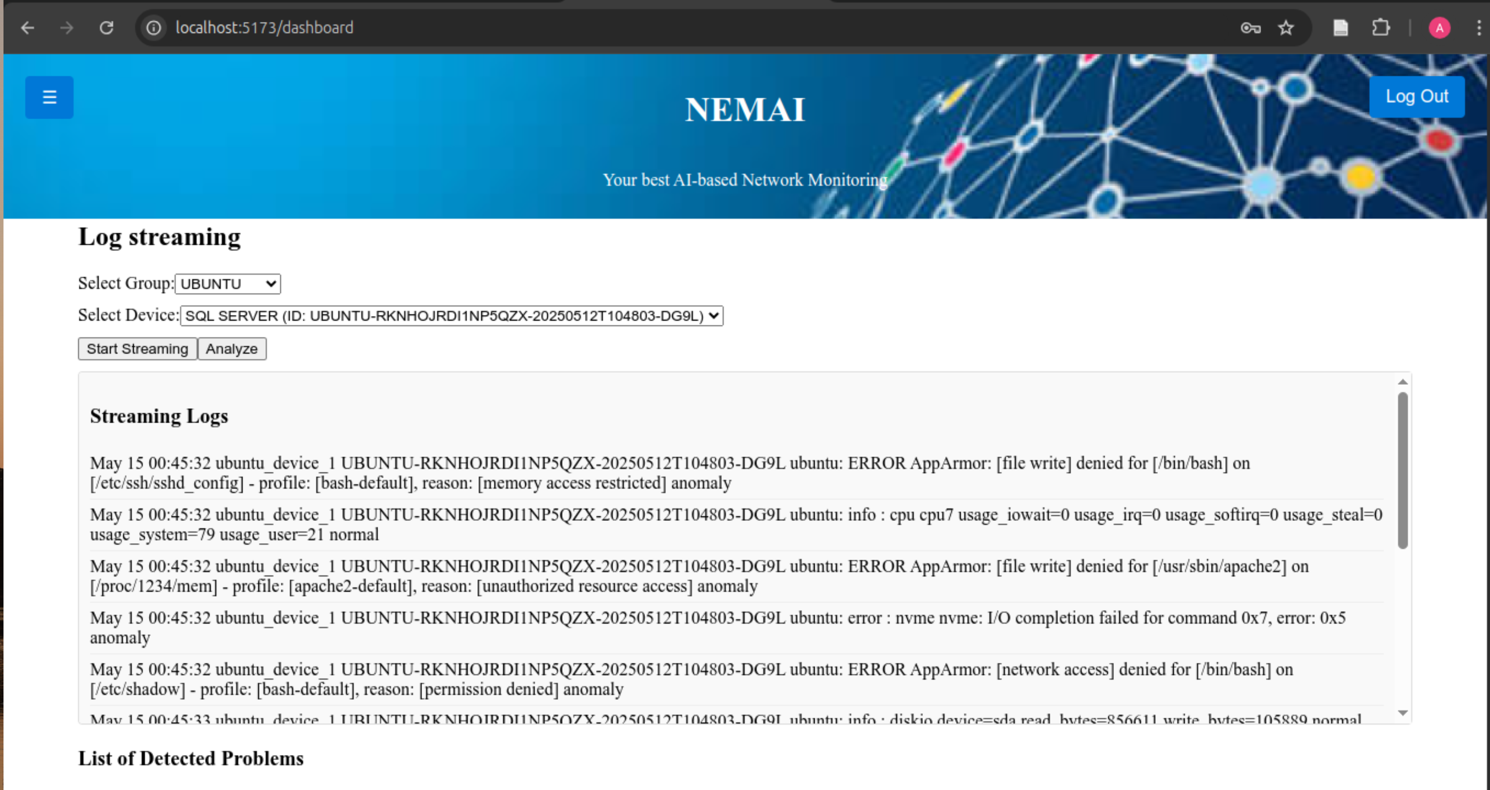
Figure 7 Log Streaming
Figure 7 shows the real time streaming of logs for a selected device. This helps to know if the device is actually connected and sending its logs to the system . Devices are assigned unique identities (ID) when they are added to the system, and this unique ID when configured in the targeted device will be received together with the logs.

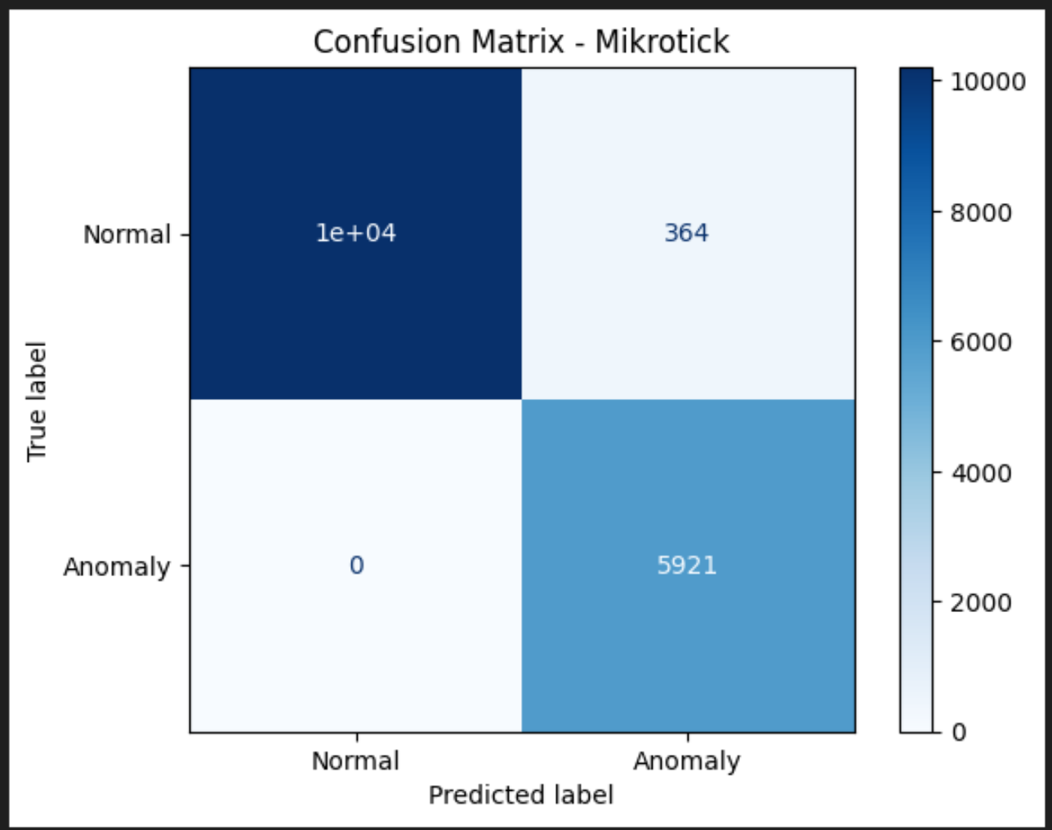
Figure 8 Model Performance
Figure 8 is a confusion matrix for the model obtained during testing. Anomalies that were detected as anomalies are 5921,anomalies that were detected as normal are 364 and normal that was detected as normal are 10 000, normal that were detected as anomaly were 0.
Precision recall and F1 Score are provided to measure the models performance and accuracy in identifying true anomalies versus false positives/negatives.
In network device logs, some logs are frequent but still critical. For example a log "device overheating" is not rare in a network system but is critical. Hence these become not anomalies in the rare sense but anomalies in the semantic way and may require immediate action.
Limitations in coverage: Even with diversifying the log data, the dataset remained non-exhaustive. There was a lack of logs coming from certain device types or from rare failure scenarios, and this might hinder the model's ability to generalise well in the much broader real world.
The researchers focused on common network events and device types which becomes a limit when considering rare or device specific failures, researcher acknowledges there is need for a deep intrusion into this scenario where we expand data collection to include a wider range of device models and network conditions
The researcher acknowledges that human in the loop evaluation was not done in this study, alternatively the researcher carried out a qualitative analysis of the LLM outputs by manually assessing the clarity and relevance of the generated explanations and recommendations serving as the initial validation of the systems usefulness, in future work we plan to include experts input evaluation to quantify satisfaction providing real relevance of the systems real world impact.

Adoption of transformer-based models: Considering models like BERT or Distil BERT could help better understand log messages at a semantic level. These models take into account word order and context, making them more effective at identifying unusual patterns—especially in complex or structured logs. Context-sensitive anomaly detection: Instead of treating each log entry in isolation, developing methods that analyse sequences of events (such as with LSTMs or Transformer-based encoders) could uncover anomalies that only appear when considering the flow of previous actions. Taking into account context meaning can improve accuracy. This learning approach can refine the model and reduce false positives with continued use.

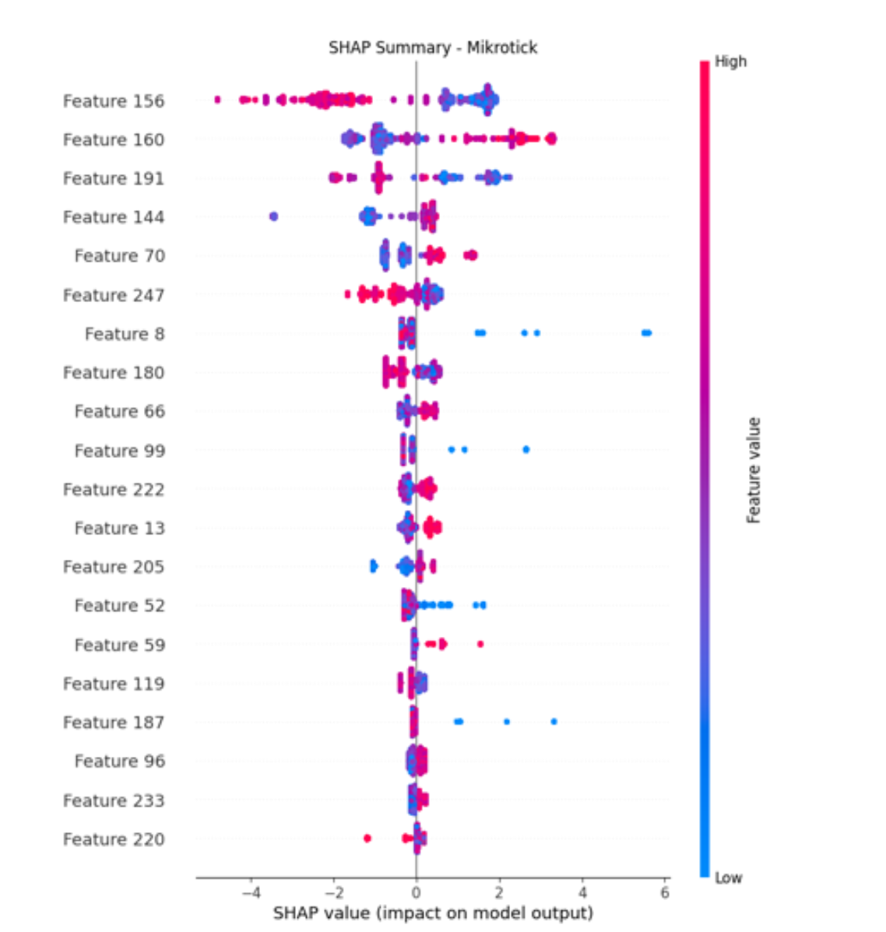
Figure 9 SHAP Summary
Figure 9 shows the impact of each feature on the model. Y-axis is the feature name and X-axis is the SHAP value, red means high feature value and blue means low feature value, the positive pushes prediction towards anomaly while the negative pushes prediction towards normal, those close to zero have low impact on the prediction which features a dominance in the prediction process. Features 156 and 160 have the highest impact on predictions.

Discussions and Future Work
This research focused on the importance and need for proactive network monitoring through ML and NLP driven log analysis. Traditional reactive approaches are not sufficient enough because of delayed ETRs leading to financial losses and business operation distraction. This gap was addressed by introducing a proactive network monitoring tool based on anomaly detection and pattern analysis through semantic understanding. The use of custom generated log data, which had been extracted from real world networks, made sure that the training set was close to real world data though there is no claim of exhaustion of the different logs.
In the current implementation, inference is only done upon user request and not continuously, the system real time component is on log streaming and only when a user selects to monitor the device. On latency the major factor influencing latency is on the network infrastructure itself that is looking at bandwidth, routing efficiency, among other network concepts and also device performance, the models inference time is minimal relative to delays in the network since they are invoked asynchronously, future work plans to accommodate log categorization on real time log streaming and real time anomaly flagging. Currently anomaly flagging is not real time per say as logs are processed in batches after being received by the server
The researcher acknowledges that the study lacks empirical testing and real world network data sets due to dataset scarcity, to mitigate this we used synthetic generated logs from authentic network templates to approximate realistic behaviour.
In the current study we focused on XGBoost in combination with other mentioned tools, for anomaly detection and did not include a comparison with random forest or LSTM models, researcher acknowledge that such comparison will be most useful in providing additional context on model performance and trade-offs. In future work such comparison need to be carried out to strengthen the empirical evaluation and reveal the advantages of our approach.
Future work should explore Transformer models like BERT LSTM and further train them on domain specific space to be understood.
Proprietary models: The use of commercial APIs does introduce operational costs, in this project the LLM component is only triggered when an anomaly is found /detected and an explanation is required, hence reducing API calls and operational costs
Reproducibility: The dependence on proprietary models can sure limit reproducibility due to changes in API behaviour or access policies, To reduce its effects, all API configurations will be documented that’s, the models, versions and prompts used in the study.in addition to this the system supports interchangeability with open source LLMS given all is in accordance to be able to use them for future offline operation.
Data/Privacy and Security: In this study the issue of data privacy had been overlooked, a consideration can be done that data is normalized before being sent to external API calls, data specific components such as person identification, network information (IP addresses or user identifiers) is stripped off and replaced with placeholders. For secured transmission API calls happen over secure https connections ensuring secured data confidentiality, these steps will make sure the study is in accordance to the privacy policy guidelines when using third party AI services

Conclusion
In conclusion, the project demonstrates a practical way to intelligent network monitoring involving machine learning, natural language and real-time log analysis, with further developments, the system can advance into an effective assistant for proactive network management.
References
[1] F. Liu, B. Farkiani, and P. Crowley, “Llms for Computer Networking Operations & Management: A Survey on Applications, Key Techniques, and Opportunities,” 2024, SSRN. doi: 10.2139/ssrn.5074973.
[2] D. L. Vajda, T. V. Do, T. Bérczes, and K. Farkas, “Machine learning-based real-time anomaly detection using data pre-processing in the telemetry of server farms,” Sci. Rep., vol. 14, no. 1, p. 23288, Oct. 2024, doi: 10.1038/s41598-024-72982-z.
[3] S. Mukherjee, “Machine Learning Methodologies for Beyond 5G and 6G Heterogeneous Networks: Prediction, Automation, and Performance Analysis,” 2024.
[4] F. Liu, B. Farkiani, and P. Crowley, “A Survey on Large Language Models for Network Operations & Management: Applications, Techniques, and Opportunities,” Dec. 10, 2024, Preprints. doi: 10.36227/techrxiv.173386065.57486944/v1.
[5] F. Wang, Y. Jiang, R. Zhang, A. Wei, J. Xie, and X. Pang, “A Survey of Deep Anomaly Detection in Multivariate Time Series: Taxonomy, Applications, and Directions,” Sensors, vol. 25, no. 1, p. 190, Jan. 2025, doi: 10.3390/s25010190.
[6] F. Vitale, F. De Vita, N. Mazzocca, and D. Bruneo, “A Process Mining-based unsupervised Anomaly Detection technique for the Industrial Internet of Things,” Internet Things, vol. 24, p. 100993, Dec. 2023, doi: 10.1016/j.iot.2023.100993.
[7] A. H. Shah, D. Pasha, E. H. Zadeh, and S. Konur, “Automated Log Analysis and Anomaly Detection Using Machine Learning,” in Frontiers in Artificial Intelligence and Applications, A. J. Tallón-Ballesteros, Ed., IOS Press, 2022. doi: 10.3233/FAIA220378.
[8] C. Cao, F. Wang, L. Lindley, and Z. Wang, “Managing Linux servers with LLM-based AI agents: An empirical evaluation with GPT4,” Mach. Learn. Appl., vol. 17, p. 100570, Sep. 2024, doi: 10.1016/j.mlwa.2024.100570.
[9] J. Cândido, M. Aniche, and A. Van Deursen, “Log-based software monitoring: a systematic mapping study,” PeerJ Comput. Sci., vol. 7, p. e489, May 2021, doi: 10.7717/peerj-cs.489.
[10] J. Cândido, M. Aniche, and A. Van Deursen, “Log-based software monitoring: a systematic mapping study,” PeerJ Comput. Sci., vol. 7, p. e489, May 2021, doi: 10.7717/peerj-cs.489.
[11] Y. Zhang, “Design and Implementation of a Computer Network Log Analysis System Based on Big Data Analytics,” Adv. Comput. Signals Syst., vol. 8, no. 6, 2024, doi: 10.23977/acss.2024.080607.
[12] S, Partovian, A. Bucaioni, F. Flammini, & J. Thornadtsson. (2023). ‘Analysis of log files to enable smart-troubleshooting in industry 4.0: a systematic mapping study’. IEEE Access, 12, 147640-147658.
[13] S. H. Kendyala, (2023). High Availability Strategies for Identity Access Management Systems in Large Enterprises. Available at SSRN 5074869.

