SENSOR FINGERPRINTING–BASED GAS IDENTIFICATION USING ARTIFICIAL INTELLIGENCE
ABSTRACT
Accurate identification of hazardous gases remains a critical challenge in environmental monitoring due to the limitations of single-sensor and threshold-based systems. This work presents an intelligent gas identification approach based on sensor fingerprinting and embedded artificial intelligence. A multi-sensor array comprising MQ-series sensors is used to capture distinct response patterns generated by different gases. These patterns are preprocessed and analyzed using a lightweight TinyML model deployed on an ESP32 microcontroller for on-device classification. The system enables real-time detection, local visualization, and wireless transmission of gas data for remote monitoring. An integrated alert mechanism enhances safety by providing immediate warnings when abnormal conditions are detected. The proposed solution offers a compact, low-cost, and scalable framework suitable for smart environments, industrial safety, and IoT-based monitoring applications.
Keywords: Gas Identification, Sensor Fingerprinting, TinyML, ESP32
INTRODUCTION
Artificial Intelligence (AI) and Machine Learning (ML) play a vital role in developing intelligent monitoring systems by enabling data-driven decision-making. In gas detection applications, ML techniques can analyze complex sensor patterns to accurately identify different gases. The availability of low-power embedded platforms and lightweight models has made it possible to implement such intelligent systems in real-time environments. This paper focuses on applying AI-based techniques to improve gas identification accuracy using sensor fingerprinting and embedded processing.
MACHINE LEARNING MODEL (DECISION TREE):
In this work, a Decision Tree algorithm is used for gas classification due to its simplicity and effectiveness in handling sensor data. A Decision Tree is a supervised learning method that makes decisions based on a series of conditions derived from input features. The model analyzes sensor readings from the multi-gas array and splits the data into branches based on threshold values, forming a tree-like structure. Each leaf node represents a predicted gas type. This approach enables fast and interpretable classification, making it suitable for real-time implementation on embedded systems like ESP32.
LITERATURE REVIEW
Several research works have been carried out in the field of gas detection and environmental monitoring. ^{[5]} Traditional systems mainly rely on MQ-series gas sensors combined with microcontrollers to detect gas leakage based on predefined threshold values. While these systems are effective for detecting the presence of a specific gas, they lack the ability to distinguish between multiple gases and often result in false alarms under varying environmental conditions.^{[4]} Recent studies have focused on integrating IoT technologies for real-time monitoring and remote data visualization. These systems enable users to monitor gas levels through mobile applications or cloud platforms. However, most of these approaches concentrate only on data transmission and do not include intelligent analysis for gas classification.^{[1]} Some advanced approaches utilize image-based smoke detection or smart sensing technologies, but they are limited to specific applications and require higher computational resources. Moreover, they are not suitable for detecting invisible gases.
To overcome these limitations, the proposed system introduces an AI-based gas identification approach using sensor pattern analysis and a multi-gas sensor array. By applying a Decision Tree model on embedded hardware, the system achieves accurate and real-time gas classification, improving reliability and safety in various applications.

PROPOSED SYSTEM
The proposed system presents an intelligent gas identification approach using a combination of a multi-gas sensor array, embedded processing, and machine learning techniques. Unlike conventional systems that rely on single sensors and fixed threshold values, this system utilizes multiple MQ-series sensors (MQ2, MQ4, MQ7, MQ135) to capture distinct response patterns from different gases. These patterns, referred to as sensor fingerprints, provide more detailed information for accurate gas identification.
The sensor data is continuously collected and processed using an ESP32 microcontroller, which performs signal conditioning and normalization to ensure reliable readings. A Decision Tree–based machine learning model is trained using these sensor fingerprints and deployed on the ESP32 using TinyML techniques. This enables real-time gas classification directly on the device without the need for external computing resources.
The system also incorporates wireless communication through Wi-Fi or Bluetooth, allowing real-time monitoring via a mobile application. The identified gas type and its safety status are displayed locally, and an alert mechanism is triggered when hazardous gas levels are detected. The proposed system is designed to be low-cost, portable, and efficient, making it suitable for applications in industrial safety, smart homes, environmental monitoring, and smart city systems.

Figure 1: Block Diagram of Proposed System
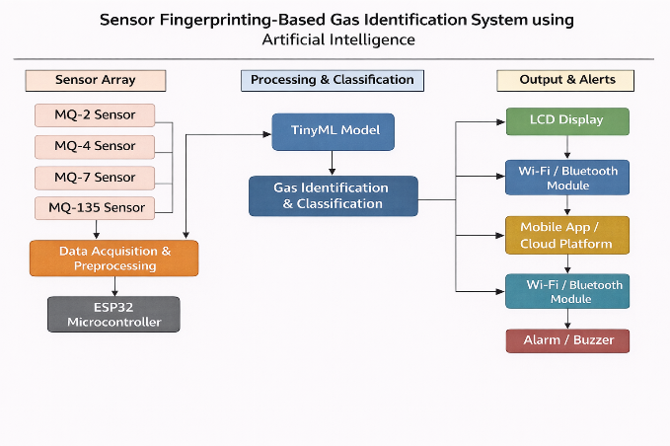
METHODOLOGY:
The development of the proposed gas identification system follows a systematic approach to ensure accurate detection and classification of gases. Initially, a multi-gas sensor array consisting of MQ2, MQ4, MQ7, and MQ135 sensors is selected to capture different gas characteristics. These sensors are interfaced with an ESP32 microcontroller, which acts as the central processing unit for data acquisition.
The sensor outputs are continuously collected in real time and undergo preprocessing steps such as signal conditioning and normalization to improve data quality. The processed sensor data forms unique patterns, known as sensor fingerprints, which are used for training the machine learning model.
A Decision Tree algorithm is trained using the collected dataset to classify different gases based on their sensor response patterns. Once the model is trained and validated, it is deployed on the ESP32 using TinyML techniques for real-time inference.
During operation, the system continuously monitors gas levels, processes incoming sensor data, and predicts the type of gas present. The results are displayed on a local interface and transmitted wirelessly to a mobile application for remote monitoring. Additionally, an alert mechanism is triggered whenever hazardous gas levels exceed safe limits, ensuring timely warning and improved safety.

RESULT
The proposed system was tested using different gases, and the sensor responses were recorded and analyzed using the Decision Tree model. The system successfully classified gases based on sensor fingerprint patterns. The results obtained are shown in Table 1.
The results indicate that the system can accurately classify different gases using sensor fingerprinting. The Decision Tree model provided reliable predictions with high accuracy. The system also responded quickly in real-time, and the alert mechanism was activated when hazardous gases were detected.
Table 1: Gas Detection and Classification Results
Gas Type | Sensor Response Pattern | Predicted Output | Accuracy (%)
LPG | High (MQ2, MQ135) | LPG | 95%
Methane | High (MQ4) | Methane | 93%
Carbon Monoxide | High (MQ7) | CO | 94%
Clean Air | Low (All Sensors) | Normal Air | 97%
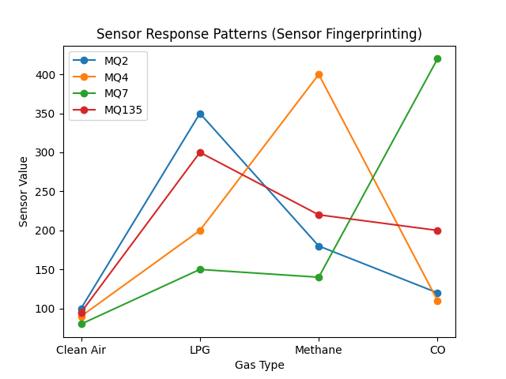
Figure 2: Gas Classification Accuracy using Decision Tree Model

Output :
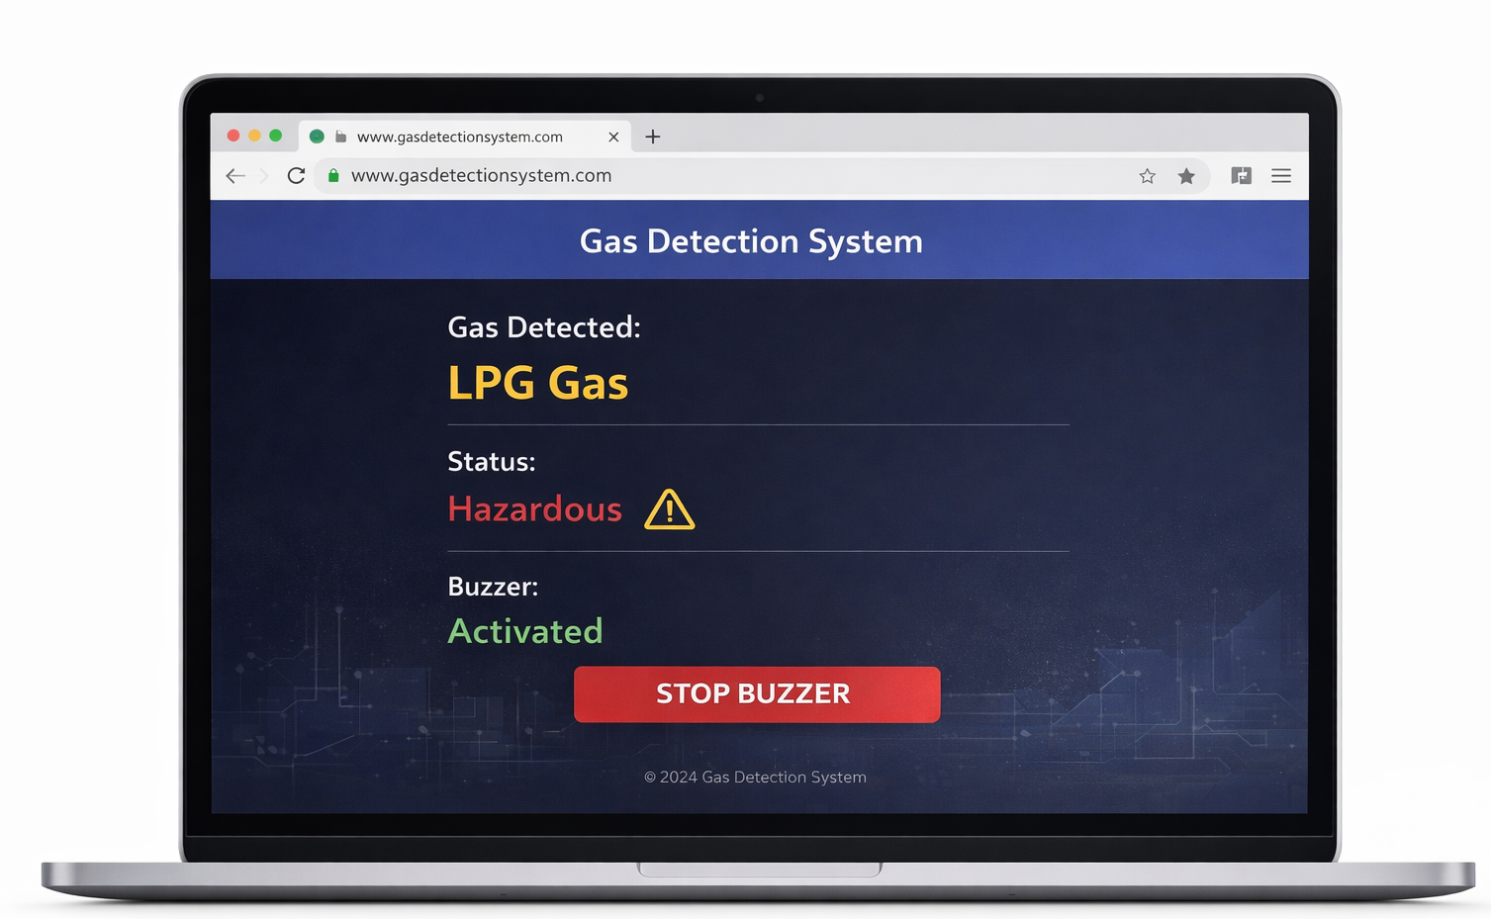
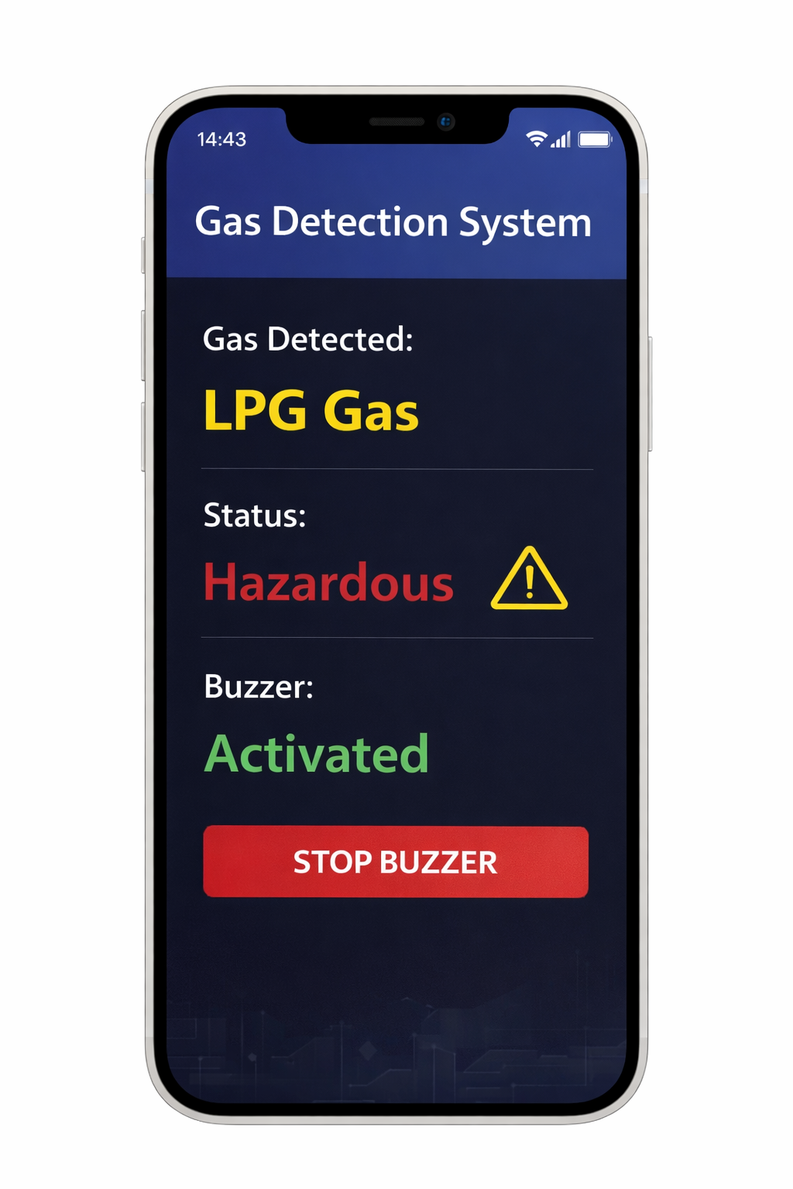

Figure 3: Mobile Application Interface Figure 4: Web Application Interface for Gas Detection
for Gas Detection System System

CONCLUSION
The proposed Sensor Fingerprinting–Based Gas Identification System using Artificial Intelligence provides an effective solution for accurate and real-time gas detection. By utilizing a multi-gas sensor array and a Decision Tree–based machine learning model, the system overcomes the limitations of conventional single-sensor and threshold-based approaches. The integration of TinyML on the ESP32 enables fast, on-device processing without relying on external computation.
The system successfully identifies different gases based on their unique sensor response patterns and provides timely alerts to ensure safety. Its ability to support wireless monitoring through mobile and web applications further enhances usability and accessibility. Overall, the system is cost-effective, portable, and suitable for applications in industrial safety, smart homes, and environmental monitoring.
Future improvements can include the use of advanced machine learning models, improved sensor calibration, and cloud-based analytics to further enhance accuracy and scalability.
REFERENCES
- U. Lee, Y. Ku, C. Lee, and Y. Koh, “Smart Sensing Technologies for Environmental Monitoring,” Journal of Smart Systems, 2023.
- V. Rathod, H. Ohal, and M. Fatangare, “Wireless Sensor Monitoring System for Industrial Safety Applications,” International Journal of Innovative Technology, 2023.
- A. Sreedher, N. Pravin, H. Nair, and P. P. Lakshmi, “IoT Based Smart Monitoring System Using Multiple Sensors,” International Journal of Smart Healthcare Systems, 2022.
- S. Kumar and R. Sharma, “IoT Based Air Quality Monitoring System,” IEEE Conference on Smart Systems, 2021.
- A. Patel and M. Verma, “Gas Leakage Detection Using MQ Sensors,” International Journal of Electronics Engineering, 2020.
- I. W. Mustika, F. Y. Zulkifli, and A. N. A. Yusuf, “Monitoring for Better Life Experience (Mooble): Smart Monitoring System Design,” International Journal of Smart Health Systems, 2018.
- Dr.J.Sampathkumar, N Malmurugan, “HELP-WSN-A Novel Adaptive Multi-Tier Hybrid Intelligent Framework for QoS Aware WSN-IoT Networks”, Computers,Materials & Continua 71 (2), 2107-2123

