A Risk-to-Action Framework for Questionnaire-Based Lung Cancer Risk Assessment and Clinical Recommendation

Abstract
Lung cancer is a major contributor to global cancer mortality, largely because many cases are detected at advanced stages and early screening services are not widely accessible. Timely recognition of warning symptoms and lifestyle-related risk factors can help improve clinical outcomes. This research presents an intelligent questionnaire-driven system for preliminary lung cancer risk assessment. The developed mobile application gathers demographic information, lifestyle patterns, and commonly observed symptoms including smoking habits, persistent cough, chest discomfort, and breathing difficulty. Based on predefined clinical rules and risk evaluation logic, the system categorizes users into Low, Moderate, or High-risk groups and generates suitable health guidance. An embedded AI Chabot enhances user support by responding to symptom-related questions and promoting awareness. The proposed solution provides an affordable, non-invasive, and user-friendly approach for early risk screening, particularly in regions with limited medical resources.

Keywords
Lung Cancer Risk Prediction, Symptom-Based Assessment, Clinical Decision Support System, Rule-Based Prediction Model, Lifestyle Risk Factors, Early Cancer Detection, Health Questionnaire System, Medical Risk Assessment, Patient Screening System, Healthcare Informatics, AI Chatbot, Mobile Health Application.
Introduction
Lung cancer continues to be a serious public health issue and remains among the primary causes of cancer-related mortality across the world. A large number of patients are identified only after the disease has progressed to later stages, which limits treatment options and lowers survival chances. For this reason, early recognition of risk indicators is important to support timely diagnosis and medical care. However, standard diagnostic procedures such as CT imaging and laboratory investigations often depend on costly infrastructure, advanced equipment, and trained healthcare personnel, making them less accessible in many locations.
Multiple factors are associated with an increased likelihood of developing lung cancer, with tobacco use being the most dominant contributor. Additional causes include second-hand smoke exposure, environmental pollution, workplace hazards, and poor lifestyle practices. Monitoring these factors can help in identifying individuals who may require further screening or clinical attention.
This work introduces a questionnaire-based lung cancer risk assessment system developed as a mobile application for preliminary evaluation. The platform gathers demographic details, symptom history, and lifestyle-related information, then applies predefined rule-based logic to classify users into different risk levels. Based on the generated result, the system provides guidance for further medical consultation. To improve usability and awareness, an AI chatbot has also been integrated to answer common health-related queries. The proposed application is designed as an affordable, simple, and accessible solution for early-stage risk screening.

Literature Survey
Several studies have explored the influence of lifestyle, environmental, and clinical factors on lung cancer risk. Smoking is widely recognized as the primary cause, while air pollution, workplace exposure, and unhealthy habits also increase the chances of developing the disease. Earlier research mainly used statistical methods to determine the association between these risk factors and cancer incidence. Lately, machine learning methods such as Logistic Regression and Random Forest have been applied to improve prediction performance using medical datasets. While these methods can offer accurate predictions, they often depend on large volumes of data and higher computational resources. In comparison, questionnaire-based systems offer a simpler and more practical solution by using symptom and lifestyle information. However, there remains a need for an approach that is both efficient and easy to implement. Accordingly, this research presents a questionnaire-based risk assessment system that can be further enhanced in the future through the incorporation of clinical data to improve reliability.

Comparison of Existing Studies and Research Gaps

Ref. No. | Focus of Study | Key Findings | Research Gap
[1] | Symptom based lung cancer prediction using ensemble learning | Ensemble learning models showed high accuracy using symptom and demographic data, but require trained models and datasets, which may limit use in simple healthcare applications. | Requires machine learning models and  training datasets, which  may limit accessibility in simple healthcare applications.
[2] | Analysis of lifestyle factors such as  smoking, diet, and  obesity among cancer  patients | The study found that smoking plays a major role in increasing lung cancer risk, and lifestyle factors were strongly related to cancer prevalence. | Focuses on statistical analysis of patient data analysis, but it does not provide an automated screening or prediction system.
[3] | Epidemiological study analysing demographic and lifestyle risk factors | Smoking, biomass fuel exposure, and rural  lifestyle was identified as significant contributors to lung cancer incidence. | Focuses on clinical observation and risk factor analysis without proposing a digital risk assessment system.
[4] | Questionnaire-based  statistical risk  assessment of lung cancer | Smoking and previous lung disease were  identified as major risk factors affecting lung cancer incidence. | The study emphasizes risk scoring and awareness but does not implement a digital health screening system.

Methodology / Proposed System

(a) System Overview
The proposed system is a rule-based lung cancer risk assessment tool that evaluates responses from a structured questionnaire including demographic information, lifestyle factors, and symptom indicators. The objective is to perform preliminary risk assessment and guide users to seek medical consultation when necessary. The system does not replace clinical diagnosis; rather, it serves as an early screening aid.

(b) Data Collection via Structured Questionnaire
User information is collected through a questionnaire designed from commonly reported lung cancer risk factors in the literature. The questionnaire includes three groups of variables:

1. Demographic Information
- Age
- Gender
- Residential environment (urban / rural)

2. Lifestyle Risk Factors
- Smoking status (active/passive)
- Alcohol consumption
- Exposure to indoor pollution or biomass fuel
- Occupational/environmental exposure

3. Clinical Symptoms
- Persistent cough
- Chest pain
- Shortness of breath
- Wheezing
- Difficulty swallowing
- Fatigue or unexplained weight loss
Each question is intended to identify the presence or absence of risk factors and symptoms commonly linked to lung cancer.
(c) Rule-Based Risk Evaluation

The system uses predefined clinical rules to analyse user responses. Each symptom or risk factor is assigned a score based on its importance. Factors such as smoking, persistent cough, chest pain, and breathing difficulty receive higher scores. The total score is calculated by adding all values and is used to determine the overall lung cancer risk level. This method provides a simple and effective approach for preliminary screening.

(d) Risk Classification
Based on the calculated score, the system categorizes users into different risk levels:
Risk Score Range | Risk Level | Recommendation
Low score | Low risk | Maintain healthy lifestyle and monitor symptoms
Moderate score | Medium risk | Seek medical advice and perform routine check-up’s
High score | High risk | Immediate medical consultation recommended

This classification allows users to understand their potential risk level quickly.
(e) System Architecture
The system architecture of the proposed model is shown in the figure above. It consists of multiple layers that work together to process user inputs and generate risk predictions.
• The User Interface Layer collects responses through a questionnaire.
• The Application Logic Layer processes the input data and applies rule-based evaluation.
• The Risk Evaluation Module calculates the overall risk score based on predefined conditions.
• The Result Generation Module displays the final risk level along with recommended actions.
This layered architecture ensures a structured and efficient flow
of data from input collection to final output.
(f) AI Health Assistant Module
An AI Chabot is integrated into the application to answer common health-related queries, explain symptoms, provide awareness guidance, and improve user engagement.

System Implementation
The proposed lung cancer risk prediction system was implemented as a questionnaire-based screening application that evaluates user responses using predefined rules. The system collects information related to demographic characteristics, lifestyle habits, and common clinical symptoms associated with lung cancer. Based on these inputs, the system processes the responses through a rule-based evaluation module and provides a risk assessment result.

(a) User Interface Module
The user interface is responsible for interacting with the user and collecting the required information through a structured questionnaire. The interface displays a sequence of questions related to lifestyle factors and medical symptoms. To improve usability, the system follows an adaptive question flow where certain questions appear only when relevant responses are provided. This reduces unnecessary inputs and improves the user experience.
(b) Rule-Based Evaluation Module
The core component of the system is the rule-based evaluation module. This module applies predefined medical rules to calculate a cumulative risk score. Each risk factor or symptom contributes a specific score depending on its clinical relevance. For example, smoking and persistent respiratory symptoms contribute higher scores compared to less significant factors. The total score represents the user's overall lung cancer risk level.
(c) Data Processing Module
The collected responses are processed and validated before being passed to the risk evaluation module. This module ensures that all required fields are completed and that the responses are in a valid format. The validated data is then prepared for further analysis.
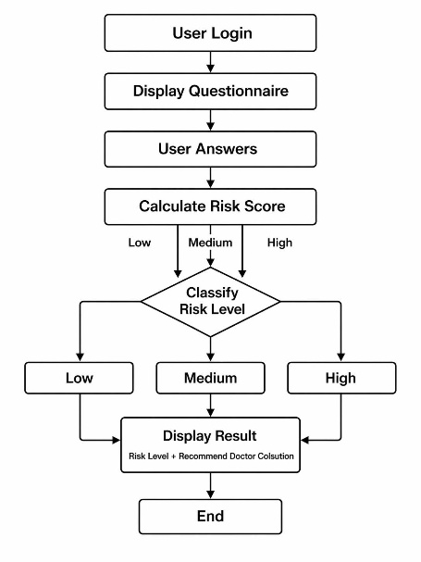

(d) Risk Classification Module
After calculating the total risk score, the system classifies the user into different risk categories such as Low Risk, Moderate Risk, or High Risk. Each category is associated with a specific recommendation, ranging from lifestyle monitoring to immediate medical consultation.

(e) Result Generation
The final output of the system is presented to the user in a clear and understandable format. The result includes the calculated risk level along with guidance on the next steps, such as seeking professional medical advice if the risk level is moderate or high.
(f) AI Chabot Module
An AI Chabot is integrated into the application to provide instant responses to user health-related queries. It helps users understand symptoms, risk factors, preventive measures, and general awareness regarding lung cancer. The Chabot improves user engagement and provides 24/7 assistance in an interactive manner.

Results and Discussion
The proposed lung cancer risk prediction system was evaluated by testing different user scenarios based on combinations of symptoms and lifestyle risk factors. The system processes the questionnaire responses using the rule-based evaluation algorithm and generates a risk score that determines the user’s risk category.

(a) System Output
The developed mobile application provides an easy-to-use platform for lung cancer risk assessment. After login, the dashboard shows the latest risk status, reports, awareness section, and AI Health Assistant. After completing the questionnaire, the system analyses user responses and generates a risk score. Based on the score, users are classified into Low Risk, Moderate Risk, or High-Risk categories. The result is displayed with percentage score, graphical indicator, and health recommendations. The application also stores previous results in the Health Summary section for future reference. In addition, an AI Chabot is integrated to answer user queries related to symptoms and health awareness.
Sample outputs of the developed system are shown in Figure 1 to Figure 5.
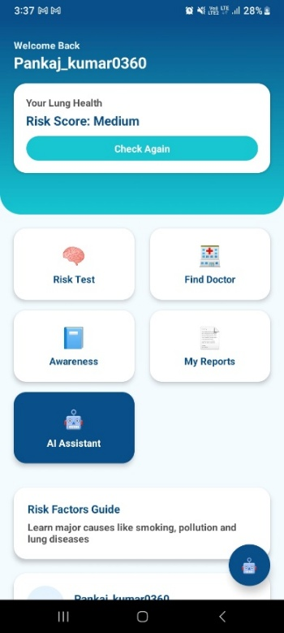
Figure 1:
Home dashboard of the proposed lung cancer risk prediction application showing user profile, latest risk score, quick navigation modules, awareness section, reports section, and AI Assistant access.
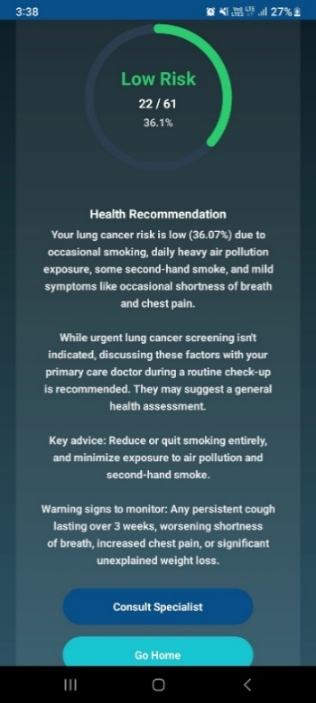
Figure 2:
Low-risk prediction result screen displaying calculated risk percentage, graphical risk indicator, personalized health recommendations, warning signs to monitor, and specialist consultation option.
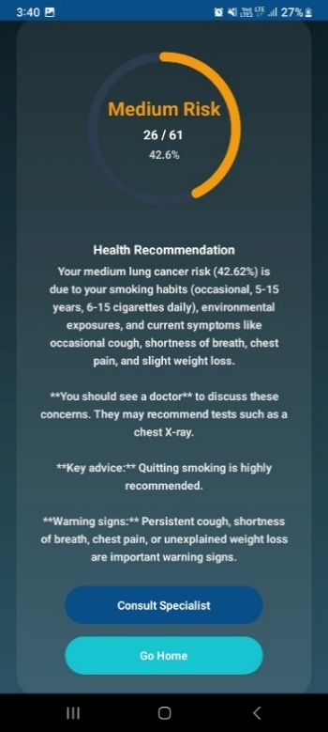
Figure 3:
Moderate-risk prediction result screen displaying medium risk percentage, advisory recommendations, preventive guidance, symptom monitoring alerts, and consultation option.
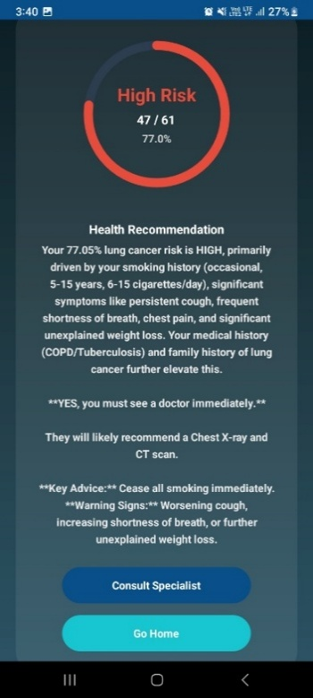
Figure 4:
High-risk prediction output screen showing elevated risk percentage with urgent medical recommendations, warning symptoms, and direct consultation support for specialist referral.

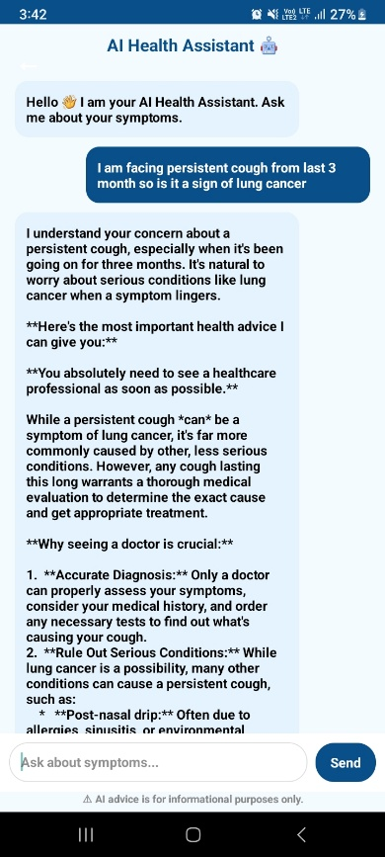
Figure 5:
AI Health Assistant Chabot interface providing interactive responses to user health queries, symptom guidance, awareness support, and informational medical assistance in real time.

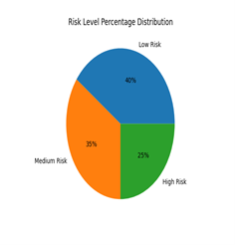
“The graphical representation of risk distribution is shown below.”
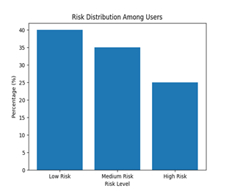
The distribution of users across different risk levels was analysed to understand system performance. It was observed that approximately 40% of users fall under the Low-risk category, 35% under medium risk, and 25% under High risk. This distribution indicates that the system is capable of effectively classifying users based on their symptoms and lifestyle conditions.
The results demonstrate that the system can differentiate between different risk levels based on the presence of symptoms and risk factors.

(b) Discussion
The proposed system provides a simple and accessible method for preliminary lung cancer risk assessment. Unlike complex machine learning approaches, it uses a rule-based method that is easy to implement and understand. The adaptive questionnaire improves usability by asking only relevant follow-up questions.
The system considers common risk factors such as smoking, respiratory symptoms, and environmental exposure. By analysing these factors, it helps identify users who may need further medical evaluation. Although it cannot replace professional diagnosis, the system can serve as an early screening and awareness tool, especially in areas with limited healthcare facilities. Logistic Regression achieved 75% accuracy and Random Forest achieved 74%, while a hybrid model showed better overall performance. This suggests that combining rule-based logic with machine learning can improve future results.
Conclusion
Lung cancer is one of the leading causes of cancer-related deaths worldwide, mainly because it is often diagnosed at a late stage and early screening facilities are limited. Early identification of symptoms and risk factors can improve treatment outcomes significantly. In this project, a lung cancer risk prediction application was developed as an intelligent and user-friendly tool for preliminary screening.
The system uses a structured questionnaire to collect information related to demographic details, lifestyle habits, and common symptoms. Based on the responses, an AI-based prediction module analyses the data, calculates a risk score, and classifies users into Low Risk, Moderate Risk, or High-Risk categories. The application also includes an AI Chabot that interacts with users, answers common health-related queries, provides guidance about symptoms, and improves overall user engagement.
The proposed system is simple to use and does not require expensive diagnostic tools or complex medical procedures. It can serve as an awareness, assistance, and early screening platform, especially in rural and semi-urban areas where healthcare resources may be limited. In the future, the system can be enhanced further by integrating advanced machine learning models and real clinical datasets to improve prediction accuracy and Chabot intelligence.
References
[1] Y. A. Husaini, “Symptom-Based Lung Cancer Prediction Using Ensemble Learning with Threshold Optimization and Interpretability,” Information, vol. 17, no. 2, p. 172, 2026, doi: 10.3390/info17020172.
[2] A. Marof, M. Al-Amin, M. S. Sultana, K. N. Konika, M. S. Roky, S. Shiddiqe, and A. Ud-Daula, “Assessment of the Relationship Between Cancer Prevalence and Lifestyle Risk Factors in Bangladesh: A Cross-Sectional Study at a National Cancer Hospital,” South Asian Journal of Public Health, vol. 13, no. 4, 2025, doi: 10.11648/j.sjph.20251304.14.
[3] S. N. Manjunath, I. V. Madabhavi, M. S. Sarkar, and S. S. Kaushal, “Risk Factor Profile of Lung Cancer Patients: A Study from the Himalayan State of Indian Subcontinent,” Asian Pacific Journal of Cancer Care, vol. 7, no. 2, pp. 239–246, 2022, doi: 10.31557/APJCC.2022.7.2.239-246.
[4] R. F. Mukti, P. D. Samadder, A. A. Emran, F. Ahmed, I. B. Imran, A. Malaker, and S. Yeasmin, “Score-Based Risk Assessment of Lung Cancer and Its Evaluation for Bangladeshi People,” Asian Pacific Journal of Cancer Prevention, 2014.
[5] R. L. Siegel, K. D. Miller, and A. Jemal, “Cancer Statistics, 2023,” CA: A Cancer Journal for Clinicians, 2023, doi: 10.3322/caac.21763.
[6] H. Sung, J. Ferlay, R. L. Siegel, et al., “Global Cancer Statistics 2020: GLOBOCAN Estimates of Incidence and Mortality Worldwide,” CA: A Cancer Journal for Clinicians, 2021, doi: 10.3322/caac.21660.
[7] World Health Organization, “Lung Cancer Factsheet,” 2023. [Online]. Available: https://www.who.int
[8] American Cancer Society, “Key Statistics for Lung Cancer,” 2023. [Online]. Available: https://www.cancer.org
[9] K. Kourou, et al., “Machine Learning Applications in Cancer Prognosis and Prediction,” Computational and Structural Biotechnology Journal, 2015, doi: 10.1016/j.csbj.2015.01.005.
[10] A. Esteva, et al., “A Guide to Deep Learning in Healthcare,” Nature Medicine, 2019, doi: 10.1038/s41591-018-0316-z.

