A Novel Polyherbal Cream for Melasma: Design, Characterization
ABSTRACT
Melasma is a chronic hyperpigmentation disorder characterized by symmetrical brown to greyish patches on sun-exposed areas of the skin, particularly affecting women with darker skin types. Although not harmful, it significantly impacts aesthetic appearance and psychological well-being. The condition arises due to increased melanogenesis triggered by ultraviolet (UV) radiation, hormonal influences, genetic predisposition, and oxidative stress. Conventional treatments such as hydroquinone, retinoids, and corticosteroids are commonly used but are often associated with adverse effects, limiting their long-term application.
The present study focuses on the formulation and evaluation of a herbal cream as a safer and effective alternative for melasma management. The cream was developed using natural ingredients including aloe vera, rose water, licorice extract, almond oil, shea butter, vitamin E, and emulsifying wax. These ingredients possess antioxidant, anti-inflammatory, moisturizing, and tyrosinase-inhibiting properties, which collectively help in reducing melanin production, protecting against UV-induced damage, and improving overall skin health.
The formulation was prepared using the oil-in-water (O/W) emulsion method and evaluated for various physicochemical parameters such as pH, spreadability, washability, texture, homogeneity, and irritancy. The results indicated that the cream had a smooth texture, good spreadability, excellent washability, and a skin-friendly pH of 5.60. No irritation or phase separation was observed, confirming its stability and safety.
In conclusion, the developed herbal cream demonstrated promising characteristics and can be considered a safe, effective, and economical alternative for the management of melasma with minimal side effects and improved patient compliance.

KEYWORDS: Melasma, Herbal cream, Hyperpigmentation, Tyrosinase inhibition, Antioxidant, Skin depigmentation, Aloe vera, Licorice extract, almond oil

INTRODUCTION
Melasma is a chronic, acquired hyperpigmentation disorder (Fig. 1–a, b) characterized by symmetrical, irregularly shaped brown to greyish-brown macules and patches, predominantly affecting sun-exposed areas of the skin such as the cheeks, forehead, nose, and upper lip¹. It is more commonly observed in women, particularly those with darker skin types (Fitzpatrick skin types III–V), and is frequently associated with hormonal changes during pregnancy, oral contraceptive use, and hormone replacement therapy. Although melasma is not medically harmful, it poses a significant cosmetic concern and can negatively impact the psychological and social well-being of affected individuals².

b
a

Figure 1: Melasma patches on skin of (a) face and (b) hand
The pathogenesis of melasma (Fig. 2) is multifactorial and complex. The primary mechanism involves increased melanogenesis, which is the overproduction of melanin pigment by melanocytes. Exposure to ultraviolet (UV) radiation plays a crucial role in triggering melasma by stimulating melanocyte activity and increasing the expression of tyrosinase, a key enzyme involved in melanin synthesis³. UV radiation also generates reactive oxygen species (ROS), leading to oxidative stress, which further enhances melanin production. In addition to UV exposure, hormonal factors such as elevated estrogen and progesterone levels stimulate melanocytes, contributing to the development of melasma. Genetic predisposition and certain medications or cosmetic products may also exacerbate the condition⁴.
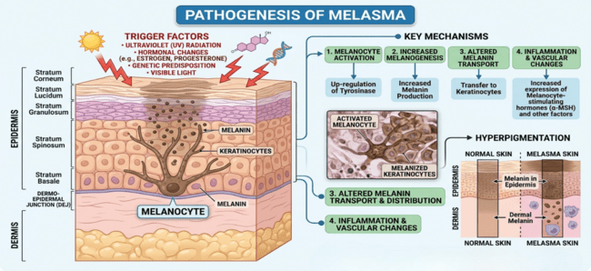
Figure 2: Pathogenesis of melasma
Melasma occurs when melanocytes become hyperactive and produce excessive melanin, which is then transferred to surrounding keratinocytes, resulting in visible pigmentation on the skin surface⁵. Depending on the depth of pigment deposition, melasma is classified into epidermal, dermal, or mixed types. Epidermal melasma is characterized by increased melanin in the basal and suprabasal layers, while dermal melasma involves the presence of melanophages in the dermis. Mixed melasma exhibits features of both types and is the most common form⁶.
Management of melasma primarily focuses on reducing melanin synthesis, protecting the skin from UV radiation, and promoting skin renewal. Conventional treatments include topical depigmenting agents such as hydroquinone, retinoids, corticosteroids, and chemical peels. These agents act by inhibiting tyrosinase activity, accelerating cell turnover, and reducing pigmentation. However, prolonged use of synthetic formulations is often associated with adverse effects such as skin irritation, erythema, contact dermatitis, and exogenous ochronosis, which limits their long-term use⁷.
In recent years, there has been a growing interest in herbal and natural remedies for the treatment of melasma due to their safety, efficacy, and minimal side effects. Herbal creams are topical formulations that incorporate plant-based active ingredients possessing antioxidant, anti-inflammatory, and tyrosinase inhibitory properties⁸. Ingredients such as aloe vera, rose water, licorice and coconut oil are widely used for their ability to reduce pigmentation, protect against UV-induced damage, and improve overall skin health. These herbal constituents help in scavenging free radicals, regulating melanin synthesis, and enhancing skin regeneration.
Herbal creams offer several advantages, including better patient compliance, reduced risk of adverse reactions, and suitability for prolonged use⁹. They also provide additional benefits such as skin hydration, nourishment, and protection against environmental stressors. Therefore, the development of the herbal cream for melasma represents a promising and safer alternative to conventional therapies.
The present study is focused on the formulation and evaluation of a herbal cream intended for the management of melasma. The formulation aims to utilize selected herbal ingredients with proven depigmenting and protective properties. The prepared cream is evaluated for various physicochemical parameters such as pH, viscosity, spreadability, homogeneity, stability, and skin irritation to ensure its quality, safety, and therapeutic effectiveness.
TYPES OF CREAM
Creams are semi-solid emulsions consisting of two immiscible phases: oil and water, stabilized by emulsifying agents. Based on the dispersion of phases, creams are classified into two main types - Oil-in-Water Creams and Water-in-Oil Creams (Fig. 3).
Oil-in-Water (O/W) Creams:
In this type, oil droplets are dispersed in a continuous water phase. These creams are non-greasy, light, and easily washable with water. They provide a cooling effect and are suitable for normal to oily skin. O/W creams are commonly used as moisturizing creams, vanishing creams, and cosmetic formulations¹⁰.
Water-in-Oil (W/O) Creams:
In this type, water droplets are dispersed in a continuous oil phase. These creams are thicker, greasy, and provide an occlusive effect that prevents moisture loss from the skin. They are not easily washable with water and are ideal for dry and rough skin. W/O creams are often used as cold creams and nourishing creams¹¹.
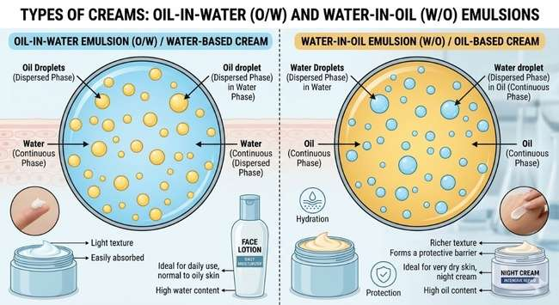

Figure 3: Types of cream
Risk Factors (Fig. 4) of Melasma¹²
Sun exposure (UV rays), Hormonal changes (pregnancy, OCPs), Female gender, Dark skin type, Family history, Cosmetics/skin products, Certain medications, Heat and light exposure.
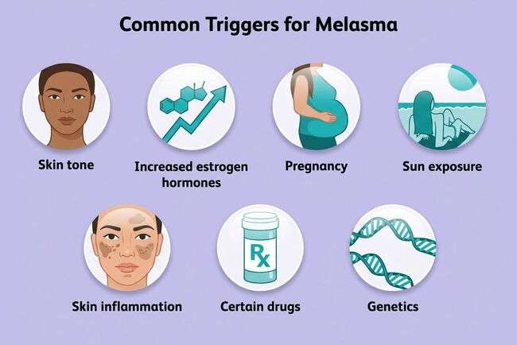
Figure 4: Risk factors of melasma
The following ingredients were used in the preparation of herbal cream for melasma
Aloe Vera
Aloe vera (Fig. 5) gel is widely known for its soothing, moisturizing, and skin-healing properties. It contains aloin and other bioactive compounds that help reduce hyperpigmentation by inhibiting melanin synthesis. It also provides anti-inflammatory effects, reducing skin irritation associated with melasma. In formulation, it acts as a natural base, enhancing hydration, improving spreadability, and promoting skin repair and regeneration¹³.
Uses:
- Reduces hyperpigmentation by inhibiting melanin production
- Soothes inflammation and irritation
- Promotes skin healing and hydration
Taxonomical Classification:
- Kingdom: Plantae
- Phylum: Magnoliophyta
- Class: Liliopsida
- Order: Asparagales
- Family: Asphodelaceae
- Genus: Aloe
- Species: Aloe vera
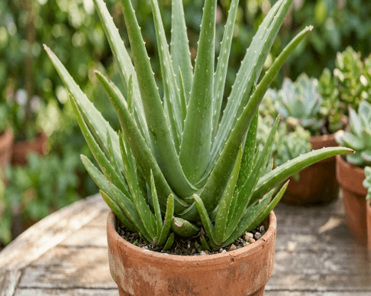
Figure 5: Aloe-vera plant
Rose Water
Rose water (Fig. 6) possesses mild astringent, antioxidant, and soothing properties, making it beneficial in managing melasma¹⁴. It helps maintain skin pH and reduces redness and irritation. It is refreshing nature supports skin toning and cleansing. In formulation, it is used as an aqueous phase component, providing fragrance, hydration, and improving the overall sensory appeal of the cream¹⁵.
Uses:
- Maintains skin pH balance
- Provides soothing and cooling effect
- Refreshes and tones the skin
Taxonomical Classification:
- Kingdom: Plantae
- Phylum: Magnoliophyta
- Class: Magnoliopsida
- Order: Rosales
- Family: Rosaceae
- Genus: Rosa
- Species: Rosa indica
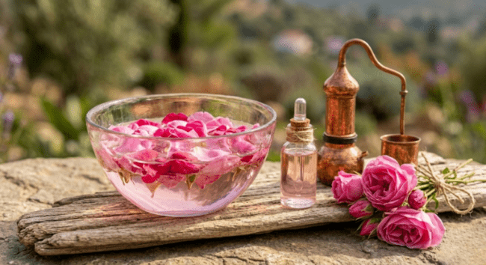
Figure 6: Rose petals and its oil
Licorice Extract
Licorice (Fig. 7) is a well-known depigmenting agent containing glabridin, which inhibits tyrosinase activity and reduces melanin production. It also exhibits anti-inflammatory and antioxidant properties, making it highly effective in treating melasma. In formulation, it acts as a key active ingredient, contributing significantly to skin lightening, improving complexion, and protecting against UV-induced pigmentation¹⁶.
Uses:
- Inhibits tyrosinase to reduce melanin synthesis
- Lightens dark patches and pigmentation
- Provides antioxidant and anti-inflammatory effects
Taxonomical Classification:
- Kingdom: Plantae
- Phylum: Magnoliophyta
- Class: Magnoliopsida
- Order: Fabales
- Family: Fabaceae
- Genus: Glycyrrhiza
- Species: Glycyrrhiza glabra
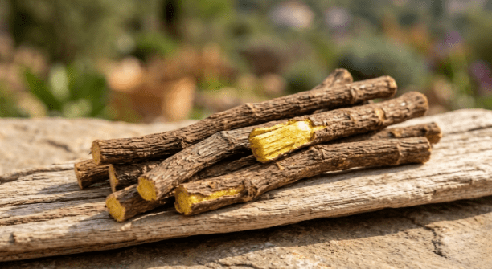
Figure 7: Licorice stem
Almond Oil
Almond oil (Fig. 8) is rich in Vitamin E, fatty acids, and antioxidants that nourish and moisturize the skin. It helps improve skin tone and may reduce pigmentation over time by promoting skin regeneration. In formulation, it acts as an emollient, enhancing softness, improving texture, and aiding in the smooth application of the cream while preventing dryness¹⁷.
Uses:
- Moisturizes and nourishes the skin
- Improves skin tone and texture
- Promotes skin regeneration
Taxonomical Classification:
- Kingdom: Plantae
- Phylum: Magnoliophyta
- Class: Magnoliopsida
- Order: Rosales
- Family: Rosaceae
- Genus: Prunus
- Species: Prunus Dulcis
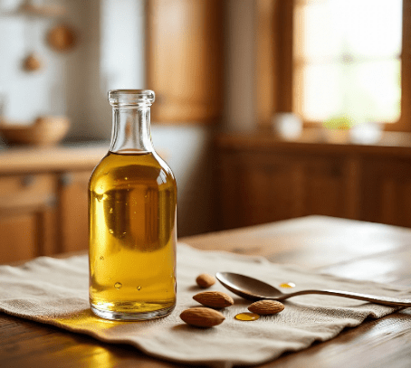
Figure 8: Raw almond and its oil
Coconut Oil
Coconut oil (Fig. 9) has excellent moisturizing and antimicrobial properties. It helps maintain skin barrier function and prevents dryness, which is important in melasma management. Its antioxidant content may support skin repair. In formulation, it acts as an emollient and oil phase component, improving consistency, spreadability, and overall stability of the cream¹⁸.
Uses:
- Provides deep hydration
- Strengthens skin barrier
- Protects against environmental damage
Taxonomical Classification:
- Kingdom: Plantae
- Phylum: Magnoliophyta
- Class: Liliopsisa
- Order: Arecales
- Family: Arecaceae
- Genus: Cocos
- Species: Cocos nucifera
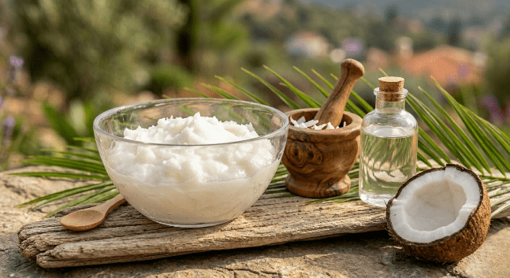
Figure 9: Coconut oil and its paste
Shea Butter
Shea butter (Fig. 10) is a natural fat extracted from the nuts of the Vitellaria paradoxa tree and is rich in essential vitamins such as A and E, along with fatty acids like oleic, stearic, and linoleic acids. These components contribute to its excellent moisturizing, antioxidant, and skin-soothing properties¹⁹. It deeply nourishes the skin by restoring the lipid barrier, preventing moisture loss, and maintaining skin softness and elasticity. Its anti-inflammatory properties help reduce redness, irritation, and sensitivity, which can be particularly beneficial in melasma-affected skin where inflammation may worsen pigmentation²⁰.
In addition, shea butter supports skin repair by promoting cell regeneration and enhancing healing of damaged skin. Its antioxidant content helps protect the skin from oxidative stress and environmental damage, which are contributing factors in hyperpigmentation disorders like melasma²¹.
From a formulation perspective, shea butter acts as an effective emollient and thickening agent. It improves the consistency and spreadability of creams, providing a smooth, rich texture. It also enhances the stability of the formulation by contributing to the oil phase and helps in delivering long-lasting hydration by forming a protective barrier on the skin surface²².
Uses:
- Deeply moisturizes and softens skin
- Reduces inflammation and irritation
- Enhances skin elasticity and repair
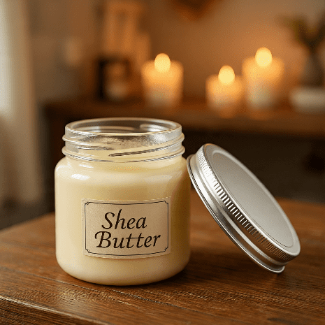
Figure 10: Shea butter
Emulsifying Wax
Emulsifying wax (Fig. 11) is essential for forming a stable oil-in-water emulsion in cream formulations. It helps blend oil and water phases uniformly, preventing separation. Although it has no direct effect on melasma, it plays a crucial role in ensuring consistency, stability, and smooth texture of the cream, thereby improving its usability and shelf life²³.
Uses:
- Stabilizes oil and water phases
- Improves cream texture and consistency
- Ensures uniform distribution of ingredients
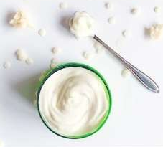
Figure 11: Emulsifying wax
Vitamin E (Tocopherol)
Vitamin E (Fig. 12) is a powerful antioxidant that protects the skin from oxidative stress and UV-induced damage, both of which contribute to melasma. It also supports skin repair and improves overall skin health. In formulation, it acts as an active ingredient and preservative, enhancing stability of oils and extending shelf life while providing skin nourishment²⁴.
Uses:
- Acts as a strong antioxidant
- Protects against UV-induced damage
- Supports skin repair and nourishment
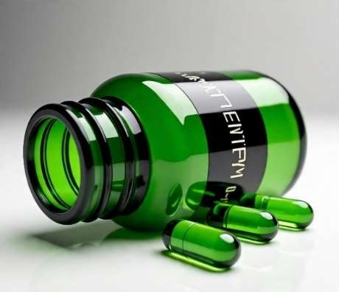
Figure 12: Vitamin E capsules
MATERIALS AND METHODS
All the ingredients were purchased from the local market of Aminabad (Mata badal pansar, Kundan kirana store), Lucknow, Uttar Pradesh and some of the crude ingredient like licorice extract, emulsifying wax were taken from pharmacognosy lab. And pharmaceutics lab. (Integral University, Lucknow Uttar Pradesh). Listed crude drugs (Table 1) were authenticated with the reference no. IU/PHAR/HRB/26/04 by Dr. Mohd. Arif (Associate Professor, Department of Pharmacy, Integral University Lucknow).
Table 1: List of ingredients used in herbal cream for melasma
S. No. | Ingredients | Quantity (100 g)
1. | Aleo vera gel | 40 g
2. | Rose water | 30 g
3. | Licorice extract | 3 g
4. | Almond oil | 10 g
5. | Coconut oil | 5 g
6. | Shea butter | 5 g
7. | Emulsifying wax | 6 g
8. | Vitamin E | 1 g

Method for preparation of Polyherbal Cream for Treatment of Melasma ²⁵.
Step 1: Preparation
- All the ingredients were accurately weighed (Fig.13) using a digital balance.
- Clean and dry glass beakers were taken to maintain proper hygiene.
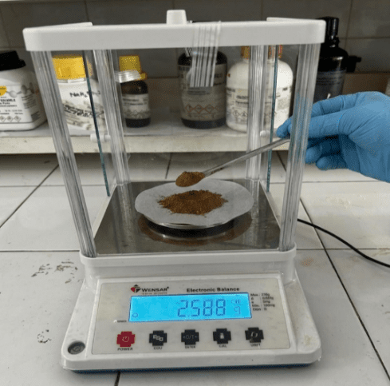
Figure 13: Weighing of licorice powder
Step 2: Preparation of Water Phase (Fig.14-a, b)
- Aloe vera gel, rose water, and licorice extract were added into a beaker.
- The mixture was heated to about 70°C with continuous stirring.
- Proper mixing was ensured to obtain a uniform solution.
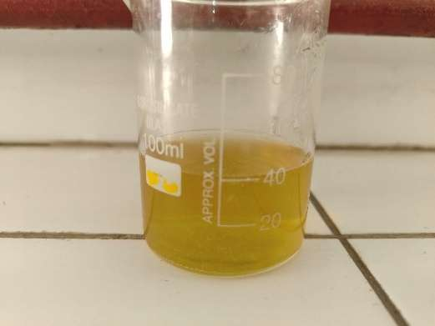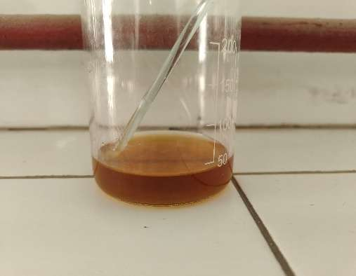
b
a
Figure 14: (a)Water phase mixture (b) Licorice extract
Step 3: Preparation of Oil Phase
- Almond oil, coconut oil, shea butter, and emulsifying wax were taken in another beaker.
- The mixture was heated to about 70°C until the wax was completely melted.
- A clear and uniform oil phase was obtained (Fig.15).
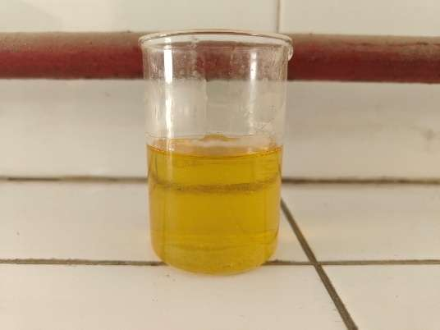
Figure 15: Clear and uniform oil phase mixture
Step 4: Emulsification
- The oil phase was slowly added into the water phase (Fig.16) with continuous stirring.
- The mixture was stirred continuously until a smooth and homogeneous cream was formed.
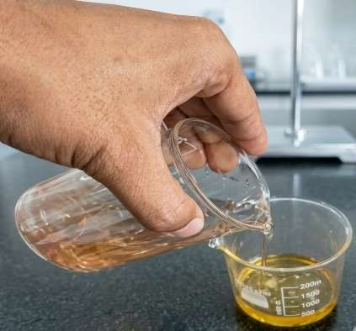
Figure 16: Combining oil phase into aqueous phase for emulsification
Step 5: Cooling Phase
- The prepared cream was allowed to cool down (Fig. 17) to room temperature (~40°C).
- Gentle stirring was continued to maintain uniformity.
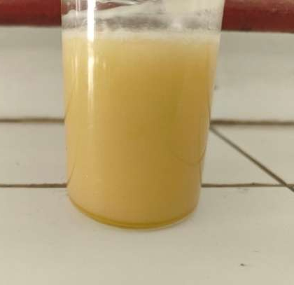
Figure 17: Clear and homogenous cream obtained
Step 6: Addition of Vitamin E
- Vitamin E was added to the cooled cream.
- The mixture was stirred thoroughly to ensure uniform distribution.
Step 7: Filling and Storage
- The final cream was transferred into a clean, air-tight container.
- The container was properly labelled with necessary details (fig.18).
- The product was stored in a cool and dry place.
- Here is a refined and melasma-focused version of your content
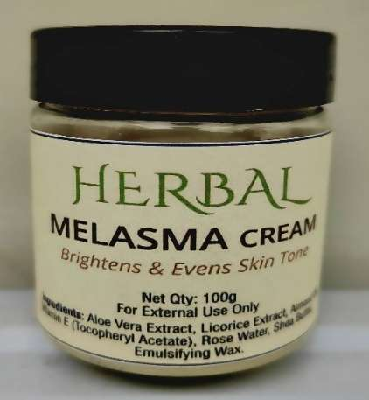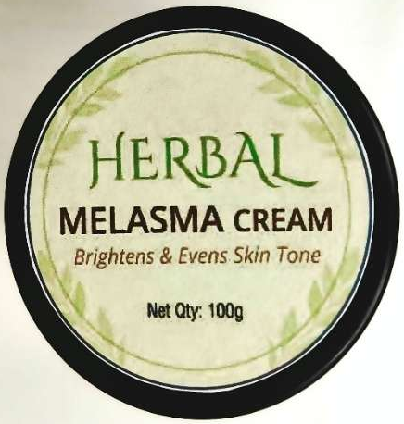
Figure 18: Cream filled in container and labelled properly
How to Use Melasma cream
STEP-1 Cleanse the area:
Gently wash the affected area with a mild, non-irritating cleanser to remove dirt, oil, and impurities. Clean skin enhances the absorption of active ingredients and prepares it for treatment.
STEP-2 Pat dry softly:
After cleansing, gently pat the skin dry using a soft, clean towel. Avoid rubbing, as melasma-prone skin can be sensitive. Ensure the skin is dry before application.
STEP-3 Apply the cream:
Take a small amount of the anti-melasma bio-ferment cream on your fingertips. Apply a thin, even layer over the pigmented areas or as directed. Avoid excessive application.
STEP-4 Massage gently:
Using light circular motions, massage the cream into the skin until fully absorbed. This helps improve blood circulation and enhances penetration of active ingredients to target melasma effectively.
STEP-5 Use sunscreen (Daytime essential):
If applying during the day, always follow with a broad-spectrum sunscreen (SPF 30 or higher). Sun protection is crucial to prevent further darkening of melasma.
STEP-6 Regular use:
For best results, use the cream consistently as advised (usually once or twice daily). Visible improvement in melasma may take a few weeks with regular use.
Evaluation of cream
Organoleptic properties: The physical characteristics of formulation including appearance, color and texture were evaluated through visual inspection (Table 4). To assess texture, a small quantity of cream was gently pressed between the thumb and index finger. Consistency and the presence of coarse particles were key indicators used in this evaluation²⁶. Additionally, the immediate tactile sensation upon application was examined, focusing on parameters such as stiffness, grittiness, and greasiness.
Spreadability: It was determined by taking 1g of melasma cream and placing it on a circle glass plate of 1cm diameter, another glass plate was placed on it and a certain weight was applied on the upper plate for 5 min. Spreadability was measured (Fig. 19) by the spread of cream uniformly and there should be no unmixed particles.
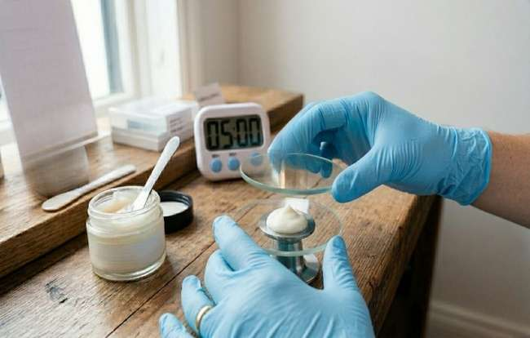
Figure 19: Spreadability testing
Washability: A small amount of the prepared cream was applied evenly to a specified area of the skin and then exposed to running water (Fig. 20) for a fixed duration. The ease with which the cream was removed on the skin surface after rinsing was observed and recorded²⁷.
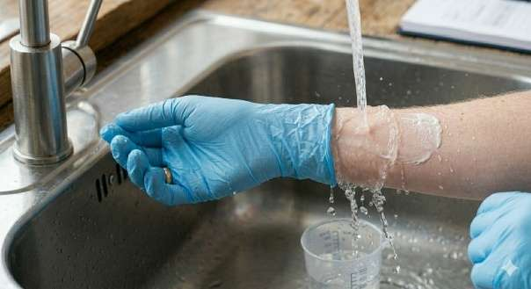
Figure 20: Washability testing
Determination of pH: A solution was prepared from the cream by weighing 1g of cream and dissolved in 10 ml of water. When a proper solution was prepared pH was determined by using a pH paper or pH meter²⁸.
Irritancy test: The formulated cream was applied to the required area of the skin. After 1 hr the skin was checked for any irritancy, redness or inflammation on the skin.
RESULT & DISCUSSION
Organoleptic Properties
The formulation exhibited desirable organoleptic characteristics. The creams were smooth, homogenous, and free from coarse particles or phase separation. Upon application, the formulation spread evenly without sigs of grittiness or greasiness, confirming good texture and aesthetic appeal. Such properties are essential as they directly influence patient compliance.
Spreadability
The spreadability studies showed uniform distribution of the cream without unmixed particles. The average spread diameter indicated good spreadability and it was found to be 96.335 (Table 2), suggesting that the formulation can be easily applied with minimal effort. It is measured from the formula S=M*L/T where, [S-spreadability, M-mass (g), L-distance (cm), T-time (s)], and spreadability is measured in (g.cm/s) where, (grams-centimeters per seconds). An ideal topical formulation should have sufficient spreadability to ensure even coverage, which was observed in this study.
Table 2. Spreadability testing of melasma cream
Trail | Time (s) | Spreadability (g.cm/s)
1 | 10 | 100
2 | 12 | 83.33
3 | 09 | 111.11
4 | 11 | 90.90
Average | 10.5 s | 96.335 g.cm/s
NOTE: For creams tested by parallel plate method, 80-150 g.cm/s is good.
Below 80: Too thick/sticky (poor).
Above 150: Too runny (may not stay put).
Washability
The formulation demonstrated excellent washability, as the cream was easily removed under running water. This property ensures convenience for users while maintaining effective adherence during the period of application.
pH Determination
The average pH values of the formulations were found to be 5.60 (Table 3), which is close to the skin’s natural pH. This indicates that the cream is skin-friendly and minimizes the risk of irritation or disruption of the skin barrier. Maintaining near-neutral pH is particularly important for long-term topical use.
Table 3. Determination of pH value
Solution | Reading
10 ml | 5.61
10ml | 5.60
10ml | 5.60
Average | 5.60
The prepared Melasma cream exhibited satisfactory physical characteristics (Table 4) with a smooth texture and yellow colour. The pH of the formulation was found to be 5.60, confirming its skin-friendly and non-irritant nature. The cream showed good spreadability, was non-greasy, and easily washable with water. The combined effects of Aloe vera, Rose Water, Shea butter, Liquorice, and Almond oil contributed to moisturizing and healing properties. Overall, the formulation was found to be stable, effective, and suitable for the management of Melasma.
Table 4. Observation of evaluation parameters for the herbal melasma cream
PARAMETER | RESULT
Colour | Light Yellow
Odour | Characteristic
Texture | Smooth
Irritancy | NO
Washability | Washable
Emulsion Type | W/O
pH | 5.60
Spreadability | 96.335 g.cm/s
Phase Separation | No Phase Separation
CONCLUSION
The present study successfully formulated and evaluated a herbal cream for the management of melasma using natural ingredients with proven therapeutic properties. The formulation exhibited desirable physicochemical characteristics, including smooth texture, good spreadability, excellent washability, and a skin-friendly pH, ensuring safety and ease of application. The presence of antioxidant, anti-inflammatory, and tyrosinase-inhibiting agents contributed to its potential effectiveness in reducing hyperpigmentation. No signs of irritation or instability were observed, indicating good tolerability. Overall, the developed herbal cream represents a safe, effective, and economical alternative to conventional treatments, suitable for long-term use in managing melasma.
CONFLICT OF INTEREST
The authors declare no conflicts of interest and agree to the publication of this work.
AUTHOR’S CONTRIBUTION
All the authors are equally contributed in this research work
FUNDING
None

REFERENCES
- Keerthi, c. (2017). A clinico-epidemiological study of melasma in men (doctoral dissertation, sri devaraj urs medical college).
- Platsidaki, E., Efstathiou, V., Markantoni, V., Kouris, A., Kontochristopoulos, G., Nikolaidou, E., ... & Gregoriou, S. (2023). Self-esteem, depression, anxiety and quality of life in patients with melasma living in a sunny mediterranean area: results from a prospective cross-sectional study. Dermatology and Therapy, 13(5), 1127-1136.
- Yang, J., Zeng, J., & Lu, J. (2022). Mechanisms of ultraviolet‐induced melasma formation: A review. The Journal of Dermatology, 49(12), 1201-1210.
- Espósito, A. C. C., Cassiano, D. P., da Silva, C. N., Lima, P. B., Dias, J. A., Hassun, K., ... & Miot, H. A. (2022). Update on melasma—Part I: pathogenesis. Dermatology and Therapy, 12(9), 1967-1988.
- Ogbechie-Godec, O. A., & Elbuluk, N. (2017). Melasma: an up-to-date comprehensive review. Dermatology and therapy, 7(3), 305-318.
- Abdalla, M. A. (2021). Melasma clinical features, diagnosis, epidemiology and etiology: an update review. Siriraj Medical Journal, 73(12), 841-850.
- Piętowska, Z., Nowicka, D., & Szepietowski, J. C. (2022). Understanding melasma-how can pharmacology and cosmetology procedures and prevention help to achieve optimal treatment results? A narrative review. International Journal of Environmental Research and Public Health, 19(19), 12084.
- Siddiqui, Z. (2025). Recent Advances in Plant-Based Therapeutics to Combat as an Anti-Ageing Health Product–Promises and Safety Concerns.: Recent Advances in Plant-Based Therapeutics. International Journal of Medical Pharmaceutical and Health Sciences, 2(4), 447-458.
- Ekor, M. (2014). The growing use of herbal medicines: issues relating to adverse reactions and challenges in monitoring safety. Frontiers in pharmacology, 4, 177.
- Sarathchandraprakash, N. K., Mahendra, C., Prashanth, S. J., Manral, K., Babu, U. V., & Gowda, D. V. S. (2013). Emulsions and emulsifiers. Asian J Exp Chem, 8(1), 30-45.
- Mohiuddin, A. K. (2019). Skin care creams: formulation and use. Dermatol Clin Res, 5(1), 238-271.
- Handel, A. C., Lima, P. B., Tonolli, V. M., Miot, L. D. B., & Miot, H. A. (2014). Risk factors for facial melasma in women: a case–control study. British Journal of Dermatology, 171(3), 588-594.
- Saleem, A., Naureen, I., Naeem, M., Murad, H. S., Maqsood, S., & Tasleem, G. (2022). Aloe vera gel effect on skin and pharmacological properties. Scholars international journal of anatomy and physiology, 5(1), 1-8.
- AlShammaa, Z. A., & AlShammaa, D. A. Molecular and cellular mechanisms of natural cosmetics and medical treatment in skin-antiaging: A review article.
- Gonçalves, G. M. S., Srebernich, S. M., Vercelino, B. G., & Zampieri, B. M. (2013). Influence of the presence and type of fragrance on the sensory perception of cosmetic formulations. Brazilian Archives of Biology and Technology, 56(2), 203-212.
- Ragul, V., Deepak, P., Dineshkumar, G., Jayachandiran, R., Muthukrishnan, E., & Ramsundar, d. Comparative analysis of whey and casein proteins in enhancing the anti-fading potential of glabridin extracted from glycyrrhiza glabra.
- Čolić, S., Zec, G., Natić, M., & Fotirić-Akšić, M. (2019). Almond (Prunus dulcis) oil. In Fruit oils: chemistry and functionality (pp. 149-180). Cham: Springer International Publishing.
- Chew, Y. L. (2019). The beneficial properties of virgin coconut oil in management of atopic dermatitis. Pharmacognosy Reviews, 13(25), 24.
- Zhang, H., Zhou, Y., & Xu, X. (2026). Shea Butter: A Comprehensive Review of Its Compositions, Processing, Applications, and Challenges. Journal of the American Oil Chemists' Society.
- Rajkumar, J., Chandan, N., Lio, P., & Shi, V. (2023). The skin barrier and moisturization: function, disruption, and mechanisms of repair. Skin Pharmacology and Physiology, 36(4), 174-185.
- Mohanan, R., Jose, S. P., Sreevallabhan, S., Jalam, J. K., Tilwani, J., Jagmag, T., ... & George, S. M. (2025). Moisturizing and antioxidant factors of skin barrier restoring cream with shea butter, silkflo and vitamin E in human keratinocyte cells. International Journal of Cosmetic Science, 47(2), 260-269.
- From a formulation perspective, shea butter acts as an effective emollient and thickening agent. It improves the consistency and spreadability of creams, providing a smooth, rich texture. It also enhances the stability of the formulation by contributing to the oil phase and helps in delivering long-lasting hydration by forming a protective barrier on the skin surface.
- Eccleston, G. M. (2013). Emulsions and creams. Aulton’s Pharmaceutics. The Design and Manufacture of Medicines, 470-472.
- Blaner, W. S., Shmarakov, I. O., & Traber, M. G. (2021). Vitamin A and vitamin E: will the real antioxidant please stand up. Annual review of nutrition, 41(1), 105-131.
- Khan, M. H., Ahmad, S., Mishra, K., & Singh, M. (2026). Formulation and evaluation of a polyherbal cream incorporating medicinal plant extracts and essential oils for heel fissures. Journal of Pharmacognosy and Phytochemistry, 15(1), 207-215.
- Abd El-Malek, F. A., El-Dardiry, A. I., & Gab-Allah, R. H. (2015). A study on improving the functional properties of cream. Journal of Food and Dairy Sciences, 6(9), 547-564.
- Lalita, C., & Shalini, G. (2020). Creams: A review on classification, preparation methods, evaluation and its applications. JDDT, 10, 281-289.
- Karmakar, P., & Mandal, R. (2024). Compositional Analysis of Cream. In Analytical Methods for Milk and Milk Products (pp. 231-256). Apple Academic Press.

