AI POWERED MOCK INTERVIEW
An AI-Powered Evaluation System

Abstract

This project presents an AI-powered mock in Online interview platform that replicates the structure and pressure of real interviews through dy namic, role-specific questioning and adaptive difficulty calibrated to user per- formance over time. Responses are captured via speech-to text and analyzed with natural language pro processing to assess relevance, reasoning depth, Structure, and clarity against rubric-aligned criteria. Parallel audio ana- lytics estimate con f Evidence and articula- tion using prosodic fea Such features as pace, pauses, and intonation Complement the con- tent scoring with delivery by very insightful remarks. Optional webcam analysis in ter- prets facial expressions and gaze to surface non-verbal cues such as engagement and ner- vous ness for a more holistic assessment of readi ness. A scoring engine fuses textual, vo cal, and visual signals into interpretable per question and session scores along with ex- planations and improvement tips that are spe- cific and ac tionable. The platform gener- ates personalized practice plans by identify- ing weak topics and recommending targeted drills or exemplar an ans for deliberate prac- tice between sessions Domain coverage spans HR, software engi neering, data roles, and system design, with Question banks evolving through generative augmentation and curator review to remain current with industry expec- tations. Progress Dashboards visualize trends across attempts to help learners and mentors track mastery and It also allows for the ob- jective assessment of communication growth over time. Secure persistence stores profiles, transcripts, features, and reports with access
controls suit Able for academic cohorts and training programs at scale. By unifying simu- lation, evaluation, coaching, and analytics, the system low ers cost and variability while in- creasing access to high-quality practice oppor- tunities.

- Introduction
Interview performance is based upon knowledge. structured thinking, and confident communication under time pressure, while actual practice is scarce and unreliable for most candidates. Traditional while mock interviews require scarce human eval- uators. suffer from variable quality and do not scale to classrooms or bootcamps during peak placement seasons. Recent advances in NLP and speech pro- cess Ing, and affect recognition enable automated simu -lations with rich telemetry that previously re- quired expert human observers to capture. Genera- tive sys Tems can synthesize role-aware prompts and prob ing follow-ups, enabling sessions that adapt to the candidate’s previous answers and skill pro- file in real time. When text, audio, and video are analyzed to Taken together, the resulting as- sessment provides a better reflection of how Real interviewers perceive both substance and delivery. ery. Standardized rubrics and normalized scoring Pipelines reduce evaluator bias and advance com- parisons across time and cohorts more meaning ful. Persistent analytics and visual dashboards en en- courage reflective learning, allowing candidates to focus Focus on high-leverage improvements, not generic ones. advice. Institutions benefit from con- sistent train ing experiences and aggregated insights

that inform curriculum design and mentoring inter- ventions. A modular, service-oriented architecture allows for rapid Iteration on models, rubrics, and content while keeping ing the user interface stable for learners. This project Operationalizes those ca- pabilities into a practical tool that unifies simulation, assessment, and coach ing in one workflow. As such, it addresses both ac Cess and Quality Challenges in Interview Preparation at scale non-verbal cues such as engagement and nervous ness for a more holis- tic assessment of readi ness. A scoring engine fuses textual, vo cal, and visual signals into interpretable per question and session scores with explanations and improvement tips that are specific and ac ition- able. The platform generates personalized practice plans by identifying weak topics and recommending targeted drills or exemplar an answer for deliberate practice between sessions. Domain coverage spans HR, software engi neering, data roles, and system design, with question banks evolving through gen- erative augmentation and curator review to remain current with industry expectations. Progress Dash- boards visualize the trends across attempts to help learners and mentors track mastery and communi- cation growth objectively over time. Secure per- sistence stores profiles, transcripts, features, and re- ports with access controls suit able for academic co- horts and training programs at scale. By unifying simulation, evaluation, coaching, and analytics, the system low ers cost and variability while increasing access to high-quality practice opportunities.
.

- Objective
The primary objective is the delivery of realistic, adap tive interview rehearsal, mirroring recruiter prob ing, follow-ups, and time constraints while re remaining scalable and affordable for large cohorts. The system targets objective multimodal evaluation. Across content accuracy, problem-solving, clarity, confidence, and non-verbal communication to re- induce bias and enhance comparability. Feedback must be rubric-aligned, prioritized by impact, and accompanied by exemplars so learners know ex Ex- actly what to change, and how to practice it effec- tively. tively. The platform should support multiple do mains and seniority levels with calibrated diffi-
culty. ladders to keep sessions appropriately chal- lenging for each learner. Longitudinal tracking and dash boards should indicate skill growth, plateaus, and Readiness indicators for placements and intern- ships. Web-based access must be implemented with secure authentication. tion and privacy-first data handling that meets insti Institutional expectations for student data.

PROBLEM STATEMENT
Conducting effective mock interviews presents a significant challenge, especially when assessing both technical competencies and soft skills such as com Communication, confidence, and emotional ex- pressiveness. Traditional means of evaluation de- pend largely on hu Human judgment does introduce subjectivity and inconsistency. Consistency in feed- back. The selected candidates, therefore, end ten re- ceive unclear or biased assessments, restricting the ability to identify specific areas where improvement might be made. ment. The proposed AI-Powered Mock Interview Evaluator system aims to mitigate these issues by leveraging artificial intelligence to deliver objective Data-driven feedback. Through an- alyzing verbal and non- with verbal cues, the sys- tem supports more precise self-management: Test- ing and enhances users’ general interview skills. readiness?.

Workflow
An AI-powered mock interview workflow is the step-by-step process that utilizes artificial intelli- gence to help candidates practice and improve on their performance by simulating real job interviews. Here is a typical workflow breakdown of how this usually happens.

AI Mock Interview Workflow Overview
- Role Selection

  - The user chooses a job role or domain, such as software engineer, data analyst, marketing manager).
  - AI uses this input to tailor questions based on industry standards and job descriptions.

Interview Simulation

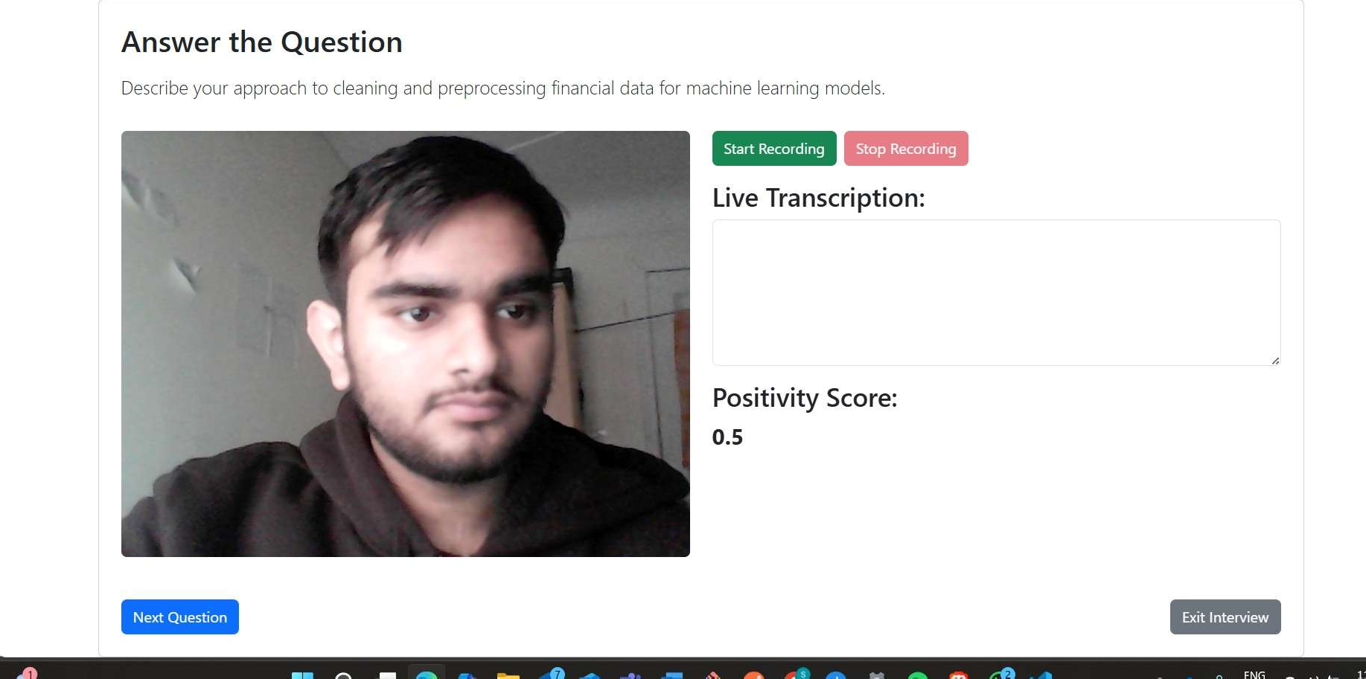
Figure 1: use interview simulator

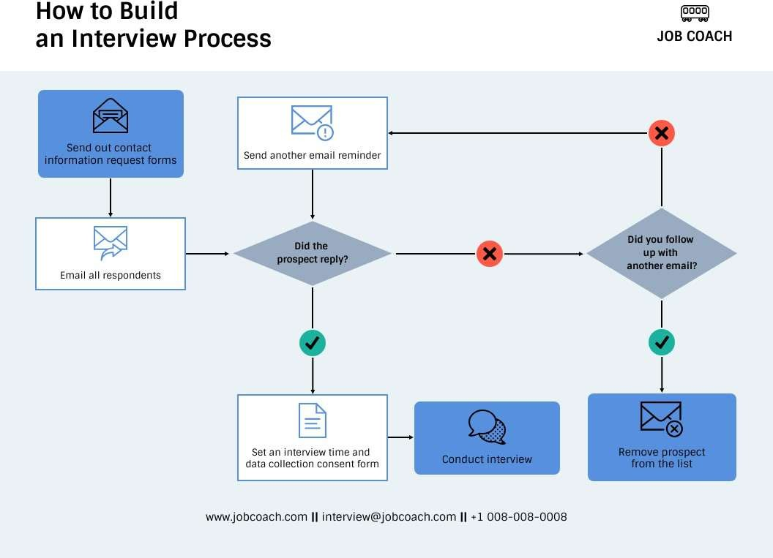
Figure 2: Interview Process

  - The system initiates a mock interview session, often via video or voice.
  - Questions are presented in real-time, mimick- ing ing the format of behavioral, technical in- terviews.

Response Capture

  - The candidate answers questions orally or in written form.
  - AImayusespeech-to-text or transcription tools to analyze spoken responses

AI-Based Evaluation
  - Answers are scored according to pre-defined crite ria such as:– Clarity and relevance– Confi- dence and tone– Use of frameworks like STAR (Situation, (Task, Action, Result)
    - Clarity and relevance
    - Confidence and tone
    - Use of frameworks like STAR (Situation, Task, Action, Result)
  - Some platforms score answers allover multiple dimensions and provide detailed feedback.
- Feedback and Reporting Candidates receive:

  - Performance scorecard
  - Suggestions for improve in further
  - A summary report, sometimes sent through email

MOTIVATION
The need for improving the effectiveness of mock interviews was the motivating factor in develop- ing an AI-Powered Mock Interview Evaluator. in- terviews as a tool for skill development and self- assessment. Traditional mock interviews are often lacking objectivity and are also highly dependent on

the perception of the evaluator, and frequently re- sult in inconsistent feedback and lack of insight into a candidate’s emotional readiness. The proposed system uses AI-based emotion and confidence anal- ysis, thereby providing candidates with with per- sonalized, data-driven feedback that allows them to pinpoint weaknesses, enhance their communication, and build confidence in their interviewing perfor- mance. Moreover, the system aims to standardize and automate the assessment process. process, re- ducing the time and effort required by human inter- viewers while ensuring consistency and fairness in feedback delivery .

FLOW CHART

Implementation
- React-based Candidate Portal and Interview Runner with Tailwind CSS, timers, and device checks for mic/cam.
- Real-time audio/video capture via WebRTC; streaming to backend over WebSocket/SignalR For low latency follow-ups.
- ASP.NET Core Web API for session orchestra- tion, authentication (JWT), role/difficulty se- lection, and interview flow control.
- Python FastAPI microservice for ASR using Whisper and rubric-aligned NLP scoring using an LLM-based evaluator.
- Prosody analysis pipeline (librosa) extracting pace, pause ratio, and energy to coach clarity and fluency.
- Optional vision cues using MediaPipe Face Mesh for gaze/expression features behind ex- plicit user consent.
- Multimodal fusion service, joining text, au dio, and vision into normalised rubric scores with brief explanations.
- PostgreSQL for users/sessions/scores, MinIO/S3 for encrypted media storage, and Redis for queues and rate limits.
- Reporting and dashboards in React (Charts) with downloadable PDF feedback, exemplars, and readiness indices.
- Docker Compose for local stacks, GitHub Ac- tions CI/CD, CORS/TLS hardening, consent logs, and retention policies.
Add to follow-up
- CONCLUSION
Here’s a more natural and conversational version of your text:
The AI-powered Mock Interview Evaluator al- lows for an innovative and impactful way of inter- view preparation. Unlike the conventional mock in- terviews, which primarily focus on technical skills, this system takes a further step in using artificial intelligence to grade how confident and emotion- ally prepared a candidate is. It pays close attention to non-verbal cues-like facial expressions, tone of voice, and language patterns-that are often missed in standard evaluations.
By creating a realistic and engaging interview ex- perience, the platform offers clear, data-driven feed- back that helps candidates understand their strengths and pinpoints areas for improvement. This not only builds confidence in them but also equips them with the soft skills required to shine in real interviews.
- REFERENCE
- Chou, W., Wongso, I. (2021). An AI-
Mock Interview Platform for Interview Prepa- ration.Semantic Scholar. Retrieved from https://www.semanticscholar.org/paper/An
AI-Mock-interview-Platform- for-Interview-Chou-Wongso/
a5249c2ef191a07af3b46fc6afb58a7f709e172f 2. Sharma, A., Dey, L. (2022). AI-Powered Interview Assistance System. IEEE Access, 10,12345-12360. doi:10.1109/ACCESS.2022.10530717. Retrieved
from https://ieeexplore.ieee.org/document/10530717
3. Gupta, S., Kumar, V. (2021). Analyzing Can- didates’ Performance in Mock Interviews using AI Techniques. Proceedings of the IEEE In- ternational Conference on Data Science and Advanced Analytics, 29-36. doi:10.1109/ ICD- SAA.2021.10100589. Retrieved from https:// ieeexplore.ieee.org/document/10100589 4. Patil, P., Sinha, R. (2016). Smart Interview Sys- tem: A Machine Learning Approach. IEEE International Conference on Computational

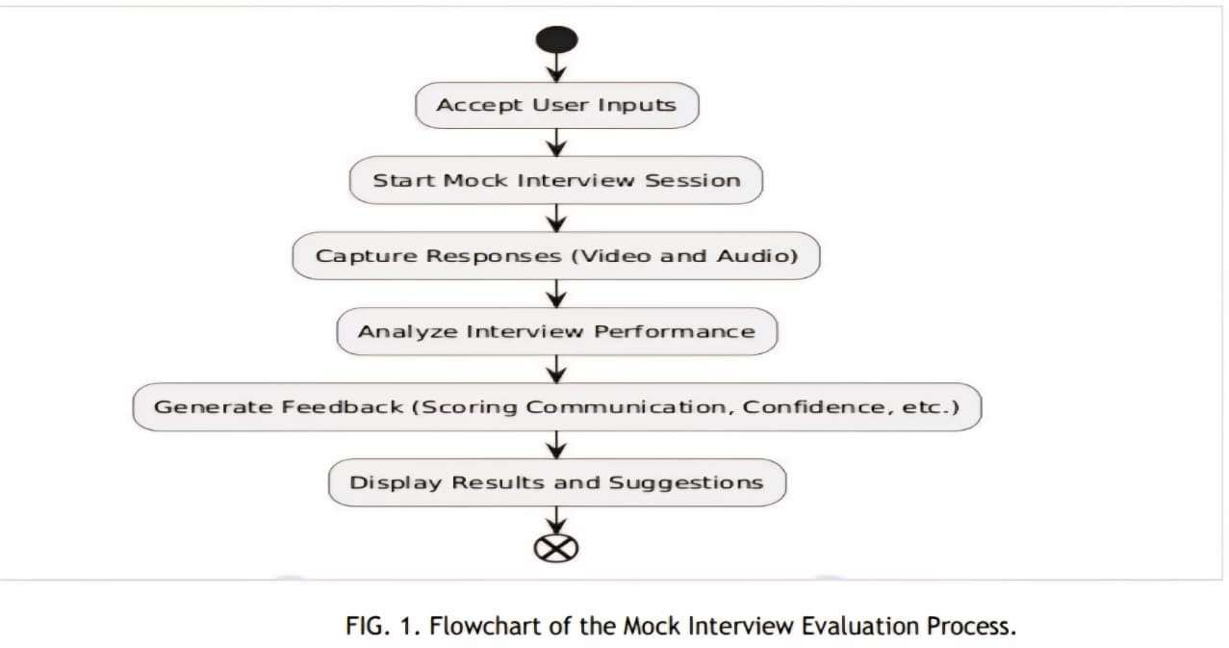
Figure 3: flow diagram for evaluation method and process.

Intelligence and Computing Research, 1-6. doi:10.1109/ICCIC.2016.7579163. Retrieved from https://ieeexplore.ieee.org/document/7579163
  - Singh, R., Gupta, A. (2018). Emo- tional Intelligence in AI: A Framework for Interviewers. IEEE Transactions on Human- Machine Systems, 48(5), 481-490. doi:10.1109/ THMS.2018.8448645. Retrieved from https:// ieeexplore.ieee.org/abstract/document/8448645
  - Zhang, Y., Wu, J. (2022). AI-Assisted Feedback Generation for Interview Preparation. IEEE Transactions on Education, 65(2), 185-192. doi:10.1109/TE.2022.9510143. Retrieved from https://ieeexplore.ieee.org/document/ 9510143

