BEHAVIOUR AND ANALYSIS OF FIXED HEADED LATERALLY LOADED PILE USING FINITE DIFFERENCE METHOD

________________________________________________________________________________________________________

Abstract : The main aim of the project is to calculate structural parameters like Deflection (Y), Moment (M), Shear (S), Soil reaction (P) etc…, at each and every point of the pile. When the soil near the ground surface is not capable of supporting a structure, deep foundations are required to transfer to loads to deeper strata. Pile foundation is used to reduce differential settlements. The deflection of the pile and the lateral resistance of soil are interdependent. Therefore, iterative techniques are almost necessary to achieve a solution for particular case of loading on the pile. In this project we are using FINITE DIFFERENCE METHOD (F.D.M) for a fixed headed laterally loaded pile. This method is applicable for regular shapes. In this project we are taking concrete and mild steel as pile materials. Finally structural parameter values are compared with C program or mat lab using matrix inversion method and also manually by using MS excel

Introduction
Deep foundations are employed principally when weak or otherwise unsuitable soil exists near the ground surface and vertical loads must be carried to strong solids at depth. In finite difference method at each of the pivotal point of intervals, an equation expressing the differential equation by the finite differences can be established. A set of simultaneous equations are developed and they are solved using the boundary conditions at the pivotal points. The computations can be easily handled mechanically on calculators or digital computers.
1.a) TYPES OF NUMERICAL METHODS
To solve engineering problems, numerical methods are classified into five categories.
- Finite element method
- Finite difference method
- Boundary element method
- Discrete element method
- Fast lagrangian analysis of continuum (FLAC)
1.b) OBJECTIVE AND SCOPE OF PRESENT WORK
Engineers understood early that a pile under lateral load would act as a beam. Hetenyi (1946) wrote a book giving the solution of the differential equations for a beam on a foundation, with a linear relation ship between pile deflection and soil response. In finite difference method at each of the pivotal point of intervals, an equation expressing the differential equation by the finite differences can be established. A set of simultaneous equations are developed and they are solved using the boundary conditions at the pivotal points. The computations can be easily handled mechanically on calculators or digital computers.

- GENERAL FEATURES OF FINITE DIFFERENCE METHOD: In Finite Difference Method at each of the pivotal point of intervals, an equation expressing the differential equation by the finite differences can be established. A set of simultaneous equations are developed and they are solved using the boundary conditions at the pivotal points. The computations can be easily handled mechanically on calculators or digital computers.
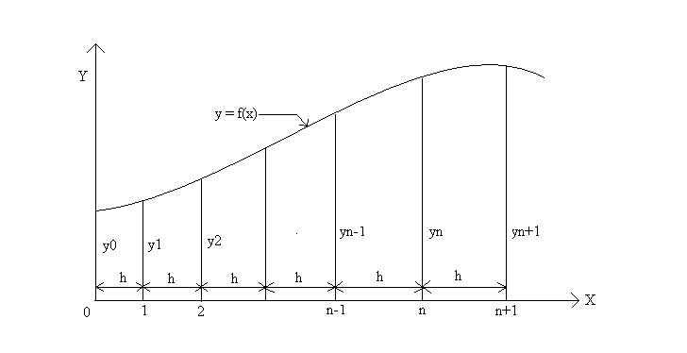
Fig 1. Derivatives of a function
- FORMULATION OF THE EQUATION BY FINITE DIFFERENCES OF LATERALLY LOADED PILE:

The derivation for the differential equation for the beam column on a foundation was given by Hetenyi (1946).

The assumption is made that a bar on an elastic foundation is subjected to horizontal loading and to a pair of compressive forces P_{x} acting in the centre of gravity of the end cross sections of the bar. If an infinitely small unloaded element, bounded by two horizontals a distance dx apart, is cut out of this bar the equilibrium of moments (ignoring second-order terms) leads to the equation.
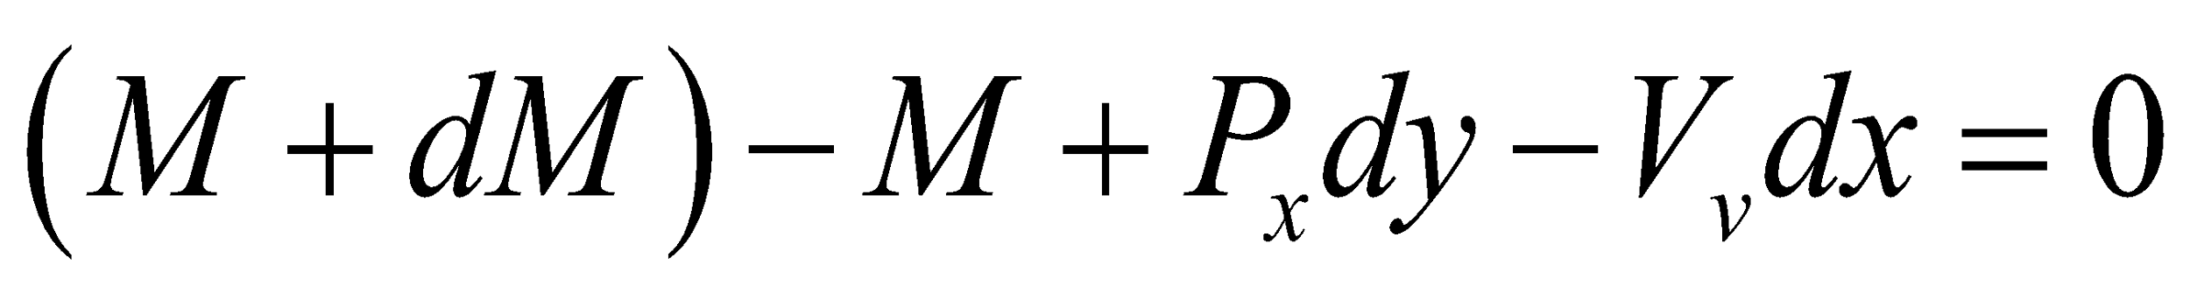

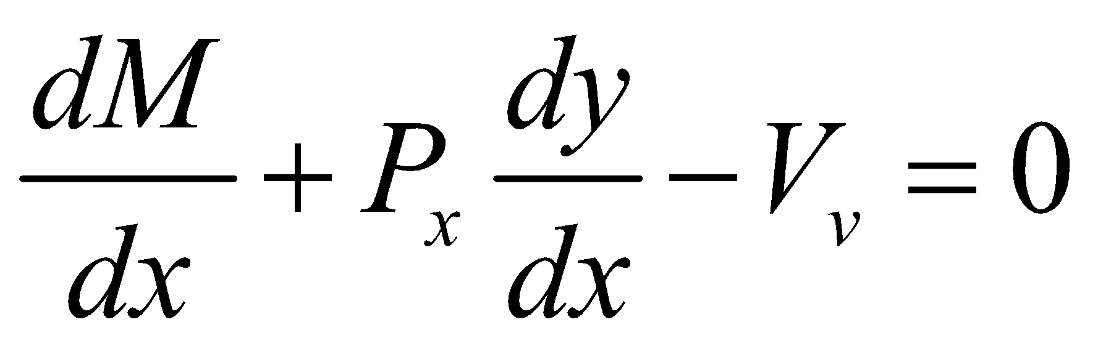
Differentiating the above equation with respect to x, the following equation is obtained.
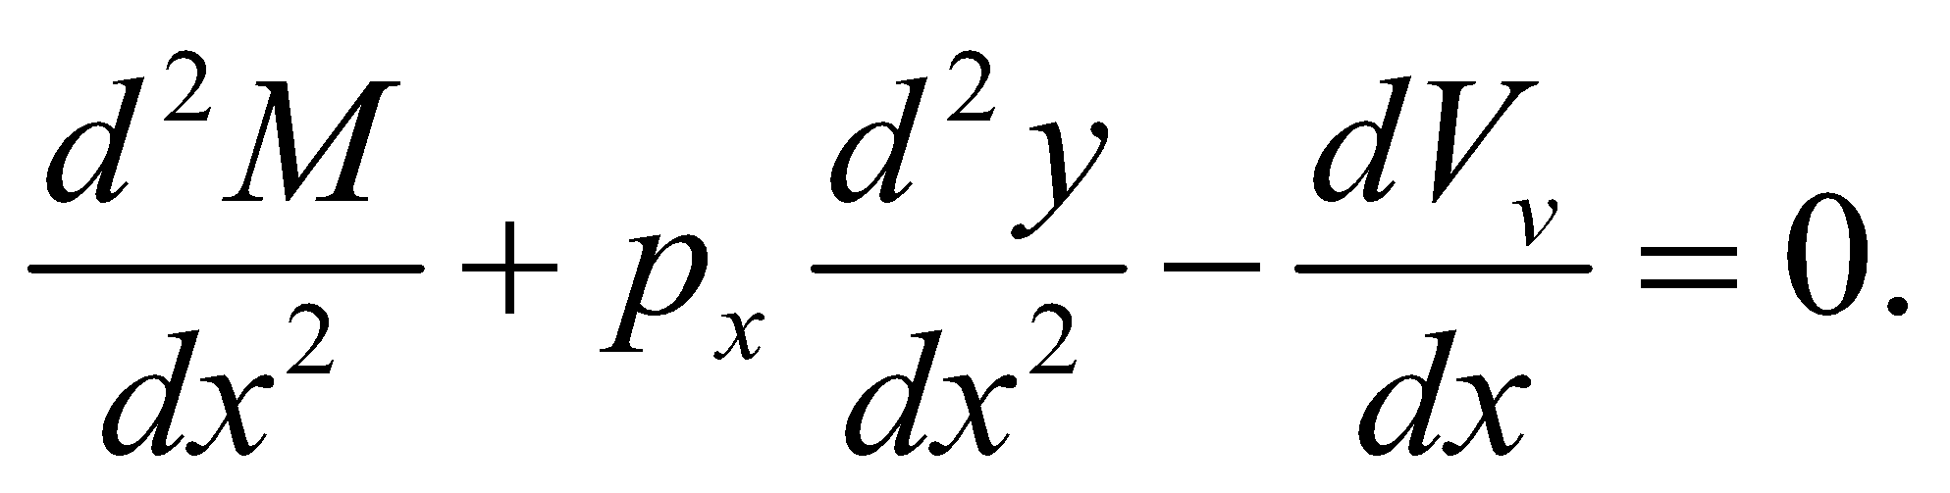

The following identities are noted:
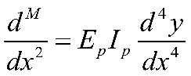
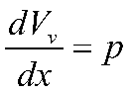
And making the indicated substitutions we get generalized governing differential equation for a pile under lateral loading which is as follows.
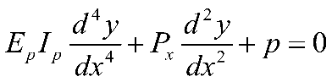
The derivatives of differential equation needed for formulation of finite difference equations are as follows.
y – Deflection
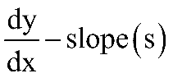
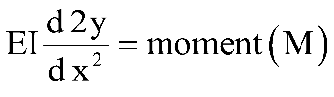
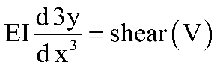
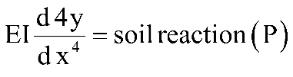
The derivatives can be written in difference form as follows.
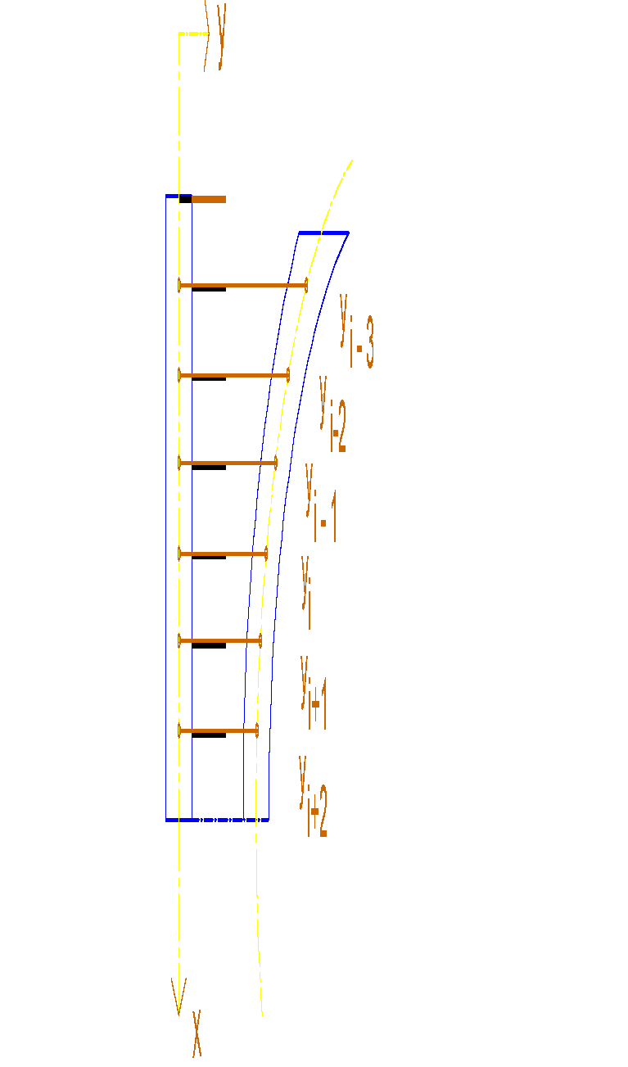
Fig 2. Computer representation of deflected laterally loaded pile
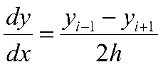
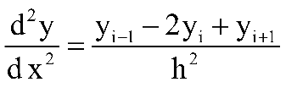
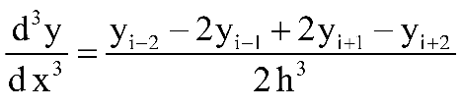
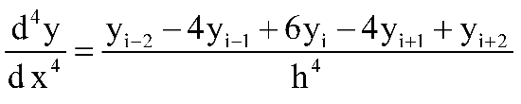
The governing differential equation for a pile under lateral loading is as follows.
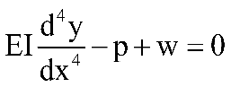------------------------------ (I)
Where P – Soil reaction (P = n).
W = distributed load along length of pile.
There is no additionally acting external distributed loaded on laterally loaded pile. Only self weight of pile is considered.
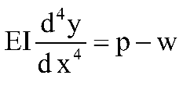
Equation (1) can be written as follows

------------------------------(II)
Substituting 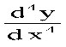 in above equation we get the governing equation as follows.
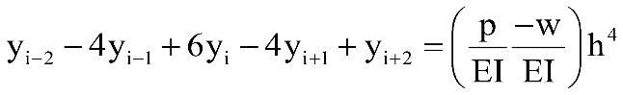
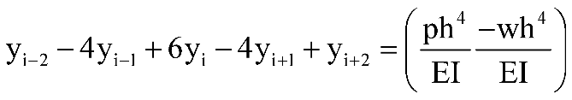
Substitute P = K_{y} n in above equation we get generalized governing differential equation for a pile under lateral loading as follows.
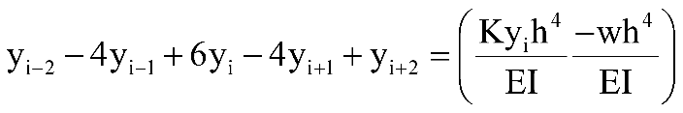
Where K_{y} = modulus of sub grade reaction
IV. EQUATIONS FOR FIXED HEADED FLEXIBLE PILE:
The governing equation for a pile under lateral loading given in equation 3 as follows.
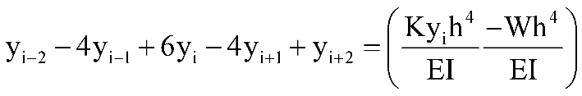
Top of the pile
Put i = 0 in governing equation we get
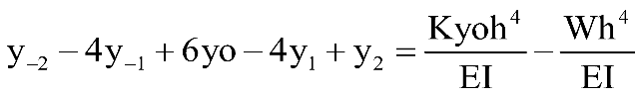--------------------(a)
Put i = 1 in above equation we get
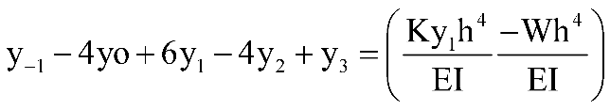---------------------(b)

Boundary conditions
Top of pile
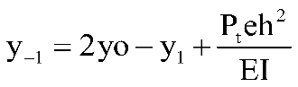
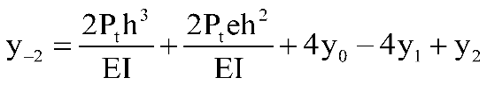
Substituting the boundary conditions in above a and b equations we get
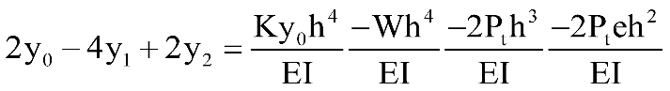………………. (3.1.1)
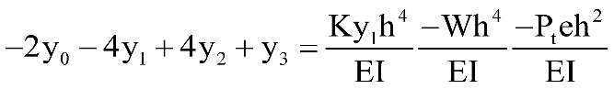………………. (3.1.2)
At any ith node we have governing equation of follows.
At any ith node i = 2 to m-2 we have following equation
……………… (3.1.3 to 3.1.m-1)
Put i = m-1 in governing equation we get
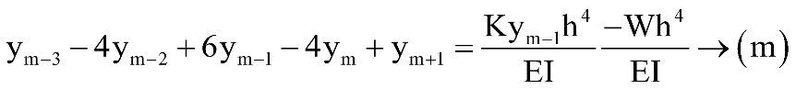
In above equation y_{m+1} is fictious node which can be eliminated by taking boundary conditions at the bottom of the pile.

Bottom of the pile
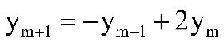
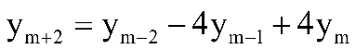
Substituting y_{m+1} in governing equation we get
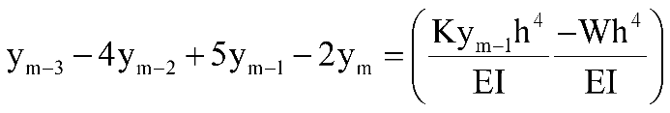……………… (3.1.m)
Put i = m in governing equation we get
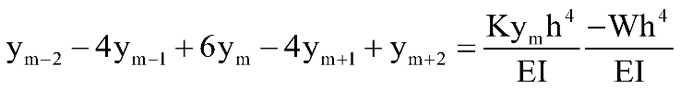
Substituting y_{m+2} in above equation we get the equation modified as follows
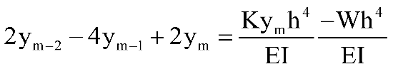……………… (3.1.m+1)

V. RESULTS AND DISCUSSION
V.I. GRAPH BETWEEN DEPTH AND DEFLECTION:
FOR MILD STEEL
Table 01. Depth and Deflection values for mild steel
S.no | Depth  (m) | Deflection (y) M
S.no | Depth  (m) | For load  57.01 n | For load  129.3 n | For load  191.08 n | For load  269.75 n | For load  401.27 n
1 | 0 | -0.0046053 | -0.0101169 | -0.0149503 | -0.0218474 | -0.0314021
2 | 0.25 | 0.0012568 | 0.00273470 | 0.00404120 | 0.00584994 | 0.00848787
3 | 0.5 | 0.0035904 | 0.00814335 | 0.01203415 | 0.01750139 | 0.02527634
4. | 0.75 | 0.0007119 | 0.00161479 | 0.00238627 | 0.00346568 | 0.00501204
5 | 1 | -0.0053142 | -0.0118260 | -0.0174768 | -0.0254393 | -0.0367082

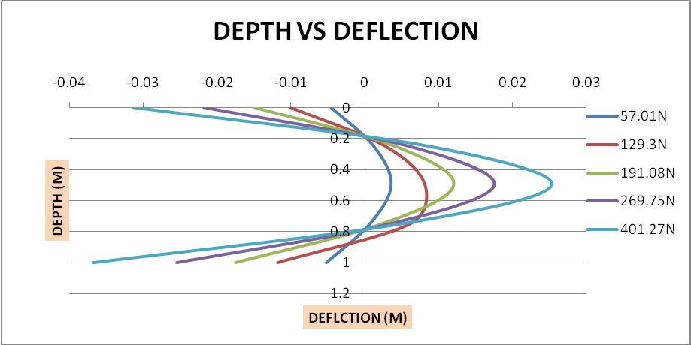
Fig 03. Graph between Depth and Deflection for mild steel
FOR CONCRETE:
Table 02. Depth and Deflection values for Concrete
S.no | Depth  (m) | Deflection (y) M
S.no | Depth  (m) | For load 57.01 n | For load 129.3 n | For load 191.08 n | For load 269.75 n | For load 401.27 n
1 | 0 | 0.456658 | 1.035725 | 1.530743 | 2.1611 | 3.214711
2 | 0.25 | 0.446665 | 1.013059 | 1.497245 | 2.113807 | 3.144362
3 | 0.5 | 0.276709 | 0.62759 | 0.927543 | 1.309503 | 1.947932
4 | 0.75 | -0.05249 | -0.11904 | -0.17594 | -0.24839 | -0.36949
5 | 1 | -0.45304 | -1.02751 | -1.5186 | -2.14396 | -3.18921

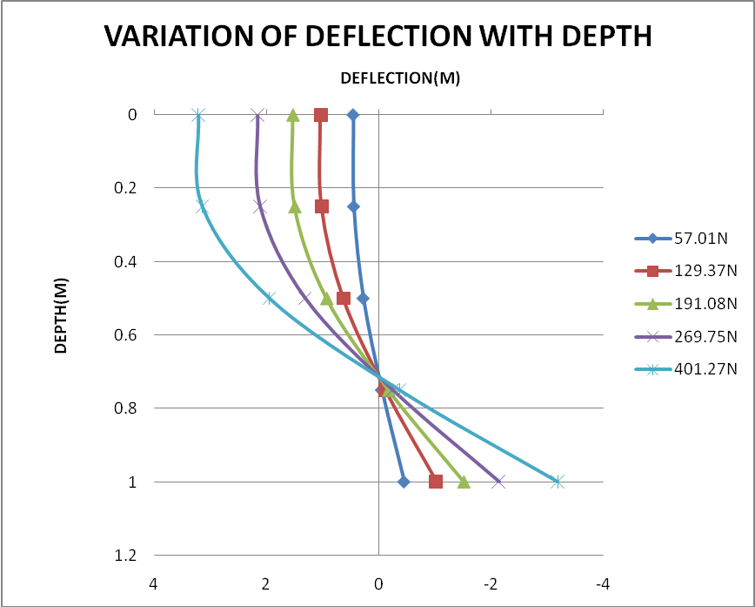

Fig 04. Graph between Depth and deflection for concrete
V.II. GRAPH BETWEEN DEPTH AND MOMENT:

FOR Mild Steel
Table 03. Depth and Moment values for Mild Steel
S.no | Depth  (m) | Moment (m) N-m
S.no | Depth  (m) | For load 57.01 n | For load 129.3 n | For load 191.08 n | For load 269.75 n | For load 401.27 n
1 | 0 | -1.99535 | -4.5255 | -6.6878 | -9.44125 | -14.04445
2 | 0.25 | -59.6442 | -135.279 | -199.909 | -290.650 | -419.893
3 | 0.5 | -95.6640 | -216.978 | -320.639 | -466.889 | -673.471
4 | 0.75 | -55.3955 | -125.633 | -185.671 | -270.364 | -389.983
5 | 1 | 0 | 0 | 0 | 0 | 0

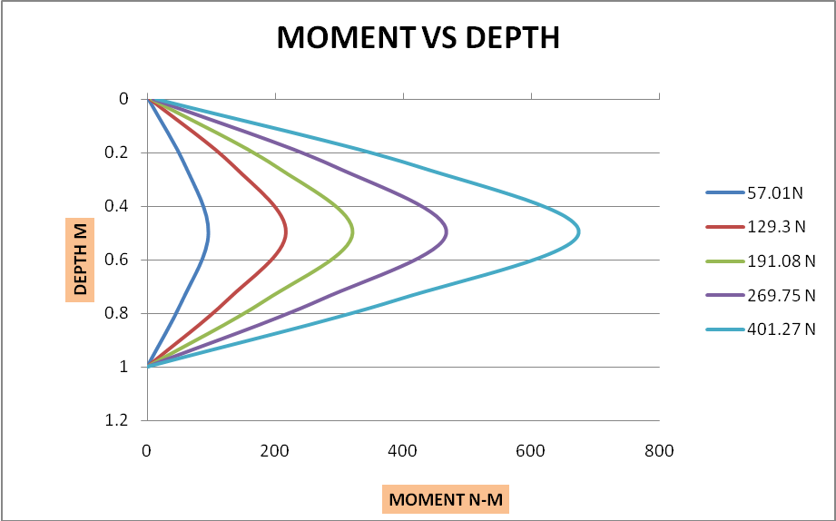

Fig 05. Graph between Depth and Moment for Mild Steel
FOR CONCRETE:
S.no | Depth  (m) | Moment (m) N-m
S.no | Depth  (m) | For load 57.01 n | For load 129.3 n | For load 191.08 n | For load 269.75 n | For load 401.27 n
1 | 0 | 1.99535 | 4.5255 | 6.6878 | 9.44125 | 14.042
2 | 0.25 | -10.75719 | -24.39609 | -36.0586 | -50.9074 | -75.72272
3 | 0.5 | -10.7087 | -24.2873 | -35.8957 | -50.67735 | -75.38447
4 | 0.75 | -4.7982 | -10.8834 | -16.08417 | -22.708 | -33.778359
5 | 1 | 0 | 0 | 0 | 0 | 0

Table 04. Depth and Deflection values for Concrete

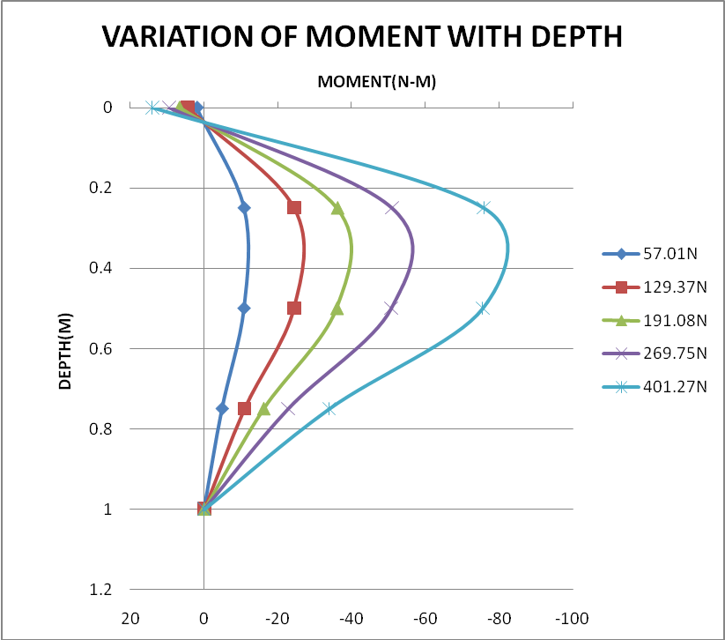

Fig 06. Graph between Depth and Moment for concrete
V. III. GRAPH BETWEEN DEPTH AND SHEAR:
FOR MILD STEEL
Table 05. Depth and Shear values for Mild Steel
S.no | Depth  (m) | Shear (v) n
S.no | Depth  (m) | For load 57.01 n | For load 129.3 n | For load 191.08 n | For load 269.75 n | For load 401.27 n
1 | 0 | 57.01 | 129.3 | 191.08 | 269.75 | 401.27
2 | 0.25 | 219.828 | 443.006 | 654.653 | 949.552 | 1375.005
3 | 0.5 | -8.4972 | -19.292 | -28.4768 | -42.772 | -59.8193
4 | 0.75 | -191.328 | -433.955 | -641.279 | -933.779 | -1346.9416
5 | 1 | 0 | 0 | 0 | 0 | 0

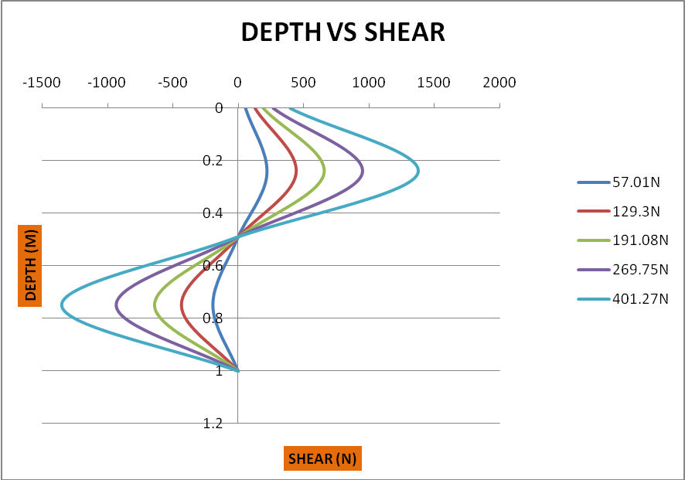

Fig 07. Graph between Depth and Shear for Mild steel
FOR CONCRETE
Table 06. Depth and Shear values for Concrete
S.no | Depth  (m) | Shear (v) n
S.no | Depth  (m) | For load 57.01 n | For load 129.3 n | For load 191.08 n | For load 269.75 n | For load 401.27 n
1 | 0 | 57.01 | 129.3 | 191.08 | 269.75 | 401.27
2 | 0.25 | 4.0848 | 9.2645 | 13.698 | 19.33765 | 28.765
3 | 0.5 | 1.51252 | 3.42708 | 5.0420 | 7.117909 | 10.58848
4 | 0.75 | -0.09487 | -0.21463 | -0.32235 | -0.45506 | -0.67679
5 | 1 | 0 | 0 | 0 | 0 | 0

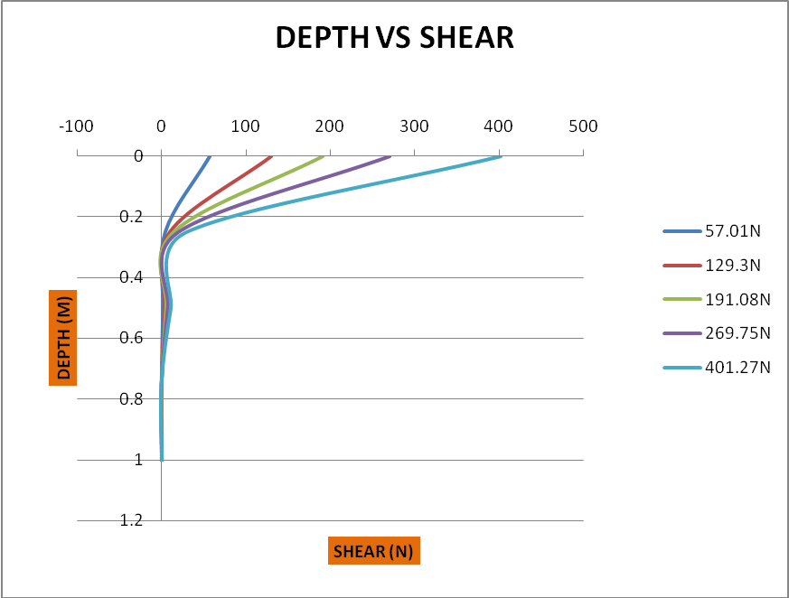

Fig 08. Graph between Depth and Shear for Concrete
V.V.GRAPH BETWEEN DEPTH AND SOIL REACTION
FOR MILD STEEL
Table 07. Depth and Soil reaction values for Mild Steel
S.no | Depth  (m) | Soil reaction (v) N/m
S.no | Depth  (m) | For load 57.01 n | For load 129.3 n | For load 191.08 n | For load 269.75 n | For load 401.27 n
1 | 0 | -1516.4 | -3439.38 | -5082.56 | -7427.32 | -10675.57
2 | 0.25 | -409.89 | 929.702 | 1373.86 | 1988.756 | 2885.56
3 | 0.5 | 1220.61 | 768.689 | 4091.173 | 5949.845 | 8593.04
4 | 0.75 | 242.033 | 548.62 | 811.246 | 1178.2099 | 1703.938
5 | 1 | -1772.65 | -4020.26 | -5941.48 | -8648.44 | -12479.47

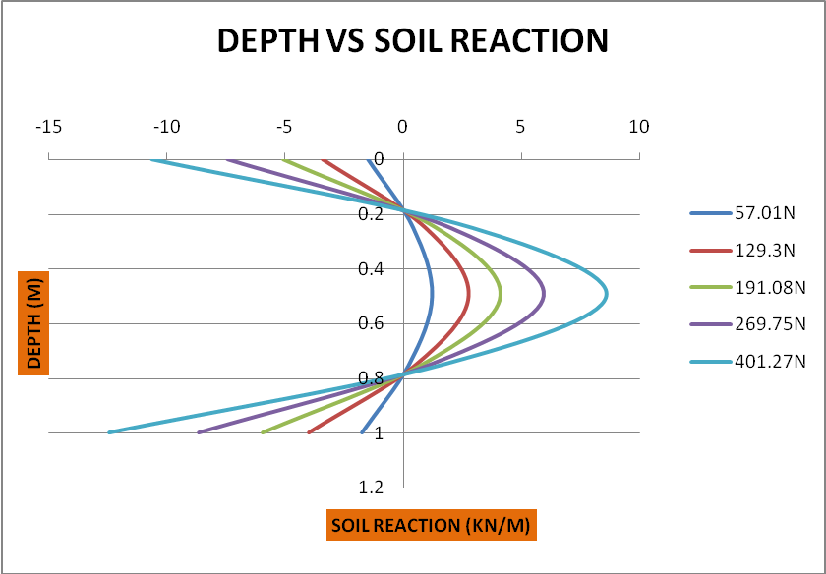

Fig 09. Graph between Depth and Soil reaction for Mild Steel
FOR CONCRETE
Table 08. Depth and soil reaction values for Concrete
S.no | Depth  (m) | Soil reaction (v) N/m
S.no | Depth  (m) | For load 57.01 n | For load 129.3 n | For load 191.08 n | For load 269.75 n | For load 401.27 n
1 | 0 | 417.311 | 945.72 | 1398.7106 | 1974.5660 | 2937.3111
2 | 0.25 | 5.9006 | 13.445 | 19.739 | 27.8660 | 41.4440
3 | 0.5 | 14.669 | 33.232 | 49.479 | 69.8497 | 103.90796
4 | 0.75 | -1.81566 | -4.11127 | -6.58235 | -9.292111 | -13.8231
5 | 1 | 1.05702 | 2.39496 | 4.00465 | 4.973822 | 8.40963

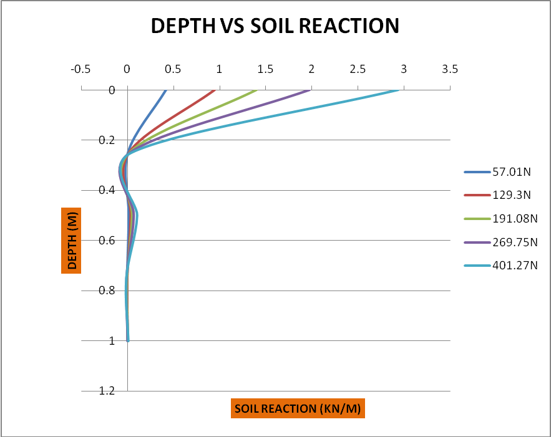
Fig 10. Graph between Depth and Soil reaction for Concrete

VI. SUMMERY AND CONCLUSIONS

- A pile subjected to lateral loading is one of the class of problems that involve interaction of soil and structures.
- For a pile under lateral loading, a solution cannot be obtained without accounting deformation of both pile and soil. The deflection of the pile and the lateral resistance are interdependent.
- Because of nonlinearity of soil, sometimes of the pile interactive techniques are always necessary to achieve a solution for a particular case of loading on pile.
- In this project a computer code has been developed for the analysis of laterally loaded pile using finite difference method. First pile is subdivided into m increments in which (m+1) equations can be written leading to (m+5) unknowns.
- Substituting appropriate boundary conditions fictious nodes at top and bottom portion of pile has been eliminated leading to (m+1) unknowns and (m+1).
The program are validated for (m+1) equations and (m+1) unknowns and checked for correctness by solving hypothetical numerical problems.

VII. REFERENCES

- Hetenyi, M. (1946) Beams on Elastic Foundations, The University of Michigan Press, Ann Arbor, Mich., USA.
- Hetenyi, M. (1950) A general solution for the bending of beams on an elastic foundation of arbitrary continuity.
- Journal of Applied Physics, 21, 55–58. Hooper, J.A. (1973) Observations on the behavior of a pile-raft foundation in london clay.
- Proceedings of the Institute of Civil Engineers, 55, 855–877. Hooper, J.A. (1979) Review of the Behavior of Piled Raft Foundations, Construction Industry Research and Information Association, Report 83.
- IS: 2911–1984 (1984) I.S. Code of Practice for Design and Construction of Pile Foundations: Load Test on Piles, Parts I–V, Bureau of Indian Standards, New Delhi, India.
- Iyer, A.N. (1995) PILEAN: An Expert System for Pile Foundation Design M.Tech Thesis, IIT, Kanpur, India.
- Jones, G. (1997) Analysis of Beams on Elastic Foundations using Finite Difference Theory, Thomas Telford, London, UK.
- Leonards, G.A. (1962) Foundation Engineering, McGraw-Hill Book Co., Inc., New York, USA.
- Lysmer, J. and Richart, F.E. (1966) Dynamic response of footings to vertical loading. Journal of SM Division, ASCE, 92(SM1), 65–91.
- Major, A. (1962) Vibration Analysis and Design of Foundations for Machines and Turbines, Collet’s Holding Ltd., London.
- Poulos, H.G. and Davis, E.H. (1980) Pile Foundation Analysis and Design, John Wiley & Sons, Ltd., Chichester, UK.
- Poulos, H.G. (2001) Piled raft foundations: design and applications. Geotechnique, 51(2), 95–113.
- Sharma, H.D. and Prakash, S. (1990) Pile Foundations in Engineering Practice, JohnWiley & Sons, Inc., New York, USA. Skempton, A.W. (1953)
- Discussion on settlement of pile group in sand. Proceedings of the 3rd International Conference on Soil Mechanics and Foundation Engineering, Geneva.

