Pharmacological Screening of Moringa oleifera : In Vitro Anti-inflammatory and Antimicrobial Activities

ABSTRACT
In Ayurveda, the traditional medicinal plant Moringa Oleifera—also known as horse radish tree is highly regarded for its healing qualities. This study aims to evaluate moringa oleifera extracts' antibacterial and anti-inflammatory qualities in vitro. The anti-inflammatory potential was assessed using the membrane stabilizing and protein denaturation methods. The antibacterial effectiveness against particular strains of bacteria and fungus was examined using the agar well diffusion method. Initial phytochemical testing revealed the presence of flavonoids, alkaloids, phenolics, and terpenoids; these substances might be in charge of the biological activities found. The extracts demonstrated significant antioxidant activity in a dose-dependent manner. The organism's significant anti-inflammatory qualities supported its traditional use in treating inflammatory illnesses. Additionally, the extracts demonstrated strong antifungal and antibacterial activity towards common strains of fungus and both Gram-positive and Gram-negative bacteria. Since it is used to boost a woman's milk production and is occasionally recommended for anemia, it is referred to as "mother's best friend" in the Philippines. Examining the antibacterial and anti-inflammatory qualities of several Moringa oleifera leaf extracts in vitro was the aim of the present one study.
Keywords:Anti-bacterial, Anti-inflammatory, Phenolic compounds, Protein denaturation,Traditional medicine.
INTRODUCTION
Often referred to as the drumstick tree, horseradish tree, or ben oil tree, Moringa oleifera Lam. (Moringaceae) is a very nutritious edible plant whose leaves and immature seed pods are especially helpful as fortificants in food items with an excellent margin of safety [1-3]. Because of its resistance to extreme dryness and moderate frost, the plant is grown all over the world [4]. Mor inga has been used historically to cure a number of illnesses. All parts of the plant were used to cure pathogens, oxidative stress, inflammatory illnesses, and high blood pressure. Its roots were employed as an antiepileptic and heart tonic[5,6].The blooms and typical stem bark were used to control blood glucose levels and aid in controlling diabetes.

Moringa oleifera has several therapeutic uses in addition to its nutritional value. Antimicrobial, antifungal, antihypertensive, anti-hyperlipidemic, anti-hyperglycemic, antipyretic, wound repair, antitumor, anticancer, anti-inflammatory, and water purification are some of the therapeutic benefits. Moringa oleifera's health benefits are indivisible since it can withstand dry conditions and has a greater amount of protein than milk or supplements. To reach the level of evidence needed for Moringa oleifera's complete biological endorsement, an in-depth examination is necessary. Because of rapid expansion rate, low farming demands, and capacity to withstand harsh weather, Moringa oleifera is regarded as a highly sustainable crop as well as due to its medical benefits. It is a multifunctional plant since its leaves, pods, seeds, blooms, and roots are all used in different ways. Because of its inherent coagulating qualities, which aid in the removal of pollutants and microorganisms from water, the seeds are also utilized in water filtration procedures.

Plant Description:
A popular tree in tropical and subtropical areas, particularly in India, is Moringa oleifera, which grows quickly and is impervious to stress. With a fragile, corky trunk and brittle, drooping branches that form a loose, open tiara, it usually reaches a height of 10 to 12 meters[7]. The tripinnate foliage is tiny, oval, vivid green leaflets that are high in calcium, protein, and vitamins A and C. The plant produces bunches of aromatic, creamy-white flowers that grow into long, thin, three-sided pods called percussion sticks. Round seeds with wing-like features that facilitate dissemination are found inside these pods.
The plant is extremely important for both well-being and the economy. Whereas the seeds yield a premium oil known as ben oil, which is utilized in lubricating, cooking, and cosmetics, the leaves are used to make powder and vitamins. Additionally, the seeds' inherent coagulating qualities aid in the purification of water by eliminating contaminants. Various are utilized for therapeutic purposes in traditional systems to cure ailments like digestive issues, anemia, and inflammation. Moringa oleifera is frequently described as a miraculous plant" or "tree of life" due to its many applications, high nutritional value, and capacity to thrive in challenging conditions[8].

TAXONOMICAL CLASSIFICATION :
Kingdom : Plantae
Sub kingdom : Tracheobionta
Division : Magnoliophyta
Class : Magnoliopsida
Sub class : Dilleniidae
Order : Capparales
Family : Moringaceae
Genus : Moringa
Species : Oleifera
MYTHOLOGICAL SIGNIFICANCE OF MORINGA:
Especially in places like India, Moringa oleifera has a little but significant role in traditional beliefs and folklore. In local customs, it is frequently considered a protective and life-sustaining tree, even when it is not closely linked to important legends like certain hallowed plants. Moringa is frequently planted close to dwellings in remote areas because it is thought to fend away evil spirits and provide good health and wealth to houses. It has been figuratively associated with strength, energy, and divine grace due to its rapid growth and capacity to sustain itself under challenging circumstances. The plant's many therapeutic qualities are frequently seen as a symbol of spiritual regeneration strength, and it is regarded in some folk beliefs as a gift from creation intended to preserve human life. Therefore, moringa has great symbolic and cultural significance as a "tree of life" with conventional religions, even if it is not fundamental to the traditional mythology[14].
CHEMICAL CONSTITUENTS:

Moringa oleifera's many different chemical components are responsible for its high nutritional and medicinal value. The plant contains important vitamins like vitamin A (as beta-carotene), vitamin C, and vitamin E in addition to essential minerals like calcium, potassium, iron, and magnesium. It is also a good source of essential proteins and amino acids. Moringa is particularly well-known for its bioactive components, which include flavonoids (such as quercetin and kaempferol), phenolic acids, and tannins with strong antioxidant properties. It also contains glucosinolates and isothiocyanates, which have anticancer and anti-inflammatory qualities. The seeds are rich in fatty acids, especially oleic acid, which is present in ben oil[17,18].The plant's many portions also include alkaloids, saponins, and glycosides, all of which contribute to its medicinal properties. Moringa is regarded as a very beneficial plant in traditional medicine and nutrition because of this wide variety of chemical components[15].
1.Leaves
Flavonoids: There is a lot of rutin, kaempferol, and quercetin. These substances exhibit potent cardiac protection, reducing inflammation, and antioxidant properties.
Phenolic acids: Caffeic acid and chlorogenic acid have antidiabetic and antioxidant properties.
Vitamins: Packed with vitamins C, E, and A (β-carotene), that promote healthy skin and immunity.
Alkaloids: Moringine and moringinine have hypotensive and vasodilator properties[19,20].
Saponins: They have anti-inflammatory, antibacterial, and cholesterol-lowering qualities.
Proteins and Amino Acids: Offers vital amino acids that promote physiologic and dietary processes, such as leucine, isoleucine, and valine.

2.Seeds

Fixed oils: High in oleic acid (ben oil), good for skincare and heart function.
Glucosinolates and isothiocyanates: Substances with antibacterial, anticancer, and anti-inflammatory properties include benzyl isothiocyanate.
Sterols: β-sitosterol has anti-inflammatory and cholesterol-lowering properties.
Proteins: Liquids-soluble proteins have antibacterial properties and help purify water[21,22,23].

3.Roots

Alkaloids: Moringine and spirochin have anti-inflammatory and analgesic qualities.

Triterpenoids: Have anti-inflammatory and liver protective properties.
Glycosides: Support antibacterial and cardiovascular calming properties.

Phenolic compounds: Offer advantages as antioxidants. [16]

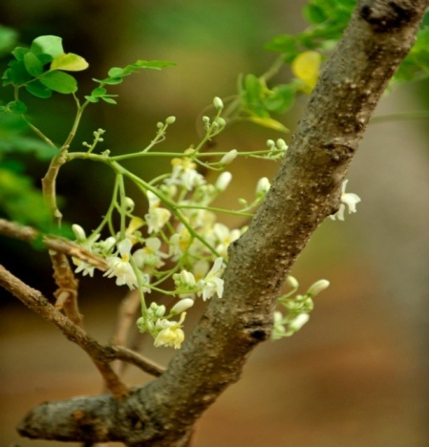
Figure 2 :Flowers
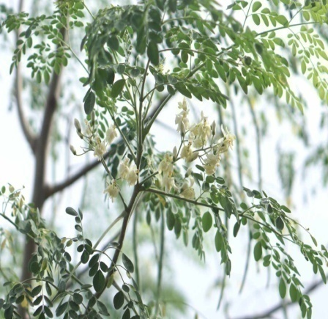

Figure 1: Branches
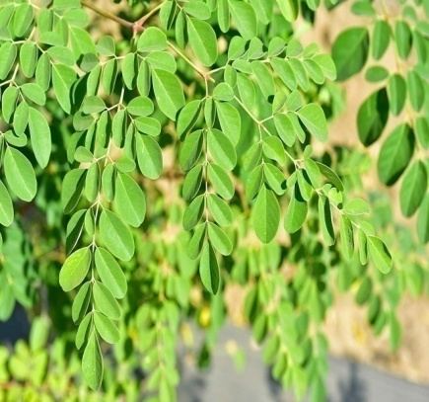
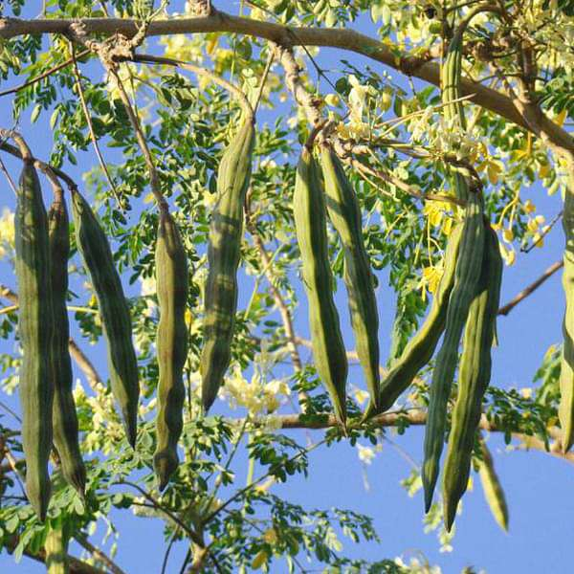
Figure 4 :Leaves
Figure 3 :Drumsticks

Table 1 :Phytochemical tests
Phytochemicals | Test name | Procedure | Observation | Inference
Alkaloids | Mayers test | Mayer’s reagent +extract. | Cream/white ppt | Presence of  alkaloids
Flavanoids | Alkaline reagent test | Add NaOH +  dilute HCl. | Yellow colour disappears | Presence of flavonoids
Tannins | Ferric chloride Test | Add FeCl₃ to extract. | greenish-black color appears | Presence of tannins
Terpenoids | Salkowski Test | Chloroform + conc.  H₂SO₄ +extract. | Reddish-brown at interface | Presence of terpenoids
Steroids | Liebermann– BurchardTest | Add acetic anhydride and conc.H₂SO₄ to  the extract. | Blue-green color is observed | Presence of steroids
Carbohydrates | Molisch’s Test | Add Molisch’s reagent, then conc. H₂SO₄. | Violet ring at interface | Presence of carbohydrates

METHODOLOGY

Collection of plant materials

1. Gathering plant material:
Gather Moringa oleifera leaves, either fresh or dried.Carefully wash to get rid of contaminants.
Dry in an oven at 40 to 50 degrees Celsius or in the shade . Prepare a fine dust[9,10].
2. The choice of solvent:
* Make use of aqueous or pure ethanol.
* Effective for the extraction of bioactive substances such as alkaloids and flavonoids[11,12].
3. Soxhlet apparatus preparation: Put together the condenser, Soxhlet extractor, round-bottom flask, and heating mantle/water bath.
4. Filling the Sample: Fill a cellulose/filter paper thimble with the powdered substance. Place the thimble inside the Soxhlet extractor.
5. The Process of Extraction:
* Fill the round-bottom flask with 1:10 or 1:20 ethanol.
* Gently heat to cause the solvent to evaporate.
* Vapors flow through the sample after condensing.
* Bioactive substances are dissolved by the solvent and then siphoned back.
* Repeat the cycles[13].

6.Concentrate the extract in a rotary evaporator.
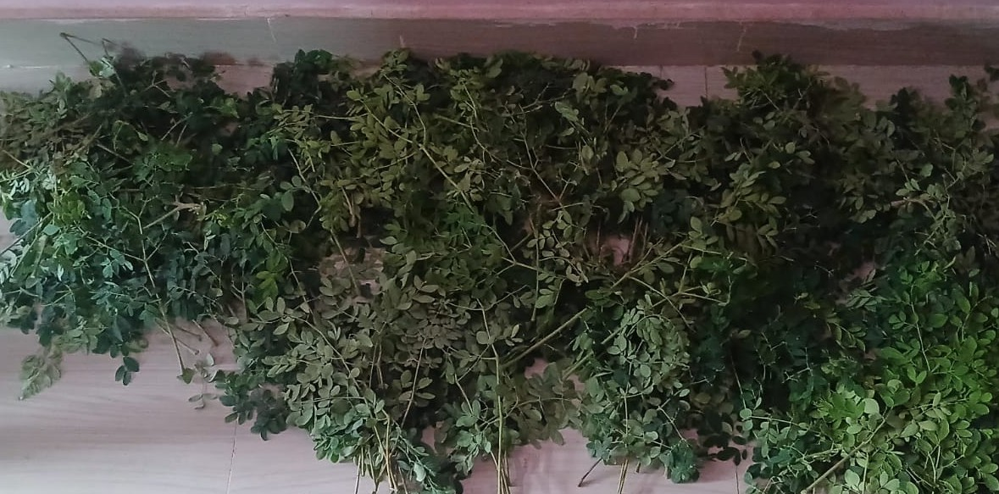
Figure 5 : Moringa leaves

Evaluation of pharmacological activities
Anti - microbial activity :
Moringa oleifera is a medicinal plant rich in bioactive substances such flavonoids, tannins, alkaloids, and phenolic compounds. These phytochemicals increase its antibacterial activity by damaging bacterial cell walls, inhibiting enzyme function, and interfering with DNA replication.
Several extracts of Moringa oleifera, including ethanolic, methanolic, and aqueous forms, have demonstrated significant antibacterial activity against both Gram-positive and Gram-negative bacteria.

Bacterial strains investigated
Gram-positive Bacteria: Staphylococcus aureus , Bacillus subtilis
Gram-negative Bacteria: Escherichia coli ,Pseudomonas aeruginosa

Mechanism of action:

Moringa oleifera's antibacterial action is ascribed to its bioactive compounds, which work through several mechanisms:
A.Disruption of bacterial cell membranes
Bioactive chemicals like flavonoids and tannins interact with membrane lipids, jeopardizing the sturdiness of microbe lipid membranes. This increases membrane porosity, resulting in the leakage of critical intracellular components, loss of ionic balance, and final cell death[24,25,26].
B.Inhibiting bacterial enzyme activity:
The substances found inhibit critical microbe enzymes involved in vital metabolic processes. This blockade impairs energy synthesis in addition to cellular activities, preventing germ growth and survival[27,28].
C.Interference with DNA Replication:
Certain chemicals block enzymes such as DNA gyrase and topoisomerase, which are required for DNA synthesis. This hinders the replication of genetic material, which leads to defective cell division and, eventually, bacterial cell death[29,30,31].

Procedure for pour plate method:

1.Preparing Culture Medium:
The agar medium (e.g., nutrient agar or selective agar) is prepared per the manufacturer's instructions and autoclaved to remove contaminants.
2. Preparing the Inoculum
A microbial suspension is formed by inoculating the desired microorganism into sterile broth and cultivating it until it reaches the required growth density.
3. Maintaining aseptic conditions:
To ensure aseptic conditions throughout the procedure, all equipment and glassware are autoclaved, and the working space is thoroughly cleaned with alcohol.
4. Pouring Sterile Agar Plates:
The sterilized molten agar is aseptically transferred to sterile Petri plates (approximately halfway filled) and allowed to cool and solidify.

5. Inoculation of the test organism:
The hardened agar surface is infected by evenly streaks or dispersing the microbes utilizing a loop of sterilization to achieve homogeneous microbial formation.

6. Antimicrobial applications:
When using liquid antibacterial agents such as S. aureus or E. coli, drop the mixture onto the plate in certain regions or mix them immediately onto the agar solution prior filling.
7. Incubation:
Incubate the Petri dishes upside down at the appropriate temperature for the microorganism. Incubating duration typically ranges between 24 and 48 hours, contingent on the microbe.
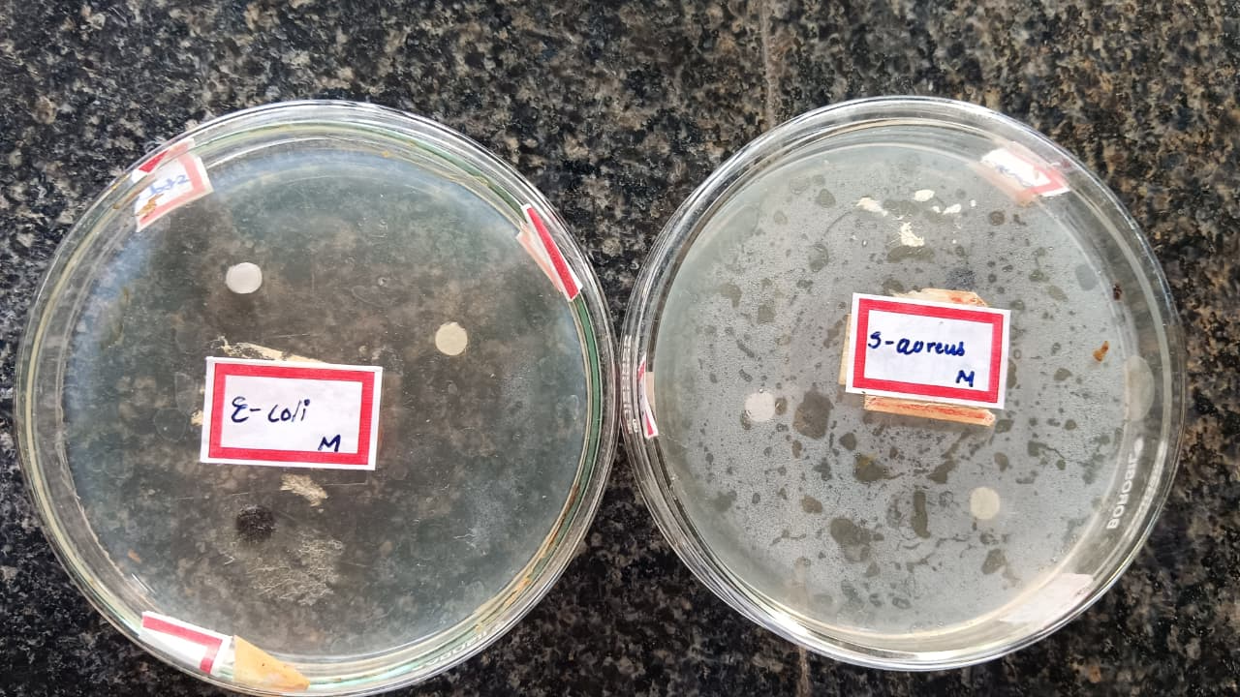
8. Observations:
After incubation, check the plates for zones of inhibition surrounding the antimicrobial agent.The zone of blockage is the area surrounding the antimicrobial agent that does not allow microbiological growth. The greater the zone, the better the antibacterial chemical works against the pathogen.

Figure 6 : Strains of pour plate method

Procedure for Spread plate method:
1.Preparation of Agar plate:
Pour sterilized molten Mueller- into a Tetra plate and allow to solidify.
2.Inoculation (The Spread Plate Step):
• Dilute a fresh bacterial culture as necessary .Place a sterile cotton swab in the bacterial suspension.
• Using a swab, equally disseminate bacteria throughout the agar surface in three directions, creating a lawn of growth.
3.Application of Discs:
• Sanitize forceps (for plain paper discs).
• Dip sterile paper discs in the test solution, or place ready-made antibiotic discs on the plate.
• Gently press each disk onto the surface of the inoculated agar.
4.Incubation:
• Allow 15 minutes at room temperature for the sample to diffuse.
• Incubate the plates at 37 °C for 18-24 hours.

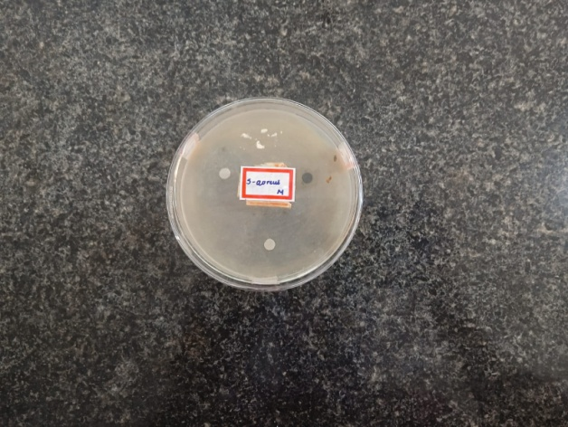
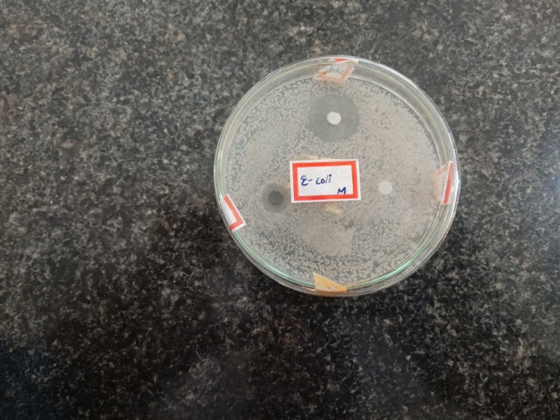

Figure 7 : Strains of spread plate method

Anti- inflammatory activity:
Inflammation is the physique's inherent defensive system versus disease, trauma, or hazardous stimuli; nevertheless, persistent inflammation can cause a variety of diseases, including rheumatism, heart problems, and diabetes. In recent years, there has been a surge of interest in plant-based medicines for treating inflammation with fewer adverse effects. Moringa oleifera has emerged as a promising therapeutic plant thanks to its powerful anti-inflammatory capabilities.
Moringa includes a variety of bioactive chemicals, including flavonoids (such as quercetin), phenolic acids, alkaloids, and isothiocyanates, all of which help to reduce inflammation. These substances block the synthesis of pro-inflammatory mediators such as cytokines, prostaglandins, and nitric oxide. Furthermore, moringa helps regulate oxidative stress, which is intimately related to inflammatory processes.

Types of Inflammation
Acute inflammation: Fluid discharge and neutrophil invasion are the hallmarks of this sudden onset and short-lived illness.
Examples include a sore throat, skin damage, and peritonitis.
Chronic inflammation: Lasting length (weeks to years), including lymphocyte and macrophages, frequently causing tissue damage.
Examples include rheumatoid arthritis and TB.

Mechanism of Anti-Inflammatory Action of Moringa

Suppression of inflammatory-promoting mediators:
Phytochemicals reduce inflammation by suppressing the production of inflammatory mediators such prostaglandins, cytokines, and nitric oxide.

Blocking of enzymes:
Moringa extracts suppress major inflammatory enzymes such as cyclooxygenase (COX) and lipoxygenase (LOX), which produce inflammatory chemicals.
Stabilization of cell membranes:
The extracts stabilize lysosomal membranes, inhibiting the release of inflammatory enzymes and minimizing tissue damage.
Manipulation of Signaling Channels:
Bioactive chemicals suppress inflammatory signaling pathways including NF-κB, resulting in reduced expression of inflammation-related genes.

Membrane stabilization method:
During inflammation, lysosomal membranes may break, releasing enzymes that contribute to tissue damage and inflammation. Anti-inflammatory medicines, notably nonsteroidal anti-inflammatory medications (NSAIDs), work by stabilizing lysosomal membranes or blocking enzyme release. Because the erythrocyte (red blood cell) membrane is physically comparable to the lysosomal membrane, it is frequently used as a model to investigate membrane stability. Access of red blood cells to harmful conditions such as hypotonic solutions or heat causes membrane injury, which results in hemolysis and hemoglobin release. This conditions induce excessive fluid to enter cells, resulting in enlargement and rupture of membranes.
Membrane degradation raises the risk of oxidative injury and the breakdown of lipids. Furthermore, lysosomes in active neutrophils contain enzymes that, when released, worsen inflammation and tissue injury. As a result, cell membrane integrity is crucial for regulating inflammation because it inhibits the release of hazardous intracellular components. The membrane stabilizing function of plant extracts, including Moringa oleifera, is evaluated using heat-induced and hypotonicity-induced hemolysis tests on erythrocytes (human or animal). The extract's ability to prevent hemolysis implies a potential anti-inflammatory impact.
Principle of heat induced hemolysis assay:
The heat-induced hemolysis assay depends on the ability of test compounds, such as Moringa oleifera extracts, to keep red blood cell (RBC) membranes intact under stressful conditions. During inflammation, cellular and lysosomal membranes disintegrate, releasing inflammatory mediators and enzymes. Compounds that inhibit or reduce hemolysis (RBC rupture) are thought to have anti-inflammatory effects.
Because the RBC membrane is structurally comparable to the lysosomal membrane, Moringa oleifera extract's ability to stabilize RBCs implies that it can likewise stabilize lysosomes and prevent the release of inflammatory compounds.

Procedure:
1. Collect fresh whole blood (human or animal, e.g., goat/sheep) and mix with an equal volume of Alsever’s solution to prevent coagulation.
2. Centrifuge at 3000 rpm for 10 minutes, discard the supernatant, and wash the packed cells with normal saline 3–4 times until clear.
3. Prepare a 10% v/v RBC suspension using isotonic saline.
4. Prepare different concentrations of Moringa oleifera leaf extract in ethanol (100, 200, 300, and 400 µg/mL).
5. Prepare similar concentrations of diclofenac sodium as the standard drug.
6. In test tubes, mix 1 mL plant extract, 1 mL phosphate buffer (pH 7.4), 2 mL hypotonic saline, and 1 mL RBC suspension.
7. Prepare a control by replacing the extract with ethanol.
8. Incubate one set of tubes at 56°C for 30 minutes (heat-induced hemolysis).
9. Keep another set at room temperature as an unheated control.
10. After incubation, centrifuge all tubes at 2500 rpm for 5 minutes.
11. Collect the supernatant and measure its absorbance at 560 nm using a spectrophotometer.
12. The control contains RBC suspension with hypotonic solution (without test sample) and represents 100% hemolysis.
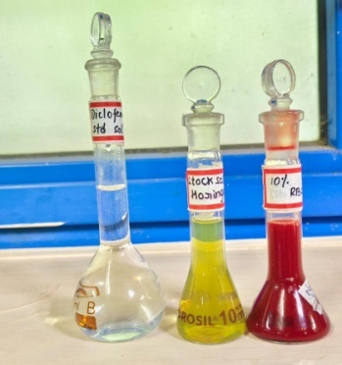
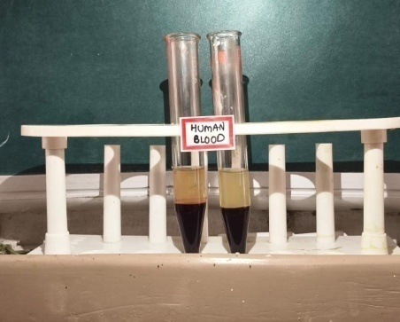

Figure 8 :Human blood
Figure 9 :Stock solutions
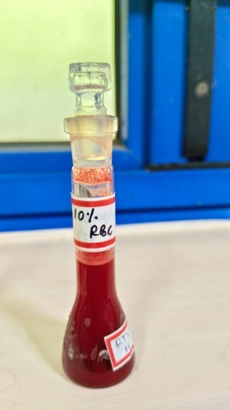
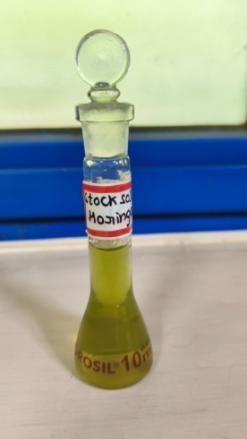
Figure 11 :10%v/v RBC Solution
Figure10 :Stock solution of moringa

Preparation of solutions
Alsever’s solution:
It is commonly used to prevent coagulation and preserve red blood cells (RBCs) during experimental procedures. It contains dextrose (2.05%), sodium citrate (0.8%), citric acid (0.055%), and sodium chloride (0.42%), and is mixed with blood in equal volume. This solution is particularly useful in in vitro anti-inflammatory studies such as heat-induced hemolysis.
Hypotonic solution:
It consists of 0.36% w/v sodium chloride (0.36 g in 100 mL distilled water), is prepared fresh and is used to induce hemolysis through osmotic imbalance, thereby helping to evaluate the membrane stabilizing effect of Moringa oleifera extract.
RBC suspension preparation:
Fresh goat blood is collected in EDTA tubes and centrifuged at 3000 rpm for 10 minutes. The packed RBCs are then washed three times with 0.9% normal saline, and a 10% v/v RBC suspension is prepared in normal saline for use in the assay.

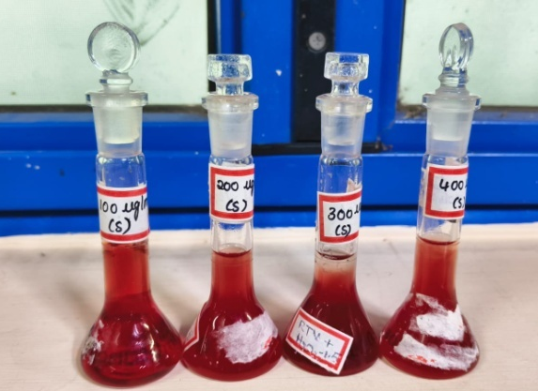
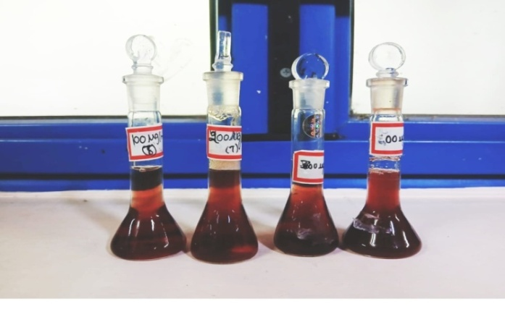
Figure 13 :Standard serial dilutions
Figure 12 :Test serial dilutions

% Inhibition of Haemolysis
(Absorbance of control − Absorbance of test)
= --------------------------------------------------- x 100
Absorbance of control

RESULTS
Anti-microbial activity:
For spread plate method:
Bacteria | Standard | Extract | Control
S.aureus | 2.5mm | 1.5mm | 1.2mm
E.coli | 2.2mm | 1.8mm | 1.3mm

Results:

S.aureus: The extract had an inhibition zone of 1.5mm, the standard 2.5mm, and the control 1.2mm.

E.coli: The extract displayed a 2.2 mm zone of inhibition, the standard 1.8mm ,and the control 1.3 mm.

For pour plate method:

Bacteria | Standard | Extract | Control
S.aureus | 2.4mm | 1.7mm | 1.4mm
E.coli | 2.2mm | 1.5mm | 1.2mm

Results:

E.coli : The extract displayed a 1.5mm zone of inhibition, the standard 2.2mm, and the control 1.2mm .
S. aureus: The extract displayed a 1.7mm zone of inhibition, the standard 2.mm, and the control 1.6mm
% Inhibition of both spread plate and pour plate method

Name of the organism | Method to determine  %Inhibition | %Inhibition for standard | %Inhibition for control
E.coli | Pour plate | 40.90% | 7.14%
S.aureus | Pour plate | 43.47% | 6.25%
E.coli | Spread plate | 23.80% | 15.78%
S.aureus | Spread plate | 57.6% | 5.35%

Report:
S. aureus shows greater inhibition in pour plate technique than E.coli when compared to spread plate technique. Hence, plant extract has mild Anti-bacterial activity.
Anti-inflammatory activity:
Standard table and graph
Control absorbance for standard is 0.45nm
S.NO | TYPE | CONCENTRATION  (µg /ml) | ABSORBANCE  (nm) | %INHIBITION (%)
1. | Standard-1 | 100µg/mL | 0.360nm | 20%
2. | Standard-2 | 200µg/mL | 0.321nm | 28%
3. | Standard-3 | 300µg/mL | 0.255nm | 43%
4. | Standard-4 | 400µg/mL | 0.219nm | 51.33%
Standard table for anti – inflammatory activity

Anti-Inflammatory activity of standard graph

Moringa oleifera table and graph

Control absorbance for sample is 0.55nm
S.NO | TYPE | CONCENTRATION  (mg/ml) | ABSORBANCE  (nm) | %INHIBITION (%)
1. | Sample-1 | 100mg/ml | 0.375nm | 31.81%
2. | Sample-2 | 200mg/ml | 0.325nm | 35.45%
3. | Sample-3 | 300mg/ml | 0.285nm | 41.81%
4. | Sample-4 | 400mg/ml | 0.215nm | 44.72%
Sample table for anti - inflammatory activity

IC50 Interpolation formula : It was obtained from the dose response curve :

IC50=C1+(50−I1/I2−I1)×(C2−C1)

For standard:

Where,

- C1=300(Concentration at C1)
- C2=400(Concentration at C2)
- I1 =43(% Inhibition at C1)
- I2 =51.33(% Inhibition at C2)

We solve for IC50 when inhibition = 50%. Therefore, final IC50 value is =354.03 μg/ml

For sample:

- C1=200(ConcentrationatC1)
- C2=300(ConcentrationatC2),
- I1=35.45(%InhibitionatC1)
- I2 =41.81(%InhibitionatC2)

We solve for IC50 when inhibition = 50%. Therefore,final IC50 value is = 400 μg/ml

Conclusion:
In the antibacterial study, the extract showed measurable zones of inhibition against both Staphylococcus aureus and Escherichia coli in both spread plate and pour plate methods. However, the standard antibiotic consistently produced larger zones of inhibition, indicating stronger antibacterial activity. Among the tested organisms, S. aureus exhibited relatively higher sensitivity to the extract, particularly in the pour plate method, suggesting that the extract is more effective against Gram-positive bacteria than Gram-negative bacteria like E. coli. The calculated percentage inhibition values further support that the extract has mild antibacterial potential.
In the anti-inflammatory study, the extract showed a dose-dependent increase in percentage inhibition, indicating its ability to inhibit protein denaturation or membrane lysis. Although the activity increased with concentration, the standard drug showed higher inhibition at lower concentrations, confirming its superior potency. The IC₅₀ value of the extract is higher than that of the standard, indicating that a greater concentration of the extract is required to achieve 50% inhibition.
Overall, the plant extract exhibits promising but moderate antibacterial and anti-inflammatory activities. These findings suggest that the extract could serve as a potential natural therapeutic agent, but further studies such as isolation of active constituents, mechanism studies, and in vivo evaluation are required to confirm its efficacy and safety.
References:
- Moringa oleifera Lam. (2001). The Miracle Tree: The Multiple Attributes of Moringa. CTA Publications, Wageningen, Netherlands.
- Lowell J. Fuglie (1999). The Miracle Tree: Moringa oleifera: Natural Nutrition for the Tropics. Church World Service, Dakar.
- Fahey JW (2005). “Moringa oleifera: A review of the medical evidence for its nutritional, therapeutic, and prophylactic properties.” Trees for Life Journal, 1(5).
- Anwar F, Latif S (2007). “Moringa oleifera: A food plant with multiple medicinal uses.” Phytotherapy Research, 21(1), 17–25.
- Leone A et al. (2015). “Cultivation, genetic, ethnopharmacology, phytochemistry and pharmacology of Moringa oleifera.” International Journal of Molecular Sciences, 16(6), 12791–12835.
- Mbikay M (2012). “Therapeutic potential of Moringa oleifera leaves in chronic hyperglycemia and dyslipidemia.” Frontiers in Pharmacology, 3, 24.
- Siddhuraju P, Becker K (2003). “Antioxidant properties of various solvent extracts of Moringa oleifera leaves.” Journal of Agricultural and Food Chemistry, 51(8), 2144–2155.
- Gopalakrishnan L et al. (2016). “Moringa oleifera: A review on nutritive importance and its medicinal application.” Food Science and Human Wellness, 5(2), 49–56.
- Kokate CK, Purohit AP, Gokhale SB. Pharmacognosy. 49th ed. Pune: Nirali Prakashan; 2010.
- World Health Organization. Quality control methods for medicinal plant materials. Geneva: WHO; 1998.
- Anwar F, Latif S, Ashraf M, Gilani AH. Moringa oleifera: a food plant with multiple medicinal uses. Phytother Res. 2007;21(1):17–25.
- Harborne JB. Phytochemical methods: a guide to modern techniques of plant analysis. 3rd ed. London: Chapman & Hall; 1998.
- Rostagno MA, Prado JM. Natural product extraction: principles and applications.
- Kumar NA et al. (2010). “Anti-inflammatory activity of Moringa oleifera.” Journal of Pharmaceutical Sciences and Research, 2(12), 789–792.
- Ezeamuzie IC et al. (1996). “Anti-inflammatory effects of Moringa oleifera root extract.” International Journal of Pharmacognosy, 34(3), 207–212.
- Sharma, S. (2026). Phytochemical Constituents and Therapeutic Potential of Indian Medicinal Plants: A Comprehensive Review.
- Gopalakrishnan, L., Doriya, K., & Kumar, D. S. (2016). Moringa oleifera: A review on nutritive importance and its medicinal application. Food science and human wellness, 5(2), 49-56.
- Moyo, B., Masika, P. J., Hugo, A., & Muchenje, V. (2011). Nutritional characterization of Moringa (Moringa oleifera Lam.) leaves. African journal of biotechnology, 10(60), 12925-12933.
- Kaurinovic, B., & Vastag, D. (2019). Flavonoids and phenolic acids as potential natural antioxidants. Antioxidants, 2(1), 1-14.
- Al Hoque, A., Begum, S., & Dutta, D. (2025). Occurrence, Chemical Nature, and Medicinal Benefits of Flavonoids-Rutin, Kaempferol, Quercetin, Anthocyanidins, Catechins, and Flavones. In Dietary Supplements and Nutraceuticals (pp. 1-24). Singapore: Springer Nature Singapore.
- GUVEN, L., IDDRISU, A. K., & DOGAN, E. AN OVERVIEW OF FIXED OILS OF PLANT ORIGIN USED FOR MEDICAL PURPOSES. BIOACTIVE COMPONENTS AND BIOCHEMICAL PROPERTIES IN FOODS, 99.
- Sumara, A., Stachniuk, A., Montowska, M., Kotecka-Majchrzak, K., Grywalska, E., Mitura, P., ... & Fornal, E. (2023). Comprehensive review of seven plant seed oils: chemical composition, nutritional properties, and biomedical functions. Food Reviews International, 39(8), 5402-5422.
- Almatrafi, M. (2017). The Effects of Moringa Leaves on Hepatic Lipid Accumulation and Inflammation in a Guinea Pig Model of Hepatic Steatosis.
- De Rossi, L., Rocchetti, G., Lucini, L., & Rebecchi, A. (2025). Antimicrobial potential of polyphenols: Mechanisms of action and microbial responses—A narrative review. Antioxidants, 14(2), 200.
- Lou, Z., Cheng, X., Dong, J., Dai, W., Chen, X., & Wang, H. (2025). The antibacterial mechanism and cell damage mechanism of natural antibacterial agents from different sources and their applications in food. Journal of Food Measurement and Characterization, 1-25.
- Ibrahim, N. A., Rathore, D., Janiyani, K., Gupta, A., Sulieman, A. M. E., Tahir, H. E., ... & Surti, M. (2025). A comprehensive review on plant-derived bioactive saponins as promising antimicrobial agents: from bioavailability challenges, molecular mechanistic insights to therapeutic applications. Naunyn-Schmiedeberg's Archives of Pharmacology, 1-31.
- Seregina, T. A., Lobanov, K. V., Shakulov, R. S., & Mironov, A. S. (2022). Enhancement of the bactericidal effect of antibiotics by inhibition of enzymes involved in production of hydrogen sulfide in bacteria. Molecular Biology, 56(5), 638-648.
- Ahmed, K. B. A., Raman, T., & Veerappan, A. (2016). Future prospects of antibacterial metal nanoparticles as enzyme inhibitor. Materials Science and Engineering: C, 68, 939-947.
- Budzowska, M., & Kanaar, R. (2009). Mechanisms of dealing with DNA damage-induced replication problems. Cell biochemistry and biophysics, 53(1), 17-31.
- Bailly, C. (2012). Contemporary challenges in the design of topoisomerase II inhibitors for cancer chemotherapy. Chemical reviews, 112(7), 3611-3640.
- Nitiss, J. L., & Wang, J. C. (1996). Mechanisms of cell killing by drugs that trap covalent complexes between DNA topoisomerases and DNA. Molecular pharmacology, 50(5), 1095-1102.

