Prevalence of Glucose-6-Phosphate Dehydrogenase (G6PD) Deficiency across Tribal, Non-Tribal, and Mixed Populations in Northeast India: A Review
ABSTRACT
The paper intends to highlight the prevalence of G6PD deficiency in various populations in Northeast India. This region, including Nagaland, Assam, and Manipur, shows significant rates of G6PD deficiency. Populations such as the Angami Naga of Nagaland (27.06%), Muslims of Manipur (21.32%), Mizos of Mizoram (17.5%) and the Rabha and Mikir populations of Assam show a high frequency of G6PD deficiency, exceeding 15%, with an overall regional prevalence of 6.56%. In which the overall frequency of G6PD deficiency is found higher among the tribal populations with 8.37% while the non-tribal populations show 4.40% and mixed populations is 4.88%. A higher frequency of G6PD deficiency is observed among Tribal populations (8.37%) compared to Mixed population (4.88%), while Non-tribal populations show a prevalence of 4.40%. These differences are statistically significant, as indicated by chi-square values of 27.4397 (p<0.00001) and 16.9447 (p=0.000038) respectively. The frequency trends reflect a complex interplay of genetic factor and environmental pressures, particularly malaria in the region.
Keywords: G6PD, prevalence, tribal, non- tribal, mixed population, Northeast India
INTRODUCTION
Glucose-6-phosphate dehydrogenase (G6PD) is an enzyme that plays an essential role in cell metabolism. The normal function of G6PD is to neutralize the oxidising substances and protect red blood cells from oxidative stress. So to get rid of such oxidative stress enough amount of G6PD enzyme is required. Otherwise damage or destroy the red blood cells by oxidative stress leading to a condition called haemolytic anaemia. The G6PD gene is located in the long arm of X-chromosome consisting 13 exon (Martini et al.1986). G6PD deficiency is very common among humans, affecting more than 400 million people worldwide and is characterised by considerable biochemical and molecular heterozygosity (Luzzatto et al. 1995). Allison (1960) and Motulsky (1960) reported that G6PD deficiency is known to provide a selective advantage in the presence of malarial parasitaemia. The deficiency of the G6PD enzyme is highly polymorphic in the malaria endemic areas. It is an example of balanced polymorphism, in which the high rate of mortality caused by this disorder is offset by the protection that it offers against plasmodium falciparum malaria (Luzzatto et al. 1979).
Alleles of the G6PD gene that encode a deficient enzyme attain high frequencies in areas where malaria is or has been endemic (Nagel et al. 1989). It was also reported that decreased parasitaemia has been observed among the patients with G6PD deficiency and the malaria parasite also does not grow well in G6PD deficient red cells as compared to normal cells (Roth et al. 1988) but is more protected against hemizygous males than homozygous females (Aldiouma et al. 2007). It is believed that this disorder has been naturally selected in regions with endemic malaria. And, a correlation was found between high prevalence of malaria due to Plasmodium falciparum and the incidence of G6PD deficiency (Mohnty et al. 2003). The paper presents a comprehensive review of the prevalence of glucose-6-phosphate dehydrogenase (G6PD) deficiency among tribal, non-tribal, and mixed populations in Northeast India. It examines existing studies to provide insights into population specific differences and the overall epidemiological patterns of G6PD deficiency in the region.

MATERIALS AND METHOD
The secondary data were collected from library in the form of journals, reference books. Research papers, articles, are also collected from Elsevier, PubMed, Google Scholar, Research Gate for comparative analyses.Comparions were made with earlier reports of Seth and Seth, 1971; Flatz et al. 1972; Das et al. 1982; Dash et al. 2005, Achoubi et al. 2010; Basumatary et al. 2021; and Parween et al. 2024, excluding hospital-based studies. A total of 6125 idividuals from different states of Northeast india were included in the study (excludiding Sikkim due to unavailability of reports). The populations were group into tribal, non-tribal and mixed categories (mixed category includes population not specifically identified in the earlier reports). Among them, 3152 were tribal population, 1887 were non-tribal and 1086 were mixed population. Chi- square test wew employed to test the significance.
RESULTS AND DISCUSSION
The state-wise distribution of G6PD deficiency among the North-eastern states of India is shown in Table 1. The Northeast region of India, particularly the state of Assam, is significant regarding G6PD deficiency, as prevalence rates of 15% or higher has been reported among the Rabha and Mikir (Karbi) populations of Assam (Das et al. 1982). Das et al. (1982) reported a G6PD deficiency rate of above 11% among the Garo and Rajbanshi populations of Assam. A G6PD deficiency rate of 5% or higher has been observed among the Ahom, Mishing, Khasi, and Dimasa populations of Assam (Flatz et al. 1972; Parween et al. 2024). In contrast, G6PD deficiency has not been detected in certain communities in Assam, such as the Chutia, Bodo, Brahmin, Bengali and Bihari (Parween et al. 2024). Among some caste populations, G6PD deficiency ranges from 0.8% in Kalitas to 4.32% in Assamese (Flatz et al. 1972; Parween et al. 2024). Intermediate frequencies are observed in Nepali (1.4%), Rajbongshi (1.4%), Muslim (1.5%), Tea Garden Labourers (1.8%), Kachari (20%), Kochari (2.1%), Ahom (2.4%), Deori (2.7%), Koibotter (3.4%), and Lalung with 3.7% (Flatz et al 1972; Parween et al. 2024). The frequency of G6PD deficiency is notably high among certain Mongoloid tribal populations of Assam and those with a close ethnic affinity to these groups (Das et al. 1982). The protective advantage of G6PD deficiency in malarial environments is a well-established concept, which helps explain the high prevalence of this trait among various populations in Northeast India (Das et al. 1982; Kar et al. 1995; Seth et al. 1971).
Table 1: Frequency distribution of G6PD enzyme deficiency in various populations of Northeast India
Population | Sample size | G6PD Normal % | G6PD Deficient % | Source
Assam
Ahom | 130 | 94.62 | 5.38 | Flatz et al. 1972
Assamese | 185 | 95.68 | 4.32 | Flatz et al. 1972
Kachari | 5 | 80.00 | (1*) 20.00 | Flatz et al. 1972
Khasi | 100 | 93.00 | 7.00 | Flatz et al. 1972
Rabha | 57 | 84.21 | 15.79 | Das et al. 1982
Lalung | 81 | 96.30 | 3.70 | Das et al. 1982
Mikir | 83 | 84.34 | 15.66 | Das et al. 1982
Garo | 76 | 92.11 | 7.89 | Das et al. 1982
Rajbanshi | 103 | 88.35 | 11.65 | Das et al. 1982
Proto Australoid | 1436 | 93.38 | 6.62 | Basumatary et al. 2021
Ahom | 379 | 97.60 | 2.40 | Parween et al. 2024
Bengali | 109 | 100.00 | 0.00 | Parween et al. 2024
Bihari | 85 | 100.00 | 0.00 | Parween et al. 2024
Bodo | 72 | 100.00 | 0.00 | Parween et al. 2024
Brahmin | 85 | 100.00 | 0.00 | Parween et al. 2024
Chutia | 73 | 100.00 | 0.00 | Parween et al. 2024
Deori | 74 | 97.30 | 2.70 | Parween et al. 2024
Kalita | 113 | 99.20 | 0.80 | Parween et al. 2024
Kochari | 93 | 97.90 | 2.10 | Parween et al. 2024
Koibotter | 88 | 96.60 | 3.40 | Parween et al. 2024
Mising | 170 | 94.70 | 5.30 | Parween et al. 2024
Muslim | 134 | 98.50 | 1.50 | Parween et al. 2024
Nepali | 71 | 98.60 | 1.40 | Parween et al. 2024
Rajbongshi | 69 | 98.60 | 1.40 | Parween et al. 2024
Tea Garden Labour | 279 | 98.20 | 1.80 | Parween et al. 2024
Others | 71 | 100.00 | 0.00 | Parween et al. 2024
Nagaland
Angami Naga | 85 | 72.94 | 27.06 | Seth and Seth, 1971
Meghalaya
Tura | 230 | 95.22 | 4.78 | Bharti et al. 2019
Arunachal Pradesh
Changlang | 267 | 95.13 | 4.87 | Bharti et al. 2019
Mizoram
Mizo | 490 | 82.5 | 17.5 | Dash et al. 2005
Lunglei | 214 | 94.86 | 5.14 | Bharti et al. 2019
Tripura
Gomti | 304 | 94.08 | 5.92 | Bharti et al. 2019
Manipur
Kabui | 51 | 94.12 | 5.88 | Achoubi et al. 2019
Brahmin | 127 | 90.51 | 9.49 | Achoubi et al. 2019
Muslim | 136 | 78.68 | 21.32 | Achoubi et al. 2019
* Total sample size of the reported Kachari population is only 5, and 1 individual is found to be G6PD deficient, which is 20%.
In Assam the prevalence the G6PD varied from 0.00% to 20% (Flatz et al. 1972; Das et al. 1982; Basumatary et al. 2021; Parween et al. 2024). In Nagaland, the prevalence of G6PD was found to be 27.06% among the Angami Naga (Seth and Seth 1971). Bharti et al. 2019 reported G6PD deficiency from Meghalaya (4.78%), Arunachal Pradesh (4.87%), Mizoram (5.14%) and Tripura (5.92%). Nevertheless, Dash et al. (2005) also reported, 17.5% from Mizo populations of Mizoram. Similarly, Achoubi et al. (2010) reported G6PD deficiency frequencies in Manipur of 5.88% among the Kabui, 9.49% among the Brahmins, and 21.32% among Muslims.
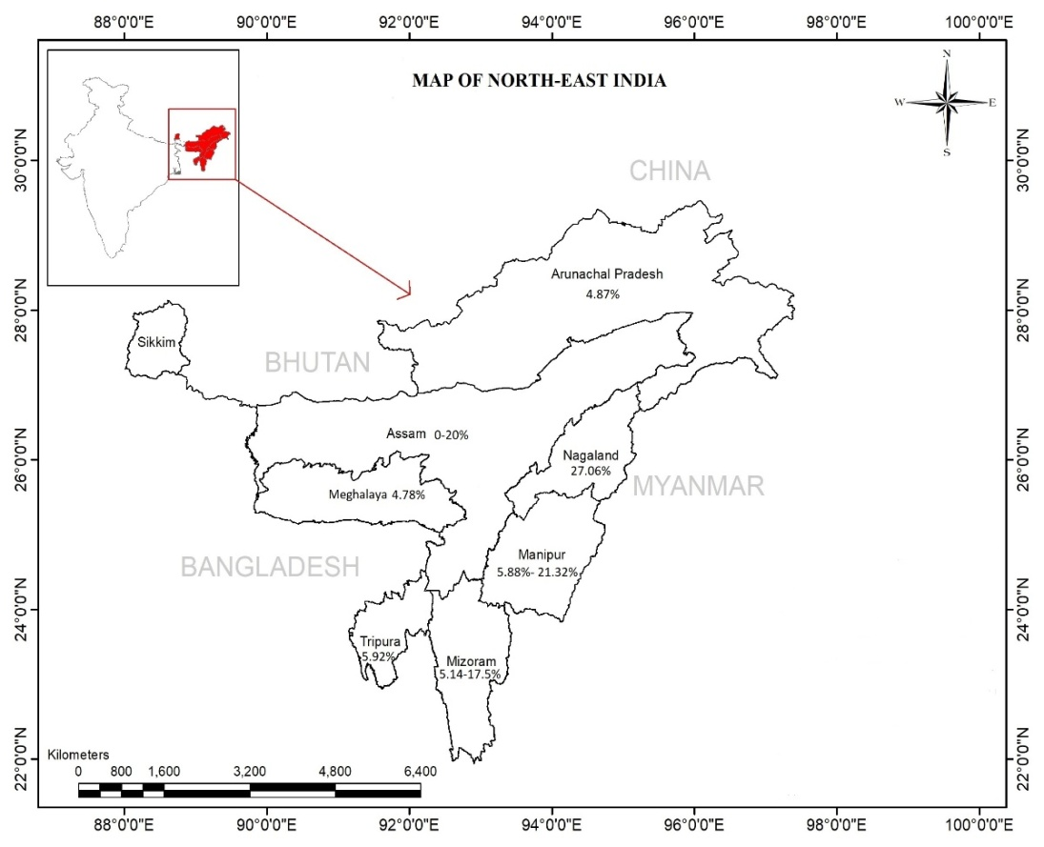
Fig.1 Prevalence of G6PD deficiency among the Northeast states of India
The distribution of G6PD enzyme deficiency across tribal, non-tribal, and mixed populations in Northeast India has been organized for clearer interpretation (table 2). Out of 6,125 individuals, 3,152 individuals were tribal, 1887 were non-tribal, and 1,086 belonged to mixed populations. The prevalence of G6PD deficiency ranged from 0 to 27.06%, with an overall prevalence of 6.57% in Northeast India. Mukerjee et al. (2015) reported an overall prevalence of 7.7% in different tribal groups in India. In Northeast India, prevalence varies across populations, being highest among tribal populations (8.37%) compared to Mixed population (4.88%) and Non- Tribal populations (4.40%).
Table 2: Frequency distribution of G6PD enzyme deficiency in Tribal, non-tribal and mixed populations of Northeast India
Population | Sample size | G6PD Normal % | G6PD Deficient % | Reference
Tribal population
Angami Naga | 85 | 72.94 | 27.06 | Seth and Seth, 1972
Kachari | 5 | 80.00 | 20.00 | Flatz et al. 1972
Khasi | 100 | 93.00 | 7.00 | Flatz et al. 1972
Rabha | 57 | 84.21 | 15.79 | Das et al. 1982
Lalung | 81 | 96.30 | 3.70 | Das et al. 1982
Mikir | 83 | 84.34 | 15.66 | Das et al. 1982
Garo | 76 | 92.11 | 7.89 | Das et al. 1982
Mizo | 490 | 82.5 | 17.5 | Dash et al. 2005
Kabui | 51 | 94.12 | 5.88 | Achoubi et al. 2010
Proto Australoid | 1436 | 93.38 | 6.62 | Basumatary et al. 2021
Tea Garden Labour | 279 | 98.20 | 1.80 | Parween et al. 2024
Deori | 74 | 97.30 | 2.70 | Parween et al. 2024
Mising | 170 | 94.70 | 5.30 | Parween et al. 2024
Kochari | 93 | 97.90 | 2.10 | Parween et al. 2024
Bodo | 72 | 100.00 | 0.00 | Parween et al. 2024
Overall | 3152 | 91.63 | 8.37
Non-tribal Population
Assamese | 185 | 95.68 | 4.32 | Flatz et al. 1972
Ahom | 130 | 94.62 | 5.38 | Flatz et al. 1972
Rajbanshi | 103 | 88.35 | 11.65 | Das et al. 1982
Brahmin | 127 | 90.51 | 9.49 | Achoubi et al. 2010
Muslim | 136 | 78.68 | 21.32 | Achoubi et al. 2010
Ahom | 379 | 97.60 | 2.40 | Parween et al. 2024
Bengali | 109 | 100.00 | 0.00 | Parween et al. 2024
Bihari | 85 | 100.00 | 0.00 | Parween et al. 2024
Brahmin | 85 | 100.00 | 0.00 | Parween et al. 2024
Chutia | 73 | 100.00 | 0.00 | Parween et al. 2024
Kalita | 113 | 99.20 | 0.80 | Parween et al. 2024
Koibotter | 88 | 96.60 | 3.40 | Parween et al. 2024
Muslim | 134 | 98.50 | 1.50 | Parween et al. 2024
Nepali | 71 | 98.60 | 1.40 | Parween et al. 2024
Rajbongshi | 69 | 98.60 | 1.40 | Parween et al. 2024
Overall | 1887 | 95.50 | 4.40
Mixed Population
Changlang | 267 | 95.13 | 4.87 | Bharti et al. 2019
Tura | 230 | 95.22 | 4.78 | Bharti et al. 2019
Lunglei | 214 | 94.86 | 5.14 | Bharti et al. 2019
Gomti | 304 | 94.08 | 5.92 | Bharti et al. 2019
Others | 71 | 100.00 | 0.00 | Parween et al. 2024
Overall | 1086 | 95.12 | 4.88
*Mixed Population - refers to reports whose specific ethnic groups were not clearly identified or mentioned, and therefore could not be classified as either Tribal or Non-Tribal.
Northeast India bears a significant malaria burden and is co-endemic for both plasmodium falciparum and plasmodium vivax malaria (Warji et al. 2016; Sharma et al. 2016). Plasmodium vivax malaria has been reported in almost all the states of Northeast India, accounting for 60-80% of all malaria cases in some states (Sharma et al. 2015). The northeastern region of India, particularly, Nagaland, Manipur, Mizoram, and Assam, demonstrates notable rates of G6PD deficiency, with some groups such as the Angami Naga (27.06%), Muslims of Manipur (21.32%), Mizos of Mizoram (17.5%) and Rabha and Mikir populations reporting prevalence rates above 15% (Seth and Seth, 1971; Das et al. 1982; Dash et al. 2005; Achoubi et al. 2010). The prevalence of G6PD deficiency in the tribal population in the Northeast India is found to be higher than national average (7.7%), with the highest prevalence also reported from this region (Angami Naga 27.06%). Nevertheless, among the non-tribal population higher prevalence rate is observed among the Brahmin population of Manipur with 21.32% (Achoubi et al. 2010). There is a significant variability in the prevalence of G6PD deficiency, ranging from 0.00-27.06% in the tribal populations, 0.00-21.32% in the non-tribal populations and 0.00-5.92% in the mixed populations. A wide range of variability is observed in the prevalence of G6PD deficiency irrespective of populations in Northeast India.
Table 3: Chi square comparison between Tribal, Non-Tribal and Mixed populations of Northeast India
Population | Sample size | G6PD Normal | G6PD Deficient | Chi-square | p-value
Tribal | 3152 | 2888 | 264
Non-Tribal | 1887 | 1802 | 85 | 27.4397 | < 0.00001
Mixed Population | 1086 | 1033 | 53 | 16.9447 | 0.000038
The Tribal population has the highest proportion of G6PD-deficient individuals, with 264 cases out of 3152 (approximately 8.37%). In contrast, the Non-Tribal population shows a much lower deficiency rate, with 87 cases out of 1887 (about 4.40%). The chi-square value of 27.4397 and the extremely small p-value (< 0.00001) indicate that this difference is statistically significant. Similarly, the Mix population also has a lower prevalence of G6PD deficiency (53 out of 1086, or about 4.88%) compared with the Tribal group. The chi-square value of 16.9447 and p-value of 0.000038 confirm that this difference is also statistically significant. Overall, the results point to a clear pattern in which G6PD deficiency appears significantly more common in the Tribal population compared with the other two populations i.e. Non-Tribal and Mixed groups (table 3).
CONCLUSION
The variation in the prevalence frequencies of G6PD deficiency among the Northeastern region highlight a complex interaction of genetic predisposition and environmental pressures, especially in relation to malaria and G6PD deficiency often follows a geographic distribution similar to that of plasmodium falciparum malaria. The significance of G6PD deficiency in this region is substantial, given the common occurrence compare to earlier finding of malaria outbreaks. Administering antimalarial drugs or other medications can pose risks of drug induced haemolysis in individuals with G6PD deficiency, underscoring the necessity for mass screening to prevent such adverse effect. Furthermore, addressing public health implications, particularly concerning G6PD deficiency and its relationship with malaria, will be essential in developing targeted healthcare strategies for this region.
REFERENCES
- Achoubi, N.; Asgar, M.; Meitei, S.Y.; Saraswathy, K.N. and Murry, B. (2010). Haemoglobinopathies and glucose-6-phosphate dehydrogenase deficiency in a malaria endemic region of Manipur, northeast India. Anthropological Science, 118(3): 201.
- Aldiouma, G.; Rick, M. F.; Ogobara, K. D.; Thomas, E. W. and Dapa, A. D. (2007). X-Linked G6PD Deficiency Protect Hemizygous Males but Not Heterozygous Females against Severe Malaria. Plos Medicine, 4(2):516.
- Allison, A.C. (1960). Glucose-6-phosphate dehydrogenase deficiency in red blood cells of East Africans. Nature, 186:531.
- Basumatary, N.; Baruah, D.; Sarma, P. Deka, M. and Sarmah, J. (2021). Prevalence and alteration in haematological parameters of glucose-6-phosphate dehydrogenase deficient proto-australoid population of malaria endemic Himalayan belt of Assam, India. Exploratory Animal and Medical Research, 11(1): 43.
- Bharti, R. S.; Vashista, K.; Ahmeda, N.; Nayak. A.; Pandeb, V. and Mishra, N. (2019). First report of glucose-6-phosphate dehydrogenase (G6PD) deficiency variants (Mahidol and Acores) from malaria-endemic regions of Northeast India and their functional evaluations and their functional evaluations in silico. Acta Tropica. http://doi.org/10/1016/j.actatropica.2019.105252
- Das, B.M.; Deka, R. and Das, R. (1982). Glucose-6-Phosphate Dehydrogenase Deficiency in five Populations of Assam Indian Anthropologist, 12(1):73.
- Dash, H.; Chhanhimi, L.; Chhakchuak, L. and Zomawaia E. (2005). Screening of haemoglobinopathies and G6PD among the Mizos of Mozoram: A preliminary study. Indian Journal of Pathology and Microbiology, 48(1):17.
- Flatz, G.; Charavartti, M.R.; Das, B.M. and Delbruck, H. (1972). Genetic Survey in the populations of Assam 1. ABO blood Groups, Glucose-6-Phosphate Dehydrogenase and haemoglobin types. Human Heredity, 22(4):323.
- Luzzatto, L. and Mehta, A. (1995). Glucose-6-phosphate dehydrogenase deficiency. In Scriver, C.S., Beaudet, A.L., Sly, W.S. & Valle, D. (eds.) The metabolic basis of inherited disease, 6th edn. McGraw-Hill, New York, 1989, pp.2237-2265
- 2265.
- Luzzatto, L. & Bienzle, U. (1979). The malaria/G-6-PD hypothesis. Lancet. 1:1183.
- Martini, G.; Toniolo, D.; Vulliamy, T.; Luzzatto, L.; Dono, R.; Viglietto, G.; Paonessa, G.; D’Urso, M. and Persico, M.G. (1986). Structural analysis of the X-linked gene encoding human glucose-6-phosphate dehydrogenase. The European Molecular Biology Organization Journal, 5:1894.
- Mohanty, D.; Sukumar, S.; Mukherjee, M.B. and Colah, R.B. (2003). G6PD deficiency & malaria in India. American Journal of Haemtology, 72:150.
- Motulsky, A.G. (1960). Metabolic polymorphism and the role of infectious disease in human evolution. Human Biology, 32(1): 28.
- Mukherjee, M.B.; Colah, B.; Martin, S. and Gosh, K. (2015). Glucose-6-phosphate dehydrogenase (G6PD) deficiency among tribal populations of India-country scenario. Indian Journal of Medical Research, 141:516.
- Nagel, R.L. and Roth, E.F. (1989). Malaria and red cell genetic defects. Blood, 74(4):1213.
- Parween, W.; Sharma, S.K. and Deka, M. (2024). Prevalence of Glucose-6-phosphate dehydrogenase deficiency in the indigenous population of Upper Assam. African Journal of Biological Sciences, (Si3):5620.
- Roth, J. J. and Schulman, S. (1988). The adaptation of plasmodium falciparum to oxidative stress in G6PD deficient human erythrocytes. British Journal of Haematology, 70: 363.
- Seth, P.R. and Seth, S. (1971). Biological Studies of Nagas: Glucose-6-Phosphate Dehydrogenase Deficiency in Angami Nagas Human Biology, 43(4): 557.
- Sharma, J.; Dutta, P. and Khan S.A. (2016). Epidemiological study of malaria cases in North East region of India. Indian Journal of Medical Research, 31:261.
- Sharma, V.P; Dev, V. and Phookan, S. (2015). Neglected plasmodium vivax malaria in northeastern states of India. Indian Journal of Medical Research. 141:546-555.
- Warjri, S.B.; Ete, T.; Mishra, A.; Barman, B.; Mishra, J.; Pala, S.; Beyong, T., and Issar N.K (2016). Association between clinical malaria and blood lipids in north east India. British Journal of Medicine and Medical Research, 16(1):1.

