Ultrasonic Velocity Measurement on Lactobacillus amylophilus at Various Growth Phases and Temperature
.

Abstract
The ultrasonic parameters were carried out at a frequency of 3 MHz using pulse technique and compared with pulse echo overlap (PEO) technique on Lactobacillus amylophilus grown in nutrient broth at a constant temperature of 37ºC at three phases of growth like Active, Stationary, Decline with optical density 1.0. The values of acoustic impedance ( Z), isotropic compressibility ( Ke) and attenuation coefficient (α) were calculated from measurement values of ultrasonic velocity (v), echo amplitude (a_{o}) and density ( ρ). The ultrasonic velocity values were correlated with Jacobson’s free length theory ( FLT). The variation of ultrasonic parameter with different bacteria has been interpreted on the basis of motility , shape and size of the bacteria in this publication.
Introduction
Lactobacillus amylophilus is a bacteria present in the earth and is non-pathogenic. In view of the extensive applications of ultrasound in medical diagnostics, a systematic study of ultrasonic behaviour of available bacteria and the control broth in which the bacteria were grown was undertaken. The results thus obtained were presented.
Experimental
In the present experiment different species of bacteria belonging to Gram positive and Gram negative were used. Gram positive bacteria was Lactobacillus amylophilus, Bacillus subtilis and Gram negative bacteria were Escherichia coli, Bacillus altidudinis. These bacteria cultures were grown at 37º C in nutrient broth containing beef extract, peptone and sodium chloride at pH 7.3 were subjected to ultrasonic wave propagation at different temperatures from 28º C to 40º C(The bacteria sustains up to 40º C). The bacteria were cultured at Microbiological Laboratory, Osmania University, Hyderabad and were brought to the laboratory for the study. The pulse technique using Ultrasonic interferometer was used for the measurement of ultrasonic velocity (v) and echo amplitudes (a_{n}) at a frequency of 3 MHz and compared with Pulse Echo Overlap technique using Ultrasonic Intervelometer ( UTI- 101) supplied by Innovative instruments Pvt.Ltd, Hyderabad, India, and found that both the results were same and within the experimental error.
The length of the liquid column was measured with liquid like double distilled water whose ultrasonic velocity is known and calculated length of the liquid column with an accuracy of 0.001cm.
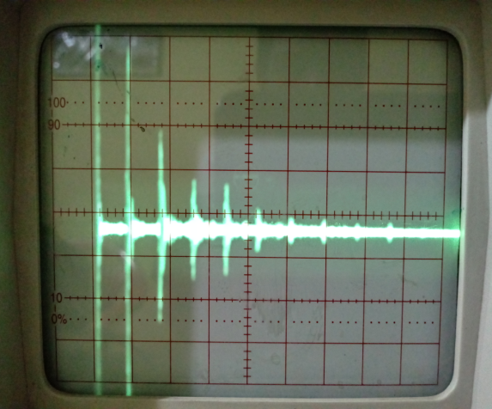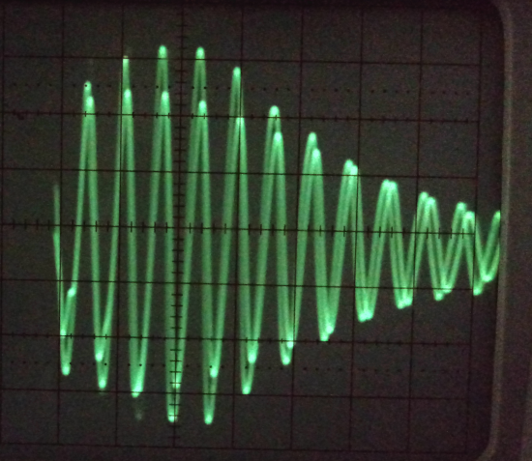
Fig (1) Echo train pattern Fig (2) Pulse Echo Overlap pattern

Theory
The longitudinal wave velocity of ultrasound and attenuation coefficients were obtained using the relations:
v = 2l ÷ T cm/s and α = ln ₍a_{o /} a_{n)} ÷ 2 nl nep/cm
where v is the ultrasonic sound velocity ( cm/s), l is the length of the liquid (sample) column (cm), T is the travel time between two selected consecutive echoes ( µs), a_{o} is the amplitude of transmitted pulse (V) and a_{n} is the amplitude of nth echo (V) .
The measured data of sound velocity (v) and echo amplitudes (a_{n}) were applied to compute the nonlinear physical parameters of attenuation coefficient (α), acoustic impedance (Z) and isotropic compressibility (K_{s}) which were shown in Table 1 for understanding Ultrasonic properties of Lactobacillus amylophilus at various growth phases and temperature.
The nonlinear parameters of ultrasound in the bacterial cultures were evaluated using the following formulae.
Acoustic impedance , Z = ρv g/cm² /s.
Isotropic compressibility , K_{s} = 1÷ ρv² cm²/dyn.

Results and Discussion:
The measured and computed parameters of Ultrasonic properties in Lactobacillus amylophilus various phases
Growth phase | Velocity  (v x 10²)  cm/s | Density  ρ g/cm³ | Attenuation (α)  Nep/cm | Acoustic impedance  ( z x 10³)  g/cm²/s | Isotropic compressibility  (K_{s} x 10⁻¹⁰)  Dynes/cm² | Echo amplitudes(a_{n})
 |  |  |  |  |  | a₀ | a₁
Control | 1630.45 | 0.9828 | 0.0518 | 160.24 | 38.27 | 3.6 | 1.2
Active | 1538.45 | 0.9926 | 0.0472 | 152.70 | 42.56 | 3.4 | 0.2
Stationary | 1584.21 | 0.9886 | 0.0335 | 156.61 | 40.30 | 2.5 | 0.2
Decline | 1565.27 | 0.9749 | 0.0292 | 152.59 | 41.86 | 5.4 | 0.6

The plot in Fig (3) shows that the measured parameters of ultrasonic velocity (v) versus bacteria growth phases. The velocity is low when the bacteria is in active phase. The velocity (v) increases when bacteria changes from active to stationary phase. The velocity further increases from stationary phase to decline phase. As velocity increases the attenuation decreases as the density of the bacteria is kept constant in all phases i.e., one optical density. It is clearly found that the ultrasonic response of bacteria at all temperatures, and at all phases are similar.
In Fig 4,5,6 and 7 it was shown the variation of attenuation coefficient (α) with temperature for all three phases of growth including control broth.
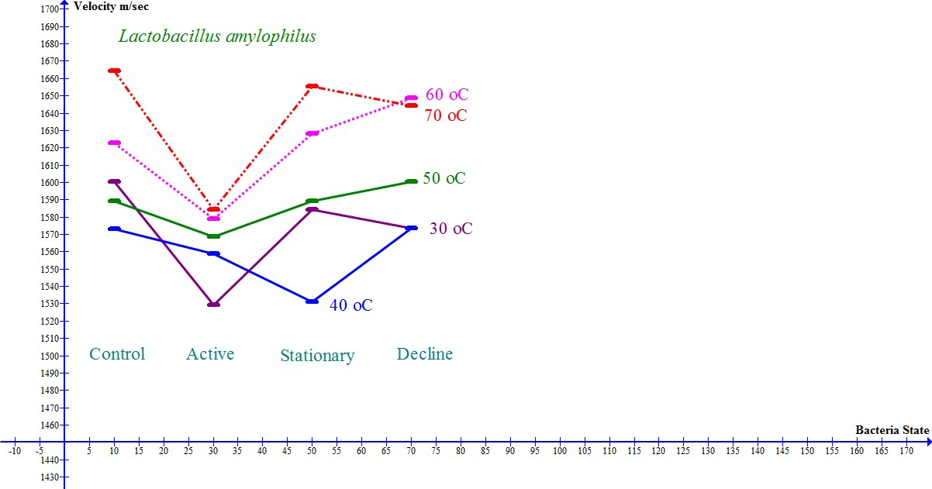
Fig(3)
Conclusions:
It was observed from fig (3) that the motility, shape and size of bacteria was effecting the velocity of sound and hence by computed parameters. It is important to observe that the motility is inversely proportional to ultrasonic velocity.
Acknowledgements
One of the author (PSK) is thankful to Dr Y.Hari Babu, Department of Microbilogy, Veterinary College, Bidar, Karnataka , Mr M.Ramakrishna Reddy, Mrs S.Maha Lakshmi, Mr K.Jyaneswar Goud and Mr Shiva Kumar Reddy, Microbiology Department, Osmania University for their help in growing the cultures for the experimental work.

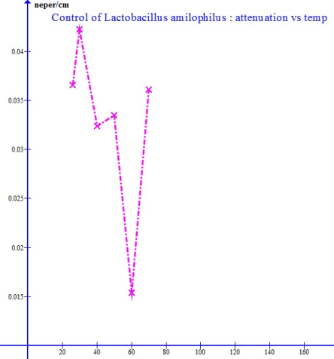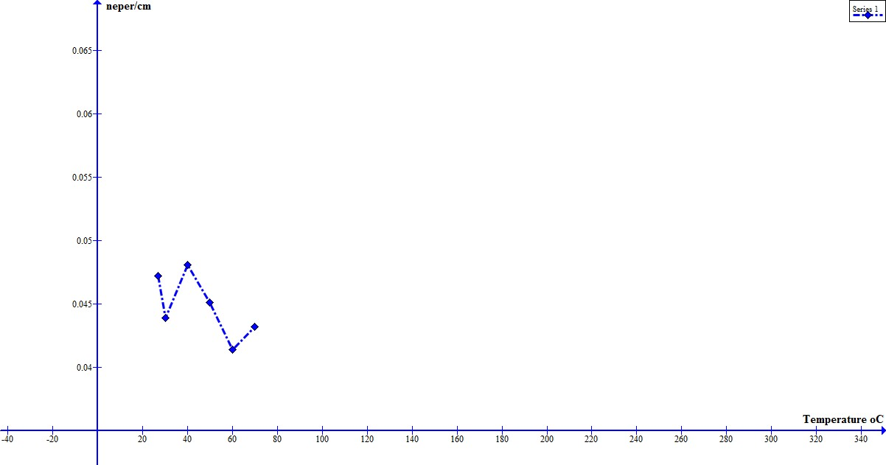
Fig (4) Control Phase: Temp Vs Attenuation Fig(5) Active phase :
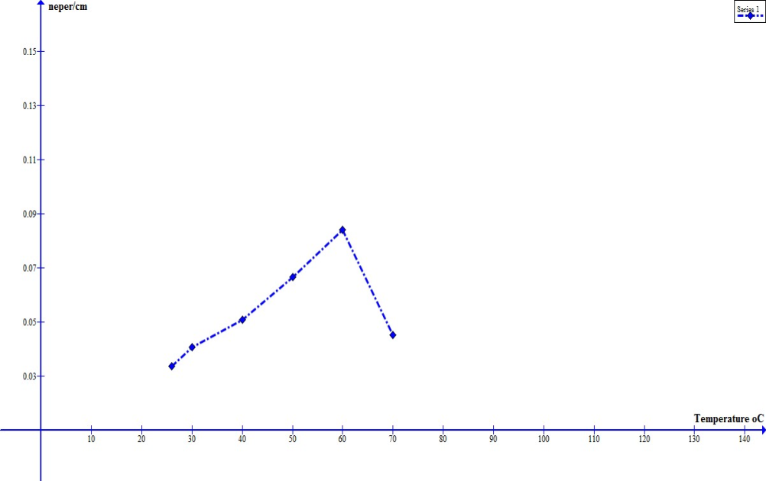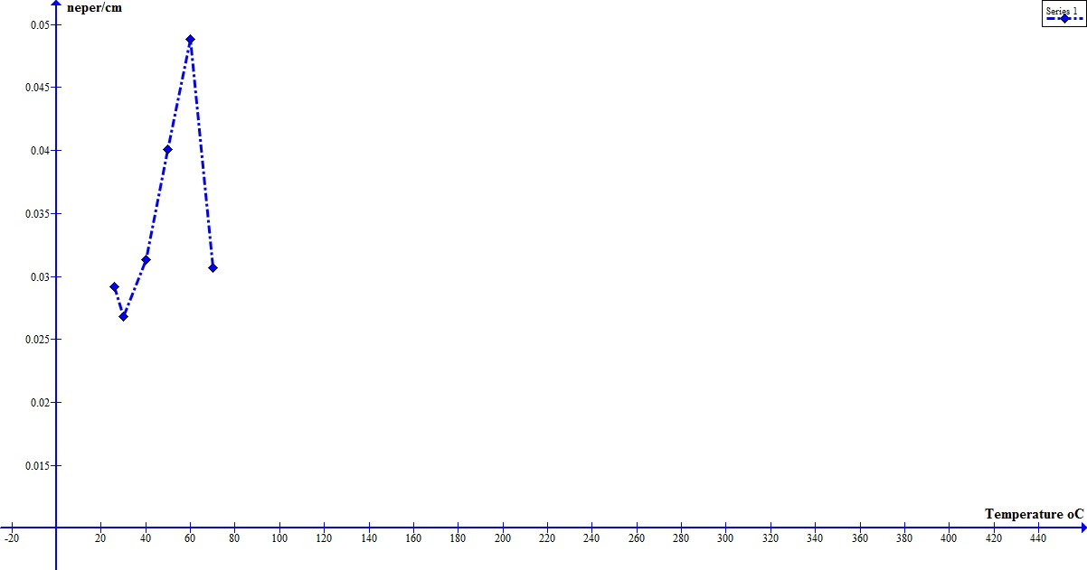
Fig(6) Stationary phase Fig(7) Decline Phase

References
- A.Szent-Guprgi. Introduction to a Sub-Molecular Biology. Academic Press, New York, 1060.
- Saksena, A.R and Aradhana, J.Mole. Liquid 26 (1983) 197.
- Suzuki.K., Hayashi.N and Sasaki.Y et.,al Ultrasound Med.Biol.18 (1992) 657
- A.R.Sajsena, Aradhana, Proc. Of IEEE Ultraso. Symp ( USA), 14 Nov., 1984
- C.Barnes. T.J. Lewis. J. Acoust. Soc. Am. 89(1991) 1792.
- R. Cruikshank. J.P.Duguid, R.H.A Swain, Med Microbiol. 2( 1975) 151.
- Topley and Wlson’s Principles of Bacteriology, Virology.
- B.Ravinder Reddy, D.Linga Reddy, Indian J. Pure Appl. Phys 37(1999) 13.
- B.Ravinder Reddy, D. Linga Reddy, J. Acoust. Soc. India XXXVII (1-4)(1999) 315.
- B.Ravider Reddy, Y. Hari Babu, D.Linga Reddy. Proc. Of ICEU, New Delhi , 3-6
Dec., 1999

