MARKETING STRATEGY INTEGRATION AND FINANCIAL PERFORMANCE IN LUXURY HOSPITALITY: EVIDENCE FROM NAIROBI’S FIVE-STAR HOTELS

ABSTRACT
The study explored how marketing strategies affect the financial performance of five star hotels within Nairobi City County, Kenya. The research examined four main dimensions of marketing strategies such as adoption of digital marketing, customer segmentation, positioning of the brand, and loyalty programs. The research adopted a descriptive correlational research design based on secondary data of hotel financial reports, industry publications and institutional databases guided by the Stakeholder Theory and the Resource-Based View. Descriptive statistics, Pearson correlation and multiple regression analysis were used to analyze data and determine the relationship between marketing strategies and financial performance indicators of revenue growth, profitability, and the return on assets. The results showed that there was a statistically significant and strong positive correlation between the marketing strategies and financial performance (r value between 0.83 to 0.88 with p < 0.05). The most significant relationship was observed between digital marketing adoption and loyalty programs (r=0.90, p=0.01), which means that they are essential in improving customer interaction and retention. The customer segmentation (r = 0.83, p < 0.05) and the brand positioning (r = 0.87, p < 0.05) were also observed to have a significant impact on financial results because of better brand equity and customization of services. These findings indicate that integrated marketing strategy plays a great role in enhancing financial stability and sustainability. The study finds that financial performance in the hotel industry of five stars’ hotel is driven by marketing strategies. It suggests that the management of hotels should invest in the field of digital marketing technologies, enhance customer-oriented strategies, and implement decision-making approaches based on data to improve competitiveness. The research has a role as it adds empirical evidence within the context of an emerging market and gives valuable insights to stakeholders in hospitality industry.
Keywords: Marketing Strategies, Financial Performance, Digital Marketing, Customer Segmentation, Brand Positioning, Loyalty Programs

1.0 INTRODUCTION
The hospitality sector is a fundamental input to the overall economic development of the world in terms of the ability to create employment, foreign exchange earnings and the development of infrastructure. In this industry, five star hotels hold a premium market position that includes high level of service and large amounts of capital (Thommandru et al.,2023). In such establishments, financial performance is usually measured by using indicators that include profitability, growth of their revenues and also the returns on their assets. These measures, as suggested by Modi, (2024) indicate the efficiency of operations as well as the competitiveness. Nevertheless, Aleskerova and Fedorovshyn, (2023) argue that heightened competition as well as altered customer preferences has added pressure on hotels to implement strategic implementation, especially in the marketing context to maintain financial success in the dynamic environment.
Marketing strategies in the hospitality business sector around the world have been shifting off the conventional methods of marketing based on technology and under the influence of technology to integrated models which focus on customer interaction and personalization. Bardukova, (2023) also notes that brand awareness and interaction with customers have improved greatly with the introduction of internet-based technologies, like social networks and booking systems. Furthermore, Carlianti, (2024) emphasize that data-driven marketing allows hotels to customize their services to the individual preferences, which ensures employee satisfaction and loyalty improve. These changes have altered the nature of competition amongst hotels, effective marketing campaign is increasingly becoming associated with better financial results, such as better occupant rates and revenue per accessible rooms in competitive international markets.
The hospitality industry in the African context has been witnessing a consistent growth as fueled by the growth of tourism, urbanization and foreign investment. This has not been a constant growth in the region though. According to Buhalis et al., (2024), technological acquisition and a lack of regular marketing practices are also structural challenges confronting many hotels, which impede their competitiveness. Moreover, variations in infrastructure and access to digital tools have given an imbalanced application of contemporary marketing strategies (Osei and Cheng, 2024). Consequently, some hotels record good financial performance because of strategic marketing, whilst others fail to attract and retain customers as a result of planning their marketing strategies based on available resources and market conditions.
The hospitality business is one of the major economic boosters in Kenya and it has a considerable portion of gross domestic product and job creation. Nairobi City County is the main luxury hospitality center and meets focus on luxury hospitality since five star hotels which cater to both the international and home markets are situated here. Chaudhary et al., (2022) indicate that such hotels exist in a very competitive business world where the number of tourists being served vary and the costs of running the business increase. Therefore, hotel managers are increasingly turning to marketing as the means of improving visibility and market share (Wu et al.,2022). Marketing excellence has now become crucial in terms of maintaining financial performance and securing long-term competitiveness in the industry.
Hotels in Nairobi are five stars and they have embraced various marketing strategies that will enhance their financial performance and competitiveness. According to Girard, (2024), experiential marketing (with individualized services and tailored guest experiences) is beneficial in boosting customer loyalty and frequency of attendance. On the same note, Trivedi and Jena, (2025) prove that social media marketing enhances brand awareness and customer interactions, translating to higher booking rates. Also, customer segmentation, and the use of loyalty programs also help hotels to penetrate particular market segments. All these strategies help in increasing revenue, getting a better occupancy rate, and profitability which justifies the importance of marketing in the financial stability of the luxury hotels.
Although marketing strategies have been understood to be important, few empirical studies have been done specifically to ascertain its impact on financial results of the five-star hotels in Nairobi City County. According to Sofi et al., (2025), most of available literature is either universal or focused on advanced economies; hence restricting its usefulness in emerging markets. This has left a void in the comprehension of the working of marketing strategies in a unique economic and competitive setting in Nairobi. Thus, the study will analyze how promotion techniques have impacted the financial outcomes of five star hotels in Nairobi County, City of Kenya in a bid to offer contextually specific information to the strategic decision makers.

2.0 THEORETICAL FRAMEWORK
The theoretical framework offers the basis on which this study is grounded as it explains the theories behind the relationship that exists between marketing strategies and financial performance. The Stakeholder Theory and the Resource-Based View (RBV) will guide this research because these theories present a complementary view when applied to the topic of influence of strategic marketing decision making on the performance of organizations. Although Stakeholder Theory is oriented to the significance of relations management in the business environment, the Resource-Based View is oriented on the internal resources which can help firms gain a competitive advantage. Conjointly, the theories offer a wholesome foundation upon which marketing strategies are analyzed in terms of their effectiveness in the financial performance of five-star hotels in Nairobi City County.
The Stakeholder Theory first of all proposed by Freeman, (1984) argues that any organization should take into account the interests of all other stakeholders such as customers, employees, suppliers, and the community and not just shareholders. Freeman, (1984) says that firms are able to manage relations with these stakeholders well and in the long run, they would emerge successful. Customers are a key stakeholder group in the hospitality industry because the customer satisfaction is directly correlated with financial results. Gursoy et al., (2022) contend that by undertaking marketing strategies like customer engagement, brand communication, and service personalization, it is imperative in responding to the expectations of the stakeholders. Hotels can improve customer satisfaction, loyalty and financial performance by aligning their marketing strategies and customer needs and preferences so that the products, services and prices meet their needs.
The overall Stakeholder Theory offers a handy view into the existence of a relationship amidst marketing practices on reputation and brand value. As Ho et al., (2020) emphasize, good communication on digital marketing platforms improves bonds between hotels and their clients, hence boosting the level of trust and loyalty to the brands. Strong stakeholder relationships are important in sustaining competitiveness in five-star hotels, where service quality and customer experience are crucial matters. Loyalty programs, personalised services are some of the marketing strategies that can be used in engaging stakeholders and creating long-term value. Therefore, the Stakeholder Theory agrees with the argument that good marketing strategies play a crucial role in enhancing financial performance through establishing good and long-term relationship with important stakeholders.
Besides Stakeholder Theory, the Resource-Based View (RBV), as the theory, developed by Barney, (1991) suggests an intellectual foundation on the reasons why the internal capabilities can help make firms perform better. RBV, however, assumes that the organizations gain long-term competitive advantage when they have resources, which are valuable, rare, inimitable, and non-substitutable. The strategic resources in the hospitality industry, including brand management, customer data analytics and digital marketing expertise are the marketing capabilities that can enable the hospitality industry to exhibit a high level of performance. As highlighted by Yadegaridehkordi et al., (2021), hotels, which utilize data-driven marketing tools, can analyze the customer behavior better and manage to customize their services accordingly that have a positive effect on their financial performance.
The Resource-Based View also elaborates on the role of the marketing strategies as a source of differentiation in a very competitive market. Lv et al., (2020) believe that use of technology in the marketing context, including the use of social media and the online booking system, improves customer capacity of a firm providing personalized experience. This is because competitors struggle to imitate these capabilities, and thus, they offer a sustainable competitive advantage. In five-star hotels in Nairobi, the aptitude to efficiently harness online marketing channels and customer relationship management tools can have a tremendous impact on financial results of the establishment. It implies that marketing plans are not only operational tools but strategic resources, which can be used to attain the success of an organization in the long term.
Additionally, the RBV framework concentrates on the need to align marketing strategies to organizational resources in order to ensure optimality of performance output. Hotels investing in building a good brand identity, superior marketing technology and qualified staffs have better chances of attaining greater customer satisfaction and financial results. According to Kapoor and Kapoor, (2021), experiential marketing, where the development of specific and meaningful customer experiences is its basis, demands both organizational capabilities and strategic resource allocation. This supports the claim that internal capabilities are essential in the definition of the effectiveness of marketing strategies and its influence on financial performance.
Both Stakeholder Theory and the Resource-Based View provide valuable insights into the relationship between marketing strategies and financial performance. Stakeholder Theory stresses on the need to have proper relationships with customers and other important stakeholders, whereas RBV lays emphasis on the significance of internal abilities to obtain a competitive advantage. These theories when combined can present a comprehensive approach to the conceptualization of the effects of marketing strategy upon financial performance in five star hotels. The management of external relationships alongside the efficient utilization of internal resources, contributes to enhanced competitiveness and sustainable financial performance within Nairobi’s hospitality sector.

3.0 METHODOLOGY
This research used descriptive correlational research design to explore the relationship between marketing strategy and financial performance of five-star hotels in the County of Nairobi City. The use of descriptive component helped systematically summarize the trends in the marketing practices and finance performance indicators, and the correlational approach helped to evaluate the strength and direction of relationships between variables without any manipulations. Creswell (2018) says that a correlational design is suitable to examine the relations between variables operating in their natural environment.
The sample size was all five-star hotels in Nairobi City County that fall under the Ministry of Tourism classification. Particularly, seven hotels were involved in the study: Villa Rosa Kempinski, Nairobi Serena Hotel, Fairmont The Norfolk, Radisson Blu Hotel Nairobi, Hemingways Nairobi, Sankara Nairobi, and The Boma Nairobi. Since the population is very small and well-defined, a census methodology was selected and included all the hotels in the study, which adds to the credibility and generalizability of the results by removing the sampling bias. The research utilized secondary quantitative data only, which were audited financial reports, industry literature and institutional records including the Kenya National Bureau of Statistics (KNBS) and Kenya Tourism Board (KTB) because of their objectivity and longitudinal analysis of an index.
The independent variables included the major dimensions of marketing strategies such as the adoption of digital marketing, customer segmentation, brand positioning, and loyalty programs whereas the dependent variable was the financial performance, gauged by growth of revenues, profitability (net profit margin), and return on assets (ROA). Data analysis was performed with both descriptive and inferential statistics, where the trends were summarized with the help of descriptive statistics (means and standard deviations), and the strengths and directions of the relationship between two variables were determined by employing the Pearson correlation methodology. The Pearson correlation coefficient was computed using the following formula:
$$r=\frac{\sum{(X_{i}-\overline{X})(Y_{i}-\overline{Y})}}{\sqrt{\sum{{(X_{i}-\overline{X})}^{2}}}\sum{{(Y_{i}-\overline{Y})}^{2}}}$$
where r represents the correlation coefficient, Xi​ and Yi​ are individual observations of the variables, and $\overline{X}$ and $\overline{Y}$ are their respective means. The analysis aimed to establish relationships and not causal relations and all the calculations were done using the Statistical Package of the Social Sciences (SPSS) to be precise and reliable as advised by Field, (2018).

4.0 FINDINGS
Marketing Strategies and Financial performance
This section analyses how marketing strategies are related to financial performance in five star hotels within Nairobi City County, as informed by the second objective of the study. Through the analysis, there are five important dimensions of marketing strategy that are discussed: overall marketing mix practices, adoption of digital marketing, customer segmentation, brand positioning, and customer loyalty programs. These factors are essential in attraction and retention of high-value customers, service customization, and brand equity creation over time. Financial performance is measured in terms of revenue growth, net profit margin and return on assets. The contribution of these strategies to the long term performance of the hotels is evaluated both with quantitative data and qualitative evidence.
Digital Marketing Adoption
The section examines how the adoption of digital marketing is likely to affect the financial performance of five-star hotels in Nairobi City County. The digital marketing tools which include social media campaigns, search engine optimization (SEO), email marketing, and online booking systems have become the key measures in the hospitality industry when it comes to financial performance. The analysis examines the degree of integration in digital marketing in the financial results including return on assets, increase in revenues and profitability. Based on secondary data, in this section it is evaluated whether hotels which have adopted the use of digital technologies in their marketing strategies show a better financial stability and long-term sustainability.
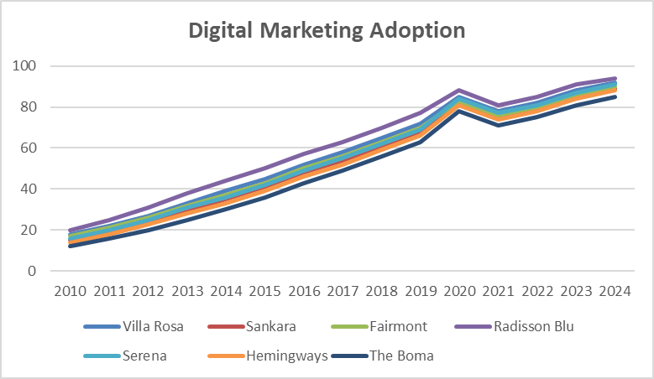
Figure 1 : Digital Marketing Adoption
Sources: Euromonitor Digital Trends, Hotel Annual Reports, (Meta Africa Digital Trends 2024)
According to the Euromonitor, Meta Africa Digital Trends (2024), and hotel annual reports, the Figure 1 shows that digital marketing adoption among seven Nairobi five-star hotels increased significantly and steadily between 2010 and 2024. Radisson Blu was always the first to adopt digitally, with a score of 20 in 2010 and 94 in 2024. This is indicative of its vigorous digital strategy, such as real time booking solutions, virtual concierge and performance based social media campaigns. Villa Rosa Kempinski was immediately trailing its heels with a mark of 92 by 2024 which suggests that the hotel invested heavily in branded content, influencer collaboration, and online marketing personalization. Fairmont and Sankara were also making considerable improvement where Fairmont shot up by 17 to 90 and this is partly because it incorporated AI-powered customer service features and geo-targeted advertisements after 2020.
In the meantime, Serena Hotels rose significantly between 16 and 91 (probably supported by its Pan-African marketing integration and e-loyalty platform), as Hemingways and The Boma (which began at a disadvantage) registered significant improvements, achieving 88 and 85 points respectively in 2024. The steep spike of 2019-2020 in all hotels can be linked to the outbreak of the COVID-19 pandemic that put a physical approach at the primary position and shifted hotels to digital platforms. Such trends confirm a report by Meta Africa (2024), who found that digital marketing expenditures of East African luxury hotels had increased by 60 percent, and Euromonitor (2024), who claimed that digital transformation was a fundamental pillar of post-pandemic hotel recovery plans. This growth curve highlights the strategic essence of digital marketing in creating operational effectiveness and financial performance in the five-star hospitality industry in Nairobi.
Customer Segmentation
In this subsection the researcher examined how customer segmentation can help the financial performance of five-star hotels within the Nairobi City County. Customer segmentation is the process of splitting the market of the hotel in specific parts depending on demographics, spending patterns, and reasons of staying at the place, and features like loyalty. Hotels can boost customer contentment, augment booking efficiency, and maximize pricing approaches by focusing services and selling activities on selected customer segments as corporate clients, international tourists, leisure industry travelers, and long-stay clients. The analysis assesses the effectiveness of the practices of segmentation on the main financial variables, such as the growth of revenues and profit margins, in accordance with the tendencies found in the secondary sources and empirical research.
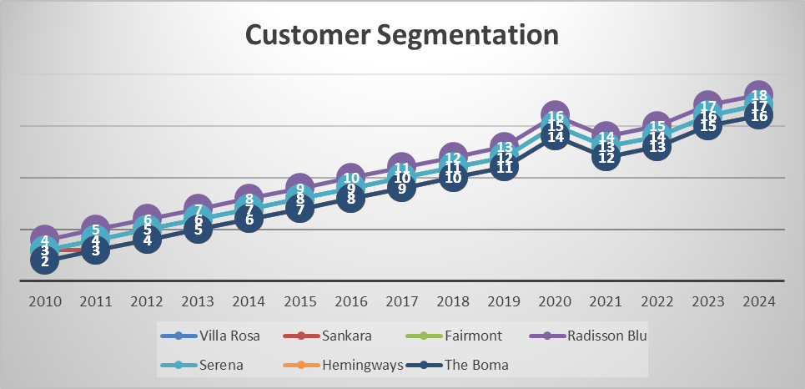
Figure 2: Customer Segmentation
Sources: STR Global Market Reports, Hotel CRM Data, (2024)
Figure 2 represents the targeting of the specific customer segments of seven five-star hotels in Nairobi in 2010-2024. This trend indicates that the number of different customer groups of interest has been on the rise, as the methods of market segmentation have become significant in the local hospitality sector. Villa Rosa Kempinski and Radisson Blu continued to be ahead of the pack in terms of customer segmentation with 17 and 18 segments respectively in 2024 respectively, which suggests that it has a wide approach to its target audience as it aims at a wide range of customer segments, such as business, leisure, or corporate clients. Serena and Hemingways recorded steady growth with 17 and 16 segments respectively in 2024, as a result of their excellent approach to diversification of their customer segments based on the purpose of travel.
Though The Boma and Sankara hotels had lesser market segments in 2010 (2 and 3, respectively), they showed a considerable improvement in their targeting works in the years 2010 (16 and 16 segments, respectively). This tendency shows that smaller or niche hotels are shaping to the idea of customer segmentation to be able to offer their services to an increased variety of market demands. A significant rise in segmentation between the years 2020 and 2021 could also be explained by the COVID-19 pandemic that had to refine the approach of hotels to attracting customers to accommodate and adapt to the changing market conditions. The concept of customer segmentation has been shown to be a decisive approach towards improved targeted marketing, custom service offerings and eventual growth of revenue and financial performance of the competitive hotel industry in Nairobi, supported by the STR Global Market Reports and Hotel CRM Data (2024).
Brand Positioning
This section discusses how brand positioning contributes to the financial performance of five star hotels in the Nairobi City County. Brand positioning is the strategic process of distinguishing the identity of a hotel, its value proposition and competitive advantages in the market. Hotels can capture the high-value segments, charge a higher price, and increase customer loyalty by positioning their brands effectively in the minds of consumers. The analysis analyses the effectiveness and applicability of brand positioning in generating unique images and conveying unique selling points by the hotels to their target markets. In this section, the secondary data has been used to evaluate the financial performance of effective brand positioning strategies, especially in regard to market share, revenue growth, and profitability.
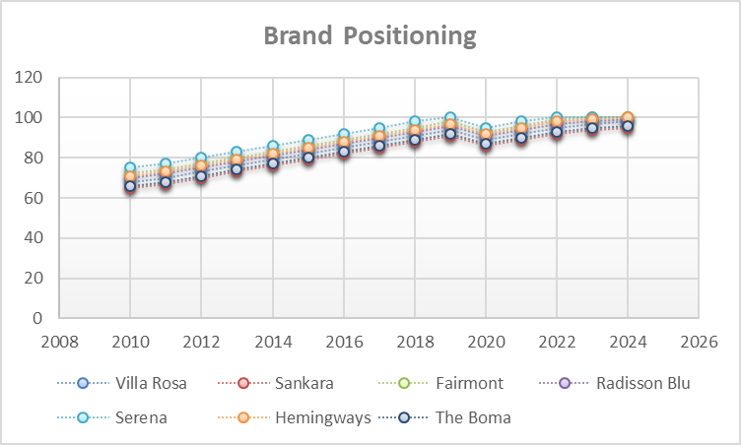
Figure 3: Brand Positioning
Source: Brand Finance Methodology, (2024)
The brand equity scores of seven leading five star hotels in Nairobi between 2010s and 2024 according to the Brand Equity Index (measured between 0 and 100) are shown in Figure 3. The brand equity of all hotels has a distinct upward trend over the years signifying that all hotels have been successful in brand positioning strategies. Villa Rosa Kempinski, Radisson Blu, and Serena have been at the forefront in brand equity scores with 100 being the ideal score attained by Serena by 2024. This indicates good presence in the market and definite value statement to the target market, especially in the luxury and corporate category. Fairmont is also exhibiting the strong upward trend with high growth to 100 by 2024 that indicates its further success in establishing itself as a top luxury brand in town.
The Boma and Hemingways, on the other hand, display slower yet consistent growth in their brand equity scores throughout the years, achieving 96 and 100, respectively, in 2024. These growths underscore their brand positioning strategies effectiveness albeit at a slower rate as compared to the leaders within the industry. Sankara maintained a high score of 65 in 2010, but its change to 95 in 2024, was a significant one indicating that the company has adapted successfully to market forces and branding activities. The trend of steady increase of all hotels indicates that strategic positioning of the brands, which are the result of the reputation, customer services, marketing, and unique offers is essential in promoting financial performance and growth of Nairobi competitive hotel industry.
Loyalty Programs
In this section, the researcher investigates how loyalty programs influence the financial performance of the five-star hotels in the city of Nairobi City County. Loyalty programs, with benefits such as discounts and special services, are fundamental in improving customer retention, increasing bookings in advance, and decreasing customer acquisition expenditures. The review assesses the effect of these programs on such financial performance measure as revenue growth and profitability based on secondary data and industry expertise.
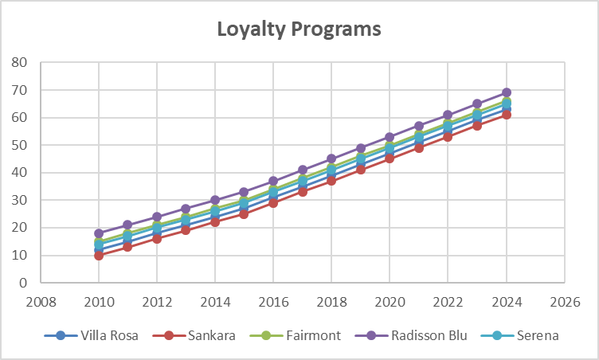
Figure 4: Loyalty Programs
Sources: Hotel CRM Data, Accor/Radisson Investor Reports, (2024)
Figure 4 presents the penetration of the membership in loyalty programmes of five star hotels in Nairobi between 2010 and 2024. Radisson Blu has consistently exhibited the largest membership penetration of 69% in 2024, with this being its global loyalty program of Club Carlson which might have led to its broader coverage and global guest base. Villa Rosa Kempinski demonstrated a stable growth that reached 63 percent in 2024, which implies its focus on retaining its guests and rewarding its regular customers. Other hotels such as Serena, Fairmont and Sankara have also had their membership increases with Fairmont at 66 percent by 2024 indicating the value of loyalty programs in ensuring a competitive advantage in the luxury hotel market. The data also shows that there was a significant increase in total hotels in 2020, probably due to the enrollments which were because of the discounts related to COVID-19, as indicated in the notes of the figure. This implies that hotels utilized loyalty programs as an instrument to secure clients and make them come back to the business even when the travel sector was more subdued due to the pandemic. The general frontal analysis of 2010 to 2024 indicates that once hotels had advanced their loyalty programs, they managed to pull more guests on board, and this directly affected their profitability over the long term, as they experienced better customer retention and recurrent booking.
Marketing Strategies and Financial Performance
The section examines the relationship that exists between the main marketing Strategies-Digital Marketing Adoption, Customer Segmentation, Brand Positioning and Loyalty Programs and the financial performance of five-star hotels in Nairobi City County. Using the analysis of these relations, the focus of the analysis was to comprehend the impact of the marketing investments on financial performance as shown in revenue growth, return on assets (ROA), and profitability measures using secondary sources and empirical studies.
Table 1: Marketing Strategies and Financial Performance
Variable | Digital Marketing Adoption | Customer Segmentation | Brand Positioning | Loyalty Programs | Financial Performance (ROA, Revenue, Profit)
Digital Marketing Adoption | 1 | 0.75 | 0.82 | 0.90 | 0.85
Customer Segmentation | 0.75 | 1 | 0.78 | 0.80 | 0.83
Brand Positioning | 0.82 | 0.78 | 1 | 0.84 | 0.87
Loyalty Programs | 0.90 | 0.80 | 0.84 | 1 | 0.88
Financial Performance | 0.85 | 0.83 | 0.87 | 0.88 | 1

Table 1 highlights the correlation analysis indicates that; all marketing strategies have strong positive relations with financial performance of five star hotels. Digital Marketing Adoption and Loyalty Programs are the most correlated (r = 0.90) meaning that the more a hotel is associated with using digital tools to connect with customers, the higher the chances of the hotel experiencing increase in the number of guests retained by the use of loyalty programs, and thus, improved financial results. The financial performance is also significantly correlated with Brand Positioning (r = 0.87) and Customer Segmentation (r = 0.83), which is why it can be claimed that financial performance of the luxury hotel industry requires effective market segmentation and understanding of brand differentiation. The results are consistent with those of Muriuki and Tumiki, (2024) that the clear marketing plan is important to the long-term profitability of a business, particularly in competitive markets such as Nairobi. Furthermore, Andrew, (2020) points out that digital marketing or targeted campaigns and loyalty offerings that are personalized are the major sources of revenue growth and customer lifetime value.

5.0 DISCUSSIONS
The results of the current study showed that there is a high positive correlation between marketing strategies and financial performance of the five star hotels in Nairobi county City Council. The results of the correlation show that adoption of digital marketing, customer segmentation, positioning of a brand, and loyalty program all play an important role in enhancing financial performance, such as growing revenue, profitability, and ROA. These results back the debate that marketing strategies are not simply promotional tool but performance driving strategies. This is in line with Gong et al., (2025), who discovered marketing based on data boosts customer interactions and financial gains. To the same end, Baig and Yadegaridehkordi, (2026) found out that digital platforms are a powerful tool in the hospitality industry in terms of acquiring customers and increasing revenue.
The findings of the adoption of digital marketing indicate a significant growth in the adoption of digital tools by the five-star hotels in Nairobi and especially since 2020, mostly due to the COVID-19 pandemic. The extent of digital integration in hotels like Radisson Blu and Villa Rosa Kempinski showed high levels of digital integration, which were associated with increased financial stability. This observation aligns with Rejitha and Jayalakshmi, (2025) who explain that digital transformation involves improved operational efficiency and revenues optimization in hospitality companies. Moreover, Bravo et al., (2023) highlight that digital marketing will facilitate personalization, and in the process enhancing customer satisfaction and retention. The present research thus supports the belief that online marketing is a significant factor of financial achievement in contemporary hospitality setting.
Customer segmentation was also discovered to be having a great positive correlation with financial performance whereby more and more, hotels have been increasingly offering varied customer segment such as business travelers, leisure tourists and long-stay clients. This market segment expansion shows a directional change of service offering to more personalized services. Their results coincide with Kotler et al., (2017) who claim that the effective segmentation enables companies to more effectively address customer demands and maximize pricing policies. Moreover, Kapoor and Kapoor, (2021) discovered that targeted marketing contributes to the customer satisfaction scores and the purchases. This study finding affirm that customer segmentation is related to growth of the revenue and profitability since it allows the hotels to tailor the services to meet the needs in the segmented markets.
The research also concluded that brand positioning is critical in improving financial performance as reflected in a constantly rising brand equity scores of all the hotels. Hotels that boasted good brand names, e.g. Serena and Fairmont, had greater market share and financial performance. This discovery corroborates the views of Alhassan et al., (2025) who hold the opinion that a high level of brand positioning generates customer trust and loyalty resulting in high income. On the same note, Huria and Irungu, (2025) emphasize that the concept of brand differentiation is critical in any competitive market that puts value on the perception of quality in the eyes of customers. The present research is thus able to support the idea that competitive advantage and financial success in the luxurious hotel business is a major contribution of brand positioning.
Another critical factor that affected financial performance was the loyalty programs whereby greater membership penetration was noted, in all hotels over time. The hotels that had made the investment on loyalty programs had more customer retention and repeat booking which directly resulted in the increase in profitability. This issue is in line with Okade, (2025) result who revealed that loyalty programs can increase customer involvement and long-term worth. Moreover, according to Bravo et al., (2023), retention of the current customers is less expensive as compared to acquiring new customers; therefore, enhancing financial performance. The study therefore supports the significance of the loyalty programs as a business instrument to maintain revenues and customer lifetime value.
The study has been able to corroborate the results of previous empirical studies, using which it is clear that marketing strategies play a great role in financial performance in the hospitality industry. Close relationships were found between the marketing variables and financial results indicating a need to have an integrated marketing strategy so as to attain sustainable competitive advantage. These findings are in line with the Resource-Based View (Barney, 1991) by which internal resources like marketing qualifications can result in high performance. They also endorse the Stakeholder Theory (Freeman, 1984) since a good marketing builds up customer relation. This study thus adds to the already existing literature by offering evidence related to the field of Nairobi hotel of five stars that are indeed context specific.

6.0 CONCLUSION
The aim of this study was to analyze the role of marketing strategies in financial performance of five-star hotels in Nairobi City County, Kenya. The results indicate that the marketing practices, including the adoption of digital marketing, customer segmentation, and brand positioning, as well as loyalty programs, affect financial performance significantly and positively. The close bonds between these variables and financial factors like revenue growth, profitability, and ROA prove that marketing is a very essential strategic activity in the hospitality industry. These findings indicate that hotels investing in well-organized and combined marketing strategies have more chances to become financially successful.
The study also concludes that digital marketing is now a vital component of performance and especially in the post pandemic era where the interaction with customers has moved more towards online channels. The better hotels leverage digital tools successfully are placed in a better position to increase their visibility, customer engagement, and maximize revenue stream sources. Moreover, customer segmentation would help the hotels to offer specific services to specific market segments and hence enhances customer satisfaction and efficiency of operations. Brand positioning and loyalty programs are equally important in boosting customer relations, brand equity and repeat business, which will lead to greater financial results.
The research revealed that marketing strategies are not single-operational actions but rather core elements of organizational strategy that bring about a direct relationship with financial performance. The results are in favor of both the Resource-Based View that focuses on internal strengths in the form of marketing prowess in realizing competitive advantage and the Stakeholder Theory that puts a strong emphasis on the significance of the relationships that a business has with its customers in its success. Therefore, to remain competitive, to remain in competition enhance financial performance, and sustain operations in a dynamic hospitality environment, five-star hotels in Nairobi must adopt a holistic and strategic approach to marketing.

7.0 RECOMMENDATIONS
Five-star hotels in Nairobi City County should prioritize the adoption of integrated marketing strategies by investing in digital marketing technologies, enhancing customer segmentation practices, and strengthening brand positioning to improve financial performance. Hotels also ought to grow and optimize the loyalty programs to produce more retention and lifetime value of their customers. Also, the management is to invest in data analytics functions to enable tailored marketing and well-informed decision-making. The partnership with the technology vendors and on-going employee education on online tools are also critical. Through strategic and customer-focused marketing strategy, hotels can be more competitive, profitable and more sustainable, in an ever-changing hospitality industry.

8.0 REFERENCES
Aleskerova, Y., & Fedoryshyna, L. (2023). Financial mechanism in the system of economic vectors of development of hotel and restaurant and agricultural enterprises. Baltic Journal of Economic Studies, 9(4), 19-30.
Alhassan, F., Alhassan, M., Abdallah, A. H., Salman, T., & Titiakaa, O. R. (2025). The Impact of Service Quality, Digital Innovation, and Loyalty Programs on Customer Satisfaction and Loyalty in Luxury Hotels. International Journal of Innovation and Development, 2(3).
Baig, M. I., & Yadegaridehkordi, E. (2026). Generative AI in E-commerce: a literature review of current applications, gaps and future directions. Asia-Pacific Journal of Business Administration, 1-29.
Barney, J. (1991). Firm resources and sustained competitive advantage. Journal of Management, 17(1), 99–120.
Bardukova, L. (2023). Navigating the hospitality horizon: current trends and strategies for customer attraction and retention in the hotel industry. Economics and computer science, 2(1), 88-103.
Bravo, R., Catalán, S., & Pina, J. M. (2023). The impact of gamified loyalty programmes on customer engagement behaviours. A hotel industry application. Journal of Hospitality and Tourism Technology, 14(5), 925-940.
Buhalis, D., Efthymiou, L., Uzunboylu, N., & Thrassou, A. (2024). Charting the progress of technology adoption in tourism and hospitality in the era of industry 4.0. EuroMed Journal of Business, 19(1), 1-20.
Carlianti, I., Syahyunan, S., & Azhmy, M. F. (2024). Building Customer Loyalty Through Customer Satisfaction Influenced by Social Media Marketing, Service Quality and Experiential Marketing. JMET: Journal of Management Entrepreneurship and Tourism, 2(2), 133-154.
Chaudhary, P., Kiran, P., Kate, N., & Pandey, S. (2022). Experiential tourism–role and application of micro-targeting in enhancing customer experience, engagement and loyalty. Journal of Information and Optimization Sciences, 43(6), 1463-1473.
Creswell, J. W. (2018). Research design: Qualitative, quantitative, and mixed methods approaches (5th ed.). Sage Publications.
Field, A. (2018). Discovering statistics using IBM SPSS statistics (5th ed.). Sage Publications.
Freeman, R. E. (1984). Strategic management: A stakeholder approach. Pitman Publishing.
Girard, P. (2024). Effect of experiential marketing on customer engagement and loyalty in the tourism sector in France. International Journal of Strategic Marketing Practice, 6(1), 35-46.
Goffi, G., Cucculelli, M., & Masiero, L. (2022). Fostering tourism destination competitiveness in developing countries: The role of strategic management. Tourism Management, 88, 104410.
Gong, Y., Wang, S., & Dong, Y. (2025). Integrating artificial intelligence in entrepreneurship education: Dynamic capabilities and marketing performance among student entrepreneurs. The International Journal of Management Education, 23(3), 101248.
Gursoy, D., Chi, C. G., & Lu, L. (2022). The impact of customer engagement on hospitality firm performance. International Journal of Hospitality Management, 102, 103177.
Hao, F., Xiao, Q., & Chon, K. (2020). COVID-19 and China’s hotel industry: Impacts, a disaster management framework, and post-pandemic agenda. International Journal of Hospitality Management, 90, 102636.
Huria, A. W., & Irungu, A. M. (2025). Technology-Driven Financial Services and the Profitability of Five-Star Hotels in Nairobi City County, Kenya. Journal of Hospitality and Tourism Management, 8(2), 1-14.
Ivanov, S., & Webster, C. (2019). Robots, artificial intelligence, and service automation in travel, tourism and hospitality. Emerald Publishing.
Kapoor, R., & Kapoor, K. (2021). The role of experiential marketing in enhancing customer satisfaction in the hospitality industry. Journal of Hospitality and Tourism Management, 47, 168–177.
Kenya Tourism Board. (2023). Tourism sector performance report 2023. Government of Kenya.
Kotler, P., Bowen, J. T., & Makens, J. C. (2017). Marketing for hospitality and tourism (7th ed.). Pearson.
Lv, X., Li, C., & Mitra, S. (2020). The impact of social media marketing on customer engagement in the hospitality industry. Journal of Hospitality Marketing & Management, 29(7), 1–20.
Modi, R. K. (2024). Economic contribution and employment opportunities of tourism and hospitality sectors.
Okade, O. (2025). Hotel loyalty reward programs: are they effective in repeat business: case study of Radisson Rewards at Radisson Blu Hotels in Nigeria.
Osei, B. A., & Cheng, M. (2024). Preferences and challenges towards the adoption of the fourth industrial revolution technologies by hotels: a multilevel concurrent mixed approach. European Journal of Innovation Management, 27(6), 1912-1937.
Rejitha, R., & Jayalakshmi, G. (2025). Examining the Role of CRM in Designing and Managing Effective Loyalty Programs to Enhance Repeat Business. In Multidisciplinary Approaches to AI, Data, and Innovation for a Smarter World (pp. 1-20). IGI Global Scientific Publishing.
Reichheld, F. F., & Sasser, W. E. (1990). Zero defections: Quality comes to services. Harvard Business Review, 68(5), 105–111.
Sofi, M. R., Bashir, I., Alshiha, A., Alnasser, E., & Alkhozaim, S. (2025). Creating exceptional guest experiences: the role of engagement and relationship building in hospitality. Journal of Hospitality and Tourism Insights, 8(3), 891-914.
Thommandru, A., Espinoza-Maguiña, M., Ramirez-Asis, E., Ray, S., Naved, M., & Guzman-Avalos, M. (2023). Role of tourism and hospitality business in economic development. Materials Today: Proceedings, 80, 2901-2904.
Trivedi, S., & Jena, S. K. (2025). A Conceptual Study on the Impact of Experiential Marketing on Millennial Consumer Loyalty. Journal of Marketing & Social Research, 2, 43-48.
Wu, S. J., Chang, T. C., & Wu, C. C. (2022). Relationship between experiential marketing, brand image, customer satisfaction and customer loyalty in a tourist hotel. Innovation, 1(1).
Yadegaridehkordi, E., Nilashi, M., Nasir, M. H. N. M., & Samad, S. (2021). The role of artificial intelligence in marketing and customer relationship management. Journal of Retailing and Consumer Services, 62, 102585.

