LEXICAL ERROR PATTERNS IN L2 WRITING: EVIDENCE FROM ENGLISH MAJORS AT A UNIVERSITY IN VIETNAM
ABSTRACT
This study investigates lexical error patterns in a learner corpus of 40 argumentative essays written by English majors at a public university in Vietnam. While existing research has largely focused on standardized testing environments, this study offers a localized empirical perspective by analysing authentic student writing within a tertiary setting. Employing a descriptive, corpus-based research design, the study analyses authentic student writing, using a taxonomy of lexical errors adapted from Llach (2005). Errors are classified into semantic, syntactic, orthographic, and pragmatic categories, with further classification based on interlingual (L1) and intralingual (L2) influences. Quantitative analysis identifies orthography as the predominant error category and reveals a higher prevalence of L2-oriented errors over L1 interference. Consequently, the results implicate the need for a pedagogical approach in vocabulary instruction, specifically targeting lexical representation and morphological stability for EFL learners in the Vietnamese tertiary context. The study contributes to a deeper understanding of lexical development in EFL contexts and offers practical implications for improving vocabulary instruction in Vietnamese higher education.
Keywords: lexical errors, EFL context, taxonomy of lexical errors, academic writing, Vietnamese learners
INTRODUCTION
Writing is a foundational element of human communication distinct from oral discourse due to its structural complexity and its ability to archive thought over time. It has been argued that writing is not merely a transcription of speech but a tool that reshapes cognition and enables the preservation and organization of knowledge (Goody, 1987).
For learners of English as a Foreign Language (EFL), the transition from general proficiency level to advanced academic literacy often presents considerable challenges, especially in the lexical domain. As vocabulary constitutes the core component of language, lexical errors can directly hinder effective written communication (Ellis, 1994). Amongst undergraduate students, such inaccuracies often result in lower assessment scores, as they negatively affect both the readability and the professional quality of written texts (Hughes & Lascaratou, 1982).
Against this backdrop, this study investigates the lexical error patterns of undergraduate English essays at University of Foreign Language Studies, the University of Danang (UD-UFLS), a public institution offering a range of foreign language programmes, with English Language and English Language Teaching programmes amongst the most prominent. The study aims to identify common lexical errors in English majors’ academic writing and to examine the underlying factors contributing to these errors, with a view to supporting the development of more effective vocabulary use in academic contexts. Accordingly, the study aims to address the following research questions:
(1) What common lexical errors can be identified in UD-UFLS English majors’ academic writings?
(2) What underlying factors contribute to the occurrence of these lexical errors?
LITERATURE REVIEW
Previous Studies
Lexical competence is an indicator of successful second language acquisition (Read, 2000; Schmitt, 2010). In academic settings, it is not merely about volume but involves two distinct dimensions: breadth (vocabulary size) and depth (the nuanced knowledge of a word’s meaning, collocations, and syntactic behavior) (Wesche & Paribakht, 1996). A robust vocabulary is positively correlated with specific linguistic skills, most notably reading and writing. In the context of writing assessment, researchers have identified several lexical measures such as variation, originality, and sophistication. These serve as predictors of writing quality (Laufer & Nation, 1995).
Lexical accuracy is an essential component of lexical richness. According to Read (2000), high-quality writing is defined by the accurate and contextually appropriate application of vocabulary rather than simple lexical volume. He identifies four key features of successful lexical performance, which are key to effective writing:
(i) a substantial presence of content words
(ii) the appropriate selection of less frequent vocabulary that matches the topic and register
(iii) a wide-ranging lexicon with minimal unnecessary repetition
(iv) a low incidence of lexical errors.
Lexical errors are often viewed as the most detrimental types of linguistic deviance because they directly impede the intelligibility of the message (Ellis, 1994). While grammatical errors might be overlooked, improper word choices frequently lead to more severe academic penalties, as they can distort the propositional meaning of the text (Llach, 2005).
Corpus-based Methodologies
Defining a Corpus
A corpus (plural: corpora) is defined as a large, systematic collection of authentic texts stored electronically for linguistic analysis ((Biber & Reppen, 1998). Unlike a random collection of writings, a corpus is designed according to specific criteria to be representative of a particular language or variety. A corpus provides empirical evidence of language use, allowing researchers to move beyond intuition and observe actual linguistic patterns. In the context of Second Language Acquisition (SLA), corpora serves as essential tools for identifying how learners utilize vocabulary and where specific errors frequently occur.
Types of Corpus
Corpora are categorized based on their content and purpose. While general corpora (such as the British National Corpus) aim to represent a language as a whole across a vast range of genres and contexts, specialized corpora is designed for a specific research purpose, focusing on a particular group of learners, a specific genre, or a distinct setting.
The distinction between these types is fundamental to research design. While the British National Corpus provides an invaluable overview of standard English, it often lacks the contextual depth required to analyze the unique developmental behaviors of non-native writers. In contrast, a specialized learner corpus captures language use within a restricted domain, providing what Granger (2009) describes as a data-driven basis for understanding the specific interlanguage of students.
This emphasis on specialized data is exemplified in the corpus-based research of Yang and He (2022), who investigated the lexical richness and stylistic features of EFL learners. Their study demonstrates that a targeted corpus is essential for uncovering the specific linguistic characteristics and developmental trajectories of student writing. For the UD-UFLS student corpus, this specialized focus ensures that the variations found in lexical richness are interpreted as a genuine reflection of learner proficiency rather than a result of differences in genre or topic. By limiting the scope to academic essays written by a specific population, the researcher can identify precise lexical gaps and error patterns.
Research Gap
Despite the growing body of research on lexical acquisition, several significant gaps remain in the current literature. Within the Vietnamese context, existing studies tend to focus narrowly on specific sub-types of lexical deviance, such as collocation errors in general essay writing (Do & Le, 2023) or within the standardized constraints of IELTS Task Two (Tran, 2021). Furthermore, many researchers attribute these inaccuracies almost exclusively to L1 interference and translation-based errors (Nguyen & Vu, 2024). Consequently, there is a lack of localized research that provides a holistic view of the lexical hurdles faced specifically by English majors at institutions like UD-UFLS. By investigating a wider range of lexical errors and their causes, this study seeks to bridge the gap between general lexical theory and the practical needs of Vietnamese undergraduate writers, providing a basis for more targeted vocabulary instruction.
THEORETICAL BACKGROUND
Lexical Errors
lexical errors extend beyond surface-level issues such as spelling and include inappropriate word choice, misuse of collocations, incorrect word forms, and semantic imprecision. As noted in subsequent research (Schmitt, 2010), such errors often reflect incomplete or unstable lexical knowledge, particularly in second language contexts. To address this limitation, a qualitative analytical approach is necessary to identify and interpret lexical errors more effectively, thereby providing a more nuanced understanding of learners’ lexical competence. Because of this need for a deeper look at mistakes, the research utilizes a framework adapted from Llach (2005).
Taxonomy of Lexical Errors
The selection of this specific taxonomy is predicated on its comprehensive evaluation of lexical competence, which evaluates a word based on its linguistic properties. This framework assesses the underlying cognitive processes of error formation, specifically distinguishing between first-language (L1) interference (Duskova, 1969) and second-language (L2) errors (Laufer, 1990). As established by Corder (1973) and synthesized by Llach (2005), a lexical item possesses four essential dimensions: semantic, syntactic, orthographic, and pragmatic.
L1-oriented and L2-oriented Errors
First-language (L1) oriented inaccuracies arise primarily from the mother tongue interference. Learners often compare the target language unit with an equivalent L1 unit. This leads to errors incorrectly assuming the L2 word shares the exact boundaries as the L1 word (Duskova, 1969).
L2-oriented errors arise from the complexity of the target language itself, independent of the learner's native tongue. These are often the result of learning strategies such as overgeneralization (applying a rule where it does not belong) or simplification. Some words are inherently more difficult to learn, leading learners to confuse words that are similar in form or content within the English language (Laufer, 1990).
Semantic Errors
Semantic errors occur when there is a mismatch between the meaning of the word a student chooses and the actual meaning required by the context. These errors typically stem from a lack of semantic equivalence (Zimmermann, 1986). This means the learner understands the general concept but cannot identify the specific boundaries of the word in English. Llach (2005) further classified by its two psycholinguistic sources. L1-oriented errors involve interlingual interference, such as literal translations or the incorrect transfer of semantic features from the native language. In contrast, L2-oriented errors arise from intralingual factors, where learners confuse English words based on their similarity in form or content. In practical terms, semantic errors most frequently manifest as inappropriate word choice, where the student selects a term that is technically an English word but is contextually incorrect.
Syntactic Errors
Syntactic errors focus on the grammatical behavior of a lexical item within a sentence. These errors occur when a word is semantically correct but used in the wrong word class (e.g., using a noun instead of a verb) or violates syntactic features, such as incorrect collocations (Lennon, 1991). L1-oriented syntactic errors stem from interlingual interference, where learners apply the grammatical patterns or word order of their native language to English, often as an incorrect transfer of syntactic features (literal translations of Vietnamese collocations or non-standard word order). L2-oriented errors arise as learners attempt to navigate complex English structures; they may produce paraphrase errors. These occur when a student tries to compensate for a lack of specific lexical knowledge by creating an ungrammatical or awkward structure that does not follow standard English syntax.
Orthographic Errors
Orthographic errors refer to the inaccuracies due to the phonological properties in spoken language. They are failures to correctly represent the target language's spelling system or its morphological rules. L1-oriented orthographic errors happen when a learner is influenced by cognates, words that look or sound similar in both L1 and L2. Vietnamese is characterized as an isolating language that relies on rigid word order and independent particles whereas English functions as a synthetic language, relying on a complex system of derivational and inflectional morphology to convey meaning (Thompson, 1965). This significant difference emphasizes the challenges when learning English for Vietnamese students. Additionally, L2-oriented orthographic errors are from the complexities of English spelling and word patterns including morphology (prefixes or suffixes), phonology (spelling a word based on how it sounds) and form similarity (confusing two words that look alike).
Pragmatic Errors
Pragmatic errors relate to the errors of usage in context (Llach, 2005). Even if a word is semantically and syntactically correct, it may be pragmatically unsuccessful if it is stylistically inappropriate for academic writing or fails to follow the social conventions of the target language. This stems from the influence of the L1 communication style.
Figure 1. Taxonomy of Lexical Errors (Adapted from Llach (2005))

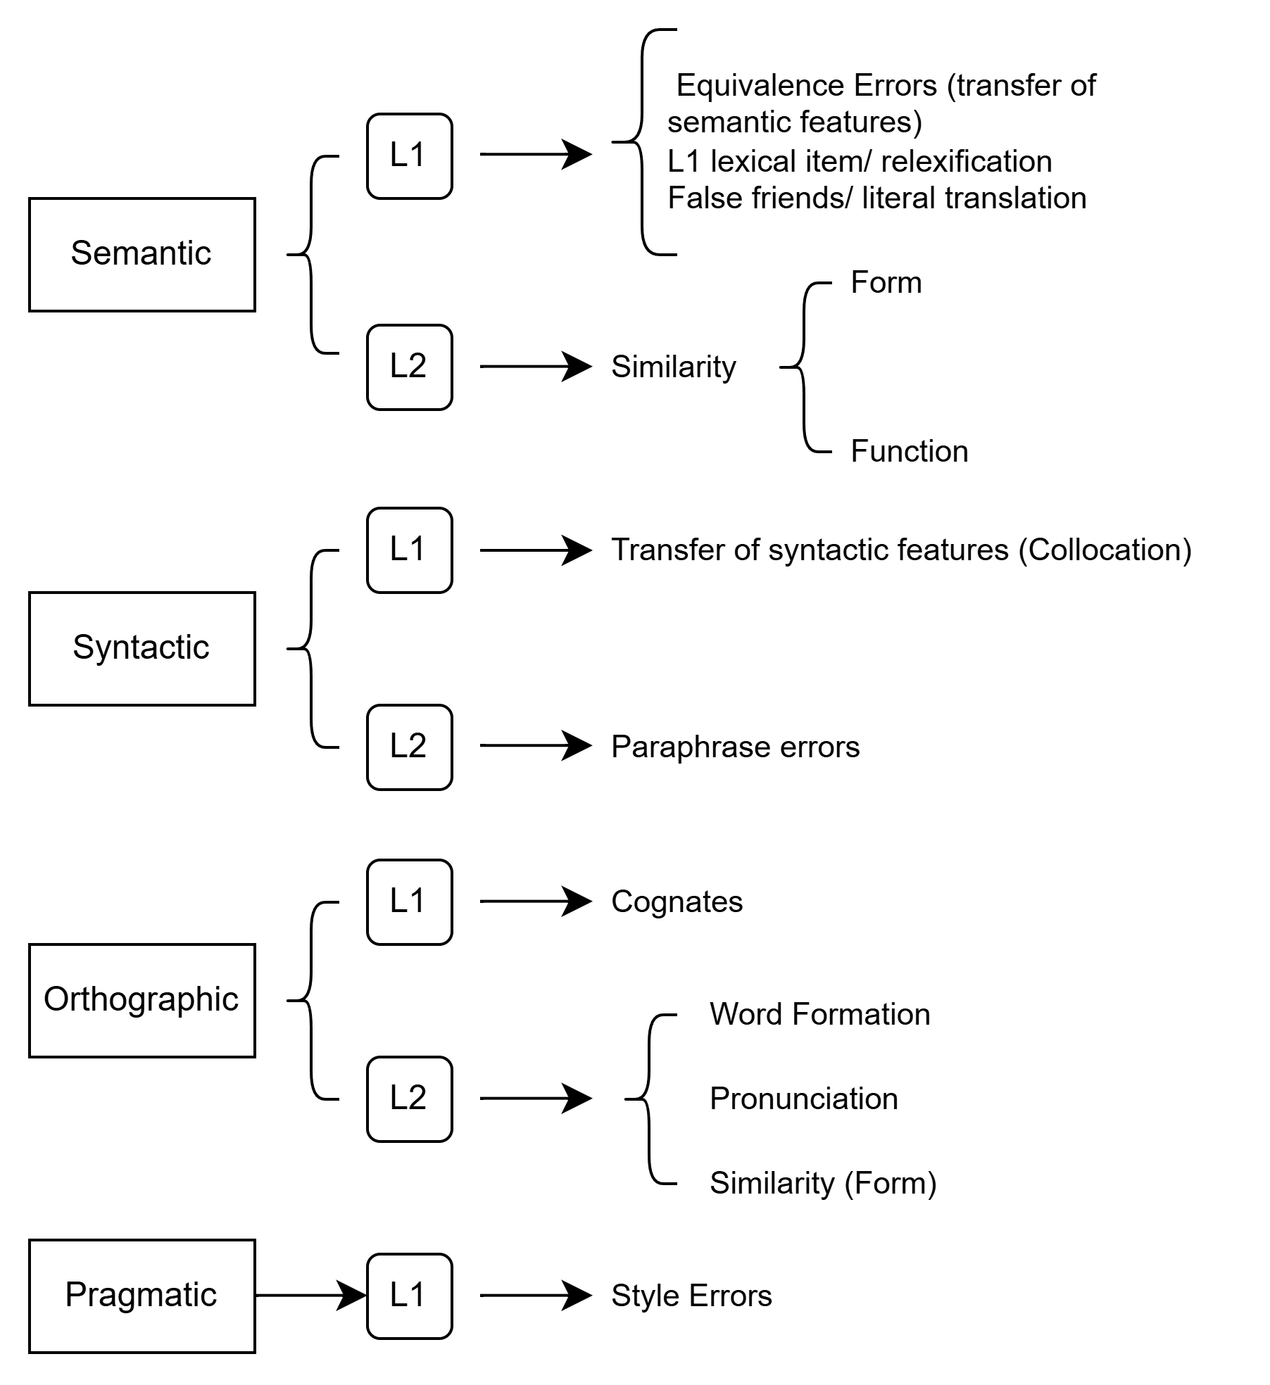

RESEARCH METHODOLOGY
This study adopts a mixed-methods approach, integrating both quantitative and qualitative analyses to investigate lexical errors in student writing. A quantitative design is employed to determine the frequency and distribution of specific error types, providing a statistical overview of the most prevalent lexical errors. Concurrently, a qualitative analysis is utilized to manually classify these errors and explore the underlying cognitive processes that lead to such inaccuracies. Such design allows the study to highlight the dominating errors and provide further insights through quantitative and qualitative data (Creswell, 2009).
The research was conducted at the University of Danang – University of Foreign Language Studies (UD-UFLS). The corpus consists of 40 argumentative essays randomly selected from the Writing Skill C1.2 course within the Faculty of English. The samples were collected from the final-term examinations of English majors, who are officially categorized at the B2 to C1 levels according to the Common European Framework of Reference for Languages (CEFR).
The classification of lexical errors was adapted from the framework established by Llach (2005) which evaluates the relationship between lexical errors and the quality of academic compositions. This framework was selected to facilitate an empirical investigation into the lexical errors of EFL learners, accounting for influences from both L1 transfer and L2 developmental patterns.
FINDINGS AND DISCUSSION
Figure 2. Percentage Distribution of Lexical Error Types
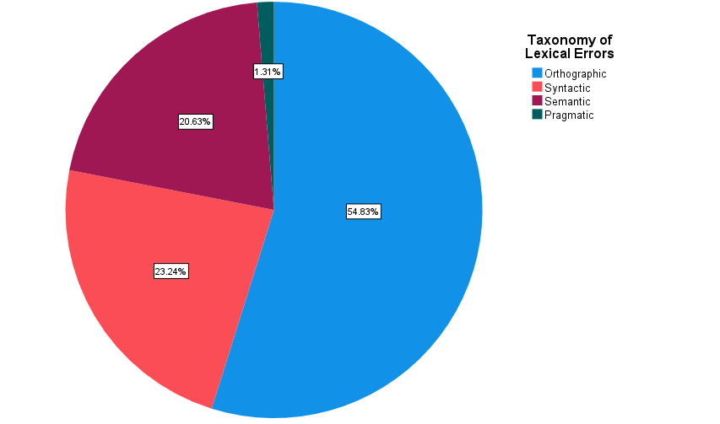

Table 1. Classification of Lexical Errors by Category and Linguistic Origin
Error Type | Subtype | Frequency | Percentage
Orthographic | L2 Word Formation | 161 | 54.83%
 | L2 Pronunciation | 45 | 54.83%
 | L2 Similarity (form) | 4 | 54.83%
Syntactic | L1 Transfer | 43 | 11.23%
 | L2 Paraphrase | 46 | 12.01%
Semantic | L1 Equivalence | 61 | 15.93%
 | L2 Similarity (Form) | 10 | 4.70%
 | L2 Similarity (Content) | 8 | 4.70%
Pragmatic | L1 Style | 5 | 1.31%
Figure 2 and Table 1, as shown above, demonstrate the distribution of the 385 lexical errors identified across 40 sampled essays extracted from the total corpus of EFL learners at UD-UFLS. The data reveals a significant concentration of errors in the Orthographic category, which constitutes over half of the findings at 54.55%. While Syntactic (23.64%) and Semantic (20.52%) errors follow as the next most frequent types, Pragmatic errors remain a marginal issue at only 1.30%.
Orthographic Errors
Orthographic errors represent the vast majority of the findings, accounting for 54.55% (210 times) of the total. Notably, every error was classified as L2, specifically involving word formation, derivatives and errors stemming from pronunciation.
L2 Word Formation
L2 Word Formation errors from students appeared 161 times, taking up the majority of the total Orthographic errors.
(1) …artificial intelligence (AI) are gradually replace traditional document due to quick respondence for student's demand on homework, paper or even report.
(1) is an example of incorrect derivation in students’ essays. In the extract from W44, there are two classic word formation errors. First, the sentence requires the present continuous form (Verb + _ing). The student, however, provides the root form of the verb (replace) Second, the student recognizes that the syntactic position following the adjective “quick” requires a noun. Then, the student likely wanted to apply an analogy from words like responses or results. However, the student created a new noun using a valid English suffix (-ence), a faulty nominalization.
(2) Lastly, not every student can have access to proper equipments required for a usable learning experience.
Example (2) shows a failure to recognize English uncountable nouns, treating them as regular count nouns.
The high incidence of L2 Word Formation errors among UD-UFLS students can be explained by the differences between Vietnamese, the mother tongue of EFL learners, and English. Vietnamese is categorized as an analytic language, whereas English is a synthetic language with a complex system of derivational and inflectional morphology (Thompson, 1965). Because Vietnamese learners do not have the habit of altering word endings in their native tongue, these errors appeared consistently throughout each essay.
L2 Pronunciation
Errors in the L2 Pronunciation subtype were identified 45 times. Errors of this subtype occur when learners rely on the phonetic sound of a word to determine its spelling, rather than its conventional orthographic form.
(3) Addition, online learning can also save time and convinient for people who work and study at the same time.
In extract (3), the student writes convinient instead of convenient. In fast speech, the second vowel /e/ in convenient is often reduced to a schwa /ə/ or a short /ɪ/ sound. It shows that the student is spelling by sound rather than by visual memory of the word.
(4) In my standpoint, I wholeheartedly align with the later statement.
In extract (4), the student uses later instead of latter. The words later /ˈleɪ.tər/ and latter /ˈlæt.ər/ are phonetically similar, differing primarily in the length and quality of the first vowel. The student likely intended to refer to the second of two mentioned points (the latter statement) but retrieved the more common chronological term (later). This error is particularly problematic because it affects the cohesion of the essay. It suggests that while the student knows the academic function of the word (pointing back to a previous statement), they lack the precise orthographic distinction required to separate the two forms.
This phenomenon happened because Vietnamese is a tonal and syllable-timed language where vowels are usually distinct (Thompson, 1965). In contrast, English vowel reduction in unstressed syllables is a major hurdle for Vietnamese learners, when their guess of the spelling might be incorrect.
L2 Similarity (Form)
Errors of L2 Similarity in Form occur when a learner confuses the target word with another word in the English lexicon that shares a high degree of graphic or phonetic similarity. Unlike Word Formation or Pronunciation, these are substitution errors because the student has a specific word in their mind but pulls out the wrong one.
(5) people should be more careful when using social networking media these days to avoid unwanted incidences like cheating or loss of privacy.

The student in example (5) confuses the noun incidence with incidents. Because they look and sound almost identical, the student selects the more academic-sounding -ence ending.
Syntactic Errors
The second most frequent category was Syntactic errors, representing 23.64% (91 times) of the total. This category showed a relatively even split between L1 (11.17%) and L2 (12.47%) sources. The L1 syntactic error often manifests as a transfer of Vietnamese collocational features into English, while the L2 errors appear as paraphrase issues of incorrect grammatical associations within the English system.
L1 Transfer
Syntactic L1 Transfer represents a significant portion of structural errors (43 cases) of the total Syntactic errors, accounting for nearly half of all syntactic deviations.
(6) For example, I can apply teach assist for Center English, and help children…
The error Center English found in (6) is a prime example of Syntactic L1 Transfer, specifically involving word order. In Vietnamese, the head noun always precedes its descriptors or modifiers (Trung tâm [Center] + tiếng Anh [English]). English follows the opposite rule for compound nouns and adjective-noun phrases. The student is not simply making a random mistake, but they are using a direct structural translation. They have the correct words in their first language but failed to translate them into English. Because this order is reinforced by their native language, it feels natural to them.
(7) For example, in poor area, some families even difficult to build a stable life.
Example (7) is another example of syntactic L1 Transfer, specifically highlighting the copula omission logic found in Vietnamese (Thompson, 1965). In the Vietnamese language, adjectives often function as complete predicates. Unlike English, which requires a linking verb like am, is, or are to connect a subject to an adjective, Vietnamese allows for a direct connection. The Vietnamese translation: “Gia đình thậm chí khó khăn (Families + even + difficult)” does not require linking the verb “to be” to make the sentence grammatically complete.
L2 Paraphrase
L2 Paraphrase errors occurred 46 times. Unlike L1 Transfer, these errors are not caused by Vietnamese interference but rather by the student's internal struggle with the complex grammatical rules of English itself.
(8) In addition, online learning affects on students' performance.
For (8), there is redundancy in the use of preposition. The student likely confuses the verb affect with its noun counterpart effect, which does require the preposition on.
(9) However, this development poses certain threats on online users,...
In contrast to the over-supply of prepositions seen in the previous examples, extract (9) demonstrates incorrect preposition selection. This occurs when students recognize that a preposition is syntactically required but choose the wrong one based on a false comparison with other English phrases. The student uses threats on instead of the standard collocation threats to. This likely happens because the student is thinking of the phrase impact on or influence on, which share a similar meaning of affecting something.
A significant portion of L2 paraphrase errors involves the misuse or unnecessary addition of prepositions. This suggests that while students have the content words, they struggle with the specific collocations required by English verbs and adjectives.
(10) Regarding large-scale businesses that establish online platforms and social media, the main responsibility lying with them is to invest more in the security system and…
As seen in (10), the use of lying with them instead of the intended resting with them (in the context of responsibility or a decision) shows that the student understands the general meaning but fails to recognize the specific syntactic constraints of the verb. While the student correctly identifies that the sentence requires a verb denoting the location of responsibility, they select a lexical substitute that lacks the formal fit required in academic English.
In this subset of L2 Paraphrase errors, students move beyond simple preposition mistakes and run into word-choice failures. These errors occur when a student has a complex idea in mind but fails to make the right word choice from their English vocabulary to express it. Instead of the mistake coming from their native Vietnamese, the student is struggling with the tricky rules of English itself.
Semantic Errors
Semantic errors accounted for 20.52% (79 times) of the findings. Within this category, L1 (15.84%) significantly outnumbered L2 (4.68%). This disparity suggests that for UD-UFLS students, the primary obstacle in word choice is the persistent influence of their native Vietnamese. Rather than struggling with internal English synonyms or definitions, learners frequently default to a literal translation of Vietnamese concepts into English.
L1 Equivalence
Semantic L1 Equivalence is the most frequent subtype within the semantic category, with more than two-thirds of the total Semantic Errors.
(11)...I think classroom teaching will have more relationship than online learning…
In Vietnamese, general-purpose verbs like làm (do/make) or có (have) are used in a wide variety of contexts. As a consequence, students frequently map these directly onto English, missing more precise academic collocations. In example (11), the use of have more relationship mirrors the Vietnamese phrase có nhiều mối quan hệ, failing to utilize more standard English collocations such as build or foster relationships.
(12) You should not click to any strange links because it can lead to the loss of personal accounts.
In example (12), the use of strange links is a literal translation of the Vietnamese word lạ, which can mean both strange and suspicious. While strange is a technically correct dictionary translation, it fails to capture the specific academic and technical nuance of suspicious required in the context of cybersecurity.
These errors show that students are using words that only have a similar general meaning to a Vietnamese word, but they don't realize that English requires more specific labels depending on the field of study (e.g., strange vs. suspicious). This suggests that even as students move beyond basic vocabulary, their word choice remains heavily affected by the broad meanings of Vietnamese words, leading to a style of writing that, while understandable, lacks the professional precision expected in university-level essays.
L2 Similarity (Form)
In contrast to errors based on meaning, L2 Similarity (Form) errors highlight a specific type of error where students are confused by the physical appearance or sound of English words.
(13) …as online learning can help with distant learning and class management while the traditional classroom…
In example (13), the student uses the adjective distant (describing a far-off place) instead of the noun-modifying form distance (as in distance learning). This is the most common pattern in the corpus, as students often pick a word with the correct root but the wrong suffix, leading to a grammatical mismatch that changes the meaning of the sentence.
(14) Many people, especially internet users, have concern about the safety when accessing any websites or applications on electric devices.
In several cases, students choose a word that looks or sounds like the correct one but belongs to a different grammatical or semantic category. With example (14), the student failed to distinguish between electric (carrying electricity, like a wire) and electronic (using circuitry, like a computer).
L2 Similarity (Content)
L2 Similarity (Content) errors are not caused by Vietnamese transfer, but rather by an internal confusion between English words that have similar meanings but different usages.
(15) People can lose contact with their friends, relatives, colleagues and counterparts.
In (15), The student uses counterparts (which implies a matching person in a different organization) when they likely mean business associates. This confusion occurs when students choose a word that is in close relation to the meaning but carries the wrong formal weight or specific application.
(16) That development creates chances for modern crime to hack and steal money from banking apps on phones.
Sample (16) is a recurring pattern in this subset where there is confusion between a person performing an action and the action or concept itself. The student used the abstract noun crime when referring to the people involved (modern criminals).
Unlike errors caused by native language interference, L2 Similarity (Form) errors can be viewed as a positive sign of vocabulary growth. While L1 Equivalence errors show that students are still anchored to Vietnamese, these mistakes demonstrate that they are actively trying to think and navigate within the English lexical system, as they are trying to use synonyms and word families. In this stage, the challenge is no longer about finding any word to express an idea, but rather learning the small, critical differences between words that appear similar on the surface.
Pragmatic Errors
Finally, Pragmatic errors were the least frequent, representing only 1.30% (5 times) of 40 essays. These were entirely attributed to L1 Style interference, where the register of a phrase was slightly inappropriate in an academic context. These errors are caused by Pragmatic Transfer, where students apply the informal, descriptive, or emotional tone of their native Vietnamese to formal English essays.
(17) By judging their friends just from the click of a button, many straight up determine whether they want to interact with that person or not without even directly interacting with them in real life.
In sample (17), the use of the phrase straight up determine serves as a clear example of an L1 Style pragmatic error. While the sentence is grammatically functional, the student adopts a conversational tone that is inappropriate for formal academic writing. The expression straight up is a colloquialism likely used to mirror the Vietnamese emphasis on immediacy or bluntness (similar to ngay lập tức or thẳng thừng).
(18) This leads to many cases that are hacked and scammed over a year, and even leads to serious situations like death.
The phrase in example (18) is quite blunt and emotionally heavy. From a pragmatic standpoint, academic writing uses distancing language or more technical terms like fatalities" or loss of life to discuss sensitive topics professionally.
The low frequency of Pragmatic errors suggests that students at the B2 to C1 level generally possess a functional awareness of the appropriate style for essay writing, even if the formal accuracy of their word choices may be inconsistent.
CONCLUSIONS AND IMPLICATIONS
This study employs a mixed-methods approach to investigate lexical errors in the academic writings of English majors at UD-UFLS. Utilizing 40 argumentative essays produced during timed examinations, the research identifies and calculates the frequency of lexical errors. Following the classification framework established by Llach (2005), the study qualitatively analyzes these errors to explore the influences of L1 transfer and L2 developmental patterns on writing quality. By integrating quantitative frequency data with qualitative error tagging, the research provides an empirical account of the most prevalent lexical hurdles faced by undergraduate students at the B2-C1 proficiency levels.
The analysis identified a total of 383 lexical errors. Orthographic errors emerged as the dominant category, accounting for more than half of the total recorded cases. This was followed by syntactic and semantic errors, whereas pragmatic errors were found to be statistically insignificant. Notably, the majority of these errors were classified as L2-oriented, indicating a shift away from direct mother-tongue interference. This trend serves as a positive indicator of linguistic development since it suggests that UD-UFLS learners are moving toward more complex lexical choices. However, the L1-oriented errors suggest that even though students have achieved sufficient lexical items for a more advanced English-level, their word choice is still influenced by their mother tongue.
The research contributes to references for further research about lexical richness or for curriculum development. By scrutinizing the four linguistic error domains, educators can have a clearer focus on writing courses to provide students with a holistic understanding of their own developmental needs. As the majority of their struggles are L2-oriented, the curriculum can be designed to encourage students to engage with complex language structures while providing the specific formal support needed to master them, helping students refine their writings.
Despite its contributions, this study has several limitations. Due to time and resource constraints, only 40 samples of students’ argumentative essays were analyzed. Therefore, it may not fully capture the entire spectrum of lexical deviance across the broader student population. Second, the categorization of errors presents an inherent challenge, as the boundaries between lexical and grammatical errors can occasionally overlap or become ambiguous within the taxonomy. To mitigate this, the researcher carefully considered the specific exam context and topic constraints during the classification process to ensure the highest possible degree of accuracy. The limitations as such provide a clear pathway for future research. Subsequent studies could involve more diverse and larger corpora to enhance the generalizability of the findings. Further investigation into lexical richness or specific error types would be highly valuable for the field of second language acquisition.

REFERENCES
- Corder, S. P. (1973). Introducing applied linguistics. Penguin Books.
- Creswell, J. W. (2009). Editorial: Mapping the field of mixed methods research. Journal of Mixed Methods Research, 3(2), 95–108. https://doi.org/10.1177/1558689808330883
- Biber, D., Conrad, S., & Reppen, R. (1998). Corpus linguistics: Investigating language structure and use. Cambridge University Press.
- Do, N. H. M., & Le, Q. T. (2023). Lexical collocation errors in essay writing: A study into Vietnamese EFL students and their perceptions. International Journal of Language Instruction, 2(2), 101–118. https://doi.org/10.54855/ijli.23226
- Ellis, R. (1994). The study of second language acquisition. Oxford University Press.
- Goody, J. (1987). The interface between the written and the oral. Cambridge University Press.
- Granger, S. (2009). The contribution of learner corpora to second language acquisition and foreign language teaching: A critical evaluation. In K. Aijmer (Ed.), Corpora and Language Teaching (pp. 13-32). John Benjamins Publishing Company. https://doi.org/10.1075/scl.33.04gra
- Hughes, A., & Lascaratou, C. (1982). Competing criteria for error gravity. ELT Journal, 36(3), 175–182. https://doi.org/10.1093/elt/36.3.175
- Laufer, B. (1990). Why are some words more difficult than others? - Some intralexical factors that affect the learning of words. International Review of Applied Linguistics in Language Teaching, 28(4), 293–308. https://doi.org/10.1515/iral.1990.28.4.293
- Laufer, B., & Nation, P. (1995). Vocabulary size and use: Lexical richness in L2 written production. Applied Linguistics, 16(3), 307–322.
- Lennon, P. (1991). Error and the very advanced learner. International Review of Applied Linguistics in Language Teaching, 29(1), 31–44. https://doi.org/10.1515/iral.1991.29.1.31
- Llach, M. D. P. A. (2005). The relationship of lexical error and their types to the quality of ESL compositions: An empirical study. Porta Linguarum: revista internacional de didáctica de las lenguas extranjeras, (3), 45–57.
- Nguyen, A. N., & Vu, T. V. (2024). Typical linguistic errors committed by tertiary students in legal written outputs. East European Journal of Psycholinguistics, 11(2), 120–141. https://doi.org/10.29038/eejpl.2024.11.2.ngu
- Read, J. (2000). Assessing vocabulary. Oxford University Press.
- Schmitt, N. (2010). Researching vocabulary: A vocabulary research manual. Palgrave Macmillan.
- Thompson, L. C. (1965). A Vietnamese reference grammar. University of Washington Press.
- Tran, T. T. (2021). An analysis of lexical collocation errors in academic IELTS writing task 2 by Vietnamese students in an English center [Master’s thesis, Dalat University]. Dalat University Institutional Repository.
- Wesche, M., & Paribakht, T. S. (1996). Assessing second language vocabulary knowledge: Depth versus breadth. The Canadian Modern Language Review, 53(1), 13–40. https://doi.org/10.3138/cmlr.53.1.13
- Yang, Y., & He, X. (2025). Lexical richness in Chinese university students’ EFL writing: A corpus-based comparison. Humanities and Social Sciences Communications, 12, Article 1199. https://doi.org/10.1057/s41599-025-05560-x
- Zimmermann, R. (1986). Classification and distribution of lexical errors in the written work of German learners of English. Papers and Studies in Contrastive Linguistics, 21, 31–40.

