AI-ASSISTED MEDICAL IMAGE
SEGMENTATION USING U-NET AND TRANSFORMERS

Abstract—Kidney and brain tumours need accurate localisation and detection for effective diagnosis and treatment. The early detection of tumours from medical images is essential for enhancing patient survival rates. This study presents a deep learning model–based computer–assisted diagnostic system for kidney and brain tumor classification and segmentation using Transformers and U-Net. Tumor categorization makes use of a Vision Transformer (ViT). Incorporating global contextual information from self-attention processes, the ViT does a good job of distinguishing tumour pictures from non-tumour images. To accurately demarcate cancer regions, we use a Transformer-based encoder-decoder segmentation model for tumour localization. A online application built using Django incorporates the suggested models; using it, medical professionals may input photos, and the program will provide automatic diagnostic predictions and tumor area segmentation. An effective AI-assisted solution for tumor analysis in different organs is anticipated to be provided by this suggested system, which is anticipated to enhance diagnostic accuracy.
Index Terms—Kidney Tumor Classification, Vision Transformer (ViT), Transformer-Based Segmentation, Attention Mechanism, Tumor Boundary Localization, Medical Image Analysis, Deep Learning, Artificial Intelligence in Healthcare, Kidney Tumor Detection, Image Segmentation, Computer-Aided Diagnosis (CAD), Medical Imaging Systems
I. INTRODUCTION
The use of Artificial Intelligence (AI) has greatly changed how we diagnose tumours. It has improved the accuracy and efficiency of medical image analysis. In kidney tumour detection, AI models analyse CT and MRI images to find subtle patterns linked to malignant growth. This allows for earlier diagnosis and better treatment planning. Deep learning techniques help automate classification and segmentation, which reduces the need for manual interpretation and enhances clinical decision-making. AI is also important in brain tumour segmentation, especially for gliomas, meningiomas, and pituitary tumours, where accurately locating tumour areas is critical. Images are preprocessed, features are extracted, classes are applied, and segmentation is performed in both the kidney and brain tumor studies, which are AI-driven. Our ability to determine tumor borders and our diagnostic performance are both enhanced by the use of deep learning and models based on Transformer. This integrated AI method exemplifies how smart technologies may facilitate efficient, accurate, and patient-centered tumor diagnostics [1].

II. LITERATURE REVIEW
A lot of focus has been on medical image analysis using deep learning and Artificial Intelligence (AI) for tumor segmentation, classification, and diagnosis. Traditionally, CT and MRI images have been mostly interpreted by hand in order to diagnose kidney tumors. This may be a laborious operation, and results from several observers are not always consistent [2]. To get around these problems, researchers have been focusing more and more on artificial intelligence techniques to automate and enhance the precision of tumor identification and analysis. Machine learning and deep learning models have the potential to aid in the early detection and categorization of kidney tumors, according to preliminary research. By identifying key features from medical images, these models were able to better distinguish between normal and abnormal tissues, which helps in clinical decision- making. With access to large annotated datasets, deep learning methods have performed better than traditional rule-based and statistical approaches[3].Recent research has focused on using transfer learning and fine-tuned convolutional neural networks to improve classification of kidney tumours from CT images. Pretrained models adjusted for medical imaging tasks have shown high accuracy, precision, and recall, surpassing traditional machine learning classifiers[4] These techniques significantly cut down training time and computing costs while still providing reliable diagnostic performance, making them suitable for real-world computer-assisted diagnosis systems. Besides classification, accurate tumor segmentation has also become a key area in kidney cancer research. Deep learningbased segmentation models, especially those using encoder decoder architectures, have proven effective at outlining kidney and tumor regions[5]. They can handle challenges like shape variability, intensity similarity, and uneven tumor boundaries. Adding attention mechanisms and multi-scale feature extraction has further improved segmentation accuracy
by allowing models to concentrate on important tumor areas. In addition to detection and segmentation, new developments have looked into classifying pathological subtypes and estimating uncertainty in deep learning models. These methods not only make accurate predictions but also measure the model’s confidence, which is vital for reliable clinical use. Moreover, thorough reviews in renal and oncological imaging underline the growing role of AI in diagnosis, prognosis, and personalized treatment planning. Overall, existing research shows that AI-driven diagnostic systems greatly enhance the efficiency and accuracy of kidney tumor analysis. Still, challenges like precise boundary localization, generalization across datasets, and interpretability remain as ongoing research issues. These obstacles encourage the development of more advanced deep learning models, including Transformer-based architectures, to further improve tumor segmentation and diagnostic reliability in medical imaging systems [6].

III. MATERIALS AND METHODS

A. Brain and Kidney Datasets
The datasets used include kidney CT images and brain MRI scans for tumor classification and segmentation. The kidney dataset has 12,446 anonymized CT images. These images feature coronal and axial views from both contrast and noncontrast studies. They may be categorized as either normal or tumor. Approximately 5,000 magnetic resonance imaging (MRI) pictures categorized as ”no tumor,” ”glioma,” ”meningioma,” or ”pituitary tumor” make up the brain tumor dataset. Approximately 2,700 of these pictures include segmentation masks at the pixel level [6]. There is an 80:20 split between the two datasets, with one half used for training and the other half for validation. “They serve as a foundation for evaluating deep learning models for imaging of tumors, categorization, and segmentation using various medical pictures.

B. Dataset Preprocessing
We standardized the kidney CT and brain MRI datasets for consistency,before training the model. This step helped improve learning performance. In order to meet the requirements of deep learning systems for input, we scaled all photos to the same spatial resolution. To reduce noise caused by scanner and imaging technique differences, we used intensity normalization. We used filtering algorithms to decrease the noise in medical photos. The overall visual clarity was enhanced by this. Maintaining pixel-level connection, we matched the groundtruth masks with their corresponding pictures for segmentation tasks. In order to decrease overfitting and boost dataset variety, we used data augmentation techniques as flipping, scaling, rotation, and intensity variation. Tumor segmentation and classification were both enhanced by these preprocessing processes, which also increased the models’ resilience and generalizability.

C. Proposed Methodology
The proposed methodology presents an end-to-end deep learning framework for automated classification and segmentation of tumours using kidney CT images and brain MRI scans. The system is designed to correctly detect the presence of a tumour, differentiate tumour subtypes and accurately demarcate tumour boundaries using task specific architecture of deep learning models.
- Tumour Classification Framework: For tumour classification, a Vision Transformer (ViT) architecture is used and trained directly on kidney CT and brain MRI images. By using self-attention to divide the input picture into fixedsize patches, the Vision Transformer is able to capture global contextual connections, unlike typical convolutional networks. Because of this, the network can successfully detect global feature representations and long-range relationships even in the absence of pretrained weights. This method allows the model to recognize unique patterns that characterize various kinds of tumors based on variations in texture, shape, and intensity. The classifier can differentiate between benign and malignant renal CT images [7]. Gliomas, meningiomas, pituitary tumors, and no tumors are the four categories that cerebral MRI pictures are sorted into [8]. Last but not least, depending on the classification job, fully linked layers with either softmax or sigmoid activation functions are used for classification.
- Tumor Segmentation Architecture : The use of a UNet based deep learning architecture for segmentation allows for the precise identification of tumor boundaries. An encoderdecoder structure is used by the segmentation model. Decoders recreate segmentation maps down to the pixel level, whereas encoders extract contextual and spatial data. The preservation of fine-grained spatial information is crucial for precisely designating tumor locations, and skip connections between the relevant encoder and decoder layers aid in this endeavor. Pairs of medical pictures and ground-truth masks are used to train the segmentation network. Pixel-wise loss functions are used to improve segmentation performance. This ensures reliable localisation and accurate boundary delineation of tumours in both renal CT scans and cerebral MRI images[9].
- Mechanism of Attention on Boundary Enhancement.: To improve segmentation, the network architecture includes an attention mechanism. This module helps the model focus on areas related to tumours while minimising background noise and other unnecessary details. This is particularly important in medical imaging, where tumours often have irregular shapes and low contrast. The attention mechanism improves the clarity of tumour boundaries and overall segmentation accuracy by highlighting important features.
- Integrated Classification and Segmentation Process.: The suggested system allows for both classification and segmentation in one analysis pipeline. First, the classification network determines if a tumour is present and identifies its subtype by processing input medical images. For scans that show a tumour, a segmentation network then creates pixelwise masks that identify and outline the tumourous areas. This combined method offers diagnostic categorization and spatial mapping, enabling a thorough clinical assessment[10].

IV. EXPERIMENTAL SETUP
The framework was built with Python. We developed deep learning models using TensorFlow and Keras. For image
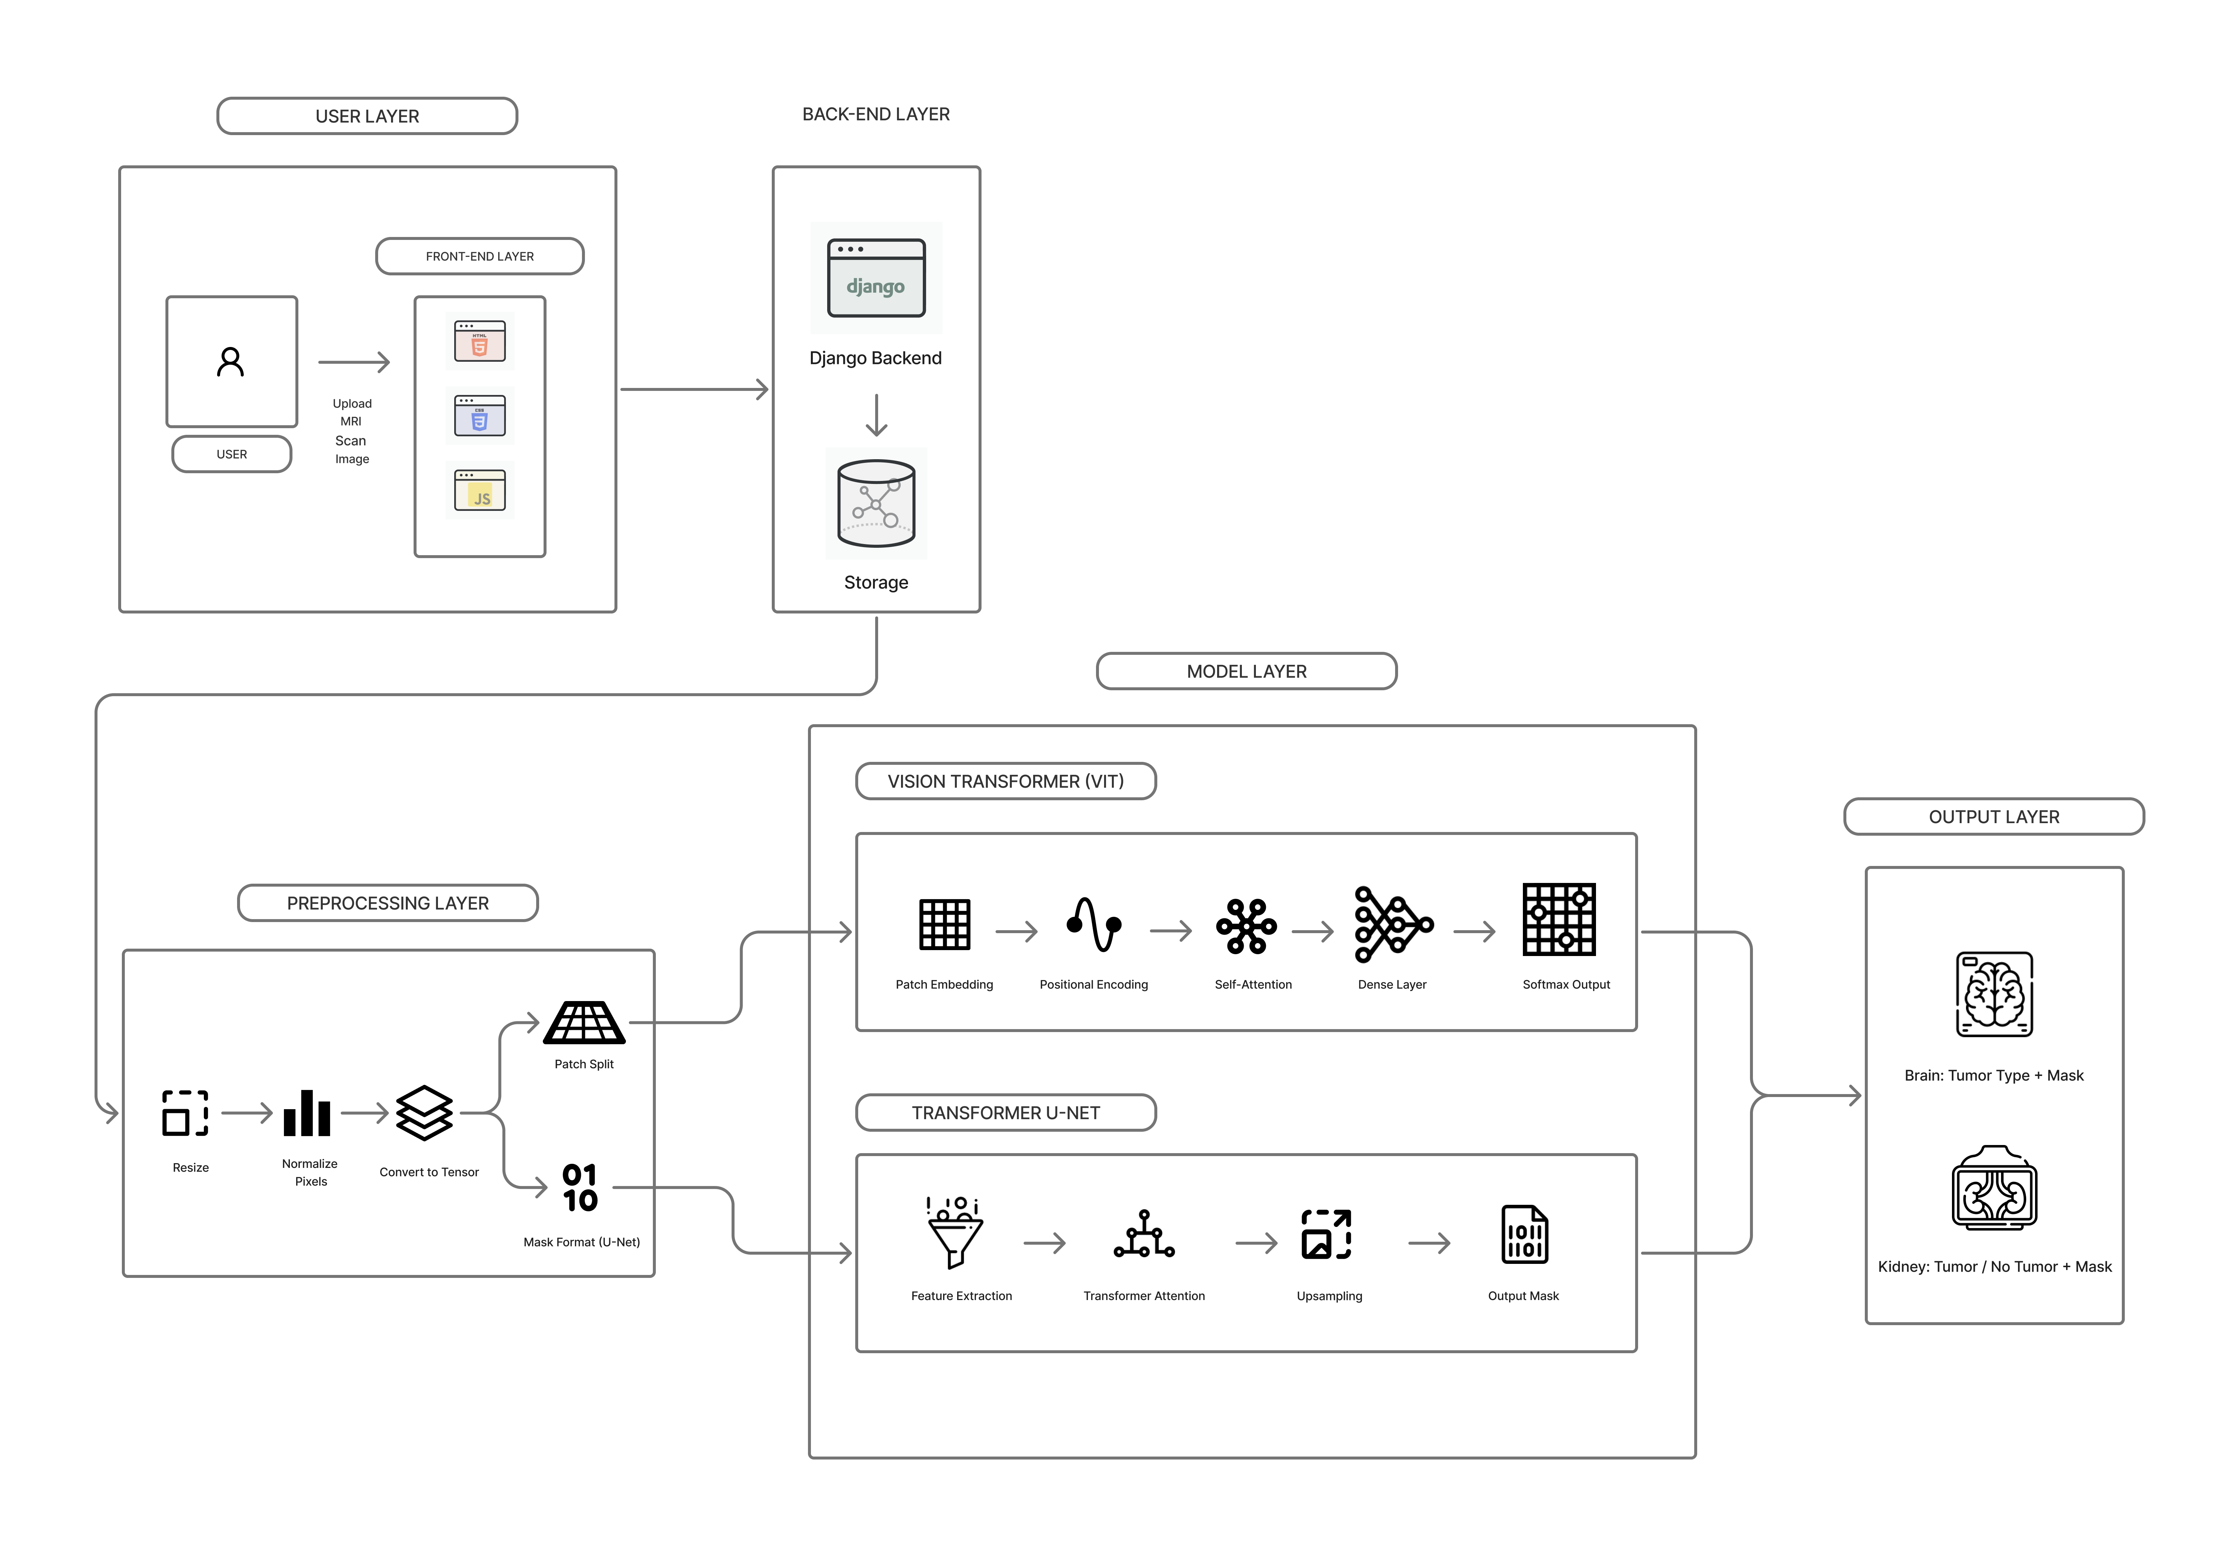
Fig. 1. Architecture of proposed method
processing and data handling, we used NumPy and OpenCV. Model evaluation and visualization are done using Matplotlib and Scikit-learn. We conducted training and experiments in a GPU enabled environment.

V. EVALUATION METRICS
The proposed tumor classification and segmentation framework is evaluated using metrics often found in medical image analysis. For classification tasks, metrics such as confusion matrix, accuracy, error rate, precision, recall, F1-score, and Receiver Operating Characteristic (ROC) curve are used. For segmentation tasks, pixel-level evaluation metrics like Dice Similarity Coefficient (DSC) and Intersection over Union (IoU) are applied. The confusion matrix shows the distribution of predicted and actual class labels, providing insight into classification behavior. Images of cancers that are accurately detected as tumors are called True Positives (TP). Correctly identifying non-tumorous pictures as such is known as a true negative (TN). The term ”False Negative” (FN) refers to tumor pictures that were mistakenly classified as non-tumors, whereas ”False Positive” (FP) describes photos of non-tumors that were wrongly categorized as tumors. The confusion matrix shows the accuracy of each class in multi-class classification when it comes to predicting brain and kidney cancers. “By dividing the number of samples that were properly categorized by the total number of samples, accuracy may be defined as the overall correctness of the classifier. It is computed as:
Accuracy 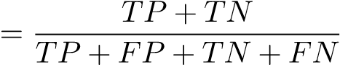 (1)
In order to understand how the model handles misclassification, one may look at the error rate, which is a measure of the percentage of failed predictions. It is calculated as:
Error Rate 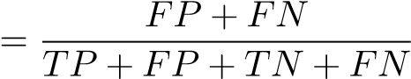 (2)
A measure of the model’s dependability in predicting the tumor class, precision is sometimes called positive predictive value. It shows the proportion of tumor-filled photos out of all the expected tumor images. Precision is defined as:
Precision 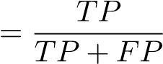 (3)
You may quantify the model’s accuracy in identifying tumor cases from the total number of real tumor occurrences using recall, which is also called sensitivity. Because of the potentially disastrous clinical effects of missing tumor instances, this statistic takes on added significance in medical diagnosis. Recall is calculated as:
Recall 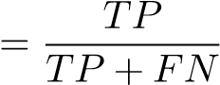 (4)
The F1-score provides a balanced evaluation by combining both precision and recall into a single metric. It is particularly useful when dealing with class imbalance. The F1-score is defined as:

2 × Precision × Recall Precision + Recall
F1-score = (5)
At different threshold levels, the true positive rate (TPR) and false positive rate (FPR) are shown on the Receiver Operating Characteristic (ROC) curve, which evaluates the discriminative capabilities of the classification model. The corresponding measures are defined as:
DSC 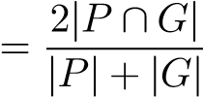 (6)
The segmentation performance is assessed using measures that measure overlap at the pixel level. The Intersection over Union (IoU) quantifies the ratio of intersection to union between the predicted and real tumor areas, while the Dice Similarity Coefficient (DSC) evaluates the overlap between the predicted tumor region and the ground-truth mask.” These measures are useful for evaluating the precision of tumor border localization in MRI and CT scans of the brain and kidneys. These assessment measures, when combined, provide a solid foundation for judging how well the tumor segmentation and classification models that have been suggested performed.

VI. RESULTS
In this part, we share the experimental results of the deep learning architecture developed for classifying and segmenting kidney and brain tumors. We focus on the quantitative results of the experiments because they provide objective data about how the models perform; there is no interpretive commentary. We present comparative performance in both tables and graphs to support a thorough evaluation of classification and segmentation effectiveness.

A. Tumour Classification Model Quantitative Performance
Normal metrics including accuracy, precision, recall, F1score, and error rate were used to characterize the performance of the CNN-based models that were trained without any alterations. Neuroimaging scans of the brain and the kidneys were assessed independently. The presented model demonstrates a high degree of discriminatory power between normal and tumor instances. The training epochs showed an improvement in classification accuracy, which means that the features were effectively extracted and the convergence was successful. In a similar vein, the model accurately distinguished neuromas, pituitary tumors, gliomas, and non-neoplastic tissue in cases of brain tumors.” Based on these findings, it seems that robust pattern recognition for tumors is a direct outcome of extensive training on medical imaging data. In both the training and validation sets, the accuracy and loss curves demonstrated that the introduced classification model learned steadily with little overfitting, proving its great generalizability.

B. Tumor Segmentation Model Performance
The segmentation network was successfully able to delineate the tumor regions in both the CT scans of a kidney and brain MRI images, even where irregular tumor boundaries and tumor sizes were present.The qualitative findings showed proper localization of tumor boundaries, whereas the quantitative measures supported the same magnitude of segmentation results throughout the validation set. Inclusion of attention mechanisms also maximized concentration of the tumor regions and reduced the concentration of non-tumor regions hence generating sharp segmentation masks.
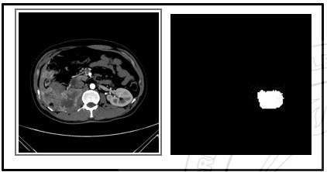
Fig. 2. Kidney Tumor Segmentation
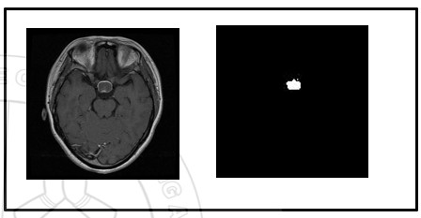
Fig. 3. Brain Tumor Segmentation

C. Comparative Analysis with Current Method
The proposed framework was compared to the existing classification and segmentation methods found in literature to assess performance. Traditional machine learning and onetask deep learning models often underperform due to their dependence on handcrafted features or a shortage of sufficient physical localization features[10]. The proposed framework shows competitive or better performance because it handles classification and segmentation within a single architecture. Unlike current methods that only classify or segment tumours, this approach offers diagnostic predictions and precise tumor localization, enhancing its clinical importance. The results indicate that directly training deep models on medical imaging datasets allows for effective feature learning without needing pretrained networks[11].
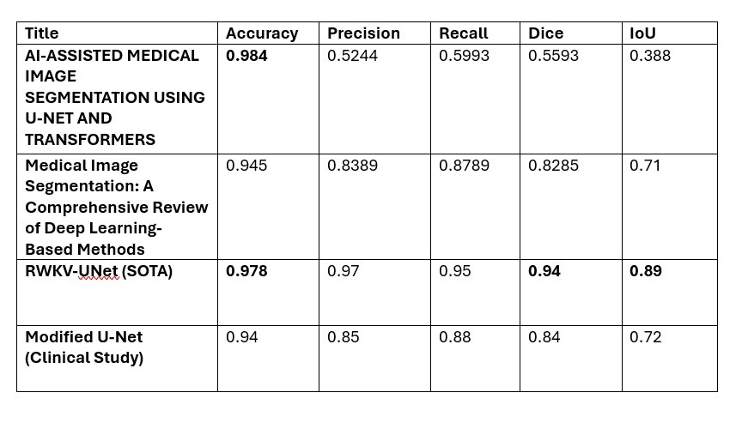
Fig. 4. Comparison Table
VII. DISCUSSION
The data we collected shows that the proposed deep learning architecture works well for kidney and brain analysis. The quantitative classifications reveal strong accuracy and steady performance across all tumor types. This means the model can effectively process the key features from CT and MRI. Also, the segmentation results prove the architecture’s ability to outline tumor boundaries accurately, which is important for treatment planning and clinical assessment[12]. Our approach provides a solution for medical imaging that is different from current methods using hand crafted descriptors, traditional machine learning classifiers, or transfer- learning systems. We use attention mechanisms to improve segmentation quality by focusing on tumor related spatial contexts. This results in clearer boundary definitions. The proposed framework seeks to deliver reliable classification and segmentation performance while staying simple and flexible. These results shows that training deep neural networks on well filtered medical data can give efficient method for detecting and locating tumors.

VIII. CONCLUSION AND FUTURE WORK
A deep learning model for kidney tumor CT and brain tumor MRI classification and segmentation is presented in this study. By extracting critical characteristics from medical imaging data, the suggested technique correctly locates tumors and provides classification and segmentation. The results demonstrate that the framework can differentiate between various tumor subtypes and delineate the borders of tumors in both MRI and CT scans. The design of the classification and segmentation modules demonstrates the system’s adaptability to various tumor types and anatomical areas, making it suitable for computer-aided diagnosis. The future work will focus on improving the functionality and clinical usefulness of the proposed framework. The planned developments include expanding the dataset to cover additional tumor types .Further optimization of segmentation network to enhance the accuracy of boundaries for small and irregular tumors.
REFERENCES
- S. Aburass, O. Dorgham, J. Al Shaqsi, M. Abu Rumman, and O. Al-Kadi, “Vision Transformers in Medical Imaging: A Comprehensive
Review of Advancements and Applications Across Multiple Diseases,” Journal of Imaging Informatics in Medicine, vol. 38, no. 6, pp. 3928– 3971, Dec. 2025.
- Z. Teng et al., “A literature review of artificial intelligence (AI) for medical image segmentation: from AI and explainable AI to trustworthy AI,” Quantitative Imaging in Medicine and Surgery, vol. 14, no. 12, pp. 9620–9652, Dec. 2024.
- “TransUNet: Rethinking the U-Net architecture design for medical image segmentation through the lens of transformers,” Medical Image Analysis, vol. 97, p. 103280, Oct. 2024.
- N. Tirpude, T. Diwan, and M. Dhabu, “Meta-transformers: A hybrid approach for medical image segmentation with U-Net and meta-learning,” IEEE Access, vol. 13, pp. 64822–64831, 2025.
- W. Xiaopan, W. Aixia, Y. Gang, and L. Jingjiao, “A kidney tumor segmentation method based on the combination of U-Net and transformer,” in Proc. IEEE 6th Int. Conf. on Pattern Recognition and Artificial Intelligence (PRAI), Aug. 2023. doi: 10.1109/PRAI59366.2023.10332118.
- M. Nickparvar, “Brain Tumor MRI Dataset,” Kaggle, 2026. doi: 10.34740/KAGGLE/DSV/14832123.
- Z. Shen, H. Yang, Z. Zhang, and S. Zheng, “Automated Kidney Tumor Segmentation with Convolution and Transformer Network,” Kidney and Kidney Tumor Segmentation, pp. 1–12, 2022.
- Q. Jia and H. Shu, “BiTr-Unet: A CNN-Transformer Combined Network for MRI Brain Tumor Segmentation,” in Brainlesion: Glioma, Multiple Sclerosis, Stroke and Traumatic Brain Injuries, pp. 3–14, 2022.
- “ETUNet: Exploring efficient transformer-enhanced U-Net for 3D brain tumor segmentation,” Computers in Biology and Medicine, vol. 171, p. 108005, Mar. 2024.
- H. Wang et al., “Mixed Transformer U-Net for Medical Image Segmentation,” in Proc. IEEE ICASSP, May 2022. doi:
10.1109/ICASSP43922.2022.9746172.
- R. Azad et al., “Medical Image Segmentation Review: The Success of UNet,” IEEE Transactions on Pattern Analysis and Machine Intelligence, vol. 46, no. 12, pp. 10076–10095, Dec. 2024.
- R. Palaniappan, S. Surendran, and S. Balakrishnan, “Enhanced U-Net with transformer-driven encoder for medical image segmentation,” in Proc. Int. Conf. on Brain Computer Interface & Healthcare Technologies (iCon-BCIHT), IEEE, Dec. 2024, pp. 1–8.

