A Robust Approach for Brain Tumor Detection using Fine Tuned Xception Model

ABSTRACT
Brain tumour diagnosis using medical imaging plays a crucial role in early treatment planning and patient survival. Manual analysis of magnetic resonance imaging (MRI) scans needs high level of medical expertise and prone to inter-observer variability, especially when tumours exhibit subtle or irregular patterns. Recent advances in deep learning have significantly improved automated tumour detection; however, conventional convolution models often struggle to capture complex and intricate patterns in an image, leading to reduced accuracy in detecting small or diffuse lesions. This paper proposes a fine-tuned Xception architecture for brain tumor classification. The proposed Xception based model was trained and tested against EfficeintNetB0, ConvNeXT, ResNet101 and inception models. And to further validate, the models were tested on two different datasets of varying size to authenticate the results obtained from anyone dataset. In both the datasets, Xception model is showing exceptional performance on both training and testing datasets. Xception shows improved performance than other models due to its representational power and efficiency.
Keywords: Brain tumor detection, CNN, Separable convolution, MRI, Xception.

INTRODUCTION
Brain is the headquarter of our human central nervous system. Peripheral nervous system connects the various other parts with the brain [1]. Brain consumes energy and works even during our sleeping hours. Proper functioning of brain is vital for our overall good health. But the functioning of brain is affected due to many types of brain illness [2]. In which, Brain tumors are a serious neurological condition. If they are not found in the early stage, it can cause serious illness to the body. Sometimes, due to its very small size variation and intensity variation with its neighboring tissues, tumors goes unnoticed at its budding stage [3]. Getting an immediate clarification from the doctor would be effective in treating the disease. Magnetic Resonance Imaging (MRI) and Computer Tomography are the two popular scanning modalities for brain tumor imaging. MRI is the preferred method for detecting brain tumors due to its non-invasive nature, exceptional spatial resolution, superior ability to visualize soft tissue and harmless compared to alternative diagnostic techniques [4]. MRI provides a clear image of the internal structures and pathologic condition present in the brain, making it highly productive in determining the size, shape, and location of tumors. However, locating tumors from MRI images manually is challenging and time-consuming, heavily reliant on the expertise of the radiologists involved. Identifying right diagnosis becomes a challenging task when faced with minute lesions, uncertain tumor margins, overlapping tissue intensities, and varied tumour compositions. This may result in discrepancies among observers and potential misclassification.
Previously, machine learning techniques were not particularly effective in automating the detection and identification of brain tumors. Successor to machine learning is deep learning which has seamless integration and automation and makes it possible for identifying and locating the tumors. With the improvements happened in the field of deep learning techniques it is now possible to design and implement automated diagnostic systems. These automated systems will be more accurate and efficient in locating the tumor cells and free from manual biases. Convolutional neural networks (CNNs), a class of deep learning technique provide better identification and classification of brain tumors [5]. CNNs can learn ordered inputs directly from unprocessed MRI data. This enables them to identify similarities within the area, including edges, textures, and the shapes of the tumor developed. CNNs perform effectively, yet they struggle to get a better relationship with the images. This limitation is particularly important for brain tumors, as tumors can infiltrate multiple areas of the body. CNNs are best at identifying single location of the tumor and may fail to capture its spread over the parts of the body.
The next wave of automated diagnosis using deep learning in medical images uses depth wise convolution models. The main task of this investigative study is to present a fundamental understanding on the effectiveness of Xception [6] architecture. Xception uses separate convolution for spatial and channel dimension. This enhances the learning and feature representational power of Xception model.

RELATED WORK

Rapid technological advancement and strong AI intervention is currently happening in the medical field. In this section, the recent works on tumor detection using deep learning architectures are reviewed.

Chauhan et al [7] have proposed a Transformer based PBVit model for tumor detection in the brain. PBVit divides the input image into tokens and compares the spatial relationship existing among the various parts of the image. Larger tumor or discontinued tumor areas are not noticed by conventional CNNs whereas PBVit is efficient at capturing these complex and delicate patterns. Figure share dataset was used for their research.

Tumor detection quality improves at the increase in the number of parameters, but it comes at the cost of increased complexity. Shah et al [8] have devised a strategy of three level pre-processing followed by fine-tuned Efficient model for feature learning and classification. Their models outperform other heavyweight CNN models with the accuracy of 98.87%.

Training dataset was multiplied using various augmentation techniques by Asif et al [9]. The authors have tested ensemble learning by combining two different deep learning (Inception and Xception) for detecting tumor cells. Ensemble model shown accuracy of 98.5% for training and 98.3% for testing datasets.

Vimala et al [10] have fine-tuned the EfficientNet family of deep learning models. They observed that EfficientNetB2 as the best model in terms of accuracy and computational efficiency.

Kumar et al [11] have built their custom CNN model for tumor detection. Though the model is compatible it may fail to generalize with different dataset. Hu et al [12] have analyzed the usability of YOLO for detection of tumor. YOLO is best at detecting the tumor but when it comes to classification it fails miserably. Other conventional deep learning models shows better performance than YOLO in classification task.

Sonia et al [13] developed a ensembled deep learning solution towards the problem. EfficientNetB1 and a custom built SCNN was ensemble to predict the final output. Some of the misclassifications by EfficientNetB1 on identifying the Glioma tumor was compensated by SCNN. In ensembling 60% weightage was given to EfficientNetB1 and 40% weightage to SCNN.

In all the above works, the flexibility and efficiency of separable convolution models were not explored. In this research, the focus is on investigating and experimenting the Xception model which is a representative of separable convolutional model. The results were compared along with the other similar CNN models.

PROPOSED METHODOLOGY
For the comparative study, the following models were considered: (i) EfficientNetB0 [14], (ii) ConvNeXT [15], (iii) ResNet101 [16], (iv) Inception [17] and (v) Xception. EfficientNetB0 was built by Google for its operational efficiency. It follows the lightweight strategy. ConvNeXT was developed by Facebook research, and it tries to combines the best of CNN and Transformer models. ResNet101 is a well-known example of Residual networks which addresses vanishing gradient problem. Inception networks extract features by using multiple sized kernels or filters at the same time.
Xception model is used as the baseline model for the proposed work. Xception, also called as Extreme convolution is more simpler and efficient than Inception and standard convolutions. The model is designed to the input image in the dimension (299 X 299 X 3). Instead of multiple inception modules, Xception applies separate convolution filters for each channel and a point convolution for cross channel feature extraction.
MRI images are prepared for training the base models. After that, these raw images go through a preprocessing stage that gets rid of noise, normalizes intensity, strips the skull, and changes the size of the space. This improves the pictures and makes sure that all the datasets are the same. These processes are highly crucial for getting rid of the discrepancies that can exist when multiple scanners, settings for acquiring data, and patient-specific characteristics are employed.
After preprocessing, the cleaned-up MRI data enters the feature extraction module. This is the most essential step in the deep learning process. We employ a convolutional neural network (CNN) backbone to build hierarchical representations that display crucial structural elements including edges, textures, and the edges of tumors. After that, these representations are used to gain a lot of local spatial features. The results are represented, which are more attention-based, help the system simulate very complex tumor patterns well, including small, diffuse, and low-contrast lesions that are challenging to discover with only convolutional approaches.
The original Xception model weights are downloaded and copied to the base model. For finetuning the base model, the following layers are added in sequence: Dense layer of 1024 units, dropout layer at the rate of 0.3 and 4 class output layer. At the output layer Softmax activation is used for classification.
The finetuned Xception backbone is structured as follows:
1. Input Layer:
Dimensions: 299 X 299 X 3. This is the default input shape for Xception and captures the spatial and color information of the input image.
2. Xception Base (Frozen):
Description: This is the core Xception feature extraction model loaded with 'imagenet' weights.
Action: The top (classification) layer is excluded (include_top=False).
State: The base model is frozen (base_model.trainable = False) to retain the pre-trained ImageNet features without updating them during initial training.
Input: 299 X 299 X 3
Output: High-dimensional feature maps (spatial representation of features).
3. Global Average Pooling 2D Layer:
Action: Performs an average pooling operation on the spatial dimensions (height and width) of the feature maps coming from the Xception base.
Result: Flattens the 3D feature maps into a 1D feature vector for each image.

4. Dense Layer (Hidden):
Units: 1024
Activation: ReLU (Rectified Linear Unit)
Purpose: A fully connected layer that learns higher-level features from the pooled output
5. Dropout Layer:
Dropout rate: 0.3 (30%)
Purpose: Randomly deactivates 30% of the neurons during training to help prevent overfitting
6. Output Layer (Dense):
Units: 4 (Glioma, Meningioma, Pituitary and No tumor)
Activation: Softmax
Purpose: Provides the final classification probability scores across the 4 categories

EXPERIMENTAL RESULTS AND EVALUATION
EfficientNetB0, ConvNext, ResNet101, InceptionV2 and Xception models were compared. Two kaggle datasets [18, 19] were used for training and testing the models. Datasets are having 4 different classes: (i) Glioma, (ii) Meningioma, (iii)Pituitary and (iv) No tumor. In Dataset 1, 7200 images are there in the dataset. For training dataset, 5600 images are used whereas 1600 images are used for testing dataset.
In Dataset 2, the models were trained and tested only on limited images of 394 with 80:20 as training and testing split ratio. The reason for training and testing over two different datasets of varying size is to validate the efficiency of the proposed finetuned Xception model. The reason for choosing the two datasets of varying size is to test the role of data size on the model performance. Training and testing were done in the Google Colab environment using their GPU support. Table 1 depicts the accuracy, Table 2 shows the Precison, Table 3 on Recall and Table 4 depicts F1 score respectively.
Figure 1. (a) Glioma, (b) Meningioma, (c) No tumor and (d) Pituitary
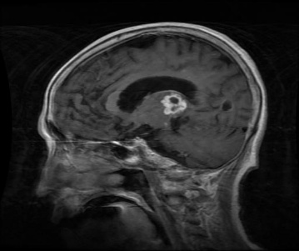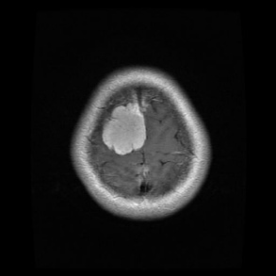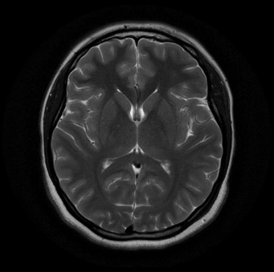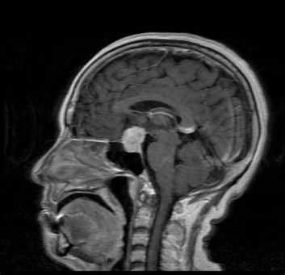
(a) (b) (c) (d)
Comparing the models based on the above standard metrics, it is observed that Xception shows better performance than all other models, ResNet101 and ConvNeXT comes next. But in terms of model size, Xception is only 88 MB whereas ResNet101 and ConvNeXT are 171 MB and 110MB. Though EfficientNetB0’s model size is only 30 MB its performance is very poor and struggles to get trained in both larger and smaller datasets. Inception model size is 92 MB but fares very poorly in all aspects compared to Xception.
The increase in number of parameters does not ensure improved accuracy and other metrics values. This clearly shows that model architecture and its learning mechanism is more significant than increased number of layers and number of parameters. Xception used depthwise and pointwise convolution which not only reduces the model size but improved prediction performance also. Decoupling spatial and channel correlations in Xception also proves that its representational efficiency is higher than convolution based ResNet and ConvNeXT models. The simpler block architecture of Xception makes it to learn quickly during backpropagation phase. In both the Datasets of varying size, Xception have shown better performance than other standard convolution-based CNN models.

Table 1. Accuracy of the models

Models | Dataset I |  | Dataset II
Models | Training | Testing | Training | Testing
EfficientNetB0 | 0.4515 | 0.5811 | 0.2473 | 0.3426
ConvNeXT | 0.7693 | 0.6398 | 0.5258 | 0.4744
ResNet101 | 0.7542 | 0.7055 | 0.4055 | 0.4615
Inception | 0.5414 | 0.5381 | 0.2863 | 0.2949
Finetuned Xception (Proposed) | 0.9728 | 0.9018 | 0.9958 | 0.7179

Table 2. Precision of the models

Models | Dataset I |  | Dataset II
Models | Training | Testing | Training | Testing
EfficientNetB0 | 0.6927 | 0.8214 | 0.2187 | 0.1817
ConvNeXT | 0.9477 | 0.9028 | 0.7197 | 0.6500
ResNet101 | 0.7983 | 0.7443 | 0.6298 | 0.7857
Inception | 0.8974 | 0.735 | 0.2031 | 0.2017
Finetuned Xception (Proposed) | 0.9738 | 0.9086 | 0.9958 | 0.7105

Table 3. Recall of the models

Models | Dataset I |  | Dataset II
Models | Training | Testing | Training | Testing
EfficientNetB0 | 0.1804 | 0.0657 | 0.0349 | 0.0233
ConvNeXT | 0.6712 | 0.5478 | 0.0147 | 0.0124
ResNet101 | 0.6958 | 0.6529 | 0.1903 | 0.141
Inception | 0.2193 | 0.2261 | 0.1719 | 0.1245
Finetuned Xception (Proposed) | 0.9716 | 0.8975 | 0.9782 | 0.6923

Table 4. F1 Score of the models

Models | Dataset I |  | Dataset II
Models | Training | Testing | Training | Testing
EfficientNetB0 | 0.2861 | 0.1217 | 0.0602 | 0.0413
ConvNeXT | 0.7857 | 0.6819 | 0.0288 | 0.0243
ResNet101 | 0.7435 | 0.6956 | 0.2922 | 0.2392
Inception | 0.3524 | 0.3458 | 0.1862 | 0.1540
Finetuned Xception (Proposed) | 0.9727 | 0.903 | 0.9869 | 0.7013
Figure 1 and 2 depicts the graphical representation of the models taken for comparison. The graph depicts value of testing data set results. Figure 1 corresponds to larger dataset and Figure 2 smaller dataset. Graphical results show the consistent performance of Xception in all the metrics for both the datasets.
From the graphs it is clearly observed that heavyweight models like ResNet101 needs larger dataset for its performance optimization. In this study, it is also noted that lightweight models like EfficientNetB0 also suffers due to small dataset. This lacking is due to lack of representational power of the parameters of the above model. Inception also lacks behind the Xception in capturing the hidden details in the images. But in the case of larger dataset, ResNet101 performance comes next to Xception architecture.
Figure 2. Dataset – 1 – Testing Performance
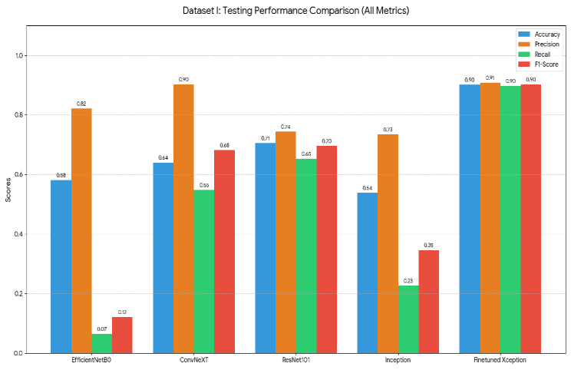
Figure 3. Dataset – 2 – Testing Performance
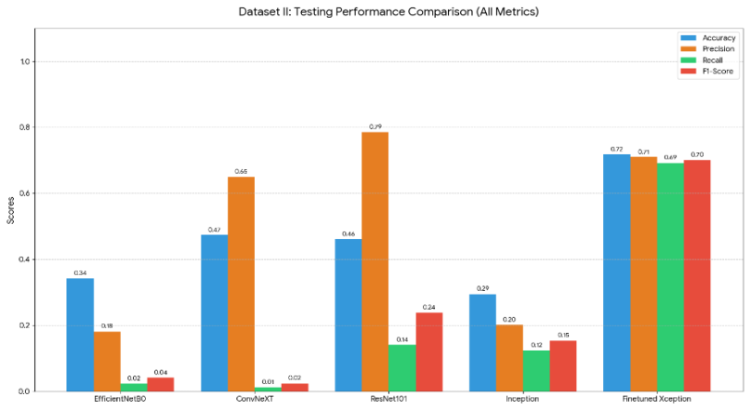

CONCLUSION

This research presented the study of Brain tumor classification using deep learning techniques. The focus is on identifying the better deep learning architecture model in the existing state of art models. EfficientNetB0, ConvNeXT, ResNet101, Inception and Xception models were taken for comparative study. The models were trained and tested on two different brain tumor datasets of varying size. In both the experiments, Finetuned Xception model have shown better results than all other models. The power of representational efficiency of Xception were proved in brain tumor classification problem also. In certain cases, Xception was ahead of 50% more powerful than other models taken for comparison. In future studies, the focus will be on further reducing the size of Xception model without comprising on quality attributes.

ACKNOWLEDGEMENT

The authors would like to thank the open-source deep learning tools and the freely available brain MRI datasets that made this study possible. We appreciate the researchers and organizations that made their datasets and technologies accessible for educational purposes.

REFERENCES

Park, Kwang Suk. "Nervous system." In Humans and electricity: Understanding body electricity and applications, pp. 27-51. Cham: Springer International Publishing, 2023.

Havaei, Mohammad, Axel Davy, David Warde-Farley, Antoine Biard, Aaron Courville, Yoshua Bengio, Chris Pal, Pierre-Marc Jodoin, and Hugo Larochelle. "Brain tumor segmentation with deep neural networks." Medical image analysis 35 (2017): 18-31.

Yang, Siwei, Xianhang Li, Jieru Mei, Jieneng Chen, Cihang Xie, and Yuyin Zhou. "3d-transunet for brain metastases segmentation in the brats2023 challenge." In International Challenge on Cross-Modality Domain Adaptation for Medical Image Segmentation, pp. 190-199. Cham: Springer Nature Switzerland, 2023.

Borys, Katarzyna, Yasmin Alyssa Schmitt, Meike Nauta, Christin Seifert, Nicole Krämer, Christoph M. Friedrich, and Felix Nensa. "Explainable AI in medical imaging: An overview for clinical practitioners–Beyond saliency-based XAI approaches." European journal of radiology 162 (2023): 110786.

Xie, Yuting, Fulvio Zaccagna, Leonardo Rundo, Claudia Testa, Raffaele Agati, Raffaele Lodi, David Neil Manners, and Caterina Tonon. "Convolutional neural network techniques for brain tumor classification (from 2015 to 2022): Review, challenges, and future perspectives." Diagnostics 12, no. 8 (2022): 1850.

Chollet, François. "Xception: Deep learning with depthwise separable convolutions." In Proceedings of the IEEE conference on computer vision and pattern recognition, pp. 1251-1258. 2017.

Chauhan, Pratikkumar, Munindra Lunagaria, Deepak Kumar Verma, Krunal Vaghela, Ghanshyam G. Tejani, Sunil Kumar Sharma, and Ahmad Raza Khan. "Pbvit: A patch-based vision transformer for enhanced brain tumor detection." IEEE Access 13 (2024): 13015-13029.

Shah, Hasnain Ali, Faisal Saeed, Sangseok Yun, Jun-Hyun Park, Anand Paul, and Jae-Mo Kang. "A robust approach for brain tumor detection in magnetic resonance images using finetuned efficientnet." IEEE access 10 (2022): 65426-65438.

Asif, Rizwana Naz, Muhammad Tahir Naseem, Munir Ahmad, Tehseen Mazhar, Muhammad Adnan Khan, Muhammad Amir Khan, Amal Al-Rasheed, and Habib Hamam. "Brain tumor detection empowered with ensemble deep learning approaches from MRI scan images." Scientific reports 15, no. 1 (2025): 15002.

Babu Vimala, Baiju, Saravanan Srinivasan, Sandeep Kumar Mathivanan, Mahalakshmi, Prabhu Jayagopal, and Gemmachis Teshite Dalu. "Detection and classification of brain tumor using hybrid deep learning models." Scientific reports 13, no. 1 (2023): 23029.

Kumar, Komuravelly Sudheer, Bhoomika Bhoomika, and Goldy Verma. "Brain Tumor Detection Using CNN: A Deep Learning Approach for MRI Classification." In 2025 6th International Conference for Emerging Technology (INCET), pp. 1-4. IEEE, 2025.

Hu, Hanming, Xin Li, Wenyi Yao, and Zhuocheng Yao. "Brain tumor diagnose applying CNN through MRI." In 2021 2nd International Conference on Artificial Intelligence and Computer Engineering (ICAICE), pp. 430-434. IEEE, 2021.

Paul, Sonia, Brijesh Kumar Soni, and B. Baranidharan. "Brain tumour detection using deep learning techniques." In 2024 2nd International Conference on Advancement in Computation & Computer Technologies (InCACCT), pp. 722-727. IEEE, 2024.

Tan, Mingxing, and Quoc Le. "Efficientnet: Rethinking model scaling for convolutional neural networks." In International conference on machine learning, pp. 6105-6114. PMLR, 2019.

Liu, Zhuang, Hanzi Mao, Chao-Yuan Wu, Christoph Feichtenhofer, Trevor Darrell, and Saining Xie. "A convnet for the 2020s." In Proceedings of the IEEE/CVF conference on computer vision and pattern recognition, pp. 11976-11986. 2022.

Zhang, Qi. "A novel ResNet101 model based on dense dilated convolution for image classification." SN Applied Sciences 4, no. 1 (2022): 9.

Szegedy, Christian, Wei Liu, Yangqing Jia, Pierre Sermanet, Scott Reed, Dragomir Anguelov, Dumitru Erhan, Vincent Vanhoucke, and Andrew Rabinovich. "Going deeper with convolutions." In Proceedings of the IEEE conference on computer vision and pattern recognition, pp. 1-9. 2015.

https://www.kaggle.com/datasets/tombackert/brain-tumor-mri-data

https://www.kaggle.com/datasets/ishans24/brain-tumor-dataset

