The Impact of Digital Infrastructure on Psychological Service Delivery in Zimbabwe: A Cross-Sectional Survey of Professional Psychologists

Abstract
This study investigated the impact of digital infrastructure on psychological service delivery in Zimbabwe, examining digital tool usage, the relationship between internet access and client reach, and barriers to technology adoption among professional psychologists. A quantitative cross-sectional survey was conducted with 130 members of the Zimbabwe Psychological Association (67.4% response rate). Results revealed that while 73.8% of psychologists reported stable internet access, only 33.9% utilized electronic records or digital assessment tools. WhatsApp (92.3%), Zoom (85.4%), and Google Meet (62.3%) were the most commonly used platforms, with minimal adoption of specialized therapy software (3.8%). Pearson correlation analysis revealed no statistically significant relationship between internet access and number of clients served (r = .103, p = .242). The primary barriers to digital adoption included cost of data (60.8%), confidentiality and privacy concerns (59.2%), and unstable internet connectivity (53.1%). These findings suggest that while basic digital infrastructure exists among Zimbabwean psychologists, significant challenges remain in the transition process to specialized digital mental health platforms. Recommendations include developing affordable, locally-designed software solutions and providing targeted training on digital tools for mental health practitioners.
Keywords: digital infrastructure, telepsychology, mental health services, Zimbabwe, technology adoption, e-mental health

Introduction

The global landscape of psychological service delivery has undergone profound transformation in recent years, with digital technologies increasingly becoming an integral part of mental health practice. The COVID-19 pandemic accelerated this digital transition, compelling mental health professionals worldwide to adopt telehealth platforms and digital assessment tools. However, the extent and nature of this digital transformation vary considerably across different geographical and economic contexts, with low- and middle-income countries facing unique challenges and opportunities.
Digital infrastructure, defined as the physical, virtual, and communication components that enable the existence, operation, and delivery of services and information exchange, encompasses telecommunications networks, servers, software applications, databases, and security frameworks. This infrastructure forms the foundation upon which digital mental health services are built and delivered. As emerging technologies such as artificial intelligence (AI) and the Internet of Things (IoT) continue to evolve, understanding the current state of digital infrastructure utilization among mental health professionals becomes increasingly important.
Zimbabwe presents a particularly compelling context for examining these issues. As a developing nation with significant mental health needs and a limited number of trained psychologists, the potential for digital technologies to extend the reach of psychological services is substantial. However, infrastructural limitations, economic constraints, and digital literacy challenges may impede the adoption and effective utilization of digital tools in mental health practice.
The present study aimed to provide empirical evidence regarding the current state of digital infrastructure utilization among psychologists in Zimbabwe. Three specific objectives guided this research: (1) to determine the extent of digital tool use by psychologists in Zimbabwe; (2) to assess the relationship between digital infrastructure access and service reach; and (3) to identify the challenges faced by psychologists in adopting digital tools. The null hypothesis posited that there is no significant relationship between internet access and the number of clients served by psychologists.

Method

Participants and Sampling
The study targeted the broader group of psychologists registered with the Allied Health Practitioners Council of Zimbabwe (AHPCZ). However, the researcher found it easier to reach out to members of the Zimbabwe Psychological Association (ZPA), which was a significantly large subset of an estimated 430 psychologists registered with AHPCZ. A sampling frame with a total of 193 names and contact telephone numbers of different categories of psychologists on the ZPA register was drawn up with an aim of carrying out a census study of the association.
The required sample size of 129 was calculated using an online sample size calculator at a 95% confidence level. A total of 130 responses were received, yielding a response rate of 67.4%, which was considered acceptable for survey research of this nature.

Demographic Characteristics
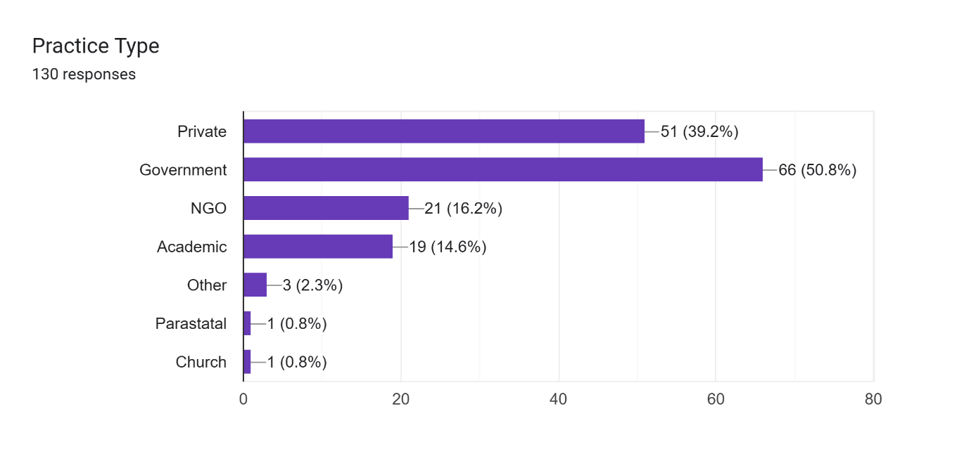
Figure 1: Type of Practice

The sample exhibited diverse demographic characteristics representative of the Zimbabwean psychology profession. Regarding practice type, the majority of respondents were employed in government settings (50.8%, n = 66), followed by private practice (39.2%, n = 51), non-governmental organizations (16.2%, n = 21), and academic institutions (14.6%, n = 19).

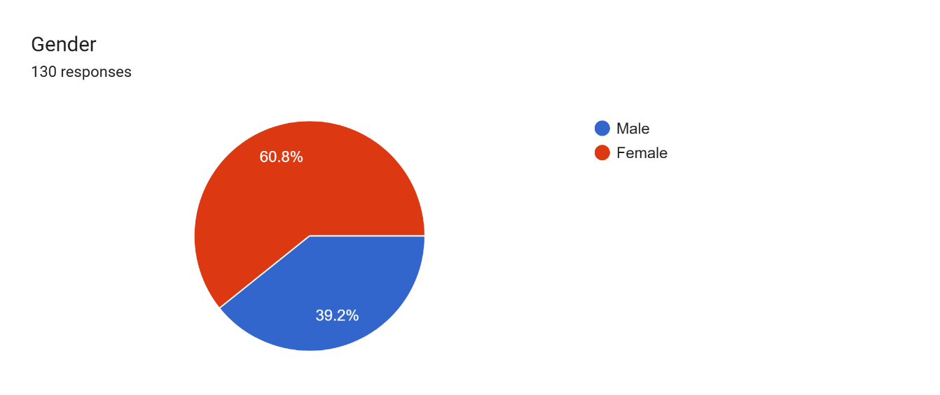
Figure 2: Responses by Gender

The gender distribution indicated a predominantly female sample (60.8%) compared to males (39.2%). Age distribution was relatively balanced across categories: 20-30 years (29.2%), 31-40 years (30.0%), 41-50 years (29.2%), and 50+ years (11.5%). Experience levels varied considerably, with the largest proportion having 1-5 years of experience (49.2%), followed by 6-10 years (17.7%), less than one year (18.5%), 11-20 years (11.5%), and 21+ years (3.1%).

Measures and Procedure
Data were collected through a structured online questionnaire designed to assess digital tool usage, internet access, platform preferences, device ownership, training in digital tools, perceptions of digital service delivery, and barriers to technology adoption. Perception items were measured using a 5-point Likert scale (1 = Strongly Disagree to 5 = Strongly Agree). The questionnaire was distributed electronically to ZPA members, and participation was voluntary and anonymous.

Data Analysis
Descriptive statistics were computed to characterize digital tool usage patterns and demographic variables. Pearson product-moment correlation was conducted to examine the relationship between internet access and the number of clients served per month. Statistical significance was set at p < .05. Data visualization included bar charts and pie charts to illustrate key findings.

Results

Digital Infrastructure Access and Device Ownership

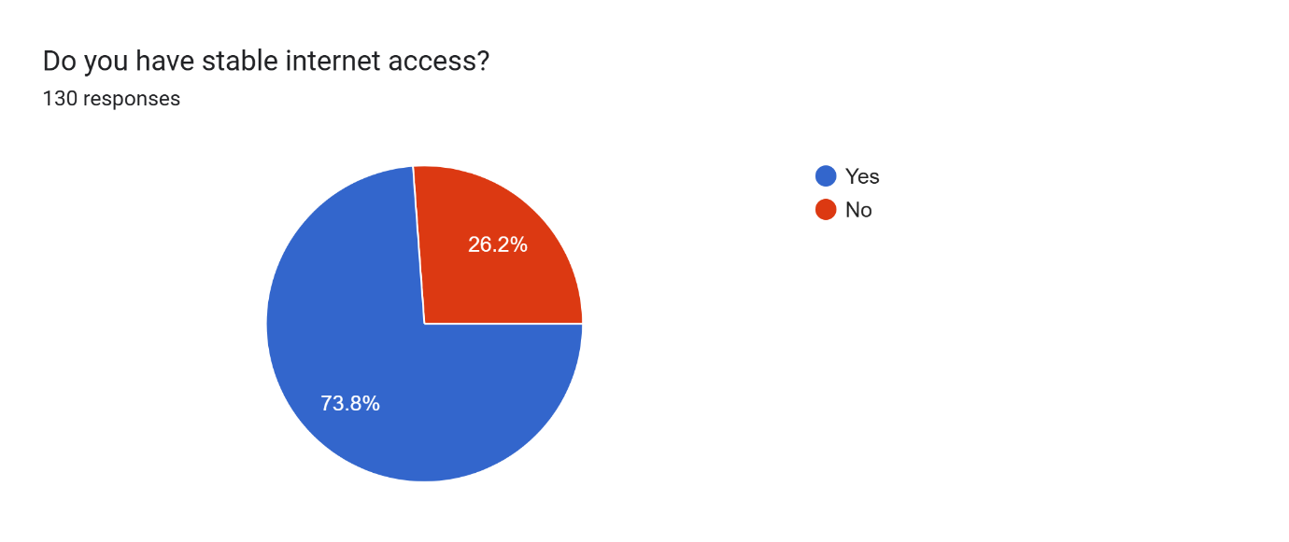
Figure 3: Access to Stable Internet

The majority of respondents (73.8%, n = 96) reported having stable internet access, while 26.2% (n = 34) indicated unstable or no internet connectivity.

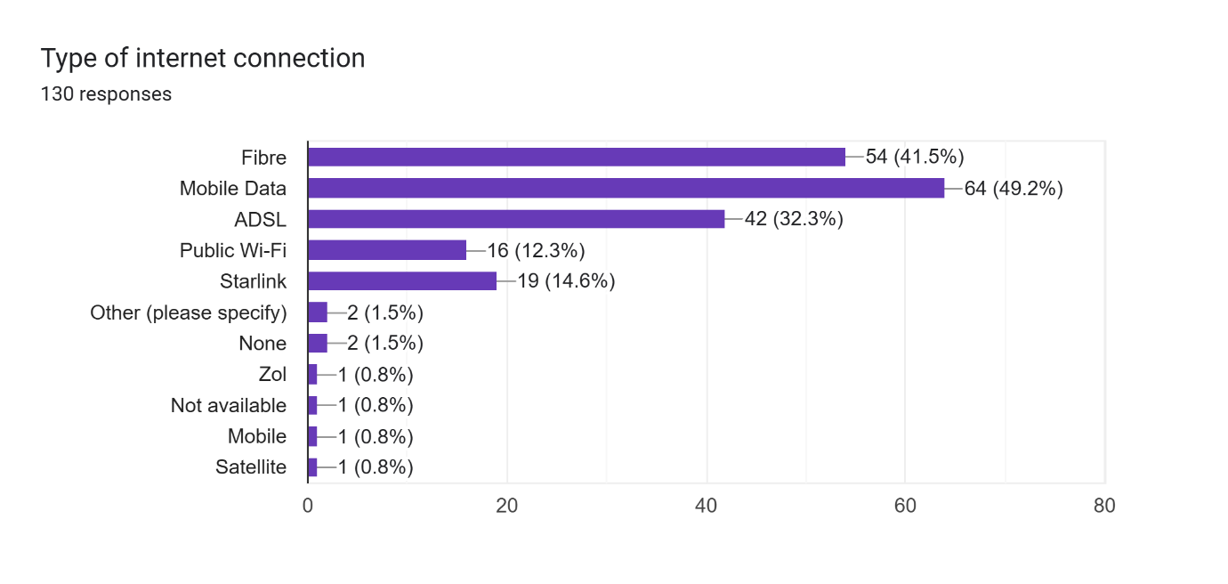
Figure 4: Type of Internet Connection

Regarding connection types, mobile data was most prevalent (49.2%, n = 64), followed by fibre optic cable connections (41.5%, n = 54), ADSL (32.3%, n = 42), Starlink (14.6%, n = 19), and public Wi-Fi (12.3%, n = 16).
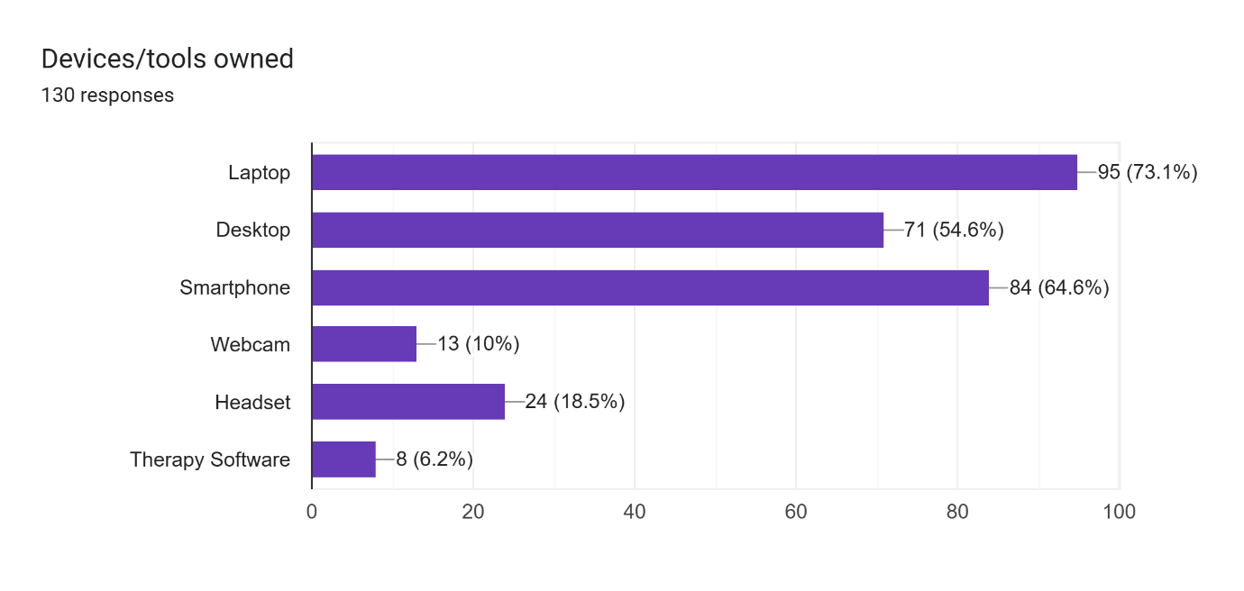
Figure 5: Devices and/or Tools Owned
Device ownership analysis revealed that laptops were most common (73.1%, n = 95), followed by smartphones (64.6%, n = 84), desktops (54.6%, n = 71), headsets (18.5%, n = 24), webcams (10.0%, n = 13), and specialized therapy software (6.2%, n = 8).

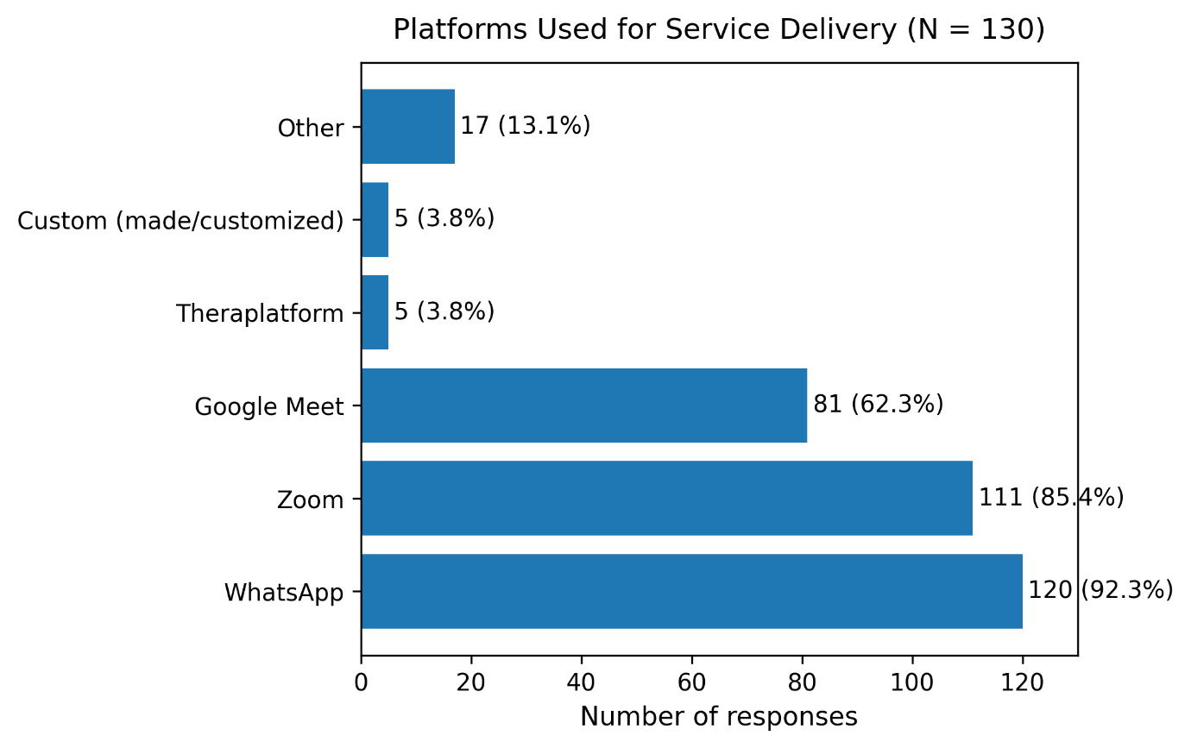
Figure 6: Digital Platforms Used

Analysis of platform preferences revealed a strong reliance on general communication tools rather than specialized mental health platforms. WhatsApp emerged as the most widely used platform (92.3%, n = 120), followed by Zoom (85.4%, n = 111), and Google Meet (62.3%, n = 81). Notably, the adoption of specialized therapy platforms was minimal: only 3.8% (n = 5) reported using Theraplatform, and 3.8% in total used any form of customized software platforms. Regarding electronic records and digital assessments, only 33.8% (n = 44) of respondents reported using such systems, while the majority (66.2%, n = 86) did not utilize electronic record-keeping or digital assessment tools.

Training and Confidence in Digital Tools
A substantial majority of respondents (69.2%, n = 90) reported having received training in digital tools, while 30.8% (n = 40) had not received any formal training. When asked about confidence in using digital platforms, responses were mixed: 34.6% were neutral, 22.3% agreed they were confident, 20.8% strongly agreed, while 20.0% disagreed and 2.3% strongly disagreed with having confidence in digital platform use.

Perceptions of Digital Service Delivery
Perceptions regarding the impact of digital tools on service delivery were notably mixed. When asked whether digital tools had improved their service delivery, 44.6% (n = 58) disagreed, 24.6% (n = 32) strongly disagreed, 12.3% (n = 16) were neutral, while only 14.6% (n = 19) strongly agreed and 3.8% (n = 5) agreed. Regarding client comfort with virtual sessions, perceptions were similarly divided: 38.5% (n = 50) disagreed that clients were comfortable, 35.4% (n = 46) strongly disagreed, 11.5% (n = 15) agreed, and 8.5% (n = 11) strongly agreed. However, psychologists held more positive views about the potential of digital platforms to increase client access to care: 42.3% (n = 55) agreed, 23.8% (n = 31) strongly agreed, 26.2% (n = 34) were neutral, while only 6.2% (n = 8) disagreed and 1.5% (n = 2) strongly disagreed.

Relationship Between Internet Access and Client Numbers
A Pearson product-moment correlation was conducted to examine the relationship between internet access (coded as a dichotomous variable: Yes = 1, No = 0) and the number of clients served per month. Results indicated a weak, non-significant positive correlation (r = .103, p = .242, n = 130). Given that the p-value exceeded the conventional significance threshold of .05, the null hypothesis was retained. These findings suggest that internet access alone does not significantly predict the number of clients served by Zimbabwean psychologists.
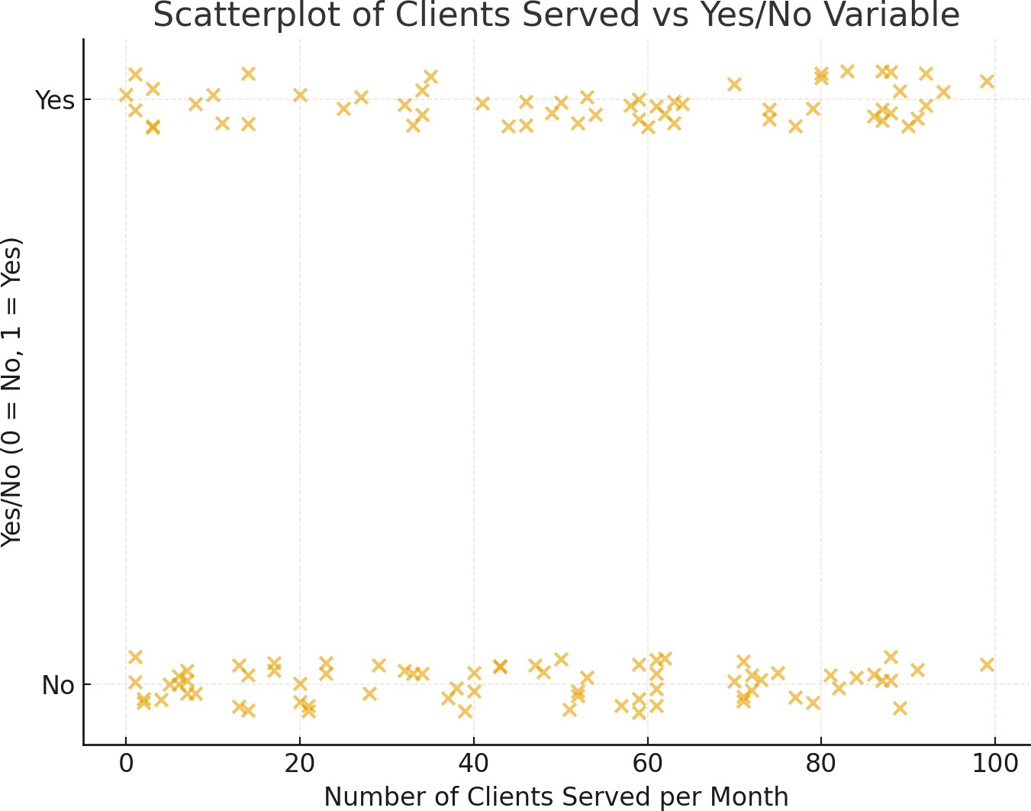

Figure 7: Scatterplot of Access to Internet and Number of Clients Served per Month
Visual representation through scatterplot analysis confirmed the absence of a clear linear trend, and comparison of mean client numbers between the internet access groups revealed minimal differences.

Barriers to Digital Platform Adoption
Participants identified multiple challenges limiting their use of digital platforms. The most frequently cited barrier was the cost of data and devices (60.8%, n = 79), followed by confidentiality and privacy concerns (59.2%, n = 77), unstable internet connectivity (53.1%, n = 69), client discomfort with technology (48.5%, n = 63), and limited digital literacy (47.7%, n = 62). These findings highlight the multifaceted nature of barriers to digital adoption, encompassing economic, technical, ethical, and human factors.

Discussion
This study provides the first comprehensive empirical assessment of digital infrastructure utilization among professional psychologists in Zimbabwe. The findings reveal a complex landscape characterized by relatively high access to basic digital infrastructure yet limited adoption of specialized digital mental health tools.
The predominant use of general communication platforms such as WhatsApp (59.2%), Zoom, and Google Meet, rather than purpose-built therapy software, represents a pragmatic adaptation to available resources. Social media “data bundles” were favoured because of their lower costs compared with therapy software. These platforms offer accessibility and familiarity but may lack essential features for professional mental health practice, including secure client records management, standardized digital assessments, and compliance with healthcare data protection standards. The finding that only 33.8% of psychologists utilize electronic records or digital assessments is particularly concerning from both efficiency and quality-of-care perspectives.
The non-significant relationship between internet access and client numbers challenges simplistic assumptions about digital infrastructure and service reach. This finding suggests that internet access alone is insufficient to expand psychological service delivery. Multiple mediating factors likely influence this relationship, including the nature of psychological services (which may favour in-person delivery), client preferences and technological capabilities, and the absence of integrated digital service delivery models. The result underscores that investing in infrastructure must be accompanied by comprehensive strategies addressing professional training, client readiness, and appropriate technology solutions.
The identified barriers illuminate critical areas requiring intervention. The primacy of cost concerns (60.8%) reflects the broader economic challenges facing Zimbabwe and highlights the need for affordable or subsidized digital solutions for mental health professionals. The prominence of confidentiality and privacy concerns (59.2%) indicates that psychologists are appropriately cognizant of ethical implications but may lack guidance on secure digital practice. These concerns may be exacerbated by the use of general-purpose platforms not designed with mental health confidentiality requirements in mind.
The perception data present an interesting paradox: while psychologists generally believe digital platforms can increase client access to care (66.1% agreed or strongly agreed), they were less convinced that digital tools had improved their own service delivery (only 18.4% agreed or strongly agreed) and perceived clients as uncomfortable with virtual sessions (20.0% agreed or strongly agreed regarding client comfort). This disconnect suggests that psychologists recognize the theoretical potential of digital tools while experiencing practical implementation challenges.

Implications for Practice and Policy
These findings have several important implications. First, there is a clear need for locally-developed, affordable digital solutions tailored to the Zimbabwean context. Such platforms should incorporate electronic health records, digital assessment capabilities, and AI-assisted features while addressing cost and connectivity constraints. Second, targeted training programs are required to enhance psychologists' competence and confidence in utilizing digital tools for clinical practice. Third, the development of clear ethical guidelines and regulatory frameworks for digital mental health practice in Zimbabwe would help address confidentiality concerns and establish standards for secure service delivery.

Limitations and Future Directions
This study has several limitations that should be acknowledged. The cross-sectional design precludes causal inferences regarding the relationships examined. The sample, while representing a substantial proportion of registered Zimbabwean psychologists, may not fully capture perspectives of mental health professionals working outside formal professional association structures. Additionally, self-report measures may be subject to social desirability bias. Also, it is possible that psychologists who are more "tech-savvy" were more likely to respond to the researcher’s electronic questionnaire, therefore introducing an element of self-selection bias.
Future research should employ longitudinal designs to track digital adoption trajectories, include qualitative methods to explore barriers and facilitators in greater depth, and examine client perspectives on digital mental health service delivery.

Conclusion
This study demonstrates that while Zimbabwean psychologists have access to basic digital infrastructure and commonly utilize general communication platforms, the adoption of specialized digital mental health tools remains limited. The lack of a significant relationship between internet access and client numbers underscores the complexity of digital transformation in mental health services, suggesting that infrastructure availability alone does not guarantee expanded service delivery. The identified barriers—cost, privacy concerns, connectivity issues, and digital literacy limitations—require coordinated intervention at multiple levels. Zimbabwean psychologists could balance the extreme accessibility of WhatsApp with the high privacy concerns noted by participants by offering a combination of both WhatsApp and physical sessions for a client.
The future of psychological services in Zimbabwe lies in the thoughtful integration of technology with human expertise. This requires investment in affordable, context-appropriate digital platforms; comprehensive training for mental health professionals; and the development of regulatory frameworks that protect client confidentiality while enabling innovation. The opportunities for local software developers to create home-grown solutions that address the specific needs and constraints of Zimbabwean psychologists represent a promising avenue for enhancing mental health service delivery in the digital era.

References
American Psychological Association. (2013). Guidelines for the practice of telepsychology. American Psychologist, 68(9), 791–800. https://doi.org/10.1037/a0035001
Naslund, J. A., Aschbrenner, K. A., Araya, R., Marsch, L. A., Unützer, J., Patel, V., & Bartels, S. J. (2017). Digital technology for treating and preventing mental disorders in low-income and middle-income countries: A narrative review of the literature. The Lancet Psychiatry, 4(6), 486–500. https://doi.org/10.1016/S2215-0366(17)30096-2
Torous, J., Myrick, K. J., Rauseo-Ricupero, N., & Firth, J. (2020). Digital mental health and COVID-19: Using technology today to accelerate the curve on access and quality tomorrow. JMIR Mental Health, 7(3), e18848. https://doi.org/10.2196/18848
World Health Organization. (2019). WHO guideline: Recommendations on digital interventions for health system strengthening. World Health Organization. https://apps.who.int/iris/handle/10665/311941

Author Note
Austin Gara is an Intern Counselling Psychologist with interdisciplinary expertise in psychology, computer science, and business administration. This research was presented at the Zimbabwe Psychological Association 9th Annual Conference on 13 November 2025. The conference theme was: "Psychological Services in The Digital Era: Challenges, Opportunities, and Future Directions." As an extension of this research, the author has developed a web-based platform www.zimdigipsych.co.zw incorporating electronic health records and AI-assisted features to address the challenges identified in this study.
Correspondence concerning this article should be addressed to Austin Gara. The author declares no conflicts of interest. This study was conducted in accordance with ethical guidelines for research with human participants.

