MALLPATH-INDOOR NAVIGATION SYSTEM

ABSTRACT

Indoor navigation within large shopping malls is often challenging due to complex layouts and lack of proper guidance systems. Visitors frequently struggle to locate stores, restrooms, exits, or other facilities efficiently. Traditional navigation methods such as static maps and signboards are often insufficient and confusing.
This paper proposes MallPath, an intelligent indoor navigation system designed to assist users in navigating malls and accurately. The system utilizes digital mall maps, real-time location tracking, and pathfinding algorithms to guide users to their desired destinations.
The proposed system provides floor-wise navigation, shop categorization, and shortest path suggestions. It enhances user experience by reducing time, improving accessibility, and offering an interactive interface. The solution is scalable and can be implemented in modern smart malls.

KEYWORDS

Indoor Navigation, Smart Mall, Pathfinding, User Interface, Location Tracking, Digital Mapping.

I. INTRODUCTION

Navigation inside large shopping malls can be confusing due to multiple floors, numerous stores, and complex layouts. Visitors often rely on signboards or security assistance, which is time-consuming and inefficient.
Traditional methods such as static maps and help desks do not provide clear and quick directions. Many users find it difficult to identify their current location and reach their destination easily, especially during busy hours.
With the advancement of digital technologies, indoor navigation systems have become essential. Unlike outdoor navigation (GPS-based), indoor environments require specialized systems due to signal limitations. Therefore, smart solutions using digital maps and algorithms are needed.
This paper introduces MallPath, a smart indoor navigation system that helps users:
- Locate shops easily
- Navigate floor-wise layouts
- Find shortest paths
- Search shops by category
- Save time and reduce confusion
- Improve overall shopping experience
The system provides an interactive and user-friendly interface that guides users step-by-step inside the mall. It can be used by both customers and mall management for better navigation support.
The system ensures efficient navigation through structured data, clear directions, and easy accessibility, making mall visits more convenient and organized..

II. LITERATURE REVIEW

Indoor navigation systems have gained significant importance due to the increasing size and complexity of modern shopping malls. Various technologies and approaches have been developed to improve indoor navigation and user experience.
Several systems use technologies such as:
- Bluetooth beacons
- Wi-Fi positioning
- QR code-based navigation
- RFID systems
- Augmented Reality (AR)
Bluetooth beacon-based systems provide location tracking by detecting nearby devices, but they require additional hardware installation and maintenance. Wi-Fi-based systems are widely used, but they often suffer from low accuracy and signal interference inside buildings.
QR code-based navigation systems are simple and cost-effective, where users scan codes placed at different locations to get directions. However, they require user interaction at multiple points, which may not be convenient.
Augmented Reality (AR) systems provide advanced navigation by overlaying directions on real-world views, but they are complex and require high processing power and modern devices.
Most existing systems use digital maps combined with pathfinding algorithms such as:
- Dijkstra’s Algorithm
- A* (A-Star) Algorithm
These algorithms help in finding the shortest path between two locations efficiently.
However, existing systems have several limitations such as:
- High implementation cost
- Dependence on additional hardware
- Inaccurate indoor positioning
- Complex user interfaces
- Lack of real-time updates
The proposed MallPath system focuses on a simple and efficient map-based navigation approach. It uses structured mall data and pathfinding algorithms to provide accurate directions without requiring expensive hardware.

III. SYSTEM SPECIFICATIONS

A.Software Requirements
The system is developed using modern technologies to ensure scalability and performance:

- Operating System: Windows / Android / iOS
- Frontend: HTML, CSS, JavaScript
- Backend: Python / Node.js
- Database: MongoDB / Firebas
B. Software Description
The system uses web technologies for interface design and backend processing. The database stores mall details such as:
- Shop names
- Floor information
- Categories
The system processes user input and generates navigation paths dynamically.

IV. SYSTEM ANALYSIS

- Existing System
Current systems include:
- Static mall maps
- Information kiosks
- Manual guidance
Limitations:
- Not interactive
- Time-consuming
- Difficult to understand
- Proposed System
MallPath provides:
- Digital interactive maps
- Floor-wise navigation
- Shortest path calculation
- Shop search functionality
C. Feasibility Study
1. Technical Feasibility
Uses simple web technologies and algorithms.
2. Economic Feasibility
Low cost compared to beacon-based systems.
3. Operational Feasibility
Easy to use for all users.

V. SYSTEM DESIGN
A. Architecture
The system consists of the following modules:

- User Interface Module
- Admin Module
- Navigation Module
- Database Module
- Map Management Module
- Pathfinding Module
- Search Module

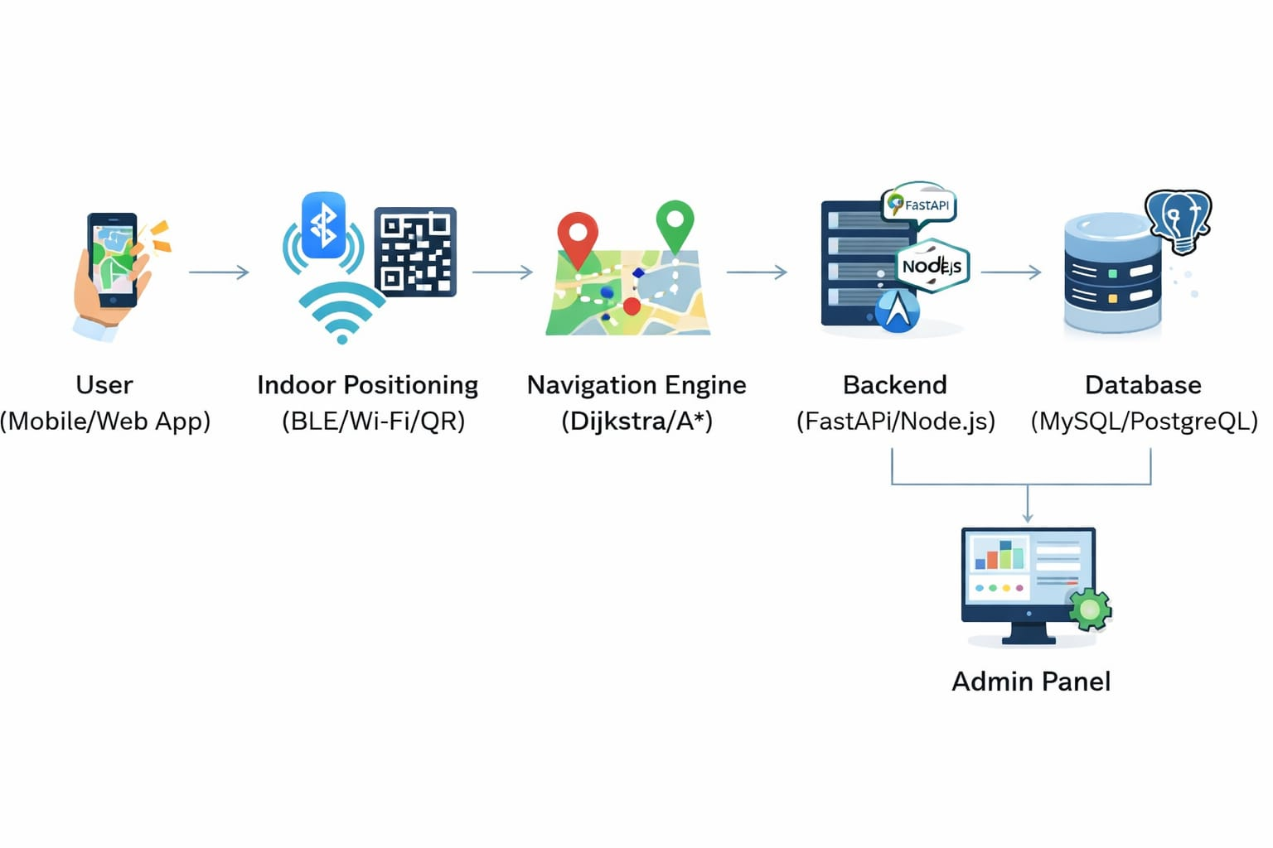
5.1 Architecture

- Process Flow Architecture
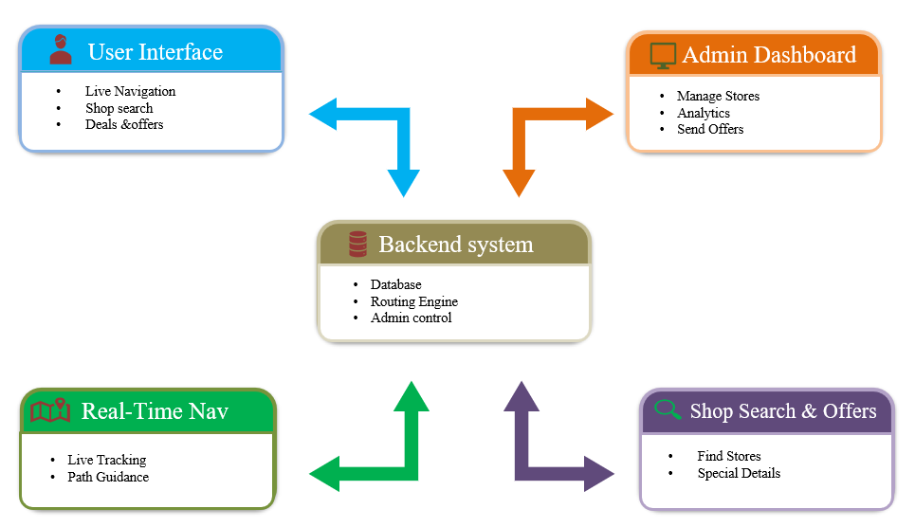
5.2 Process Flow Architecture

C. Input Design
Inputs include:
- Mall selection
- Shop name
- Category
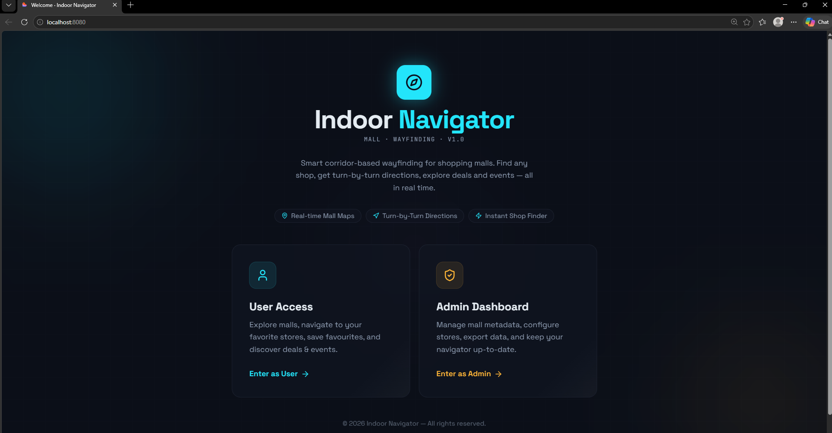
5.3 Input Design
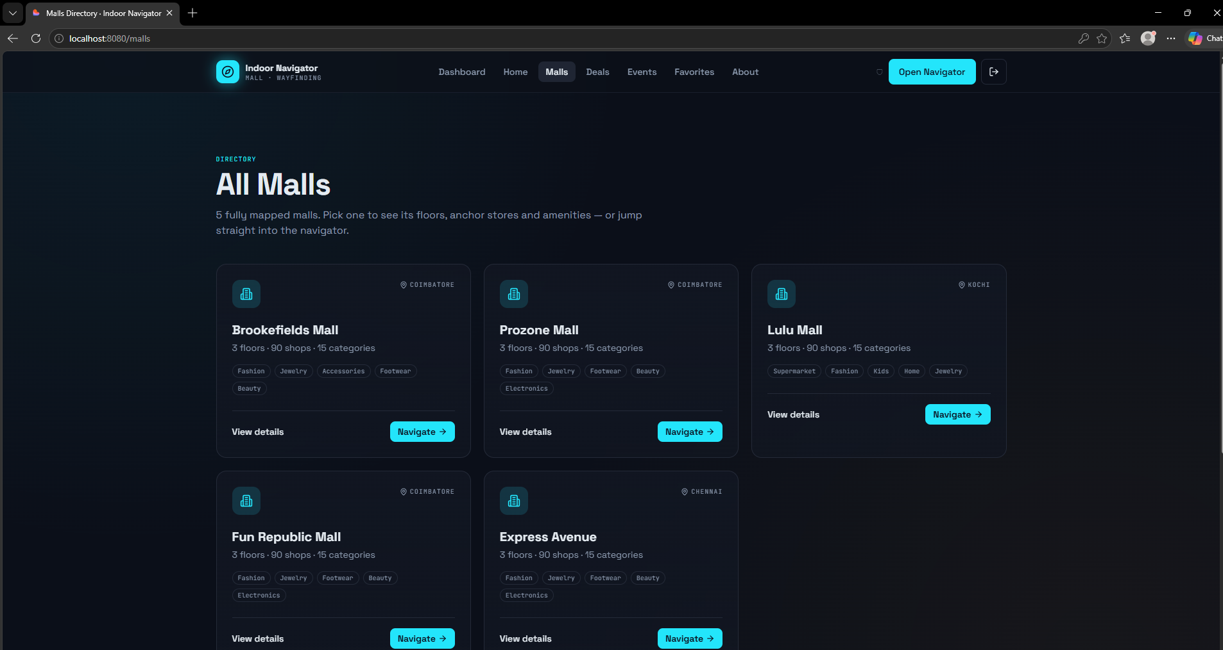
5.4 Input Design

D. Output Design
Outputs include:
- Navigation path
- Floor details
- Shop location
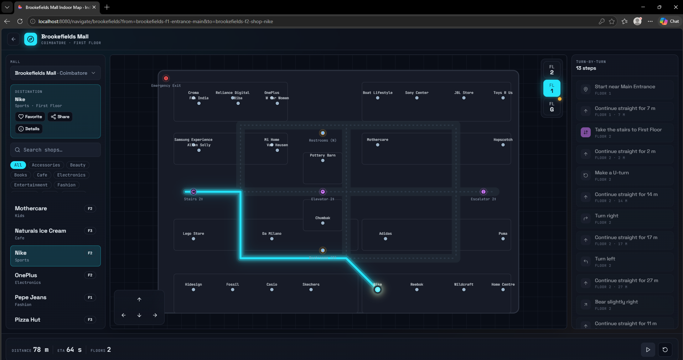
5.5 Output Design

VI. METHODOLOGY
The system follows a structured methodology
A. Data Collection
Mall data including shops and layouts are collected.
B. Preprocessing
Data is organized floor-wise.
C. Pathfinding Algorithm
Shortest path is calculated using algorithms like:
- Dijkstra
- A*
D. Navigation Display
Path is visually shown to the user

VII. IMPLEMENTATION AND TESTING

A. Implementation
- Frontend for user interface
- Backend for processing navigation
B. Testing
- Unit Testing
- Integration Testing
- User Testing

VIII. RESULTS AND DISCUSSION

The system successfully provides:
- Accurate navigation
- Faster shop location
- Improved user experience
It reduces confusion and saves time for users.
IX. FUTURE ENHANCEMENTS
- Real-time indoor tracking
- Voice navigation
- AR-based guidance
- Multi-language support
X. CONCLUSION
MallPath is an efficient indoor navigation system that simplifies mall navigation. It provides a user-friendly interface, accurate directions, and improves overall shopping experience. The system is scalable and can be implemented in smart malls.
ACKNOWLEDGMENT
We sincerely thank our project guide Mrs. S. Haripriya, M.E., (Ph.D) for her valuable guidance and support throughout the development of this project. Her mentorship played a vital role in the successful completion of this work.
REFERENCES
[1] Z. Ayaz, “Digital Advertising Using BLE Beacons,” IEEE, 2025.
[2] L. Bouska et al., “Indoor Localization Using BLE and RSSI,” IEEE, 2024.
[3] M. C. Sakman et al., “Indoor Navigation for Personalized Shopping,” ScienceDirect, 2023.
[4] A. Saeidi et al., “AR-Based Indoor Navigation in Shopping Malls,” IEEE, 2022.
[5] N. Narayana et al., “Smart Indoor Navigation Using BLE,” IEEE, 2021.
[6] P. Pešlácio et al., “BLE Indoor Positioning Using Neural Networks,” IEEE, 2021.

