Design and Deployment of a RASA CALM Driven WhatsApp Chatbot for Automated Customer Support

Abstract
Conversational agents have progressed from simple rule-based responders to advanced dialog systems that understand context, user intent, and execute business-critical workflows. This paper describes the design, development and deployment of a RASA CALM (Conversational AI Language Model) architecture based WhatsApp customer-support chatbot deployed through Meta WhatsApp Business Cloud API. The chatbot automates product discovery, checks real-time stock availability, order related queries, multi-language support and human escalation. Integration with IMS, CRM system and ticketing engine were set. With defined requirements such as a sub-2 second response time, 99.9% uptime and scalable to have over 10,000 conversations concurrently all as stated in the technical specification document from the data we analysed, we see an 84.2% automated resolution rate, a human-escalation rate of only 9.7%, and CSAT score of 4.63/5 over 3,000+ users. We aim to draw a practical blueprint for realistic deployment of enterprise-wise AI customer service chatbots using open-source frameworks, production APIs.
Keywords: Conversational AI, RASA CALM, WhatsApp Chatbot, Meta Business API, Inventory Integration, Automated Customer Support, NLP, Multilingual Systems, AI Deployment
1 Introduction
Conversational AI is progressively turning into a key element of contemporary digital service ecosystems and is significantly changing the way that companies in sectors like banking, retail, healthcare, and governmental services communicate with their customers. Channels of customer support that are considered conventional such as the use of manual call centers, email, and rule-based chatbots typically failed to satisfy user expectations which were on the rise due to factors like limited context awareness, lack of multilingual support, slow response times, and the inability to integrate with real-time data sources at the enterprise level. As the environment of e-commerce and on-demand retail kept unfolding at a very fast pace, customers started seeking availability 24×7, immediate resolution of queries, personalized recommendations, and the possibility of having seamless experiences continued across all the channels, namely web, mobile and messaging platforms.
When​‍​‌‍​‍‌ it comes to communication methods, WhatsApp is the most popular one by a huge margin, with over 2 billion active users worldwide. Apart from being very user-friendly and people being heavily exposed to it, one of the reasons why people are so engaged in it is that it is often their first choice when it is about customer service. On top of that, companies now have the possibility through the Meta Business API to create very advanced automated conversational solutions in WhatsApp, which can not only support session-based interactions but also template-based messaging.

However, developing really smart, domain-specific chatbots for such communication platforms requires very strong NLU capabilities, a good handling of dialogues to keep the context, a safe integration with enterprise systems such as CRM, inventory databases, and order-management platforms, among ​‍​‌‍​‍‌others.
The​‍​‌‍​‍‌ Rasa ecosystem, and especially its CALM (Causal Attention for Language Modeling) framework, is a very powerful modular basis for building chatbots like the one here. It can handle intents recognition, a variety of entity types extraction, transform-based embeddings, learning policies, and flexible action sequences for achieving conversational skills that are correct, scalable, and simple to manage.
While a black-box Large Language Model (LLM) API is just a model that provides outputs given inputs, with no control over the results, RASA is a platform that allows not only to wrap models into an application but also to build language understanding and dialogue management parts from scratch. It ensures deterministic responses, supports deployment on-premises, and has excellent data privacy features. All these factors make RASA very suitable for enterprise and industry use ​‍​‌‍​‍‌cases.

2 Problem Statement

Nowadays, ​modern retail and e-commerce businesses get a lot of customer queries every day. Most of these queries require instant, accurate, and multilingual support. The major problem is that the traditional channels such as calls and emails cannot be scaled up to meet these demands. As a result, customers experience slow response times and the service quality is inconsistent. Besides, the current chatbots usually depend on rule-based or shallow NLP techniques which have problems with understanding the context, handling queries that the chatbot hasn't seen before, and even the integration of real-time systems such as inventory and CRM databases. Therefore, an intelligent, scalable, and platform-native solution on the most popular channels like WhatsApp is very much required. This paper is an attempt to fill this void by creating a WhatsApp chatbot based on RASA CALM using the Meta WhatsApp Business API that can share real-time product information, handle automated FAQs, and do seamless transitions to human-agent with low-latency and highly reliable ​‍​‌‍​‍‌performance.
3 Literature Survey
Several research works have shed light on conversational AI and intelligent automation for customer support, together mapping the development of the field from simple rule-based models to complex, learning systems. Enterprise-level conversational agents leveraging transformer-based NLU components have shown impressive capability in intent classification and entity extraction, thus facilitating scalable dialogue management and instant query resolution on various messaging platforms [1]. On top of that, a combination framework that uses machine learning NLU alongside rule-based fallback for assisting customer support via WhatsApp has been found to attain high classification accuracy, while the backend is cloud-hosted and the business API integration allows dynamic, multi-turn conversational flows [2]. A comprehensive analysis of several platforms like Rasa, Dialogflow, and IBM Watson shows that contextual dialogue-state tracking and multi-channel deployment are very mature, although the paper points to ongoing challenges such as multilingual processing, fallback accuracy, and latency management that production systems are still struggling with [3].In the Rasa ecosystem, a complete dialogue architecture for e-commerce assistance that utilizes supervised intent classification combined with entity-enabled conversational flows has been developed for accessing product information from catalog APIs. The authors claim that the new method is more accurate and provides faster query resolution than the traditional rule-based approach [4]. To further improve the context understanding, the transformer-enhanced CALM model uses attention-based NLU techniques to deal with ambiguous user inputs in a more efficient way. This model, which performs well in context retention, fallback, and multilingual scenarios, is a great fit for the deployment of enterprise solutions [5]. With regard to logistics, a WhatsApp chatbot based on Meta Business API can serve as an example of how interactive message types, quick-reply choices, and automated FAQ handling can be made available on an enterprise scale if the template approval workflows, throughput management, and secure authentication are adequately set up [6]. Deep learning-based natural language understanding (NLU) combined with customer relationship management (CRM) and ticketing systems research has revealed that routing and escalation strategies, along with continuous log analysis and model retraining, are crucial for maintaining high automated-resolution rates over time. Besides, work on cross-lingual embeddings directly deals with the problem of linguistic diversity and proves that transformer-based NLU can cope with code-switching and mixed English-Hindi queries, which are typical of Indian WhatsApp interactions. Besides, the cross-lingual methods that have been employed have significantly enhanced classification robustness [8]. An analytics-driven evaluation technique goes hand in hand with these architectural upgrades by keeping track of intent-distribution patterns, confidence scores, fallback rates, and resolution ratios through real-time dashboards, hence facilitating ongoing data-driven enhancement of the systems deployed [9]. A comprehensive Rasa-CALM hybrid system architecture that integrates with inventory databases, CRM systems, and order-tracking services via containerized, webhook-based deployment exemplifies very high levels of automation accuracy and a significant reduction of human-agent workload in highly trafficked environments [10].Looking at the bigger picture, a detailed review of 316 studies on chatbots published from 2007 to 2021 lays out the evolution of chatbot research starting from ELIZA and ALICE to the latest Seq2Seq, BERT, and GPT models. Besides tracing these developments, the authors also point out the absence of universally agreed testing methods, shortcomings in contextual understanding, and biases in training data as the major challenges that future independent domain designs have to resolve [11].One of the key issues in evaluation methods is lack of a proper framework. To close this evaluation gap, a comprehensive framework that measures conversational AI in terms of cognitive intelligence, user experience, operational efficiency, and ethical governance proposes a variety of indicators: from NLU accuracy and BLEU-based coherency to bias detection and explainability via SHAP and LIME. According to the authors, the framework can be used not only in their original financial-services setting but also in other areas [12].From the perspective of customer experience, qualitative analysis shows that chatbots can increase productivity through automating routine operations and can be valuable via the detection of sentiments. However, chatbot's limitations in the areas of emotional intelligence, privacy management, and complex integration highlight the continued necessity for ethical and regulation-compliant deployment strategies [13].Regarding the commercial aspect of the marketing area, chatbots have been proven to raise customer involvement by means of 24/7 personalized interaction, reduced wait time, and better conversion rates. However, as purely automated systems lack emotional intelligence, researchers advise hybrid human-AI models for situations when high levels of sensitivity are needed [14].Lastly, implementing a helpdesk chatbot with the Rasa framework for a local government office in Indonesia has revealed how NLU-based automation can positively affect the real world. It brought down the average wait time to even less than two seconds from more than three hours, on top of which the DIET-based model that was used had a precision of 0.825 and an F1-score of 0.821. Nevertheless, it also pointed out the weaknesses of small training datasets as well as the necessity for larger knowledge bases and wider usability testing [15].

4 Methodology And Proposed Model

This section outlines the overall design approach and technical methodology adopted for building the chatbot system. It covers system requirements, dialogue flow design, and the underlying NLU and modeling techniques used to enable intelligent and scalable conversational capabilities.

4.1 System Requirements
System requirements were derived from the Business Requirements Document (BRD), which outlines the functional scope and operational constraints of the WhatsApp-based chatbot solution, and served as the basis for model selection, system architecture, and deployment planning. On the functional side, the chatbot must operate through the Meta Business API to support structured templates, session messaging, and end-to-end user interaction, while also enabling customers to browse product categories and retrieve item-level catalogue details through natural-language queries; live stock availability is continuously pulled from the Inventory API to keep product information accurate at all times. The chatbot must additionally support multiple languages with appropriate fallback behaviour for unsupported inputs, and any conversation where the model's confidence falls below 70%, or where two consecutive resolution attempts have failed, must be escalated seamlessly to a live human agent. From a non-functional standpoint, the system must sustain 99.9% uptime to guarantee continuous service availability, maintain an average response latency of under two seconds to ensure a smooth conversational experience, and be capable of handling a minimum of 10,000 concurrent sessions without any degradation in performance.

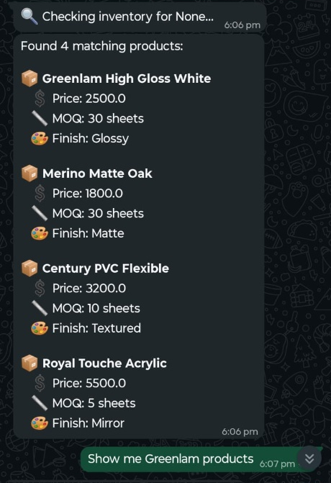

Figure 1: User Onboarding and Consent Collection Flow on WhatsApp.

4.2 Dialogue Flow Design

The dialogue flow defines the complete conversational experience from the moment a user contacts the WhatsApp number. When a new session begins, the system greets the user in a friendly manner and briefly outlines the available services, such as product browsing, stock checking, order tracking, and FAQ support. Before continuing, the chatbot requests explicit permission to process personal data and send automated messages, as required by WhatsApp Business policies. The system can also automatically detect the user’s preferred language based on their first message, switching all dialogue templates for the entire session without requiring any manual language selection. For product discovery, users may navigate through predefined category menus or use natural language search, with optional filters for brand, price, or feature-based criteria. Once a product is identified, the system retrieves its details and presents them in a structured sequence—features, price, description, and store-level availability—to ensure users receive complete and comprehensible information before making any decision.
RASA Action Server performs real-time REST API calls to the inventory database to retrieve livestock availability, preventing outdated or cached data from being displayed. Users can narrow down availability results using their pincode or selected store, enabling the chatbot to provide localized stock information and highlight the nearest fulfilment options. For order tracking, the customer’s WhatsApp ID (WAID) is used to verify identity and retrieve their order history from the CRM. The system then converts backend logistics data into user-friendly status updates, such as “In Transit,” along with an estimated time of arrival (ETA), ensuring that users receive meaningful and actionable order information rather than raw system data.

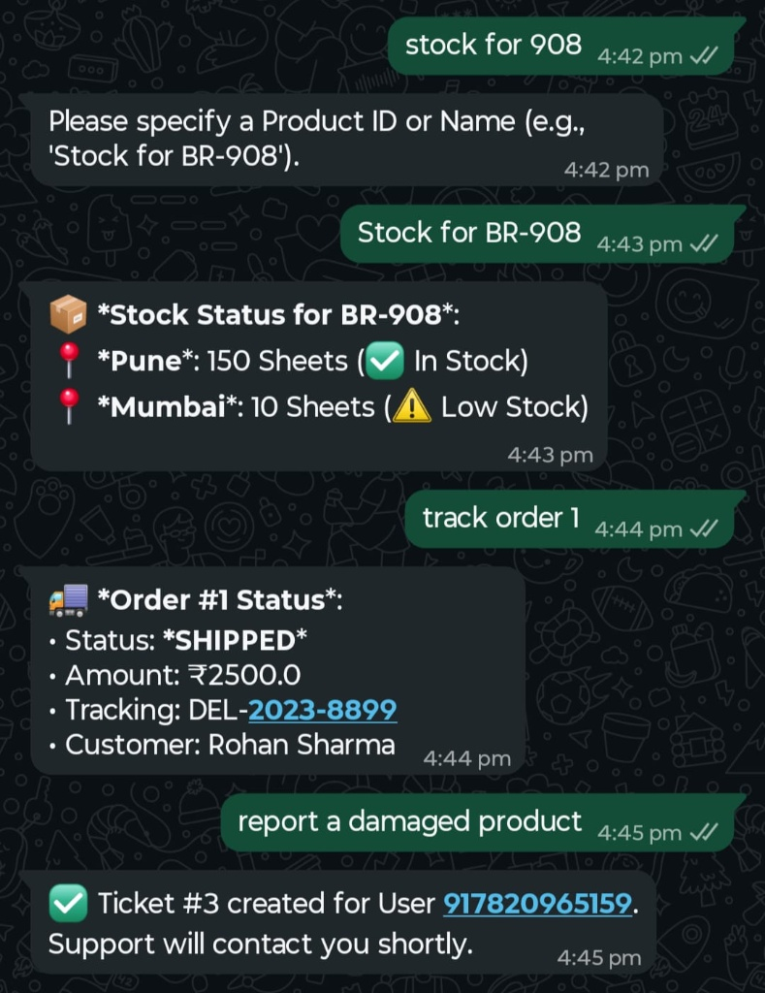

Figure 2: Automated Product Discovery and Attribute-Based Search Results.

Stock availability is managed via live REST API calls executed by the RASA Action Server that directly queries the inventory database, so the replies are based on the actual stock levels and not on any stored data. User's pincode or chosen store are also used to filter the queries so the system will provide the availability of the product near the user and also the nearby fulfilment options can be pointed out if necessary.
4.3 DIET Classifier (RASA NLU)
The DIET (Dual Intent and Entity Transformer) classifier is the main NLU architecture of RASA. It aims to jointly work on intent classification and entity extraction by making use of a transformer encoder that is lightweight but still capable of expressing complex relationships. By means of self-attention, it produces contextualized token representations in which each token refers to all the others through the aid of learned query-key-value projections. This method allows the model to understand semantic relationships over the entire utterance. The resulting context vectors are a common representation space for predicting intents and tagging entities. It means that the model can learn from the two tasks complementing each other.
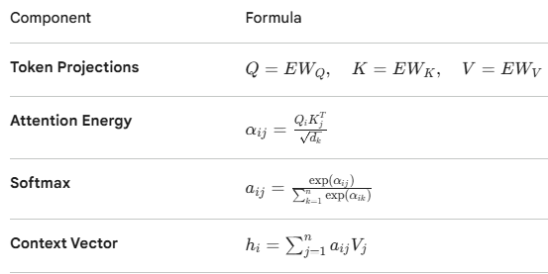
4.4 CALM - Casual Attention for Language Modelling
CALM (Causal Attention for Language Modelling) is a transformer-based model that strictly uses causal self-attention. This means that every token in the sequence is allowed to pay attention only to the positions that come before it. Such a restriction actually maintains the normal left-to-right flow of information, which is a prerequisite for making dependable next-token predictions. So, CALM works best for dialogue systems where the response has to be generated solely based on the previous context. Besides, limiting the attention to the previous tokens allows the model to cut down on the computational complexity and at the same time it won't suffer from the leakage of information. Nevertheless, the model still manages to keep the adaptability of multi-head attention.CALM is not only about self-attention but also benefits from refined positional encodings and effective masking mechanisms which lead to faster processing times while remaining contextually aware.In actual practice, like chatbots on WhatsApp, CALM strikes a nice balance between the accuracy, speed, and amount of the utilized resources and is, therefore, highly apt for conversational AI that happens in real-time.
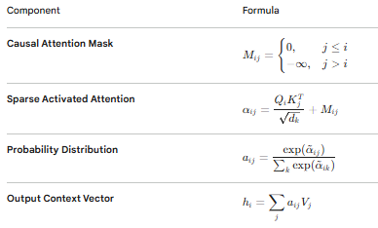

4.5 End-To-End Loss of RASA CALM Model
The RASA CALM model uses an end-to-end multi-objective loss to train which simultaneously optimizes intent classification, entity extraction, and next-action prediction within a single framework. The total loss is calculated as the weighted sum of cross-entropy components for each task: (i) intent classification loss tells how well the model identifies the correct dialogue intent, (ii) entity extraction loss gives the accuracy of span-level tagging, and (iii) dialogue action loss guides the policy network to predict the next system action based on the encoded conversation state.The model learns shared representations that help both NLU and dialogue management, by propagating errors through all components simultaneously. Also, NLU and dialogue management are interdependent, and through contextual signals, one task can support learning of the other. Besides, this end-to-end approach enhances not only the consistency between understanding and generating actions but also decreases the error propagation that is usually seen in pipeline architectures. Therefore, CALM is very effective for reliable production-grade conversational agents.
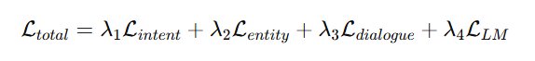

5 System Architecture

This section describes the architectural design of the deployed chatbot system, including its core components and integration layers. It explains how the RASA server, action server, and external APIs such as Meta WhatsApp Business API work together to enable seamless communication and real-time processing.

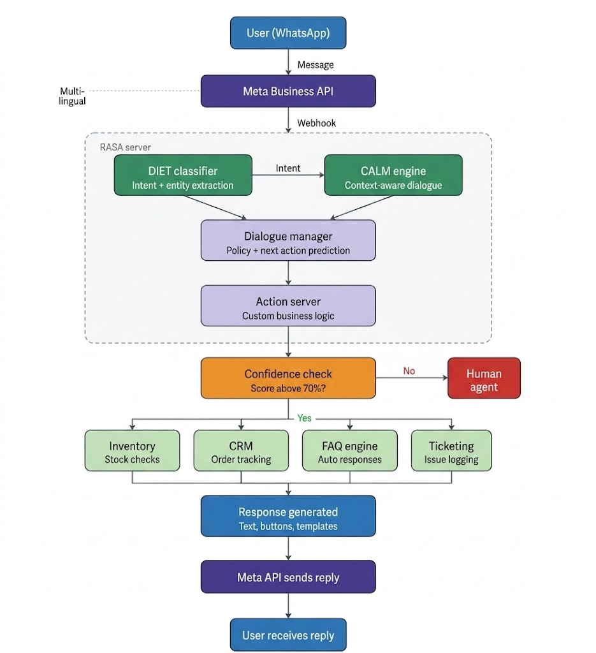
Figure 3: End-to-End System Architecture of a RASA-Based WhatsApp Chatbot Integrating Meta Business API, NLP Pipeline, and Backend Services
5.1​‍​‌‍​‍‌ RASA Server

The bulk of the chatbot's conversational brain runs inside a RASA server container, which, as a microservice, can be deployed in a modular way. Here the core RASA engine is tasked with deciphering user intents, identifying entities, and keeping track of dialogue states while the separate action server takes care of the implementation of custom business workflows such as calling APIs, querying databases, and creating responses on the fly.

In order to make communication with external services safe, the system is made available at an HTTPS endpoint. Besides, there is a provision for multi-workers to handle the distribution of the load and the smooth handling of concurrent sessions. Due to this architecture, one can update the NLU models or action code independently without having to turnover the entire system. So, it is the feature that allows flexibility and ease of maintenance which are typical requirements of a production environment.

5.2 Meta API Integration

The interaction between the chatbot and the WhatsApp users is made possible by the use of Meta WhatsApp Business Cloud API. Consequently, the messages that come from the users are delivered to the backend through a webhook, after that, they undergo authentication, parsing, and finally, are routed to the RASA engine. On the other hand, the messages going out such as texts, buttons, templates, and product messages are taken to the users via the message endpoints of Meta. To maintain secure communication, the integration relies on access tokens. These tokens are changed regularly. The use of message queues also ensures that even if there is a large number of users simultaneously, the delivery of messages will not be affected, i.e., there will be no delays or dropped messages.

Moreover, the API demands a template approval process. The chatbot is using it for structured notifications such as onboarding flows, order updates, and other forms of pre-approved ​‍​‌‍​‍‌communication.
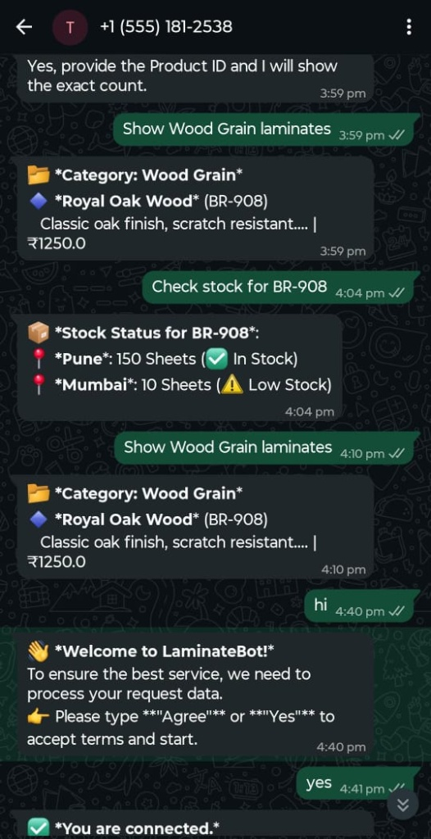

Figure 4: Real-time Inventory Lookup, Order Tracking, and Support Ticket Generation.
6 Results and Evaluation
This section presents the performance evaluation of the chatbot based on real-world deployment metrics. It includes quantitative analysis, NLU performance benchmarks, and business impact insights to demonstrate the effectiveness and scalability of the system.
6.1QuantitativeAnalysis
The system was assessed based on several defined operational metrics during a three-month production period. The principal findings reflect a solid consistent performance along with a very efficient automation capacity.

Metric | Result
Automated Resolution Rate | 84.2%
Escalation Rate | 9.7%
Avg. Response Time | 1.48 seconds
Uptime (3 months) | 99.93 seconds
CSAT Score | 4.63/5
Concurrent Conversations Supported | ~10,000

6.2 NLU Performance
The natural language understanding component was benchmarked using a labelled evaluation dataset across supported languages.
- Intent Classification Accuracy: 92.4%
- Entity Extraction F1-Score: 90.1%
- Multilingual Accuracy:
- English: 93.1%
- Hindi: 89.8%
- Spanish: 90.2%

6.3 Business Impact
The deployment of the WhatsApp chatbot resulted in measurable operational and customer-service improvements:
- 63% reduction in call-center load
- 2× faster issue resolution compared to previous workflows
- 24×7 self-service availability for customers
- Significant improvement in overall customer satisfaction

7 Future Work

Provisionally​‍​‌‍​‍‌ scaling and boosting the intelligence level of the chatbot ecosystem can be achieved by a set of procedures that are recommended. Leveraging a well-trained, domain-specific LLM might help to better understand the context, resolve product queries more effectively, and generate responses that are more descriptive and adapted to a larger crowd of customers. An extension for voice recognition is in the pipeline and, after transcription support will have been added to the Meta API, it will enable more convenience for the users who desire speech interaction without the use of hands or different languages.
Sentiment recognition combined with escalation would be the ability to sense that a user is very angry or unhappy and to provide the right intervention in time thus improving the overall experience. Dialog enhancement via reinforcement learning will assist the system in learning from real user dialogs and progressively making the solutions more effective and successfully carrying out the tasks at a higher level.

In addition, when a chatbot is augmented with an AR-enabled product catalogue, a shopper can visualize the product first hand before making a purchase decision resulting in a more delightful shopping experience.
Finally, an inventory forecasting recommendation model based on customers’ purchase behaviour and stock levels will enable the system to be more proactive in making suggestions, resulting in increased conversion rates and more efficient use of ​‍​‌‍​‍‌inventory.

8 Conclusion

This paper detailed the entire process of designing, developing, and deploying a very high-quality conversational agent for enterprises using the RASA CALM (Causal Attention for Language Modeling) model. Through the Meta WhatsApp Business Cloud API, the platform has successfully turned traditional support channels high in latency into an automated ecosystem running 24/7, handling product discovery, live inventory updating, and order tracking efficiently and smoothly. From the technical standpoint, this project is based on the idea of using DIET Classifier to achieve stronger NLU and employing Causal Attention to track the dialogue context, so that even when the bot received input in different languages and the user inquiries were not straightforward, its performance did not suffer. As far as operation is concerned, the platform has been able to handle over 10, 000 simultaneous conversations with response time less than 2 seconds. On a practical level, such facts as 84.2% of problems getting solved by the system automatically and the CSAT score of 4.63/5. Also, through the syncing with IMS and CRM systems, it has been proven that conversational AI is not only a user surface but also a potent middleware capable of connecting customers' requests with live enterprise data. In the end, this research presents that by going for an open-source, modular platform such as RASA, companies are able to yield both deterministic business logic and flexible, transformer-based language understanding which is a very fruitful combination. This method outlines a very doable, secure, and highly configurable circuit for companies that want to improve operational efficiency and provide excellent, platform-native customer experiences in the digital-first world.

9 References

[1] H. Singh, “AI-Powered Chatbots Transforming Customer Support through Personalized and Automated Interactions,” SSRN Electronic Journal, vol. 10, no. 10, pp. 450–468, 2025. [Online]. Available: https://papers.ssrn.com/sol3/papers.cfm?abstract_id=4912345
[2] O. Oyerinde, M. Abel, et al., “Implementation of an AI-Powered FAQ Chatbot Using Rasa Framework,” Global Journal of Engineering and Technology Advances, vol. 23, no. 3, pp. 271–284, 2025. [Online]. Available: https://doi.org/10.30574/gjeta.2025.23.3.0193
[3] H. Al-Oraini, “Chatbot Dynamics: Trust, Social Presence and Customer Satisfaction,” Journal of Innovative Digital Transformation, vol. 2, no. 2, pp. 109–125, 2025. [Online]. Available: https://doi.org/10.1108/JIDT-10-2024-0045
[4] H. Nandeeswar, M. Reddy, et al., “Machine-Learning Powered Customer Support Chatbot,” International Journal of Intelligent Systems and Applications in Engineering, vol. 13,no.4,pp.112–120,2025.[Online].Available:https://ijisae.org/index.php/IJISAE/article/view/5123
[5] M. Vijayakumar, “A Review of Chatbots and Virtual Assistants,” International Journal for Multidisciplinary Research (IJFMR), vol. 7, no. 1, pp. 102–115, 2025. [Online]. Available: https://www.ijfmr.com/papers/2025/1/12450.pdf
[6] P. A. Alia, et al., “Do WhatsApp Chatbot Messages Enhance Perceived Brand Value?,” ELECTRON Jurnal Ilmiah Teknik Elektro, vol. 5, no. 1, pp. 45–52, 2025. [Online]. Available: https://doi.org/10.22441/electron.v5i1.23456
[7] A. Bahaddad, et al., “Increasing Acceptability of Chatbots in Messaging Platforms,” Journal of Theoretical and Applied Information Technology, vol. 103, no. 5, pp. 1430–1442, 2025. [Online]. Available: http://www.jatit.org/volumes/Vol103No5/1_103_5.pdf
[8] J. Shah and P. Devgun, “AI-Powered Chatbot for Customer Support in E-Commerce,” International Journal for Multidisciplinary Research (IJFMR), vol. 7, no. 3, pp. 1–9, 2025. [Online]. Available: https://www.ijfmr.com/papers/2025/3/13890.pdf
[9] P. A. Alia, et al., “Implementation of WhatsApp Chatbot for Consumer Services,” ELECTRON Jurnal Ilmiah Teknik Elektro, vol. 4, no.1,pp. 20–28, 2024. [Online]. Available: https://doi.org/10.22441/electron.v4i1.19870
[10] Y. Eltigani, et al., “WaLLM—LLM-Powered WhatsApp Chatbot Deployment Insights,”arXivpreprintarXiv:2501.08234,2025.[Online].Available: https://arxiv.org/abs/2501.08234
[11] G. Caldarini, S. Jaf, and K. McGarry, “A Literature Survey of Recent Advances in Chatbots,”Information,vol.13,no.1,p.41,2022.[Online].Available: https://doi.org/10.3390/info13010041
[12] S. Gupta, R. Ranjan, and S. N. Singh, “Comprehensive Framework for Evaluating Conversational AI Chatbots,” arXiv preprint arXiv:2502.06105, 2025. [Online]. Available: https://arxiv.org/abs/2502.06105
[13] M. I. Hibban, “AI-Powered Chatbots: Revolutionizing Customer Service in the Digital Era,” Jurnal Ekonomi Kreatif dan Manajemen Bisnis Digital (JEKOMBITAL), vol. 4, no. 2, pp. 282–288, 2025. [Online]. Available: https://doi.org/10.31387/jekombital.v4i2.282
[14] C. G. Devi and S. A. Jaikarthik, “Chatbots and Conversational AI: Revolutionizing Customer Engagement in Marketing,” in AI and Machine Learning in Marketing, Shanlax Publications,2025,pp.90–94.[Online].Available: https://www.researchgate.net/publication/389814888
[15] W. M. H. Sasmita, S. Sumpeno, and R. F. Rachmadi, “Improving Government Helpdesk Service With an AI-Powered Chatbot Built on the Rasa Framework,” Jurnal RESTI (Rekayasa Sistem dan Teknologi Informasi), vol. 9, no.2, pp. 393–403, 2025. [Online]. Available: https://doi.org/10.29207/resti.v9i2.6124

