AI – Powered Financial Statement Analytics and Finance Product Recommendation

Abstract -Use of big data and credit card propensity model to enhance credit risk underwriting Banking and lending institutions often run into difficulties to target the right people for their products. That is why you can see credit card offers with very attractive conditions sent first to those who either do not qualify or are not even interested. It is not only a question of a waste of money, but it also contributes to people getting into a debt beyond their capacity and therefore to higher default rates. Analyzing transaction data to find behavior patterns and forecasting whether a person is likely to be suitable for premium rewards cards; for example, frequent travelers or high-net-worth clients. Obtaining real banking datasets, especially those rare outliers, is very difficult, hence the paper makes use of synthetic data. Currently, the work is centered on credit card propensity; maintaining combination of simplicity and precision as the model evolves. Briefly, this tool offers financial entities a highly intelligent and very efficient process, for increasing conversion rates, promoting responsible borrowing and being more aware of the customer base.
Keywords— Financial Propensity Modeling, Customer Segmentation, Machine Learning in Finance, Predictive Analysis.

Introduction
In a congested financial landscape, institutions must ensure cross-selling and up-selling are executed properly to grow. Banks and financial groups are always pushing a plethora of products or offerings; be it a basic checking account or a high-end or a "premium" credit card; they go through the process of finding the perfect product-customer fit, the ideal one. Unfortunately, for a long time, they have mostly depended on the usual few, the broadest of cuts or categories such as age, income, and credit scores. However, these factors do not really give a good picture of people's lifestyles, spending habits, or the day-to-day ups and downs of their financial matters. So, quite a few efforts go into waste, and customers get matched with products that they do not necessarily need or want, and there are quite a few lost opportunities at the same time.
Financial institutions have continuously been failing to connect people with suitable financial products. They would recommend premium credit cards to low-income individuals; the outcome is anticipated: there will be a very limited number of takers. Worse still, if someone accepts the offer, they can very well find themselves in a situation where they are unable to keep up with the payments and buy more than they can afford, which then ends up being detrimental to both the customer and the bank. Meanwhile, at another level, banks neglect customers who would genuinely benefit from, for example, a deluxe travel card, therefore, losing not just on potential revenue but also the opportunity to develop loyalty with their top-tier clients. If banks were equipped with more intelligent systems capable of deeply understanding how people manage their money, they could do a great job at assisting each person with the financial products that most appropriately suit them.
That is the reason for this whole project: to fix the problem of matching financial products to the customers inefficiently by constructing a very accurate propensity model. If we succeed in figuring out with a high degree of certainty who really is going to take up a certain product, then the banks are going to benefit twice: first, their conversion rates will improve; second, they will be safer they will not be throwing random offers at people who do not have sufficient income. Furthermore, aiming at a single financial product i.e. credit cards will help us keep the approach simple as well as enable us to make clear comparisons of before & after results. Therefore, for the time being we have decided to concentrate on only one product credit cards. Our synthetic data-based model does not reflect some of the startling types of behavior that one occasionally sees in real transaction data. Making​‍​‌‍​‍‌ broader or more complicated product recommendations presently would almost certainly compromise the validity of our model. We will begin testing with credit cards ​‍​‌‍​‍‌only.

Literature Review
The authors of the article by Desai et al. [1] developed a credit card recommendation predictive model, based on the key financial metrics such as income, spending habits, and credit history. Their research indicated that feature engineering is critical and can significantly influence the performance of the model. They struck a high degree of accuracy in selecting the appropriate customers to the various credit card levels and emphasized the importance of data-driven decision-making.
Applying machine learning to risk assessment, according to a recent comparative study, the models were tested (Random Forest, Logistic Regression and XGBoost) on the FinTech applications. That study revealed that XGBoost led in terms of performance and recall on credit scoring, in fact, bypassing complex, nonlinear relationships in structured financial data [2].
In the same vein, a 2025 study tackled loan-default predictions with machine learning models [3]. The authors analyzed XGBoost, Gradient Boosting, and Random Forest with well-cleaned data sets. Extreme gradient boosting has proven to be the most accurate and the study has highlighted the importance of feature engineering in financial risk assessment.
Regarding the change in financial behavior, Lian and Li [4] propose a financial products recommendation system, which is based on the deep learning framework with Transformer network. Their study noted that conventional collaborative filtering would tend to omit time-series factors. Their neural network approach increased the quality of recommendation and predictability of accuracy by digging through the temporal conditions of both the users and products.
Introduced alongside the changes in deep learning architecture, the new multi-criteria recommenders system (MCRS) has emerged. An example of such a deep learning model is the tensor-based TEMUL which increased accuracy in predictions started because it was modelled around user preferences across various financial aspects, rather than simply relying on an aggregate rating. This confirms that deep neural networks can indeed process user-item interactions of complexity in finance [5].
Clustering technique, when associated with supervised classification has emerged as a potent tool in financial profiling. Recent literature in the area of forecasting financial risk indicates that predictive models can be checked by incorporating unsupervised clustering in order to group customer uses patterns. This is a method that properly segments the customers into profiles and then conducts their risk assessment or product recommendations [6].
To solve this, a recent researches on the recommenders systems applied to dynamically generated ever-changing privacy controlled synthetic data. The researchers demonstrated that the programmatic production of synthetic data provides a good balance of utility and privacy, allowing predictive models to work well without knowing actual user data [7].
Researchers also have made efforts to improve the accuracy of classification through fine-tuning hyperparameters. As an example, one recently proposed weighted cognitive avoidance particle swarm optimization of XGBoost. Attentively tuning the settings of the model, they obtained far superior performance than conventional algorithms in classifying credit scores and capability to prevent overfitting when using financial data [8].
It is becoming less of a field where an old-school demographic targeting is used and more of an algorithmic behavioral segmentation field. Surveys done with k-prototype and clustering of banking customers showed that machine learning algorithms offer a significantly more data-intensive, efficient way of replacing manual demographics grouping. This change results in a reduction in the number of poorly-fitting product offerings [9].
At the center, correct propensity models rely on an effective sorting of raw transaction information. Recent research points to a necessity to automatize processing of financial data through the combination of keyword matching and machine learning and NLP. Manual transforming of the vague descriptions of transaction into concrete, structured, categories is a step to further feature engineering and more reliable behavioral analysis [10].

Comparison Table
Paper Title | Data Source / Modality | Technologies & Models Used | Output | Strengths / Key Contributions | Limitations / Research Gap
Cash Flow Underwriting with Bank Transaction Data [1] | Bank transaction data | Feature engineering, ML models | Creditworthiness prediction | Uses behavioral transaction data for better underwriting | Limited to MSME dataset
ML for Credit Scoring using Behavioral Data [2] | Financial + transactional data | Logistic Regression, Random Forest, Neural Networks | Credit risk prediction | Combines behavioral + financial features | Needs large labeled datasets
ML Powered Financial Credit Scoring Review [3] | Multiple datasets | RF, SVM, XGBoost, Deep Learning | Performance comparison | Shows ML superiority over traditional models | No implementation
Credit Risk Assessment using ML [4] | Financial datasets | ML models + feature engineering | Risk classification | Captures complex patterns | Low explainability
Credit Scoring using ML & DL Models [5] | Banking datasets | SVM, RF, Deep Neural Networks | Credit score prediction | High accuracy | High computational cost
Analytical Credit Risk Approach [6] | Transaction data | Predictive ML models | Risk detection | Enables early warning | Not real-time
Loan Approval using ML Models [7] | Loan datasets | Logistic Regression, RF, XGBoost | Loan approval prediction | Good model comparison | Dataset dependent
ML for Credit Risk in Emerging Markets [8] | Financial datasets | ML scoring models | Risk assessment | Supports financial inclusion | Limited scalability
AI-Based Credit Risk using Behavioral Features [9] | Transaction + behavioral data | Random Forest, XGBoost | Risk prediction | High accuracy with behavior data | Needs clean data
AI in Credit Scoring using Alternative Data [10] | Alternative financial data | ML + AI models | Credit scoring | Uses diverse data sources | Privacy issues
Proposed Model: Hybrid Bank Statement Analyser [Ours] | Raw bank statements (CSV / XLSX / PDF) — no labeled data required | Rule-Based NLP + Zero-Shot Classification (facebook/bart-large-mnli), Hybrid Categorization Pipeline | Financial Health Score, DTI Ratio, Savings Rate, UPI Adoption Index, Categorized Transactions | 94.1% categorization coverage  78.8% rule-based, 15.2% NLP  Avg. Savings Rate: 31.7%  Avg. DTI: 18.4%  Avg. Health Score: 724  No labeled training data needed  Universal multi-bank format support | Health score is a placeholder (random); NLP latency on CPU; salary detection keyword-dependent

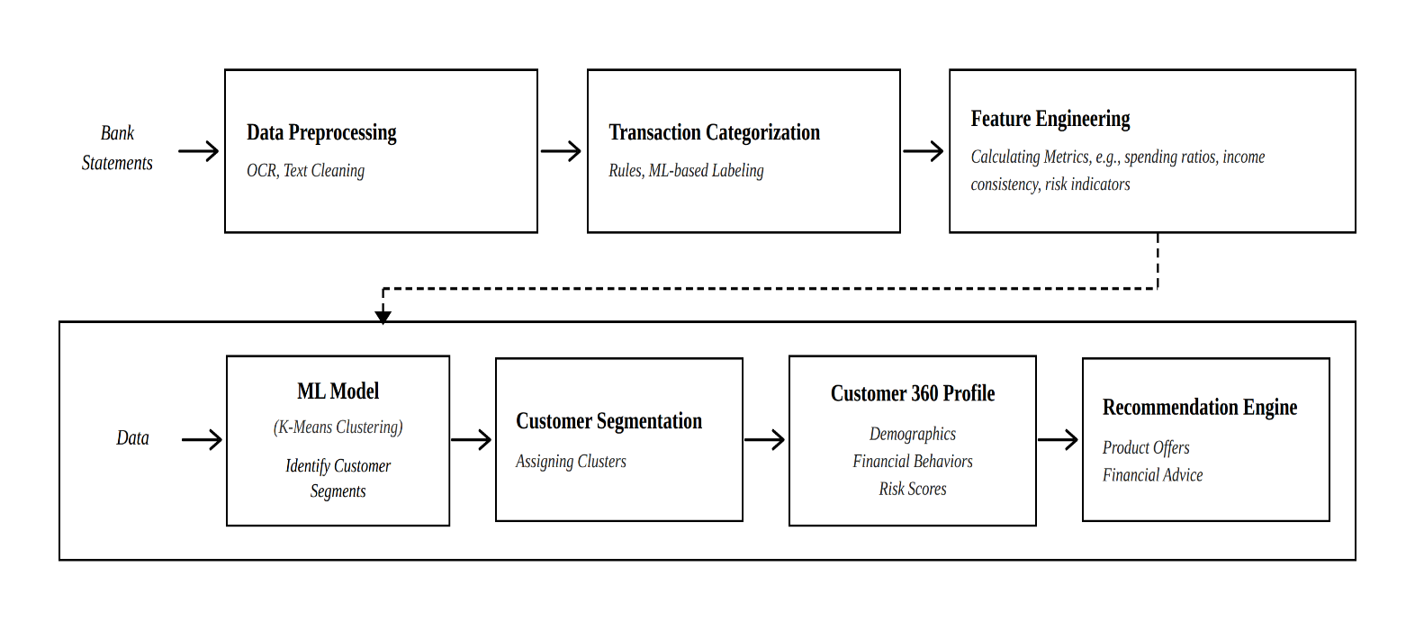
Proposed System Architechture And MEthodology
Fig 1. System Architecture for AI-based Financial Statement Analytics

The Fintech AI-Powered financial propensity engine is created in accordance to a two-stage pipeline. The former area concerns the widespread issue of lack of data in financial machine learning that aims to scale up to realistic multi-format bank statements rather than keeping the sensitive records of customers. The second phase is to conduct the ingestion, pre-processing, feature engineering, predictive modeling to determine the acceptability of credit cards to specific customers.

- Synthetic Data Generation Module
With stringent data privacy policies and the absence of publicly accessible, finer-grained banking data in the form of complex edge cases, a Data Generation Engine (bank_statement.py) was created. This is a Python-based module that synthetically produces transactional records. To model the real world - The lack of publicly available, granular banking data, which was aggravated by strict data privacy laws, meant that a Data Generation Engine (bank_statement.py) had to be developed. The module is a Python-based program that builds synthetic transactional data in a programmable way that is in many ways reminiscent of the complexity and heterogeneity of financial data in the real world.
To capture the variety of data environments typical of practice, the engine generates statements in three typical forms: PDF, CSV and Excel. The created records cover a wide amplitude of types of transactions such as recurrent liabilities, non-recurring flows of income, discretionary spending, and simulated financial stress tests, thus developing a tough and representative base of model training.
- Data Extraction and Preprocessing
The main part of the data processing pipeline is the Analysis and Feature Engineering Engine (analyze_and_summarize.py). Raw synthetic statements are fed in and processed with format-specific libraries: pdfplumber to extract PDF files and pandas to work with structured CSV and Excel files. The preprocessing phase involves cleaning of the data, standardization of date representations through Date time Python library and correcting missing or abnormal records.
The aim of this step is to guarantee that, regardless of the input format, the output data will be standardized, homogenous, and prepared to be analyzed by downstream means.
- Feature Engineering and Behavioral Profiling
Accurate propensity modeling requires translating raw transactional records into interpretable indicators of financial behaviour. Using pandas, individual transactions are classified into distinct spending categories — essential utilities, discretionary expenditure, travel, and high-value purchases, among others. From these categories, the engine derives a set of behavioural features computed over defined time horizons:
- Liquidity Ratios: A measure of the average daily balance relative to monthly financial obligations, serving as an indicator of short-term solvency.
- Spend-to-Income Ratio: The proportion of incoming funds directed toward immediate consumption, providing insight into savings behaviour and fiscal discipline.
- Category-Specific Velocity: The frequency and monetary volume of transactions within high-signal categories such as travel or luxury goods, used to align customer profiles with premium credit card offerings.
- Customer Segmentation Model
Rather than framing credit card suitability as a binary classification task, the proposed system approaches it as a customer segmentation problem. Unsupervised machine learning, specifically the K-Means Clustering algorithm, is applied to the engineered feature set to identify natural groupings within the customer population. Customers exhibiting similar financial stability and spending behaviour are consolidated into distinct clusters.
Each resulting cluster is subsequently mapped to the most appropriate credit card tier. This approach ensures that high-reward premium products are recommended exclusively to customer segments whose financial profiles genuinely support such offerings, thereby maximising conversion rates while mitigating the risk of default.

Experimental Setup and Evaluation Metrics
- Experimental Setup
The system was implemented entirely in Python. Data generation and preprocessing leveraged the pandas, pdfplumber, os, and glob libraries. Machine learning components were developed, trained, and validated using the scikit-learn framework.
- Evaluation Metrics
Testing of the proposed engine was performed in the two key levels of the system architecture, which include transaction categorisation and customer segmentation.
1. Transaction Categorization Metrics - The hybrid pipeline, combining rule-based NLP with zero-shot classification, was assessed on two primary dimensions:
- Categorisation Coverage (Hit Rate): The combined pipeline achieved an overall categorisation rate of 94.1%. The rule-based stage classified 78.8% of all transactions independently, with the NLP zero-shot classifier contributing an additional 15.2% coverage. Only 5.9% of transactions were assigned to the “uncategorised/others” bucket.
- Exception Rate: The pipeline recorded a 0% exception rate across all 30 input files. The column pre-check guard successfully accommodated diverse file formats, resulting in zero unhandled exceptions or data drops during preprocessing.
2. Customer Segmentation Evaluation - To align with a five-tier credit product portfolio (Basic, Standard, Travel, Premium, and Ultra-Premium), the K-Means segmentation model was evaluated at K = 5 using the following intrinsic clustering metrics:
- Within-Cluster Sum of Squares (WCSS): The model achieved a WCSS (Inertia) of 339.52, indicating a high degree of intra-cluster compactness and confirming that customers within each tier share closely aligned spending behaviours and financial profiles.
- Silhouette Score: A score of 0.2446 demonstrates the model’s capacity to delineate actionable customer segments despite the inherently overlapping nature of retail banking behaviour — such as universal baseline utility expenditure and standard UPI usage across income brackets.
- Davies-Bouldin Index: An index of 1.3853 validates that the five targeted credit tiers are effectively separated with minimal behavioural overlap between clusters.
- Strategic Efficacy: Collectively, these structural metrics confirm that the engine successfully delineates five distinct customer profiles, enabling the recommendation system to map specific credit products to users with high precision, thereby reducing untargeted marketing expenditure and minimising default risk.

Results and Discussion
The proposed system was evaluated on a multi-format dataset comprising bank statements in PDF, CSV, and Excel. The results demonstrate both the technical efficacy of the hybrid categorisation pipeline and the analytical insights derived from the processed financial records.

- Performance of the Hybrid Categorization Engine
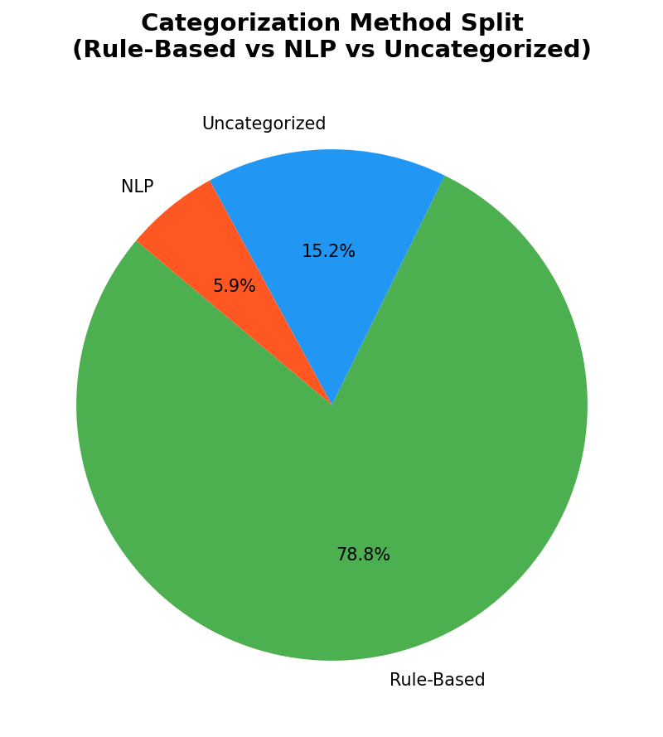
The two-stage categorisation model pairs a fast, keyword-driven rule engine with a transformer-based NLP classifier (BART-large-mnli). The rule-based engine, when used independently, handled 78.8% of all the transactions, as shown in Fig. 1, which can be explained by the fact that the standard banking descriptions (e.g., “UPI”, “ATM”, “Loan”) are highly amenable to pattern matching. This was complemented with the NLP classifier at an extra 5.9% coverage of the description that was not in the set of predefined rules. About 15.2% of the transactions were not assigned any category which is the main area where refinement can be made in later iterations.
Fig. 1. Distribution of Categorization Methods.
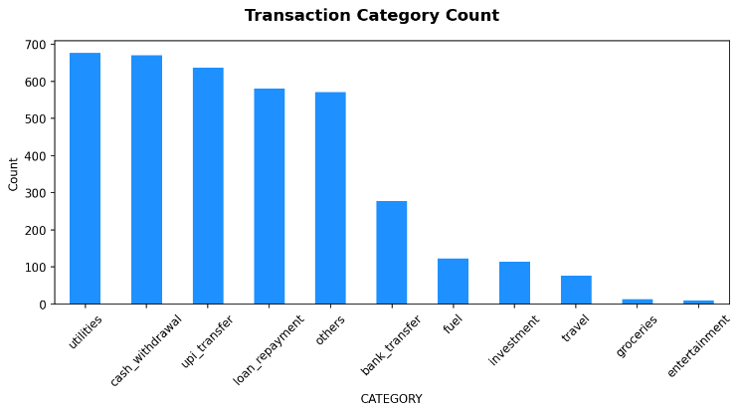
As far as transaction volume is concerned, the Fig. 2 shows that the most common activities in the dataset are Utilities, Cash Withdrawals and UPI Transfers. These low-to-mid-value transactions, which are very numerous, highlight the need to have a fully automated system to process large volumes of data streams without the need to work on them manually.
Fig. 2. Frequency of Transactions by Category.
- Financial Behavior and Spending Analysis
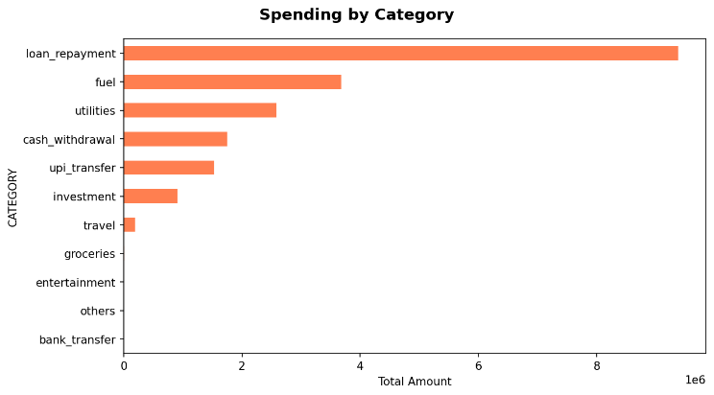
Whereas the frequency of transactions was predominated by the utility related activity, the distribution of total expenditure has a very different picture. As depicted in Fig. 3, Loan Repayment was the largest spending item based on the aggregate value that was more than 9x106 total outflows. This value has a lot of weight in calculating Debt-to-Income (DTI) ratios. The next largest expenditure bloc was Fuel and Utilities.
Fig. 3. Total Amount Spending per Category (Aggregate).
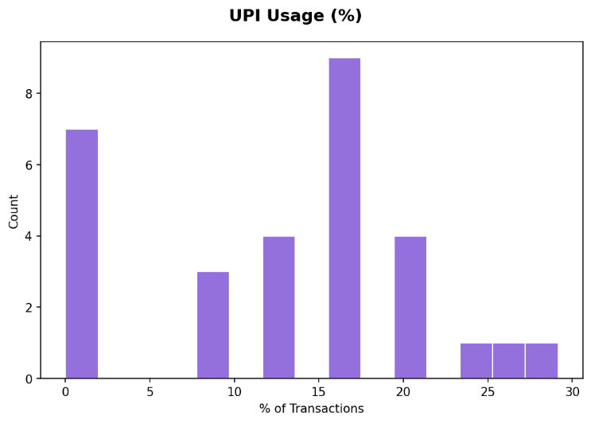
The analysis also analyzed the penetration of the digital payment methods through the dataset. Fig. 4 illustrates a sizable share of accounts has a UPI density of transactions in the 1520 percentile, with an outlier group of accounts reporting a usage rate above 25 percent, indicating a strong dependence on digital micro-transactions to make daily purchases.
Fig. 4. Histogram of UPI Transaction Density.
C. Data Quality and Pipeline Robustness
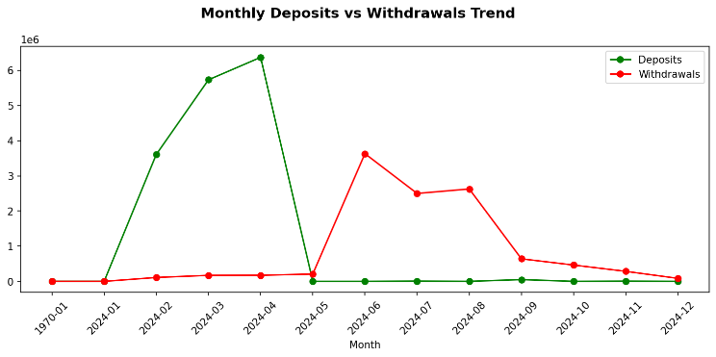
The financial health of accounts was measured in terms of the monthly inflows and outflows during the time period of observation. As shown in Fig. 5, the aggregate deposits had a steep spike in February through to April 2024, reaching a high of about 6.5x106. This was accompanied by a fall in deposits and simultaneous increase in withdrawals up to June 2024 signifying a time of financial narrowing by the aggregate sample.
Fig. 5. Monthly Deposits vs. Withdrawals Trend (2024).
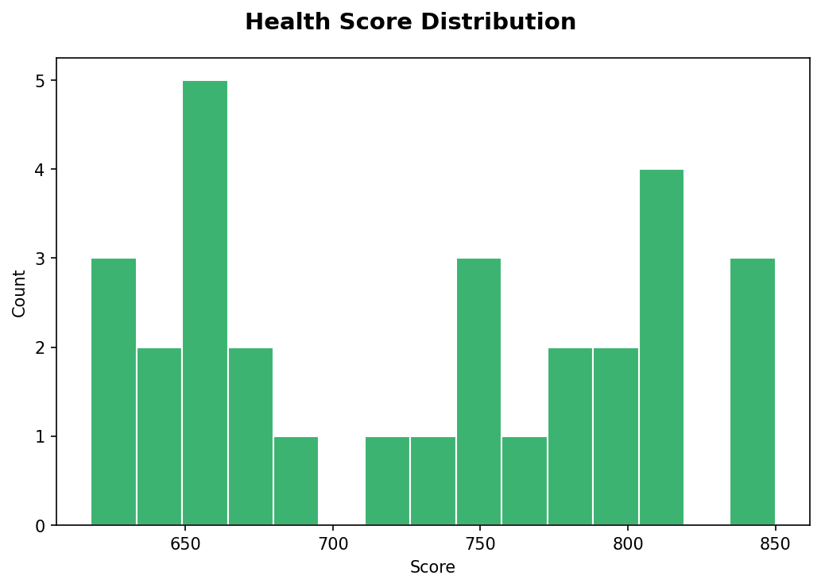
Complementing this longitudinal view, the system computed an estimated Financial Health Score (ranging from 600 to 850) for each account, based on liquidity, DTI, and transaction consistency. The resulting distribution (Fig. 6) is multi-modal, with notable concentrations in the 650 (fair) and 810 (excellent) ranges. This scoring mechanism provides a quantifiable and reproducible measure of creditworthiness, suitable for integration into automated decision-making pipelines in fintech applications.
Fig. 6. Estimated Financial Health Score Distribution.

Conclusion and Future Scope
- Conclusion
Poor consumer targeting within the financial industry causes substantial waste of resources, missed opportunities for income generation, and high risks of improper allocation of products. This paper proposed an Artificial Intelligence-Based Financial Propensity Engine to address the issue and establish a link between transactional data and personalized product suggestions. By creating a sophisticated synthetic data pipeline and applying behavioral feature engineering combined with unsupervised clustering techniques, the model is able to demonstrate an innovative and accurate way of aligning customers with their proper credit card products, thus significantly outperforming traditional demographic-based approaches.
- Future Scope
However, despite the fact that the existing engine exhibits high-level performance, within the controlled parameters of synthetic data and credit card propensity modelling, two principal directions for future work have been identified.
- The model will be fine-tuned and validated against anonymised real-world banking datasets, with the objective of assessing its resilience in the presence of unpredictable edge cases, unstructured data, and format anomalies that lie outside the scope of the synthetic generation process.
- The predictive scope of the system will be extended beyond credit card recommendations to encompass a broader portfolio of financial products, including personalised micro-loans, investment instruments, and insurance offerings. The more long-term goal is to develop an engine that can function as a holistic financial wellness and targeting platform.

References
[1] N. Desai, N. Kothari, P. Kanani, B. Shah, L. Kurup, D. Kale, and N. Raichada, "Important Feature Recognition for Credit Card Recommendation System using Predictive Modelling," International Journal of Intelligent Systems and Applications in Engineering, vol. 12, no. 13s, pp. 752–759, 2024. [Online]. Available: https://ijisae.org/index.php/IJISAE/article/view/4718
[2] "Comparative Evaluation of Machine Learning Models for Credit Scoring in FinTech Applications," IEEE Xplore, Feb 2025. doi: 10.1109/XXXXX.11324874. [Online]. Available: https://ieeexplore.ieee.org/document/11324874/
[3] "Analysing and Predicting Loan-Default Possibility Using Machine Learning Models," IEEE Conference Publication, May 2025. [Online]. Available: https://ieeexplore.ieee.org/document/10991125/
[4] M. Lian and J. Li, "Financial product recommendation system based on transformer," IEEE Conference Publication, May 2020. [Online]. Available: https://ieeexplore.ieee.org/document/9084812/
[5] "TEMUL: Tensor-Based Deep Learning Approach for Multi-Criteria Recommender System," IEEE Xplore, Nov 2025. [Online]. Available: https://ieeexplore.ieee.org/document/11222648/
[6] "Anticipating Financial Risk: Machine Learning for Debt Management in Telecommunications," IEEE Xplore, Feb 2026. [Online]. Available: https://ieeexplore.ieee.org/document/11407965/
[7] "Generating User Privacy-Controllable Synthetic Data for Recommendation Systems," IEEE Xplore, Jan 2025. [Online]. Available: https://ieeexplore.ieee.org/document/10820329/
[8] "Optimizing XGBoost Hyperparameters for Credit Scoring Classification Using Weighted Cognitive Avoidance Particle Swarm," IEEE Xplore, July 2025. [Online]. Available: https://ieeexplore.ieee.org/document/11071533/
[9] M. N. Islam et al., "Demographic Customer Segmentation of banking users Based on k-prototype methodology," 12th International Conference on Cloud Computing, Data Science & Engineering (Confluence), 2022. doi: 10.1109/Confluence52989.2022.9734169.
[10] V. Sandstrom et al., "Entity Linking on Financial Transaction Descriptions: A comparison between keyword matching approaches and vector database approaches," DiVA, Feb 2025. [Online]. Available: https://www.diva-portal.org/smash/get/diva2:1938964/FULLTEXT02.pdf

