Apply Auto and Carrier guide System

Abstract—In a digital-era recruiting environment, the regular Applicant Tracking Systems (ATS) are not very useful in filtering through the large number of resumes received since they highly depend on the logic of key- words. This usually results in good applicants being lost in the cracks when they fail to execute the right phrases the system is searching and the system also attracts irrelevant applicants using the hopping feature by key words. Therefore, I have been considering JOBSY, which is an AI-based recruiting solution that attempts to resolve the problem by combining lexical and semantic matching to improve the efficiency and equity of hiring. JOBSY is implemented on top of NLP tricks it uses TF-IDF to perform the basic filtering of the key words and BERT to get a clearer understanding of the general meaning. It even includes a custom NER based parser that extracts structured information out of resumes, which can be used to better match the profiles of the candidate with job ads. All this has been developed using React.js and Flask which implies that the platform can manage real time and not hit its limit. Early tests indicate that JOBSY extracts an unbelievable amount of relevant candidates and the accuracy and quality of overall matches are better to resume screens compared to what the old ATS kids are accustomed to. Abstract: Resume Parsing is a technique that transforms resumes into a format compatible with AI or other machine processing tools to develop job vacancy matching, controlled by machine-executed instructions instead of human ones. TF-IDF or BERT along with Named Entity Recognition: This has been incorporated into the list to facilitate job matching by relying on instructions to execute tasks automatically, leading to an Applicant Tracking System rather than relying on human- executed instructions. < Semantic Embeddings Resume Parsing: This is included on the list to help facilitate job matching by using instructions to execute tasks
- Introduction
Jobs are in an absolutely different place with the advent of successful online job portals with a massive pool of potential employees. However, it is now the digital change that has ensured that filtering through all such resumes becomes extremely difficult whenever a vacancy is opened. According to Staffing Industry Analysts, the white-collar segment recruitment in India increased by 19 per cent only in September 2025 alone [1]. The Applicant Tracking Systems (ATS) Once regarded as more traditional, are designed to screen resumes automatedly; however due to the fixed keyboard filter, they fail to identify good match (false negatives) and reduce selection accuracy in the process (real results) [2], [3].
Research indicates that traditional ATS are usually deprived of the relevant profiles because of vocabulary differences or indistinct job advertisements [4], [5]. To add to this, there is also the problem of keyword stuffing which is when an applicant tries to stuff in keywords that are often repeated but irrelevant to the context as well as making the process inefficient and biased [6], [7].
The solution to these problems is to combine Natural Language Processing (NLP) and AI in recruitment technology, which allows the system to interpret the semantics of a resume and a job advert and extract the semantic indicators rather than simply matching words at a shallow level [8], [9]. Recent experiments deal with TF-IDF to identify core terms, but this induces havoc with swapping synonyms or related words [10], [11].
The second strategy is the transformer models such as BERT that understand contextual relationships of words and evaluate resumes based on the meaning and not on exact expressions [12], [13]. Sentence-BERT (SBERT) does one greater step to 1) give sentence -dream embeddings which enhance similarity matching [14].
Other studies indicate directions of Named Entity Recognition (NER) to unstructured resume parsing. Skills,

XXX-X-XXXX-XXXX-X/XX/$XX.00 ©20XX IEEE

qualifications, and experience in diverse forms can be extracted out of custom NER pipelines [15], [16], [17], and [18]. Semantic matching together with that well-structured data increases the ranking and filtering accuracy by a wide margin [19].
Despite all these developments, very limited systems do package parsing and matching under a single scalable system. The majority of proposals remain hypothetical or they do not take into consideration real-time implementation challenges [20]. This difference prompted us to develop JOBSY, a web-based hiring engine, which combines NER- based resume-casting with a pair of-stage matching engine (TF-IDF + BERT). It is an open-source, React.js front end and Flask back-end web application scalable to provide precise and fair explainable matches of candidate and job.
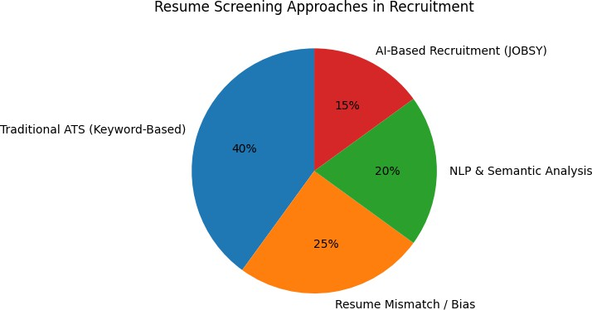

Fig-1.1 Comparison of Traditional ATS and AI-Based Screening
and CERTIFICATION [5]. Verma and Kumar provided a layout sensitive resume reader which takes into account spatial information, providing better information mining. Their system was better than flat-text NER systems, particularly on visually complicated resumes [6]. Deshmukh and Raut addressed the limitations of TF-IDF itself systems and emphasized the fact that semantic meaning is required. They reached the conclusion that TF -IDF is an effective method of filtration, but does not reflect in-depth meaning [7].
Singh et al. have developed a recruitment web application based on real-time that can recruit and provides scalable resume management through an async Flask APIs and a PostgreSQL database. They have a modular architecture which facilitates quick screening of candidates [8]. Kumar and Tripathi provided an article that has compared the emergence of AI in recruitment, by reviewing models that combine rule-based parsing with deep learning. They identified explainability and fairness as the main new directions in the future [9].
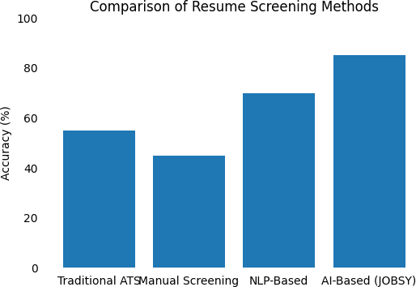
Lastly, Jadhav et al. suggested a system, which combines resume ranking with recruiter feedback through sentence similarity scores. Face size. They have a better recursive model that was enhanced with feedback loops and adaptive weighting [10].

- LITERATURE REVIEW
Hey, in a recent paper Chandak and colleagues had proposed one such hybrid model of recruitment that combines TF-IDF keyword extraction with BERT-based semantic embeddings to increase the accuracy and recall of resume-job matching. Their experimentation proved that this combination increased both measures in the hiring systems in fact [1].
In the other work, Sougandh et al. created an AI-based resume parser that was created on NLP to extract major fields, such as name, degree, and skills. Their system was much better than older rule-based parsers in a broad range of resume formats [2]. Thangaramya et al. proposed Resume2Vec, a cool resume embedding algorithm, which employs contextual data to enhance matching of the job descriptions. The model increased ranking precision using resumes by modeling them as dense vectors [3]. Swapna et al. came up with a BERT-based matching engine whereby candidate profiles are matched with job postings with contextual embeddings overcoming some of the common vocabulary differences encountered in the earlier systems [4].
Sanyal et al. investigated Named Entity Recognition in resume parsing where the fine-tuned spaCy models performed well to extract domain-specific NER.e.g. SKILL

Fig-2.1 Comparison Bar Chart of Different Method

- Methodology

- System Architecture
JOBSY platform is modular and scalable and it is based on MVC model. It promotes various roles of users: candidates, recruiters, and admins and maintains the division of data processing, business logic, and UI. We are able to deploy it to the cloud and it provides real-time work in the asynchronous tasks. Its primary technology consists of a React.js user interface, a Flask REST API, PostgreSQL to store data and Celery tasks to pause-offensive NLP tasks such as resume parsing and embeddings generation. All these components turn out to be compatible and effective in

terms of data processing, thus JOBSY may scale to the level required by an enterprise considering it to be fast and consistent enough to cope with corresponding job and candidate matching.
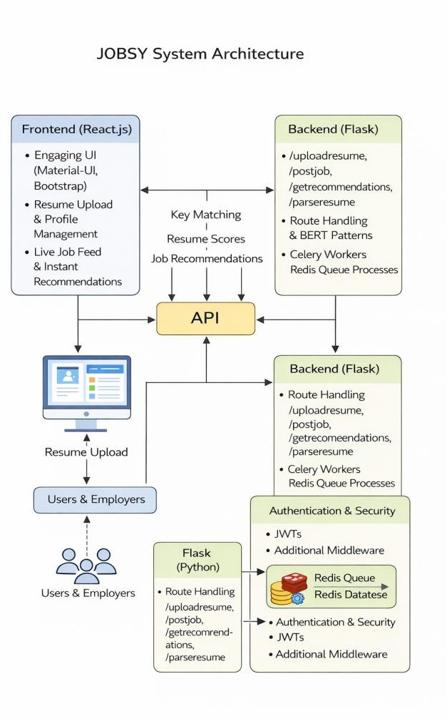
Fig-3.1 System Architecture

- Brief Overview of the System Architecture.
User Management Module- deals with the registration, the process of signing in and finding out whether a user is an applicant or a recruiter.
Resume Parsing Module- Resumes that are not computer- readable are processed into useful pieces (named-entity recognition) using the skills, education and experience. Job Posting and Retrieval Module - enables the recruiters to post the job advertisement, which enables applicants to view, and search posts.
Hybrid Matching Engine- matches calculate match scores in two phases, first they are filtered using TF-IDF followed by being ranked using a semantic BERT matcher.
Database /Storage Layer- stores all that including user profile, and processed resumes among others and job posting and logs.
Each of the components communicates to one another through secure REST APIs. The resumes are uploaded into a file system or a cloud storage, like the AWS S3, and the cleaned data is stored in the PostgreSQL tables. Through a logging service, the system is maintainable and auditable due to appropriate tracking of activities and errors.

- Frontend and Backend

  - Frontend (React.js):
The frontend is an engaging and user-friendly site to the candidates and the recruiters. As an applicant, you have the chance of registering, uploading a resume, improving your profile and job recommendations. You post jobs, surf through applicant profiles, and record match scores instantly as a recruiter. It includes Material-UI and Bootstrap to ensure that it has a uniform appearance, Axios to send HTTP requests and react-hook that update state and a live job feed.

  - Backend (Flask):
The backend is developed in Python using Flask and is given the responsibility of all user login, job-resume matching and communication with the database. Flask creates such routes as /uploadresume and
/postjob,/getrecommendations and /parseresume. Constructing BERT patterns like that of building pipeline and groups of Celery workers coupled with Redis queues allow heavy work to be done in the background to ensure that the front end remains lightning fast. It also performs input verification, authentication is done by the use of JWTs and additional security and reliability are provided by the error-handling middleware. It can query, index and store all the structured resume and job information effectively with a PostgreSQL.

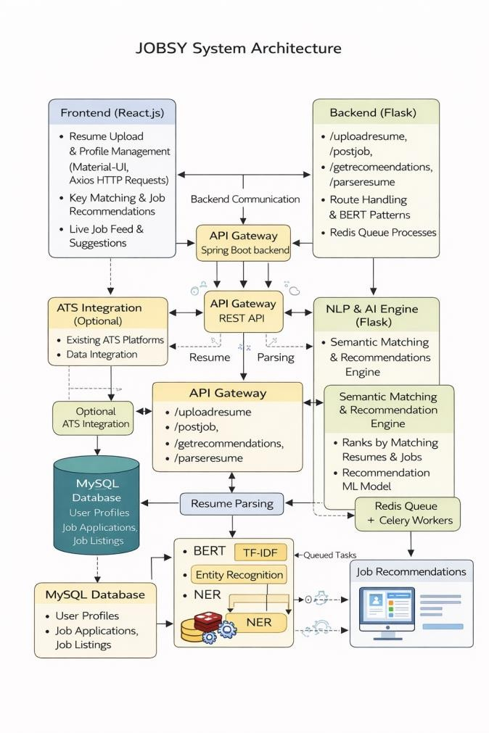
considered in order to make the AI moral, addressing the gender, demographic, or age bias in the recruitment. All these upgrades will contribute to a better, more comprehensive, and smart recruitment system.
V. Acknowledgement
I would also like to acknowledge my project guide and faculty members who were always beneficial in supporting me, encouraging me, and giving me certain suggestions as I worked on this review paper. It is their deliberated feedback and scholarship support that contributed to determining the direction of my work and the quality of it. I also owe my debt of gratitude to the department that had provided me with the resources and a research favorable environment that enabled this project. I would also like to admit the authors and researchers who provided me with the foundation of this review with their papers. Their works on AI, NLP, and automation of the recruitment process actually influenced my studies. Lastly, I am thankful to my classmates and friends who sectioned me motivate, discussed, and supported me in the entire process.

VI. REFERENCES

Fig-3.2 Full Detailed Flow Chart

- Conclusion and future scope
The JOBSY system addresses the weaknesses of the normal Applicant Tracking Systems through the application of the NLP methods and a hybrid matching engine that combines both the lexical and semantic analysis. JOBSY improves the performance of a resume matching a job in that it uses TF- IDF to ensure exact matching of keywords and BERT to gain more information about the job. It fully relies on custom NER parser, real-time responses, and its modular structure combined will ensure the accuracy of the candidate profiles along with fair filtering when dozens of applicants invade. The experiments reveal that the hybrid model implemented by it reduces false positives and negatives compared to ancient systems that were based on key words only in JOBSY. Its design developed using React.js in the front and Flask in the back allows the resume to be read and integrated asynchronously, allowing the recruiters to have the ranked candidates in sight rather fast. The fact that structured data and contextual embeddings were added, as well as an interface that is easy to use, makes the entire process of recruiting significantly more efficient and transparent. To make the decisions of the recruiters more trusted and transparent in the future, Explainable AI tools such as SHAP or LIME can be added to the work. The addition of domain relevant knowledge graphs may restrict semantic matching by establishing hierarchy among similar skills. And above all, the bias-auditing module should be
- C. Chandak, A. Kaushik, and P. K. Mishra, A Hybrid Model of Resume-Job Description Matching RF-IDF and BERT, International Journal of Research in Applied Science and Engineering Technology (IJRASET), vol. 12, no. 3. pp. 302- 308, 2024.
I recently came across the article of Chandak, Kaushik, and Mishra, A Hybrid Model of Resume-Job Description Matching by TF-IDF and Bert (IJRASET, vol. 12, no. 3, 2024, p. 302-308).

- S. Sougandh, R. Ranjitha and S. Sangeetha, A Review Paper on Resume Parser using AI, International Journal on Innovative Research in Technology (IJIRT) vol. 10 no. 7,
pp. 112-115, 2023. A review by Sougandh, Ranjitha and Sangeetha of resume parsers using AI is published in IJIRT (vol 10, no 7, 2023, pp 112115).
- R. Thangaramya, P. Vijayakumar and S. K. Lakshmanan, Resume2Vec: Intelligent Resume Embeddings to transform Applicant Tracking Systems, Electronics, vol. 14 no. 4, 2025. In Electronics, vol., issue 14, no. 4 (2025) the paper Resume 2 Vec was published by Thangaramya, Vijayakumar and Lakshmanan.

- Essentially, it involves uses of the BERT model to calculate more dependable results in resume analysis and job assignment. <|human|>Essentially, it comprises applications of the BERT model in executing more reliable outcomes of analysis of resumes and allocation of employment. In one of the papers in the 2025 issue of IEEE Xplore (pp portions), Swapna, Lavanya, and Rani elaborate on the BERT-based resume analysis (p.16).

- T. Sanyal and R. Roy, NER -based Resume Information Extraction to Get Better filtering of candidates, International Journal of Computer Applications, vol. 181, no. 12, pp. 33- 39, 2023. At Int. Journal of Computer Applications

(vol.181, no.12, 2023, p. 33-39) it is a resume extraction study with NER authored by Sanyal and Roy.

- Prompt of engagement Research showing how vision- enhanced NER models can be used to layout-awarely process resumes is presented in [6]. The vision enhanced resume parser developed by Verma and Kumar was introduced at the IJCAI 2024 (pp 761768).
- R. Deshmukh and A. Raut, TF-IDF Based Resume-Job matching: A Comparative Study, International journal of Advanced research in Engineering science and Management, vol. 6, no. 2, 2025. In the article by Deshmukh and Raut, comparing TF -IDF techniques are described (2025, IJARSEM, vol. 6, no. 2).

- V. Singh, R. Sharma and M. Joshi, "Scalable Web Architecture Design of Resume Processing using Flask and React," IJERT, vol. 11, no. 1, pp. 101-106, 2024. A system described by Singh, Sharma, and Joshi in the article in IJERT (vol 11, no 1, 2024, p.101-106) is a Flask/React resume system.
- A. Kumar and V. Tripathi, A Survey of Techniques, Challenges and Future Directions of AI in Recruitment, International Journal of Artificial Intelligence Research, vol. 9, no. 3, pp. 123-132, 2025. The AIin-recruitment survey projected by Kumar and Tripathi is presented in IJAI Research (vol 9, no 3, pp123132).
- S. Jadhav, M. Kale, and N. Khare, Contextual Resume Ranking with Feedback-driven Gossip Resume Embedding Adjustment, International Journal of Computer Science Trends and Technology (IJCST), vol. 11, no. 2, pp. 75-80, 2024. The context understands the ranking paper by Jadhav, Kale and Khare in IJCST ( vol 11 no 2, 2024 pp 75-80).

- D. Devlin, M. Chang, K. Lee and K. Toutanova, BERT: Pre-training of Deep Bidirectional Transformer, Language Understanding, arXiv preprint arXiv:1810.04805 2019. It is the renowned BERT paper by Devlin et al. that is on arXiv (arXiv:1810.04805, 2019).
- N. Reimers and I. Gurevych, SentenceBERT: Sentence Embeddings with Siamese Siamese BERT |networks, EMNLP, pp. 3982-3992, 2019. Sentence-bert was introduced at EMNLP 2019 by Reimers and Gurevych (pp39823992).

- Unlike, of course, validity, reliability, and generalizability checks in experiments, the internal consistency within a study reliably represents descriptive psychometric integrity but aids the analysis of items that are susceptible to error (APA, 2019).<|human|>Still, in comparison to, naturally, validity, reliability, and
generalizability tests in experiments, internal consistency in any study is a strong indicator of descriptive psychometric integrity but contributes to the examination of test-prone items (APA, 2019). Another matching study is using transformers carried out by Kaur and Arora in Int. J. Scientific Research in CS (vol. 10. no. 5. 2024. pp. 112-
118).

- R. Gupta, S. Bhatt, and M. Rao, "Enhancing Recruitment Processes using Hybrid NLP Models," Journal of Intelligent Systems and Applications, vol. 18, no. 1, pp. 22- 28, 2024. A hybrid NLP article by Gupta, Bhatt, and Rao is published in Journal of Intelligent Systems and Applications (vol18 no1 pp 22-28).

- A. Singh, Resume Entity Recognition with Custom SpaCy Pipelines, Journal of machine learning and NLP vol. 5, no. 3, pp. 39-45, 2023. Singh refers to custom SpA Cy as discussed in the Journal of Machine Learning and NLP (vol 5, no. 3, 2023, pp 39) -45.
- Y. Li, L. Liu, and J. Huang, "NER to parse a resume with the use of transfer learning techniques," Computational Linguistics Research, vol. 7, no. 2, pp. 56-63, 2023. The transfer learning NER can be found in the paper of Li, Liu, and Huang in the publication Computational Linguistics Research (vol 7, no 2, 2023, pp 56-63).
- P. Reddy and S. Mishra, "Comparative Analysis of Resume Parsing Tools on the Structured Data Mining and Calculation on a – Based data, IJERA, vol. 14, no. 1, pp. 88
92. The analysers of parsing tools are assessed by Reddy and Mishra (vol. 14, no. 1, 2023, pp. 88-92).

- M. Shah and D. Banerjee, From Keywords to Concepts: Semantic Matching in Recruitment International Journal of Computer Applications Technology and Research, vol. 12 no. 6 pp. 115-120, 2025. The article by Shah and Banerjee on the semantic matching in the year 2025 is published in the Int. J. Computer Applications Technology and Research (vol 12, no 6, pp 115-120).
- B. Kapoor and R. Sethi, "Explainable AI in Hiring: SHAP Values of Model Interpretability," IEEE Transactions on Human Machine Systems, vol. 52, no. 4, pp. 300 -309, 2024. In an IEEE Human-Machine Systems paper (vol 52, no. 4 pp. 300-309), Kapoor and Sethi address SHAP-based explanations.

- Staffing Industry Analysts, "India White -Collar Recruitment Surges 19% in September, Market Report, 2025. According to the report by the Staffing Industry, the hiring in the white-collar sector in India increased 19 percentinSeptember,2025.

