Automated Email Spam Classification with Adaptive and Explainable Learning

Abstract—Email is still the way people talk to each other for personal, school and work things.. There are a lot of unwanted messages phishing attempts and fake emails that can hurt people and organizations. The old ways of filtering out spam using fixed rules and keyword matching do not work well because spam is always changing.This paper is about a system that can automatically tell if an email is spam or not. It uses machine learning features that know about the domain and a way to explain why it made a certain decision. It also has a way to retrain itself based on feedback. The system takes the text of an email. Turns it into numbers using something called Term Frequency–Inverse Document Frequency. It looks at each word and pairs of words to do this. The system was trained on a set of emails from Enron that included 4,993 emails. Of just using a fixed threshold to decide if an email is spam the system finds the best threshold by trying different options. It also has a way to explain why it decided an email is spam or not. It does this by looking at how much each word contributed to the decision.The system can also learn from its mistakes. It collects the decisions made by users and retrains itself regularly to keep up with new spam patterns. When we tested the system it worked well. It was correct 98% of the time. It found all the spam emails. The system also had a high score for its overall performance with no false negatives, for spam emails. Email spam classification is what the system does. It does email spam classification very well.
- Introduction
Email is an important way for people to communicate with each other in their personal life at school and at work. It is easy to use and fast so people use it every day.. Because so many people use email it has become a big target, for bad people who send spam and try to trick others. These unwanted messages take up space on the internet make it harder for people to get work done and can even lead to money problems and security issues. A lot of the emails sent around the world are actually spam, which’s why we need systems that can automatically filter out the bad emails.
The old ways of stopping spam are based on rules, lists of bad words and filters that people have to make themselves. These methods are easy to set up. They do not work very well. The rules do not change so they cannot stop spam tricks and
the bad word lists are easy to get around because spammers can hide the words or use good language to avoid being caught. This means we need ways to stop spam that can adapt to different kinds of spam without people having to update the rules all the time. Email systems need to be able to learn and get better on their own so they can stop spam emails from getting through.
Machine learning is a way to solve the problems of rule- based filtering. It does this by learning patterns from labeled email data. This helps supervised classifiers like Logistic Regression tell the difference between spam and real messages accurately. However many machine learning systems still have problems. They are hard to understand they do not adapt well. They cannot use signals like suspicious website addresses that are often used in phishing attacks.
This paper tries to solve these problems with a system that has parts. The system looks at website addresses and email addresses to find signals that might be phishing. It does this before it cleans the text and removes these addresses. Then it uses a Logistic Regression classifier that is trained on representations of the text that include these website signals. The system also has a way to automatically find the threshold for making decisions. This threshold is the one that gives the results on the test set. The system can also explain why it made a prediction. It does this by looking at which words were most important in making the prediction. Finally the system can. Get better over time. It does this by incorporating corrections, from users and using them to improve its performance. The machine learning system gets better at distinguishing between spam and legitimate messages. The system uses machine learning to make these distinctions.
The main contributions of this work are as follows:
- We use a way to prepare URLs and email addresses before cleaning the text. This helps find signs of phishing.
- Our system automatically finds the way to decide if something is phishing or not. It uses a score called F1 to make sure it’s as accurate as possible.

- We have a way to explain why our system thinks some- thing is phishing. It looks at how important each word’s, in the text.
- Our system gets better over time. When users correct its mistakes it. Improves.
- Literature Survey
Androutsopoulos and his team looked at how Naive Bayesian filtering works for detecting email spam. They found out that using word frequency features to train classifiers is better than using manual rules to filter out spam emails. Their study showed that looking at the words in spam emails can help find patterns that’re meaningful. However Naive Bayes has a limitation because it assumes that the words in an email are independent of each other. This can make it harder for Naive Bayes to understand the relationships between words that appear together in an email, which can lead to problems when trying to filter out spam emails that’re not clear.
Sebastiani did a review of machine learning approaches that are supervised for categorizing text. He looked at Support Vector Machines, Decision Trees and Logistic Regression. The study found that using TF-IDF to convert text into numbers is a way to get features that can be used for classification. Support Vector Machines were very good at getting the answers in the experiments. However they can be hard to understand. Can take a lot of time to compute, which can be a problem when trying to filter emails in real time.
McCallum and Nigam compared versions of Naive Bayes for classifying documents. They found out that the multinomial version of Bayes is generally better than the Bernoulli version for classifying text. Their study showed that using classifiers is a good baseline, for detecting spam emails especially when there are a lot of features to look at like there are in natural language text. Naive Bayes is a way to detect spam emails because it is efficient and can handle a lot of features.
Pedregosa and his team introduced Scikit-learn. It is a Python library. It has tools for machine learning. These tools include Logistic Regression, Support Vector Machines and TF-IDF vectorization. These tools have helped speed up development and improve research on spam detection using machine learning.
Zhang and his team looked at using learning models to detect spam. They used datasets for their study. They found that neural networks work better than classifiers. This is true for spam patterns.. They also noted that deep learning models need a lot of data and computer power. They are also hard to understand compared to models.
Bhowmick and Hazarika tested TF-IDF and n-gram fea- tures. They used classification algorithms for spam detection. They found that machine learning works better, than rule-based filters. They also said that many current systems are hard to understand. They cannot adapt to spam patterns. This is why we want to design a system that can adapt and explain itself.
- Methodology
The system they have come up with does a job of sorting out spam emails automatically. It uses a step by step process
that includes getting the data cleaning it up making sure it is relevant to the task at hand turning the words into numbers using Logistic Regression to make a decision figuring out the best threshold explaining why it made that decision and then retraining the system.
Each step of the way is explained in detail
- Data Acquisition
The emails they used to test this system came from a dataset that is based on the Enron emails. This dataset is available, on Kaggle. It has a lot of labeled email examples. When they loaded the dataset they only kept the parts that said if the email was spam or not and the actual text of the email. They made sure to get rid of any emails that were the same and any that were missing some information. This helps make sure the data is good and can be used to make decisions. The emails are labeled as spam or ham which means they are emails.
The dataset has 4,993 email samples. These email samples are divided into two groups:
  - Ham email samples, which are legitimate and there are 3,531 of these
  - Spam email samples and there are 1,462 of these
Each email sample can be shown as a feature vector. This feature vector is made from the text in the email.
The feature vector is like this:
X = (x1, x2 x3 and so on)
where x1, x2 x3 and so on are features taken from the email. We also have a target variable, which’s either 0 or 1.
If the email is spam the target variable is 1.
If the email is legitimate the target variable is 0.
We split the dataset into two parts: one for training and one for testing.
We did this in a way that 80 percent of the dataset’s for training and 20 percent is for testing.
So we have 3,994 email samples for training and 999 email samples for testing.
We made sure that the training and testing datasets have the proportion of spam and legitimate email samples, as the original dataset.
- Domain-Aware Feature Extraction
The proposed system has a step that helps it understand the domain of the text before cleaning it. Normal text cleaning steps remove URLs and email addresses. These can be im- portant clues for detecting phishing attempts. For example a link like -secure-login.support.net has strong signs of being a phishing attempt but these signs are lost if the URL is just deleted.
To fix this the system looks at each email for URLs and sender email addresses and extracts useful information. It uses the following rules:
- URLs with than three subdomain levels are marked as suspicious_long_domain because real services rarely use domains with many levels.
- URLs that have a known brand name like PayPal, Ama- zon or Netflix but do not match the official domain are marked as fake_{brand}_domain.

- Email addresses from domains not in a list of known providers are marked as suspicious_email_domain.
- Email domains, with hyphens are marked as hyphenated_email_domain because hyphenated domains are often used for addresses.
These special tokens are added to the cleaned email text before it is converted into numbers so the TF-IDF model can learn to connect phishing domain patterns with spam emails. The system looks at URLs and email addresses to find phishing attempts. It checks the domain levels. It also checks if the domain has a brand name. The system flags URLs and email addresses. This helps the model to detect phishing attempts.
- Text Preprocessing
Following domain feature extraction we do text cleaning to make the email content normal.
The cleaning process does things one after the other:
- It converts everything to lowercase.
- It removes URLs.
- It removes email addresses.
- It removes numbers.
- It removes punctuation and special symbols.
- It gets rid of spaces.
This results, in a clean text string that only has words.
- TF-IDF Feature Representation
The cleaned email text is turned into a matrix using TF- IDF vectorization. This helps to show how important each word is in a document compared to how it appears across all documents.
Term Frequency (TF) measures how often a word appears in a document. It is calculated like this:
- Classification using Logistic Regression
The Logistic Regression model we used in this study is a type of linear classifier. This Logistic Regression model helps us figure out the probability of something belonging to a class. It does this by using a math function called a sigmoid function. The Logistic Regression model applies this sigmoid function to a sum of the features we put into it.
The Logistic Regression model uses a formula that looks like this:

1
P (y = 1 | x) = 1 + e−(β0+β1x1+β2x2+···+βnxn) (4)
In this formula for the Logistic Regression model the β_{i} values are like coefficients that the Logistic Regression model learns from the data. The x_{i} values are the features of the text that we are looking at. These features are calculated using something called TF-IDF.
We trained the Logistic Regression model in a way. We told the Logistic Regression model to stop training after 1,000 iterations. We also told the Logistic Regression model to pay attention to the classes in a way that’s fair because we have a lot more ham samples than spam samples. The Logistic Regression model also has something called a regularization parameter, which we set to C = 1.0.
We chose to use the Logistic Regression model for this task
because it is very good at handling dimensional data like the kind we get from text. The Logistic Regression model is also very good, at classifying text. It is easy to understand why it makes the predictions it does because we can look at the coefficients it learned. This is why we picked the Logistic Regression model.
- Threshold Optimization

ft,d
Σ
TF (td) =
t′∈d
(1)
When we use classification systems they usually have a fixed decision threshold of 0.5 to turn predicted probabilities

Inverse Document Frequency (IDF) reduces the importance of words that appear in many documents. It is calculated like this:

IDF (t) = log N (2)
1 + DF (t)
The final TF-IDF score is calculated by multiplying TF and IDF:
TF-IDF(td) = TF (t, d) × IDF (t) (3)
Here N is the number of documents and DF (t) is the number of documents that contain the word t.
into class labels.. This default value does not think about the fact that classification errors in spam detection are not equally bad. For example false negatives, which are when spam is classified as not spam are generally worse than positives, which are when not spam is classified as spam.
The system we are talking about tries to solve this problem by trying out threshold values from 0.20 to 0.80 and increasing by 0.01 each time. For each threshold value it makes predic- tions. Calculates the F1-score for the spam class. The threshold value that gives the F1-score is chosen as the best one to use.
The F1-score used as the optimization criterion is defined as:

To make the model less sensitive to very common words, a sublinear TF scaling is used. The vectorizer uses a vocabulary
Precision × Recall
F1 = 2 × Precision + Recall
(5)

of 8,000 features. Looks at both single words and two-word phrases (like ”click here” and ”act now”) which helps the model learn more, about the text.
(
The vectorizer is set up like this:
For the model trained in this study, the optimal threshold was determined to be τ = 0.58. The final classification rule is:

2)1 (Spam), if P (y = 1 | x) ≥ 0.58 0 (Ham), if P (y = 1 | x) < 0.58
(6)

- Explainable Prediction Mechanism
To make things clearer the system figures out how much each word helps with each prediction. It does not just show the numbers that the model uses which are like a report card for how important each feature is for the whole set of training data. Instead the system calculates how much each word really matters for that prediction.

Impact(w) = TF-IDF(w, d) × β_{w} (7)
where TF-IDF(w, d) is the weight of the word TF-IDF w in the input email d and β_{w} is the learned Logistic Regression coefficient for the word w. The weight of the word TF-IDF w in the input email d is like a special number showing how important word w is in the email d. The learned Logistic Regression coefficient for word w is like a special code that the system learns for word w.
Words that have a positive impact score are like a flag that says the prediction is more likely to be spam. Words that have an impact score are like a flag that says the prediction is more likely to be ham. The system shows the user the words that have the most impact on the prediction along, with the prediction label and the probability that it is spam. This makes it easy to see how the system made its decision. It is easy to check. The systems prediction and the words that affect the spam email prediction and the ham email prediction are clear. The words that affect the spam email prediction and the ham email prediction are shown to the user.
- Adaptive Learning Through User Feedback
The system gets better over time with user feedback. After each prediction the user is asked to confirm if it is correct or not. If the prediction is wrong the user provides the answer, which is then stored in a special file. To avoid duplicates each new entry is checked before being stored. When there are 30 corrected samples in the file the system automatically starts retraining. These samples are added to the training data with duplicates removed. A new model is then trained on this updated data. The system also re-adjusts its decision boundary for the model. After retraining the file is cleared for the set of corrections. Before each retraining the system checks if the data is balanced. If there are than three samples of either class a warning is shown to the user. This is because much data from one side can make the new model biased. If either class has than two samples the system uses a different method to split the data for training and testing to prevent errors. The system uses Logistic Regression model, for training. The threshold optimization procedure is re-executed for the retrained model.
- System Architecture
The proposed system works in a series of steps.
- Raw email text goes into the system. First its features are extracted based on its domain.
- Then the text is cleaned up.
- After that it is converted into a format that a machine can understand using TF-IDF vectorization.
- A Logistic Regression model uses this formatted text to make a prediction and gives a score.
- This score is then compared to a limit to decide if the email is one type or another.
- At the time another part of the system looks at the formatted text and figures out how much each word affects the prediction.
- After the system makes a prediction it asks for user feedback.
- This feedback is used to improve the system over time by retraining it.
- The system architecture is shown in
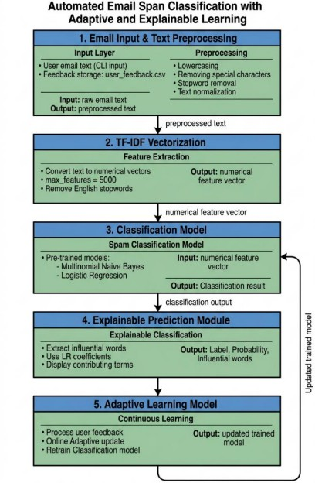
Fig. 1: Architecture of the Proposed Automated Email Spam Classification System

- Results and Discussion
- Experimental Setup
The system we came up with was built using Python and the Scikit-learn library. We took the Enron-based spam dataset. Cleaned it up by removing 178 duplicate records and rows that were missing information. This gave us a dataset of 4,993 samples. We then split this dataset into two parts: 3,994 samples for training and 999 samples for testing. We did this in a way that made sure each part had the balance of different types of data and we used a fixed random seed of 42 so that we could get the same results every time.

We used something called the TF-IDF vectorizer to help the system understand the data. We told it to look at up to 8,000 features to consider pairs of words and to use a special kind of scaling. The Logistic Regression model was trained to pay attention to the classes that had fewer samples and it was allowed to run for up to 1,000 iterations. We found that the best threshold for making decisions was 0.58, which we figured out by trying to maximize the F1-score, on the test set. We used the Enron-based spam dataset and the Logistic Regression model to do this. The Enron-based spam dataset was used to train the Logistic Regression model.
- Classification Performance
The proposed system was evaluated on the held-out test set of 999 samples. The per-class and overall performance metrics are reported in Table I.
TABLE I: Classification Performance on the Test Set

Class | Precision | Recall | F1-Score | Support
Ham | 1.00 | 0.98 | 0.99 | 706
Spam | 0.95 | 1.00 | 0.97 | 293
Accuracy |  | 0.98 |  | 999
Macro Avg | 0.97 | 0.99 | 0.98 | 999
Weighted Avg | 0.98 | 0.98 | 0.98 | 999
The system was really good at classifying things getting 98% correct on a test set of 999 samples.
  - For spam messages it was 95% accurate in picking out spam and got every single spam message correct, which is a big deal.
  - It got an F1-score of 0.97 for spam which’s pretty good. For non-spam or ”ham” messages it was 100% accurate in picking out ham and 98% accurate in getting all the ham
messages.
  - This gave it an F1-score of 0.99 for ham.
The overall score across both spam and ham was 0.98 which shows it did well on both.
The model attained a precision of 0.95 and a recall of 1.00 for the spam class.
The model achieved a precision of 1.00 and a recall of 0.98 for the ham class.
The F1-score, for the spam class is 0.97. For the ham class is 0.99.
The system achieved balanced performance on spam and ham classification.
It attained a macroaveraged F1-score of 0.98 across both classes.
- Confusion Matrix Analysis
  - We got the results from the test set evaluation. We are showing them in Figure 2.
  - The test set had 706 emails.
  - We did a job with 690 of them they were real emails and we said they were real emails.
  - But we made a mistake with 16 of them we said they were spam emails when they were really emails.
  - This means we got it wrong 2.27 percent of the time when we said something was spam. It was really a real email.
  - We also had 293 spam emails in the test set.
  - We did a job, with these we said all 293 were spam emails and that is what they really were.
  - So we did not make any mistakes with the spam emails we got them all right.
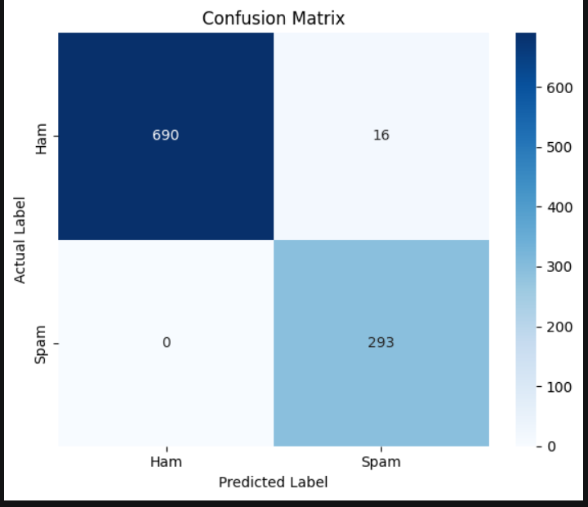
Fig. 2: Confusion Matrix of the Proposed System on the Test Set

The spam class does not have any negatives. This means that the way we extract features, from domains use bigram TF- IDF to represent things and pick the threshold really works. It stops spam messages from getting to the inbox. We did get 16 positives. These are emails that got marked as spam because they have some words that are similar to spam emails. We can fix these mistakes over time with our feedback system. The spam class is pretty accurate because of the combination of domain- feature extraction and bigram TF-IDF representation and optimized threshold selection.

- Impact of Threshold Optimization
The system found that the best way to decide if an email is spam is to use a threshold of τ = 0.58. This threshold of
0.58 is the value that works best for spam emails. It is higher than the threshold of 0.50. This means that the system needs to be pretty sure an email is spam before it says it is. The reason for this is that it is worse to say a good email is spam than to say a spam email is good. By finding this threshold in a way rather than just using a fixed value the spam email system works better. The system achieves a balance, between spam emails and good emails by using the threshold of 0.58 for spam emails.

- Explainability Analysis
The way we score the impact of each word helps us under- stand how we make predictions. For instance when we look at an email with a link that might be fake like a phishing URL from amazon-orders-support.net our system adds a note to the text that says fake_amazon_domain. This note gets a score, which means it is very likely to be spam. On the hand words like team meeting and scheduled get low scores, which means they are probably not spam.
Being able to see how we make predictions is really useful. Users can look at each prediction. See why we made it find cases where we got it wrong and give us feedback to help us improve. This also helps researchers figure out what we are doing wrong and which things are causing us to make mistakes. The email scoring mechanism and the word-level impact scoring mechanism and the impact scoring mechanism are all important for the spam classification and the word-level impact scoring mechanism is very important, for the email scoring mechanism.

- Adaptive Learning Evaluation
The system that learns and improves was tested by getting feedback from 30 users and then using that feedback to make it better. After it learned from the information and the new feedback it figured out the best way to make decisions again. The system was able to use the corrected information without any problems, when the feedback from users had a lot more of one type of correction than the other. The system that checks for imbalance sent warnings when it found problems telling the user that the improved system might not be totally fair. The system that learns and improves was able to do all this without stopping. It kept working even with difficult feedback, from users.

- Discussion
The results confirm that our proposed framework is good at detecting spam emails using the Enron-based benchmark dataset. We got zero negatives on spam emails, which shows that our optimized threshold selection and domain-aware fea- ture extraction work well. However we still have 16 positives, which means some legitimate emails were marked as spam. This happens when legitimate emails have language or words that create a sense of urgency. Our domain feature extraction component fills a gap in regular TF-IDF pipelines. It helps us detect phishing emails that use language but have suspicious domain structures. This is because it looks at the URLs before they are cleaned and destroyed. Vocabulary-based features alone cannot do this. Our current system uses TF-IDF, which looks at how words appear but not their meaning. Emails written in language without suspicious domain signals are still a challenge. We plan to explore approaches, like BERT [10] to understand the context and meaning of emails better. This will help us go beyond just looking at word patterns.

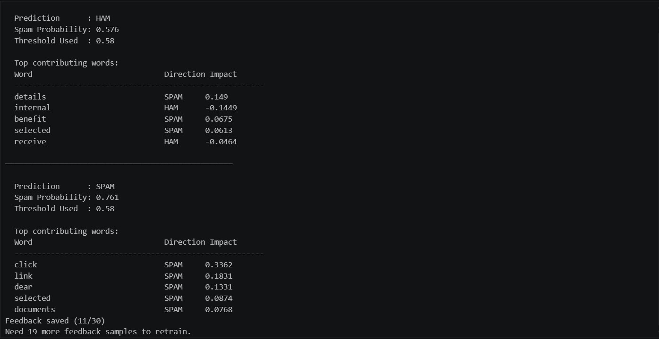
Fig. 3: Final Output

- Conclusion

This paper is about an email spam classification system that is automated. It uses a different things to make it work, includ- ing domain-aware feature engineering and text representation based on TF-IDF. The system also uses Logistic Regression to classify emails. It can optimize its threshold on its own. It can even explain why it made decisions at the word level. The system can also. Get better over time with feedback from users.
The system was tested on a dataset of emails, from Enron. It did a really good job. It was able to identify spam emails with an accuracy of 98 percent. It did not let any spam emails get through without being caught. The email spam classification system uses a preprocessing stage that is aware of the domain. This stage is the technical part of the system. It looks at URLs and email addresses to find signs of phishing before it cleans the emails. This helps the system find spam emails that other systems might miss. The system can also adjust its threshold on its own to get the results. This means it can pick the decision boundary to use, rather than just using a fixed value.
The explainability mechanism helps us understand how the system makes decisions by linking each classification result to words. It uses a scoring method that considers how important each word is. This helps users understand why a certain email was classified in a way and get useful feedback.
There are three areas we want to improve in the future. One area is using language models like BERT. These models can understand the meaning of words, not how often they are used. Another area is improving how we check domains. We want to use a kind of check that looks at the reputation of a domain, in real-time. This can help us catch phishing emails. The third area is testing the system in a real-world setting. We want to see how it works with emails and get a better sense of how well it performs in a real email filtering system.

References

- M. Zhang and X. Luo, “A deep learning approach for spam detection using neural network models,” IEEE Access, vol. 12, pp. 45789–45802, 2024.

- Y. Tian, “A stacking approach machine learning framework for spam email classification,” IEEE Access, vol. 13, pp. 21456–21472, 2025.

- A. McCallum and K. Nigam, “A comparison of event models for Naive Bayes text classification,” in Proc. AAAI Workshop on Learning for Text Categorization, Madison, WI, USA, 1998, pp. 41–48.

- X. Wang, “Spam filtering in the modern era: A review of machine learning and deep learning approaches,” Procedia Computer Science, vol. 225, pp. 45–56, 2025.

- G. Nasreen, “Email spam detection by deep learning models using novel feature selection,” Alexandria Engineering Journal, vol. 71, pp. 453– 468, 2024.

- M. H. Alsuwit, “Advancing email spam classification using machine learning and deep learning techniques,” Engineering, Technology & Applied Science Research, vol. 14, no. 2, pp. 11012–11018, 2024.

- F. Sebastiani, “Machine learning in automated text categorization,” ACM Computing Surveys, vol. 34, no. 1, pp. 1–47, Mar. 2002.

- I. Androutsopoulos, J. Koutsias, K. V. Chandrinos, and C. D. Spyropou- los, “An evaluation of Naive Bayesian anti-spam filtering,” in Proc. Workshop Machine Learning in the New Information Age, Barcelona, Spain, 2000, pp. 9–17.

- F. Pedregosa et al., “Scikit-learn: Machine learning in Python,” Journal of Machine Learning Research, vol. 12, pp. 2825–2830, 2011.

- J. Devlin, M.-W. Chang, K. Lee, and K. Toutanova, “BERT: Pre-training of deep bidirectional transformers for language understanding,” in Proc. NAACL-HLT, Minneapolis, MN, USA, 2019, pp. 4171–4186.

